**GROUP ASSIGNMENT 1**

**Page 36 No. 13**

13.

1. The Funciton of this program is to determine are the number input included in the overweight class or not overweight class.

Getch()

Read weight

Print

“Try to maintain normal weight”

NO

YES

Print

“You are OK”

Print

“Enter your body weight”

Weight > 110

Weight <= 110

NO

YES

Print

“You are overweight!”

1. 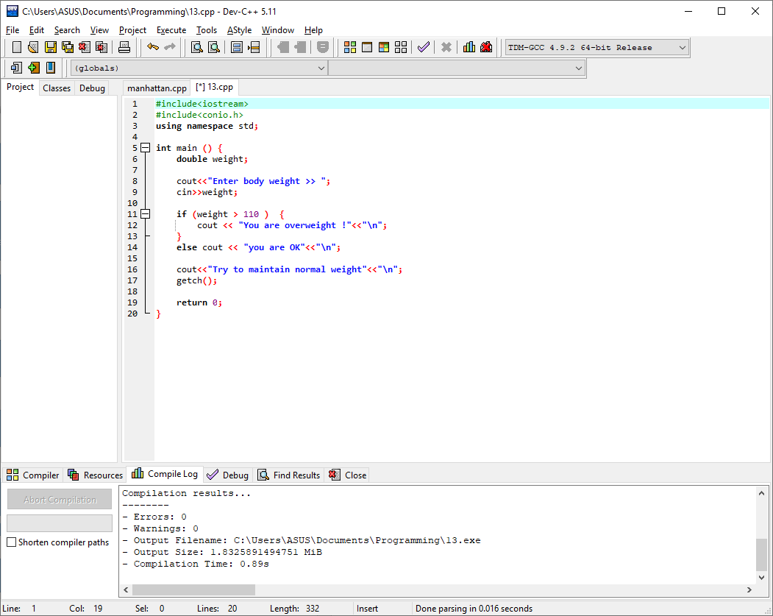
2. If if statement

Getch()

Read weight

Print

“Try to maintain normal weight”

NO

YES

Print

“You are OK”

Print

“Enter your body weight”

Weight > 110

Weight <= 110

NO

YES

Print

“You are overweight!”

If else statement

Getch()

Read weight

Print

“Try to maintain normal weight”

Print

“Enter your body weight”

Weight > 110

NO

YES

Print

“You are overweight!”

Print

“You are OK”

**Page 39 No. 16, 17**

16.

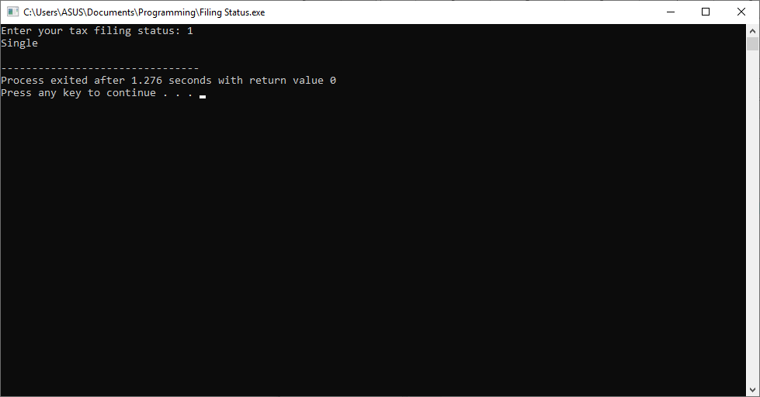a. If the user put the input 1, it’s going to display “Single”

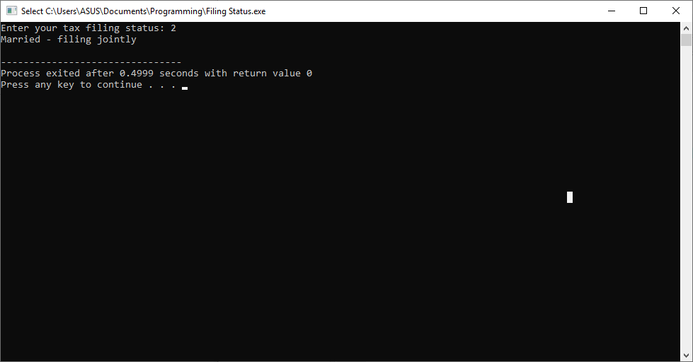If the user put the input 2, it’s going to display “Married – filing jointly”

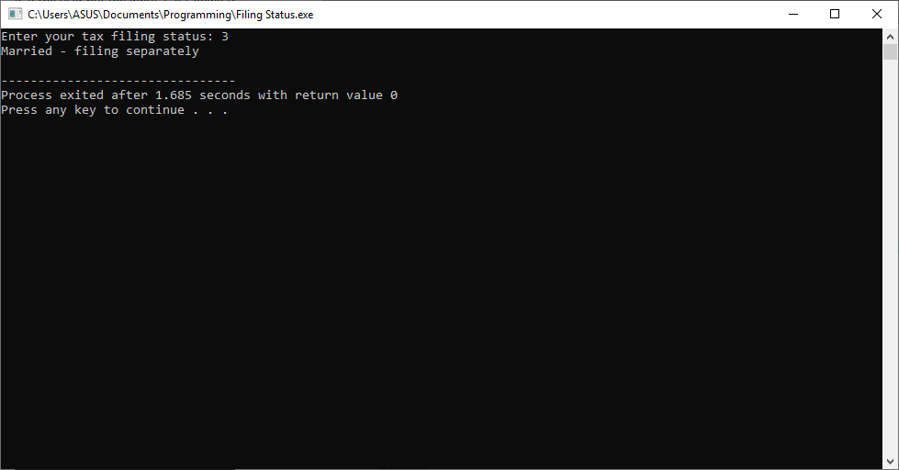If the user put the input 3, it’s going to display “Married – filing separately”

If the user put the input 4, it’s going to display “Head of household”

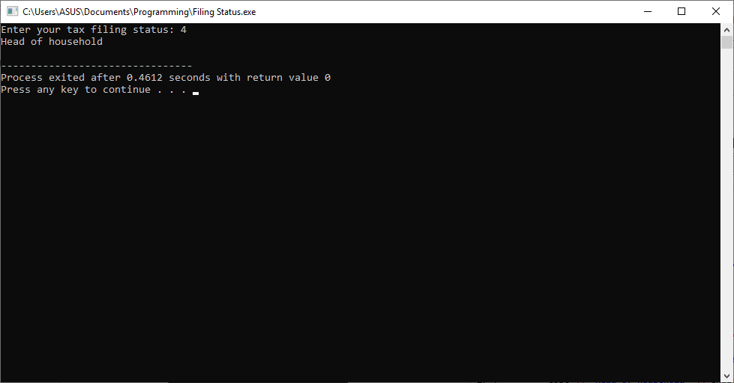

If it’s none of the above, it’s going to display “Error in filing status”

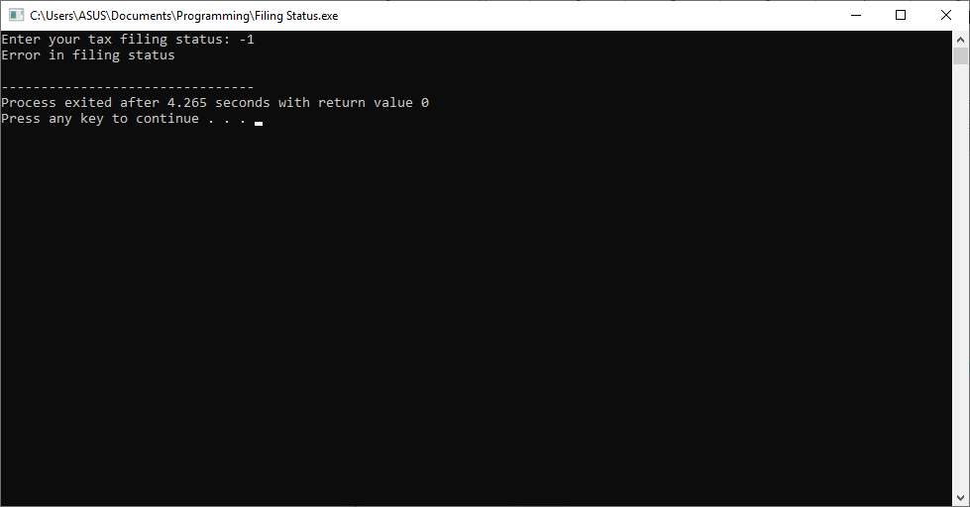

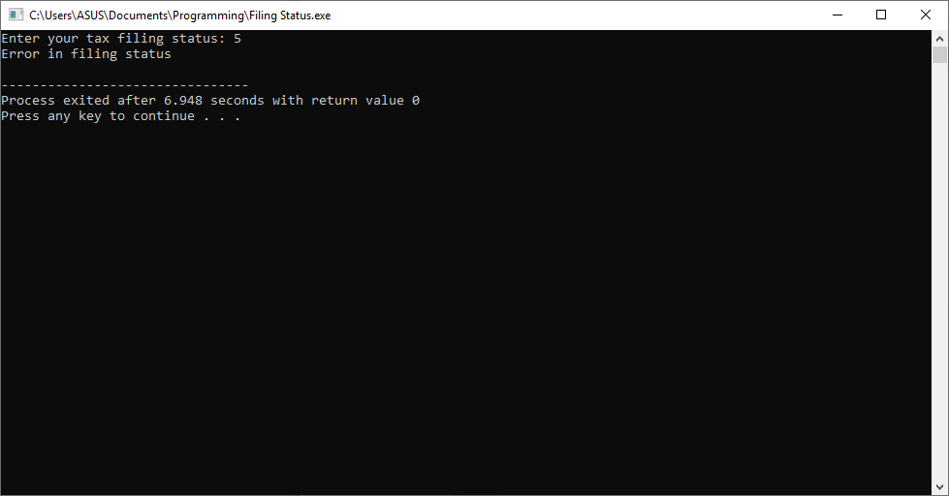

b. 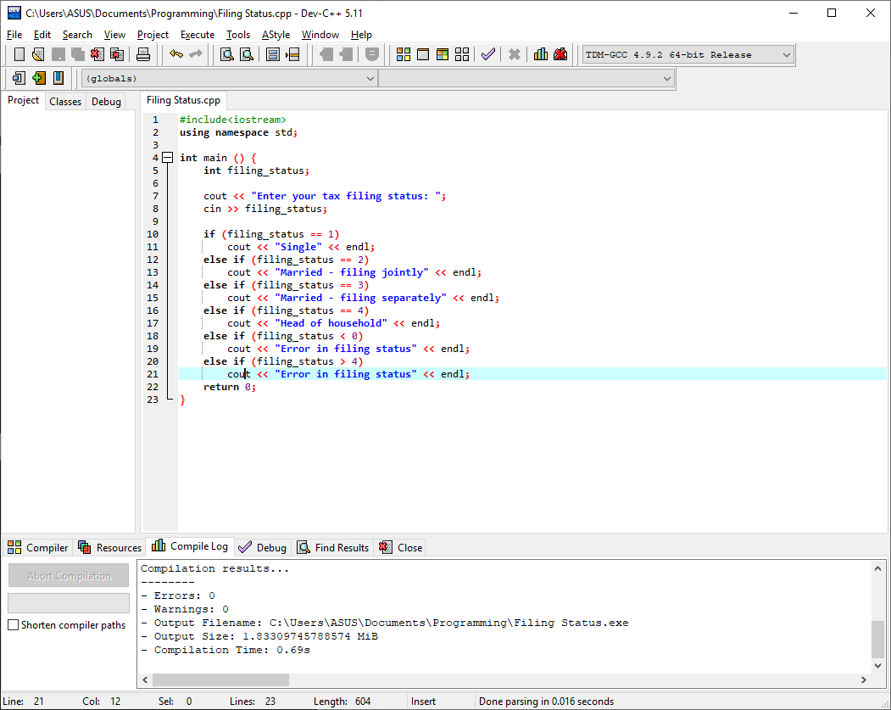

17.

a.

Read mark

Print

“Enter your mark >> ”

NO

Print

“Your score: A”

YES

mark >= 75

YES

Print

“Your score: B”

mark < 75 && mark >= 60

NO

Print

“Your score: C”

mark < 60 && mark >= 45

YES

NO

YES

Print

“Your score: D”

mark < 45 && mark >= 30

Print

“Your score: E”

YES

NO

NO

mark < 30

b. if the mark = 90.6, the one will be evaluated is the “if mark >= 75” statement. Because 90.6 is greater than 75, or in other word 90.6 >= 75.

The results of the expressions will be “Your Score A”.

c. So the difference between if statement anda if…else if statement is, when in if statements all of the statements will be tested and if it’s fill the required procedure it will run the if program, so no matter how much the if statement it goes through as long as it fulfill the statement it’ll run it.

Difference with the if..else if statement, where in this statement it’ll only run the if statements once, the program will check the statements from top to bottom, if it’s already fulfill one statements it will stop the checking and to the end of if..else if statements.