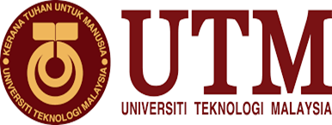

TECHNOLOGY & INFORMATION SYSTEMS (SECP 1513)

INDUSTRIAL VISIT 2: GALERIUM, PSZ.

PREPARED BY
NAME: | MATRIX NUMBER:
THANNEERMALAI A/L UDAYAPPAN | AI9EC0171
FATIMA AZ DZIKRUN BINTI SAHROL NIZAM | A19EC0046
ALVIN HEE JUN SHEUNG | A19EC0015

LECTURE NAME: DR. ARYATI BT BAKRI
SUBMISSION DATE: 11.11.2019
Contents
INTRODUCTION 3
DETAILED STEPS AND DESCRIPTIONS 4
ORGANIZATION STRUCTURE 5
HISTORICAL COMPONENT 6
MAINFRAME 6
CPU (COMPUTERS) 7
MOUSE 8
MOTHERBOARD AND PRINTER 9
REFLECTION 11
THANNEERMALAI A/L UDAYAPPAN 11
FATIMA AZ DZIKRUN BINTI SAHROL NIZAM 12
12
ALVIN HEE JUN SHEUNG 13
TASK OF EACH MEMBER 14
CONCLUSION 15
REFERENCE 15

Figure 1 Organizational Chart Of UTM LIBRARY 6
Figure 2 Mainframe Data Storage 6
Figure 3 Apple Macintosh Classic 2 Computer 7
Figure 4 Computer for Kodak's Film 7
Figure 5 Apple's mouse 8
Figure 6 Generation of Mouses 8
Figure 7 Collection of motherboard and processor 10
Figure 8 Old edition of printer 10

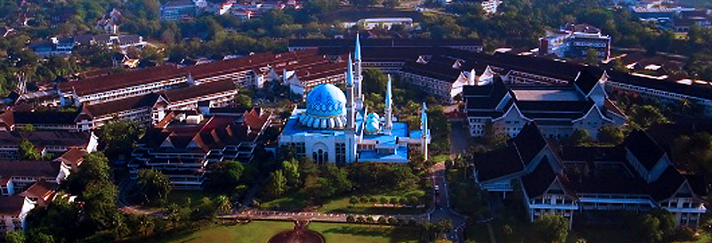
INTRODUCTION

The success of UTM today began with the efforts of the previous generation of leaders. History has captured the diverse history of transfusions, challenges and successes of the University since its inception. The library is located in a central location and is very assessable both by foot and by vehicles in the main campus in Skudai. UTM Kuala Lumpur also has a branch. The library was named after the Her Majesty Sultanah Zanariah, the Chancellor of University Teknologi Malaysia that was also officiated by her on 3 February 1991. The library plays an important role in the pursue of higher education. There are many services geared towards the student here in UTM and some of the services offered are discussion rooms, PC, thesis, etc.

At 23 October 2019, we went to the Galerium at Perpustakaan Sultanah Zanariah to look the historical items in information technology system. UTM GALERIUM is an important entity for the University in its quest to collect, preserve and record the University's historical heritage. The University's diversity of artifacts across technology, science, engineering and cultural arts should be nurtured with the commitment of all parties for the benefit of the next generation.

DETAILED STEPS AND DESCRIPTIONS

DATE | ACTIVITIES
14 OCTOBER 2019  MONDAY | - Briefing about the project by Dr. Aryati
21 OCTOBER 2019  WEDNESDAY | - Gathered in front of the Sultan Zanariah library with course mates  - Entered the library and lined up in front of the PSZ galleria  - A small talk by Mr.Mohd Zahari  - Tour around the galleria by Mr Mohd Zahari
23 OCTOBER 2019  THURSDAY | - First meeting with group members  - Distribute the tasks for each group member  - Plan a rough outline of the report  - Sort through the pictures
3 NOVEMBER 2019  SUNDAY | - Do assigned task  - Second meeting with group members  - Compile all the work  - Correcting and editing the mistakes
4 NOVEMBER 2019 | - Present the idea to lecturer and get the approval for completion
5 NOVEMBER 2019 | - Each member write a reflection based on the outcome of this project  - A conclusion is drawn upon the reflection of each member  - Final editing of report  - Citations of reference

ORGANIZATION STRUCTURE

These people are the backbone to the libraries here in UTM and the higher positioned officers whom are in charge of various departments.

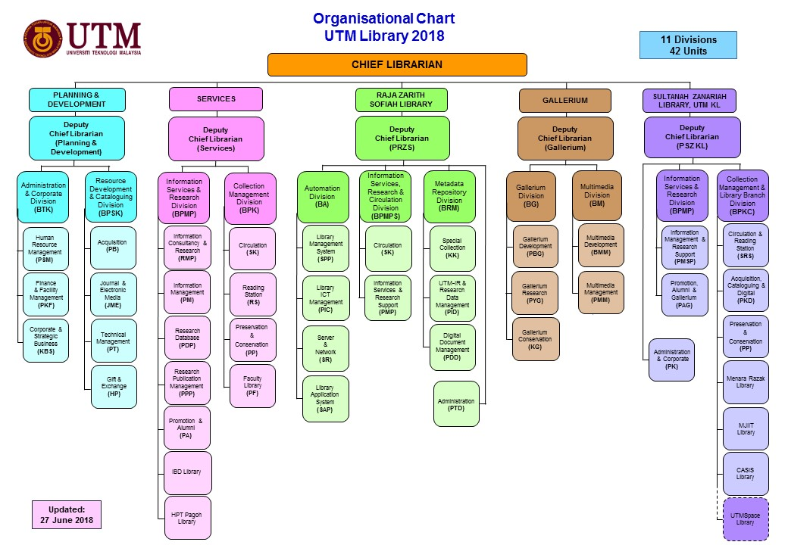
Figure 1 Organizational Chart of UTM LIBRARY

HISTORICAL COMPONENT

MAINFRAME
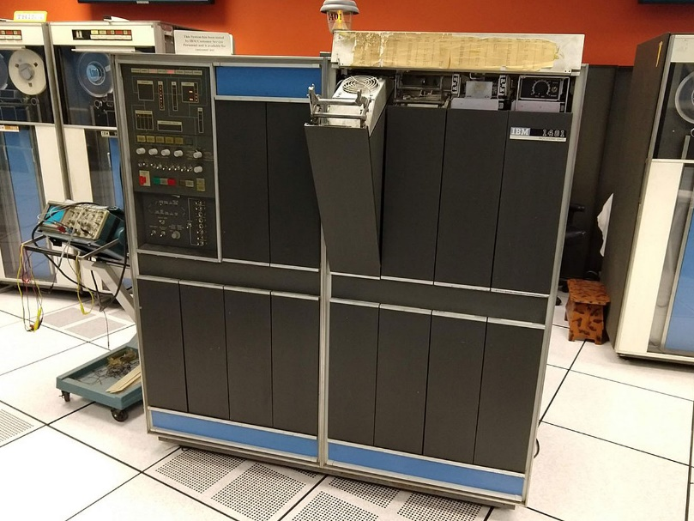
First off, we are glad that to have a golden chance meeting an old Mainframe Data Storage Model namely IBM (9345B22). UTM has begun using this device for almost 20 years in the early 70’s back in the past. One of the main functions of this device was to control the data information of students and staffs of UTM. Moreover than that UTM has made it into the core device of entire university as it provided several functions, that are securing, storing processing as well as printing the university‘s information data. Before this visit, I know nothing about how the mainframe works but with the great explanation done by the facilitator, me and my group members have discovered more about the secret of mainframe, unlike supercomputer that solves complex numerical problems, make forecasts, analyse scientific or engineering problems, mainframe has higher reliability in performing large scale transaction processing, managing terabytes of information in databases.
Figure 2 Mainframe Data Storage

CPU (COMPUTERS)
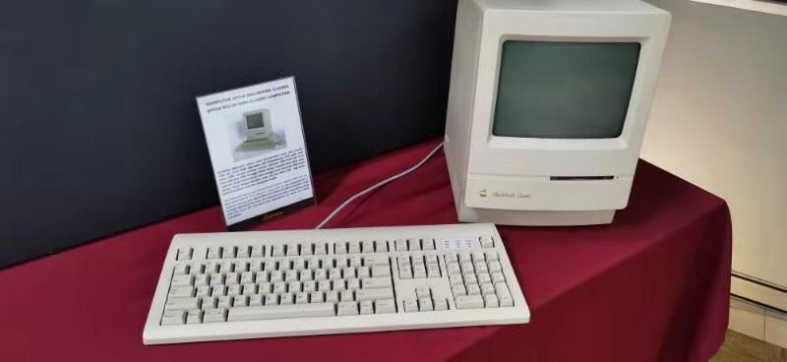
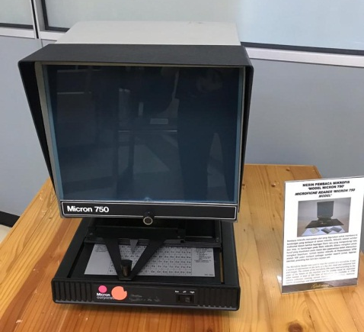
Besides that, we have been introduced to the apple Macintosh classic-2 computer. Some of the facts about this computer are it has a Motorola 68000 microprocessor as the cpu, yet it has a resolution up to 512x 342 pixel per inch. This computer has more than 20 years of history in UTM since it was firstly used in UTM library back in 1990. Moreover than that, this computer has equipped with a storage capacity of 1 MB ram and a 2 to 40 MB of hard disk, hence it is tremendous enough to store all the data and information of UTM. One thing special about this computer is it worked together with an application namely Lotus 123, which made for standardizing the library data in a much more proper format. Another word processor application, Word Star Application has used to further enhance the smoothness of library‘s work. Although having this computer in today ‘s world is no longer useful to us but we as the young generation should appreciate these inventions back in the past, everything comes with flaws but it wouldn’t have been possible until we see how advance is our current computer in nowadays without the existence of the older generation computer. Hence, instead of feeling how lucky we are able to born in the world of nanotechnology, we should always remember where these computer components came from.
Figure 3 Apple Macintosh Classic 2 Computer
Figure 4 Computer for Kodak's Film

MOUSE
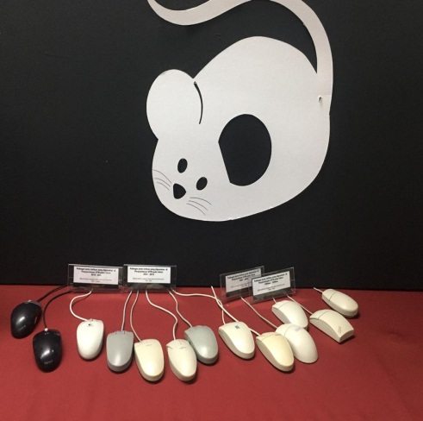
Douglas Engelbart was the first person to invent the first ever computer mouse in 1964. It was made up of a wooden box, two metal wheels and a single key. After many years of inventions, trials and errors a computer mouse using wheels was invented for more movement to be achieved. Nevertheless, it was soon replaced with Opic Led design from Microsoft. This mouse unlike the older version did not require a mouse pad hence making it more advanced. Later down the road, Apple also started to investigate the concept of a wired mouse and was in the pursue of simplifying the complicated wired mouse. Moreover, through perseverance Apple was finally able to achieve their very first USB interface computer mouse. The nickname “Ice Ball” was given to this mouse due to its distinct round shape, which confused many of its users. In addition, after many years later there were many different type of computer mouse. For an example, Microsoft pushed out the bendable Arc computer mouse. When not used, this type of mouse can be laid flat. When used, it can bend to adjust to its user's palm shape. Microsoft says that with the Blu-Ray technic, it allows the mouse to be used on wood or even carpet.
Figure 6 Generation of Mousse

MOTHERBOARD AND PRINTER
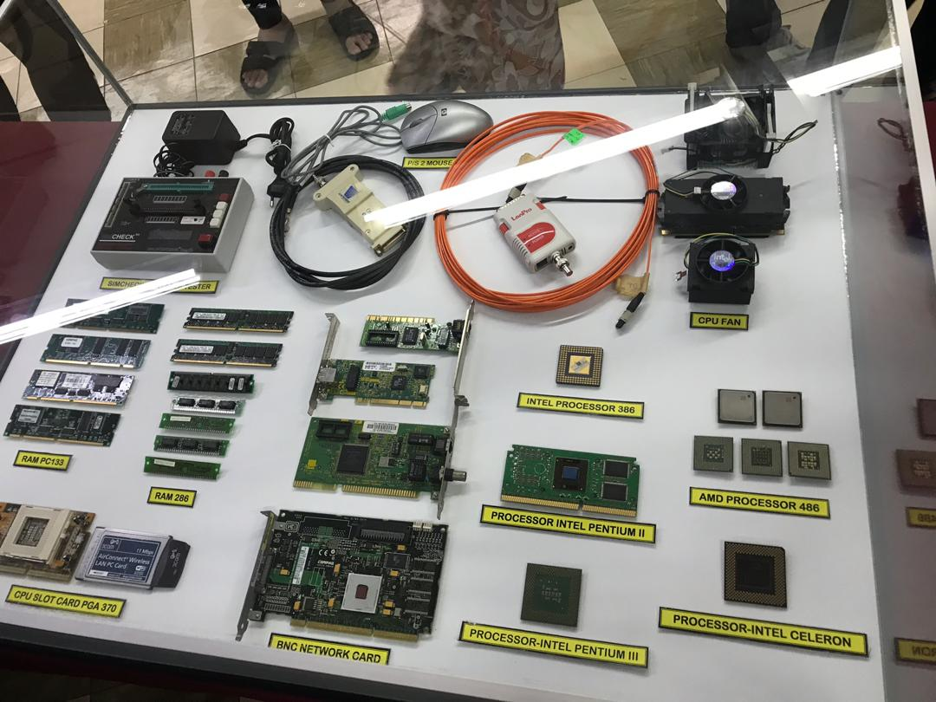
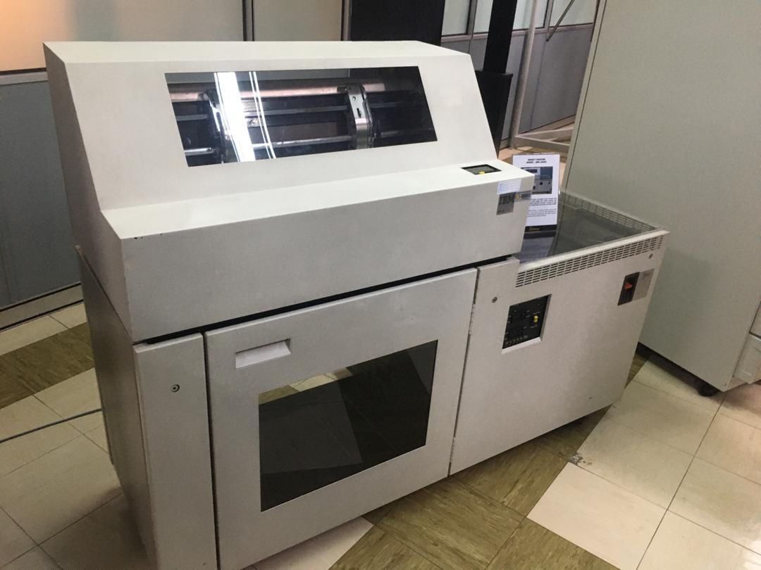
The facilitator did share to us some fundamental knowledge on the computer ’ components namely motherboard, impact printer, processor chips.Motherboard has known as the largest printed circuit board that covered in slots, connectors chips in a computer , if central processing unit (CPU)is the brain of a computer, then motherboard is often described as the backbone of computer. It contains no actual processing power and it has to reply on other processors like CPU or GPU that are attached directly on motherboard, enabling it to perform all of the actual work. Moreover than that, he did introduce to us some of the older generation of Intel processor chips. Intel processor 386 is a microprocessor that was introduced back in 1985; it was a 32-bit microprocessor, which at first consisted of 275000 transistors. Intel Celeron processor who is first launched in 1998 until today, he told us that mostly we could found this processor in those low cost and affordable laptops in nowadays. One thing to know about this Celeron processor is it featured with less cache memory hence slowing down the computer operations and processing. Impact printer or commonly known as Dot matrix printer that has been used in UTM in 1990s until 2011. The main purpose of having this printer is to print the data information of UTM’ students and staffs in a large amount of quantity. This printer is capable of functioning nonstop up to 48 hours in order to fulfill the tremendous demand of printing paper material to supply the whole UTM back in the time. The facilitator told us this printer was responsible for printing the exam paper and exam result for whole UTM’ students. Hard disk drive (HDD) is one of the computer components he did explain to us the working principle of it.
Figure 7 Collection of motherboard and processor
Figure 8 Old edition of printer
.Our stored data are recorded as a magnetic pattern, formed by groups of tiny grains. In each group also known as bit and all of the grains will have their magnetizations’ aligned in one or two possible states which correspond to 0 and 1.

REFLECTION
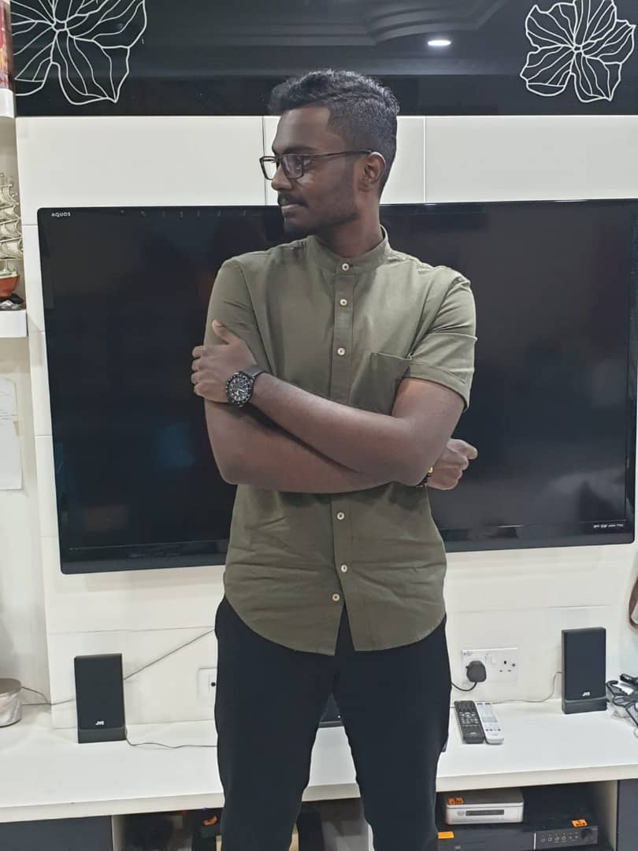  THANNEERMALAI A/L UDAYAPPAN | The visit to CICT has really made an impact on me as a human being and as a future data engineer. After attending this said visit to CICT, I have a better understanding on the evolution of technology since the dawn of the digital era until now and the role we humans play in this technological advancement. Many might ask what my goal is and dream as a future data engineer is? My dream is to be one of the pioneer in Data Engineering Specialist in Malaysia and further improve Malaysian’s standard/skills in the IT department. My first step in achieving that is obtaining the highest honors in UTM in my bachelor's degree. I hope that this degree in UTM will be the perfect stepping-stone for me to step into the wilderness, and potentially enable me to work overseas and gain more skills there.  This visit has influenced me in a few aspects especially my imaginative and creative side of me. This visit had me thinking of the type of problems people have faced and the ingenious technology created to help overcome these problems. This visit has made me more aware of the necessities of the importance of advancement of technology to the betterment of humans. For an example, if the very first computer had not been invented we would not have our advanced super computers and the list of examples are endless and I hope to be one of the pioneers in my field to have created something beneficial for everyone before my time passes.  In my opinion, a few things should be learnt before entering the industry. First, I believe that it is necessary for me to learn multiple coding language such as C++, C and Python, especially Python as it is currently being used widely in the industry. These can be learnt through online learning platforms. Other than that, we should also have a good foundation on how a system/invention works to make our own modification to make said system/invention work better. Besides that I should also work on my soft skills by attending professional courses being held in UTM like HOW TO MANAGE YOUR PERSONAL FINANCE , HOW TO GET YOURSELF EMPLOYED, and etc.
FATIMA AZ DZIKRUN BINTI SAHROL NIZAM  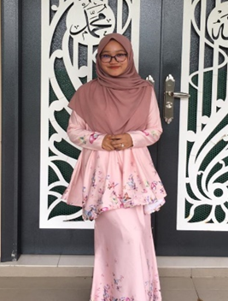 | My goal regarding to this course is to get flying colours for my result in each semester. After completing my studies, I want to improve and make Malaysia well known as a well-known country with a first class tech. This is because many advanced countries have a head start in the 4.0 industry revolution.  From my visit to the galleria, PSZ, I obtained a lot of information about technology system. I was amazed with scientist and technology that they created to revolutionize the information system. The revolution are very precise and very detailed to make it easier to use. This improvement is not an easy process and need criticism to make it better. From this revolution, it has increased my desire to keep learning about technologies because it is evolving from year to year according to user requirements. Therefore, it will enhance my curiosity in my program and sharpened my critical thinking to solve problems. Other than that, the main evolution of these inventions were , the scientists kept on improving the components from complex to simple, and from big to smaller sizes. This innovation is not easy to accomplish since the mechanism in the components need to be changed and should have the same output like the old ones. From this innovation, it also opened up my mind to take a risk to make something better than before.  To improve my potential in the industry, I will improve my critical thinking in solving problems since the reality is that I will face during my industrial training are not the same like what I faced in my studies. Other than that, to get myself more marketable to industry, I will learn several computer languages such as Python, SQL, and C++ and so on. This is because the industry requires skills in computer languages to work with them especially graduates from my courses.
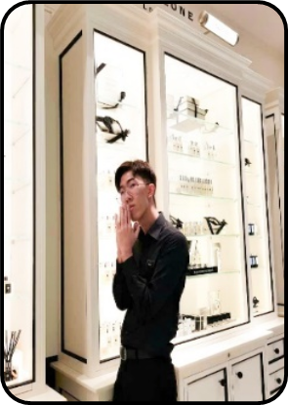  ALVIN HEE JUN SHEUNG | I was glad to join the visit to Galleria UTM where I got a chance to witness the revolution of computer components in the past until the current latest version.  I truly appreciate that I was born in the era of technology advancement where our current world is powered by modern technologies, making our life much easier compared to the past but on the other hand, I truly respect the computer scientist deep down from the bottom of my heart who became the pioneer in creating all these things that came along with lots of failure and criticism, without their effort, things that we are seeing today could probably be seen in our dreams where we hardly can achieve it. These people come from humble beginnings and have achieved something great through innovation and hard work, this gives me hope to achieve something great in the future, and making it happen instead of letting it only being a dream although not everyone might support me at first but I just need to believe in myself.  Action always speaks louder than work, being curious all the time helps me in making a greater step in the respective industry. The more we ask, the more we get to discover and as a result the more we know compared to others who pretend to know everything. Staying competitive is another way to improve my potential, it motivates me to compete with others but in a positive way, none of us will feel uncomfortable winning or losing it, but it only awakes the true fighter inside our heart to bring out the best of our own. From the competition, we can learn things from the good ones and see them as our role model.

TASK OF EACH MEMBER

CONCLUSION

Concisely, from this visit we saw the innovation occurred in technology system. By that, we learn that curiosity to make improvement is important to make future life more convenient. As an example, the first computer that Apple Inc. made went to lots of improvement until the mac Air book had been created. This innovation is not easy to do because many components need to be concentrated for better results. We hope that future generations will appreciate the hard work of our scientists in doing the improvement in technology systems and keep learning to do improvement for better future especially our generation leading to IR 5.0.

REFERENCE

Palermo, E. (2014, February 25). Who invented the printing press? Retrieved October 30, 2019, from LIVESCIENCE: https://www.livescience.com/43639-who-invented-the-printing-press.html
Reddy, A. (2019, January 3). History Of Microprocessor. Retrieved October 30, 2019, from tutorialspoint: https://www.tutorialspoint.com/history-of-microprocessor
UTM Library. (2019). Retrieved November 3, 2019, from UTM Library: http://library.utm.my/about-the-library/zaidi-divisions/
Z, J. (2017, November 28). History Of Computer Mouse. Retrieved November 3, 2019, from Sutori: https://www.sutori.com/story/history-of-computer-mouse--2yUFPn6vNQBstaaz2x4FTdsy
ZimmermanN, K. A. (2017, September 7). History of Computer: A Brief Timeline. Retrieved November 2, 2019, from LIVESCIENCE: https://www.livescience.com/20718-computer-history.html

