**SCSV 2113**

HUMAN COMPUTER INTERACTION

(Session 2020/2021 Semester 2)

School of Computing

Universiti Teknologi Malaysia



**LECTURER**

NOR ANITA FAIROS BINTI ISMAIL

(Section 01)

**GROUP NO 5 (Auspicious)**

*Prepared by*

MAIZATUL AFRINA SAFIAH BINTI SAIFUL AZWAN A20EC0204

MADINA SURAYA BINTI ZHARIN A20EC0203

NAYLI NABIHAH BINTI JASNI A20EC0105

MADIHAH BINTI CHE ZABRI A20EC0074

NURFARRAHIN BINTI CHE ALIAS A20EC0121

SAFIRA NURUL IZZA A18CS0323

**TELEPHONE**

1. Visibility

* The colour from the LCD screen helps the user to see the screen very well even in the dark. It also provides the user only some necessary menus for the user to choose. Other than that, while calling, the user could know the current time shown by the digital clock.
* Different colours of the telephone body and icons improve readability.

1. Feedback

* LCD screens benefit the user to identify which buttons or numbers they are pressing. It also provides additional functions by helping the user to know how long they make a call. Since it is a digital telephone, surely it will provide sound when the user presses the buttons and the user could disable it if the sound feels distracting.

1. Constraints

* Physical constraints

The design does not have braille that could help blind people determine the buttons. Thus, it is not user friendly.

* Logical constraints

There are icons with short instructions at each button that make people easy to understand. The buttons also are not too big and not too small for the user to press.

1. Mapping

* Good mapping arrangement for the numbers,arrows and other icons.

1. Consistency

* External consistency

Consistent arrangement of keypad numbers layout.

1. Affordance

* Button’s icons give simple instructions to improve learnability.

**MODERN CLOCK WALL**

1. Visibility

* The design which is needle-like shapes help the user to differentiate the hours. However, the user cannot determine the exact time as the minute marks are invisible. Hence, it does not have good visibility for the user.

1. Feedback

* This design does not provide outstanding feedback for the user as it does not tell anything to the user in terms of what they should do and what they have done. It also does not include any sound to indicate anything.

1. Constraints

* There is no actions needed in this design

1. Mapping

* There is no mapping needed in this design because this design is not to be controlled by the user

1. Consistency

* The needle of the clock wall rotates in clockwise direction
* The color is not consistent and not attractive as it has too much blue color

1. Affordance

* The user will immediately know that one needle means one hour

**LIFT BUTTON CONTROL**

1. Visibility

* The position of the buttons are easy to see so that the user does not face any problem such as mistakenly pushing another button.

1. Feedback

* The light will switch on when the user pushes the control button. This will notify the user on which button that they just pushed.

1. Constraints

* The design has a logical constraint as it shows clearly that to access a certain floor or the functions, only the specific button can do that and it can be differentiated by the user easily.

1. Mapping

* The lift control button has good mapping arrangement and is less confusing in order for the user to use.

1. Consistency

* The font of the numbers and icons on each button are usually seen and familiar by other people so that it is easy to use. The pattern of the button control is also usually used in other lifts.

1. Affordance

* The numbers and symbols on the button shows that, to operate it, it needs to be pushed to perform the specific instruction. This shows that the design has good affordability as the user can understand it easily.

**SPEED METER**

1. Visibility

* The meter should start with 0 and not continuous with another number before that. It really has a bad visibility.

1. Feedback

* It has a marker that mark the maximum speed for the car if the needle exceeds the marker.

1. Constraint

* The design has a logical constraint as it clearly shows the speed and it also has different size of line.

1. Mapping

* This design has a good mapping but it is a bit confusing because of the speed before 0.

1. Consistency

* The numbers are consistent after 0. However the numbers are inconsistent with the line before 0.

1. Affordance

* The user will immediately recognize the small line, long line and the needle that represents the speed.

**CALCULATOR**

1. Visibility

* Since every button is labelled clearly and the mode can be distinguished by colors on top of the button. The output can also be seen on top of it so it can be helpful for the user to keep on track on the calculations

1. Feedback

* It is very poor in terms of feedback, as it does not provide any indicator for user as a guide on what has been done and what needs to be done

1. Constraint

* It is very precise as the buttons can only be used for specific function(s)

1. Mapping

* The arrangement of the buttons provides a logical sequence such as numbers are placed in one area and operators in another separate part which makes it easier to be found.

1. Consistency

* It contains an externally inconsistency as it is common and can be found on the other type of devices

1. Affordance

* The buttons were labelled which can be guide for the users on how to use it

**EXAMPLE 2**

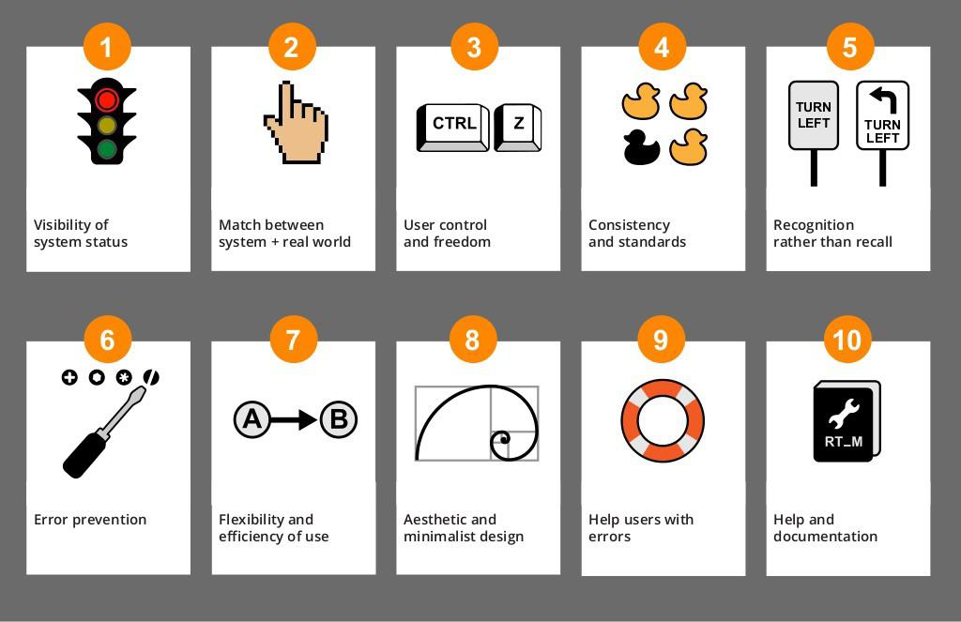

1. Visibility

* Each design from 1 to 10 can be easily understood by all users.
* Have its own description under each icon.

1. Feedback

* Each design from 1 to 10 has its own feedback and can be easily understood as it is universal.
* Some icons do not match with the functions.

1. Constraint

* The descriptions are easy to understand by the user.

1. Mapping

* Good mapping arrangement for the user to use and it's not confusing.
* Each icon has the same design for the background so it looks neat.

1. Consistency

* The icon are usually use by others

1. Affordance

* Each icon represents an explanation or description of their functions.



1. Visibility

* The button is big
* The colour of buttons and icons are different so it is readable.

1. Feedback

* The words give direct instructions to the user.
* Social media’s icons are being shown to make sure the user knows which social media platform they want to use.

1. Constraint

* Direct instructions and big buttons prevent the user to select incorrect options
* The colour coding follows the social media’s logo colour.

1. Mapping

* All the buttons are aligned so the user could easily make their selection.

1. Consistency

* The shape and font size are consistent.
* Logos are recognizable.

1. Affordance

* The icon and words on the button gives out clues for the user on how the button is going to work.