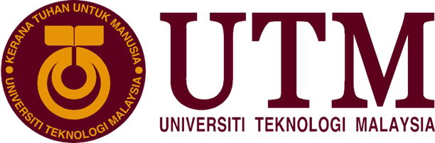

**INDUSTRIAL VISIT**

**CICT**

Course/ Section : SECP1513-08

Lecturer’s Name : Dr. Haswadi bin Hassan

Group Members : Jack Lee (A19EC0057)

Ameenuddin bin Ismail (A19EC0016)

Nur Azizah binti Mohammad Mokhtar (A17KM0351)

Ng Pei Wen (A19EC0117)

Table of Contents

Introduction 2

About CICT 3

CICT Gallerium 4

Mainframe Data Storage 4

Magnetic Tape Unit 4

Impact Printer 4

Apple Macintosh Classic Computer 4

IBM Personal Computer 300GL 5

IBM P70 Model 6554-673 5

Mainframe Tape Subsystem 5

‘PYE Model-Cambridge, England’ Radio 5

Microfilm Processor ‘Kodak Prostar Model’ 6

Kodak ProstarReplenixher Machine 6

Microfilm Reader ‘Allen Micro Model’ 6

Microfilm Machine ‘Recordak Model’ 6

Appendix 7

Reflection 10

References 13

Table of Figure

Figure i: Mainframe Data Storage 8

Figure ii: Magnetic Tape Unit 8

Figure iii: Impact Printer 8

Figure iv: Apple Macintosh Classic Computer 8

Figure v: IBM P70 Model 6554-673 9

Figure vi: IBM Personal Computer 300GL 9

Figure vii: 'PYE Model Cambridge England' Radio 9

Figure viii: Mainframe Tape Subsystem 9

Figure ix: Kodak Prostar Replenisher Machine 10

Figure x: Microfilm Processor ‘KodakProstar' Model 10

Figure xi: Microfilm Machine 'Recordak Model' 10

Figure xii: Microfilm Reader ‘Allen Micro Model' 10

# Introduction

On 21 October 2019 our class, Technology and Information System (SECP1513) section 08 were visiting the Centre of Information and Communication Technology (CICT) galleria for Industrial Visit 1. Industrial Visit 1 was organized by our lecturer, Dr. Haswadi bin Hassan. 40 students from section 8 and section 9 accompanied by Dr. Haswadi visit the CICT galleria at Sultanah Zanariah library, UTM Johor Bahru. When we arrive, CICT's staff member gave us a brief explanation about some devices that were used by UTM’s Information and Communication Technologies (ICT) department from 1990 until 2010 which is the mainframe tape subsystem and mainframe data storage. After that we were given time to look around the galleria ourself.

# About CICT

CICT, also known as the Centre for Information and Communication Technology, is a support unit that offers and delivers ICT services for the university (staff and students) especially in ICT infrastructure, system development and academic or administrative activities. CICT also provides multiple services such as internet, infrastructure and security, application development, web management, software, and ICT support.

CICT builds and manages administrative, support, multimedia, teaching and learning applications to improve the university’s service efficiency and quality. CICT also develops and maintain new and current UTM application (web base and mobile). They provide multimedia development such as montage, corporate video, promo video and quality video editing. At the same time, graphics design for logo, presentation slide, web, bunting and banner are also provided. Recently, an Information Technology Galleria was launched at the Perpustakaan Sultanah Zanariah (PSZ) by the CICT of Universiti Teknologi Malaysia (UTM), located at the UTM Johor Bahru campus.

# CICT Gallerium

## Mainframe Data Storage

During the visit, we were introduced to the history component related to computing in the gallerium. One of them was the Mainframe Data Storage IBM (9345B22). The usage of Mainframe system at UTM began in 1970s at Computer Centre, UTM campus, Kuala Lumpur. It was used as a data control of informations related to students and staffs. This system has been used for almost 20 years for various components and functions such as processing, staring, securing, and printing the University’s information data. (*Figure i)*

## Magnetic Tape Unit

The magnetic tape unit was used as a ‘back up’ for the mainframe system and information database of staff and students and also other information system of the University’s from 1976 until 2010. Initially, the model used a round shape tape, but then later converted to square shape tape. ( *Figure ii*)

## Impact Printer

The Impact Printer, also known as the Dot Matrix Printer is a printing machine used in UTM from 1990s until 201. Its function was to print the data information of students and staff to meet the requirements. This printer was also capable of printing high volumes and non-stop for 48 hours. ( *Figure iii*)

## Apple Macintosh Classic Computer

The Macintosh Classic had been used in the UTM library in early 1990 even though it was first introduced in January 1984. Its software memory was contained with 1 MB of RAM and 2MB to 40MB of hard disk. With its large capacity at the time, the computer was used in the Library along with the Lotus 123 and Word Star applications for work and simple calculations. ( *Figure iv*)

## IBM Personal Computer 300GL

The IBM Personal Computer 300GL was an all-inclusive and affordable computer. This is because it helped to increase the productivity and reduced the cost of ownership of UTM Library. Transformation of system is still taking place constantly in the library. Apparently, the technology revolution of computer usage coincides with system change and this was evident with the application of Dynix system for 10 years. (*Figure vi*)

## IBM P70 Model 6554-673

The IBM P70 Model 6554-673 was used in UTM Library in early 1998. It was used to contribute to work performance. As such, the library was liable of all modules, databases, software operations and data accessibility. It was able to support up to 16 MB on disk storage. Hence, the computer system had provided a performance improvement on desktop operation. *(Figure v)*

## Mainframe Tape Subsystem

Similar to magnetic tape unit, the Mainframe Tape Subsystem was used as a ‘back up’ for mainframe system and information database of staff and students from 1987 until 1995. This model uses a square shape tape after the round shape tape was no longer in use. *(Figure viii)*

## ‘PYE Model-Cambridge, England’ Radio

This radio was produced in the 1950s. However, it was used during the 1960s until 1970s in Technical College, Kuala Lumpur. It was used as one of the medium of information dissemination and with the purpose of supporting the learning and teaching activities.

*(Figure vii)*

## Microfilm Processor ‘Kodak Prostar Model’

The ‘Kodak Prostar II Processor’ was used to cleanse the 16mm and 35mm sized microfilm f ‘Recordak Micro-File’ machine and the ‘Zeutschel’ microfilm camera machine. It also produced negative microfilms for UTM theses. It was also capable of processing microfilms with a speed of up to 10 feet per minute. *(Figure x)*

## Kodak ProstarReplenixher Machine

This machine was used to mix two types of chemical compound, which are ‘Kodak Developer’ and ‘Kodak Fixer’. The mixture was then transferred into the ‘Kodak Prostar II Processor’ machine to be used during the microfilm washing process. *(Figure ix)*

## Microfilm Reader ‘Allen Micro Model’

The microfilm reader was first used in UTM Library around early 1980s and early 2000s. It was used for reading thesis content (text and images) which was stored in microfilms and displayed on the machine’s screen. At that time, the online information development was very limited. It gave an impact to users’ reference approach. Therefore, microfilm became one of the main resources of information in UTM Library. The microfilm was considered essential in the Library’s collection. This is because it can store a large amount of data with a small medium. *(Figure xii)*

## Microfilm Machine ‘Recordak Model’

The machine’s function was to capture small image of UTM theses. The images were recorded into microfilms or microfiche. It utilised a special film, which was the ‘Kodak Ektacrhrome’ The film was 35mm in size, and its capacity reached 100 feet per film roll. This machine was used first in UTM library around early 1980s until around 2007. *(Figure xi)*

# Appendix

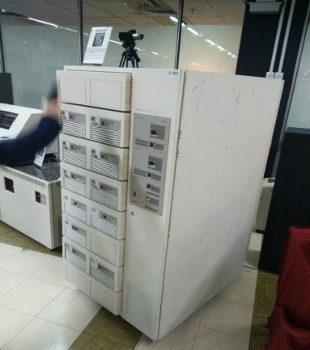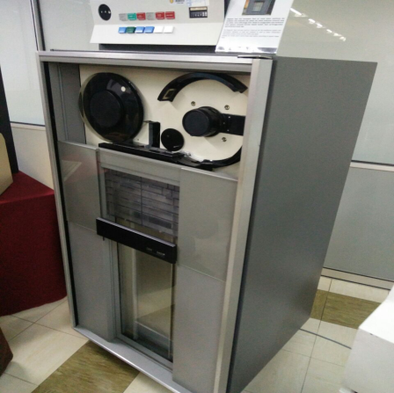

Figure i: Mainframe Data Storage

Figure ii: Magnetic Tape Unit

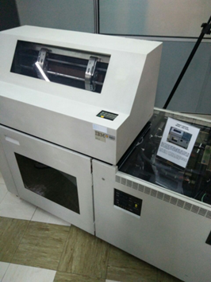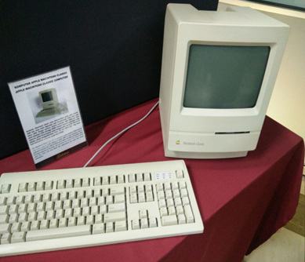

Figure iii: Impact Printer

Figure iv: Apple Macintosh Classic Computer

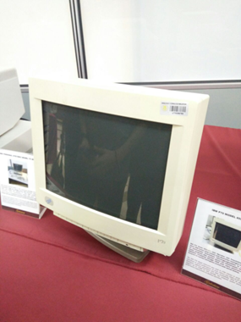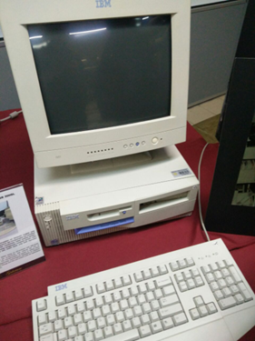

Figure v: IBM P70 Model 6554-673

Figure vi: IBM Personal Computer 300GL

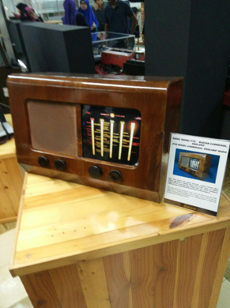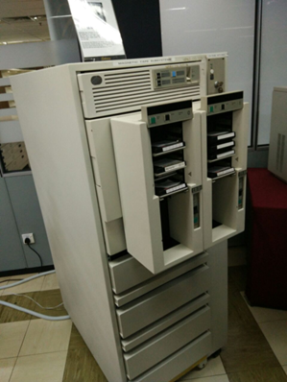

Figure vii: 'PYE Model Cambridge England' Radio

Figure viii: Mainframe Tape Subsystem

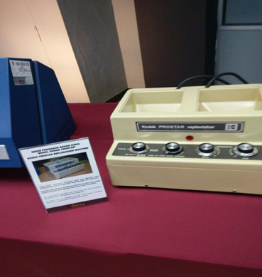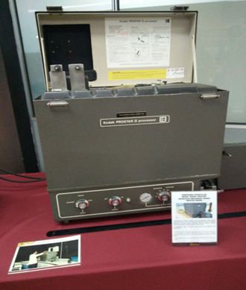

Figure ix: Kodak Prostar Replenisher Machine

Figure x: Microfilm Processor ‘KodakProstar' Model

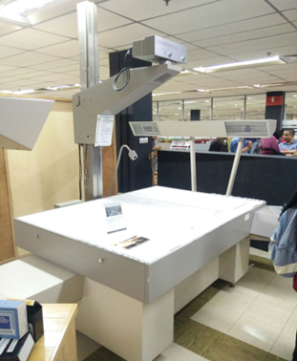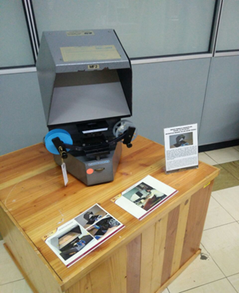

Figure xi: Microfilm Machine 'Recordak Model'

Figure xii: Microfilm Reader ‘Allen Micro Model'

# Reflection

1. **What is your goal/dream with regard to your course/program?**

As students of computing engineering in Network and Security, it is to be expected that our main goal is to be a successful engineer. Network Security is a method to prevent unauthorised access, malfunction or destruction into certain corporate networks. Therefore, in this course we learn deeper things such as coding and information systems which sharpen our knowledge regarding application of firewalls, Secure Information and Event Management (SIEM) and many more. Besides, we genuinely hope that in the future we will be engineers that possess all the necessities in configuring and managing firewall. We are looking forward to work in a team where they provided a platform to create more innovative solutions in order to build a better prevention in intrusion of computer networks. Lastly, we hope our generation will be able to improve Malaysia’s network technologies.

1. **How does this visit impact on your goal/dream with regard to your program?**

After the visit, we realized that our technologies have improved significantly. We started out by using a big sized mainframe or printer that is quite difficult to move them around. But nowadays, most of our technologies are portable and easier to configure. There are few issues we manage to point out in this visit. First and foremost, most of the engineers learn only one programming language. They developed applications or systems using one language and sometimes it becomes difficult for other programmers who use different type of languages. Next, many youngsters, the people that are responsible for our future do not know about the development in technologies. This is because most of us gained such knowledge only during the visit. None of us actually try to learn about it ourselves. Lastly, students lack of knowledge in job scope in network and security. If they do not enlighten themselves with such informations, we will face difficulties in planning our future.

1. **What is the action/improvement/plan necessary for you to improve your potential in industry?**

There are several actions to be taken to improve our potential in industry. Firstly, we should learn more types of programming language and master the programming language that we learn. Through this we can done the works given in a shorter time and easier. There are many types of programming language in the industrial parts so it is important for us to know more than one programming language. It is better if we can master three to four different types programming languages. Other than this improving our skills in programming is also important as we will face different problems and tasks in our career or working life, we will require different skills to overcome the problems and complete the tasks given.

Secondly, self-learning is also a very important action to be taken. This is because the knowledge taught by lecturer in university is limited which is not enough for us to compete with other graduates and people which has more experiences in working or more skilful than us. Therefore, we have to carry out self-learning through internet during weekend or when we have free time. We have to do more research on a certain topic after lecture to have deeply understanding in the fields that we learned.

Thirdly, we have to plan which field do we want to focus more on. We have to surf more in the field that we will work in the future that is networking and computer security. The network engineer basic such as clients and servers, network hubs, IP address, firewalls and route and many more. There are many professions available in the industrial which may need different skill or specific requirement that we need to know.

For example, the professions are :

* Network Specialist
* Network Administrator
* Network Technician
* Network Analyst
* Network Manager
* Network Engineer

Lastly, the future plan is we can attend the professional courses and network training courses offered. By attending the courses we will learn more on operating system, network security, programming skill and network administration. Some organization also require the workers to have specific certification or attend the course stated in the qualification.

# References

* [https://cict.utm.my](https://cict.utm.my/)
* <https://www.cisco.com/c/en/us/td/docs/solutions/Verticals/Industrial_Automation/IA_Horizontal/DG/Industrial-AutomationDG/Industrial-AutomationDG.html>
* <https://www.newhorizons.com/article/how-to-become-a-network-engineer>