**Semester I 2021/2022**

|  |  |
| --- | --- |
| **SUBJECT NAME:** | **TECHNOLOGY INFORMATION SYSTEM** |
| **SUBJECT CODE:** | **SECP 1513** |
| **SEMESTER:** | **1** |
| **PROJECT 2 :** | **LOW FIDELITY PROTOTYPE** |
| **GROUP MEMBERS :** | **1. NAME : MALLEYLENE PENEH**  ***MATRIC NUMBER: A21EC0052***  **2. NAME : NASRUL AMIN BIN AB HADI**  ***MATRIC NUMBER: A21EC0099***  **3. NAME : HARCHANA A/P ARULAPPAN**  ***MATRIC NUMBER : A21EC0028***  **4. NAME : PUTERI NUR ELEEYA SYAFIKA BT MOHD ZABIDI**  ***MATRIC NUMBER :A21EC0124*** |

**INTRODUCTION**

As we can see, the Fourth Industrial Revolution, also known as IR4.0, is sweeping the world, and Malaysia is at the forefront of this transformation. IR 4.0 is concerned with physical and cyber systems that can integrate the digital world with biological systems, which has implications for all aspects of business and economics. For example, bioprinting, which uses digital data to create products such as organs from cells and biological materials, falls under this category. In the fourth industrial revolution, cloud computing, big data analytics, the internet of things, autonomous robots, cyber security, and system integration are all important elements. The implementation of IR 4.0 has an impact on operations, customer happiness, and the overall productivity of the organisation. Technology such as Machine Learning, the Internet of Things, Big Data Analytics, High-Speed Mobile Internet, and Artificial Intelligence are all examples of Industry 4.0. We concentrated on artificial intelligence, which is rapidly becoming more prevalent across the globe. In artificial intelligence, the ability of a digital computer or a computer-controlled robot to do tasks that are often associated with intelligent organisms is referred to as artificial intelligence. A major goal of artificial intelligence is to create systems that can function intelligently and independently by simulating the functions of the human brain. Our concept is a smartphone application driven by artificial intelligence for those with limited eyesight. The major purpose of developing this software is to make the world accessible to low-vision people without requiring them to rely on friends and family. Our crew opted to use artificial intelligence on the fourth infrared technology for our project after conducting some study and observation. In this study, we employ limited memory artificial intelligence, which makes predictions and performs complicated categorization tasks by combining historical, observational data with pre-programmed knowledge. In our project, this application employs artificial intelligence with limited memory to observe surrounding regions and directions, assisting them to "read barriers" and modify as needed, such as utilising prior observations to forecast crossing the road. However, memories are not permanently preserved and are restricted in size. We picked artificial intelligence for our research because we would be utilising computer vision, which is a subset of artificial intelligence. Computer vision allows computers to recognize items by using an algorithm train to gather specified attributes, allowing them to pick objects out of a crowd of possibly millions of objects with quicker identification. This computer vision technology is known as object detection, and it is used to discover drawings of items in a picture. This item detection is not only identified, but also located in an image, allowing many things to be detected and found inside the same picture. In conclusion, there will be so many people that can be helped by this system.

**DETAIL STEPS AND DESCRIPTIONS**

Our group members believed that, when we break a project into stages, it becomes more manageable. It is simpler to control the project. The project planning step is the main step which includes the details since it lays out the project's road map. On 15th January 2022 (Friday), our first project discussion is held virtually through WhatsApp.

1. Everyone in the group has a chance to share their own ideas.
2. In this phase (planning and execution), we identified the technical requirements, building a thorough project timeline, designing a communication plan to discuss more about the project, and constructing brainstorms of the project.
3. We assign the whole project into individual tasks for each member.

* Nazrul – Introduction, detailed descriptions include problem, solution, and team working.
* Eleeya - A business process flow diagram and description.
* Harchana - Detail steps and descriptions related to the project, low-fidelity mock-ups.
* Malley - AWS Architecture Design that showcases the entire ecosystem

1. Graphical user interface, text, chat or text message

   Description automatically generatedA detailed project timeline is created in our first discussion.

On 17th January 2022 (Monday), we decided to update our project progress with our lecture Dr. Azurah. Our second project update meeting is held via Google Meet.

1. This propose of this meeting is to get an update on project activities, identify the obstacles and how to tackle them.
2. In the phase (monitoring and control), we continually monitoring the condition of the project as it progresses, assessing any major obstacles, and making appropriate modifications
3. Discussion on

* Organizations and descriptions of the Project
* Prototyping
* AWS Architecture Design

1. At the end of the meeting, our lecture motivates us to be focus and complete the project on time.
2. We continued the project with clear mind.

On 21st January 2022(Friday), we entered the final stage which is submitting and closing out the project. Once the monitoring period is complete, we are ready for the project review and close phase.

1. All the group members submitted their individual tasks in the WhatsApp group.
2. Ensured all tasks are complete and combined the separated tasks into one report.
3. After the documenting project review, we submit the project in e-learning on time.
4. Discussion on lesson learned, appreciate the group members’ hard work and cooperation.

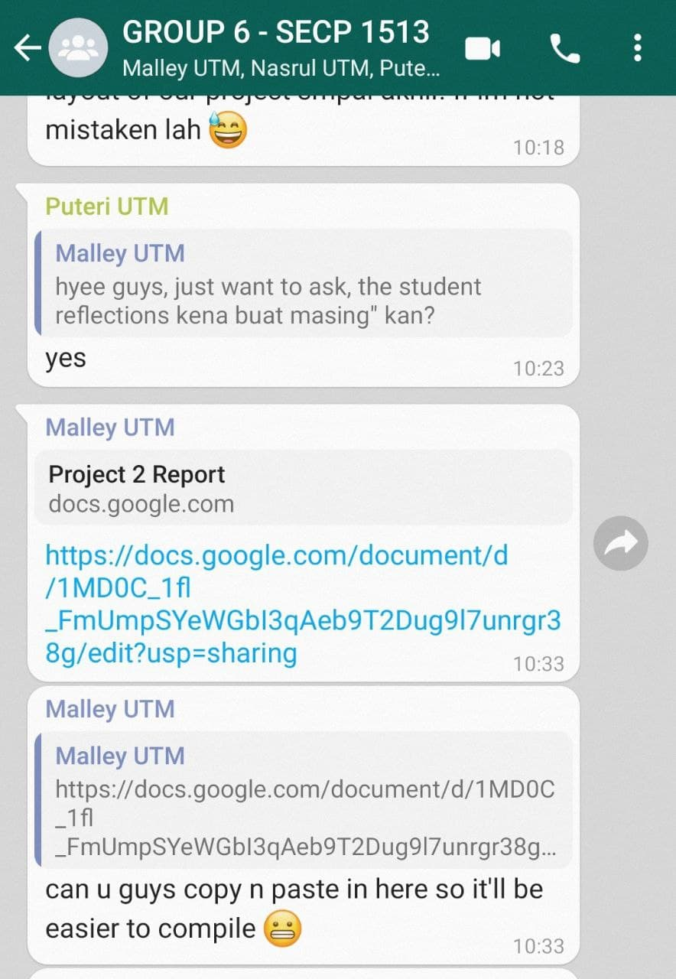

**DETAILED DESCRIPTIONS**

**PROBLEM**

During this project, we seem to have encountered several difficulties in meeting our customers' expectations, despite our best efforts to comprehend their situation and need by determining the conclusion itself. In addition, we have difficulty choosing which customers, who are either persons with impaired eyesight or those who are blind, we should concentrate our efforts on. Finally, but certainly not least, we seem to be stuck on this project as a result of a lack of knowledge regarding the project.

**SOLUTION**

After many talks among the group members, we were able to come up with a few solutions to the difficulty that we were experiencing over the course of this project's development. One of them is the result of extensive study on the internet, which resulted in the development of a single application system that can meet all of the criteria of our customers. Following that, we eventually chose to concentrate our efforts on those with impaired eyesight since our application system seems to be more ideal for them than it is for blind people. Finally, in order to deal with the issue of us being stuck, we approached our lecturer, Dr. Azurah A Samah, and asked her to help us to resolve our problem of being trapped on this assignment.

**TEAM WORKING**

In terms of teamwork, we eventually decided to allocate each person to a certain aspect of the project. For example, Nasrul is responsible for the introduction and detail description’s part, Eleeya is responsible for the business part, Harchana is responsible for the detail steps and low fidelity mock-ups, and Malleylene is responsible for the AWS architecture portion of the project.

**AWS ARCHITECTURE**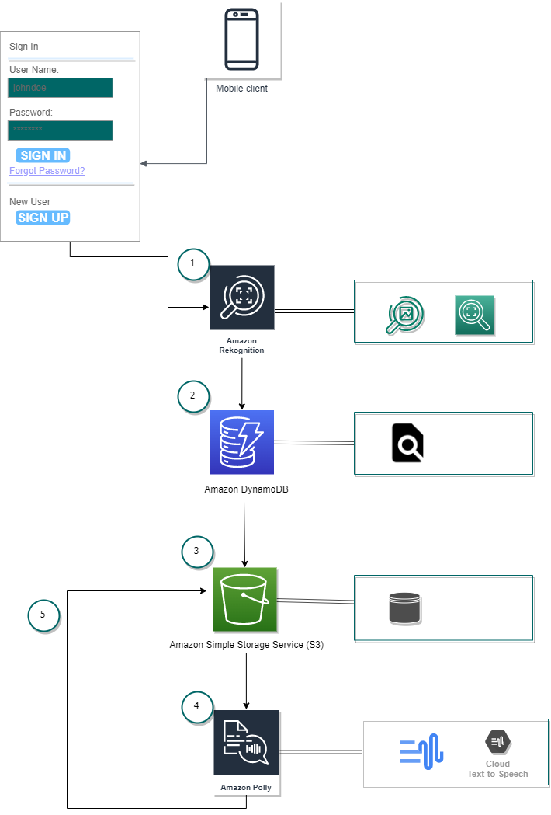

**AWS Architecture (ecosystem)**

**Description**

The database and storage will be the major elements of the architecture that we will employ in this project. After signing into the mobile apps, clients will reach the scanning images user interface, Amazon Rekognition will act as an input to recognize and detect the captured object or text. Therefore, Amazon Polly will be used as an output for this project.

1. Various images will be provided in Amazon Rekognition API. Amazon Rekognition will identify the objects and text. It also can detect, analyse and compare faces for a wide variety of use cases for clients.

2. Amazon DynamoDB will scan through all the items in the database to find the ones that match the criteria on the image that had been captured by clients. It works well for this project because it is compatible with mobile applications.

3. Amazon Simple Storage Service (S3) will store and retrieve the data from the mobile apps. This will make it easier and quicker for clients to find the object or text that they had captured.

4. Amazon Polly will be used to convert the input text into life-like speech. After the client had captured the objects or text that they cannot see well, Amazon Polly will deliver it to the speech. This AWS system will act as an output for this application.

5. After Amazon Polly gives output to the client, the previous data output will be stored at Amazon S3. So, it will be easier to access later by the client. They don’t need to scan the image or text again later.

**BUSINESSES PROCESS FLOW**

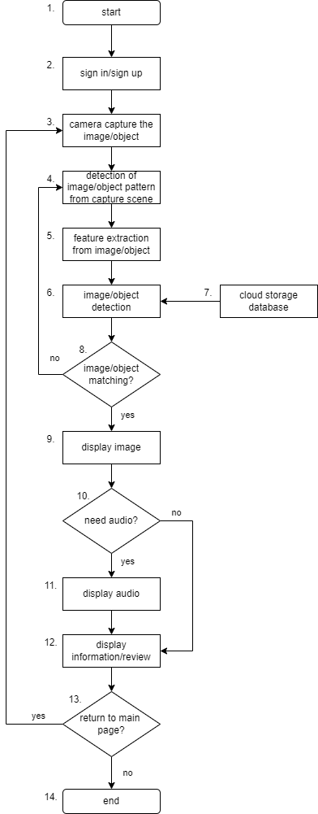

1. The application will start when the user opens the application

2. Users need to sign in if they already have an account meanwhile those who are first time using this application and don't have an account need to sign up.

3. Camera will display an image taken by using the mobile's camera. Similar and history of the images will appear on this page.

4. Will read the current image and detect whether the image or not. If the image blurs, it will return to the camera display.

5. A method for selecting or combining variables into features. Its function is to differentiate between objects/images. It's also a process to reduce the number of resources needed for processing without losing important or relevant information. Can reduce the amount of redundant data.

6. Image/object detection will perform by comparison with the trained image in the database.

7. A cloud storage database has been created using AWS which is Amazon DynamoDB for database meanwhile Amazon Elastic File System (EFS) for storage.

8. In this state, there are conditions in which image/object detection is matching or recognizing or not with images/objects in the dataset. If it does not recognize the images/objects, it will return.

9. Images will display when image/object detection is matching and recognized by images that are contained in the dataset.

10. This state also contains conditions where users can choose to hear the output using audio or not. If the user skipped the audio, it would automatically display the information or review the images.

11. Audio output will produce when the user wants to hear the audio by recognizing the text.

12. The information and review about the images/object will display and users also can save the image/object that they can to the files. Not only that, but this state also will display user usage history.

13. At this state, users can choose to return to the main page or not. If the user chooses to return to the main page, a camera will appear to capture the images/object.

14. The application will close when the user chooses to not return to the main page.

**LOW FIDELITY MOCK - UPS**

**SELF REFLECTION**

**NASRUL AMIN BIN AB HADI (A21EC0099)**

In the process of finishing this project, I have received a wealth of information and experiences that have led me to believe I am a wiser person than I was before. Several aspects regarding cloud computing, notably Amazon Web Services (AWS), have been taught and practiced prior to the creation of this project. I have also experimented with a variety of applications, including creating new servers and many others. In line with my expectations, the route to completion of this project did not seem to be as smooth as it appears, owing to the fact that we were overloaded with other evaluations for other courses, and I also had a health issue throughout the duration of this project. In the end, though, we were able to complete our assignment on time as a group. The time that we spent in constant debate, on the other hand, was something that I really appreciated. I also wish that I can gain more knowledge and information so that I can manage to achieve my dream one day. Finally, we would like to express our gratitude to Dr. Azurah, our lecturer, for providing us with some excellent suggestions while also assisting us in resolving our difficulty of being imprisoned on this project till we are able to complete our Low Fidelity Project.

**PUTERI NUR ELEEYA SYAFIKA BINTI MOHD ZABIDI (A21EC0124)**

During the process of completing this project, I learned and gained a lot of information about cloud computing and IR4.0, especially about artificial intelligence (AI). For cloud computing, I am aware that its use is growing rapidly, and its use can benefit various parties. When I learn Amazon Web Service (AWS), I more expose to cloud computing and it helps and encourage me to explore more about cloud computing and IR4.0 to improve my potential in industry. There are some issues that I and my group faced during complete this project. One of problem which is I got stuck on businesses process flow and take time to solve the problem. To solve this problem, I manage to ask clarification from Dr Azurah during meeting in google meet. Communication among group member also one of our problems that we faced during completed this project. We take a lot of time to discuss about the project. To handle this problem, we appoint a leader to distribute the task. After completing this project, I want to explore more about this project and try to succeed this project because I think this project can help a lot of people out there. To improve my potential in the industry, I need to explore more about IR4.0 and get more certifications such as AWS and MATLAB. From this project, I could find my weaknesses and skill that I need to improve. One of skills that I need to improve is leadership because I need learn how to assist the group to complete the task. Before this I always depends on other to manage our group. Besides that, I need to improve my problem-solving skills because this skill very important to everyone for our industry. I want to be a person that can deal any unexpected problem that I will faced. In conclusion, we manage to solve the problem that we faced, and each member gives great cooperation to complete this project.

**MALLEYLENE PENEH (A21EC0052)**

Throughout the process of finishing this project, I learned a lot about how to manage and accomplish a project, which has made me a smarter person. I also realized that every problem has a solution, especially in this digital era, which makes it easier to solve than before. I also had a great time investigating and learning about Amazon Web Services (AWS). My objective and motivation for creating this project were to assist clients in resolving difficulties and restoring their vision. It will make their life easier than before and save them money on lens equipment. During finishing this project, I encountered various challenges, including tests and the unloading of other course assignments while also grieving the loss of a loved one. But, with the support of my amazingly supportive group, I was able to overcome it. After finishing this project, my purpose is to help solve future problems and give as much understanding as I can to better the community's quality of life. The necessary improvement that I require in order to grow my potential in the sector is to consistently improve my talents and abilities, as well as my communication skills in order to extend my networking. Last but not least, I would like to say thanks to Dr. Azurah, who has mentored us while this project has been conducted.

**HARCHANA A / P ARULAPPAN (A21EC0028)**

While conducting this project, I learned and able to improve my interpersonal skills such as speaking and listening to others. I am able to exchange and share ideas with my group as group members give their ideas as well as the advantages and disadvantages of each approach. This style of teamwork benefits the project and allows me to rebound around ideas to find the best fit. During our project discussion, I also learned on how to accept the feedback, respect and empathize with the viewpoints of others. Other than that, I managed to think creatively and come up with an innovative solution to organizational problems. Completing a difficult project and seeing it through to the end is the tagline that have been motivated me to complete this project. Moreover, working well as part of a team is my responsibility as a group member of this project.

Here are a few issues which we experienced during our group project and solutions that we implemented to make the project a success:

* Unoptimized workflow and systems

The group work was a little delayed and some work was postponed while we were working out the task and attempting to figure out everyone's role in the group. By creating a workflow, help us to minimize confusion.

* Get stuck on tasks

We do not manage to move forward and finish the project at the beginning stage. Lack of clarity is the main reason. At the end, we tackle the problem by having a discussion with our lecture.

After completing this project, I realized that the Amazon Web Service (AWS) has drastically grown within the last decade. I truly understand on how complex is project management to complete a project along with the developing using current technologies. As a student, I plan to learn additional skills to adapt and qualify to industry demands, for increasing employability possibilities. Our passion for projects will make us overcome all obstacles. The trend is continually wavering, yet it does not mean that it is tough to get into it. We need to be prepared to face challenges in our life else we fail.

At the end of the project, I could find out the improvement necessary for me to improve my potential in the industry. I learnt that personal development skills are fundamental because they enable me to design strategic and tactical strategies for professional progress that will help me to perform well in industry. Skills that I should enhance are:

* Problem-solving

Problem-solving refers to my capacity to deal with difficult or unexpected situations. When dealing with a challenge, I want to be a good problem-solvers who maintain the calm and evaluate all the choices before deciding on the best course of action.

* Self-confidence

I learnt that self-confidence is the belief in my abilities, actions and decisions. I want to overcome my fear of taking risks This energy will help me to motivate and instil confidence in me.

* Work ethic

I learn that it includes responsibility, determination and discipline. So, I will give more importance on organizing my time and work. A good work ethic manner will help me to be productive and have a positive attitude.

In conclusion, everyone in the group actively contributes and exchanges ideas about our project. All the groupmates have a good cooperation and we have distributed the tasks evenly. We were able to accomplish our assignment in the allotted time. A very good bonding between our group members was formed which makes us easier to communicate and work together flexibly.

**REFERENCES**

1. Klaus, S. (2020, September 22). *The Fourth Industrial Revolution: what it means and how to respond*. World Economic Forum. Retrieved January 19, 2022, from <https://www.weforum.org/agenda/2016/01/the-fourth-industrial-revolution-what-it-means-and-how-to-respond/>
2. Antjet. (2017, December 6). Introduction to Image Recognition – AI for Dummies (1/4). Deepomatic. Retrieved January 19, 2022, from <https://deepomatic.com/introduction-to-computer-vision-and-image-recognition>
3. Copeland, B. J. (2021, December 14). Artificial intelligence - Methods and goals in AI. Encyclopedia Britannica. Retrieved January 19, 2022, from <https://www.britannica.com/technology/artificial-intelligence/Methods-and-goals-in-AI>
4. LogicAI. (2019, December 20). Blog. Retrieved January 20, 2022, from <https://logicai.io/blog/using-artificial-intelligence-ai-image-recognition/>
5. Burns, E., Laskowski, N., & Tucci, L. (2022, January 4). What is artificial intelligence (AI)? SearchEnterpriseAI. Retrieved January 21, 2002, from <https://www.techtarget.com/searchenterpriseai/definition/AI-Artificial-Intelligence>
6. Lisowski, E. (2021, October 13). Using Artificial Intelligence (AI) for Image Recognition (update: May 2021). Addepto. Retrieved January 21, 2022, from <https://addepto.com/using-artificial-intelligence-ai-for-image-recognition/>
7. What is Artificial Intelligence? How Does AI Work? | Built In. (n.d.). Builtin. <https://builtin.com/artificial-intelligence>
8. <https://docs.aws.amazon.com/rekognition/latest/dg/what-is.html>
9. <https://www.uofmhealth.org/health-library/uq2622>