

**SESSION 2018/2019 SEMESTER 1**

**GROUP DISCUSSION ESSAY:**

**TRAFFIC ACCIDENT CASES IN MALAYSIA**

|  |  |
| --- | --- |
| **NAME** | **MATRIC CARD NUMBER** |
| MUHAMMAD DANISH BIN RASALI | B18CS0013 |
| YE YAN FANG | X18CS0006 |
| CHOY WAN LING | A18CS0049 |
| LEE CHOI WEI | A18CS0095 |
| MUHAMMAD IMRAN BIN AHMAD SHABULI | B18CS0014 |

**Code & Subject:** UHAK 1012 – 21 – Graduates Success Attributes

**Name of Lecturer:** Dr. Nurwina Akmal binti Anuar

**Submission Date:** 5 November 2018

**Table of Contents**

The Essay _3 – 7

Minutes Meeting 8 – 10

References 11 – 12

**TRAFFIC ACCIDENTS IN MALAYSIA**

KUALA LUMPUR: Motorists nationwide have been reminded to be more alert on the road as there are approximately 30,000 accidents every year, said Datuk Seri Dr Ahmad Zahid Hamidi. The Deputy Prime Minister said operations conducted by the police have been unable to curb the number of road accidents, especially during festive periods.

"The road accident rate has reached about 30,000 cases each year," he said, adding that over a 10-year period, this would reduce the nation's workforce considerably.

As we know, traffic accident is a type of man-made accident, it is not a natural disaster which we can’t control and prevent. Traffic accident often occurs in everywhere whether in Malaysia or other countries. The main reason is the bad road design and lack of maintenance of road. The road design should correspond to the weather, car designs and road environment. This meant by the road design must have the features which can fit the changing of weather and match with the car design which the driver can drive safety on the road. For examples, the road must be made by lime because it won’t slippery during raining. However, the traffic accident still can happen due to the lack of maintenance of road although the road built up is the requirements of road design. It is mostly happened road or traffic accident in old lime road rather than the lime road which is always repairing and in maintenance. Lacking of maintenance include the road pits and lack of road facilities such as traffic light, road light, signboard and guidepost. It is important for drivers when they drive the car in the road. It ensures them to drive safety and act as a guider in the road. It guides the driver to drive in their own pathway and make the direction in the road.

Next, the careless and not attentive of driver when driving on the road also can cause the traffic accident. Generally, everyone uses the mobile phone to do anything. As we know, we must focus when drive on the road. Datuk Seri Dr Ahmad Zahid Hamidi said safety must be prioritised at all times and all road rules adhered to. "Once we are on the bike, we have to be alert and focused," he said, adding that he was a biker himself. However, some drivers are not follow the rules of road when drive. They use the mobile phone when driving. It causes them distract when driving. Traffic accident also happens due to the irresponsible of driver and the driver always against the rules. For examples, the driver take drug before drive on the road and sometimes the driver is rush to arrive their destination and ignore the traffic light.

Mostly the traffic accident is happened during peak road hours, before working hour and after working hour which the road is congested and make the driver easily to crush with other cars. The traffic accident also often happens after midnight and after rain. The reason behind is the driver will drive faster and ignore the speed limit on the road although the road is not congested. When drive speed exceeds the speed limit, it may cause the driver hard to break their car when obstacles are in front of them.

Serious traffic accidents can lead to injury, disability, amputate and even death. Traffic accident makes victims get injured, at the same time also bring trouble and pain to their family. It can see from the medical expenses which make additional burdens to their family, time taken to take care of the victims in the process of healing, family members may lose the job and cause loss of income sources.

Whether it causes human casualties or property damage, it will cause waste of social resources. It not only consumes the property of the families affected by the accident, but also drives the traffic polices to the scene of the accident to deal with the accident, the hospital organizes the medical force to rescue the victims from injury, fire control in rescue and so on, which needs to increase the social cost. Traffic obstruction or interruption caused by the accident will also have an impact on the life of the people. The costs on road maintenance also cannot be ignored because heavy accident may break down the road facilities such as traffic light and signboard. The high rate of traffic accident destroys country's reputation.

From the traffic accident, perpetrator need to take the responsibility to repair their cars and victim’s car. It cost a lot of expenses. They may also suffer from more serious injuries from that accident rather than victims. In case of traffic accident caused by violation of road traffic safety laws and regulations, the perpetrator will face three responsibilities:

(1) Administrative responsibility

If drivers violate road traffic safety regulations, they will be subject to administrative penalties such as warning, fine, temporary detention and detention.

(2) Civil liability

If a driver causes a traffic accident and his illegal act constitutes a causal relationship with the occurrence of the accident, he shall bear the corresponding civil compensation liability for the consequences of the injury.

(3) Criminal responsibility

Be equally liable for the accident, compensation for property losses and convicted may be caused.

The main roads like North-South Highway, Jalan Tun Razak and KESAS Highway are routes where the accidents usually happen. The first suggestion is road user need to follow the speed limit and traffic rules. Most of the accidents happen when the users obey the speed limit where they usually lose control for their vehicles. The speed limit also must be followed to have more consideration and safety to the other road users and also people around. There are many cases that with an extreme speed have crash the other vehicles and lot of people killed. The speed limit must be followed to avoid accidents that will affect some of the road users.

Second, the government should add more advertisements and awareness signs at the roads. There are a lot of traffic signs that cannot be seen due to vandalism and old version without maintenance. The additional road awareness signs should be in very good shape to make sure the road users follow the traffic rules completely. If people follow and notice the additional parts, the traffic accidents can be reduced in a long time. The awareness advertisement should be added more at the roads to ensure the safety of all road users.

Next, the government must create more campaigns about road safety to the public. The campaign is the simplest method to educate people to aware of all traffic offenses. For the campaign, there can be at the big event like Jom-Heboh, Open Day Event and Hari Sukan Negara where there are lot of people that gather around. Some NGOs also can take part to give some talks and show some guides to be a good road user. Since it is simple to conduct, the campaign should be more for the netizen to create more awareness to all. The contents can be the effects of driving fast, the fine that waiting for the traffic offenders, driving rules and more. The campaign also can help to increase the safety awareness to all people by explaining the benefit of following the traffic rules. The explanation with some examples may lead netizens to clear vision of the road safety awareness.

Forth, fine. The national government must pay attention to the matter seriously. The fine is actually not so effective to remind the road users to be more responsible towards the others. Some of the amount is too low for some faults. So, the fines are easy to settle down by the traffic offenses with small amount of money. This is not right for the settlement method where they can make another mistakes without any worries about the fine and the most important one, other people safety. For the solution, ministry of transportation should increase the amount of fine for the traffic offenses. It can make sure the road users can put more consideration and respect to all people.

Lastly, the government should take a lot of initiative to repair and rebuild the damage facilities like roads, signs and conjunctions. Sometimes, the traffic accidents happen without any mistakes from anyone, but the damage facilities make it happen. The slippery and perforated roads can make cars and bikes lose control from the road even the users follow the speed limit and the other rules. The damages can put the problems of the traffic to the worst condition. The condition of the facilities also has been worse than before at the most part of the country. Due to the issue, the traffic accident is common things at the highway. The negative impacts can lead to trauma and sadness to young generation. The government can slowly repair and rebuild the damage facilities. Put the highest amount of accident's place at the top of priority and do not stop the repairing works to make sure every deficiency will be reduced.

We found out the issue is a serious matter for the people. The incidents are one of the crucial things that will affect physical, mental and health. As a driver, we must think about other people on the road rather than ourselves. Some people also can be traumatized for everything that happened to them. The traffic incident happened due to many aspects like the behaviour of the road users and the damage of the facilities. People need to change the mind-set of using the vehicles for the wrong purpose such as street racing and non-permit gathering. Those activities can affect the safety of the public and other road users as well. If the incident happened, there will be some troubles for the traffic and the rescue team need to have some additional works. We also think that the government also should upgrade the awareness of traffic incidents. They need to think for some solutions to make sure the cases can be reduced from time to time. This serious matter also has been talk for many times before and some of the problems are not solved either until now. There are many roads and signs that not upgraded and repaired at some places. We hope that the government can realise the problems to help the road users to be more secure anytime. We realise that the traffic problems can be solved if everyone can play their role perfectly.

**Minutes Meeting 1**

|  |  |
| --- | --- |
| **Location** | Computer Room, KTDI (M01) |
| **Date** | 30/10/2018 (Tuesday) |
| **Time** | 4.00 p.m. |
| **Attendees** | 1. Choy Wan Ling 2. Ye YanFang 3. Muhammad Danish Bin Rasali 4. Lee Choi Wei 5. Muhammad Imran Bin Ahmad Shabuli |

**AGENDA**

1. Title of the project - Traffic Accident in Malaysia
2. Progress

We discussed about the definition, causes and impact of traffic accident. We searched some current traffic accident cases in Malaysia from the internet. We exchanged our information with each other especially with the China student, Ye YanFang.

1. Distribution of jobs

The group leader started to divide jobs and distributed them fairly.

1. Appoint for next meeting

The next meeting will be held on 2/11/2018 (Friday), 3.00 p.m. at Computer Room Kolej Tun Dr. Ismail.

The meeting end at 4.45 p.m.

**Minutes Meeting 2**

|  |  |
| --- | --- |
| **Location** | Computer Room, KTDI (M01) |
| **Date** | 2/11/2018 (Friday) |
| **Time** | 3.00 p.m. |
| **Attendees** | 1. Choy Wan Ling 2. Ye YanFang 3. Muhammad Danish Bin Rasali 4. Lee Choi Wei 5. Muhammad Imran Bin Ahmad Shabuli |

**AGENDA**

1. The Information

We collecting all the information that we searched. Most of the data come from journals and articles in the internet and compile it together.

1. Progress

We discuss about the accuracy of our data and eliminated some of the fake news and articles. We listed out all the information according to the sections of the essay.

1. Distribution of jobs

The group leader started to divide jobs and distributed them fairly.

The meeting end at 4.50 p.m.

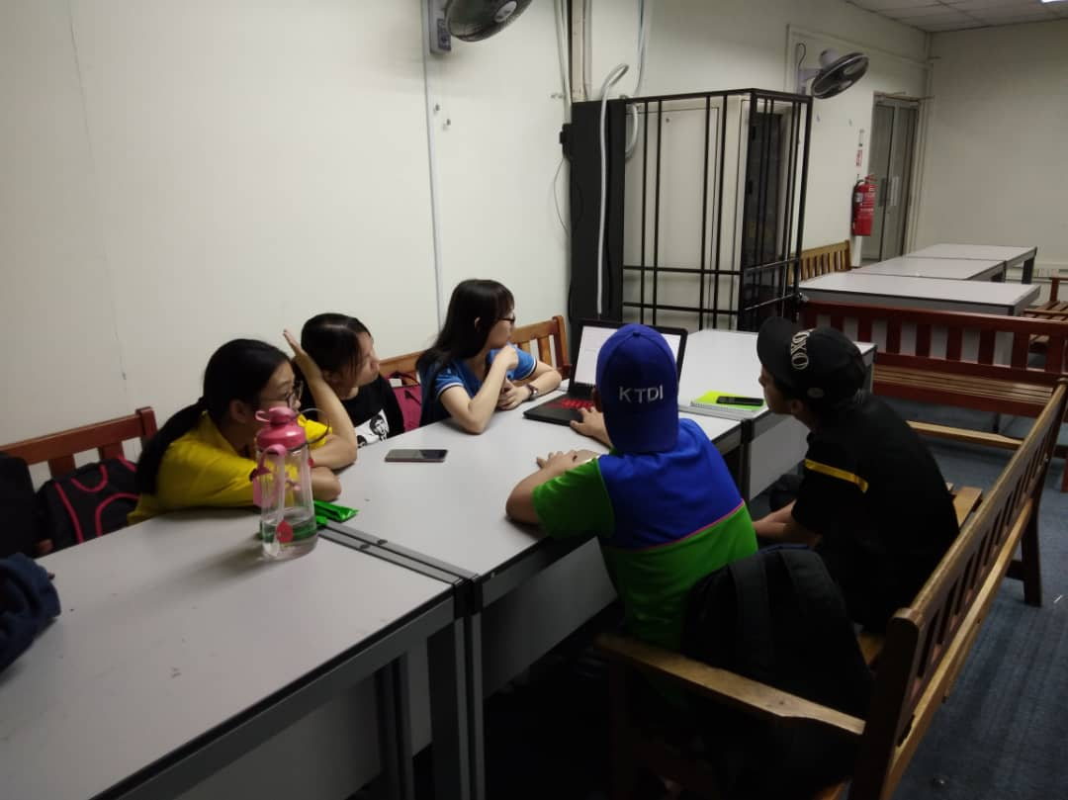

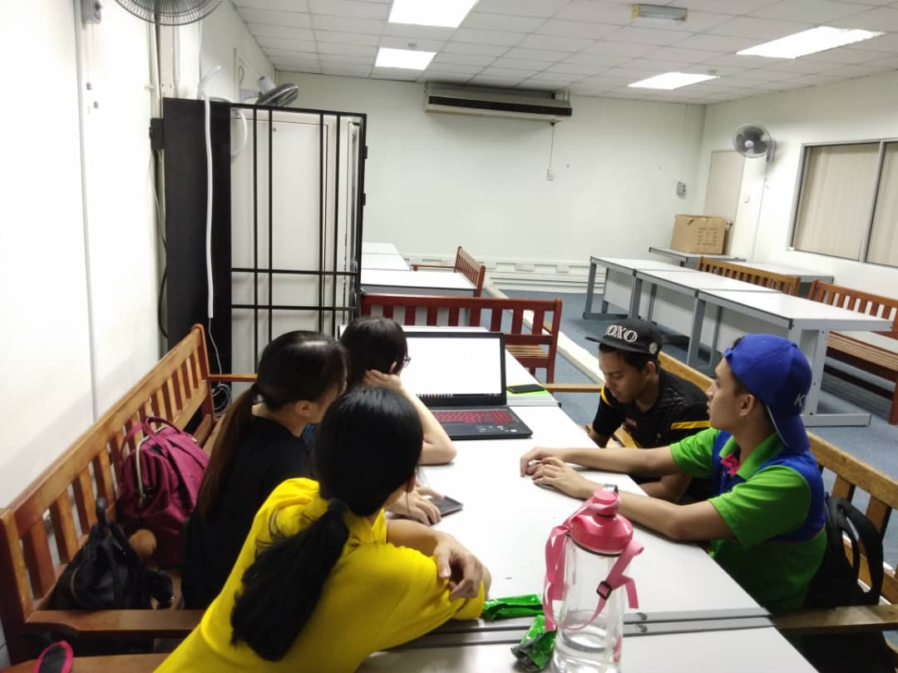

Group discussion in Computer Room KTDI

**REFERENCES:**

1) Berita Harian Online - Traffic Delinquency went up threefold; Published on 3 September 2018; last surveyed on 4 November 2018.

<https://www.bharian.com.my/berita/kes/2018/09/469310/kesalahan-lalu-lintas-naik-3-kali-ganda>

2) Utusan Malaysia Online – JPJ-WPKL Succeed to reduce traffic problems over 60%; Published on 30 June 2018; last surveyed on 4 November 2018.

<http://www.utusan.com.my/berita/nasional/jpj-wpkl-berjaya-kurangkan-kesalahan-lalu-lintas-lebih-60-peratus-1.699855>

3) Channel News Asia – 5 Family Members Burnt to Death in Perak accident along North-South Expressway; Published on 07 Oct 2018; last surveyed on 1 November 2018.

<https://www.channelnewsasia.com/news/asia/malaysia-accident-5-family-members-north-south-expressway-10799720>

4) find-a-driving-school.ca – Top 8 Driving Tips to Avoid Accidents; last surveyed on 5 November 2018.

<http://find-a-driving-school.ca/top-8-driving-tips-avoid-accidents/>

5) Official Portal Ministry of Transport Malaysia – Index of Accidental Road Death; last surveyed on 5 November 2018.

<http://www.mot.gov.my/en/lands/public%20safety-roads/statistics-accidents-jalan-raya-index-death>

6) The Star - DPM: Up to 30,000 road accidents yearly; Published on 24 Feb 2018; last surveyed on 5 November 2018.  
<https://www.thestar.com.my/news/nation/2018/02/24/dpm-up-to-30000-road-fatalities-yearly/#aRlctopyMVVIWu8k.99>

7) Traffic Accidents: Causes and Outcomes; Graham P. Bartley; Nova Science Publisher, Inc. New York; Published on 2008; last surveyed on 5 November 2018.

<https://books.google.com.my/books?id=vk0riqj8a2gC&printsec=frontcover&dq=traffic+accident&hl=zh-CN&sa=X&ved=0ahUKEwi06-PlvLfeAhULpY8KHfYEB7EQ6AEIUDAG#v=onepage&q=traffic%20accident&f=false>

8) Traffic Accident Summary; Seattle (Wash.) Dept. of Engineering. Traffic and Transportation Division; The Department, 1973; last surveyed on 5 November 2018.

<https://books.google.com.my/books?hl=zh-CN&id=ewHi4cxHKUUC&dq=traffic+accident&focus=searchwithinvolume&q=traffic+accident>

9) Research Article: Study of the Injured Persons and the Injury Pattern in Road Traffic Accident in Sana’a City, Yemen; Abdulhameed Ali Al-Thaifani, Nabil Ahmed Al-Rabeei, and Abdulsalam Mohammed Dallak; Advances in Public Health Volume 2016, Article ID 4138163, 5 pages; Department of Nursing, Faculty of Medicine and Health Sciences, Sana’a University, Sana’a, Yemen; Academic Editor: Julio Diaz; last surveyed on 1 November 2018.

<https://www.hindawi.com/journals/aph/2016/4138163/>

10) Road traffic accident mortality in Singapore; Evelyn Wong, MBBS (S’pore) (FRCS Ed (A&E)) Correspondence information about the author MBBS (S’pore) Evelyn Wong, Mark K.F Leong, MBBS (S’pore) (FRCS Ed (A&E)), Venkataraman Anantharaman, MBBS (S’pore) (FRCP (Edin) FAMS), Lata Raman, MBBS (Ranchi, India), Keng Poh Wee, MBBS (S’pore) (FRCPA, FAMS), Tzee Cheng Chao (FRCPath, FCLM, FAMS); Elsevier Science Inc 2002; February 2002 Volume 22, Issue 2, Pages 139–146; last surveyed on 1 November 2018.

<https://www.jem-journal.com/article/S0736-4679(01)00455-3/fulltext>

11) The Straits Times - Three killed, 14 injured in Malaysia highway crush; Published on 10 September 2018; last surveyed on 1 November 2018.

<https://www.straitstimes.com/world/three-killed-14-injured-in-malaysia-highway-crash>