|  |  |  |
| --- | --- | --- |
| // Inspiring Work Experience and Covid-19 Pandemic Challenge Amir Hanis bin Azman, Muhammad Faiz Aiman bin Fakhrurrazi, Siew Yu XuanUniversiti Teknologi Malaysia29 December 2020 | | |
| Introduction  On 29th December 2020, a sharing session has been held for UTM students who are taking courses in School of Computing. The sharing session was held at 10.00a.m which was organized by Technology and Information System, School of Computing. During that session, there were four speakers invited to give the talk, which were also the former UTM students. There were Batrisyia binti Azman Shah, Mohamad Zamarul Akmal, Teo Wen Long and Tan Yong Keong.  General Info  Sharing session held for School of Computing students helped us with some good information about our future job. Firstly, we learnt about some of the former UTM students’ experience with their job and current position. The first one is we need to have good technical skills by taking some online courses and training programs. Another tip for us is that we need to improve our soft skills, specifically in communication. Last but not least, we need to have good confidence in our job. Some of the former students suggested us to take lots of programs and expose ourselves more during our studies. |  | Woman explaining plan to her co-workers |
| Universities life is enjoying and students have a lot of free time. We must adapt the knowledge that already learnt from to the job life. A good attitude and communication skills is the main important aspect | | |

|  |  |  |  |
| --- | --- | --- | --- |
|  |  | | Two persons busy in discussing a plan on paper with their laptops open on table |
| **What Happen?**  As those 4 speakers share about their first year experience, there are a lot of leisure time that we can use for to give more beneficial things to ourself such as by joining competitions or programs in campus. By doing so, we could involve ourself to community and practice our communication skills.  Purpose Of The Talk  The purpose of the talk held for UTM students is to provide us with some of the experience given by some of the former UTM students who have graduated and currently having a job related to their courses.  Some of the experience including their exposure of work, what are their current position and their motivation for the job. Another main purpose of the talk is to provide us with some of the challenges occurred when doing our job. As we know, we are currently having  Covid-19 pandemic and it does affect the state of working for some workers. As for former UTM students, they shared with us their experience of work from home and their management of having meetings from home. | |  | |
|  |  | |  |
| MOTIVATION We need to have good plan on our future so that we clearly understand where we should start and study on. Planning is always a good step to start all over. If we did not step this out, we will never gain more than what we want. As for individual, soft skills like communication skills are rather as important as technical skills as there will help us to work as a team and might help us keeping our job safely. | | | |
| strenghtness of the talk It can help the students involved to be clearer to their future goals as seniors shared their experience from studying in UTM to their working experience. Students can learn what should they do and participate in such as international. Besides, students involved in this talk also learned on how important communication skill is as in a working place, we may face a lot people who speak different languages. | | | |
| Weaknesses of the talk  We cannot have face-to-face session cause of this Covid-19 situation. When we are doing this talk online, alumni cannot really answer all questions from the students one by one and some questions are hard to be express by words only. | | | |

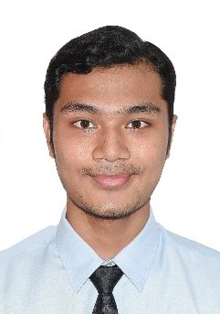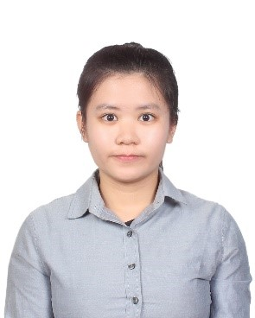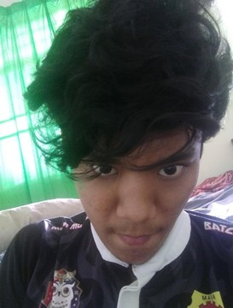

* Muhammad Faiz Aiman bin Fakhrurrazi
* Siew Yu Xuan
* Amir Hanis bin Azman