

TECHNOLOGY AND INFORMATION SYSTEM (SCSP1513)

PREPARED FOR:

DR. ARYATI BINTI BAKRI

PREPARED BY:

MUHAMMAD SYAFIQ HANIF BIN MOHAMAD HALIM

(A19EC0107)

MANFRED JOHN JASON DASS

(A19EC5238)

NOOR ARINIE BINTI NORHALIL

(A19EC0121)

LI ZHAOSONG

(A18CS309)

**Table of Content**

|  |  |
| --- | --- |
| Content | Page |
| 1. Introduction | 1 |
| 1. History of component | 2 - 4 |
| 1. Reflection | 5 - 6 |
| 1. Task of each Member | 7 |

**1. Introduction**

An Industrial Visit Program for Technology and Information System Course was arranged the visit to Center of Information and Communication Technology (CICT) on Sunday, 20 October 2019. First Year Students from School of Computing, Faculty of Engineering was visited to Galerium in CICT that was moved to Perpustakaan Sultanah Zanariaah, Universiti Teknologi Malaysia. The purpose of this program is to expose the students about the growth of the technology. Every student was so excited during this program.

In the afternoon at 3.15 pm, all students we visited to Galerium. Muhd Zahari bin Zainal Abidin , is the instructor. He gave a brief introduction about the function of the machine and how it was developed. It was very informative session for the students. In Galerium, there are a lot of components like Proses Camera, Radial Line Plotter, Block Hot Stamping, Mainframe Tape Subsystem, IBM Powerserver 550, IBM Personal System/2 Model 70 386, IBM P70 Model 6554-673, IBM Personal Computer 300GL, Computer Mouse, Apple Macintosh Classic Computer, Magnetic Tape Unit, Impact Printer, Mainframe Data Storage and many more. So, from this program we can learn about what the difference between the old product and current product

**2. History of component**

**TYPEWRITER**

This brilliant mechanical or some an electromechanical machine used for the ease of writing as it is capable of writing character similar to those made by printers. A single typewriter basically has a variety of keys, by striking the key we can produce characters. Characters are produced by the machine by the method of striking the paper surface with steel types through an inked ribbon with the types being stimulated by the corresponding on the keyboard of the machine. The paper will be held by a platen that is specialized to move automatically along with a carriage whenever a key is struck by the user. Many inventions were made in attempt to create this such machines in the 19th century. The creations are large, bulky, some might resemble a piano and basically all comes with different shapes and size. Sadly, most of them are slower than the usual speed of writing by hand ourselves. The typewriter was commercialised and introduced in 1874 but was not that common to see one around in an office until came the mid years of 1880s. The machine become an essential tool during the time as was widely used by professional writers, offices and business-related jobs. Typewriter were a standard fixture in most offices and also around most places in the time like in the 1980s. Then comes the age of digital where there is also comes the new age of type writing, which via computer and printers. There are less use of typewriters today but in some part of the world there some people or subcultures are still using them.

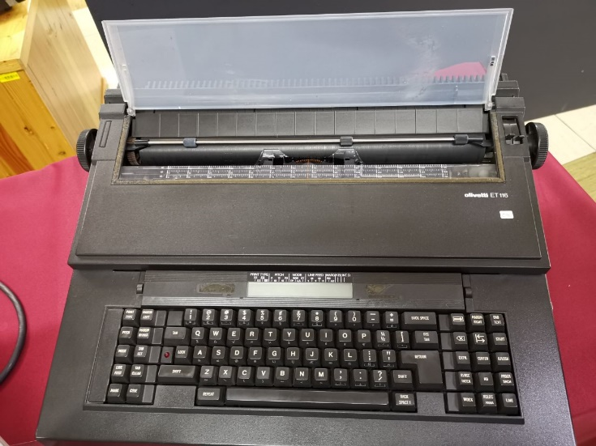

Figure 1. Olivetti ET 116 Typerwriter

**MOUSE**

A mouse or computer mouse is something that we always see people have with their computer which basically mean that this device virtually on every computer. The mouse was invented by Douglas Engelbart in 1963 while he was working at Xerox PARC (PALO ALTO Research Center) and also was originally known as the X-Y Position Indicator. But the use of mouse controlling a computer system was only demonstrated in public This hand held pointing device works by detecting two-dimensional motion relative. Thus, the detection of motion will be used to create into a motion for the cursor which is on the display, this allows the user to easily control around the graphical user interface. The mouse design is most commonly consisting of two buttons, the left and right, and the scroll wheel however if we look todays mouse designs, there are some with more than 4 button and some up to more than that for much more applicable function.

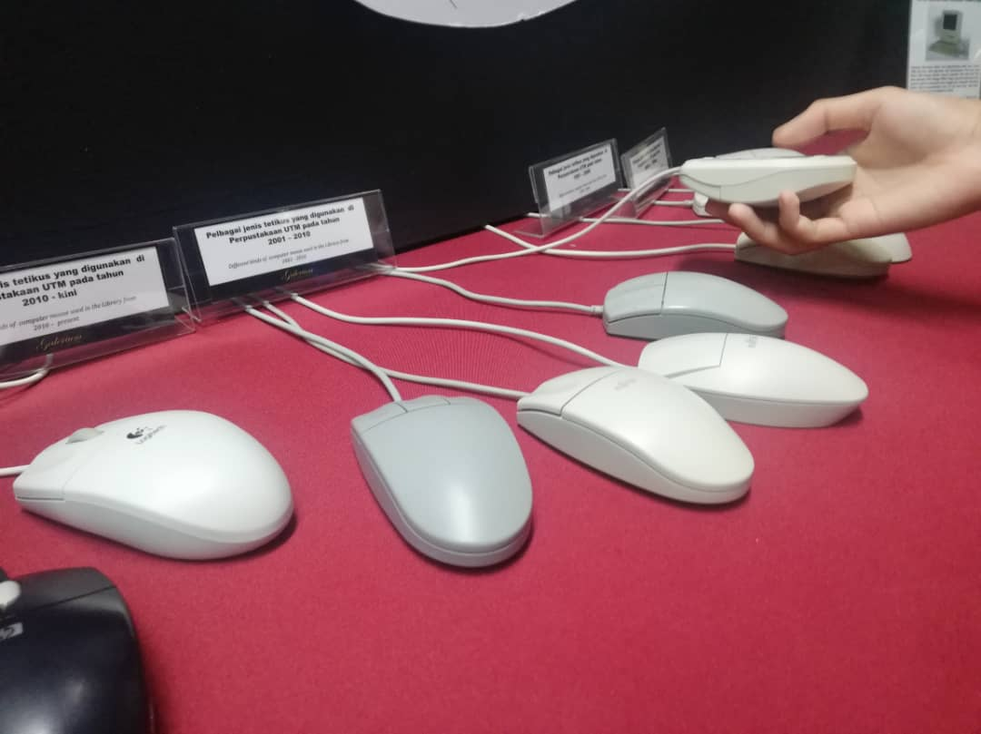

Figure 2. Mice design from the early days.

**IBM Personal System/2 model 70 386**

The IBM Personal System/2 or PS/2 is IBM’s line-up of the newer third generation personal computer. The Personal System/2 is made official as a replacement to the previous generation like the IBM PC, XT, AT and PC Convertible in the company’s computer line-up. The IBM PS/2 was officially released in April 1987 which is 32 years ago and the model 70 386 is one of them. The Personal System/2 model 70 is more advance upgrade of the PS/2 family of system as the enhanced line-up offered a brand-new level of performance in a single desktop unit. This system is boasted by the Micro Channel™ Architecture with a 16 up to 20 MHz 32-bit Intel 80386 DX microprocessor, equip with a high-density memory technology and also multiple variety of integrated features. The IBM Personal System/2 model 70 has the capability of supporting high speed real memory at up to 16MB, also comes with advanced graphics (VGA) built in. The system maintains its compatibility with most existing software products for Personal Computer systems during it time. In the future, where the computer systems have reached the fifth of its generation and begin use AI (artificial intelligence), an exciting innovation in technologies that possess many amounts of potential and still yet have much room for future enhancement.

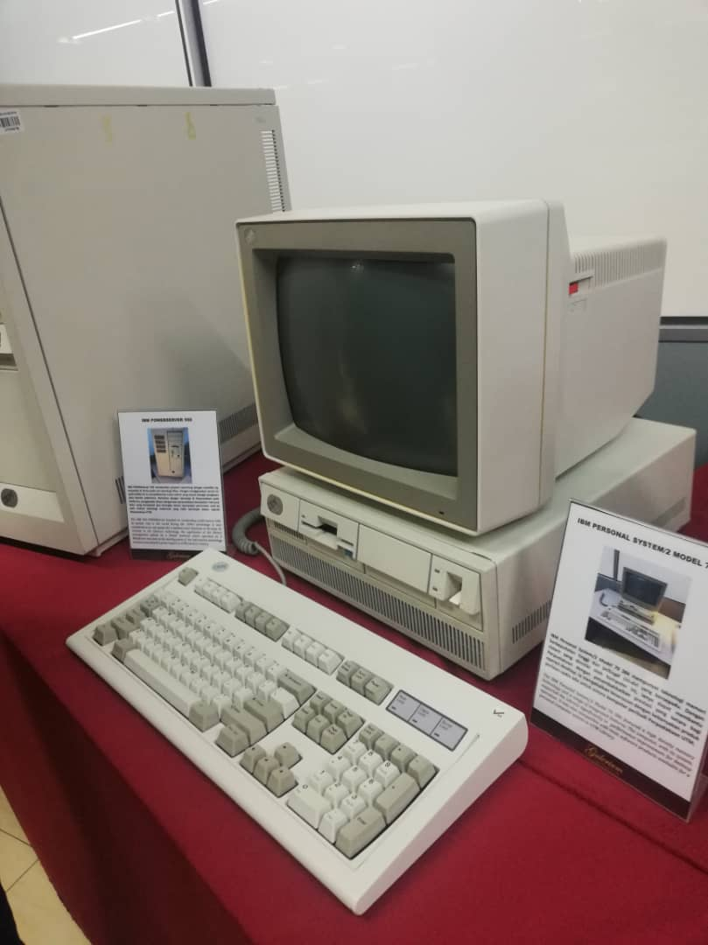

Figure 3. The looks of the PS/2 model 70 386

**3. Reflection**

Our goal as computer science students is to learn as much as we can about our field and to use all the knowledge we have obtained and all that we will obtain in the coming years to become successful computer programmers. By successful, we mean that we will be able to correctly and practically use the knowledge we have gained in our careers to solve problems, to innovate and to progress the industry as a whole.

This visit to the Centre of Information and Communication Technology (CICT) UTM made us aware of the technology which was previously used in UTM over the last few decades. We also got to see how the technology progressed and improved as the years went on. One of the major examples on display was data storage. We saw how much more compact and portable data storage is today compared to the data storage options which were available in the 80’s and 90’s. Another display showed one of the first cameras ever built, it was almost the size of a small car. This display was particularly astonishing as today, we have cameras in our pockets which are smaller than coins. The visit merely showed us how we too could make an impact on technology and how there is always room for improvement. This brings us back to our point earlier about solving problems, innovating and progressing the industry. The goal remains the same, but now we are able to see that is both possible and needed.

The industry is a very competitive place with many people fighting to get the same job, we feel that in order for us to stand out in the industry, we have to see how technology has progressed so far and try to come up with ways that we could improve this technology. This can even be done before we graduate as not all improvements require large funding and resources. Some improvements can be made just by having a different approach to the problem at hand. Another thing we could do to improve our potential in the industry is to constantly do research and be aware of new technological developments so that we will always be up to date. This will give us a head start compared to others who wait for the industry to offer courses in these new developments. Finally, much like technology, we must always be open to progress. As computer science students, we are well aware of how the tech and cyber world is constantly changing and we have to embrace these changes instead

of resisting them. Technology will continue to progress whether you accept it or not, so it is better to go with the flow and progress oneself as technology does the same.

**4. Task of each Member**

a) Muhammad Syafiq Hanif bin Mohamad Halim

* Information finder, photographer

b) Manfred John Jason Dass

* Information finder, Report writer

c) Noor Arieni binti Norhalil

* Photographer, Report writer

d) Li Zhaosong

* Report compiler, Take notes