

TECHNOLOGY & INFORMATION SYSTEMS (SECP 1513)

Design Thinking

*PREPARED BY*

|  |  |
| --- | --- |
| *NAME:* | *MATRIX NUMBER:* |
| *THANNEERMALAI A/L UDAYAPPAN* | *A19EC0171* |
| *NUR SHUHADA BINTI ABDUL HAKIM* | *A19EC0202* |
| *NUR HADIRAH MUNAWARAH BINTI ROZMIZAN* | *A19EC0201* |
| *NUR IRDEENA BINTI CHE MOHAMAD ZULKEPLI* | *A19EC0130* |

*LECTURE NAME: DR. ARYATI BT BAKRI*

*SUBMISSION DATE:*

TABLE OF CONTENT

INTRODUCTION 4

What is a Database? 4

DETAILED STEPS AND DESCRIPTIONS 5

DETAILED DESCRIPTIONS 6

Hierarchical Database Model 6

Relational Database 7

Multidimensional database 8

Object-oriented database 8

ASSESMENT POINT 9

EMPATHY (STEP 1) 11

DEFINE (STEP 2) 17

IDEATE (STEP 3) 19

PROTOTYPE(STEP 4) 21

REFLECTION 23

THANNEERMALAI A/L UDAYAPPAN 23

*NUR HADIRAH MUNAWARAH BINTI ROZMIZAN* 24

NUR IRDEENA BINTI CHE MOHAMAD ZULKEPLI 25

NUR SHUHADA BINTI ABDUL HAKIM 26

TASK OF EACH MEMBER 27

CONCLUSION 28

REFERENCE 29

TABLE OF FIGURES

Figure 1 4

Figure 2 6

Figure 3 7

Figure 4 7

Figure 5 8

Figure 6 8

Figure 7 11

Figure 8 12

Figure 9 13

Figure 10 14

Figure 11 15

Figure 12 16

Figure 13 20

Figure 14 21

Figure 15 21

Figure 16 21

Figure 17 21

Figure 18 22

Figure 19 22

Figure 20 22

Figure 21 22

Figure 22 23

Figure 23 24

Figure 24 25

Figure 25 26

# INTRODUCTION

## What is a Database?

A database is a collection of data, which is not bound by size and easily accessed, managed and updated where it is arranged and presented systematically. Manipulation of data and the support of data is the main job of a database. Complicated data is filtered and made more accessible, hence making data management easier. (What Is Data Management?, n.d.)

Figure 1

There are many real-life situation where we use database and here are a few examples.

Let us consider Instagram, it is one of the hottest and one of the most used social media platforms currently. There are 400 million people using Instagram sharing videos, photos and stories and that is a large amount of data being received. Where does all this big data go? The answer to that question is that all that data is being stored in a database.

Besides that, your phone service provider is using a database to manage your current bill, internet plan, new subscription plan and many more. This proves there is countless application of database in our daily life and there are unlimited examples of the use of databases.

# DETAILED STEPS AND DESCRIPTIONS

Table 1

|  |  |  |
| --- | --- | --- |
| DATE | TIME | ACTIVITIES |
| 23 SEPTEMBER 2019  MONDAY | 2 P.M. | * Briefing about the project by Dr. Aryati during lecture |
| 25 SEPTEMBER 2019  WEDNESDAY | 8 P.M. | * First meeting with group members * Distribute the tasks for each group member |
| 8.30 P.M. | * Prepare a list of questions relating to database system to ask users |
| 26 SEPTEMBER 2019  THURSDAY | 4 P.M. | * Interview some of the users about their background, the problems they are facing, their experience and feelings about it * Try to engage with the problems that are bothering the users |
| 8 P.M. | * Second meeting with group members * Brainstorm about the solutions to the problems that are related to the concept and theory of database system |
| 9 P.M. | * Start working on the project written report * Start editing the video |
| 29 SEPTEMBER 2019  SUNDAY | 8 P.M. | * Third meeting with group members * Finalise the idea before presenting it to the lecturer |
| 30 SEPTEMBER 2019  MONDAY | 2 P.M. | * Present the idea to lecturer and get the approval to proceed with the prototype * Design the prototype of the system |
| 4 P.M. | * Meet people who have experience in using developed database system and discuss with them the advantages and disadvantages of database system |
| 1 OCTOBER 2019  TUESDAY | 9 A.M. | * Demonstrate how the system works to the users using the prototype |
| 8 P.M. | * Improve, upgrade and finalise the prototype based on users’ feedbacks |
| 3 OCTOBER 2019  THURSDAY | 8 P.M. | * Each member writes a reflection based on the outcome of this project * A conclusion is drawn upon the reflection of each member * Final editing of video and report |

# DETAILED DESCRIPTIONS

FIVE DATA MODELS

♣ Hierarchical database

♣ Network database

♣ Relational database

♣ Multidimensional database

♣ Object-oriented database

## Hierarchical Database Model

A hierarchical database model portrays data in a tree-like arrangement where there will be one origin for each collection of data. This type of data model was created in the early years of database system development. This model can represent one-to-one and one-to-many connections between different groups of data. A hierarchical model will become handy in explaining a variety of links between data in the real world or any nested data. This model is normally used as the physical sequence of files or data in storage. We can get any specific data or file by navigating down through the data structure using pointers, which are combined with sequential accessing. The hierarchical database model is unsuitable for some database operations if each file or data does not include complete path. (Sam, 2018)

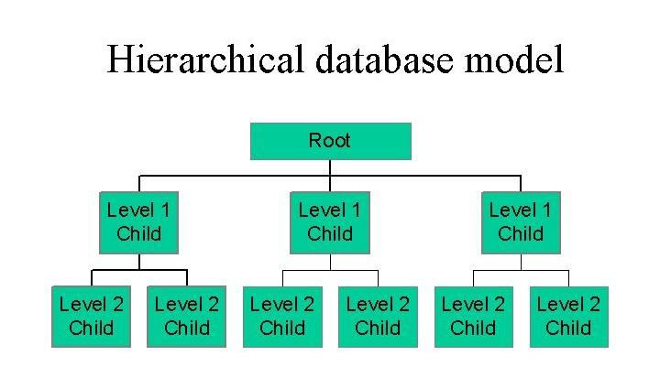

Figure 2

**Network Database Model**

A network database is a type of database model where several number of files or data are attached to different parent files and vice versa. This model is sometimes presented as an inverted tree where each member data is the branch connected to the parent, which is at the bottom of the tree. The relationships between the data are in a web-like pattern where a data can link to several other data and can itself be linked by other multiple data. The network database model lets each file or data to have several parent and member or minor files that will form a web-like shape of networked data. This is a contrast to hierarchical model data which each member data can only have a single parent record but can have many child records. (Network Database , n.d.)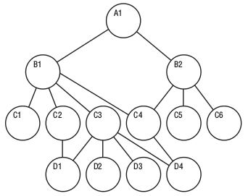

Figure 3

## Relational Database

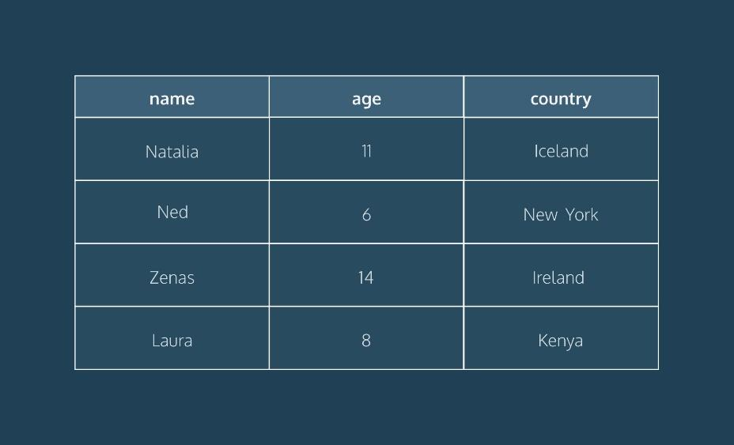As the name states a relational database, system allows the end user to access data, which is related to one another in the database. The data in the relational database system is usually organized and arranged in tables. Relational database plays an important role because this database system is used to create multidimensional database and object orientated database system. Hence, it could be said the relational database system is a building block for other database systems (DBS).

Figure 4

Based on Figure 1.0, the relational database works by relating all the three main columns to one another (name, age and country). For an example, the end user will be able to list all the names of people whom are from a specific country by entering the name of the country and vice versa. (Boyini, 2018)

## Multidimensional database

This type of database is used to show the multiple dimensions of the data to the end user and this database is usually used for online analytical processing (OLAP). OLAP is a powerful system used to discover data and to carry out complex calculations. Multiple relational databases are used in the creation of multidimensional databases. The main difference between relational and multidimensional databases are, relational databases allows the user to access data from inquiry where else, multidimensional database allows the end user to ask analytical queries related to the data being accessed.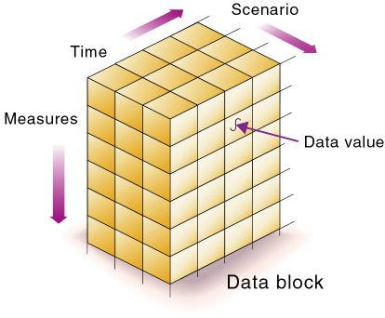 (Osman, 2018)

Figure 5

Multidimensional online analytical processing (MOLAP) is used in multidimensional databases, which allows the extraction of data quickly through analysis, which generates data quickly. The data is stored in a 3-D shape (Cube shape) hence the data can be observed from different perspective.

## Object-oriented database

The combination of object-oriented programming and a relational database forms an abject-oriented database (OOP). C++, java, ruby and python are example of OOP languages, which can be stored in relational database, but storing them in object-oriented database is better for storing them. An object-oriented database is organized around objects rather than actions, and data rather than logic.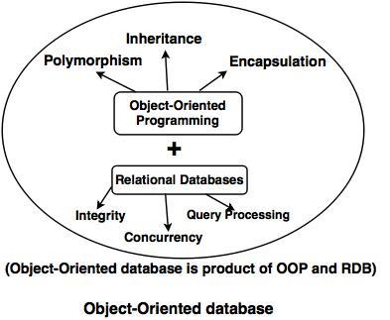 (What Are Object-Oriented Databases and Their Disadvantages, 2019)

The major benefit of using OODB is that, the consistency between database (DB) and programming language is much more consistent and accurate when the data is integrated OOP language.

Figure 6

# ASSESMENT POINT

Assessment and evaluation are crucial in design thinking because without evaluating our own work, we are unable to really make any progress. Hence, if we skip this step we will most probably end up with a bad or failed product. Assessment are made after each stage of design thinking to avoid a dysfunctional decision-making outcome, which deviates from the original problem. Hence the derailment of a project and downfall of a group. As a solution, assessment points play an important role to prevent this problem. Assessment points is conducted during the end of project demonstration and during each stage of design thinking.

|  |  |
| --- | --- |
| EMPATHIZE | Our target audience for this new database system is leaning more towards technical staff, lecturers and anyone who deal with big data. Hence, we decided to interview a lecturer and a technical staff to deeper understand what their problems that they face are. |
| DEFINE | In this phase, we analysed and synthesised the problems that we identified in the empathy phase in order to better understand the end users’ needs and wants. We defined the problem as how to automate the data analysing process, after we evaluated the problem, we changed the question into how to access the data quickly and efficiently while being user friendly. |
| IDEATEImage result for ideate | In this phase, we begin our brainstorming. Brainstorming means coming up with logical ideas from multiple views and perspectives. During this phase, we listed all the ideas followed by filtration process then, we chose the idea which is most likely to succeed (the darling) and we chose a more complex way to solve the problems but was less likely to succeed (the long shot). |
| PROTOTYPEImage result for prototype icon | After careful deliberation and rational reasoning, we decided to come up with a prototype that is a database. To be more specific, we came up with a multidimensional database management system (MDBMS). In the prototyping phase, we made sure our design was in line with our outline of the problems. We also kept in mind of our user throughout the prototyping phase to make it more user friendly. We also made sure to evaluate our prototype after the prototype has been completed before finalising the project and we found out there are a few tiny parts where we can improve the database system. |

Table 2

During the end of the project, reflections are carried out to verify whether the results and outcomes were in line with our initial idea and the weather it answers or biggest question, weather it solves our problem.

In conclusion, assessment points are very important in design thinking because this step plays an important role in keeping our ideas in line with our intention and prevent the project from wandering too much.

# EMPATHY (STEP 1)

IDENTIFYING THE PROBLEMS BY INTERVIEWING SOME DATABASE SYSTEM USERS

RESPONDENT 1

Venue: School of Computing, UTM Johor

Date: 30 September 2019

Name: Madam Sharin Hazlin Binti Huspi

Position: Senior Lecturer, Department of Information Systems, Faculty of Computer Science and Information Systems

Q: What is your perspective towards database system currently and do you think it is good?

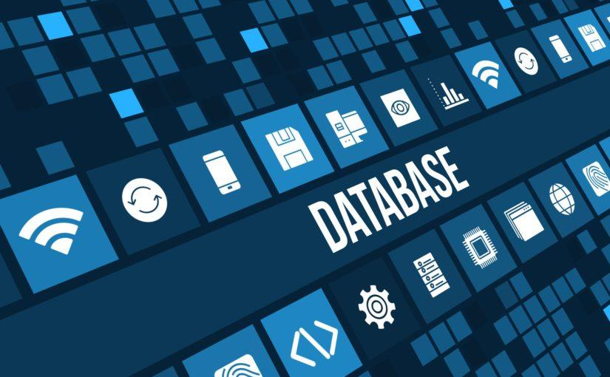A: Currently, most information is available in database systems. We can see that there is a lot of systems that are already developed and have been very good, compared to last time. Even in UTM itself, we can see a lot of improvement in course registration system and the student management system which contain a lot of data. They are in a good place and have improved a lot.

Figure 7

Q: During last time, before database system has developed, did you find it difficult to enter and manage the data?

A: Yes, I did, especially previously for student registration system where students had to queue for a very long time, some of the students even slept in front of the academic office just so that they can register for the class that they wanted. However, for now, as you can see during the registration day, the students only need to register the courses using their own PC or laptop. As long as they have a network and they know what subjects to take, they can just complete the registration process themselves and there is no need for them to queue all day and night anymore.

Q: What do you think is the future of database system?

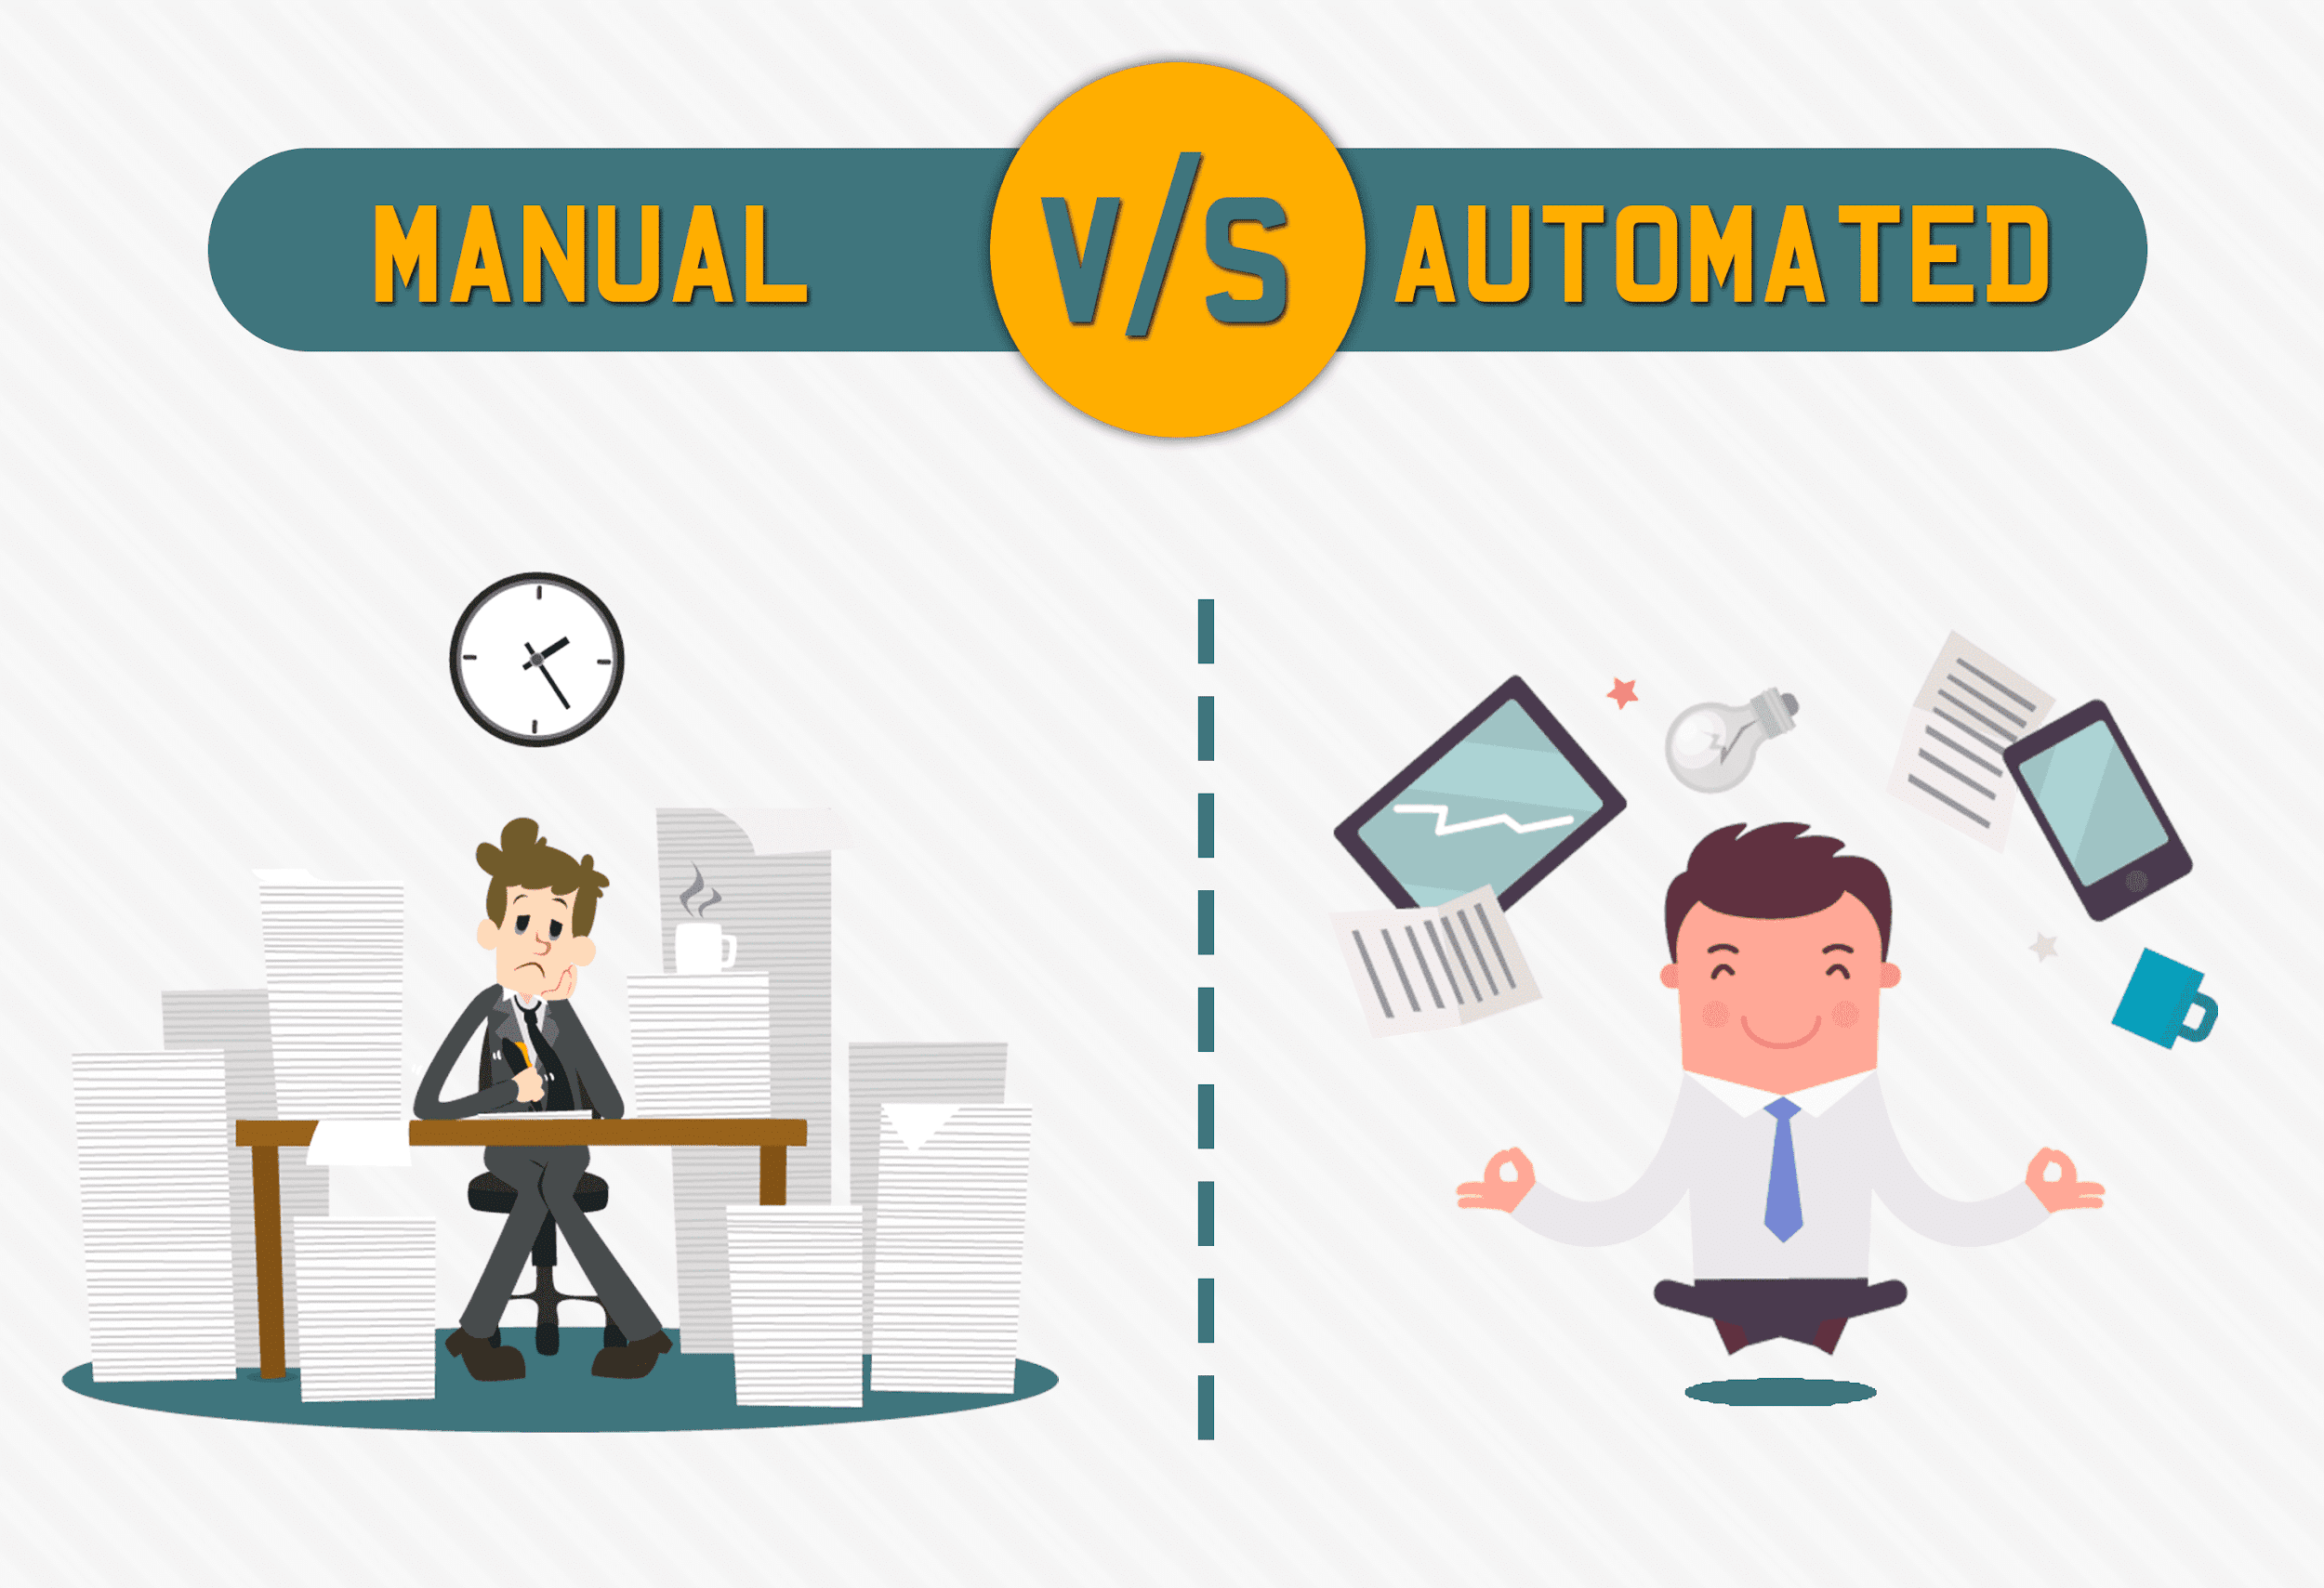A: I think for the database system itself, it would not change much because nowadays, every data and information is already in a system, so we are now in the phase of having an overloaded information and data. This means that there must be a system where we will be able to reduce all of the data, so it would make sense where you can predict the future of something based on the trends and the information that you get from those data. Basically, I think the database system is already stabilised, it is just that what can you do to all the data that you have in the database. I think that is the next thing that we should start to think about.

Figure 8

RESPONDENT 2

Venue: Centre for Information and Communication Technology, UTM Johor

Date: 30 September 2019

Name: Madam Norqumariah Binti Saad

Position: Official Technology Officer, Application Development and Multimedia Management Division

Q: Do you have any experience in using database system and what type of database management system or software do you use back then and now?

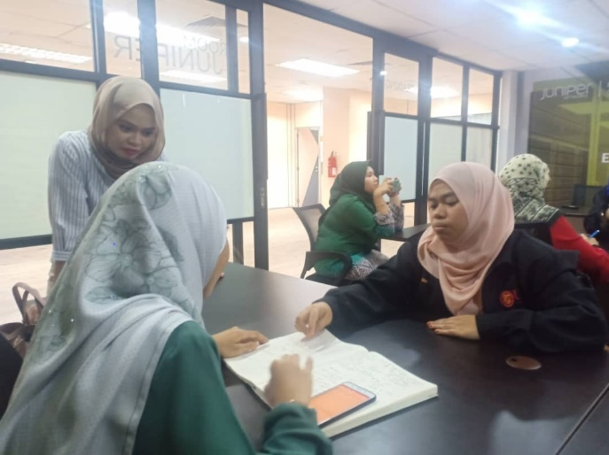A: I do, since my daily job scope is mainly focussing on storing and managing data. Currently I am using Oracle and previously I used MySQL to process the data.

Q: May I know the disadvantages of both Oracle and MySQL?

A: Oracle requires users to have an official license, which is quite costly, while MySQL is an open source, which is free of charge. However, there are several limitations of data that can be processed in MySQL, while the amount of data that can be operated in Oracle is unlimited.

Figure 9

Q: How long have you worked in this database sector?

A: I think it has been around 10 years since I started using Oracle to complete my tasks in this sector and I only used MySQL when I was a student.

Q: That being said, how many generations of database system have you gone through.

A: Here in UTM, there have never been any change yet in terms of generation of database system. We have been using Oracle since forever because we only bought Oracle’s license and no other database management software.

Q: Can you tell me how frequent do you use database system?

A: I think almost every day I need to use database system as my job scope literally covers database management.

Q: Have you ever used an older version of database system?

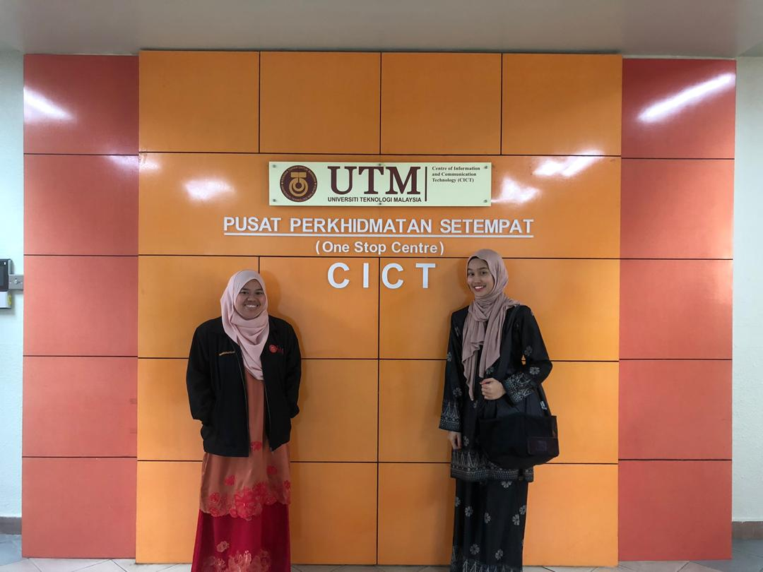A: I have because some types of data requires us to manage them in certain database system model. For example, we will use object-oriented model if the data is mainly about finance as the model can display the connection between parent records and child records, which makes it easier if we need to navigate or search for some specific data. Adding more data using the model will also be a lot easier compared to using other models.

Figure 10

Q: How do you feel about the development of the database system?

A: Compared to previous time, I now think that database system has been very useful in our daily working life. Maintaining, reporting and retrieving data are uncomplicated since the database system developed. Thus, I feel the database system nowadays are good enough even though there are several improvisations that can be made.

Q: If we were to improve the current database system, how do you expect us to do that?

A: For long term solution, I think you should refine and upgrade the process of data archiving. Every day, the amount of data we need to manage is huge. Archiving the data can make the procedure of retrieving data a lot more unchallenging.

RESPONDENT 3

Venue: School of Computing, UTM Johor

Date: 30 September 2019

Name: Madam Lizawati Binti Mi Yusuf

Position: Lecturer, Department of Computer Science, Faculty of Computing

Q: What is your perspective towards the current database system? Do you think it is good?

A: That depends on whether we are a developer or not. I am only a user and not a developer, so I am not aware of the development of database system, but from what I know, the best database software currently is Oracle, however it is very expensive, thus normally, only big and international companies use it. As for the small or medium companies, they will use the second level of database software which is Microsoft SQL because it is free and does not require the users to buy the license. From my point of view, I think both Oracle and Microsoft SQL are very systematic and well-developed.

Q: What are the disadvantages did you find in managing data manually without using database software?

A: Nowadays, if we look at our management, they will usually use a system to manage a large amount of data, no matter if it is a ready-made system or a system that they themselves developed. When we talk about doing things manually, that means we manage the data by using file manager on a PC or laptop, which I find it very rare among any organisations these days. This is because if they use file manager, there are several problems they will face. One of them is the large amount of data will be very difficult to be stored. Secondly, it will be very hard to find any specific data that they need in a short period of time. Thirdly, the data tends to be misplaced easily. As we move forward to a more technologized world, it will be much better to use an organized database system, instead of using the file manager.

Figure 11

Q: How do you think we can improve the file manager so that it can fulfil your needs as a user?

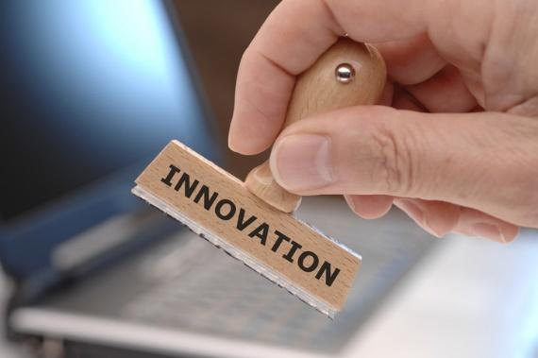A: Everyday, we have a huge amount of data to be managed and that requires us to store the data in one same place. Also, we need to create a backup just in case the data go missing. For big companies, they have their own data centre to store all the data. But for normal users like us, I think the security of the file manager or any database system needs to be upgraded. Anyhow, we as users also must master the knowledge about managing data and be responsible towards the data that we deal with so that the data will be kept safely and securely.

Figure 12

# DEFINE (STEP 2)

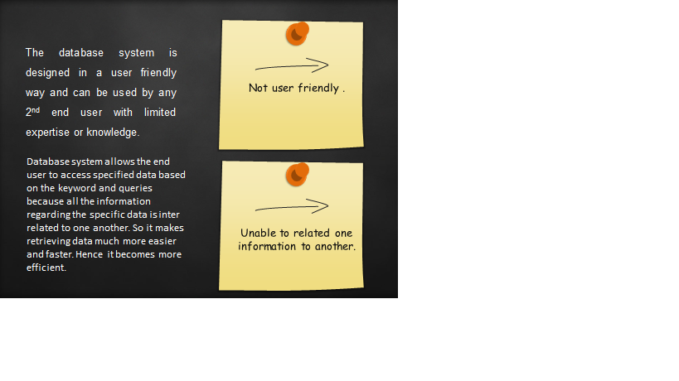

# IDEATE (STEP 3)

**BRAINSTORMING**

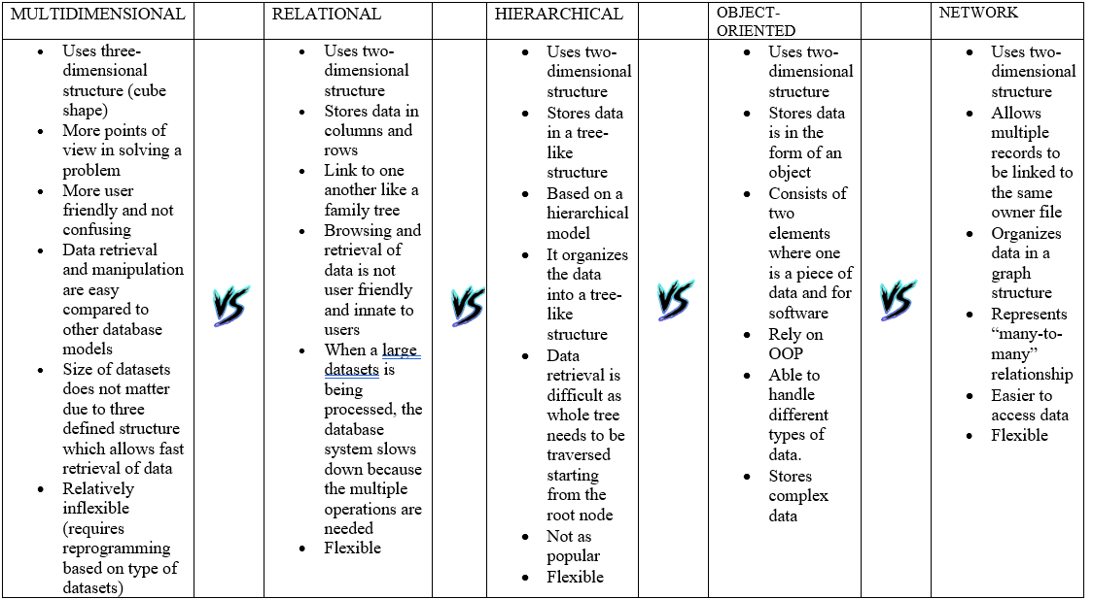Table below describes the characteristics, advantages and disadvantages of each database models.

Table 3

Based on the comparison above, we found that all five of database models fulfil users’ needs and expectations as they can store the data efficiently and systematically. Multidimensional database system are easier to be utilised by users as it displays the data in three-dimensional structure which sometimes viewed as a rubix’s cube, thus it is not too difficult for the users to understand the information in the model as it can have more than one points of view. This will also not be a problem for those who have zero understanding in managing large amount of data because multidimensional database model is more user friendly than other models. (Multidimensional Basics, n.d.)

On the other hand, relational database model will slow down the database system as several steps and operations are required to complete the process of datasets, compared to multidimensional model that can approach and process datasets no matter how huge the size is.

An action that might take a relational database system a minute will only take a few seconds for a multidimensional system to do that might seem like a small amount of time but in the end, you might lose days or even weeks’ worth of time. (Collins, 2003)

Hierarchical database model will display data in tree-like structure which is two-dimensional. This makes data retrieving difficult as users need to start from the root node if they want to search from a certain data. Thus, hierarchical database model is not very systematic compared to other models. (Hierarchical Database Model, n.d.)

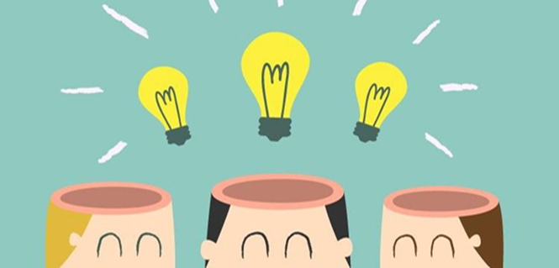Although object-oriented database also uses two-dimensional structure to display the data, it can process several types of data including complex one and can store a huge amount of data. It also relies on Object-Oriented Programming (OOP), which is a software that can describes the type of data and can suggest what operations that can be used to process the data. (Bial, n.d.)

Figure 13

Network database model arranges data in web-like structure which consists a lot of links and connection between data. This makes the process of accessing the data easier as users can see the relationships between each data. Network data is also flexible as it can process many types of data and can display it in a graph, which can be read by users from any background, even if they have no basic knowledge about database systems.

# PROTOTYPE(STEP 4)

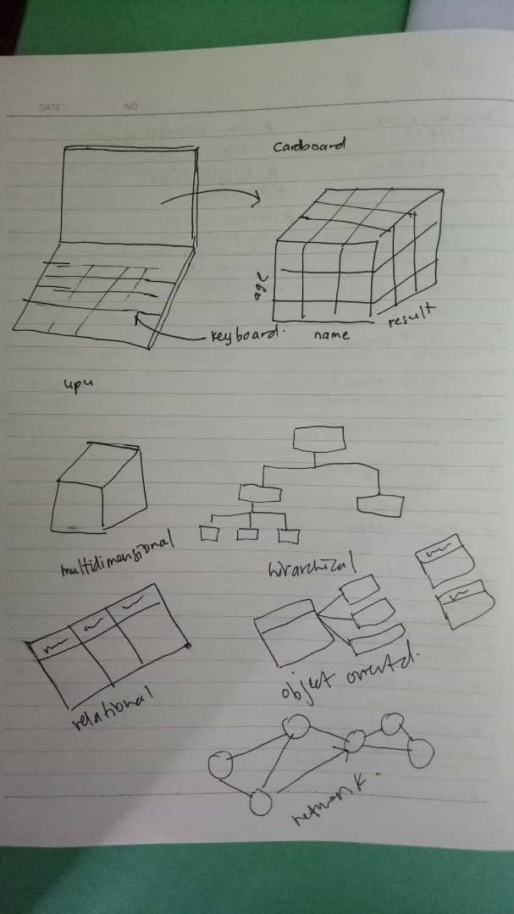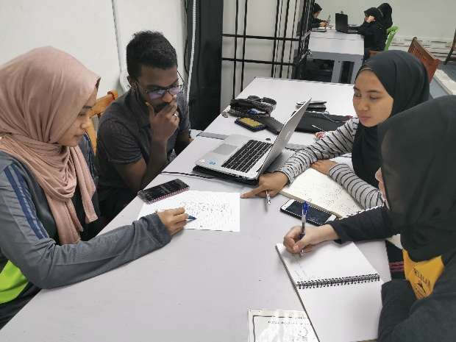We began the prototype process by having a discussion with group members about the best design of the system so that it can display all five of database models. We sketched the design and presented it to our lecturer. We had many different and creative prototypes to overcome this problem but we unanimously decided to go with this said model .

Figure 14

Figure 15

# 

# 

# 

Figure 16

Figure 17

After getting her approval, we proceeded with crafting the prototype; a laptop that has a system which can process data and arrange it in all five database models and lay them out on the screen quickly and efficiently whilst maintaining an attainable budget whilst keeing the prototype user friendly.

# 

Figure 18

Figure 19

# 

# 

Figure 20

Figure 21

# REFLECTION

|  |  |
| --- | --- |
| THANNEERMALAI A/L UDAYAPPAN Figure 22 | Our goal or dream with regard to our course/program is to be the a respectable data engineers in the industry with a high level of competence and problem thinking skill which I believe this subject, Technology & Information System will be able to equip me before graduating. The goal is to be an employed graduate by a well-known industry in a very short period. I also hope to be able to open my very own start-up business after accumulating a few years of experience and for me to achieve that dream I believe this subject will be a good stepping-stone for me. Besides that, this course really gives a detailed explanation on how every day technology we see works and it gives me a new perspective on how things work.  Design thinking has an impact on my dream because it has sharpened my critical thinking skill where we are given a real life problem where have to solve real life problems. I also learned how to organize and strategize my thoughts clearly and how to present my idea confidently. We also learned how to cooperate and work together with teammates when carrying out a project that helped improve our communication skills. We also learned the importance of trust and teamwork whilst working on this project because “2 minds are better than 1”. This also gave me a chance to expand my perspective and widen my horizon.  In my humble opinion, I believe we all have room for growth, and I believe I can also improve myself in a few areas. Firstly, I think I can become more useful and competent to the industry by having a good grasp on programming language especially PYTHON as it is the most widely used programming language currently in the industry.  I should also think outside the box to solve problems by thinking up of creative and insightful solution that will help me in becoming a better Data Engineer.  New problems require new solutions. Finally, I believe soft skills is as important as knowledge because there is no point in being a genius if I am unable to present my idea. Hence I, hope to better my soft skill in the next 4 years by attending classes and seminars. As a conclusion, there are many things for me to improve and learn and I believe this course will help me in realizing my dreams. |
| *NUR HADIRAH MUNAWARAH BINTI ROZMIZAN*   Figure 23 | My goal is to be a successful data engineer in an international company. Being such in a big company is definitely one of my dream lists. Furthermore, this project really does impact me in many aspects. From what I learnt in this project, all of us managed to finish this project on time. This really shows that our time is manageable and punctual. The efforts that we made were beyond than our expectation. Based on my opinion, this project gave me more ideas about making new advanced technology. Databases is one of the most subtopics that are challenging for us. However, we all able to cope them and putting them into practice. This made more focus, fully aware on the problems that we had. Moreover, my thinking towards the project are quite thoughtful. This is because this technology has capable of doing everything at once especially our safety purposes. They are more friendly, intelligent and easily to install. Their flexibility on performing tasks is more consistent and more accurate without any mistakes.  This will give more good impacts for humans. I really enjoyed the project the most because the functionality of the prototype that are capable of multitask than any other projects. The part that I found hard to do was making the videos or editing the videos throughout the project. Nevertheless, all of our team member can solve the problems by doing some research. Another interesting thing about technology is it can make us feel better too. Take for example, our security prototype or devices will secure our home when we’re away. Therefore, it makes users to feel more protected in either personal or business reasons. Besides that, this project encourages us to become self-awareness and develop soft skills. The confidence level and acting skills become slowly improve. It enhances better understanding of our emotions, weaknesses and strengths. Finally, making a proper plan is necessary for us as it helps to organize our process and achieves our ultimate goals. |
| NUR IRDEENA BINTI CHE MOHAMAD ZULKEPLI   Figure 24 | In the next 5 years, I dream to be an influential data expert who masters in solving real world problems using data engineering theories. In the meantime, I aim to increase my knowledge and deepen my understanding about the course I am currently taking, which will be useful when I enter work life in the future. I also look forward to building and expanding my network by being socially active, which, too, will increase my confidence in communicating with others, and enhance my soft skills.  By completing the design-thinking project, I can see the progress I am making in achieving my goals. Coming out with ideas of solutions to the problems given using the concept that we have learned so far escalates my critical thinking skills that can help me solve other complex issues in the future. Other than that, I have acquired an increment in my knowledge by doing research about the problems given and the way to solve them.  My network has also been enlarged, as I had to work with several people from other classes and courses during the process of completing the project.  One of the essential actions I must take in order to prepare myself for industry is gaining more experience by joining activities and trips organised by the school. This will help broaden my exposure to real work life. Other than that, I believe that starting from now I need to prepare and groom my personality as well as improve my soft skills so that I will be an excellent employee who fulfils most of the employers’ expectations. |
| NUR SHUHADA BINTI ABDUL HAKIM   Figure 25 | My goal is to become a professional data engineer that have the abilities to produce various system that can benefits wide range of industries/companies. I plan to train myself with the ability to make short-term critical decisions, which is very crucial in nowadays-industrial field. I very much admire a few data engineers that I have come across, how they are highly trained and equipped with a very special level of skills. From this activity, I learned a lot about the design thinking process (empathy, define, ideate, prototype, test) whereas I can implement all these steps when I need to solve a problem or creating my own system later in future. This process teaches us on how to be more strategic and systematic in planning a very thorough solution for a high-risk problem. By knowing this design thinking process, I can train myself to design a solution system with a thorough planning yet I am able to finish the design in a short time and in a systematic way. In my opinion, if I want to improve my potential in the industry later on, I need to be more focus in class and train myself to understand the teaching well that I can implement them in my daily routine.  I also believe that, I need to always revise everything that was taught to me so that I would not be the kind of person that can only answer on examination but fail to solve real-life industrial problems. It is my only goals to be a multi-tasking and highly skilled person that are able to solve any real-life problems that I come across anytime soon.  I also think that I need to be ready with all kind of incoming pressure and tons of task. Therefore, it is very crucial for me to be strategic and being able to handle all the stress, pressure and not to force myself too extreme that it would affect my mental health. I really hope that I can cope with this course/program and be able to achieve my goals someday. |

Table 4

# TASK OF EACH MEMBER

Table 5

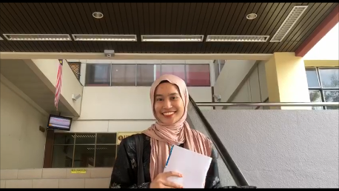

-Editor

-Reflection

-Introduction

-Prototype

-Brainstorming

-Problem analysis & solution

-Conclusion

-Interviewer

-Reflection

-Prototype

-Brainstorming

-Problem analysis & solution

-Videographer

-Reflection

-Empathy

-Prototype

-Brainstorming

-Problem analysis & solution

-Photographer

-Reflection

-Prototype

-Brainstorming

-Problem analysis & solution

PICTURE 1.0: THANNEERMALAI A/L UDAYAPPAN

PICTURE 2.0: NUR IRDEENA BINTI CHE MOHAMAD ZULKEPLI

PICTURE 3.0: NUR SHUHADA BINTI ABDUL HAKIM

PICTURE 4.0: NUR HADIRAH MUNAWARAH BINTI ROZMIZAN

# CONCLUSION

Design thinking is one of the systematic processes that can be used to solve a problem. Engaging with users is vital to unravel the problems that they are facing. From here, we can then easily know the next steps that we should take in order to solve the difficulties. Design thinking not only enhances our critical thinking skills in resolving complications, this process also leads us to meeting new people from different backgrounds and at the same time strengthens our communication skill.

By interacting with some of the database system users, we too, know that database management system plays a major role in making the process of collecting, storing and arranging data much easier than before. Each database model has its own advantages and disadvantages and some of the models are only suitable to be used to display data in certain fields. Although there are still improvements that can be made to the system, the current system is already efficient enough and fulfils users’ needs.

Throughout completing this project, we gained a lot of new information mainly about databases. The course we are enrolling itself generally relates to databases. Thus, we are thankful that we are being exposed to databases topic at early stage. This has helped us deepen our insights on the course. At the same time, we feel encouraged to learn more about databases in order to prepare ourselves to be a career-ready student. This project has also assisted us in brushing up our soft skills, which are one of the skills employers are looking for in an employee.

# REFERENCE

Bial, V. (n.d.). *OOP - Object Oriented Programming*. Retrieved from webopedia: https://www.webopedia.com/TERM/O/object_oriented_programming_OOP.html

Boyini, K. (23 July, 2018). *Relational Database Model*. Retrieved from tutorialspoint: https://www.tutorialspoint.com/Relational-Database-Model

Collins, J. (27 November, 2003). *Comparison of Relational and Multi Dimensional Database Structures*. Retrieved from alphadevx: http://www.alphadevx.com/a/36-Comparison-of-Relational-and-Multi-Dimensional-Database-Structures

*Hierarchical Database Model*. (n.d.). Retrieved from educba: https://www.educba.com/hierarchical-database-model/

*Multidimensional Basics*. (n.d.). Retrieved from olap: https://olap.com/learn-bi-olap/multidimensional-basics/

*Network Database* . (n.d.). Retrieved from techopedia: https://www.techopedia.com/definition/20971/network-database

Osman, A. (31 July , 2018). *Multidimensional Database Model*. Retrieved from tutorialspoint: https://www.tutorialspoint.com/Multidimensional-Databases

Sam, S. (23 July, 2018). *Hierarchical Database Model*. Retrieved from tutorialspoint: https://www.tutorialspoint.com/Hierarchical-Database-Model

*What Are Object-Oriented Databases and Their Disadvantages*. (5 September, 2019). Retrieved from c-sharpcorner: https://www.c-sharpcorner.com/article/what-are-object-oriented-databases-and-their-advantages2/

Link YouTube:

https://youtu.be/Bd5k6LNxI_c