

**GROUP PROJECT**

**“STUDENT ENTREPENEUR”**

**PROBABILITY AND STATISTICAL DATA ANALYSIS**

**SCSI-2143/09**

**Dr. NOR ERNE NAZIRA BINTI SAZINI**

**GROUP 11 MEMBERS:**

1. ARIQ NAUFAL (A18CS0292)

2. FARID ABDULLAH RANGKUTI (A18CS0300)

3. PREMA KARIRA ANAS SULAIMAN (A18CS0320)

4. SYAFA NABILA MAULIDYA (A18CS0328)

**INTRODUCTION**

Student entrepreneurs are youths who start or already have their own business during their studies. They’re exist between us, It could possibly our friends, brother, sister, etc. They choose to become entrepreneurs while studying in university base on many reasons. What we analyse is that how the student entrepreneur could change the financial circle of a society, and what is the benefit of their existence in a society.

**METHODOLOGY**

To develop our question, we only take from our experience or ask about student entrepreneur to the student entrepreneur about their experience. We collected the entire question and we decided to choose the great question. After that we make a questionnaire for our survey to collect the data from participants, because every person has a different opinion. We conduct our survey through google form to make easier for us to data, then we spread out the questionnaire through whatsapp group.

**DATA ANALYSIS AND RESULT**

1. Detail of Volunteer

In this first project we have collected 30 responses from 30 persons, of two genders 40% of female sex and 60% of male sex.

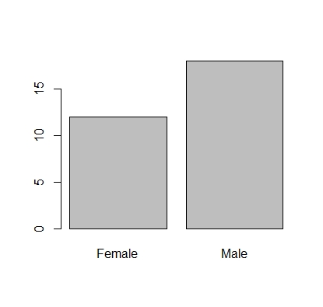

Most of those who are responded to our survey were eighteen years old and the lowest are twenty three years old. In the below we will give the diagram of age.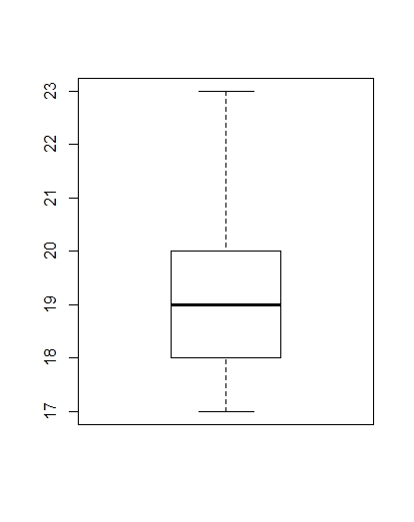

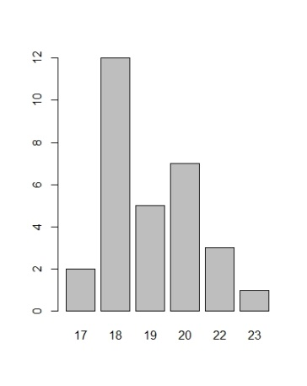

Almost those who give their respond to our survey are student of Universiti Technology Malaysia, because we shared our questionnaire via WhatsApp group. There were various courses participating in filling out this questionnaire, one of which was SCSR from faculty of computing. They are the most participate in our survey, there are 12 persons and from other courses are SCSV (2 perso

ns) and SCSJ (7 persons). Not only from faculty of computing have who participated of this form, but from other faculty with different courses also give respond to our survey like SBEL (2 persons), SMBE (1 person), SSCG (1 person), SKEM (1 person), SHAC (1 person), SGHP (1 person), SCEE (1 person), Visual Art(1 person). 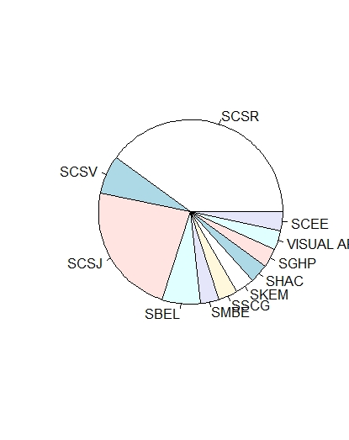

Student first year are more dominant (80% around 24 persons), second year (13.3 % there are 4 persons), third and fourth year 3.3% each, 4 people.

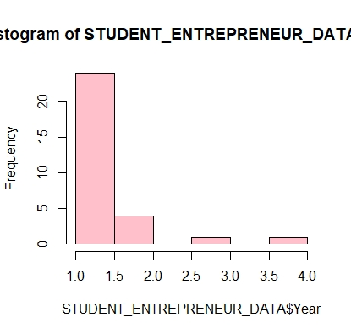

1. Do You Know Anyone who is a Student Entrepreneur?

Nowadays, many who want to be an entrepreneur, including a student and also who know anyone who is a student entrepreneur. Some of them are young entrepreneur and some of them have a friend who is a student entrepreneur. But 50% for those who known or have a friend student entrepreneur and 36.7 % for those who do not know or have not known a

student entrepreneur.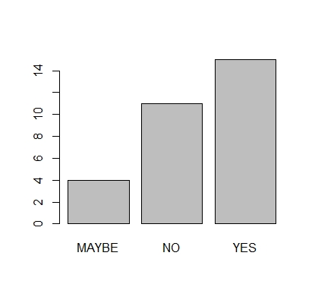

1. The Impact from Student Entrepreneur to Society

Become young entrepreneur or student entrepreneur definitely have many impacts for themselves or for society around them. From survey that we have been did, on average they choose student entrepreneur give so many impacts to society.

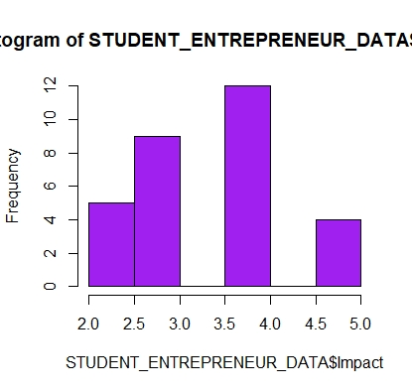

1. Point of View About Student Entrepreneur

Some point of view from student for those who is a student entrepreneur are given many positive things, some of them said if is it does not affect to anyone, only give bad impact, not quite sure, and not really care about it. They have their own argument to someone in different word. 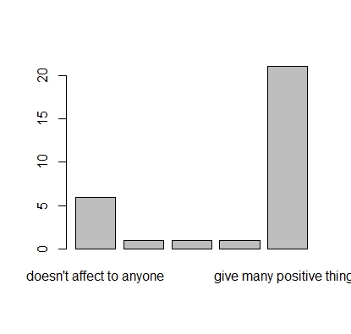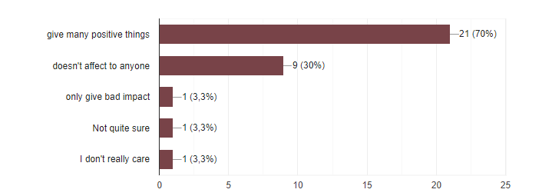

1. Difference between Student Entrepreneur and Regular Student

Between student entrepreneur and regular student have a different way of life? Maybe some people’s view said if they are have no different, both have their own best, depend on the situation, depends on the individual who do some business, or cannot discern between the two. Other views are student entrepreneur is better than regular student or otherwise; student entrepreneur can manage time better than regular student. 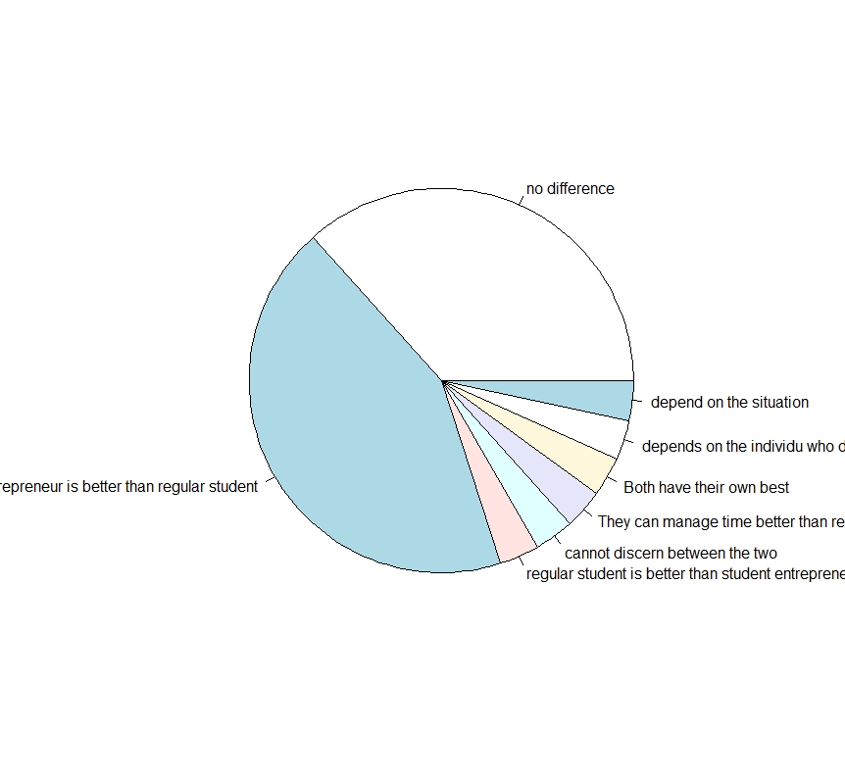

1. Feelings Some People Towards Young Entrepreneur Who also Become a Student

Anyone feel if they have friend who is also become a student entrepreneur is just like a regular friend and there are some of them if have friend a student entrepreneur only mind their own business and does not affect to anyone and some of them have no friend student entrepreneur. 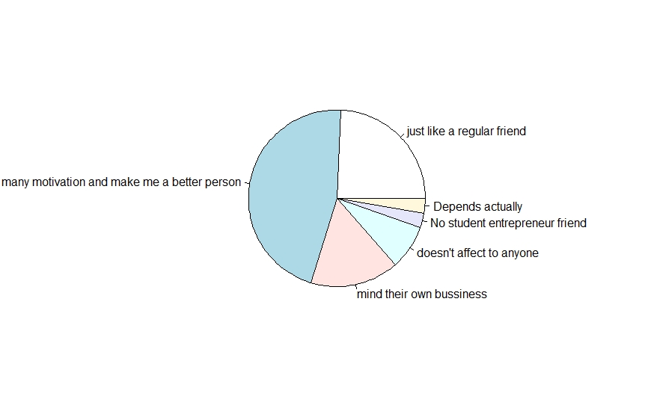

**DISCUSSION AND CONCLUSION**

1. Do You Want to Become A Student Entrepreneur?

46.7% of student said yes to become a student entrepreneur and 43.4% said maybe they want to become a student entrepreneur, it depend on their future later, maybe yes or maybe no, and for 10% they choose no it means they did not want to become a student entrepreneur.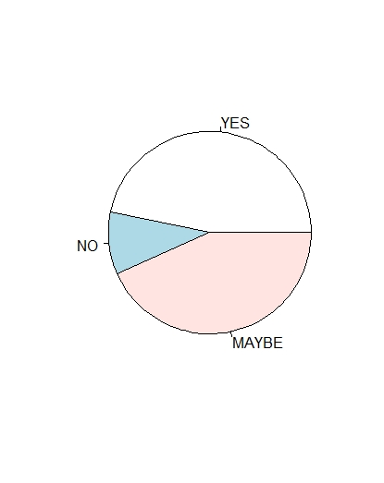

1. The Reason

Some of the reasons they gave us are :

* YES
* It is important for my future
* Make me want to be a businessman for my future
* Because it could help us to reach field easily, because we already have the experience
* Making some money
* To be more independent and creative instead of the monotone of student life
* Why not
* NO
* I don’t want to be
* Entrepreneur need handsome and beautiful face and also money
* MAYBE
* Cause it would bring me fortune
* Need to sustain my life and fuel the hopes for the future
* Interesting
* To fill the spare time

After spreading questionnaires about finding out whether people know or not about being a student entrepreneur, and whether they want to become one, we can see most of the respondents answered “Yes” and 6 people provided reasons, which we can conclude that most of the respondents which consists of 18 male and 12 female who came from Faculty of Computing wants to become an entrepreneur. They agree that being a student entrepreneur will give many positive things such as better time management between study and entrepreneur, becoming more productive and creative, etc.