**NURAMALINA BINTI AHMAD TAHIR A11SC0232**

**AUFA A’QILAH BINTI A HAMID A11SC0223**

**AFIQAH HANIS BINTI SHURBAINI A11SC0299**

**SECTION2 1SSCM**

**ASSIGNMENT R**

**1(a)**

> a<-function(x)

+ {

+ y=sqrt(4-x^2)

+ y

+ }

> integrate(a,-2,2)

6.283185 with absolute error < 4e-09

**1(b)**

> a<-function(x)

+ {

+ y=1/(3+5*sin(x))

+ y

+ }

> integrate(a,0,pi/2)

0.2746531 with absolute error < 6.5e-13

**2(a)**

> a<-expression(x^2)

> D(a,"x")

2 * x

**2(b)**

> b<-expression(exp^(-x)/sinh(2*x))

> D(b,"x")

-(exp^(-x) * log(exp)/sinh(2 * x) + exp^(-x) * (cosh(2 * x) * 2)/sinh(2 * x)^2)

**3.**

First, save the babies data in ‘dat’ format. Change directory and type the command below:

> babies<-read.table("babies.dat",header=T,as.is=T)

> babies[1:5,]

id pluralty outcome date gestation sex wt parity race age ed ht wt1 drace

1 15 5 1 1411 284 1 120 1 8 27 5 62 100 8

2 20 5 1 1499 282 1 113 2 0 33 5 64 135 0

3 58 5 1 1576 279 1 128 1 0 28 2 64 115 5

4 61 5 1 1504 999 1 123 2 0 36 5 69 190 3

5 72 5 1 1425 282 1 108 1 0 23 5 67 125 0

dage ded dht dwt marital inc smoke time number

1 31 5 65 110 1 1 0 0 0

2 38 5 70 148 1 4 0 0 0

3 32 1 99 999 1 2 1 1 1

4 43 4 68 197 1 8 3 5 5

5 24 5 99 999 1 1 1 1 5

**4.**

> x<-rnorm(100,0,1)

> x

[1] -0.55432975 0.54289545 -1.63445291 0.74004720 0.99837211 -1.14993203

[7] 1.47161999 0.86487324 0.59606314 -1.93739182 0.62518701 -0.51260186

[13] -0.59298716 -1.33911947 0.95502702 0.64362124 -0.49364676 2.19953795

[19] 0.35023959 -0.20849173 0.10886974 -1.52812348 0.98080727 0.80849948

[25] 0.06432748 -1.61504981 0.66555438 1.22134198 -0.47763067 2.07208714

[31] -0.13154948 0.41782681 -0.52043885 1.61596791 1.27563052 0.51590405

[37] 0.70715112 0.44742242 0.64051143 -1.11406321 -1.05739755 1.01036266

[43] 1.28422918 0.06388498 0.24669336 -0.08287328 0.31775211 0.69688037

[49] -0.82149169 1.49311089 -0.80712165 -1.87845057 1.17884294 0.13629301

[55] 0.75472733 -0.31328381 0.38249516 -0.13173177 -0.74171960 -1.03033757

[61] -0.57414198 1.02029458 -0.67908881 -0.07994356 0.38998152 -1.34443703

[67] -0.76131413 1.82295674 -0.23352591 0.71800656 0.06135957 -2.29723364

[73] -0.45107225 -0.16736992 -0.66651477 0.05620649 -0.69818031 -0.33661516

[79] 1.14760151 0.40161860 0.89414642 0.78622858 1.56190538 1.08581169

[85] 0.70554653 -0.37415925 -0.11012868 -0.47622903 -1.54449059 -0.40018234

[91] 1.29965685 0.92965296 0.67771469 0.82713496 -0.71683751 0.72377339

[97] 0.48702834 -1.32763334 0.88810118 1.89020308

> mean(x)

[1] 0.1355627

> sd(x)

[1] 0.9655398

> x[x>1.96]

[1] 2.199538 2.072087

**5.**

> rgamma(100,shape=1,scale=0.5)

[1] 0.010614668 0.228030370 0.696825024 0.577597016 0.145642883 0.607997883

[7] 0.030481424 0.943092517 0.017671617 0.563319362 0.145376669 0.031439506

[13] 0.711019435 0.825880642 0.254925993 0.036722065 1.035826630 0.196486175

[19] 1.278166618 0.423880549 0.226400523 0.331061356 1.329310579 0.061221551

[25] 0.245795871 0.476405945 0.093856652 0.337712510 0.246125408 0.898811667

[31] 0.522966584 1.307682265 0.158578574 0.318873719 0.103274279 0.874934692

[37] 1.861354219 0.189472777 0.688623757 0.184186862 0.103268472 0.101494193

[43] 0.668572977 1.416972001 0.253955031 0.449725747 1.066475382 0.213766268

[49] 0.655807106 0.259894804 0.009289611 0.381311404 1.404137075 0.138413385

[55] 0.062661665 0.124437991 0.450932540 0.270089263 0.150451021 0.355874587

[61] 0.024111179 0.115100409 0.024230986 0.535270350 0.303124616 0.205828427

[67] 0.659826027 0.055655727 0.072302265 0.989551241 0.421052520 0.194636919

[73] 0.635830146 0.089543411 0.575498064 2.396762586 0.558084888 0.543479030

[79] 0.531794634 1.089128676 0.483325936 0.510945892 1.793813275 1.179317601

[85] 0.341621316 0.803077885 0.517585223 0.033627982 0.425823776 0.074916188

[91] 0.051295232 2.596550586 0.457668917 0.656601616 0.104718898 0.010949041

[97] 0.289687463 0.132214026 0.064514392 0.040606266

> y<-rgamma(100,shape=1,scale=0.5)

> hist(y)

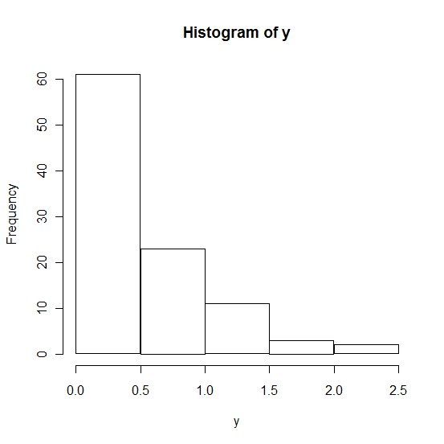

**6(a)**

> A<-matrix(c(3,1,-4,2),ncol=2)

> A

[,1] [,2]

[1,] 3 -4

[2,] 1 2

**6(b)**

> t(A)

[,1] [,2]

[1,] 3 1

[2,] -4 2

**6(c)**

> solve(A)

[,1] [,2]

[1,] 0.2 0.4

[2,] -0.1 0.3

> b<-matrix(c(6,-3),ncol=1)

> b

[,1]

[1,] 6

[2,] -3

> solve(A)%*%b

[,1]

[1,] -2.775558e-16

[2,] -1.500000e+00