

**Semester I 2017/2018**

Subject : Technology and Information Systems (SCSP1513)

Section : 02 – Dr Aryati Bakri

Task : Industrial Visit 3 – CIMB

Due : 15th November 2018

Student : HAFSYAHIRA BINTI OTHMAN A18CSOO68

## CHUA HUN HO A18CS0050

AIMAN HAZIM BIN MOHD ARSYAT A18CS0020

On 26th October, the Data Engineering students from two classes subject of SCSP1013 (Technology and Information System) had an Industrial Visits at CIMB Bank Berhad HQ at Kuala Lumpur. We reached there approximately between 2 p.m to 3 p.m. As we arrived there, they were 3 workers of CIMB greeted us and the students divided into 3 groups, following the CIMB workers respectively. They brought the students to the 17th floor to see the exhibitions and work areas. After that, we were taken to 15th floor and they served us a late lunch before briefing started. During the talk, there are two speakers. The first speaker was introducing us about CIMB and internship. The second speaker was Mr. Ahmad Affzan bin Mokhtar Anuar. He is Director, Head of Production Support of CIMB. He explained more detailed about CIMB. During the talk, whoever wanted to ask questions will get the Touch n Go card exclusively from CIMB. After finished the talk,the students, lecturers and the staffs took pictures together. In the end of the briefing, The staffs gave all the students a CIMB bag and the Touch ‘n Go to those didn’t yet have a the card.

CIMB or its long name, Commerce International Merchant Bankers is a leading KL-headquartered ASEAN universal bank, one of the largest investment banks in Asia and one of the largest Islamic banks in the world.

**Vision:**

To be the leading ASEAN company

**Our Mission:**

To provide universal banking services as a high performing, institutionalised and integrated company located in ASEAN and key markets beyond, and to champion the acceleration of ASEAN integration and the region’s links to the rest of the world.

**Values:**

Our values are the beliefs that guide our actions as we pursue our vision.

|  |  |
| --- | --- |
| * **Customer-centric:** | We exist to serve our customers and we sell products and services that our customers understand and value. |
| * **High performance** | We work hard and we work strategically for customers, staff and other stakeholders. |
| * **Enabling People** | We empower and align our people to innovate and deliver value in their workplace as well as for the community they serve. |
| * **Strength in Diversity** | We have respect for different cultures, we value varied perspectives and we recognise diversity as a source of strength. |
| * **Integrity** | We are honest, respectful and professional in everything we do because integrity is the founding value of CIMB |
|  | |

**Group Structure**

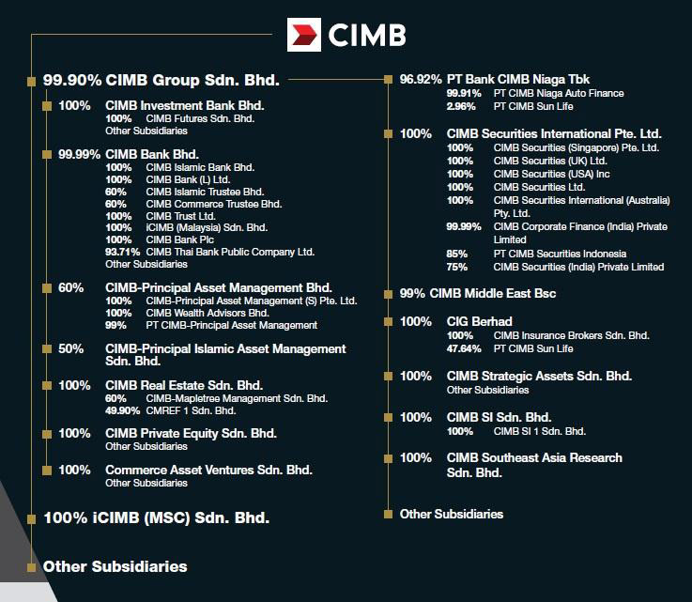

Figure 2 : CIMB Group structure

**PRODUCT AND SERVICES**

The services are:-

1. Wholesale banking - cooperate finance, equity capital markets, institutional broking, equity derivatives, securities borrowing and lending, corporate banking, trade finance, cash management securities services, global financial institutions, structured finance and syndication and research.
2. Treasury - contains debt capital market and syndicate, cross markets trading and derivatives and government bond market making.
3. Asset Management - retail and institutional funds (Islamic and Conventional), real estate funds, infrastructure funds management, private equity funds and real estate funds.
4. Retail and commercial banking - deposits, private banking, loan and financing, mortgage, leasing, credit card, microcredit, ASBs, remittances, wealth management, self service terminal and digital banking.
5. Islamic banking - ‘wadiah’,’ mudharabah’ and ‘sukuk’.

**ACHIEVEMENTS**

In ASEANCIMB is the fifth largest banking group. Approimately 37,000 staff CIMB have in 15 countries in ASEAN region and other countries. Around 850 branches CIMB retail banking network have and serving more than 13.5 million customers. They have branches all over ASEAN countries and China, Hong Kong, India, Sri Lanka, Korea, United State and the United Kingdom. 30 June 2018, CIMB Group Corporate has RM 511.2 billion total assets, RM84.1 billion total funds under managements, 15 global markets and RM 46.9 billion total shareholders’ funds.

Malaysia CIMB Bank received numerous awards at Alpha Southeast Asia 12th Annual Best Financial Institution Awards 2018 in 2018 such as best equity house, best Islamic finance retail bank, best Islamic finance commercial bank best Sukuk and Islamic finance investment bank. They also won best cooperate and investment bank and best bank for SMEs at Asiamoney Best Bank Awards 2018. Next, they won best Islamic investment bank at The Asset Triple A Islamic Finance Awards 2018. There are many more that CIMB got under the name of other countries branches.

*For more award list, please refer to :* [*https://www.cimb.com/en/who-we-are/overview/awards/2018.html#read*](https://www.cimb.com/en/who-we-are/overview/awards/2018.html#read)

.

CIMB are not just a bank, they also provide flexible career pathways for fresh graduates to experience the financial world and bring new idea to them. For examples, CIMB offers “The complete banker programme”, “CIMB Fusion”, “FSTEP” and so on.

For the programme “The complete banker”, the graduates will undergo two-year structured development programme. There are 1 month of“Intensive Classroom Training” and also “Job Rotations” for 11 months in the Year 1, while in Year 2, the graduates will have “Elective Development” for 3-months and “Job Replacement” for another 9-months. The graduates who have achieved academic excellence and have the following characteristics, which are passion for success, communication, agility, collaborative and also think without a box.

Besides, CIMB also offers internship opportunities for the under graduates. For examples, CIMB provides “My ASEAN Internship” . The requirements of the internship programme are the graduates should able for a minimum of two months up to six months, strong academic results with minimum CGPA of 3.0, active in extra-curricular activities, good soft-skill. The intake is available in all year round.

My ASEAN Internship offers the opportunities for those high-achieving individuals to develop skill sets required by leading employers through a 8-week internship, take part in ASEAN - themed activities and competitions planned at the start and completion of the programme and adapt with the working culture of top employers in the region before embarking on the career.

The requirements of MY ASEAN Internship are the must be an ASEAN youth from public and private universities based in Malaysia or Malaysian youths who study abroad, the minimum CGPA of 3.0, at least band 4 for those took MUET (IELTS: 7.0 and above or TOEFL: 95 and above) and having good skills.

This topic is spoken by the speaker Mr. Ahmad Affzan bin Mokhtar Anuar who is the current Director or Head of Production and also MY IT Infrastructure. According to the speaker, there are 6 groups of IT groups which are application, infrastructure, financial and administrator, risk and compliance, service management and IT security.

Application of the IT group is business aligned setup which develop, manage and maintain business applications. “Consumer and Islamic Bank”, “Commercial and Transaction Bank”, “Wholesale Bank”, “Business Enablers” and “Digital” are the examples of the business applications of CIMB. In the team, the members will engage and manage some projects, delivery and also as a support of systems.

Next, infrastructure is split by Technology Domains which will operate and manage IT infrastructure that includes hardware, software and IT environments. There are some infrastructures used which are data centre operations, platforms, network and communications, storage, end user computing, disaster recovery. All of these infrastructures are provided to ensure that the systems can be carried smoothly and reduce the bugs that may occur in the system. For example, CIMB provides a platform to let costumers get more interest about them when costumers can use CIMB online (CIMB Clicks) anywhere and anytime.

IT security is the most important part of the infrastructure of CIMB. This is because people nowadays more likely to use online banking due to its convenience.

Therefore, IT security group is more concern about the parameter security, IT policy management and enforcement, vulnerability assessments and penetration testings and also the Security Operation Control(SOC) to ensure the data of costumers is confidential.

Risk and Compliance is also a part of the responsible scope of the infrastructure. There consists of four components which are regulatory and standards compliance, audit management, IT risk managements and also ongoing risk assessment. This group is made to reduce the risk of being hacking and provide costumers a safety environment for online-banking.

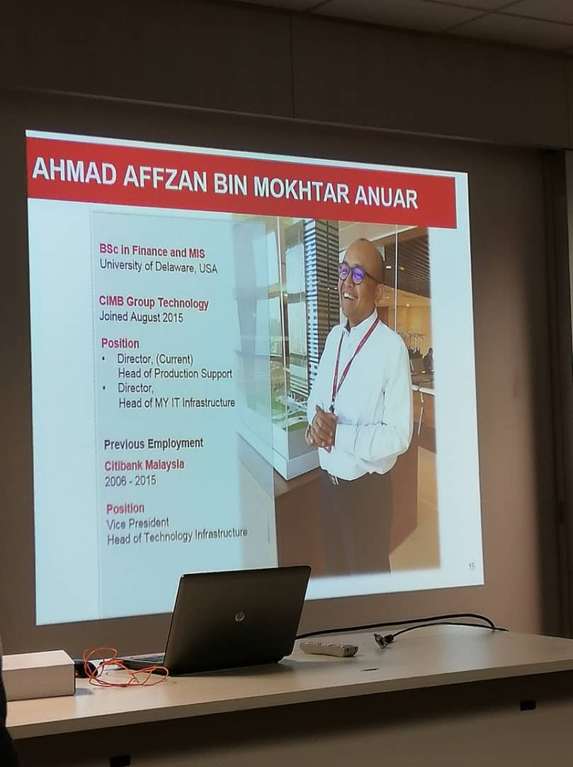

Image 1: The introduction of the speaker of IT infrastructure.

From the visiting at CIMB programme, I see that CIMB not only a bank but also provide opportunity for fresh graduate especially to get involve in CIMB.The programme by CIMB overall has boosted me to become more excellent in study to get high pointer in exam and curricular.

I need to learn from the mentor to increase my knowledge and always meet them to learn how to lead in one organization. After that I can learn from their experience if I had problems in industry. From that our relation be more closer and I will more confident around in people. Then I have to increase my knowledge by reading motivational book. That can make me more confident in myself and I can improve my words especially when speaking with others. That can make me confident with my self.

The most interesting programme offered by CIMB is "My ASEAN intership".It is because this programme offered for fresh graduate and the minimum pointer is 3.0. So I have opportunities to join this programme and I also active in curicular even I need to fight with other graduate to get this offered.

**REFERENCES**

* <https://www.cimb.com/en/index.html>
* <https://www.cimb.com/en/who-we-are/overview/awards/2018.html#read>
* CIMB slide presentations