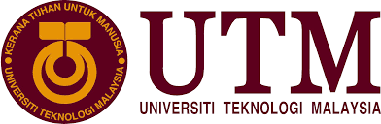

SECP1513 SECTION 8

TECHNOLOGY AND INFORMATION SYSTEM

LECTURER’S NAME: DR HASWADI HASSAN

GROUP 7

SUBMISSION DATE: 11 NOVEMBER 2019

|  |  |  |
| --- | --- | --- |
| NO | NAME | MATRIC ID |
| 1 | NOR FARAHZIBA BINTI HAMADUN | A19EC0123 |
| 2 | ANGELICA | A19EC0181 |
| 3 | MUHAMMAD ‘AFIF AZHAN BIN MOHD ISMAIL | A19EC0092 |

Table of Contents

**Introduction** 1

Detail of the industrial visit 1

Overview of the visit 1

**Historical Components** 2

Mainframe Data Storage Model: IBM (9345B22) 2

Mainframe Tape Subsystem Model: IBM 0309 3

IBM Powerserver 550 3

IBM Personal System/ 2 Model 70 386 4

IBM Personal Computer 300GL 5

IBM P7 Model 6554-673 5

Impact Printer 6

**Reflection** 7

# **Introduction**

## Detail of the industrial visit

On 20th day on October 2019, we had an industrial visit of CICT at the Gallerium UTM in Sultanah Zanariah Library level 2. We went there at 2 p.m. after our class after the lunch break. There are about 36 students from our class section. Below are the objectives of the visit to the Gallerium UTM.

**Objectives:**

* To gain knowledge about the history of UTM
* To learn about the technologies that had been used in the past that made UTM became a successful university
* To increase our understanding about how certain devices work
* To encourage students to be more appreciative towards the technologies in the current days

## Overview of the visit

ICT and information system had played a big role to improve UTM to become one of the best universities in Malaysia. One of the main purposes for this visit is to learn about technologies that had been used during the early stages of UTM development and how it had changed UTM.

They introduced to us, a lot of technologies that had been used in the early years of UTM such as mainframes and its components, the earliest backup laboratory, disk and storage cabinet. We had learnt about the functions of each devices and how it can help UTM to become a better place. The person in charge also gave us motivation to keep striving for excellence in our studies.

The main device that have been mentioned was the main frame of a computer. Mostly, they are used by some large organizations for mission-critical applications requires on high volumes of mainframes that are common among all mainframe vendors. As we know, most of the mainframes can run multiple operating systems. It also can add or hot swap system without disruption. As they said also, supercomputers are the most powerful computer than others and followed by mainframes.

Other than that, they also told us some of the others old devices that have been showed to us at the gallerium in Perpustakaan Sultanah Zanariah. For example, there are some old kind of projectors, cameras, printers and so on. They also allowed us to take some pictures of them. This visit had given us a lot of knowledge and give some idea about how UTM operated back in 1975.

As we heard in during the industrial visit, we had realized that UTM has the biggest data station that can supply all the UTM faculties important information data for the storage and have been safely kept for a long time. UTM has the biggest data station which is in the first level of CICT block in front of N24. That’s a place that been quarantined and only specific and specialised authorized have the access to the station.

# **Historical Components**

## Mainframe Data Storage Model: IBM (9345B22)

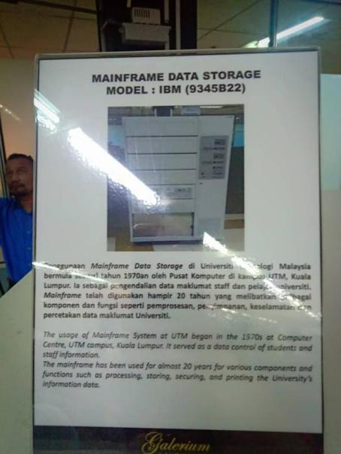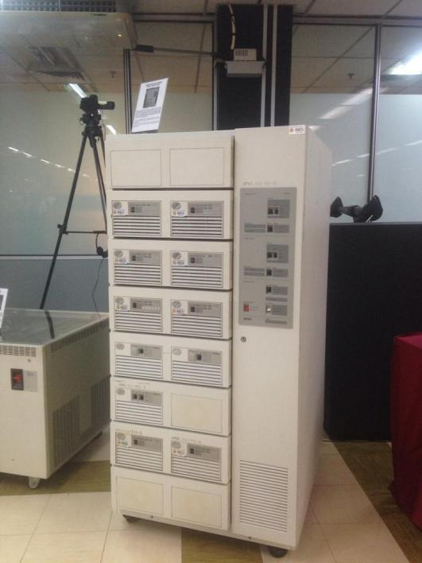

Firstly, we want to mention about the mainframe of the data storage. The mainframe that been shown in library was the first data storage in the UTM. The usage of mainframe System at UTM began in the 1970s at Computer Centre Kuala Lumpur. It served as a data control for the staffs and students’ information. The mainframe has been used for almost 20 years for various components and functions such as printing, storing and processing the university’s information data.

## Mainframe Tape Subsystem Model: IBM 0309

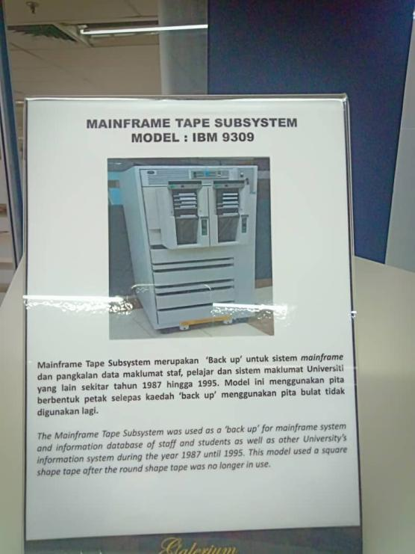

Secondly is the Mainframe Tape Subsystem (Model: IBM 9309). The mainframe tape Subsystem was used as a ‘Back Up’ for mainframe system and information database of staff and students as well as other University’s Information system the year 1987 until 1995. This model used a square-shaped tape after the round shape tape was no longer used.

## IBM Powerserver 550

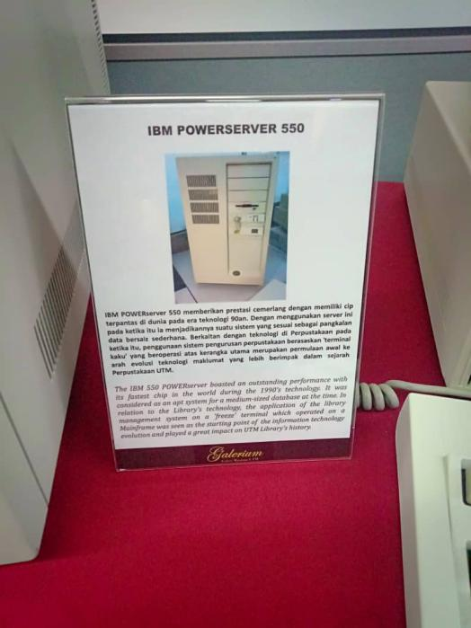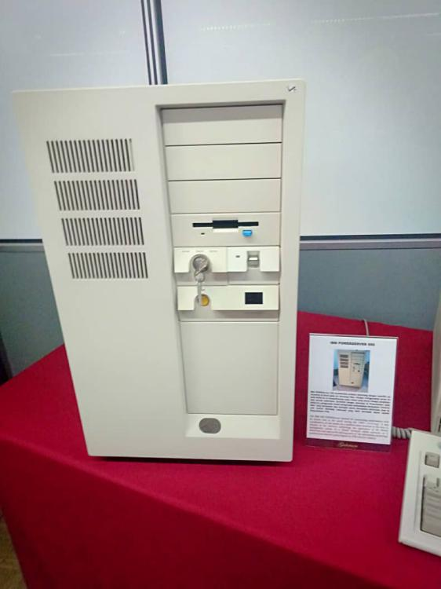

Third device that we are going to talk about is the IBM POWERSERVER 550. It was not as huge as the Mainframe System and Mainframe Tape System, that needed huge space and heavy to carry. The IBM 550 POWERSERVER boasted an outstanding performance with the fastest chip in the world during 1990’s technology. It was considered as an apt system for a medium-sized database that time. In the relation to the library’s technology, the application of the library management system on the ‘freeze’ terminal which operated on a mainframe was considered as the starting point of the information system technology evolution and produced great impact in the UTM Library’s history.

## IBM Personal System/ 2 Model 70 386

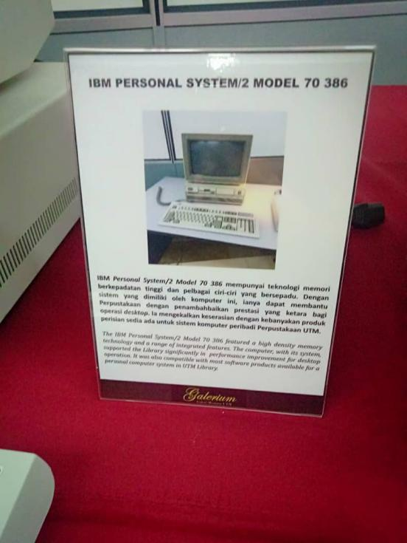

Next is IBM PERSONAL SYSTEM/ 2 MODEL 70 386. The IBM Personal System /2 Model 70 386 featured a high-density memory technology and a range of integrated features. The computer with the system had experienced significant boost in performance on the desktop operation. It was also the compatible with most software that was available for a personal computer system in the UTM library.

## IBM Personal Computer 300GL

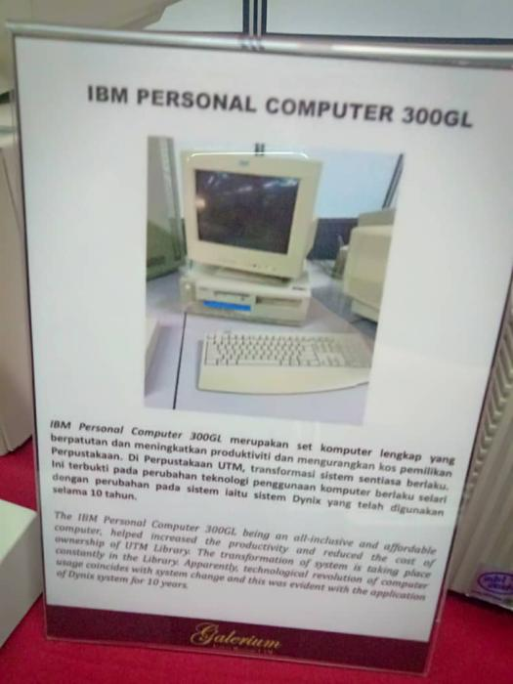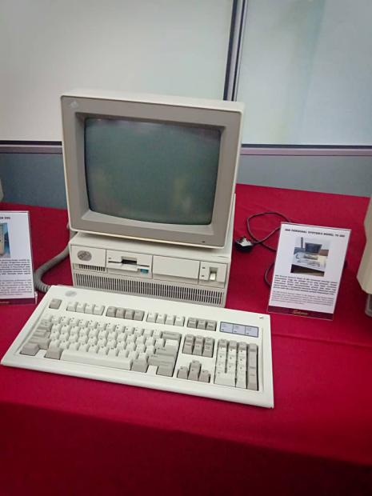

Also, there was the IBM PERSONAL COMPUTER 300GL. The IBM Personal Computer 300GL being an all-inclusive and affordable computer, helped to increase the productivity and reduced the cost of ownership for the UTM Library. The transformation of the system is taking place constantly in the Library. Apparently, technological revolution of the computer usage coincides with the system change and this was the evident with the applications of the Dynix system for 10 years.

## IBM P7 Model 6554-673

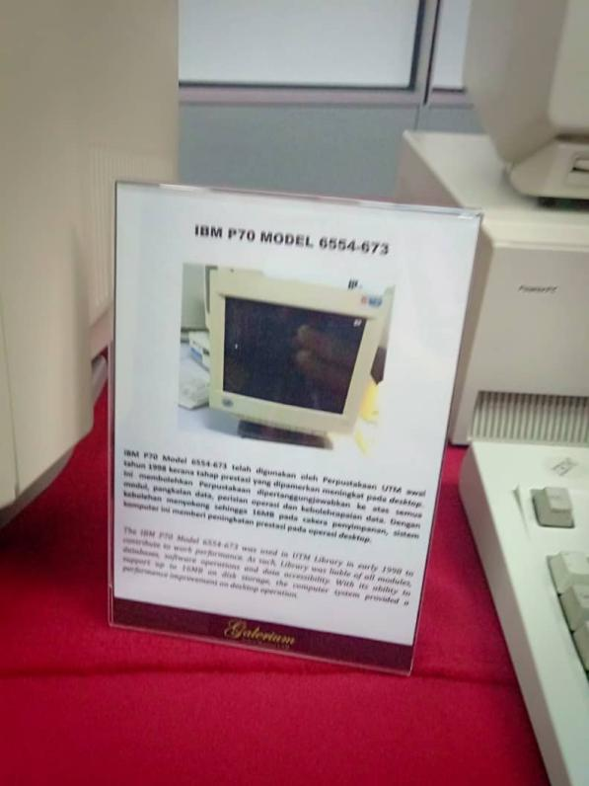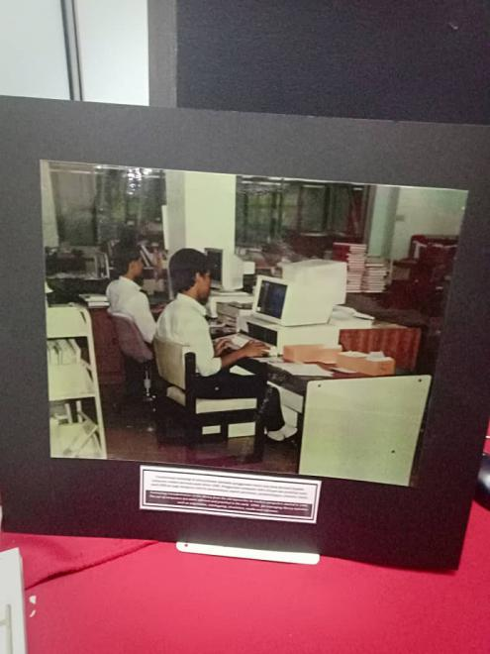

Other than that, the IBM P7 MODEL 6554-673 was used in UTM Library in the early 1998 to contribute to work performance. As such, UTM Library was liable of all modules, database, software operations and the data accessibility. With its ability to support up to 16 MB on disk storage, the computer system provided an improvement in performance on desktop operation.

## Impact Printer

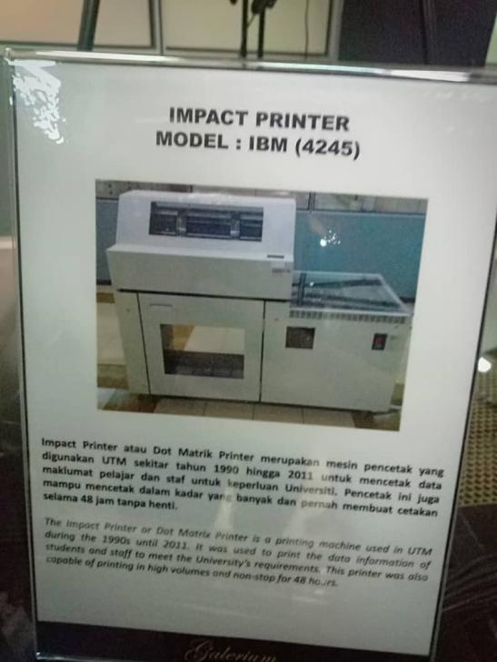

Back then, UTM also had impact printer. The Impact printer or Dot Matrix printer is a printing machine used in UTM during the 1990s until 2011. It was used to print the data information of students and staff to meet the University’s meet requirements. This printer was also capable to print of printing in high volumes and non-stop for 48 hours.

# **Reflection**

Regarding to our course, our main goal is to protect the computer network from viruses, spoofing and hacking. Next, we wanted to prevent precious data from unauthorized access and only the one who permitted can access the data. We also want to ensure the accuracy and consistency of the data are maintained and not changed by hackers. Furthermore, making sure the information accessible to an authorized person whenever they want is one of our goal. From this course we could be a network specialist that keep criminal out of the computer system by monitoring the system and upgrading the security measures. Nowadays, the number of cyberattacks are increasing and their expertise are growing. An industry or organization will lose their private data contents if no security equipped on their network. Therefore, through our course we learn on how to provide security to prevent sabotage and espionage in that industry.

The visit had made us aware about the rapid evolution of technologies as innovation had been invented every year. Thus, technology keep evolving, as the next generation will be more experts in technology information systems than the previous one. The fast development of technologies in the current days, had encouraged us to be more creative to solve modern problems. Moreover, we had learnt internet that we used nowadays will connect computers around the world and allow the users to share information to others. However, this will lead to the growing threat of cyberattack that trying to infect the computers. Many viruses will be deployed by attackers to harm a computer or a system. Without the security, the internet is unsafe to use. For that reasons, we more conscious of the importance of the network security as the technologies getting more sophisticated and more the hacking tools produced. Since our course was about security and network, we admit that it is our responsibility to stop these cyberattacks. We will ensure that our goal will be achieved so that our information will not at risk because no classified information exposed or get leaked. We will make sure the information security system will be upgraded from time to time to defend the system from malicious attacks.

There are so many actions and plans necessary in order to improve our potential in the industry. One of them is listing our weaknesses. We will identify our weaknesses specifically by considering the incidents that left us feel disappointed in our previous performance and try to improve it. Next action is finding a mentor. The mentor must provide us advice and honest feedback about our performance because they can tell us the truth about the area we need to improve. The last one is to attend any program that related to computing. Through this program, we can find our new way to do thing differently for our professional growth. Being around with the experts will get us feel highly motivated and learn new skills. We will also meet new people with different personalities and talents where we learn new ways to communicate to different people. We gain new knowledge and boost ourselves by sharing our idea with others. From this, our main vision and mission will be more crystal clear. Thus, joining events is a step to challenge ourselves and while improving our soft skills.

From the visit, we had learnt a lot about information technologies that had been used in the early UTM days. We felt very proud to see that UTM had improved and upgraded the technologies that had been used for daily tasks. We realized that we should be more appreciative towards the existence of technology as it surely had made our daily life easier. We hope we will be having more industrial visits in the future, so we will gain more benefits to become a better individual in the future.

Task for Each Members

|  |  |  |
| --- | --- | --- |
| Task | Responsibility | Completion Date |
| Visit the UTM library to obtain information for the report | Everyone | 20 October 2019 |
| Distribute task among group members | Farahziba | 25 October 2019 |
| Write introduction and the overview of the visit for the report | Angelica | 5 November 2019 |
| Write detailed description of the historical components | Afif | 10 November 2019 |
| Completing the reflection section for the report | Farahziba | 5 November 2019 |
| Completing the work plan for the assignment | Angelica | 8 November 2019 |
| Compiling every work that had been completed by the members | Afif | 11 November 2019 |