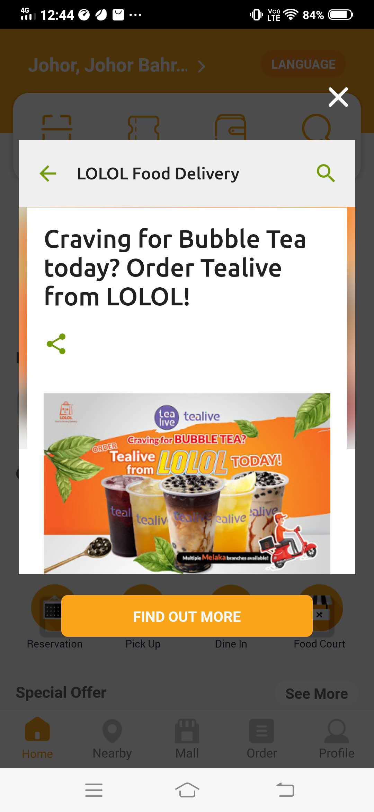

Figure and ground perception is about simplification of a screen into main object and its background. Then, user will know what to focus on. The application that I choose is the application of LOLOL food delivery. The figure and ground are obvious here. The figure is the advertisement of Tealive bubble tea while the ground is the transparent background that soften the content in the back. Human mind will focus on the Tealive bubble tea advertisement as there is a colour contrast between the background and the object. The bright orange and white colour of the bubble tea advertisement catch the human eyes. The bright colours cue the viewer in on the advertisement to be focus. The “return “ sign, “search” sign, “share” sign, “find out more” button and the “cross” sign that look like the press-able buttons make the users more focus on the figure when users enter the food delivery application.

