UNIVERSITI TEKNOLOGI MALAYSIA, JOHOR BAHRU
FACULTY OF COMPUTING,
SEMESTER 1, SESSION 2018/2019

LAB 4 :MINI PROJECT PHOTOCOPYING (XEROX) MACHINE

NAMA | NO MATRIK
ALVIN HEE JUN SHEUNG | A19EC0015
CHUA CHEN WEI | A19EC0038

SUBJECT CODE : SCSR 1013 – 04
LECTURER : MADAM RASHIDAH BINTI KADIR

Dedication & Acknowledgement

First of all , we are able to finish this final project all thanks to our lecturer , Madam Rashidah Binti Kadir due to her dedication and patience and we would like to express our gratitude towards her . She patiently taught us the module of the Digital Logic so that we can apply it in this final project and in real life . She also helps us when we face difficulties and problems during the project . She guides us and give explanation in details about this final project and we are very thankful to have such a good and kind lecturer .

Next , we want to thank the lab assistants who helped us throughout the projects. They also provide guidance and facilitation when we face difficulties without any complaint . The lab assistants are very helpful and informative to assist us in the problem we faced .

Then , we would also like to thank our families who give us mental and financial support so that we can continue our study in UTM without feeling burdened and focus especially in the academic aspect .

Finally , we want to thank our coursemate and friends who assist us in this final project . We discussed and share information between one another to lend a helping hand to each other so that we understand more and know how to operate and program the Programmable Logic Devices .

Table of Content

Dedication & Acknowledgement 2
Table Of Content 3
Report Content 4
The Background 4
Problem 4
Objectives 4
Components 4
Materials 5
Software Used 5
Flowchart 6
Circuit Implementation 7
Physical System Implementation 9
Discussion 10
Conclusion 11
Reference 12
Appendix 13
2 bit Xerox Machine 13
3 bit Xerox Machine 14

Report Content

The Background
In this mini project , we implemented 3 different components on a single GAL device , those components are :

- 3 - bit Count Up Counter
- 3 - bit Comparator
- Clock Disable

Problem
User will initially enter amount of copies , the counter will count the number of copies that has been photocopied. The machine will stop once the required number of copies produced.

Objectives
The obectives of this laboratory are to introduce the students to :
- The development of a PLD device
- A simple Hardware Description Language

Components

- Switches - to set the required number of copies
- Counter - to count the number of copies that has been made
- Comparator - to compare the number of copies required with the number of copies produced
- Clock Disabler
- To stop the operation of the counter
(If copies produced is less than required copies , the counter will count up , else , the counter will stop counting )

Materials
- Breadboard
- A breadboard is a solderless device for temporary prototype with electronics and test circuit designs. Connections are made when the wires are inserted into the holes and all the holes in selected column are interconnected.

- GAL 22V10
- Is a series of programmable-logic device which has 12 input pins, and 10 pins that can be configured as either inputs or outputs and have total o f24 pins including the Gnd and Vcc.

- ETS - 5000 Digital Training Kit
- Is where the breadboard home. Contains 2 digits of 7-segment LED display, 8 bit. LED display when the mode selector switch was set to ‘TTL’ and so on.

Software Used
- Wellon Universal Programmer & Tester
- This software reveive the .JED file and capable to use the .JED file to change the program in the Programmable Language Device . The PLD is reprogrammed to our preference by using this software .
- WinCUPL 5.0 Software
-This software is designed so that we can write coding for the Programmable Language Device and after successful compilation of the code , ,JED file and .PLD file is created which is required for programming of the PLD ( GAL 22V10 ) .

.

Flowchart
User key in the required number of copies by using switches ( 2 switches for 2 bit and 3 for 3 bit Xerox Machine )
Required Copies = Y
2 bit Xerox Machine , Y = 0 – 3
3 bit Xerox Machine , Y = 0 – 7

User will reset the counter ( START button )
Counter = 0

The counter will start counting and determine the number of copies that has been made
Counter ++

Value is not same
Value is same
A signal is generated to stop the counting
Comparator will determine whether the required number of copies has been met .
IF the value is not the same , it will keep counting up.
IF the value is the same , A signal will be generated to stop the counting
Counter == Required Copies

Circuit Implementation
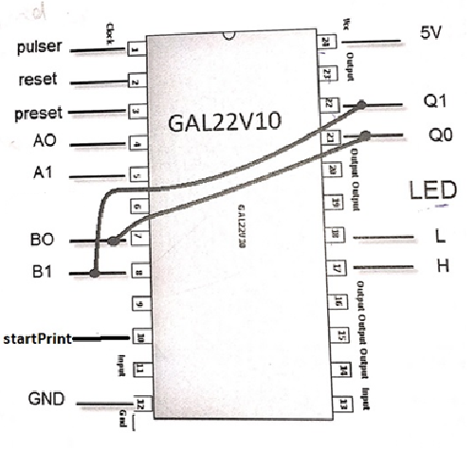

Figure 1 : Block Drawing of 2 bit Xerox Machine
First of all , this PLD ( GAL22V10 ) has to be connected to Power supply (Vcc) and Ground (GND) . Then ,(Pin 1 ) Pulser act as a clock which we can control the clock pulse by hand and the counter will count up according to the pulse of the pulser . Pin 2 serves as Reset which is used to reset the initial value of the counter to LOW ( 0 ) while Pin 3 serves as Preset which is used to reset the initial value to High . Q0 ( Pin 22 ) and Q1 ( Pin 21 ) are the output of the 2 bit count up counter .Since the counter only have 2 bits , it has only 4 states which is 00 , 01 , 10 , 11 which allow the range of counting from 0 to 3 . A0 (Pin 4 ) , A1 ( Pin 5 ) and B0 ( Pin 7 ) , B1 ( Pin 8 ) are the input for the comparator and L ( Pin 18 ) and H ( Pin 17 ) are the outputs of the comparator . Comparator compares the value between A0 A1 and B0 B1 . Output of L will be high if the value are the same while output of H will be high if the value are not the same . If the value is the same , the output of L will be high and H will be low and vice versa . In figure _ , Q1Q0 is connected to B0B1 so that the comparator can compare between the output of the counter and the required amount of copies by the user .
$$L=\overline{A1} \overline{A0} \overline{B1} \overline{B0}+\overline{A1} A0 \overline{B1 }B0+A1 A0 B1 B0+A1\overline{ A0} B1 \overline{B0}$$
$H=\overline{L}$
StartPrint ( Pin 10 ) serves as the “Start Button “ of the Xerox Machine . The StartPrint must be switched to High to allow the Xerox Machine to operate , else the Xerox Machine would not start counting .

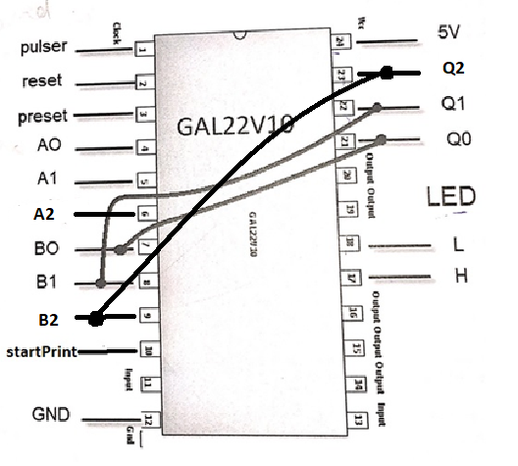

Figure 2 : Block Drawing of 3 bit Xerox Machine
In the 3 bit Xerox Machine , the circuit implementation is actually quite similar with the 2 bit Xerox Machine . The only differences is the Counter and the Comparator has switched from 2 bits to 3 bits . The output of counter now adds 1 more which is Q2 ( Pin 21 ) and Input of Comparator A2 ( Pin 6 ) and B2 ( Pin 9 ) . In 3 bit Xerox machine , the input of required copies has increased . It has the range from 0 – 7 and the counter have 8 states which is 000 , 001 , 010 , 011 , 100 , 101 , 110 ,111 .

Physical System Implementation
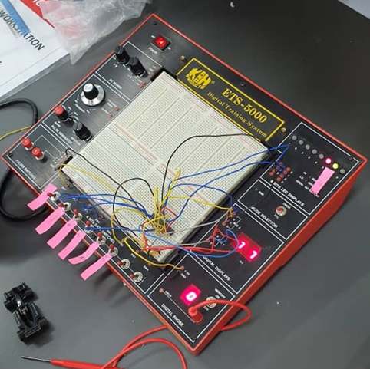
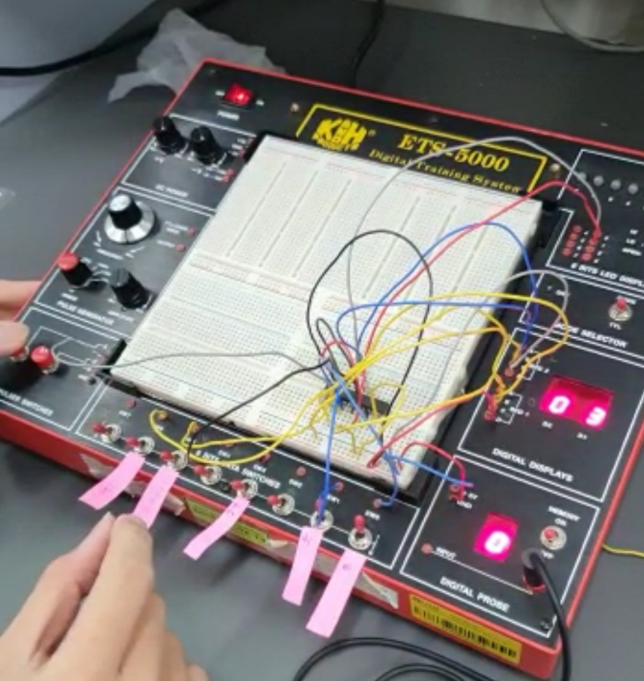

Figure 3 : 2 bit Xerox Machine Figure 4 : 3 bit Xerox Machine
In the physical system implementation , for the 2 bit Xerox Machine , Firstly , Pin 24 is connected to the Vcc and Pin 12 is connected to the GND . Pin 1 (Pulser) is connected to the pulser switch (A), Pin 2 (Reset) and Pin 3 (Preset) to switch 5 and 6 . Pin 4 (A0) and pin 5 (A1) is connected to switch 0 and switch 1 respectively .Pin 10 (StartPrint) is connected to switch 3 . Pin 7 (B0) and Pin 8 (B1) is connected by wire to Pin 22 (Q1) and Pin 21 (Q0) respectively. Then, Pin 17 (H) and Pin 18 (L) is connected to the LED (LED 2 and LED 3 respectively ) . At the same time , Pin 21 and Pin 22 is connected to Digital Display A and Pin 4 and Pin 5 is connected to Digital Display B . To test the circuit , Asynchronous pin switch input switched to the correct setting and the initial output of the counter is set to ZERO .Switch 4 , Switch 0 and Switch 1 all are set to High (11 as 3 copies) and the pulser switch is pressed to increase the counter .When the counter output = comparator output , the LEDs will change .
In the 3 bit Xerox Machine , the physical implementation is also quite similar with the 2 bit Xerox Machine , the difference is there is extra output Pin 21 (Q2) is connected to Pin 9 (B2) by wire . In 3 bit , we changed the switch position , Switch 7 (Reset) , Switch 6 (Set) , Switch 5 (StartPrint) , Switch 4 (A0) ,Switch 3 (A1) , Switch 2 (A0) .The PLD had to be reprogrammed into a 3 bit Xerox Machine using Wellon Universal Programmer & Tester.

Discussion
We managed to complete the project successfully . In this project , we are exposed to the software WinCUPL and Wellon . It is our very first time to interact with the software and learning how to use them . It all thanks to Dr. Rashidah by giving proper guidance and fellow coursemate for helping us . We learnt a lot of new knowledge in this project . Such as using software to program Programmable Logic Devices (PLD) to change it to our preference , learning to understand the coding and modify it from 2 bit to 3 bit , we spent hours and hours to try to understand how it works .We also implemented the knowledge we learnt from our lectures and book in this project so that we can understand about the functionality of the PLD .
Our strength is we have a very good working system and communication going on throughout the mini project . One of us is the one who give instructions and one of us will do the wiring to the PLD and the switches . The cooperation between us makes this mini project go through considered smoothly and we actually achieved to strengthen our bonding with each other and managed to finish it in a short period . There are also some problems that we faced such as the counter did not count up even though we pressed on the pulser switch , however , we discussed between ourselves and asked our lecturer , Dr Rasyidah for advice and finally managed to solve it . We also faced some problems due to wrong wiring and we also managed to find out the problem after checking for errors .
We would like to suggest that the Xerox Machine system can add on some functionality such as PASSWORD by using the encoder so that the user have to enter password to make the Xerox Machine operate instead of the StartPRINT switch . Also , MUX and DEMUX where we can input several input into the multiplexer and it selects one to perform , therefore , several task can be operated instead of entering the input one by one after a task finishes.

Conclusion
In a nutshell, we were able to perform this mini project successfully although we have been facing certain problems in this project but at the same time, we found out the problems and solved it with the aid of the lab assistant and Dr Rashidah and the circuit is performing well with expected outcomes . We spent hours and hours to understand the coding for the PLD so that we can modify it to the 3-bit Xerox Machine .We learnt to be persevere and remain patience even though problems came up and we have to do the whole circuit again and check for the wire one by one . We also learn that Xerox Machine is composed of several combinational logic such as counter and comparator . After the project , we are more clear about how the combinational logic works after real implication on a Digital Kit where we would not gain it only by learning theories .
We also learnt teamwork and communication during this mini project . Precise instruction and direction should be given to another partner while another partner should also do the wiring with full concentration . None of us should be slacking during this mini project to avoid problems . Discussion before the project is also done to make sure we are on the same channel and clear about what are we going to do ,including the coding . These two soft skills are the key components to finish the project successfully and smoothly.
Digital Logic subject is very important for a computer science student because we have to know how the hardware of computer interact with each other and the logic inside the hardware . This is required so that we can truly manipulate and only be able to create innovation such as modifying and creating useful devices with the knowledge that we had in the future and in the IT industry . This subject also provide us a platform for practical application of the theories that we learnt and we understand that practical application is much more better than just learning theories . It is different because in order to do it practically , we need to make sure we have the knowledge to complete it and many problems will come out to the surface when we truly implement it on a circuit .We believed that this subject is considered as the basics and we need this subject to learn more complex things in our future learning process to advance us into a greater computer science student .

Reference
Abd. Bahrim Yusoff, M. S. (n.d.). Digital Logic ( Fifth Edition ). Desktop Publisher.

Appendix

2 bit Xerox Machine
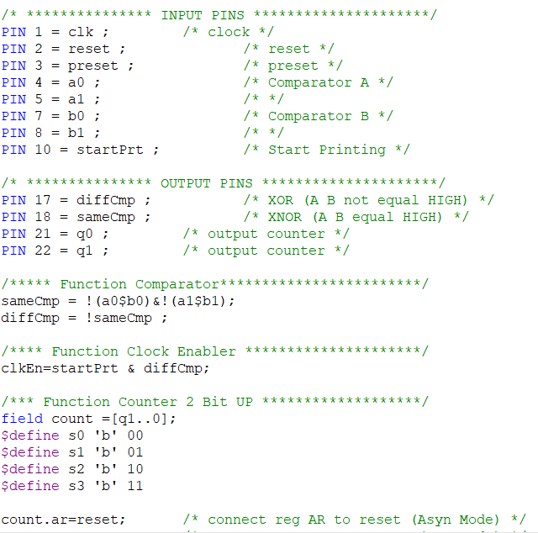
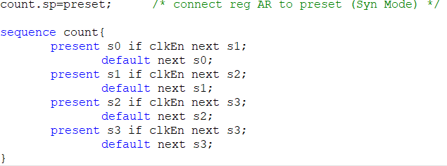

3 bit Xerox Machine
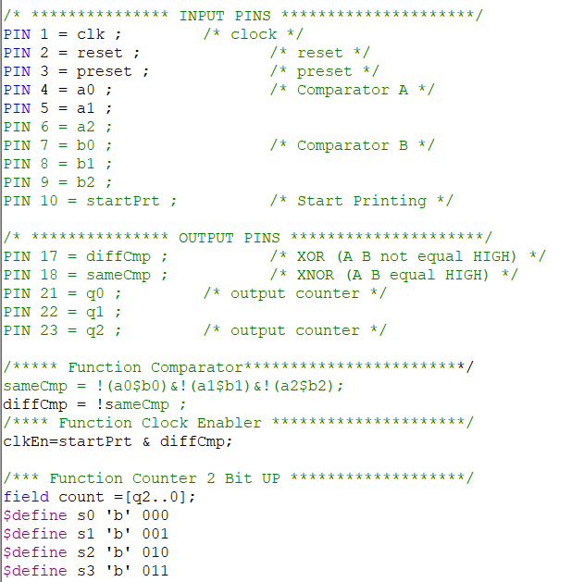
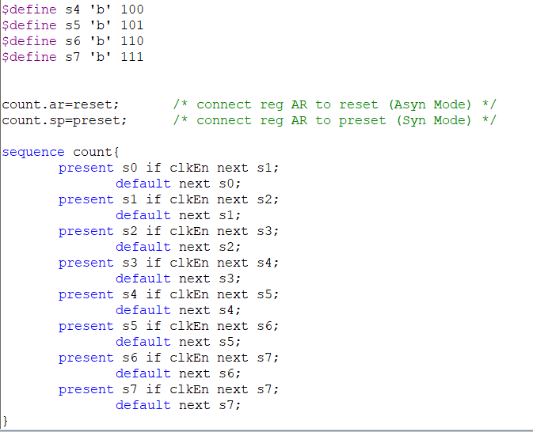
Conclusion
As a conclusion, we manage to complete the project successfully. Every
component we use works and functions very well. The solution we proposed has also
solved the problem to enhance the photocopy machine.
We face several problems throughout the project and we manage to solve them
successfully. We have gained a lot of experience from this project as well. We
understand that practical application is much better than just studying the theory
because it helps us understand how the component functions better. Besides, we have
learned a lot of new knowledge and skill. For example, we now are able to use
WinCUPL software and Wellon Universal Programmer & Tester.
Lack of exposure to the application of components in real life brings us some
difficulties in the process of completing the project. It is a weakness if a student can
score theoretically but not practically. Thus, we would suggest having more practical
class and lab session for the students to apply the knowledge they have learnt in
lecture. This will help the students to have a deeper understanding on what they have
learnt on books.
Lastly, we would like to thank our lecturer, Madam Rashidah again for teaching
us a lot of knowledge about Digital Logic and guiding us to complete the project. We
would also like to express our gratitude towards the lab assistants, friends, seniors and
family for the helps and supports they gave during the project
As a conclusion, we manage to complete the project successfully. Every
component we use works and functions very well. The solution we proposed has also
solved the problem to enhance the photocopy machine.
We face several problems throughout the project and we manage to solve them
successfully. We have gained a lot of experience from this project as well. We
understand that practical application is much better than just studying the theory
because it helps us understand how the component functions better. Besides, we have
learned a lot of new knowledge and skill. For example, we now are able to use
WinCUPL software and Wellon Universal Programmer & Tester.
Lack of exposure to the application of components in real life brings us some
difficulties in the process of completing the project. It is a weakness if a student can
score theoretically but not practically. Thus, we would suggest having more practical
class and lab session for the students to apply the knowledge they have learnt in
lecture. This will help the students to have a deeper understanding on what they have
learnt on books.
Lastly, we would like to thank our lecturer, Madam Rashidah again for teaching
us a lot of knowledge about Digital Logic and guiding us to complete the project. We
would also like to express our gratitude towards the lab assistants, friends, seniors and
family for the helps and supports they gave during the project.
As a conclusion, we manage to complete the project successfully. Every
component we use works and functions very well. The solution we proposed has also
solved the problem to enhance the photocopy machine.
We face several problems throughout the project and we manage to solve them
successfully. We have gained a lot of experience from this project as well. We
understand that practical application is much better than just studying the theory
because it helps us understand how the component functions better. Besides, we have
learned a lot of new knowledge and skill. For example, we now are able to use
WinCUPL software and Wellon Universal Programmer & Tester.
Lack of exposure to the application of components in real life brings us some
difficulties in the process of completing the project. It is a weakness if a student can
score theoretically but not practically. Thus, we would suggest having more practical
class and lab session for the students to apply the knowledge they have learnt in
lecture. This will help the students to have a deeper understanding on what they have
learnt on books.
Lastly, we would like to thank our lecturer, Madam Rashidah again for teaching
us a lot of knowledge about Digital Logic and guiding us to complete the project. We
would also like to express our gratitude towards the lab assistants, friends, seniors and
family for the helps and supports they gave during the project.

Conclusion
As a conclusion, we manage to complete the project successfully. Every
component we use works and functions very well. The solution we proposed has also
solved the problem to enhance the photocopy machine.
We face several problems throughout the project and we manage to solve them
successfully. We have gained a lot of experience from this project as well. We
understand that practical application is much better than just studying the theory
because it helps us understand how the component functions better. Besides, we have
learned a lot of new knowledge and skill. For example, we now are able to use
WinCUPL software and Wellon Universal Programmer & Tester.
Lack of exposure to the application of components in real life brings us some
difficulties in the process of completing the project. It is a weakness if a student can
score theoretically but not practically. Thus, we would suggest having more practical
class and lab session for the students to apply the knowledge they have learnt in
lecture. This will help the students to have a deeper understanding on what they have
learnt on books.
Lastly, we would like to thank our lecturer, Madam Rashidah again for teaching
us a lot of knowledge about Digital Logic and guiding us to complete the project. We
would also like to express our gratitude towards the lab assistants, friends, seniors and
family for the helps and supports they gave during the project.
Conclusion
As a conclusion, we manage to complete the project successfully. Every
component we use works and functions very well. The solution we proposed has also
solved the problem to enhance the photocopy machine.
We face several problems throughout the project and we manage to solve them
successfully. We have gained a lot of experience from this project as well. We
understand that practical application is much better than just studying the theory
because it helps us understand how the component functions better. Besides, we have
learned a lot of new knowledge and skill. For example, we now are able to use
WinCUPL software and Wellon Universal Programmer & Tester.
Lack of exposure to the application of components in real life brings us some
difficulties in the process of completing the project. It is a weakness if a student can
score theoretically but not practically. Thus, we would suggest having more practical
class and lab session for the students to apply the knowledge they have learnt in
lecture. This will help the students to have a deeper understanding on what they have
learnt on books.
Lastly, we would like to thank our lecturer, Madam Rashidah again for teaching
us a lot of knowledge about Digital Logic and guiding us to complete the project. We
would also like to express our gratitude towards the lab assistants, friends, seniors and
family for the helps and supports they gave during the project.

