

**SECR2013-10 NETWORK COMMUNICATIONS**

**TASK 4: MAKING THE CONNECTIONS - LAN AND WAN**

**GROUP 7 – SUNFLOWER**

Nurul Syamira binti Amat Jifri (A19EC0145)

Khaireennur Khaliesha Binti Mohamad Jais (A19EC0300)

Sarah Chintya Rachmi (A19EC0283)

**Lecturer’s Name**: Dr. Syed Hamid Hussain Madni

1. ***Identify work areas on your floor plan***

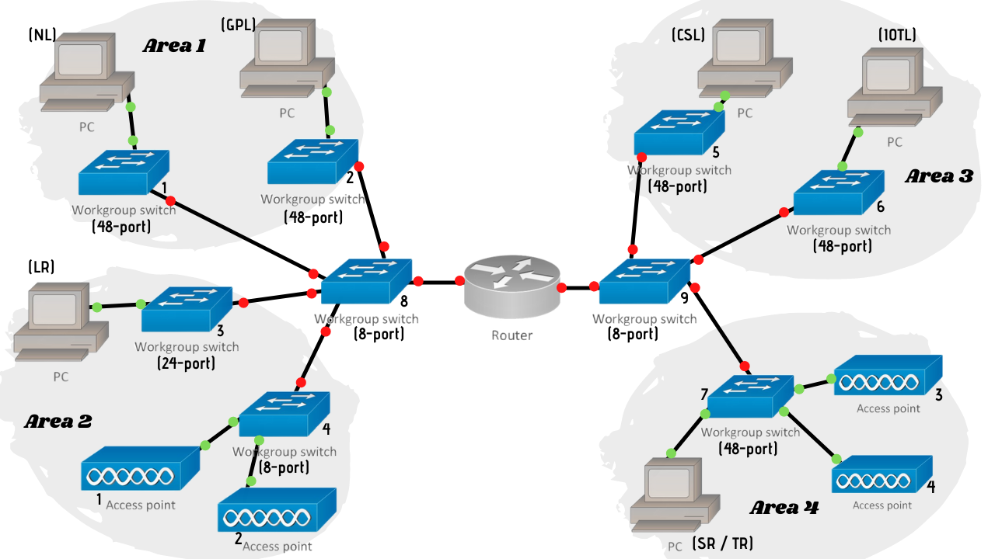

**Work Area 1**

The north-east area which is placed in the first floor, there are two labs which are Network Lab (NL) and General Purpose Lab (GSL). In NL, switch1 (48-port) connects to the end user (student’s PC). In GSL, we use the same method that connects the student’s PC to switch2 (48-port). 48-port switch enables connection to all PCs with the servers.

**Work Area 2**

The west-south area that is also on the first floor of the building, there is one Lecturer’s room (LR), Conferencing Room 1 and students’ study area. End user (lecturer’s PC) is connected to switch 3 (24-port). Meanwhile, access point1 and access point2 are placed in the area since there is space for end users (students and lecturers) to sit and access to WiFi provided. These access points are connected to switch 4 (8-port). Also, Conferencing Room 1 also needs access to WiFi in case the users are accessing video in the room.

**Work Area 3**

Moving to the second floor of the building, there are placed another two labs which are Computer Security Lab (CSL) and IOT Lab (IOTL). In CSL, switch5 (48-port) connects to the end user (student’s PC). In IOTL, we use the same method that connects the student’s PC to switch6 (48-port).

**Work Area 4**

The other areas on the second floor are Staff Room (SR) and Technician Room (TR), Conferencing Room 2 and students’ study area. There are few PCs in SR/TR, so the PC is connected to switch7 (48-port). While in the other two areas that need WiFi connection to be allowed, there are access point3 and accespoint4 placed in both areas.

1. ***How many connections, patch cords and switch ports have you determined you need?***

***Connections***

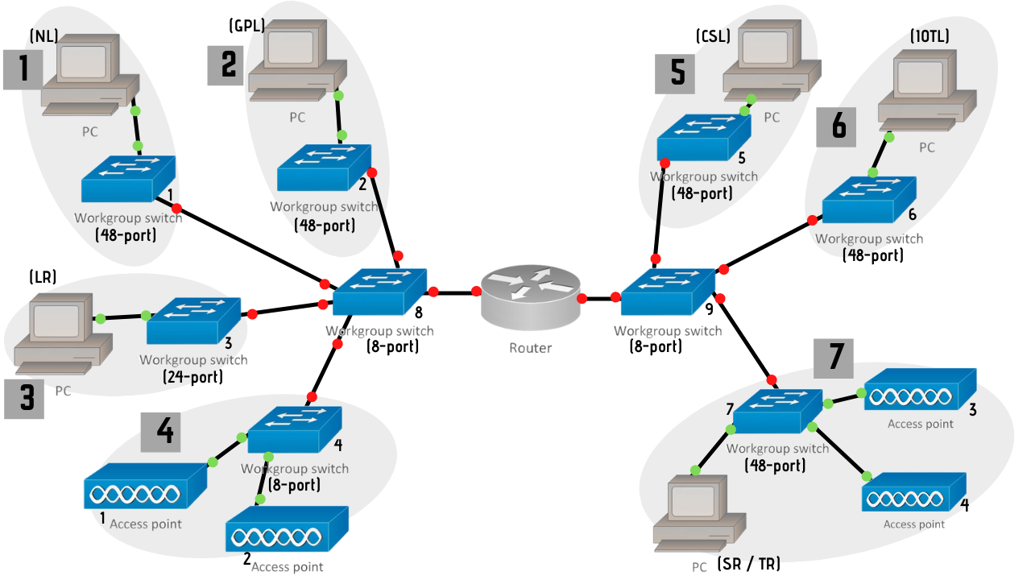

Based on the topology we have done above, there are seven (7) connections for this building.

***Connection 1***

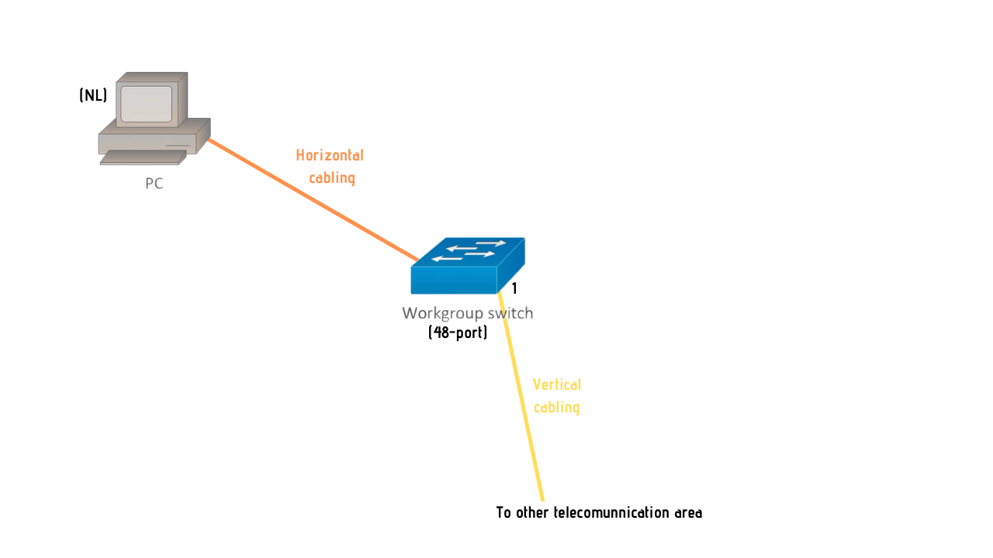

***Connection 2***

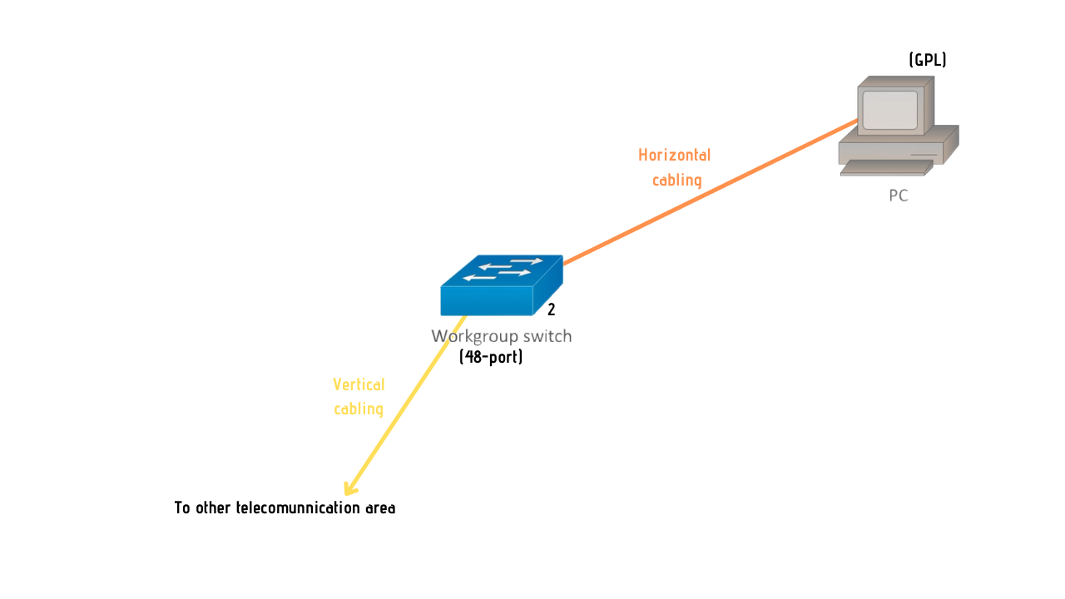

***Connection 3***

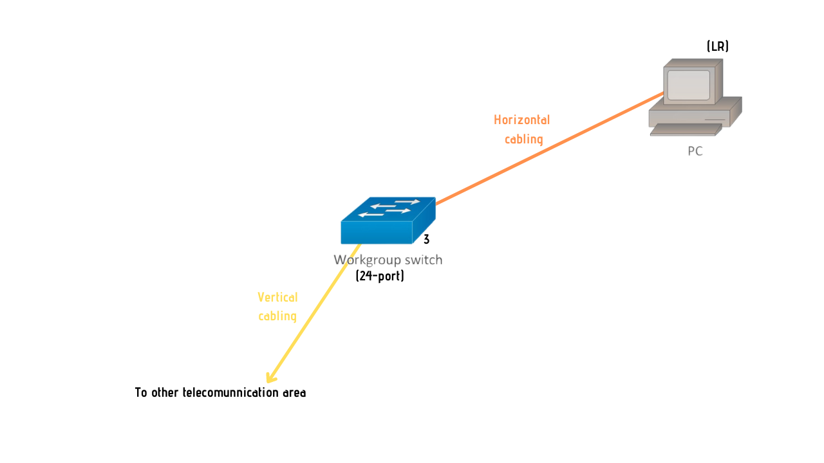

***Connection 4***

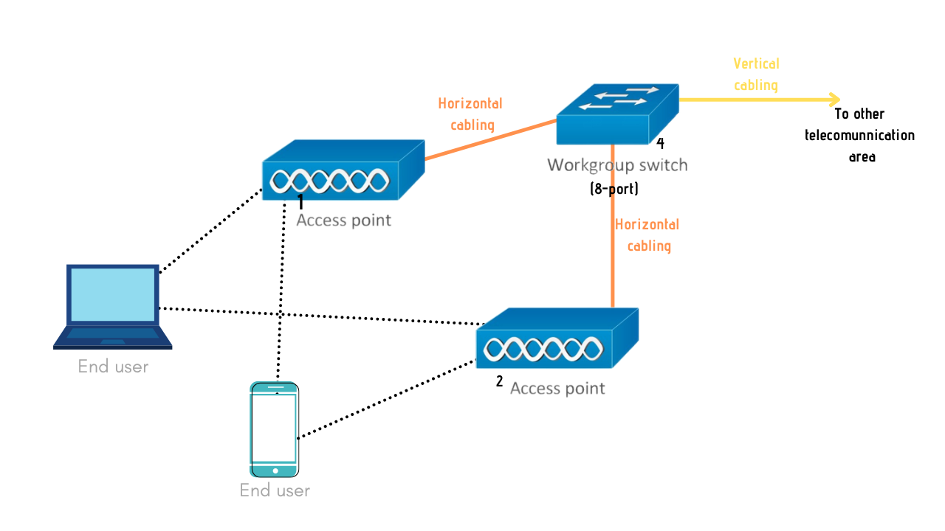

***Connection 5***

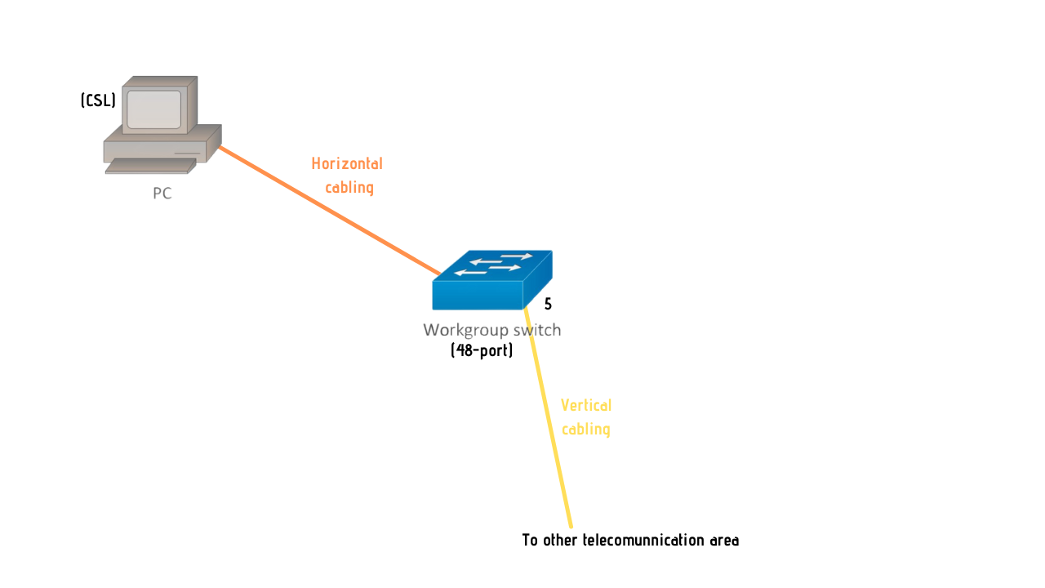

***Connection 6***

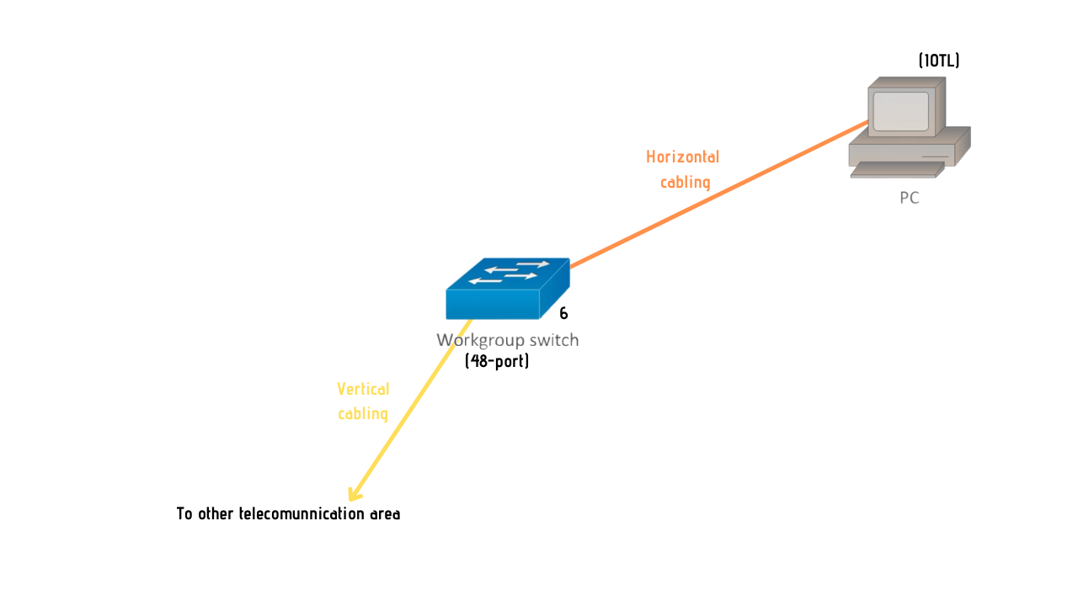

***Connection 7***

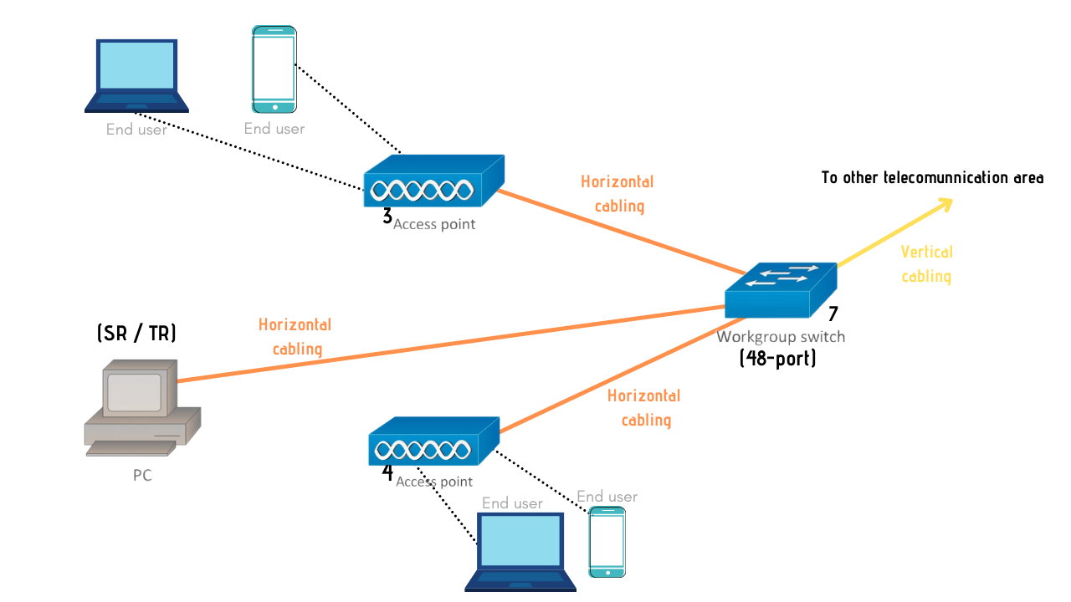

***Patch Cords***

For the patch cords, we have decided to use 5 'Patch Cable Cat6 for patch cord (patch cable) (# A3L980-05-BLU from Belkin). The price for a unit of this cable is approximately RM58.88, according to what we find. We will use approximately 32 patch cords because we assume that these short cables are used in Iot lab and Computer Security Lab to link the patch block to the switch. So, now the average price is RM1884.16.

***Switch Ports***

For the switch ports, we intend to use two 48-port switches, three 24-port switches, and four 8-port switches for this project. To build a mesh network topology, a total of nine switches are required. At IOT Lab and Network lab, the 48-port switches are used. Finally, the 8-port switches are used to connect all five network access points.

The total cost expected to pay for all the switches is approximately RM240,068.20. In addition, we have selected switches that have PoE. Power over Ethernet (PoE) is a technology for wired Ethernet LANs (Local Area Networks) that requires data cables rather than power cords to hold the electrical current required for the operation of each unit. In order to mount the network, doing so minimizes the amount of wires that must be strung. The switches we select are capable of transmitting high-speed data according to what the main staff at the School of Telecommunication want.

***(c)Identify cable types and length***

1. Network Lab

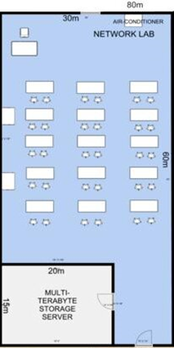

UTP Cable Because it is the best option for a student's PC. There is no problem to use this standard cable only for Network Lab. As long as the cable length is enough to accomplish the needs of the regular use.

Cable length: Ethernet cables should be limited to a maximum distance of 100 meters or 328 feet between active devices. Either a capacitive tester that is calibrated to the capacitive characteristics of the cable or a Time Domain Reflectometer (TDR) tester may measure the cable length. So, we decide to use 30 meter in network lab.

1. General Purpose Lab

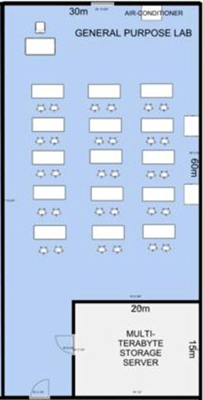

UTP Cable Because it is the best option for student’s PC

Cable length: Ethernet cables should be limited to a maximum distance of 100 meters or 328 feet between active devices. Either a capacitive tester that is calibrated to the capacitive characteristics of the cable or a Time Domain Reflectometer (TDR) tester may measure the cable length. So, we decide to use 30 meter in network lab.

1. Lecturer room / Admin room

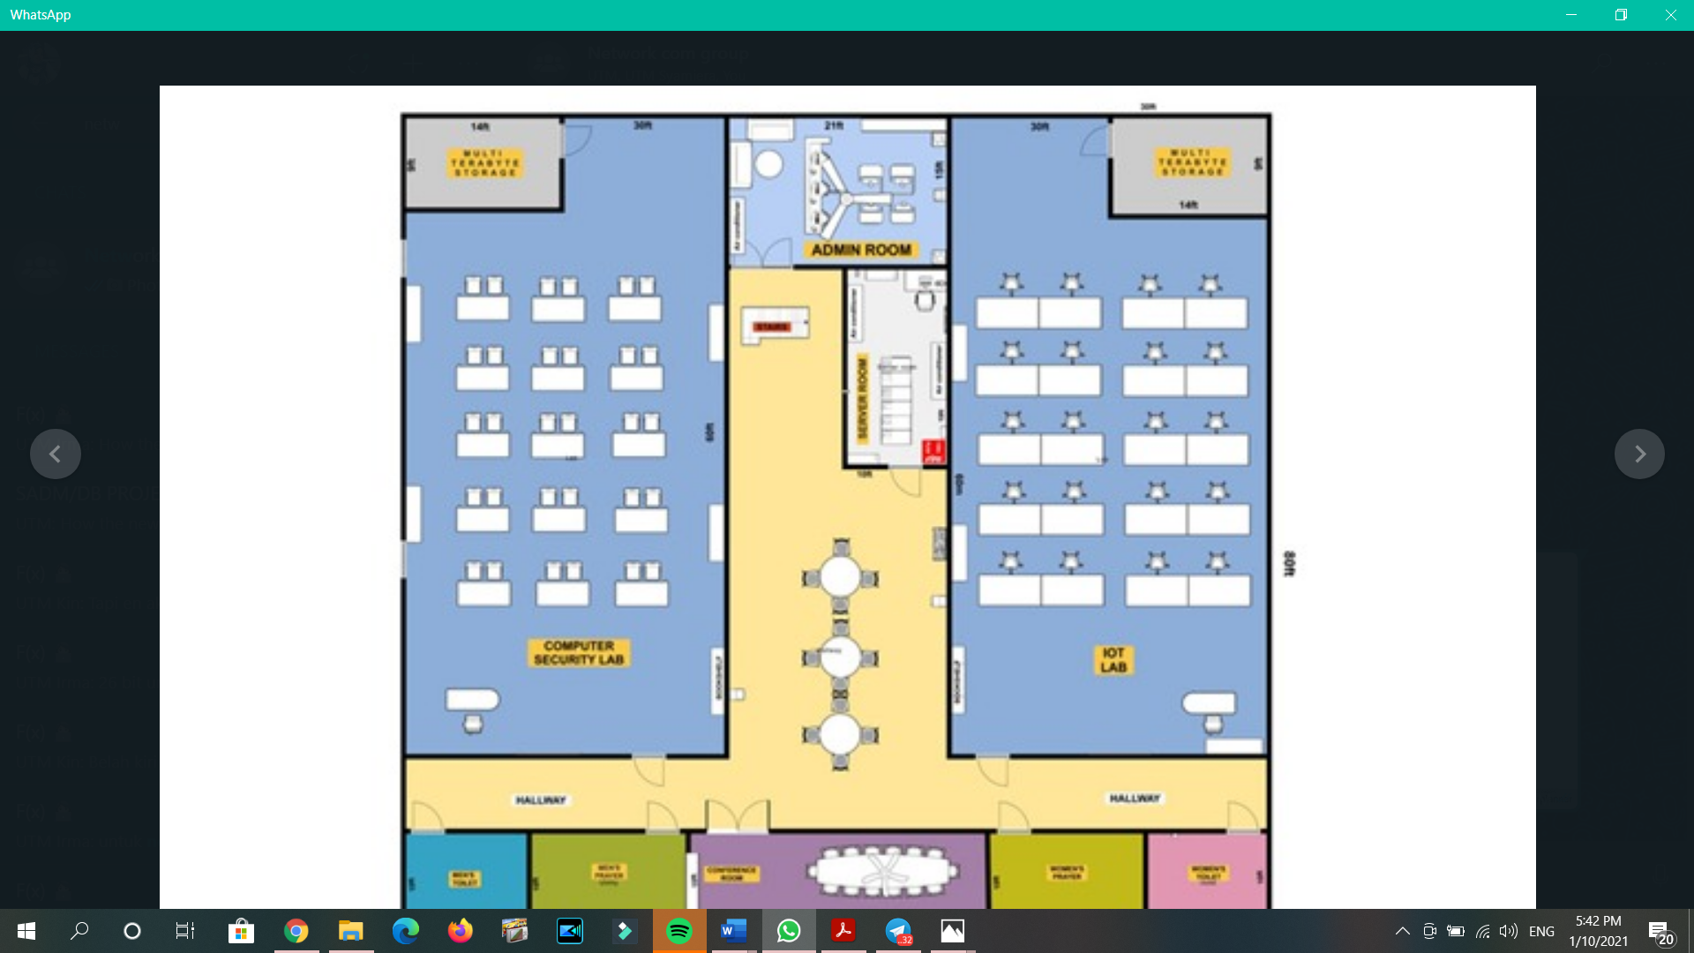

UTP Cable is the most suitable for this room because the lecturer room/admin room doesn’t have too many signal interference device and least expensive, and also enough for the room condition

Cable length: Ethernet cables should be limited to a maximum distance of 100 meters or 328 feet between active devices. Either a capacitive tester that is calibrated to the capacitive characteristics of the cable or a Time Domain Reflectometer (TDR) tester may measure the cable length. So, we decide to use 30 meter in network lab.

1. Conferencing room 1 / 2

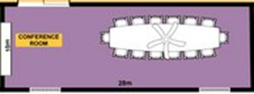

STP Cable because it need to be protected from the signal interference that might exist in the conferencing room

Cable length:The maximum length is 100 meters, without using any kind of signal regeneration device, and a maximum data transfer rate of 1000 Mbps for Gigabit Ethernet. Shielded Twisted Pair (STP), like UTP, also has four pairs of wires with each wire in each pair twisted together. So in conferencing room, we decide to use 10 meters.

1. Computer Security Lab

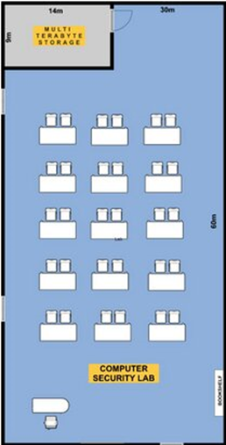

UTP Cable Because it is the best option for student’s PC .

Cable length: Ethernet cables should be limited to a maximum distance of 100 meters or 328 feet between active devices. Either a capacitive tester that is calibrated to the capacitive characteristics of the cable or a Time Domain Reflectometer (TDR) tester may measure the cable length. So, we decide to use 30 meter in network lab.

1. IOT Lab

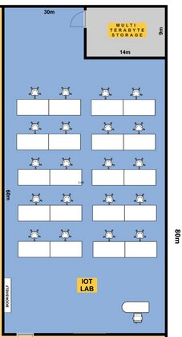

UTP Cable Because it is the best option for student’s PC

Cable length: Ethernet cables should be limited to a maximum distance of 100 meters or 328 feet between active devices. Either a capacitive tester that is calibrated to the capacitive characteristics of the cable or a Time Domain Reflectometer (TDR) tester may measure the cable length. So, we decide to use 30 meter in network lab.