**Question 3**

i. double *numptr;

ii. * numptr = &value1;

iii. cout << "The object pointed to by ptr is: " << numptr <<endl;

iv. value2= numptr;

v. cout << "Value 2 is: " << value2<<endl;

vi. cout << "Value 1 is: " << value1 <<endl;

**Question 6**

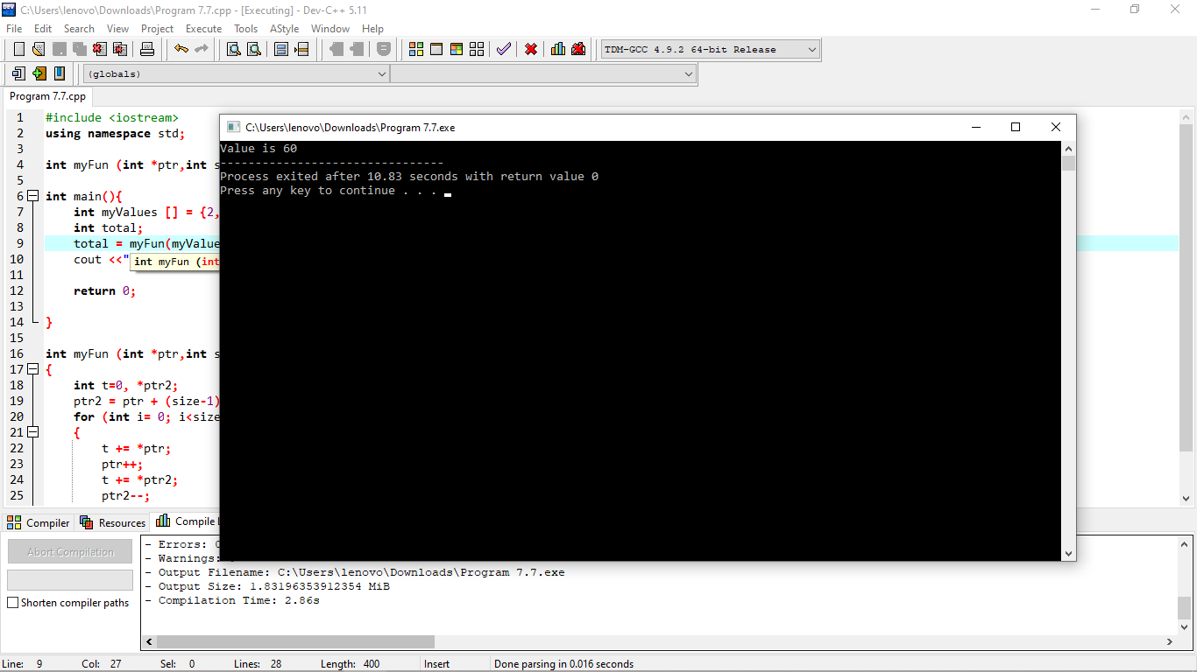i.

ii. int myFun (int values[],int size)

{

int t=0;

for (int i= 0; i<size; i++)

{

t=t+values[i];

t=t+values[5-i];

}

return t;

}

**Question 9**

i. int numbers[]={10, 20, 30, 40, 50};

cout<<"The fourth element in the array is ";

cout<<*(numbers+4)<<endl;

ii. int values[20],*iptr;

iptr=values;

*iptr*=2;

iii. int *pint = new int;

iv. int *pint,i ;

pint = new int [100];//Allocate memory

for (i=0;i<100;i++)

{

cout<<pint[i]<<endl;

}

delete pint;//Free memory

v. const int *ptr;

int arr[]={1, 2, 3};