

COURSE CODE : SKAA 1012

( INDIVIDUAL ASSIGNMENT )

SUSTAINABLE DEVELOPMENT AND CIVIL ENGINEERING

" F10 HOUSE "



**NUR AMIRA BINTI MOHD ANUAR**

**A12KA0122**

**Introduction**

First of all, thank God finally I found one of the sustainable building among many sustainable development all over the world. I chose "F10 House" in Chicago as my sustainable project because I was attracted by its sustainability design and characteristics designed by EHDD architecture which is also known as Esherick Homsey, Dodge and Davis. By using the four strategies of size reduction, improved efficiency, extended life span and impact reduction, F10 House strives to reduce life-cycle environmental impacts by a factor of 10 compared to the average home in America today. The city of Chicago Departments of Environmental and Housing sponsored a national competition to find most creative modifications to their New Homes for Chicago program that incorporate innovative, sustainable buildings practices. Factor 10 House was one of five affordable designs chosen for construction and was completed in August 2003.

In addition, according to some sources that I have read before, F10 House's design is a straightforward response to four primary considerations, there are; a narrow city site with adjacent buildings, a modular design, an open 1,234-ft2 floor plan plus a 605-ft2 conditioned, unfinished basement, and a solar chimney incorporates into a stairwell. Besides that, F10 does not have a garage because the town are near to that house. By now, F10 being a single-family residence. Next, I will show to you the sustainable characteristics of F10 House.

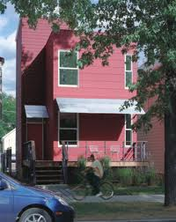

Figure 1 :

View from the front of F10 House

**SUSTAINABLE CHARACTERISTICS**

There are some features of F10 House that qualify it to be chosen as AIA/COTE Top Ten Green Projects in 2004 :

**DESIGN**

EHDD Principal Marc said, F10 House is designed to reduce energy consumption in a holistic way. There are natural ventilation where transom window at all second floor doors to facilitate natural air movement, the window placement maximizes reflected light into the interior of the home and the solar chimney includes a south-facing clerestory window bring natural light to the core of the house. Besides that, the ceiling of the house are high to avoid home from being hot in a day as shown in Figure 2 below.

**Ceiling fan**

Up to the solar chimney to circulates warm air down into the whole house during winter or night

**Solar chimney**

Pulls cool air through the house and evacuate hot air out from the house.

**Clerestory window** Bring natural light through the house

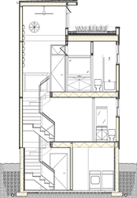

**High fly ash concrete**

Figure 2

**MATERIAL**

Recycled and sustainable materials were selected for their durability and low production impact throughout the building in order to maintain the concept of sustainable development.

The concrete of fly ash as shown in Figure 2 in previous page is made up from less intensive manufacturing and creates fewer global warming than other concrete, use fiber-cement siding and colored with a low-emission stain. Besides that, wood framing in this house are use framing technique that use less wood than standard constructions (Figure 3.1) and the wrap around deck is constructed from a Brazilian hardwood (certified Ipe) as shown in Figure 3.2 that resist rot, has no natural contaminants or chemicals and mold.

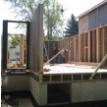 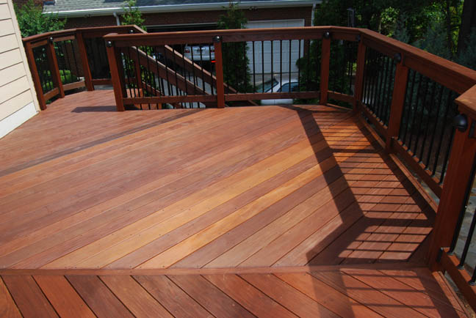

Figure 3.1 : Wood Framing Figure 3.2: Ipe Hardwood

Furthermore, F10 House uses cork floors as the usage of sustainable materials just like in Figure 4 below , the carpet are made up from recycled soda bottles and the cellulose insulation made up from recycled paper.

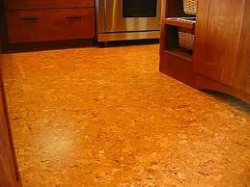

Figure 4 : Example of Cork Floor

**SUSTAINABLE CONCEPTS**

What's really amazed me with F10 House is when the recycled water bottle were served as a heat sink to help maintain warmer temperatures at night with no energy consumption. The bottles were mounted onto the wall with metal holder, so that, when sun light hit the metal, the bottle collecting heat and slowly emitting the heat during night. Besides that, this house also does not use air conditioning to cool the home. So, there are no CFC's gas released.

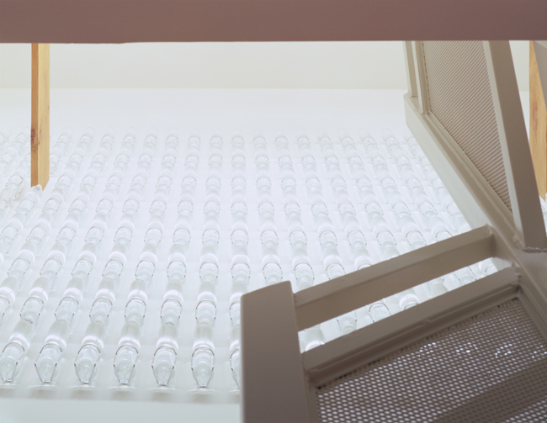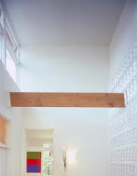

Figure 5 : Recycled water bottles

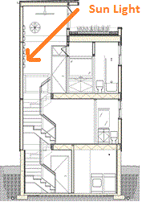

Sealed plastic bottles collecting the heat after the sun light heat the metal holder of the bottles.

Next, the permeable landscape. The ground around the house were not concrete or asphalt, only grass that can absorb water such as rainwater. Non-Toxic paints were used. In addition, F10 House used green roof system where sedum plants growing in shallow dirt-filled flat plastic trays and the plants do not need water except natural rainfalls and sun light. This system prevents city-heat build-up and also discharges oxygen.

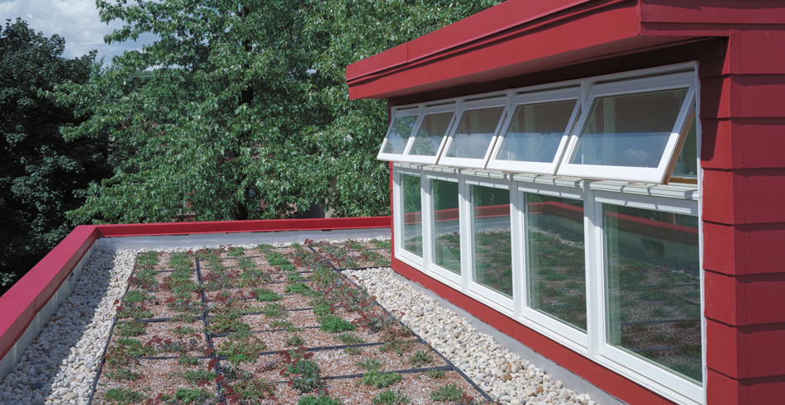

Figure 6 : Green roof system on top of F10 House

**CONCLUSION**

A source have said, the key to sustainable design is in working with a specialized team of people and integrating the expertise into an efficient design. With increasingly complex technical issues associated with sustainable design, no one can accomplish the entire design alone any longer. As for me, F10 House had changed my thinking about sustainability. Sustainability can overcome cost problems and so on. So, why not Malaysian architects and engineers design many building like Z6, Factor 10 House, Dubai's skyscraper and so on in order to reduce life-cycle environmental impacts in Malaysia and save cost.

**REFERENCES**

1. Figure 1 : <http://www.google.com.my/imgres?um=1&hl=en&sa=N&tbo=d&biw=1366&bih=643&tbm=isch&tbnid=wLx8g2z7bAe9wM:&imgrefurl=http://dsc.discovery.com/tv-shows/curiosity/topics/10-sustainable-buildings.htm&docid=GPf4ic0iS4ln1M&imgurl=http://static.ddmcdn.com/gif/ten-sustainable-buildings-3.jpg&w=200&h=252&ei=iRKuUPb1OITSrQeKo4CgCQ&zoom=1>

2. Figure 2 : <http://www.google.com.my/imgres?um=1&hl=en&tbo=d&biw=1366&bih=643&tbm=isch&tbnid=ZDvOwY0qYW1HvM:&imgrefurl=http://tours.architecture.org/archhandbook/f10house.html&docid=zDTjz64OXgTe8M&imgurl=http://tours.architecture.org/archhandbook/images/F10draw1.gif&w=174&h=250&ei=ZBO>

3. Figure 3.1 :

<http://tours.architecture.org/archhandbook/pdfs/f10house.pdf>

4. Figure 3.2 :

<http://www.google.com.my/imgres?um=1&hl=en&tbo=d&biw=1366&bih=643&tbm=isch&tbnid=sjzD67MTQsaBAM:&imgrefurl=http://gawain.membrane.com/decks_and_porches/decks_2.html&docid=Uax6Ywl-Skdp9M&imgurl=http://gawain.membrane.com/decks_and_porches/deck_pictures/decks_21.jpg&w=648&h=434&ei=ozuuUNvgIYfzrQeZz4CQBQ&zoom=1&iact=hc&vpx=1051&vpy=348&dur=2139&hovh=184&hovw=274&tx=156&ty=187&sig=105236133391592758027&page=1&tbnh=140&tbnw=198&start=0&ndsp=20&ved=1t:429,r:19,s:0,i:138>

5. Figure 4 :

<http://www.google.com.my/imgres?num=10&um=1&hl=en&tbo=d&biw=1366&bih=643&tbm=isch&tbnid=PRwZeslGaVmFeM:&imgrefurl=http://homerepair.about.com/od/interiorhomerepair/ss/cork_flooring.htm&docid=mWW6h338E4JMnM&imgurl=http://0.tqn.com/d/homerepair/1/0/L/3/-/-/cork_flr_kitch.jpg&w=400&h=300&ei=IUGuUMCuA8K8rAf0j4H4AQ&zoom=1&iact=hc&vpx=594&vpy=122&dur=4316&hovh=194&hovw=259&tx=133&ty=96&sig=105236133391592758027&sqi=2&page=1&tbnh=138&tbnw=188&start=0&ndsp=21&ved=1t:429,r:3,s:0,i:90>

6. Figure 5 :

<http://www.google.com.my/imgres?start=24&num=10&hl=en&tbo=d&biw=1366&bih=643&tbm=isch&tbnid=pxqD9iTMJqAngM:&imgrefurl=http://homes-across-america.org/search/details.cfm%3Fwho%3D112%26Feature%3Dall%26action%3DshowInnovation%26Query%3DMultiQuery&docid=zFeLmAwSP3B1rM&imgurl=http://homes-across-america.org/innoArt/ACF7FD0.jpg&w=290&h=224&ei=PkquUMb4EI3qrQf7rIHgBg&zoom=1&iact=hc&vpx=96&vpy=194&dur=1718&hovh=179&hovw=232&tx=129&ty=94&sig=105236133391592758027&sqi=2&page=2&tbnh=139&tbnw=168&ndsp=29&ved=1t:429,r:25,s:0,i:19>

7. Figure 5:

<http://www.google.com.my/imgres?um=1&hl=en&tbo=d&biw=1366&bih=643&tbm=isch&tbnid=Qq5oPkL0xIqt7M:&imgrefurl=http://www.treehugger.com/sustainable-product-design/factor-10-house.html&docid=kFOCmiOsi4K75M&imgurl=http://media.treehugger.com/assets/images/2011/10/factor_10_house_water_bottles.JPG&w=254&h=325&ei=bU6uUPrOKs_OrQfltYHgDw&zoom=1&iact=hc&vpx=423&vpy=125&dur=1355&hovh=254&hovw=198&tx=70&ty=113&sig=105236133391592758027&page=1&tbnh=146&tbnw=110&start=0&ndsp=24&ved=1t:429,r:4,s:0,i:93>

8. Figure 6 :

<http://www.google.com.my/imgres?um=1&hl=en&tbo=d&biw=1366&bih=643&tbm=isch&tbnid=scR2q_b2jxm_gM:&imgrefurl=http://www.ehdd.com/work/f-10-house&docid=bLVFpLMaXozFhM&imgurl=http://www.ehdd.com/sites/ehdd2/images/4196/F10%252520Greenroof.jpg&w=950&h=490&ei=hVCuUJ_9L4rprAfet4DgCQ&zoom=1&iact=rc&dur=1&sig=105236133391592758027&page=1&tbnh=126&tbnw=242&start=0&ndsp=22&ved=1t:429,r:1,s:0,i:84&tx=228&ty=56>

9. <http://dsc.discovery.com/tv-shows/curiosity/topics/10-sustainable-buildings.htm>

10. <http://buildingdata.energy.gov/content/factor-10-house-f10>

11. <http://www.archnewsnow.com/features/Feature117.htm>