MECHANICS

SSCP 1143

GRAVITATION

GROUP MEMBERS NAME

SIA JIA YONG

911103-01-6097

A11SC0227

FADHILAH BT. ABU BAKAR

920102-01-6700

A11SC0301

MAYAMIN SYAFINI BINTI MOHAMED AZLAN

921119-06-5634

A11SC0176

NUR MURSYIDDAH BT. AZIZ

920627-07-5498

A11SC0224

1SSCM

1SSCE

SECTION 1

PN MASLEEYATI BT YUSOP

**CONTENT**

1. Newton's law of gravitation
2. G value
3. Weight
4. Satellites
5. Kepler's law
6. Apparent weight
7. Weightlessness

**Newton's law of gravitation**

Every particle of matter in the universe attracts every other particle with a force that is directly proportional to the product of their masses of the particles and inversely proportional to the square of the distance between them.

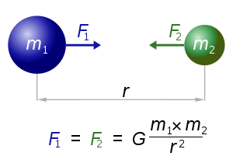

Where,

is the magnitude of the gravitational force on mass

are their masses

is the distance between two masses

is gravitational constant

**G value**

The gravitational constant, denoted *G*, is an empirical physical constant involved in the calculation of the gravitational attraction between objects with mass.

*G* = 6.6742 × 10-11 N m2 kg-2

**Weight**

We can defined weight as:

**The weight of a body is the total gravitational force exerted on the body by all other bodies in the universe.**

We also know that the weight *w* of a body is the force that causes the acceleration *g* of free fall, so by Newton’s second law, *w=mg*. By equating the equation, we find:

(acceleration due to gravity at the Earth’s surface)

**Satellites**

The force acting on a satellite in circular orbit around the earth is the earth’s gravitational attraction, which is directed towards the center of the earth and hence toward the center of the orbit. The satellite is in uniform circular motion and constant speed. The satellite never falling toward the earth, rather, it’s constantly falling aroung the earth. In a circular orbit the speed is just right to keep the distance from the satellite to the center of the orbit constant.

By the law of gravitational, the net gravitational force on the satellite of mass *m* has magnitude *Fg* = *GmEm/r2* and is in the same direction as the acceleration. Newton’s second law *F = ma* then tell us that:

Solving this for *v*, we find

(circular orbit)

Where *v* is speed of the satellite in a circular orbit

We derived a relationship between the radius *r* of a circular orbit and the period *T* , the time for one revolution.

Where,

*v* is the speed of the satellite

*r is the radius*

*T* is the time for one revolution

We solve the equation, for T and substitute *v* from :

(circular orbit)

This show the larger orbits correspond to slower speeds and longer periods.

We also can derived the equation from above,

http://www.syvum.com/iosundry/physics/gravitation/images/img49.gif

For the case of a satellite revolving around the Earth in a circle at a height *h* from the Earth's surface with *h* much smaller than *R*

http://www.syvum.com/iosundry/physics/gravitation/images/img51.gif

The escape velocity of a body is defined as the minimum velocity with which a body must be projected from the surface of the Earth, so that it may not return.

The work done in taking a body from the surface of the Earth to infinity is

http://www.syvum.com/iosundry/physics/gravitation/images/img52.gif

If a body is to be projected such that it may never return, then its kinetic energy must equal this work done as given below.

http://www.syvum.com/iosundry/physics/gravitation/images/img53.gif

Thus, the expression for the escape velocity is

http://www.syvum.com/iosundry/physics/gravitation/images/img54.gif

**Kepler’s law**

1. 1st Kepler’s Law **(Law of Ellipses)**

* Planets move in ellipse with the sun at one focus.

*How To Illustrate?*

1. Tack the sheet of paper to the cardboard using the two tacks.
2. Tie the string into a loop and wrap the loop around the two tacks. Take pencil and pull the string until the pencil and two tacks make a triangle.
3. Trace out a path with the pencil, keeping the string wrapped tightly around the tacks. The r shape will be an ellipse.
4. An ellipse is a special curve in which the sum of the distances from every point on the curve to two other points is a constant. The two other points (represented by the tack locations) are known as the **foci** of the ellipse.
5. Kepler's first law is rather simple - all planets orbit the sun in a path that resembles an ellipse, with the sun being located at one of the foci of that ellipse

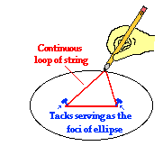

1. 2nd Kepler’s Law **(Law of Equal Areas)**

* Radius vector describes equal areas in equal times.

*How To Illustrate?*

1. It describes the speed at which any given planet will move while orbiting the sun. The speed at which any planet moves through space is constantly changing. A planet moves **fastest** when it is **closest to the sun** and **slowest** when it is **furthest from the sun**. As can be observed in the diagram, the areas formed when the earth **is closest to the sun** can be approximated as **a wide but short triangle**; whereas the areas formed when the earth is **farthest f**rom the sun can be approximated as **a narrow but long triangle**
2. Since the base of these triangles are shortest when the earth is farthest from the sun, the earth would have to be moving more slowly in order for this imaginary area to be the same size as when the earth is closest to the sun

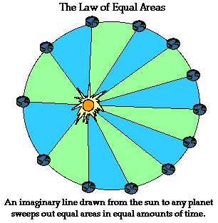

1. 3rd Kepler’s Law **(Law of Harmonies)**

* The square of the periodic times of any two planets is equal to the ratio of the cubes of their average distances from the sun.

*How To Illustrate?*

1. It compares the orbital period and radius of orbit of a planet to those of other planets.
2. The third law makes a comparison between the motion characteristics of different planets which compares the ratio of the squares of the periods to the cubes of their average distances from the sun is the same for every one of the planets.

*A table illustrates as below:*

|  |  |  |  |
| --- | --- | --- | --- |
| **Planet** | **Period**  **(s)** | **Average**  **Dist. (m)** | **T2/R3**  **(s2/m3)** |
| Earth | 3.156 x 107s | 1.4957 x 1011 | 2.977 x 10-19 |
| Mars | 5.93 x 107 s | 2.278 x 1011 | 2.975 x 10-19 |

Observe that the **T2/R3**ratio is the same for Earth as it is for mars. In fact, if the same **T2/R3**ratio is computed for the other planets, it can be found that thisratio is nearly the same value for all the planets (see table below). Amazingly, every planet has the same **T2/R3** ratio.

|  |  |  |  |
| --- | --- | --- | --- |
| **Planet** | **Period**  **(yr)** | **Ave.**  **Dist. (au)** | **T2/R3**  **(yr2/au3)** |
| Mercury | 0.241 | 0.39 | 0.98 |
| Venus | .615 | 0.72 | 1.01 |
| Earth | 1.00 | 1.00 | 1.00 |
| Mars | 1.88 | 1.52 | 1.01 |
| Jupiter | 11.8 | 5.20 | 0.99 |
| Saturn | 29.5 | 9.54 | 1.00 |
| Uranus | 84.0 | 19.18 | 1.00 |
| Neptune | 165 | 30.06 | 1.00 |
| Pluto | 248 | 39.44 | 1.00 |

1 a.u = 1.4957 x 1011 m 1 year = 3.156 x 107 seconds

**Apparent Weight**

## An apparent weight is the normal force exerted on it by a body with which it is in contact. This will only equal the object's actual weight if it holds the object at rest or at constant.

* A person with mass, *m*, who is located at or near the surface of the Earth will always have some weight *W=mg*. When a person stands on a scale, the reading (the number of pounds or newtons) on the scale is actually the Normal Force that the scale exerts back towards the person to support the person's weight. (Note that the person and the scale are stationary relative to each other, in other words they are always in contact with each other, so they always have equal and opposite action and reaction forces acting between them.)
* **EXAMPLE OF CASES**

**Case 1: No acceleration of elevator**

If the acceleration of the elevator is zero, then there are two possible

scenarios; the elevator can be at rest (stationary, zero velocity) or moving

with a constant speed (no acceleration if velocity does not change).

In this case, the action and reaction force pair between the person and the

scale is just the weight. The person pushes down on the scale with a force of

*-W=-mg* (negative direction) and the scale pushes back up against the man

with a Normal Force of *FN = +W = +mg*. Because the reading on the scale is

the magnitude of the normal force, the scale will read the true weight when

the elevator is NOT accelerating.

**Case 2: going up & speeding up (acceleration a is positive (up))**

In this case, the elevator and the person are starting from rest at a lower

floor. The elevator accelerates upward. The inertia of the person would

prefer to stay stationary, so the elevator floor and scale must push up on

the person to accelerate him upward along with the elevator. (The person

doesn't sink into the floor when the elevator accelerates up. The elevator

and the scale and the person all move together.)

The scale therefore has to push upward with extra force on the person to

accelerate the person's mass upward. This results in a greater contact

force between the scale and the person. Therefore the Normal Force is

larger, so the reading on the scale is a number that is GREATER than the

true weight. Let's consider Newton's 2nd Law (*ΣF=ma*) acting on the person. The overall acceleration of the person is upward (with the elevator). So *ma* is positive (upward). The only external forces acting on the person are the force of gravity acting down (-W=-mg) and the supporting Normal Force FN that the scale applies upward on the person. So *ΣF=ma= -mg+FN* . We want to know

*FN* because that is the number that we read off the scale. *FN* =*mg+ma*, which is GREATER than the true weight.

**WEIGHTLESSNESS**

* It is experienced by an individual when there are no external objects touching one’s body and exerting a push / pull upon it
* Happened when all contact forces(*result from the actual touching of the two*
* *interacting objects; e.g: CHAIR and YOU)* removed.
* You would feel weightless when in a free fall state (the only force acting upon your body is **Gravity**-non-contact force).
* Has very little to do with weight. You are not lost your weight when in a free fall

state but actually **experiencing earth’s Gravitational attraction.**

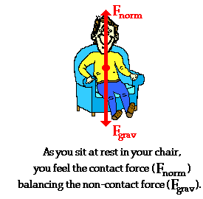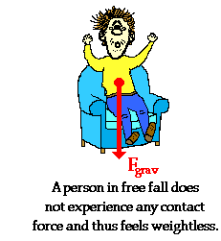

*Example:*

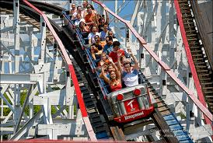

**Riding Roller Coasters**

**WEIGHTLESSNESS IN ORBIT**

* Astronauts are weightless because there is noexternal force pushing/ pulling upon their body.
* The only force acting on the body is Gravity, which supply centripetal force requirements to allow inward acceleration causing Circular motion.

