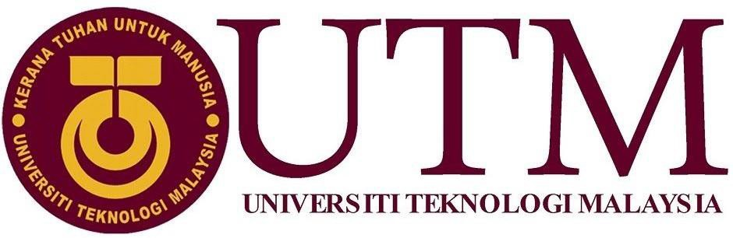

Alumni Sharing Session (Inspiring Work Experience & Covid-19 Pandemic Challenge) Report

Technology and Information System (SECP1513) - Section 15

**Done by: Group-01**

**MD MEHEDI HASAN(A20MJ4005) SIDDAREDDY USHA SREE(A19MJ4002) NAFI AHMED(A19MJ3073) DACHIYANI MOGAN(A20EC5020)**

**THE DAILY CHRONICLE**

|  |  |  |
| --- | --- | --- |
| [www.utm.my](http://www.utm.my/) | UTMNEWS | 21 January, 2021 |

UTM ALUMNI SHARING SESSION

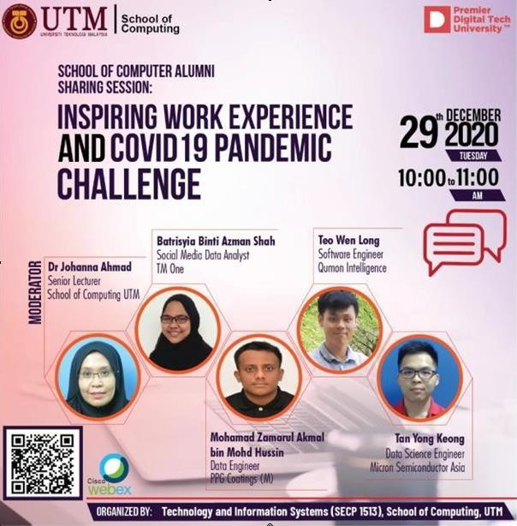

We had a talk discussing the experiences successful UTM alumni had in their endeavors. This talk has been held to motivate UTM students so that they do not lose hope in themselves during the current pandemic. The purpose of the talk has been to show UTM students how former UTM students became successful, so as to let the current UTM students know that if they work hard enough, they can also become successful just like them.

When we think of job after graduation and the possibilities we have in the fields, we remember the experiences shared by our alumni how they were able to get a job after graduation. Every person will have a different story/experience in the same way, the story of

Zamarul getting a job is one-of- a-kind than that of Tan Young. This talk was hosted by a senior lecturer, Dr. Johanna Ahmad. We got introduced to three alumni who has been successful with their achievements. Tan Yong Keong, Zamarul and Qistina Azman were the three alumni we got introduced to.

As he was an intern in an industry training company, he got a job as a permanent worker in that company. The thing he did to get the job as a permanent employee was just to be free in

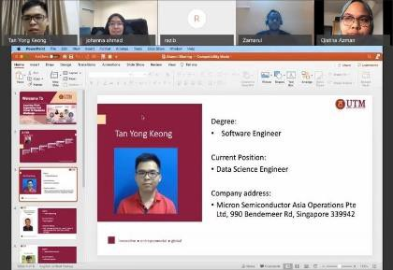

expressing himself constantly by

changing ideas and valuable opinions. Whilst working for his internship company, he was offered to create a monitoring dashboard. The company was using big data company environment, so huge amounts of data was coming in everyday, but they were still using manual monitoring. Then Zamarul proposed to create a system that can monitor all the work at once with a single click. That proposal became everyone`s favorite and his supervisor began to pay more attention towards him. Even if he is still working as an intern there, Zamarul was offered a permanent position. That is how he plans to join as a permanent employee in that organization.

Just like Zamarul, Qistina also had a similar experience. During

the internship, she put in a lot of effort to be a part of actual lifestyle projects during the time she worked. From there, her supervisor offered her a permanent spot to develop that project even more. She was praised for her work for the project's dashboard and for all her efforts. The project she was praised for, was a social media project and she had to collect all social media data and bring that information into the dashboard. The dashboard was then used to enhance the branding of consumers based on marketing using those data.

We got introduced to another alumni, whose name was Tan Yong Keong. Tan is currently working in the semiconductor manufacturing company. His job is to work with factory loading optimization. He uses huge amounts of data to optimize market demand. We learned a valuable lesson from him, which has been a confusing topic for many software engineering students: instead of focusing on learning programming

languages for better employability, it gets easier if we just focus on learning the concepts.

The session included a session where the UTM alumni gave advices to the fresh graduates. Then the talk ended with a Q and A session, where the alumni cleared any doubts that the new graduates might have had.

For starters, the conference was a big hit for the first-year students because of how relatable the conference was to the students. Most newcomers get overwhelmed within the primary year of the semester and they get confused on what they

should do throughout their studies to increase their employability chances. Thus, we rely solely on our seniors. But the seniors barely have time to put onto their fellow juniors. So, a lot of juniors crave help during their studies so that they can be pointed to the right direction. This is where this talk comes in, now we are aware of what should be done to compete in a market which is already competitive.

Overall, the talk has been very well-structured to point newly joined students to the right direction. However, it lacked some aspects that would have helped the students even more. For example, we did not get to know how the pandemic affected their working lifestyle. One other weakness that this talk had is that we did not get introduced to any alumni who has been employed for a few years for example, those that are more experienced to the alumni we have been introduced to. We are sure most would agree that this talk has helped to point any confused students to the right direction. So, this could be this talk’s strength. From this talk, we saw how UTM graduates have been successful. This torched the flame in our hearts that if we keep working, we can be just as successful if not more. This is the motivation we gained from this talk. We gained various insights/information from this talk, most of it has been to how we can make ourselves employability ready and how one can adapt to the job market. These are the crucial aspects that every graduate needs to be aware of.

**Reflection**

**Nafi Ahmed:** As a new graduate, I wanted to know about the difficulties a new graduate could face when they graduate in order to land their first job. To overcome those situations, I needed to know how I can better prepare myself throughout my studies. This talk has provided just that. I also learnt about the importance of certificates, the online courses provide when you finish them, when an alumnus mentioned how those helped him land the intern. I will make sure to implement what I have learnt during this talk.

**Usha Sree:** This talk has provided me the knowledge on how I can show off my skills to employers to increase my employability chances. As a new graduate, I was very confused on how I can make myself employability ready. I did not know of any seniors to whom I could share my problems with, so this talk filled that void.

**Mehedi Hasan:** I learnt that a high CGPA is not the only important factor I need to focus on. I learnt of all the other important factors in this talk that ensure employability like if I improve my skills on something that the average university graduate is not aware of, I set myself apart from the competition and this can attract employers.

**Dachiyani Mogan**: I learnt how I can compete in the job market when I graduate and what I should do during my studies to ensure I get the right job. I will make sure to follow, what I have been taught during this talk to land my first job.