**Literature Review on the most prominent Cloud Computing Service Providers**

Goo Ye Jui1, Kelvin Ee2, Ahmad Muhaimin Bin Ahmad Hambali3, Myza Nazifa Binti Nazry4, Yong Zhi Yan5

1 Universiti Teknologi Malaysia,Sultan Ibrahim Chancellery Building, Jalan Iman, 81310 Skudai, Johor, Malaysia

# 1 Introduction

Cloud computing is the on-demand availability of computer system resources, especially computing power, storage (cloud storage), networking, and analytics, without direct management by the users. It is managed by a third party company who are called cloud computing service providers. For example: Microsoft, Amazon, and Google.

The word “cloud” is a metaphor for the internet,it was used to represent the huge server-farm infrastructure of the internet back then[1]. Cloud computing appeared as early as 1996, it was first mentioned by a company called Compaq in their internal document[2]. It was then popularized with Amazon releasing their own cloud computing platform, Amazon Elastic Compute Cloud (EC2) in 2006.

Users have many choices of cloud computing services providers to choose from the market but all of them have different advantages and disadvantages. This paper shall review the comparative evaluation of the three main cloud computing service providers and suggest the best cloud service provider for software development.

# 2 Comparative Evaluation

This comparative evaluation will focus on three most prominent cloud computing service providers : Amazon EC2, Google Cloud Platform, and Microsoft Azure. It will be focusing on the following comparative points which are service model, virtual machine(VM) instance types offered, storage, OS environments offered, security, performance and scalability, pricing model, auto-scaling/elascity, monitoring tools/service provided.

## 2.1 Service model (IaaS, PaaS, SaaS)

There are commonly three unique cloud service models to be compared through as-a-service types that are growing gradually day by day which are Infrastructure as a Service (IaaS), Platform as a Service (PaaS) and Software as a Service (SaaS). These are the main types of cloud computing. They are all experiencing an increment in popularity as more businesses move into Cloud. IaaS accounts for approximately 12% up from 6% and SaaS is hovering around 24% of all enterprise workloads up from 14% in 2016. Meanwhile, PaaS is currently the most favoured model with accounting around 32% from the market and yet expected to grow in 2020. These three services mainly differ in what they provide out of a box. IaaS is a cloud-based service that helps companies to build the infrastructure which includes content, software, or networking. PaaS helps vendors to build a customised application where the hardware and software tools are available over the Internet. SaaS lets users with access to a cloud-based software by a vendor as a user do not have to install the application on their computer or any local devices. These models are always differing by “Pizza as a Service” where the traditional on premises is described as making pizza at home, IaaS as take and bake, PaaS as pizza delivery and SaaS as dining out for pizza. The popular examples of IaaS are AWS EC2 and Google compute Engine (GCE) while PaaS examples are AWS Elastic Beanstalk and Window Azure. The SaaS examples are Dropbox and Salesforce. The system administration knowledge level decreases as it went down through the list in these orders: On-premises > IaaS > PaaS > SaaS. When it comes to handling the pre-built applications, IaaS provides vendors with maximum flexibility by providing a common data centre for storage purpose. To reduce the need for system administration, PaaS is most often built on top of an IaaS platform while SaaS provides ready-to-use solutions as it is usually built on IaaS and PaaS platforms. IaaS provides vendors more direct control toward the systems where PaaS provides users a larger capability of flexibility to ease the operation. Meanwhile, SaaS products are completely owned and managed by another company whereas PaaS can be treated as the foundation for developing a different product on top of the platform network.

## 2.2 Virtual Machine (VM) instance types offered (such as micro, small, medium, large etc.)

A virtual machine (VM) is a virtualisation environment of a computer that works as a virtual system with its own CPU, network interface, memory and storage that is created on a physical hardware system. Machine types are usually specialized and vary by combination with disk capability, virtual CPU (vCPU) and memory size, providing several options to match any types of workload. Each instance type has one or more sizes that allow users to scale their resources based on the requirement such as GPU, compute optimized, memory optimized, and storage optimized. Compute Optimized instances are most ideal to benefit from high performance processors for computing bound applications. It is well developed for media transcoding, High-performance web servers and High-performance computing (HPC). Besides, memory optimized instances are designed to deliver furious performance for workload in huge data sets that are going to be processed. For example, there are various types of memory optimizer in Azure VM such as M, MV2, DV2 and so on which are used for high ratio of memory to compute in relational database services. For storage optimized virtual machines, it is usually created for big data, large transactional databases, data warehousing SQL and so on. It requires high sequential read and write access to a very huge data set on local storage. There are several types of instances such as i3.large, i3.xlarge , i3.2xlarge and so on where they can support bare metal instance size for workloads.

## 2.3 Storage

Google Cloud Platform provides a lot of storage categories like Object Storage, Block Storage, Archival Storage, File Storage, and others. In each of the categories, there will be one or more products to be chosen. On the other hand, Microsoft Azure has an even wider range of choices and variety in storage services, database services, and backup services. There are 5 core storage services in the Azure Storage platform which are Azure Blobs, Azure Files, Azure Queues, Azure Tables, and Azure Disk. Microsoft Azure and Google Cloud Platform offer services that function very similar to one another but some may be better than the other. For example, in Persistent Disk Storage, Azure offers Ultra Disk SSD with up to 2GB/second which is very fast compared to Google Cloud Platform. On other hand, Google Cloud Platform offers the cheapest price/performance for HDD/SSD and a lot of choices. The most significant difference between these two Cloud Providers is that Microsoft Azure provides backup services which is Site Recovery meanwhile Google Cloud Platform has Archival Storage that almost works like backup services but it is only ideal for data you intend to access less than once a year. One of the advantages of having a backup service is that it will ensure business continuity by keeping workloads running during the outage.

## 2.4 OS environments offered

The OS environments supported by Google are CentOS (CentOS 5 to CentOS 8), Container-Optimized OS (COS) (COS 69 LTS to COS 85 LTS), Debian (Debian 7 to Debian 10), Fedora CoreOS (FCOS) (Fedora CoreOS Next, Fedora CoreOS Testing and Fedora CoreOS Stable), Red Hat Enterprise Linux (RHEL) (RHEL 7.4 for SAP to RHEL 8), SQL Server (SQL Server 2012 to SQL Server 2019), SUSE Linux Enterprise Server (SLES) (SLES 12 SP1 for SAP to SLES 15 SP2), Ubuntu LTS (Ubuntu 12.04 LTS to Ubuntu 20.04 LTS), Windows client (Window 7 to Window 10) and Windows Server (Window Server 1709 to Window Server 2019). The OS environments supported by Microsoft azure are Window (Window Server 1709, 2008, 2012, 2016, 2019 and Window 10) and Linux system such as CentOS-based 6.9, CentOS-based 7.3, CentOS-based 7.5, ClearLinux, CoreOS Linux (Stable), Debian 8 "Jessie", Debian 9 "Stretch", Oracle Linux, Red Hat Enterprise Linux 7.1 (and later), SLES 11SP4, SLES 12SP3, Ubuntu 14.04-LTS, Ubuntu 16.04-LTS and Ubuntu 18.04-LTS.

## 2.5 Security

Both Google and Azure had implemented different security policies and processes to meet the compliance requirements such as CSA STAR, GDPR, HIPPA, PCI-DSS, and a range of ISO standards. Azure compliance is the highest among all the cloud providers available which has accomplished 90 and above compliance standards across 50 global regions, whereas Google compliance is also impressive, meeting 45 compliance standards. Encryption is an important factor in ensuring the data sent or stored is kept safe within the cloud server and not easily accessed by others without password and etc. Both Azure and Google Cloud support encryption as default using 256-bit AES within their cloud infrastructure, and also provide the users the ability to control their own encryption keys and deliver encryption at rest and in transit. Google refers to its service as the Cloud Key Management Service, while Microsoft refers to its Azure service as Key Vault. Firewall acts as a defence against virtual attack by virus. Both Google Cloud and Azure provide state-of-the-art firewalls, which provide the users with configuration capabilities through firewall rules so that the users can control who has the access to the network.

## 2.6 Performance and scalability

The difference between performance and scalability is performance is the indicator of the ability of the cloud to react quickly to execute a certain action within a certain time interval while scalability is the ability of the cloud to control the increasing load without any impact on the cloud’s performance by adding resources to the system. Since cloud applications usually come across variable workloads and peaks in activity, the cloud applications should be able to scale in and scale out depending on the number of demands.

For Microsoft Azure, the performance and scalability of the services has been developed and improved through a number of proven practices. The services scalability have their own expected targets for their capacity, transaction rate and bandwidth. When the scalability target for an account is exceeded, the users can build multiple storage accounts and partition the data across the accounts which will be identified by a partition key. Meanwhile, Google Cloud specializes in high compute offerings such as Big Data, analytics and machine learning. The service also offers considerable scale and load balancing and it also has really fast response time. To build an efficient application, GCP offers a lot of features such as its serverless platform which provides managed compute, database and other services that could scale from zero to high request volumes quickly.

For Amazon Web Services, it also provides additional features that can help the users to deploy, manage and scale the application. EC2 allows the users to choose between Fixed Performance Instance (M5, C5, and R5) and Burstable Performance Instance (T3). Between both performance, Fixed Performance Instance is recommended when the users need high CPU performance for applications such as video encoding. Meanwhile T3 instances are used if the application really needs CPU performance since it is designed to perform as if the service have dedicated high speed Intel cores available while protecting the users from variable performance or other effects that can happen from over-subscription.

## 2.7 Pricing model

Microsoft Azure is not like Microsoft office 365, it has complicated software licensing options and use of situation-based discounts. It is very difficult to understand the pricing for a less experienced user. On the other hand, Google Cloud Platform uses its pricing as a point of differentiation. It can be considered as the most “customer-friendly” compared to the other cloud providers. The flexible contract attracts companies to take them as their first choice Google Cloud Platform before starting a new project. Azure offers a free tier with minimal services, many more services for 12 months, and a $200 credit to try any other paid service. Google Cloud Platform offers a free tier with some basic services that are always free and a $300 credit to try other services.(*Azure vs Google Cloud: How They Compare*, no date)

## 2.8 Auto-Scaling/Elascity

Auto-Scaling/Elascity enables the users to scale their cloud services such as server capacities or virtual machines up or down automatically.[6] Auto-Scaling helps the users to add instances only when needed, whether to increase during demand spikes or to decrease during demand drops. This enables a consistent performance at a lower cost.

Based on the scaling policy, 3 types of auto scaling policy were provided in AWS which are target tracking scaling policy, step-based auto-scaling policy and simple scaling policy. Steps-based auto scaling policy allows users to add instances as per level of alarm breach and simple scaling policy adds instances linearly until the target value is achieved. On the other hand, both GCP and Azure only provide target tracking scaling policy which users can create autoscale rules that built-in host metrics available from your VM instances.

EC2 provides additional scaling parameters from GCP and Azure, which is scaling based on SQS(Simple Queue Service). Amazon SQS is a simple queue service offered by AWS that lets customers integrate and decouple distributed software systems and components. Autoscaling will scale in and out based on the number of messages in the queue. Both EC2 and GCP provide scheduled scaling that tells the system to perform a scaling action at specified times.

Based on instance protection and scale-in policy, Azure has two types of instance protection which are protect from scale-in and protect from scale-set actions. A protected virtual machine is not deleted through a scale-in action, regardless of the scale-in policy applied.A protected virtual machine can be manually deleted by the user at any time, regardless of the scale-in policy enabled on the scale set.

**Table 1.** Auto-Scaling/Elascity comparison of EC2, Azure, and GCP

|  |  |  |  |
| --- | --- | --- | --- |
| Characteristics | Amazon EC2 | Microsoft Azure | GCP |
| Auto-scaling policy | Target tracking scaling policy, Step-based auto-scaling policy and Simple scaling policy. | Only target tracking scaling policy | Only target tracking scaling policy |
| Additional scaling parameters | Scaling based on SQS(Simple Queue Service) | No | No |
| Scheduled Scaling | Yes | No | Yes |
| Instance protection and scale-in policy, | Yes | Yes | No feature to protect instances |

## 2.9 Monitoring tools/service provided

## Amazon EC2 provides various monitoring tools.Their very own monitoring tools is Amazon CloudWatch. CloudWatch helps you to make sure your AWS operations are in good shape. They provide two types of monitoring tools which are automated monitoring tools and manual monitoring tools. Automated monitoring tools include : system status checks, instance status checks, amazon CloudWatch alarms, amazon CloudWatch Events, Amazon CloudWatch Logs, CloudWatch agent, AWS Management Pack for Microsoft System Center Operations Manager.

Google Cloud Platform provides constant monitoring to keep it’s overall health and performance intact. Google Cloud Platform have three main types of monitoring tools which are Google Cloud Storage Monitoring, Google Cloud Filestore Monitoring, Google Kubernetes Engine Monitoring. Google Cloud Storage Monitoring proactively monitors critical areas of storage buckets and dissect network requests. Google Cloud Filestore is a managed file storage service for applications that require a filesystem interface and a shared filesystem for data. Google Kubernetes Engine Monitoring monitors KPIs that define the performance in the cloud.

Microsoft itself provides a lot of Azure monitoring services, each with their own specific purpose. For examples, Microsoft Azure Monitor collects and analyzes performance metrics as well as diagnostic and activity logs from cloud environments to determine application availability and performance. Azure Advisor is another monitoring tool that can scan resource configurations and then provide possible actions to improve resources for high availability security, performance and cost.

# 3 Challenges

**3.1 Analysis**

From the evaluations above, we can know that three of the cloud service providers have different target groups with their own advantages and disadvantages. AWS EC2 targets users that need more global reach as they have the largest market share in 2020 [7]. They are also the most stable, reliable cloud platform with the benefit of their age and experience. EC2 is more suitable for bigger organizations as they provide better flexibility and wider range of services/tools. Besides, EC2 is more cost-effective for large scale storage.

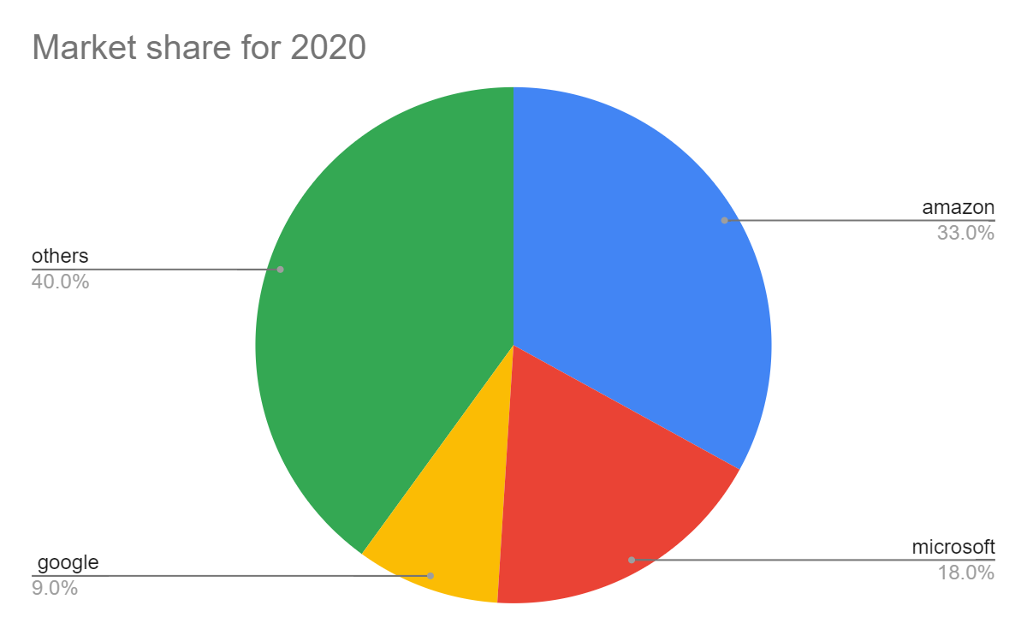

**Source : Synergy Research Group**

**Fig. 1.** This pie chart shows the market share of cloud services in the year 2020

Azure as a cloud computing service provider is more of a starter for those who are first time using this service. The biggest advantage of Azure is that everything is Windows-based. It’s much more user-friendly for Windows users. If you’re looking for a hybrid cloud model, Azure is your only choice from these three.

If you’re looking for a green-tech solution, Google Cloud Platform is the only one that is carbon neutral to support resource conservation. They even provide extra incentive for companies looking for greener tech. GCP is good in their compute platform Google Compute, but lacks storage solutions. They don’t have any backup options available for the users.

**3.2 Selection and opinions**

If I were to choose one of the cloud service providers for my software development, I would select Microsoft Azure. As this is my first time migrating to the cloud service as a software developer. Azure Migration center would make it easier. I would also need a user-friendly service that suits very much to my original Windows PC. Azure tends to advance the open-source community with software and apps that companies are already using. This makes it more ideal for software developers. Azure gives users 12-months free trial period with access to all popular services.

# 4 Conclusion

In conclusion, there are a lot of factors that differentiates the three cloud computing services such as the service model, the virtual machine instance types offered, the storage, the OS environments offered, the security, the performance and scalability, the pricing, the auto-scaling or elasticity and lastly the monitoring tools and service provided. With those distinct differences between them, from each aspect, there will be pros and cons for each of the services. Some may be suitable for some users while some may not be able to satisfy a certain user's needs. With that, it is important for users to do a little research on these cloud computing services so that they can choose the most suitable cloud services that can satisfy their needs as each cloud service has its own characteristics.

# 

# 

# 

# 

# 

# References

1. Eric Griffith (29 June 2020). “What is Cloud Computing” Retrieved from <https://sea.pcmag.com/networking-communications-software/2919/what-is-cloud-computing> on 18 January 2021
2. Antonio Regalado (31 October 2011). ["Who Coined 'Cloud Computing'?"](http://www.technologyreview.com/news/425970/who-coined-cloud-computing/). *Technology Review*. MIT. Retrieved 31 July 2013.
3. *Azure vs Google Cloud: How They Compare* (no date). Available at: https://cloud.netapp.com/blog/azure-vs-google-cloud-how-they-compare (Accessed: 18 January 2021).
4. Höfer, C. N., & Karagiannis, G. (2011). Cloud computing services: taxonomy and comparison. *Journal of Internet Services and Applications*, *2*(2), 81-94.
5. Marr, M. D., & Kowalski, M. P. (2014). *U.S. Patent No. 8,825,550*. Washington, DC: U.S. Patent and Trademark Office.
6. Chris Heggem (2020) Auto Scaling Definition. Retrieved from <https://avinetworks.com/glossary/auto-scaling/> on 19 January 2021
7. Felix Richter (18 August 2020) Amazon Leads $100 Billion Cloud Market Retrieved from <https://www.statista.com/chart/18819/worldwide-market-share-of-leading-cloud-infrastructure-service-providers/> on 19 January 2021
8. Github (19 July 2016). *Azure Storage Scalability and Performance Targets.* Retrieved from

<https://github.com/uglide/azure-content/blob/master/articles/storage/storage-scalability-targets.md>

1. Cynthia Harvey and Andy Patrizio. (22 October 2020). *AWS vs Azure vs Google : 2021 Cloud Comparison.* Retrieved from: <https://www.datamation.com/cloud-computing/aws-vs-azure-vs-google-cloud-comparison.html#:~:text=Google%20has%20a%20strong%20offering,centers%20and%20fast%20response%20time.>
2. Google Cloud. (n.d.). *Patterns for scalable and resilient apps.* Retrieved from: <https://cloud.google.com/solutions/scalable-and-resilient-apps>
3. Amazon. (n.d.). *Amazon EC2 Instance Types.* Retrieved from:

<https://aws.amazon.com/ec2/instance-types/>

1. Edward Jones (23 November 2020). *Google Cloud vs Azure in 2021 (Comparing the Giants).* Retrieved from: <https://kinsta.com/blog/google-cloud-vs-azure/>
2. Google Cloud (n.d.). *Operating system details.* Retrieved from: <https://cloud.google.com/compute/docs/images/os-details>
3. Microsoft (15 December 2020). *Guest operating systems supported on Azure Stack Hub.* Retrieved from: <https://docs.microsoft.com/en-us/azure-stack/operator/azure-stack-supported-os?view=azs-2008>