**MDEC e-Rezki**

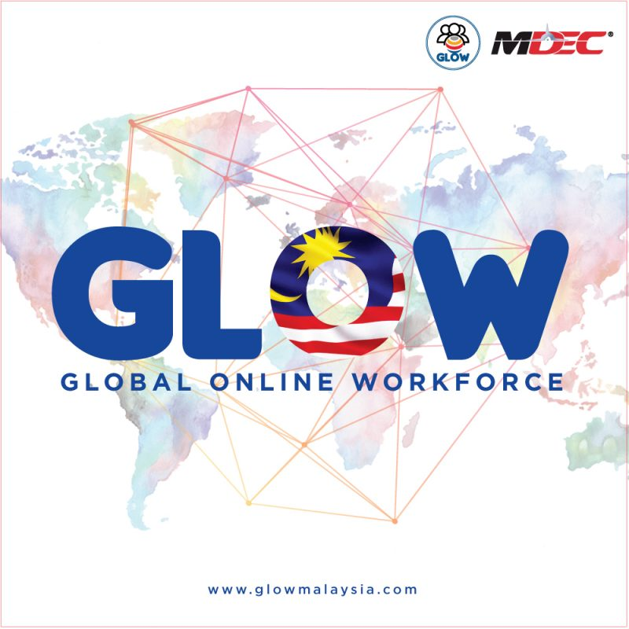

Name : Muhammad Ridha

Matric card number : A18CS0314

Course : Software Engineering

**Introduction**

Today we live as the world is in the palm of our hands, everything we want can be achieved with just one tap of a finger, all the information in the whole world can be seen in a minutes. Despite of that there are also a lot of people that have a lot of potentials to work for a good company but they did not get the proper job or proper company for themselves. In this era, a lot of people have very big desires to be fulfilled,but they are have difficulties to find a job that has shorttime work and can earn a lot of money.nowadays there a lot of system or web that offer you to have an easy work and also can gain a lot of money in a short period of time. For example Jack Ma, Jack Ma is one of the richest person in the world, he was born from a family that has a very poor economic financial.but after he learn about computer he start to build something new from that. In 1992, he was searching about interesting word and it very general word that we heard basically, he searched about “ Beer” and from that he found a weird fact that he can not found china at the data base. Because of that he becoming interested with the internet and suddenly he asked 2000 US dollar from his relatives to set up a computer company that based on the internet. In fact he can not understand about computer and also about electronic letter, even he do not know how to use the keyboard. Because of his will and brave to take the risk at the internet now his company that named as “ Alibaba” has gain more than US$ 200 million. From that story we can see that working in the internet nowadays can gain a lot of money in a very short time. Now in Malaysia there is an online platform named GLOW ( Global Online Workforce). GLOW is an international online platform that offers huge opportunities to get a job using your own skills. You can earn money by helping people or a company and also you can search for the job that you love and you wanted to do for yourself that you can do anywhere and whenever you want as a Freelancer. “eRezeki taught me effective techniques and good ethics in managing clients, and maintain professionalism as a digital freelancer. I am living the life of freelancer and I aspire to serve more clients.” Said Nor Ashikin Binti Halil the speaker of MDEC. She also earn money by translating seven dramas and 4 films and she earned around 150.000 rm.

**GLOW (Global Online Workforce)**

GLOW is the alternative way to earn in Malaysia through online platform using your skill,to earn on the internet GLOW is not selling product but GLOW is selling skills. So we are not selling the product. It is very good chance for freelancer to apply for the job what they want according to the skills that they got. They can choose their own project and companies they want to cooperate with. You can be the boss and you can also be a worker in a multiple companies in a single time without being push by everyone.

Basically, GLOW will help you by by introducing to various sources of income from online platforms. They can give you tips and tricks of online freelancing. You will be closely guided and coached by freelancing practitioners. In GLOW mentoring programme, you will learn to be a good freelancer and of course teach you how to deal with customers.

**Common profession**

There a lot of jobs that you can find at GLOW or you can also provided for other users,you can find a lot of things there such kind:

1. Translator : you need to translate something from one language to another language.translate drama text, translate film subtitles
2. Graphics Designing :design applications, games, websites and campaigns, and create marketing ideas
3. IT consultant : work with clients to improve the structure and efficiency of their IT systems.
4. Logo design and illustration: Design logos forwebsites
5. Creative design : design related work such as PowerPoint presentation or desktop designing with Adobe Photoshop

**Benefit to be a freelancer**

Many people thought being a freelancer means do not have any job. Well that is just people prespective, if you search more about freelancing you will discover that freelancing not just a job but by being freelancer you are not just earning money, you can also search for the job that suit to you.you can apply for different of jobs at the same time that you have skill with. Also you do not have to spend a lot of time at the office to work. You can freely work whenever you want and wherever you want, so it makes more relaxing than just work at the office in front of your documents and computer. You will also earn a lot of benefits by being freelancer.thes are abenefits that you will eran by being freelancer:

1. Improve your communication skill by have a lot interacsion with other people in the world
2. You can manage your time wisely,you can manage between you freelancing time and also you reality life to make you become a better person in managing time
3. You will know your skills better by work in a any division you like
4. Earn a lot of monet whenever you want and wherever you want
5. You will know how to treat your customer better
6. Gain a lot of work experience to increase your CV

**Join GLOW**

GLOW can help you in alternative way to earn a lot of money in Malaysia through online platform using your own skill. You will be selling your skills here. You do not have to sell any product. But you will earn a lot of money depend on task you coul done here. GLOW is on website. If you take a look to eat on website, you will find success stories from people who joined this platform and becoming successful. You can register for thee workshop on the program at the website. They offer a very Fast Track Program that will allows you to join the workshop for 1-2 days. There is also Higher Learning Institution Program for future graduates from selected faculties and Premium Program for intensive exercises with experienced mentor.

**Impact of The Program to Malaysia**

GLOW is agood program in Malaysia that provide for all of freelancer all around Malaysia.with this program all of freelancer at Malaysia can easier to search or provide a job to others. This program also bring good and bad impact for Malaysia, here is the good and bad impact of the program:

1. **Good impact**

* **Have flexible hour**  : with freelancing, freelancer can can have flexible hour for managing his/her life,with that he/she can spend more time with their family,friends or other quality time and also they can work whenever they want.they don’t to have to work early in the morning,they can just work at their prime time to reach a very good result
* **Control over jobs and clients** : when you are not a freelancer you will apply for work and when you found a work you will not know how the company and the oos that you have, it is really risk if you will get unprofessional boss and you will stuck there so will not improve your skills. But in this case if you are a freelancer you can choose the company without any contract and you can resign whenever you can if you see the work is not suit for you.
* **You keep all the profit** : . No longer do you have to work for a flat rate, no matter how large the projects are that you complete. Now, you get to allocate or keep all the profits from your large and small projects and clients. This gives you the freedom to then use that money to improve yourself and expand your business.

1. **Bad impact**

* **Distinguishing Between Work and Personal :** being your own boss and working from your home also means that it can be really difficult for a person to separate their work time and their personal/family quality.
* **Not getting paid :** being a freelancer do not thimk you have already safe, sometime you will choose a wrong work. Why? Because some provider also use this advantages to play tricks on you. For example they will provide you a work and will promise you with a huge income then you will take the job,but at the end of your work they will betrayed you and will not pay you. So be carefull for the job
* **No Employer Benefits** – Health benefits are expensive. Depending on your current health, switching to a freelance lifestyle might not be in your best interest. Also, starting your own freelance business means you no longer have paid sick days or vacation time to use. Every day you don’t work is a day you won’t get paid and you will not be provided by health guarantee.

**Reflection from this issue**

From this issue I can learnt that Malaysian government is really good in publishing modern issue to provide Malaysian people an easy job so they can reach money easily. It will deacresing poverty if Malaysian people can take advantages from this. The low income people can also use this opportunity as a part time job, so they can ba more flexible to fulfill their need. Actually this was avery huge program that will has a massive impact for Malaysian goverment to increase the economic site of the country. Me as a student of school of computer science that take software engineering really interesting to try this program as a part time job to increase my economy so that I can reduce my parents load. And also I will try to make a program like GLOW to increase my country economiy also. Because as we know Indonesia still has a lot of poverty.

**Sources and references**

* [**https://theamericangenius.com/entrepreneur/10-advantages-and-disadvantages-of-becoming-a-freelancer/**](https://theamericangenius.com/entrepreneur/10-advantages-and-disadvantages-of-becoming-a-freelancer/)
* [**https://glowmalaysia.com/?lang=en**](https://glowmalaysia.com/?lang=en)
* [**https://id.wikipedia.org/wiki/Jack_Ma**](https://id.wikipedia.org/wiki/Jack_Ma)
* **Speaker of industrial talk that named Said Nor Ashikin Binti Halil**