Technology Information System
(SCSP1513 Section 7)

Report : PROGRAMME GLOBAL ONLINE WORKFORCE

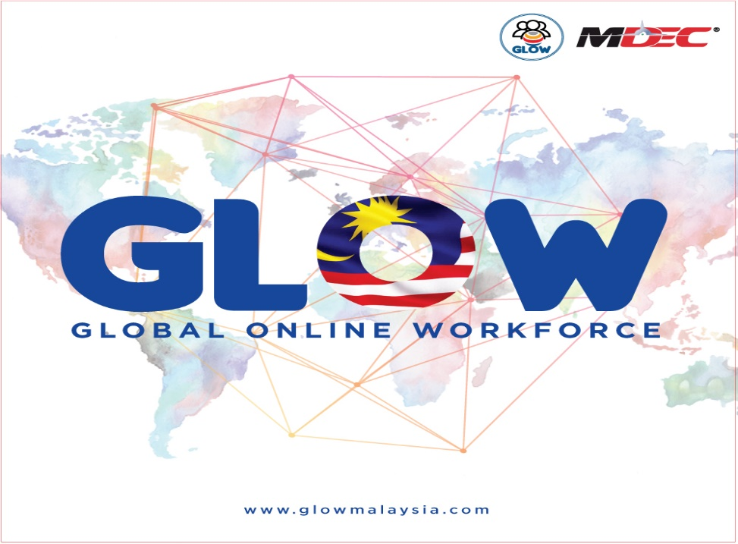

Name : Choy Wan Ling

Matrix Number : A18CS0049

IC Number : 980822 – 06 - 5468

Course : Computer Science - Network and Security

Lecturer : En. Hairudin bin Abdul Majid

Summary

In the era of globalization, everyone has their own electronic gadgets such as mobile phone, laptop and iPad. What is the function of these electronic gadgets? One of its useful functions is we can use it to access internet. We can use internet to connect with friends. We can also send, download and search informations from internet. It builts up an online platform and this encourages the existence of digital economy. GLOW programme promotes digital economy in Malaysia which offers online jobs for people to get career opportunities online. It provides digital tasks and assists people to earn income by doing the digital tasks. It builts up many freelancers until they become a full-time freelancer to work at flexible working environment and working time. This is the main option that people always do to become a full time freelancer online in this modern technology society because they need more personal time to travel and accompany with their family. They prefer to complete their works at home because it has a comfortable working environment and flexible working time. They can decide what time to work and what time to have meals and rest.

To join GLOW programme, you must register online first at GLOW website and create your own account. It needs you to provide your personal informations such as bank account, address, name and your age for profile setting up. At the website, it will also ask you to provide your life skills, academic skills, professional skills and your language level that you have learned. After registration, you can choose your preferences of the digital works among the choices given. This step is to allow the website to help you find a digital task matching to your respective skills. Once hired and completed the job, the payment will then be transferred to your bank account. It is such an easy and convenient way to gain additional income. The reason you must join in this programme is it assists you to find a job which you expert in and at the same time, you can earn your income online.

Introduction

Industrial Talk 1 :
Programme Global Online Workforce

Speaker : Cik Nor Ashikin binti Halil
(having working experiences as Virtual Assistant, Writer, Translator, Social Media Manager and Voice Over in GLOW programme)

Date : 24 September 2018 (Monday)
Time : 4.00 pm – 5.00 pm
Venue : Dewan Seminar, N28A

Nowadays, everyone can benefit from the digital economy. A government-owned agency called Malaysia Digital Economy Corperation Sdn. Bhd. (MDEC) is building Malaysia’s digital future through developing the transformation of Malaysia’s digital economy. A digital economy programme that introduced by MDEC with others global crowdsourcing platforms is Global Online Workforce Programme (GLOW). It is a programme that offers online jobs and people can get the jobs and earn the income by completing the digital tasks via online platforms.

The people who use telecommunications technologies to earn a living is called digital nomad. And this programme helps the digital nomad continue their life by doing digital works online. They will become more active when doing their works. Everyone are welcomed to register yourself as participant in this GLOW programme and give you a chance to start make a job online and gain additional income in this modern technology society !

Content

- What is GLOW programme and what are the benefits from this programme?

GLOW programme is a programme that provides exclusive online service to the Malaysians to build their income gap and increase their monthly income. It is easy to assist Malaysian to generate digital income consistently and on a full time basis.

GLOW programme is an online platform for freelancers to get hired and get paid. It provides digital tasks and assists you to earn income by doing the digital tasks. Digital tasks provided in GLOW programme is involving academic works, technical works, marketing works and transcription works. Digital task is a simple task that required non-specific high level of skills to perform. For examples, data entry of online forms, removing duplicated data, photo or image reviews, download or install tasks and SEO related tasks which is a marketing discipline that encompassed both the technical and creative elements required to improve rankings, drive traffic, and increase awareness in search engines.

Moreover, digital marketing also provided to the participants of GLOW programme. It encompasses all marketing efforts that use an electronic device or the internets. You can use the numerous digital channels to contact with your customers where they spend most of their time online. The most familiar of the digital marketing is digital advertising which promote your online business. You just post your business content on your social media channels such as Facebook, Instagram, Twitter, Snapchat, Google+ and Pinterest. This action increases brand awareness, drive traffic, and generates leads for your business. There are also some marketing works such as copied writing, development of a website and mobile application, creation of logo, graphic designs, software testing, audio or video transcription work, translation and document format conversion.

This programme brings up many freelancers. The benefits of GLOW programme is to provide huge job opportunities and alternative sources of income for Malaysians via multiple online platforms. It lets you to become a freelancer which have a flexible working time and places. It also develops a support programme for Malaysian freelancers to remain motivated and commited in generating digital revenue via online crowdsourcing platforms. Many freelancers become a full time freelancer once they bulit up their online platforms and have experience to gain money from their online platform.

The best part be a full time freelancer is you have a flexible working environments and time to get the satisfied income. It assures you to working at a no pressure place, and you can choose any job which suits with your skills and experiences. By doing jobs online, you are in-charge with your own jobs and free from administrate by anyone. No more meetings in office building and you can also travel to everywhere and at the same time can earn your income through online platforms. You will free from harassment and stress because you communicate with your customers or clients using very simple languages through online platform and not face-to-face. If troubles appear between you and your customers, it will reduce the brawl and can face the problem peacely using online platform.

In addition, although you already had a job position in any company which have a fixed working time and place, you are also encouraged to join the GLOW programme to do your part time online job to generate your additional income by doing digital tasks online. It helps you to improve standard of your living towards a leisure life. Money can be angel or evil. You can do anything with money, but you are nothing without money. Therefore, GLOW programme offers an online platform to allow you to earn more money by doing online jobs. Meanwhile, you will be more productive, preferable and have a lot of enthusiasm towards your online job because the job matches your respective skills which you expect in the area.

This GLOW programme is advanced to those who have the digital knowledges such as ICT, computer science because this programme prepares many career opportunities in digital field. A stable and consistent income can easily generated by the people who have digital knowledges through their skills in digital field. The thing that worth celebrating is they gain their income and they are doing their preferable works. They will become more disciplined and independent by having to complete digital works as per requirements by employers. By doing this, they are cultured to have an ability to open and develop a digital agency.

- How MDEC gets people to join GLOW programme and who can join this programme?

MDEC gets people to join this GLOW programme by organising seminars in schools include secondary schools, pre-universities , private schools, international schools and universities in Malaysia. The MDEC agency also can set a booth in career exhibition to allow people who interested in this GLOW programme to understand about this programme. In the career exhibition, the staff at the booth can prepare brochure which contains the informations about GLOW programme and give it to people. If the people are interested about this programme, they will stay at the booth and the staff can explain this programme to the people. The staff can take the initiatives to let the people who are interested in this programme to fill in their personal informations by means of forms. The people who are interested will receive a reply of email with attachment of informations regarding to this programme after filling in the form. It allows public who are probably never knew this programme before to get to know deeply about this programme.

This programme focuses on the low-income groups including students, housewives, retirees, senior citizens and the families having household income less than RM4,000 per month. It creates a gap or a platform to allow them find extra jobs online and gain extra income. Everybody can join this programme as long as you have the enthusiasm towards the job scope although you never have any working experiences.

- What is the impact of this programme to Malaysia?

Impacts of GLOW programme to Malaysia :
- Improve economy in Malaysia
- Unemployment rate decreases
- Standard and quality of life getting improve
- Investment of foreign countries
- Country income increases
- Transfer of technology between Malaysia and foreign countries
- Traditional business getting fewer and fewer attention by people

GLOW programme gives impacts to Malaysia. One of it is to enhance economy in Malaysia. It provides large career opportunities and allows people getting the job which they are able to complete it and get paid after they complete the works. This programme promotes job online and thus offers an alternative way for people to find a job. It bulids the income gaps among Malaysia citizens. People who have low education and are difficult to achieve the requirements of certification in company or offices can also obtain advantages from this programme. They can do simple digital tasks at least they possess the basic knowledge on how to use internet and connect network by electronic gadgets. Unemployment rates will decrease because people who are unemployed can easily earn income by working online. Meanwhile, standard and quality of life of Malaysia citizens will improve and raise dramatically because of income increases and liability decreases. People who are located at the low level of economic pyramid get the chances to improve their economic status and their life.

In addition, investment of foreign countries will increase due to the faster growing of digital economy in Malaysia. GLOW programme brings Malaysia to the international stage and connects Malaysia to international network. The development of economy Malaysia incites the foreign countries to invest in Malaysia. This is because they believe that their investment in Malaysia can return back with a huge of profit to their countries. Moreover, country income of Malaysia also increases due to the investment of foreign countries and development of digital economy. By having the raising of country income, Malaysia can utilise the income to develop other industries like academic education and tourism industry. It will improve our academic education level in Malaysia. The development of tourism industry to become more attractive can attract tourists and visitors from other countries to travel in Malaysia. This action will bring up the name of Malaysia on the international stages.

Transfer of technology also exists when faster development of digital economy. The reason behind is the development of modern technology and a new technology may appear on the next day. So transfer of technology is needed based on the development of digital economy. This action connects the technology networks between countries and thus having a good relationship between countries to discuss the facts of modern technology.

Being of the development of the digital economy, traditional business techniques and skills will get fewer and fewer attention by Malaysia citizens compared to the communities before. Nowadays, everyone only focuses on how to do business or engage online jobs until neglecting the traditional business techniques and skills. The is due to the business in this modern society are mostly conducted using internet or network on a system basis. Traditional business is not popular and familiar anymore as it is replaced by online system in the digital economy. The traditional business is changing to fit the developing digital economy.

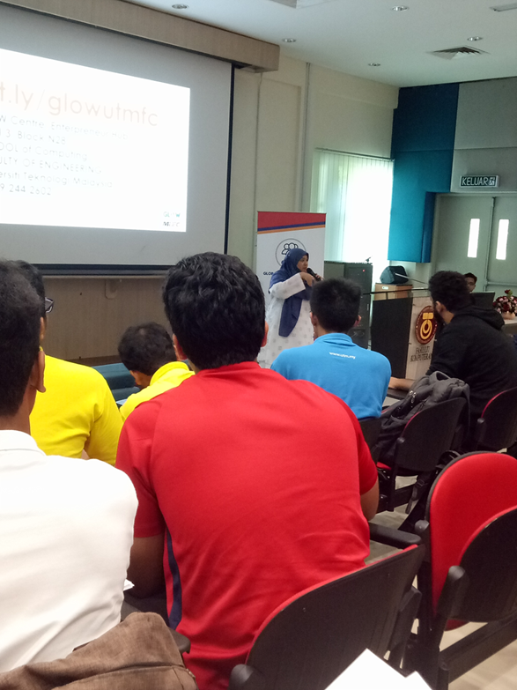
The speaker is explaining the GLOW programme to the students UTM.
Below are the slides show presented by the speaker, Cik Nor Ashikin :

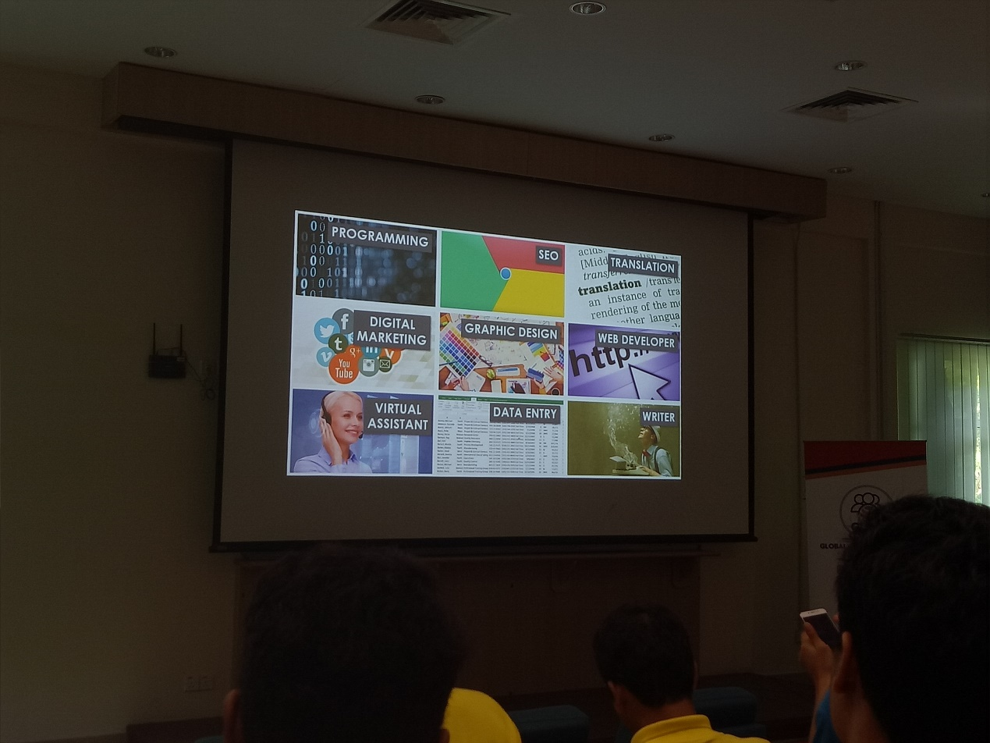

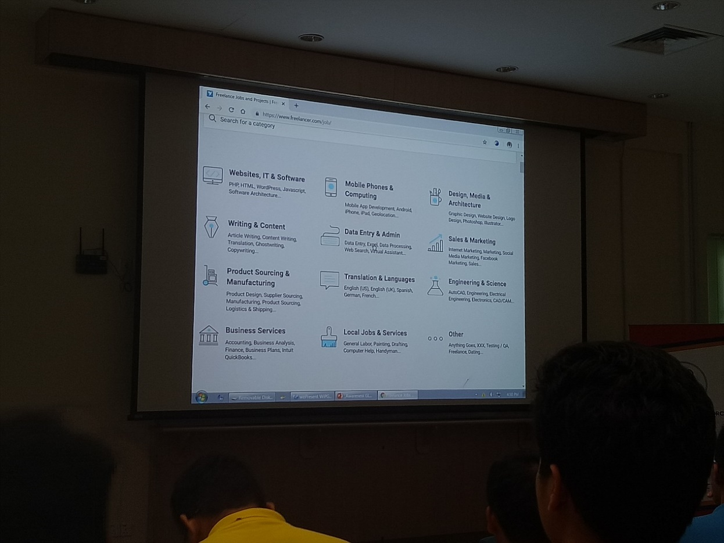
Example of digital tasks provided on GLOW website.

Here are the example success stories of the speaker and some students to gain income from online platform :

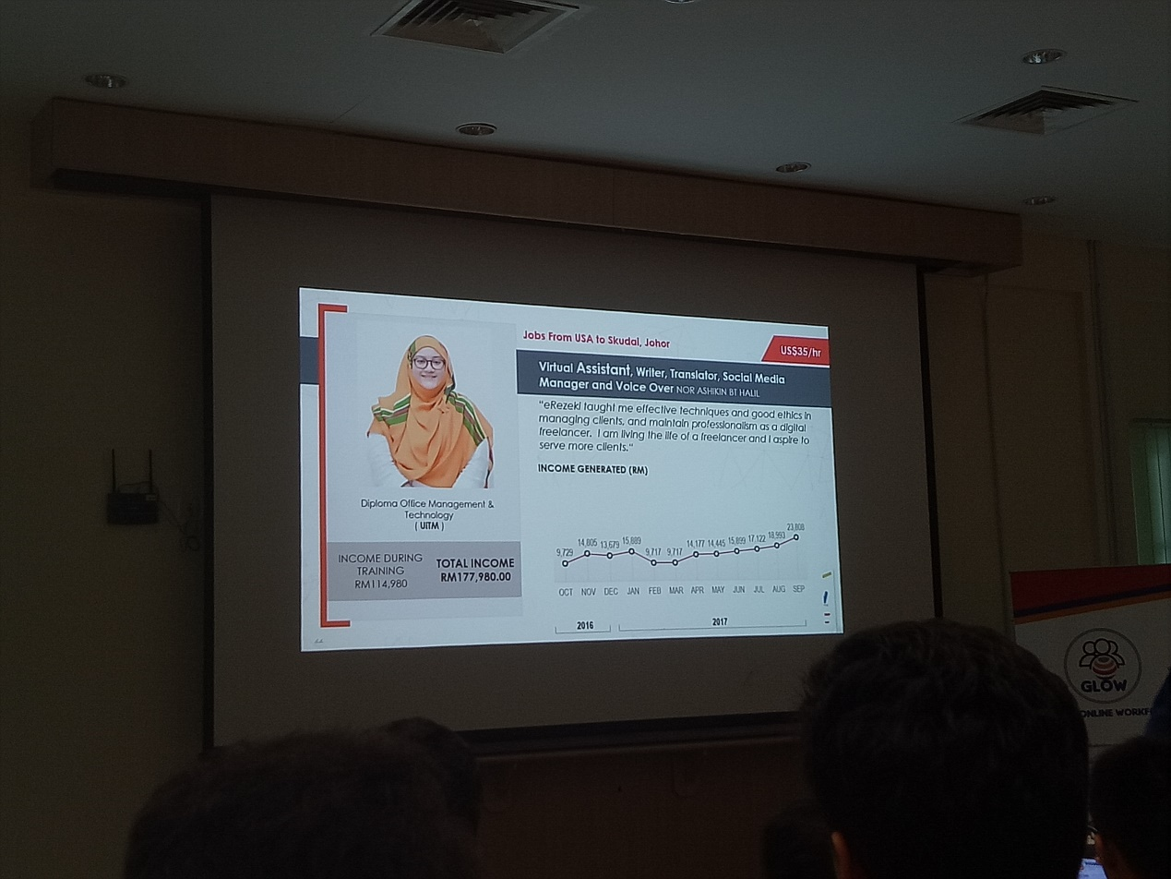

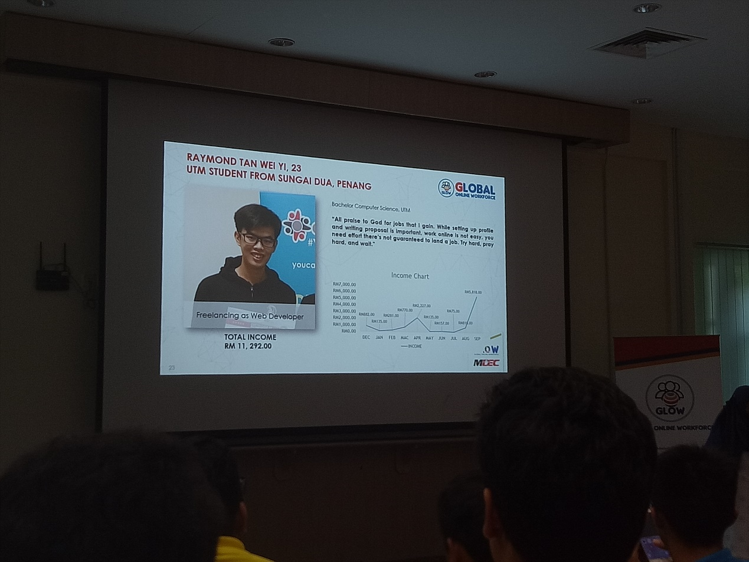
Attachment

What would you like to choose either working at home with a flexible working time or get a job from a company with a fixed working time ?

FlexJobs had done a survey to see whether the people are seek for a job with flexible working time or not. FlexJobs published a breakdown of data from the respondents mostly from working parents (those with children 18 years old or younger at home), freelancers, entrepreneurs, introverts, students and retirees who took the 6th Annual Work Flex Super Survey.

According to FlexJobs’ 6th Annual Work Super Survey 2017, 62% of the survey respondents have left or considered leaving a job because it did not have work flexibility, below is the percentages of the options :

Options | Percent (%)
Yes, I have left a job. | 32
Yes, I am currently looking for a new job. | 16
Yes, I have considered leaving a job. | 14

Each year, they ask people to choose the factors that make them want a job with a flexible work option. Since 2013, work-life balance (78%), family (49%), time savings (46%), and commute stress (45%) have been the top four reported reasons people seek flexible work.

People interested in work flexibility evaluate job prospects with that in mind. Respondents said the “most important factors” considered when they evaluate a job prospect are:

Factors | Percent (%)
Work-life balance | 72
Flexible schedule and salary | 69
Telecommuting | 60
Meaningful work | 57
Work schedule | 48
Location | 45
Company reputation | 40
Health insurance | 37
Professional challenge | 36
Company culture | 34
Career progression | 30
Amount of travel required | 25

Survey also asked whether they would be more productive working remotely or in a traditional office space.

Productivity | Percent (%)
More productive in a home office | 66
Probably about the same productivity | 32
Less productive in a home office | 2

That’s understandable when you consider their answers to this question:
“Where do you go when you really need to get something done for work?

Working place options | Percent (%)
My home or my home office | 52
The office during regular office hours | 32
A library, coffee shop, or coworking space | 6

The top reasons that respondents said they would be more productive working remotely at home or working with flexible time are:

Reasons | Percent (%)
Fewer distractions | 76
Reduced stress from commuting | 70
Minimal office politics | 69
Quieter noise level | 62
More comfortable clothes | 54
More personalized office environment | 51
Less frequent meetings | 46

(Sources : from FlexJobs’ 6th Annual Work Super Survey 2017)
https://www.flexjobs.com/blog/post/productive-working-remotely-top-companies-hiring/

Conclusion : Nowadays, the people are more preferable to stay at home or working at home if possible. They want to have a flexible working time due to the reasons above in the survey. And the reasons are promoted to their working productivity.
For them, finding an online job or doing online business is the first choice !

According to the Gallup survey, it shows the report that people spent a day or less a week working remotely shrank substantially from year 2012 to 2016, falling to 25 percent from 34 percent. At the same time, the report also shows working remotely four to five days a week grew by nearly the same amount, rising to 31 percent from 24 percent.

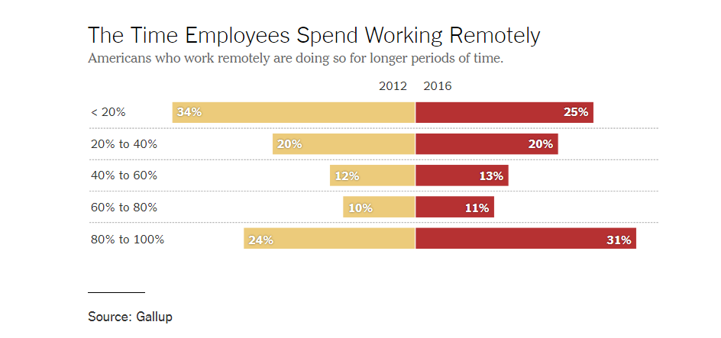

(Sources : from Gallup survey)
https://www.nytimes.com/2017/02/15/us/remote-workers-work-from-home.html

Conclusion

As a conclusion, GLOW programme provides a digital economy and thus offers huge career opportunities for people to earn income from it. These online platform is not selling product, but selling skills. You can find the online jobs through the online platform like international and domestic platform based on your respective skills. You can generate and earn your digital income from this programme because this programme provides an online platform to let you get hired and get paid once you get your jobs online.

Among the successful businessman who do their business online, Brian generated an application system called Airbnb. He is a good example for people who wish to gain their income through digital economy and online platform. He allows people to work and earn money from him in the field of digital economy and online platform. Besides that, another famous entrepreneur, Jack Ma who established Taobao, a large international business network. He discovered the potential of online business, having people to get reach to a product of services by just a click on the gadgets. These examples show how a big effect of digital economy and online platform to the modern technology society nowadays.

Reflection :
According to my attendance to the briefing about GLOW programme, I had gained some informations and knowledge about how to use online platform to access a business and job in anywhere. I have some ideas after attended the briefing of GLOW programme. In this modern world, network and internet are considered neccessities to everyone. Internet offers online platforms to us. We are able to access internet to do everything because nowadays every field of business has its respective online platform which using internet to conduct it such as education, technology industry, service industry, catering industry, clothing industry and others. The reason behind of using online system is making everything simple and easy. Hence, online business provides career opportunities so that people can get jobs online. All informations can be transferred to whole world just in one second. The industry’s advertisements can be spread to every corner of this world since every place at this world has internet. From here we realise the importance of internet in this world nowadays and cannot ignore the conveniences and advantages of internet that brought to us.

References

- https://glowmalaysia.com/what-is-global-online-workforce-freelancer/?lang=en ; Global Online Workforce ; last surveyed on 1 October 2018

- https://www.flexjobs.com/blog/post/productive-working-remotely-top-companies-hiring/ ; 2017 Annual Survey Finds Workers Are More Productive at Home, And More ; last surveyed on 29 September 2018

- https://www.nytimes.com/2017/02/15/us/remote-workers-work-from-home.html ; Out of the Office: More People Are Working Remotely, Survey Finds ; last surveyed on 29 September 2018

