

**School of Computing** Faculty of Engineering

**Semester 1 2020/2021**

Subject: Technology and Information Systems (SECP1513)

Section: 04

Task: Design Thinking Report

Title: Privacy, Security, and Ethics

Lecturer: Dr. Goh Eg Su

Prepared by:

Group members: Lai Leng Shuen A20EC0060

Muhammad Shawaluddin Bin Shaari A20EC0099

Muhammad Fakhrullah Bin Kamal Bahrin A20EC0087

Muhammad Fadthun Amierrun Bin Md Nor'azam A20EC0085

Preparation for:

Lecturer: Dr. Goh Eg Su

University Technology Malaysia (UTM)

**CONTENTS**

**Introduction** 1

**Step and descriptions in design thinking and evidence for each phase** 2

**Descriptions include problem, solution and team working** 4

**Problem** 4

**Details about problem:** 4

**Malicious Codes** 4

**Solution** 5

**Team-working evidence** 5

**Design thinking evidence** 7

a) **The sample work by students working to solve the design challenge** 7

**b) Record for each phase** 7

**(i) Empathy** 7

**(ii) Define** 7

**(iii) Ideate** 7

**(iv) Prototype** 8

**(v) Test** 8

**Reflection** 9

**Task for each member** 10

**References** 11

# **Introduction**

In this modern-day, creative thinking skills are one of the aspects that need to be emphasized in the community especially among the youth. This is because society nowadays prefers tasks that can be completed in a short time so that they can use the remaining time to do another job. Not everyone was born with a creative mindset of various innovations. Therefore, society needs to do something that can produce creative-minded youth. Design thinking is one of the ways to overcome this problem.

Execute problem-solving solution can be easier with design thinking methods because it can help students to gain an understanding. The implementation of Design Thinking makes students determine the root cause of the problems that their facing. Furthermore, design thinking encourages students to think about innovative thinking and come out with creative solutions. Thus, it also helps to enhance the students’ level of thinking skills. Lastly, the prototyping in the design thinking application will give the students an opportunity to acquiescence their experiment. However, it is not a method to validate your idea but it is a part of your process. Design thinking process can be divided into 5 major steps:

• Empatize

• Define

• Ideate

• Prototype

• Process

# **Step and descriptions in design thinking and evidence for each phase**

For this project, we use 5 phased before came out with this new product.

**Empathize**

For this phased, we interviewer one of the IT staff from UTM through google meet and ask him a few questions. We try to find the common problem that the staff always faced as database management. We note that the most common problem that the staff faced was the virus that is carried by the end-user or student who used the UTM website. The IT staff said that the virus usually came from users or students who used Windows to open the UTM website. If this problem continues to happen, it can harm UTM data, even though the anti-virus is already been provided to all end-user. Other than the virus problem, the IT staff told us that the money budget is one of the problems, since building a more secure system cost a lot of money.

**Define**

During this phase, we make group discussions through google meet. We divided all the problems that we could found from the interviewer with the IT staff and defining all our problems and matter into detailed information. For every problem that we found, we try to come out with every possible solution that is really suited to the problem.

**Ideate**

For this phase, we had the brainstorm session. Each of our members needs to come out with their own opinion and point of view for each of the problem and solution that we already discussed during the defined phase based on these criteria:

* The rational choice
* The most likely to delight
* The long shot

**Prototype**

This is the phase when we are developing our idea by making a prototype. For the prototype, we use a slide-show to briefly explain how the prototype works in solving our main problem, which is a virus that is carried out by the end-user. So basically, our prototype is making an anti-virus that can fit any type of virus or virus attack such as malware. This prototype can help the end-user to fight any type of virus by only using one antivirus. As we all know, the anti-virus that we have now is fixed with one type of virus only. This prototype can help to solve many problems and also reduced the cost of making many types of anti-virus.

**Test**

To complete this design thinking project, we briefly explain to our IT staff that we interviewer earlier and ask him about his opinion about our prototype whether our project works on solving his problem.

# **Descriptions include problem, solution and team working**

## **Problem**

Data observed:

Problem that the IT staff faced was the virus that is carried by the end-user/ student who used the UTM website.

* That virus usually came from users or students who used Windows to open the UTM website. If this problem continues to happen, it can harm UTM data, even though the anti-virus is already have been provided to all end-user.

IT staff also stated that money budget is one of the problems, since building a more secure system cost a lot of money.

## **Details about problem:**

Our main focus about our problem is virus attack. In technology security, it not only about virus but it has a lot of attack and that all categorized as Malicious Codes. Description below tells details about Malicious code.

## **Malicious Codes**

Malicious code is the term used to describe any code in any part of a software system or script that is intended to cause undesired effects, security breaches or damage to a system (DuPaul, 2019). Potential damage can include modifying, destroying or stealing data, gaining or allowing unauthorised access to a system, bringing up unwanted screens, and executing functions that a user never intended. Examples of malicious code include computer viruses, worms, trojan horses, logic bombs, spyware, adware and backdoor programs(Region, n.d.).

Example of Malicious code:

1. Virus

A computer virus is malicious code that replicates by copying itself to another program, computer boot sector or document and changes how a computer works(Rouse, 2019).

1. Worm

A computer worm is a type of malicious software program whose primary function is to infect other computers while remaining active on infected systems (Rouse, 2019). Worms don't need to be attached to other files (McElhearn, 2018). They often replicate over networks, rendering them particularly dangerous (McElhearn, 2018). Example is the “Oompa-Loompa” worm.

1. Trojan Horse

A Trojan horse, or simply Trojan, is a type of malware that is disguised as a useful piece of software or data file (McElhearn, 2018). Hackers use a digital Trojan horse to hide malicious files in seemingly harmless files with the intent to attack or take over your device (McCafe, 2014). There are several types of Trojan horses which are Backdoor Trojan, Downloader Trojan, Info Stealer Trojan, Remote Access Trojan and Distributed Denial of Service.

## **Solution**

As we know that every antivirus software has specific function for specific malicious codes. We need to have every antivirus for every malicious code to make system more secure. However, it cost money for every antivirus software.

We decided to create antivirus software which its speciality can cover all kind of attack in malicious codes like virus, worm, Trojan horse and also add some firewall feature to filter any kind suspicious harm files.

## **Team-working evidence**

We had conducted some brainstorming session by using google meet due to the covid-19 pandemic. Besides that, we also had an interview session with Mr. Aris Arifin, staff from UTM DBA about the problems he faced in his workspace.

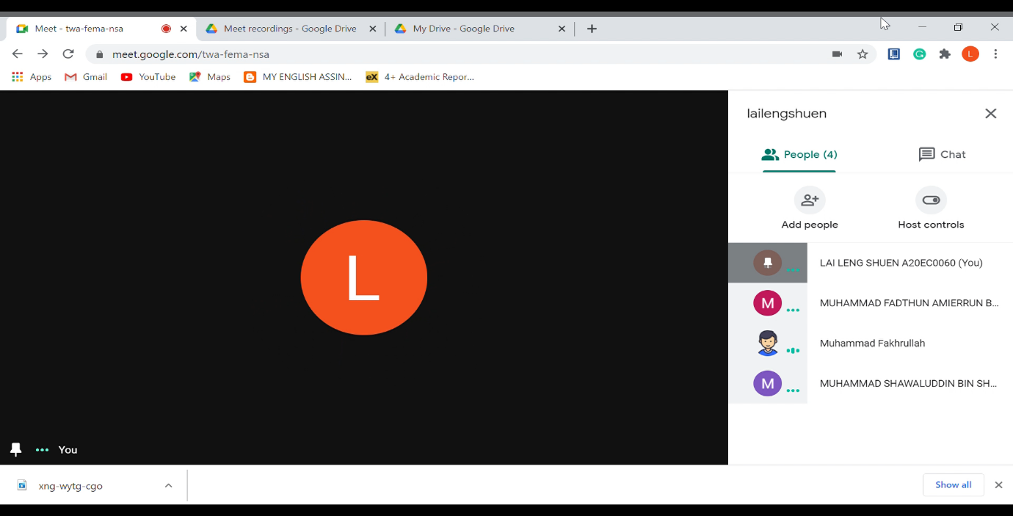

Figure 1 First meeting conducted on 2th November 2020

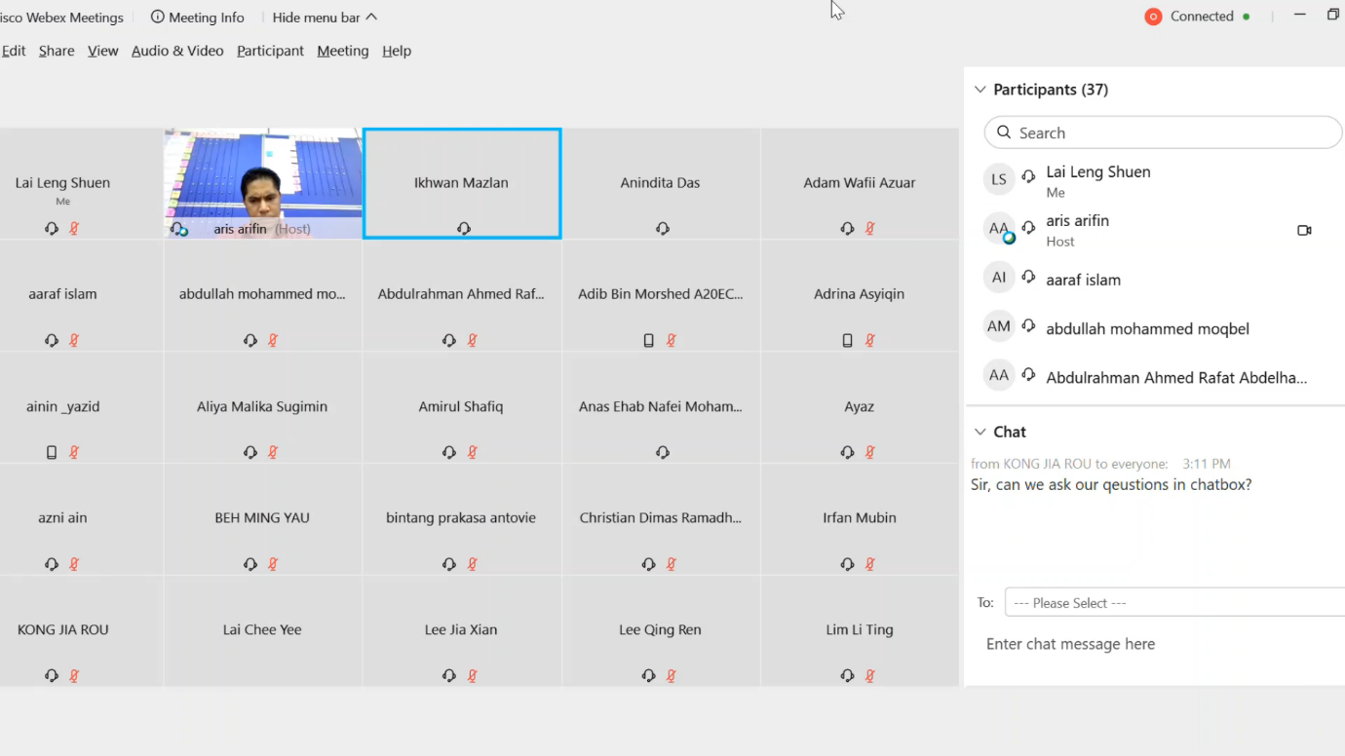

Figure 2 Interview session with Mr. Aris Arifin on 3th November 2020

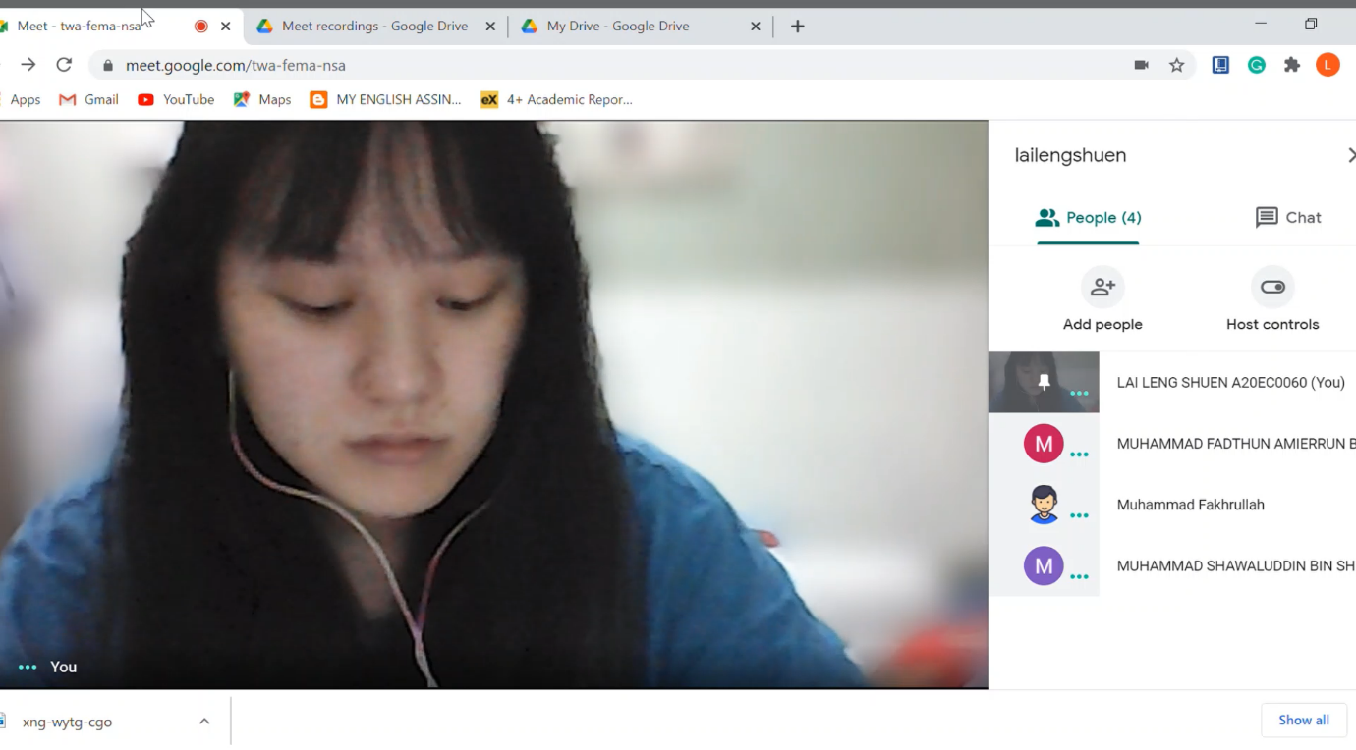

Figure 3 Second group minute meeting on 7th November 2020

# **Design thinking evidence**

## a) **The sample work by students working to solve the design challenge**

Hackers always love using mutations like a biological virus once the malware infects a device. There are different types of malware unknown to the virus database but we design to do an antivirus have a few extra tricks of their own.

Firstly, we want to use heuristic analysis. Instead of trying to detect just a single signature and fall victim to a mutation, our prototype will combine all related ones into families that way that looks like a virus from each family. Besides, the second technique is through using a sandbox before installing any new software. A sandbox will test a new file or run new software in a contained environment and then sit back and wait. It will watch what happens and what the programs try to do and all of that will be conducted in a safe isolated environment. In our project, we try to design an antivirus that is user friendly, low on resources, and can use a multi-pronged attack against the newest and most sophisticated malware.

## **b) Record for each phase**

### **(i) Empathy**

We had an interview with UTM DBA staff, Mr. Aris Arifin. We found out that the problem that the IT staff faced was the virus that is carried by the end-user or student who used the UTM website. We had done some research on the Internet and Youtube about the type of malware that is invasive and tries to figure a way out to solve the problem of users. As the user are all university students, we decide to design a prototype which is easy to use in their daily life.

### **(ii) Define**

From the questions we extract from our interview video clip, we found out that there is various antivirus that has an expensive price that cannot affordable by most of the students. Other than that, we also found out that most of the antivirus software installed by students is illegal and not safe to use. So, we have decided to help solve these problems by having a deeper understanding of the problem so that we can produce the best prototype that suits the need of all users.

### **(iii) Ideate**

We had our brainstorm process in this phase. Every member needs to give their idea about how to overcome the user’s main problem. Finally, we come to an agreed-upon decision to make antivirus software that is legal and free from malware.

### **(iv) Prototype**

In this phase, we had visualized our prototype with our group members. Basically, our prototype is used for students to protect their devices from being attack by malware. We had done some research on the internet about how effective antivirus software looks like. We had developed our prototype by using some techniques such as heuristic analysis and sandbox. The antivirus is installed in user’s devices, and whenever there exists malware that may attack the user’s device, this antivirus software will block all the unknown sources and keep the devices in a safe condition.

### **(v) Test**

By reaching this stage, we had briefly explained how our prototype works to the IT staff that we interviewer earlier and ask him about his opinion about the idea of whether our project works on solving his problem.

# **Reflection**

**Lai Leng Shuen**

Throughout the project, the most obvious thing that I discovered was the advantage of working as part of a gaggle. I have never thought of myself to be a leader. Luckily, I had met group members that are cooperative and willing to share their knowledge. I communicate my ideas to the group while trying to balance the ideas of others so that the group can come to an agreed-upon decision. I revealed that good teamwork is the key to success in design activities when time and resources are limited. As everyone had their point of view, many various ideas could be produced, and I feel more energetic to contribute when I am in my group.

I had revealed my strength which is time management in doing my job. I had made some timetables in making an appointment with our group members to have an online meeting to discuss our project due to the pandemic. From this project, I had taken my responsibility as a group leader to generate momentum within our group so that each part distributed to group members has been completed perfectly. Overall, this project could be a great introduction for me towards this course and I hope that I will be able to have the opportunity to try and do another similar project in the future.

**Muhammad Fadthun Amierrun Bin Md Nor'azam**

I hope that technology and information system course can help me to know much more about computer by making me fall in love with computer. This is because I have an ambition to get a job base on computing.

The design thinking impact on me is it help me to enhance my thinking skills and helps me to interact more people to solve the problem in easier ways.

The plan that is necessary for me to improve my potential in the industry are by always asking for help if there is something that I cannot solve it by myself and always work in a group to solve a problem

**Muhammad Shawaluddin Bin Shaari**

My goal for this course, is to learn and explore new things about technologies. I want to know more about IT world and create new things like new software and technologies.

I think, this design thinking project give me a new fresh idea and also helps me to think more maturely in the future. I become wiser when making decision and always plan 1 or 2 steps ahead from others.

Necessary thinks that I can do to improve my potential is learn from my previous mistake and keep moving forward.

**Muhammad Fakhrullah Bin Kamal Bahrin**

I always have difficulty to face problems. After I learned about design thinking method, I am so grateful this method very helpful to finish my tasks. It makes tasks more systematic and also more professional. I was hoping this can be used for my job in the future and also compatible with any kind of solutions.

# **Task for each member**

Lai Leng Shuen

* Distribute works equally between members
* Ensure all the task complete on time
* Record the interview and group minute meeting

Muhammad Shawaluddin Bin Shaari

* Make a group discussion to brainstorming idea
* Briefly explain about the prototype to the staff
* Briefly explain about every phased in the report

Muhammad Fakhrullah Bin Kamal Bahrin

* Elaborate about virus
* Explain details about malicious code
* Elaborate antivirus functionality

Muhammad Fadthun Amierrun Bin Md Nor'azam

* Asking permission from the UTM staff for an interview
* Discuss introduction part in the report
* Making prototype

# **References**

DuPaul. (2019). *Malicious code*. Retrieved from Veracode: https://www.veracode.com/security/malicious-code

McCafe. (27 October, 2014). *What is trojan horse*. Retrieved from McCafe: https://www.mcafee.com/blogs/consumer/family-safety/trojan-horse/

McElhearn, K. (2018). *Viruses, Worms and Spyware—Yikes! A Look at Malware*. Retrieved from Intego.

Region. (n.d.). *What are Virus &amp; Malicious Code*. Retrieved from Infosec: https://www.infosec.gov.hk/en/knowledge-centre/malware

Rouse, M. (2019). *Virus*. Retrieved from TechTarget: https://searchsecurity.techtarget.com/definition/virus