

**SECR2013-10 NETWORK COMMUNICATIONS**

**TASK 3: CHOOSING THE APPROPRIATE LAN DEVICES**

**GROUP 7 – SUNFLOWER**

Nurul Syamira binti Amat Jifri (A19EC0145)

Khaireennur Khaliesha Binti Mohamad Jais (A19EC0300)

Sarah Chintya Rachmi (A19EC0283)

**Lecturer’s Name**: Dr. Syed Hamid Hussain Madni

**Table of contents**

|  |  |
| --- | --- |
| Title | Page |
| Research on the different network devices that needed to accomplish the objective | 2 |
| Decide which LAN devices needed to accomplish the needs as mentioned in the case study | 3-5 |
| Information on the devices that have chosen | 6-20 |
| Reflection & References | 21 |

**a) Research on the different network devices that needed to accomplish the objective**

Choosing network devices is one of the most important decision to make for the technology infrastructure and will have far-reaching result over the long-term. It’s a decision that requires careful thought in order to get it right from the start to prevent wrong choices that can lead to an expensive mistake. There are considerations to be done when selecting network devices:

* Ease of use - Lecturers, staff and students be able to use the devices easily
* Compatibility - The devices to be used together without problems and then can connect to network
* Ease of maintenance
* Ease of installation

Without network devices such as router, hub, switch and more, data cannot be transmitted from one computer to another in a LAN or WAN network. These devices will connect all local and remote network segments with each other to make data communication from one segment to another. Two important devices for a big network are routers and switches. A computer network with a good base that is properly placed and configured, is helpful in reducing the operational cost, improve the performance, manageability and reliability.

**b) Decide which LAN devices needed to accomplish the needs as mentioned in the case study**

LAN devices can be grouped into two categories, hardware components and software components. The most important is the hardware components which consists of:

* Workstations and servers
* Network Interface Card (NIC)
* Cabling and connectors (Twisted Pair Cable)
* Hub
* Switch
* Router

**Switch**

A switch receives a frame and regenerates each bit of the frame on to the appropriate destination port. This device is used to segment a network into multiple collision domains. In general, switches are chosen fro connecting devices to a LAN. Inside the LAN will be one or more hubs or switches to connect the end devices to the LAN.

In a network, a network switch performs the same functionality as a hub expects a separate switch that does not broadcast the data packets on all computers like a hub in a network. There are several ports for a network switch, such as 4, 8, 16 and 24, etc. The Ethernet cable links all the computers in a wired network directly to the switch. Switches restrict traffic to and from each port and provide the full available bandwidth for all the devices connected to the switch. The built-in firewall features like the routers are not supported by Switch. Infrastructure switches play an important role in telecommunications and packet switches. Based on the IP address, they send the data towards their destination. Switches operate on a layer of data connections.

**Router**

Router is the primary devices used to interconnect networks. Each port on a router connects to a different network and routes packets between the networks. Routers have the ability to break up broadcast domains. Routers are also used to interconnect networks that use different technologies. They can have both LAN and WAN interfaces. Each LAN will have a router as its gateway connecting the LAN to other networks.

When selecting a router, we need to match their expandability to its purpose. Since router can be used to connect different types of networks, extra care must be taken to select the appropriate models. Also, router already has built-in Operating System known as IOS.

We choose network-edge router because as more services and applications begin to be managed on the network edge of an organization rather than in its data center or in the cloud, edge routers play a fundamental role. Wireless capabilities, often built into network edge devices, Dynamic Host Configuration Protocol (DHCP) services and domain name system (DNS) services are considered suitable services for edge router management.

**Workstations and servers**

A workstation is a personal computer used for high-end applications including graphic design, video editing, CAD, 3-D design, or other intensive programs for CPU and RAM. Usually, a workstation has a top of the line, fast processor, several hard drives, and a lot of memory for RAM. For special editing work, a workstation can also have special audio, video, or processing cards. A workstation, while the server is more of a utility system, is sold to technical users by computer manufacturers.

A server is an application or device that performs a linked client service as part of the architecture of the client server. It may also be a computer device designated to run a particular program for the server . On an intranet, a server can also serve applications to users.

Workstations are mainly intended to be used by one person at a time, although other users can typically still access them remotely when needed. Servers fulfill the user link task and usually have no user or just one user. The most popular operating systems for servers are [FreeBSD](http://en.wikipedia.org/wiki/FreeBSD), [Solaris](http://en.wikipedia.org/wiki/Solaris_%28operating_system%29) and [Linux](https://www.diffen.com/difference/Linux_vs_Windows) while workstations run on UNIX.

**Network Interface Card (NIC)**

A network interface card (NIC) is a part of hardware without which it is not possible to link a device over a network. It is a machine-installed circuit board that provides the computer with a dedicated network connection. It is often referred to as a network interface controller, LAN adapter or network adapter. NIC enables communications between local area network (LAN) connected computers as well as large-scale network communications through Internet Protocol (IP).

**Cabling and connectors (Twisted Pair Cable)**

Both wired and wireless communications are possible via NIC. NIC is both a physical layer and a data link layer unit, i.e. it provides the hardware circuitry required so that it can operate on the physical layer processes and certain data link layer processes.

Twisted pair cable is a pair of wires running through a flat and lightweight cable. It is lighter than any cables so it is easier to install. It has phone-style plugs at the end of the cable that can easily put into jacks of computer, switches, hub or more.

**c) Information on the devices that have chosen**

**Switches**

# **D-Link PoE+ Switch, 24 28 Port Fast Ethernet Managed Web Smart 2 Gigabit**

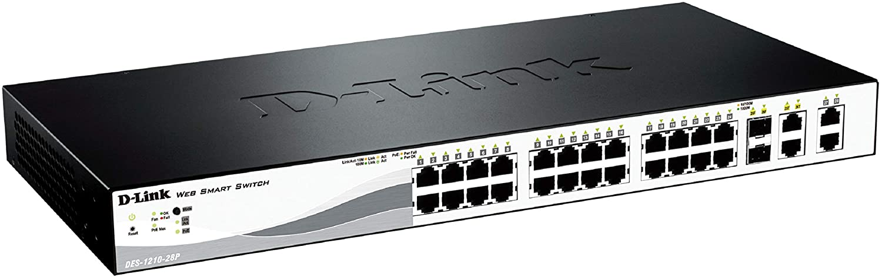

* Web Smart Switch with 24 10/100Mbps Ports, 2 10/100/1000BASE-T and 2 combo 10/100/1000BASE-T/SFP.
* For the security features it can access control list, D-Link Safeguard Engine and Port Security.
* Intuitive Management: SmartConsole or Web-Based GUI, Built-in MIB Browser for SNMP, D-View 6.0 Module Support and Compact CLI through Telnet
* PoE support for 802.3af and 802.3at up to 193W total budget.24-Port Fast Ethernet PoE Smart Managed Switch with 4 Gigabit Ethernet ports (including 2 Combo SFP) (24 x PoE ports, smart fans).
* Cost for this switches is around RM1000 and above.

# **D-Link DGS-1210-10P Smart Gigabit Ethernet Switch 10 port**

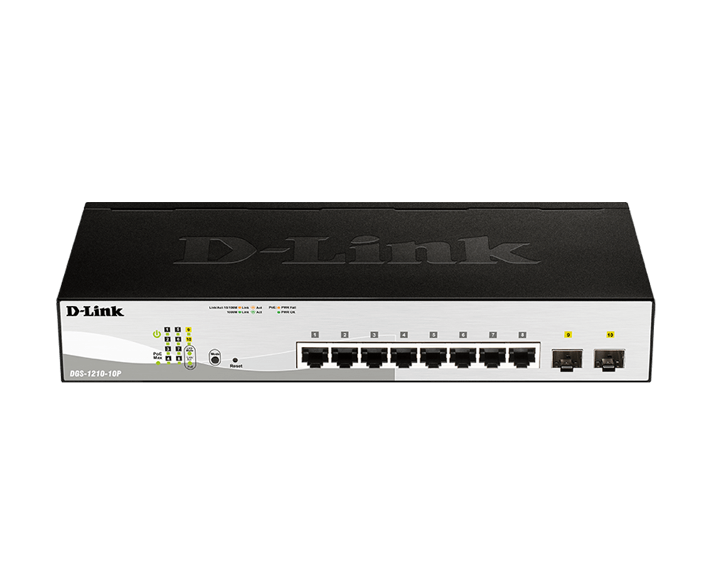

* 2 10/100Mbps Fast Ethernet ports
* 2 10/100Mbps copper gigabit ports
* Auto MDI/MDIX for each port
* Full/half-duplex support for each port
* Flow control for protection against data loss for each port
* Auto-learning of network configuration
* Secure store and forward switching scheme
* Per port auto correction of reverse twisted pair polarity
* Standard 19 inch rack mount size Non-Blocking and wire speed
* Cost for this switches is around RM900 and above.

# **CISCO Four port 10/100/1000 Ethernet switch interface card EHWIC-4ESG**

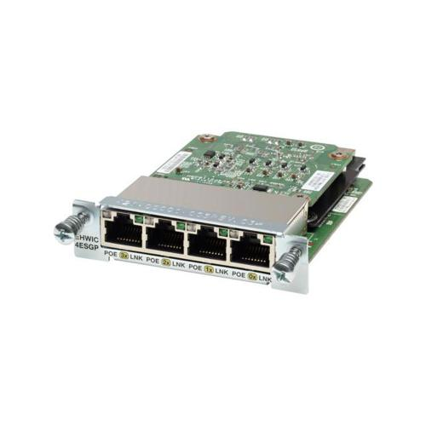

* 4-Port Gigabit Ethernet Enhanced High-Speed WAN Interface Card
* 4 x RJ-45 10/100/1000Base-T Network WAN
* IEEE 802.1P QoS
* IEEE 802.1Q VLAN
* SNMPv1; v2; and v3
* Telnet
* CiscoWorks LAN Management Solution
* Price: RM2069 and above

**Router**

# **Cisco 900 Series Integrated Services Routers**

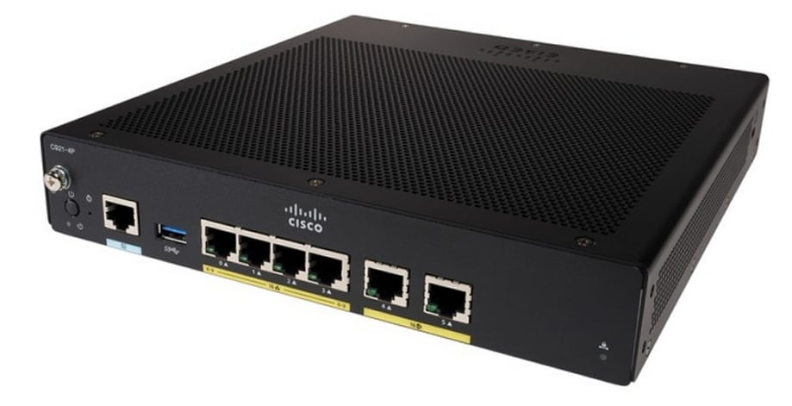

* Redundant WAN connections for failover protection and load balancing
* Dynamic failover protocols such as VIRTUAL ROuter Redundancy Protocol (VRRP , RFC 2338) , Hot Standby Router Protocol (HSRP) , and Multigroup HSRP (MHSHRP)
* Can run multiple services simultaneously with no performance degradation
* Supports LAN connections
* Simplifies and centralize configuration and management of wireessand wireline devices
* Support separate console ports
* Network perimeter security with integrated application inspection firewall.
* Data privacy through high speed IP security (IPsec) Triple Data Encryption Standard (3DES) and Advanced Encryption Standard (AES) encryption
* Enforced security policy with intrusion prevention
* Flex VPN
* Price: RM3000 and above
* **Cisco IR1101 Integrated Services Router Rugged**

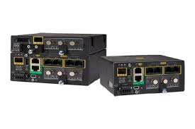

* A single form factor with multiple WAN (LTE, LTE-Advanced, SFP Ethernet) and storage options enable flexibility to add or upgrade modules as technologies evolve.
* With two LTE modules (LTE and LTE-Advanced1 with carrier aggregation), the IR1101 enables concurrent connectivity to two cellular networks for WAN redundancy, enhanced data throughputs, and reliability.
* Open and standards-based APIs with programmable manageability. Enables end-to-end security with next-generation encryption, and reduces business and network complexity allowing you to deploy new services faster.
* High WAN availability and simplicity for large-scale distributed networks.
* Multi-layer security for mission-critical deployments. Cisco Trust Anchor technologies to ensure authenticity of hardware and software,hardware-accelerated next-generation encryption and Quantum computer-resistant algorithms,firewall and VPN services and alerts and notifications for physical and cyber security.
* Price: RM2800 and above
* **Cisco 4000 Router ISR4331 (ISR4331/K9)**

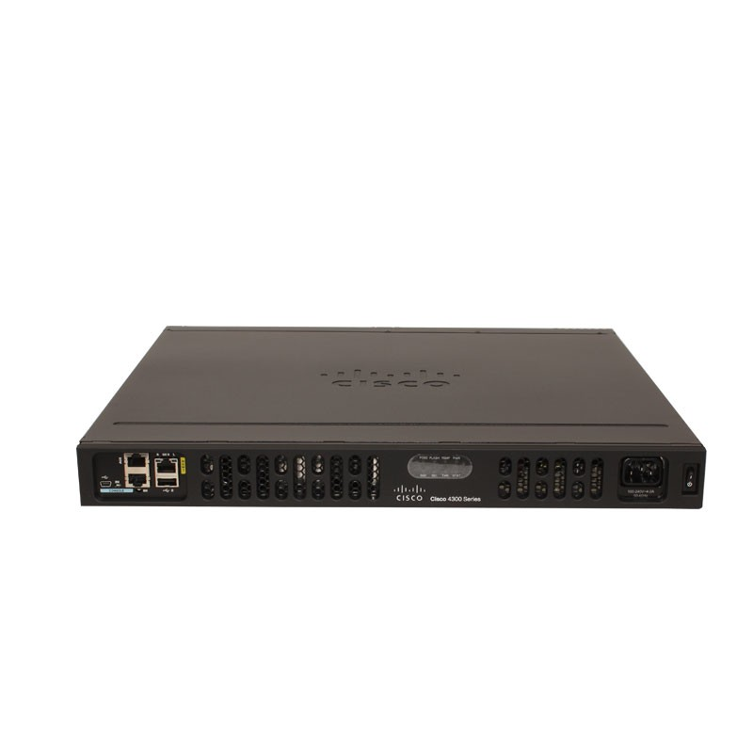

* (3GE,2NIM,1SM,4G FLASH,4G DRAM,IP Base)
* Cisco 4000 Router
* 100Mbps-300Mbps system throughput
* 3 WAN/LAN ports
* 2 SFP ports
* multi-Core CPU
* 1 service module slots
* Security
* Voice
* WAAS
* Intelligent WAN
* OnePK
* AVC
* Price: RM4000 and above

**Cabling and connectors (Twisted Pair Cable)**

* **EZ RJ45 CAT6 connector with 3U gold RJ45 pass through connector**

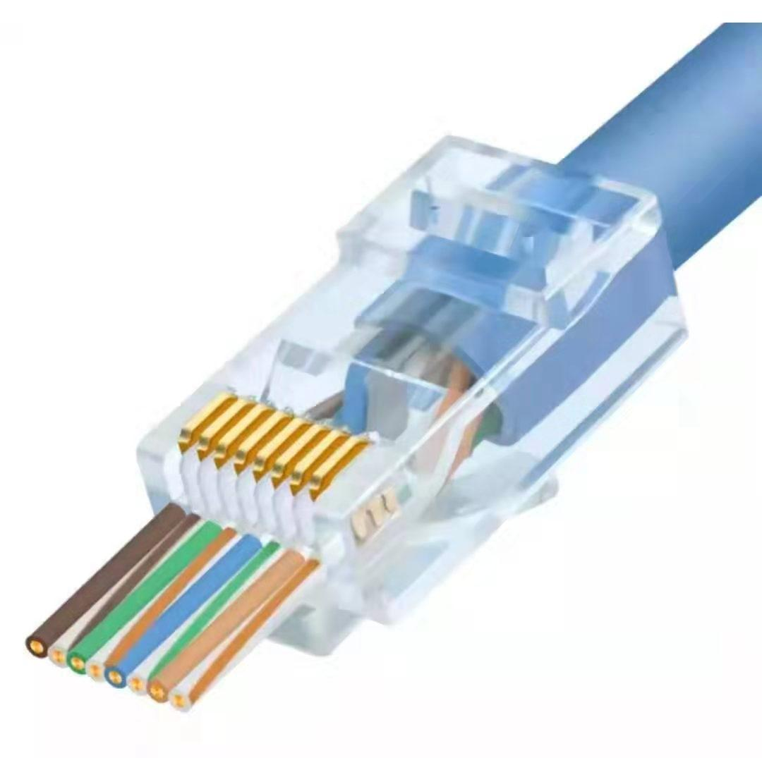

* 250V AC max at 2 amps.
* Dielectric with standing 500volts AC.
* Insulation Resistance: 500 megaohms.
* Termination Resistance: 35 megaohms.
* Cable-to-plug tensile strength-20lbs ( 89N ) min.
* 500 mating cycles
* Price: RM200 and above
* **Fiber Optic Cable**

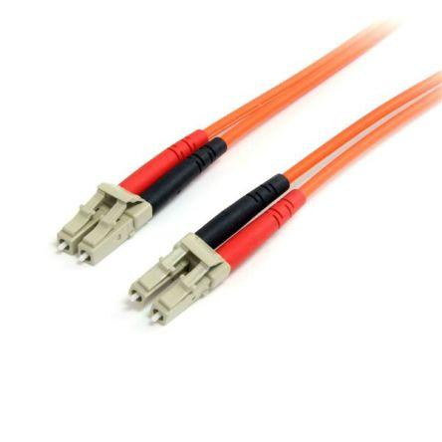

* **Bandwidth and data transfer** - In contrast to fibre optics, older metal data cables, typically copper, provide comparatively small bandwidth. Initially, copper-type communication cabling was designed to transmit voice signals that do not need almost as much bandwidth for mass data transmission as is now needed by many modern applications.
* **Speed** - As opposed to other data transfer modes, the use of light signals as the primary source of information conveyance gives fibre optic cables a significant speed advantage. In this respect, fibre will usually well exceed the predicted output of even high-grade (Cat5 or Cat6) copper cables.
* **Distance** - As well as being lightning fast, due to their low rate of signal power loss, fibre optic cables can also carry their signals over far longer distances than conventional forms of cabling. In terms of decent quality transfer reach, copper cables are commonly quoted as having a 328-foot limitation; on the other hand, provided the right combination of materials, signal form (wavelength) and network configuration, some single fibre optics can carry a signal over hundreds of kilometers.
* **Interference -** Fibre optics, since they do not physically bear an electrical signal, have far greater interference protection than conventional metal cable types. This further increases their ability to easily transmit data over much longer distances without experiencing severe loss of the signal.
* Price: RM25 and above depending on metre of cable

**Network Interface Card (NIC)**

#### **Ethernet NIC**

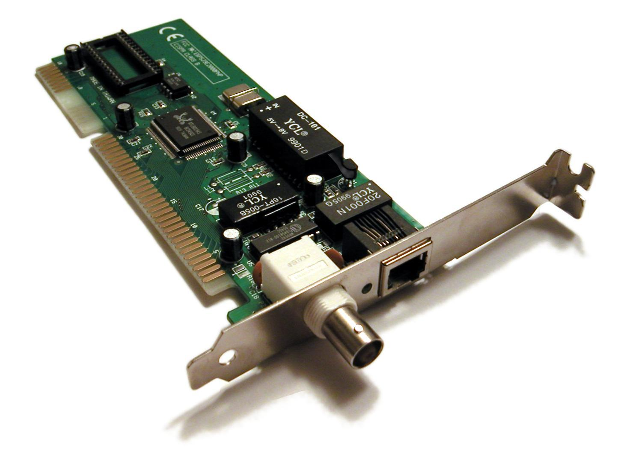

# **PCI Express LAN RJ45 4port Gigabit Ethernet NIC Wiretek**

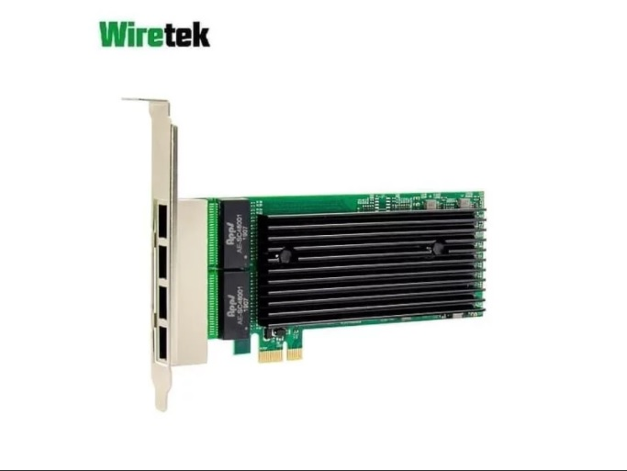

* PCIe v2.0 (2.5 GT/s) x4/x2/x1
* Quad Port 10/100/1000Mbps adapters
* MDI (Copper) standard IEEE 802.3 Ethernet interface for 1000BASE-T, 100BASE-TX, and 10BASE-T applications (802.3, 802.3u, and 802.3ab)
* RJ45 Connectivity
* Network Virtualization
* Improves performance and throughput by reducing the I/O overhead due to the software virtualization layer
* Data Plane Development Kit (DPDK) support
* Simple Network Management Protocol (SNMP) and Remote Network Monitoring (RMON) statistic counters
* Low profile and full-height bracket
* Price: RM 260 and above

# **Maikou Pci-e Adaptor Lan Ethernet Gigabit Rtl8111e 1000mbps Nic 8111e**

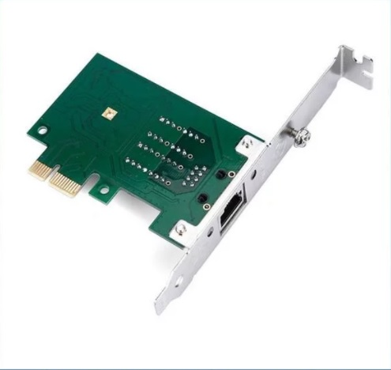

* Realtek RTL8111E
* 10 M 100 M 1 Gbps (1000 Mbps)
* PCI-Express 2,5 Gb/s
* PCI Express 1.0a.
* PCI Express x1 interface compatible PCI Express x1... x4... x8... x16
* duplex (IEEE 802.3x).
* compatible IEEE802.3, 802.3ab, 802.3u, 802.3x, 802.1q, VLAN.
* Compatible IEEE 802,1 P
* Sistem operative compatible: Windows 98SE, Windows ME, Windows 2000, XP, Vista, windows 7/8/10, Mac Linux/Unix
* Price: RM152 and above
* **Wireless Network NIC**

# **Wareshare Wireless Network Card Intel 8265AC 8265NGW 2.4G/5G**

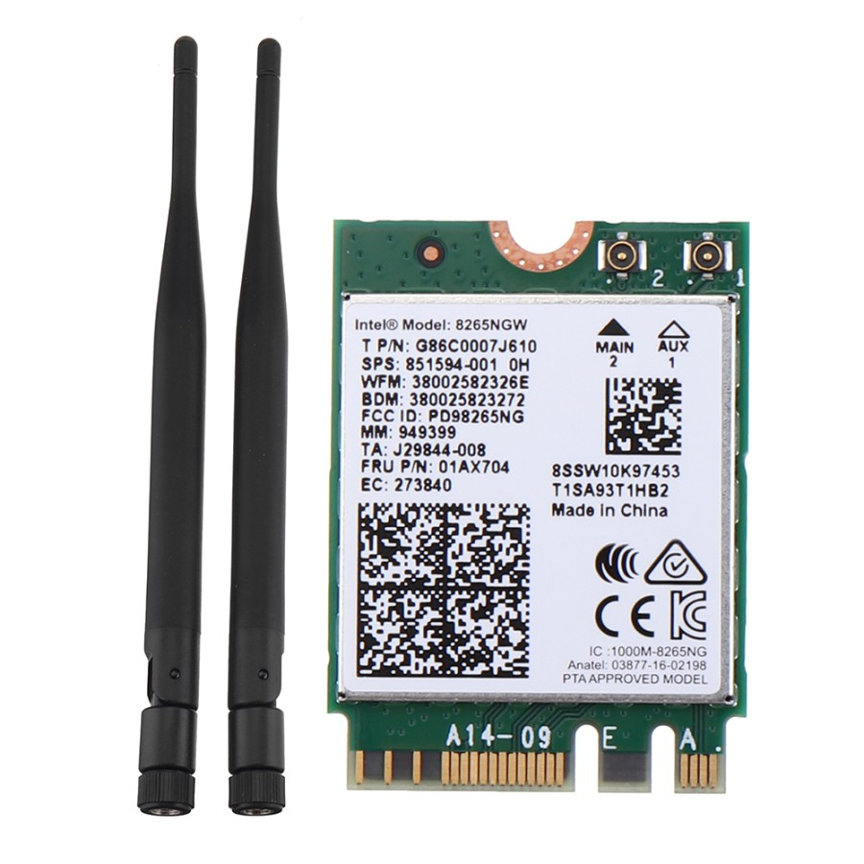

* The dual-mode wireless network card for Jetson Nano supports 2.4GHz / 5GHz
* dual-band WIFI and supports Bluetooth 4.2.
* Parameter: NIC
* chip: Intel 8265ACWireless
* band: 2.4GHz / 5GHzWireless
* rate: 300Mbps / 867MbpsWIFI
* protocol: 802.11acBluetooth
* version: 4.2Network
* card interface: NGFF (M.2)Antenna
* interface: IPEX interfaceCompatible
* systems: Linux, Windows 10/8.1/8/7Product
* Price: RM150 and above
* **TP - Link AC1300 Wireless Dual Band PCI Express Adapter - Archer T6E**

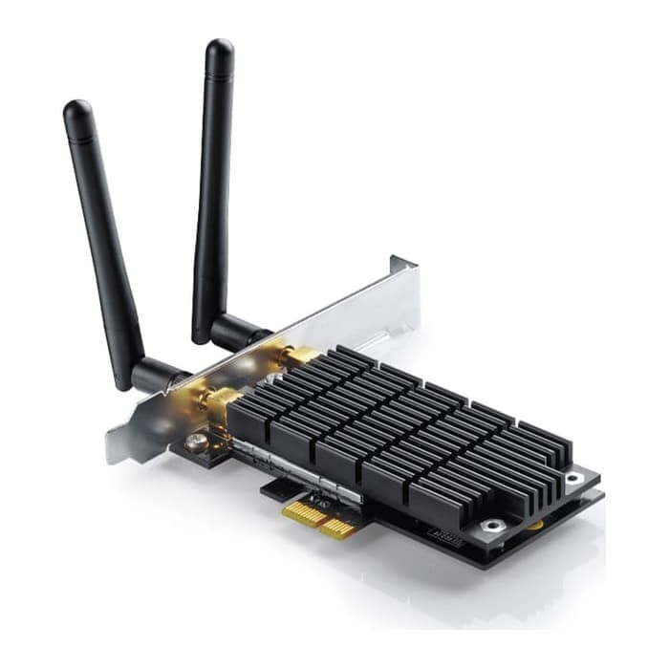

* Easy Installation – Upgrade your desktop system easily by plugging the Archer T6E Wi-Fi adapter into an available PCI-E slot
* Hi-Speed Wi-Fi – Up to 1300Mbps Wi-Fi speeds (867Mbps on 5GHz band or 400Mpbs on 2.4GHz band)
* 802.11ac Dual Band – 3 times faster than the 802.11n standard, perfect for hi-intensity network usage
* Backward Compatibility – With support for 802.11 a/b/g/n standards
* Broad Wireless Range – 2 external antennas ensure a greater range of Wi-Fi connection and stabilit
* Price: RM137 and above.

**Workstations and servers**

* **C240 M5 Rack Server**

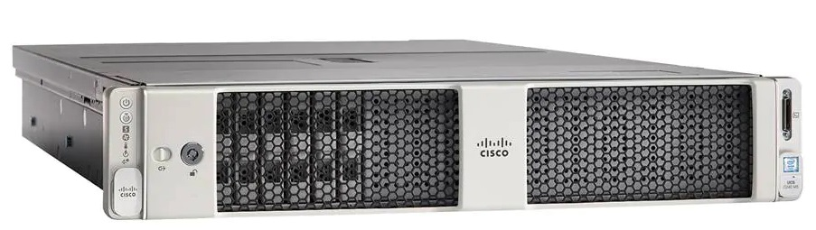

* The latest second-generation Intel Xeon Scalable CPUs, with up to 28 cores per socket
* Supports the first-generation Intel Xeon Scalable CPU, with up to 28 cores per socket
* Support for the Intel Optane DC Persistent Memory (128G, 256G, 512G)[[1]](https://www.cisco.com/c/en/us/products/collateral/servers-unified-computing/ucs-c-series-rack-servers/datasheet-c78-739279.html#_ftn1)
* Up to 24 DDR4 DIMMs for improved performance including higher density DDR4 DIMMs
* Up to 26 hot-swappable Small-Form-Factor (SFF) 2.5-inch drives, including 2 rear hot-swappable SFF drives (up to 10 support NVMe PCIe SSDs on the NVMe-optimized chassis version), or 12 Large-Form-Factor (LFF) 3.5-inch drives plus 2 rear hot-swappable SFF drives
* Support for 12-Gbps SAS modular RAID controller in a dedicated slot, leaving the remaining PCIe Generation 3.0 slots available for other expansion cards
* Modular LAN-On-Motherboard (mLOM) slot that can be used to install a Cisco UCS Virtual Interface Card (VIC) without consuming a PCIe slot, supporting dual 10- or 40-Gbps network connectivity
* Dual embedded Intel x550 10GBASE-T LAN-On-Motherboard (LOM) ports
* Modular M.2 or Secure Digital (SD) cards that can be used for boot
* Price: RM346 and above
* **Cisco UCS C4200 Series Rack Server Chassis**

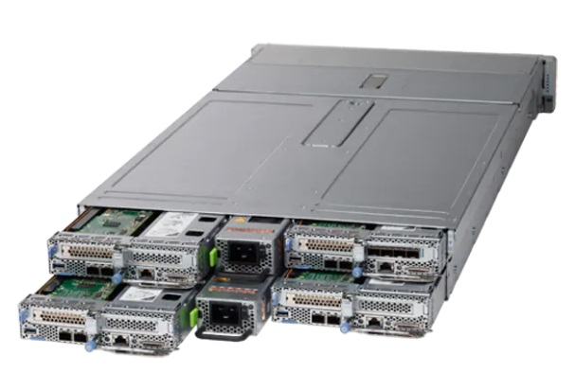

### More servers per rack. Scale out applications need more servers and data center space can be at a premium. With the C-Series Multinode Rack Servers, you get up to 100% more server density compared to the Cisco UCS C220 M5 rack server.

### More processor cores. Compute intensive, scale out, workloads benefit from additional cores per server. The UCS C125 M5 server node with AMD® EPYC™ processors have 128% more cores than other UCS M5 servers and up to 343% more cores per rack.

### Better memory bandwidth. Process data as fast as memory can deliver it. The UCS C125 M5 server node has 33% more memory bandwidth that other UCS M5 servers allowing to unlock and quickly extract economic benefit from your data.

* Price: RM733 and above.

**Reflection**

At the end of research and choosing, we concluded that prices for network devices are quite high. Beside, it helped us to improve our understanding of networking models, networking protocols, networking devices, networking media, networking topology, the concept of various servers, the concept of network security, the implementation of LAN and WAN, the connection to the internet of a particular office or site, the safeguarding of a particular site from outside the wireless network and its security, simple troubleshooting of the network.

There are comparison for same network devices but from different brands. For example, Cisco is known as the best brand for most of network devices because it is said that Cisco have a massive support machine. Users can get their customer service online and also through WebEx meeting which users can share their screen and the staff will get it done for them. Besides that, Cisco is a well certified company for their equipments. Cisco is a functionality wise and worth the money purchase for their devices. Hence, most of the devices we chose are from Cisco.

In conclusion, to setup network in a building do need a big budget. This is to ensure that the money invested on all the devices give the best outcomes to the clients. This includes the functionality, application, management, security, maintenance and more are working well.

**References**

1. <https://www.cisco.com>
2. https://sites.google.com
3. <https://www.amazon.com>
4. <https://computermalaysia.com.my>