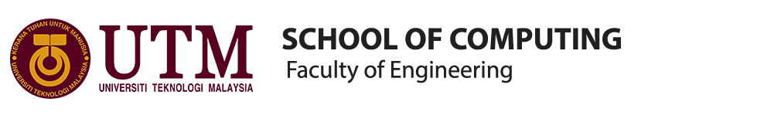

**TECHNOLOGY AND INFORMATION SYSTEM**

**REPORT OF VISIT TO THE PERPUSTAKAAN SULTANAH ZANARIAH (UTM GALERIUM)**

**GROUP MEMBERS:**

1. **ABDUL AZIM BIN ABDUL MALIK (A19EC0002)**
2. **IZZATUN NADIAH BINTI ABDUL RAHMAN (A19EC0056)**
3. **ONG YIN REN (A19EC0204)**
4. **LEE HUI ZHONG (A19EC0067)**

**LECTURER:**

**DR. SARINA BINTI SULAIMAN**

**INTRODUCTION**

On the 20th of October 2019, the Technology and Information System’s class have visited the Perpustakaan Sultanah Zanariah (PSZ), as a replacement for Centre for Information and Communication Technology (CICT), Universiti Teknologi Malaysia. During that time, we were required to gather at PSZ at 3.00p.m. The visit started at 3.30p.m. at level 2 of the PSZ. At level 2, we entered the Galerium UTM, where our tour really started. Galerium UTM is a place with historic devices from the past and how it evolved by time. Since UTM is one of the biggest technological institute in Malaysia, the UTM staffs’ tried to acquire as much technology in the past as they can so that it will make an easier explanation in giving lectures and so on with the related subjects in UTM.

The main purpose of the visits is to expose us with how well the technologies have advanced. Inside the gallerium, there are lots of ancient devices used in the past. Most of the devices could also be considered as the pioneer of the technology advancement. There are so many exposures given to us. For example, we were given a simple briefing about how some of the devices works during that period of time. At the same time, he compared it with today’s technology. With that, we can see clearly how well the innovation have become. It also make us conscious, that we are what we are today because of the past. It was truly unique to know how these devices have done what most of us think, in the current era, as impossible with that kind of system. But there it was, standing as a historic item that shows us even without the most advance, with efforts and right knowledge, we can achieve what seems abdurd.

Galerium UTM’s name was taken from two words, Muzium and Galeri that is combined together. Galerium UTM consists of 4 main galleries that is Galerium UTM, Galeri Tangga Ilmu, Galeri Raja Zarith Sofiah, Galeri Terbuka and Galer@UTMKL. The one that we have visited was the main, the Galerium UTM. Galerium UTM is under two divisions. The gallerium and the multimedia division. PSZ had undergone some structural changes which have impacted the display area of Galerium UTM in terms of space sizing. It becomes much larger while the other gallery owns their own place without disturbing the main gallery.

**COMPUTER**

Computer is a machine that can carry out sequences, arithmetic or logical operations using computer programming. The concept of programmable computer was originated by Charles Babbage, an English mechanical engineer and polymath. He conceptualized and invented the first mechanical computer in the early 19th century. He is known as the “father of the computer”. A computer consists of hardware, software and computer system. There are many types of computer such as analog computer, digital computer, hybrid computer, supercomputer, laptop, tablet computer, smartphone and others. The traditional computers were very big, heavy and not portable. The storage of the computer was very small as compared to modern computer. Through the revolution of technology, computers have become very light, high capability of storage, high RAM and others. Modern computers are very convenient in helping us to do many things instead of only calculation. There are some traditional models of computer shown in the library.

**Apple Macintosh Classic Computer**

The Macintosh Classic was introduced in early January 1984 and has been used in UTM Library in early 1990. It was equipped with a software memory of 1MB of RAM and 2MB to 40MB of hard disk. With its large capacity at that time, the computer was used in the Library along the Lotus 123 and Word Star Applications for work and simple calculation.

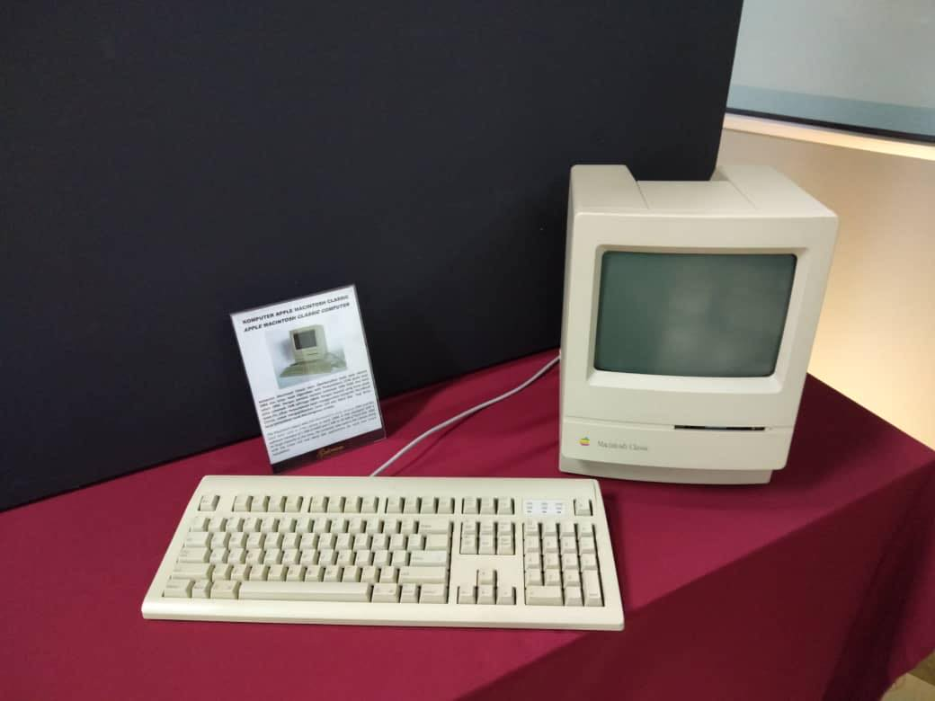

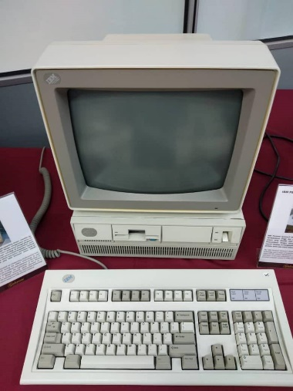**IBM Personal System/2 Model 70 386**

The IBM Personal System/2 Model 70 386 featured a high density memory technology and a range of integrated features. The computer, with its system, supported the Library significantly in performance improvement for desktop operation. It was also compatible with most software products available for a personal computer system in UTM Library.

**IBM P70 Model 6554-673**

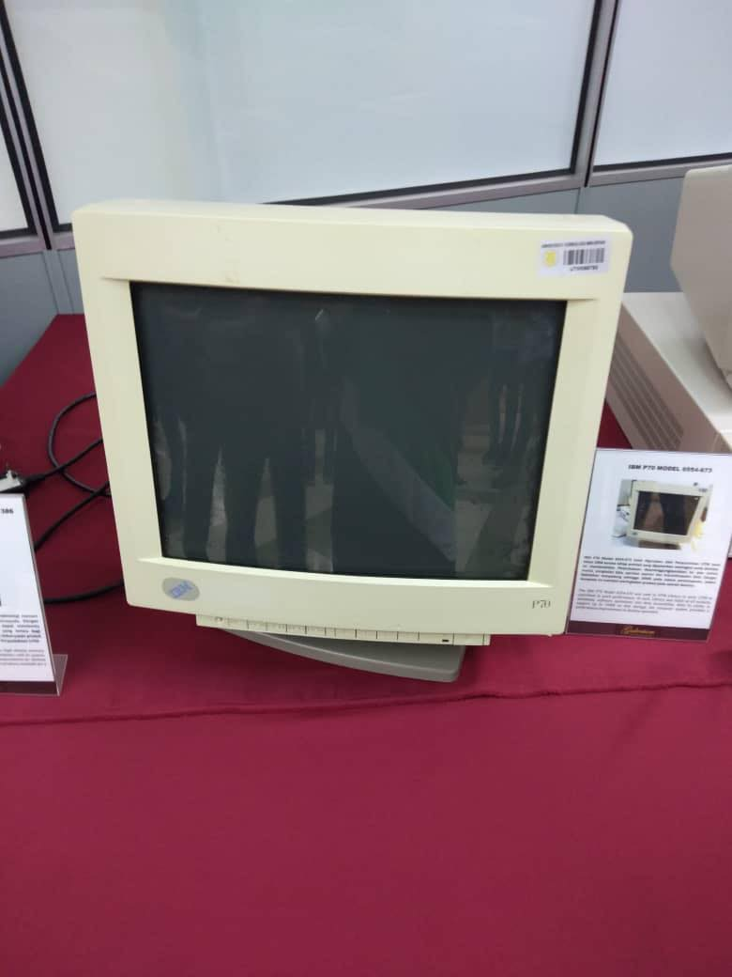The IBM P70 Model 6554-673 was used in library in early 1998 for contributing to the work performance. As such, library was liable of all modules, databases, software operations and data accessibility. The computer system provided a performance improvement on desktop operation with its ability in supporting up to 16MB on disk storage.

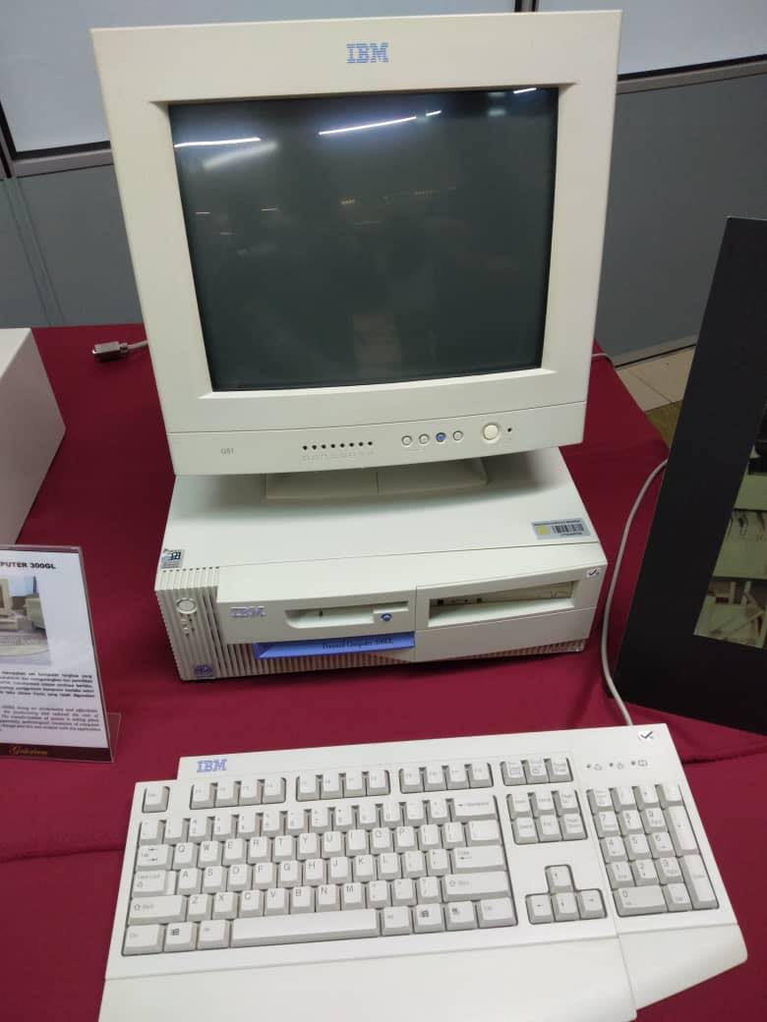**IBM Personal Computer 300GL**

IBM Personal Computer 300GL being an all inclusive and affordable computer, helped increased the productivity and reduced the cost of ownership of UTM Library. The transformation of system is taking place constantly in the library. Apparently, technological revolution of computer usage coincides with system change and this was evident with the application of Dynix system for 10 years.

**TYPE WRITER AND KEYBOARD**

The type writer keyboard was developed and patented in [1868](https://www.computerhope.com/history/1800.htm) by [Christopher Sholes](https://www.computerhope.com/people/christopher_sholes.htm) and is considered to be the first typewriter but it only become famouse usage in office until mid-1880s.

The type writer keyboard is a mechanical or electromechanical machine for writing similar character. It has an array of keys and each of it can causes different type of single character which can be produced onto the paper.Also, the Type-Writer introduced the [QWERTY](https://www.computerhope.com/jargon/q/qwerty.htm) layout, which is still used on almost all US keyboards today.

The typewriter which present in the library were used in the library during the early 1976s until early 1980s. Before the application of computers in1985, these application were used in administration tasks such as printing letters.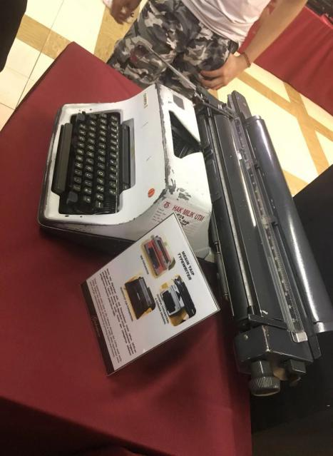

With the development of technology, the keyboards began to resemble what we use today and were heavy mechanical keyboards or converted electric typewriters by IBM company. But the qwerty keyboard continues to be the standard used in computers too. In 1986, IBM released the Model M keyboard that resembles what most keyboards look like today with the [function keys](https://www.computerhope.com/jargon/f/funckeys.htm) across the top of the keyboard. The Model M is still a highly regarded keyboard even today, as it introduced the 101-key standard US layout that is used today for full sized keyboards. It has also been adapted to the 104-key layout for Windows 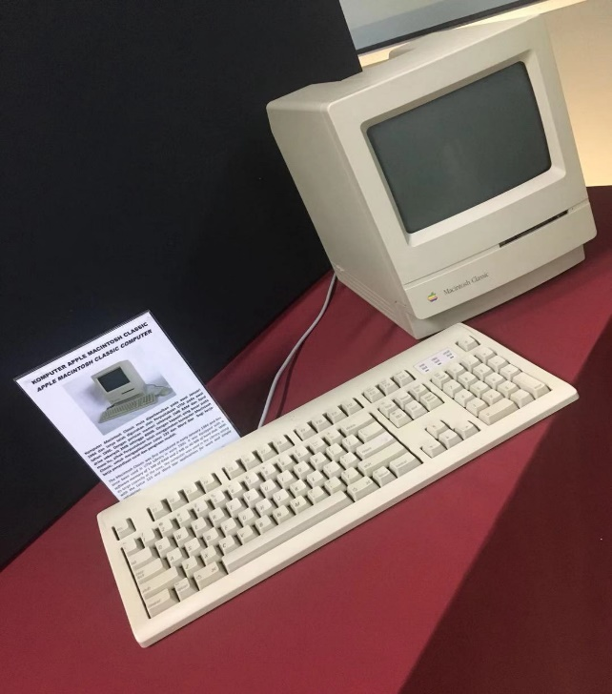keyboards with the [Windows keys and Menu keys](https://www.computerhope.com/jargon/w/winkey.htm). As time goes on, the keyboard also has been in changes which changes is moving from a mechanical [switch](https://www.computerhope.com/jargon/s/switch.htm) to a membrane. A membrane makes it much easier and cheaper to manufacturer computer keyboards. A membrane keyboard also makes the keyboard quieter, lighter, and thinner than the first mechanical keyboards.

**MAINFRAME DATA STORAGE**

**Model : IBM(9345B22)**

The usage of Mainframe System at UTM began in the 1970s at Computer Centre, UTM Campus, Kuala Lumpur. It served as a data control of students and staff information.

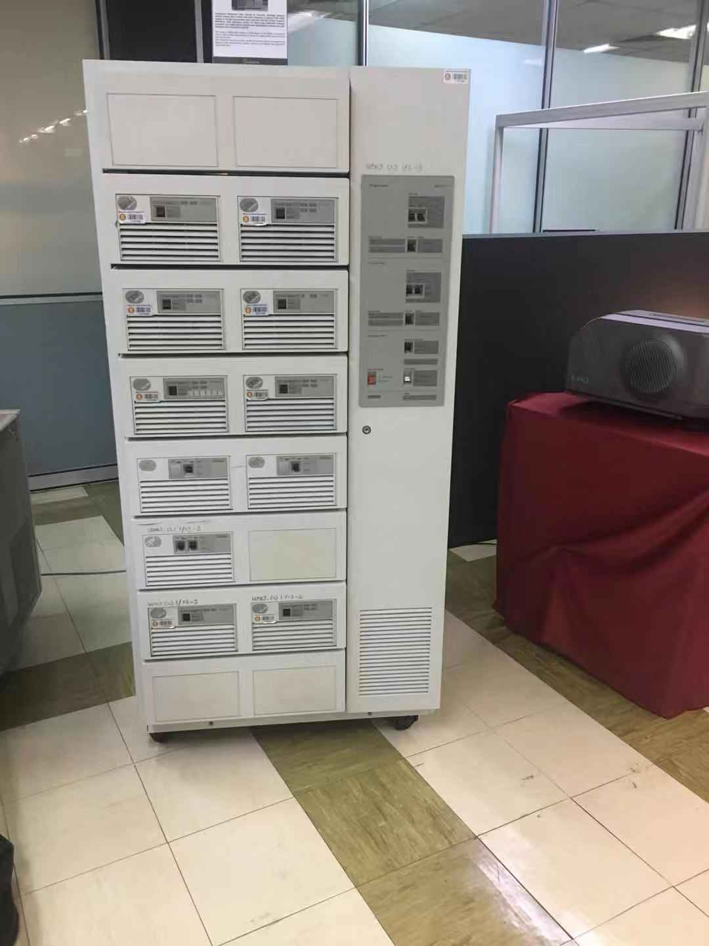The mainframe has been used for almost 20 years for different components and functions. It included for the processing, storing, securing, and printing the University’s information data.

Whether you need to store more data and gain faster insights by applying AI and big data, to deploy applications in containers to improve data mobility in hybrid multi-cloud environments, or to improve your cyber resiliency and data protection, IBM Storage provides solutions to address all modern data requirements

* Modernize and secure your hybrid multi-cloud infrastructure with AI-infused, automated data storage solutions.
* Unleash developers with API support to manage complex environments.
* Avoid unplanned outages and achieve cloud-like reliability.

**COMPUTER MOUSE**

Computer mouse is a hand-held [pointing device](https://en.wikipedia.org/wiki/Pointing_device) that detects [two-dimensional](https://en.wikipedia.org/wiki/Two-dimensional_space) motion relative to a surface. This motion is then will be translated into the motion of the [pointer](https://en.wikipedia.org/wiki/Pointer_(user_interface)) in the computer, which allows a smooth control of the [graphical user interface](https://en.wikipedia.org/wiki/Graphical_user_interface). It was invented by Douglas Engelbart in 1964.

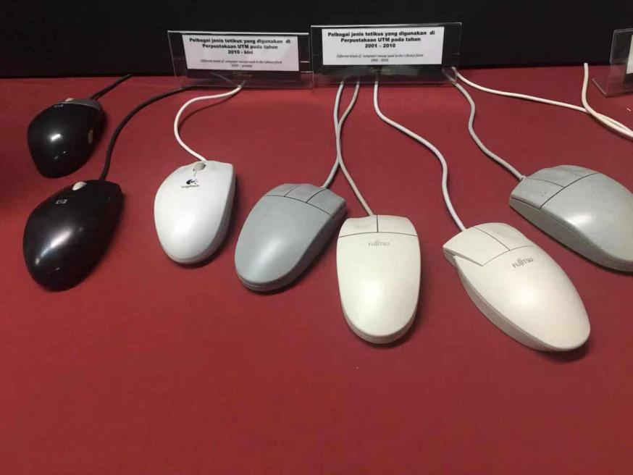A computer mouse with the most common features, it consists of two buttons (left and right) and a scroll wheel, which can also act as a third button. In addition to moving the cursor, the computer mouse also has one or more buttons to allow operations such as selecting menu items on the display. In time, there are some inventions that adds some additional button that is programmable by the user. It was done so that it will not require to move the pointer across the whole screen just to click on something. With programmable function, user can use to have a much friendlier mouse and reduce restraints on the wrist.. Mice typically also have other elements, such as touch surfaces and "wheels" that allow for additional control and size input. Nowadays, we can also control the speed of the pointer with a physical button on the mouse.

**REFLECTION**

In this visit, we have been briefed with lots of technologies that once UTM had used in the past. Because of that, the UTM staffs’ decided that it was a good idea to introduce such things to us. Some of the devices are the mice, the computer, mainframe and keyboard which, during that time, is already powerful enough to keep UTM databases. Mr. Zahari bin Zainal Abidin was the person in charge of giving us the information we need. He clearly is experienced with these devices since he can explain to us very clearly what is this and that. He explains everything from the mainframe function, to how a hard disk used to be and much more. For example, to make the explanation much more understandable, he compares two devices, past and current together so that we can comprehend what he is talking about. He was talking about how small a RAM and hard disk used to be and he compares it with nowadays RAM and hard disk which have already reach the size of absurdity such as 4TB of RAM and literally hundreds GB of RAM. He asked, why the difference in size is so significant? He then told that in the past, the information send was not as detailed as how it currently. In the past, for example, most of the information is in black and white so that it requires such small space to be filled. While now, everything has to be in great details, so the amount of memory needed to support certain actions in a system greatly affect the performance of the system itself. He also explains that UTM has its own database centre that will immediately transfer to the base in UTMKL should that some events related to data loss is happening.

To conclude, new technology brings new qualities to the life of human beings. It is like the new way of thinking or doing the normal things differently, better and faster than before. Before the technologies, our life was more complex because it was very difficult to get many things done due to the size of the technologies. So, in order to make our life much more easier, we need to see how past technologies works to improve the usage of technologies. In this visit, we had learnt how the technologies had changed our life. For example, in the past we need a truck to bring all the complete set of computer and now we just can simply bring it everywhere because it is much more smaller and more lighter than before. So, we think the gallerium can be improved by putting current computer so that we can see how the technologies changes from time to time.