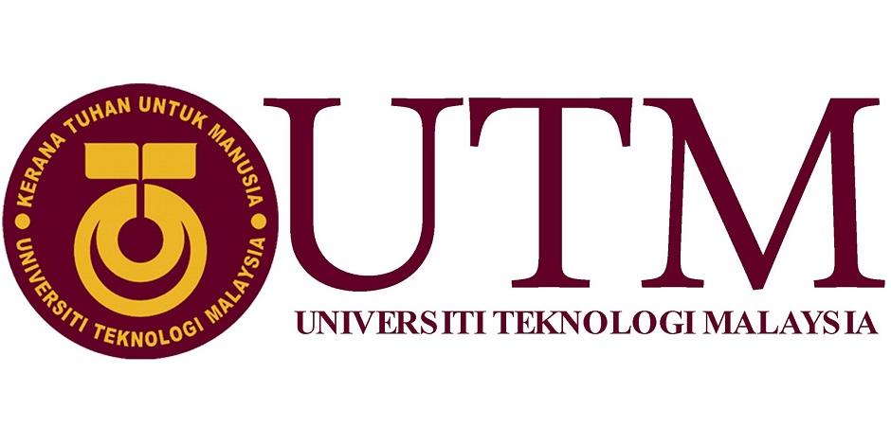 **Semester 1 2020/2021**

**School of Computing** Faculty of Engineering

Subject: Technology and Information Systems (SECP1513)

Section: 04

Task: Industrial talk 3

Title: Inspiring Work experience & Covid19 Pandemic Challenge

Lecturer: Dr. Goh Eg Su

Recorded Video Link: https://utm.webex.com/utm/ldr.php?RCID=229f04aabeec42d8b14d786986de897f

Prepared by:

Group members: Lai Leng Shuen A20EC0060

Muhammad Shawaluddin Bin Shaari A20EC0099

Muhammad Fakhrullah Bin Kamal Bahrin A20EC0087

Muhammad Fadthun Amierrun Bin Md Nor'azam A20EC0085

Preparation for:

Lecturer: Dr. Goh Eg Su

University Technology Malaysia (UTM)

Covid 19 pandemic challenge

**RM1.50**

Tuesday, December 29, 2020

**INSPIRING WORK CHALLENGE**

|  |  |  |
| --- | --- | --- |
| **Job Need Skills Not Only Your Intelligent**  Muhammad Fakhrullah Bin Kamal Bahrin  **JOHOR BHARU** – UTM held an industrial talk and the talk’s guests are Alumni from school of computer which are Batrisyia, Tan Yong Keong and Muhammad Zamarul.    Example of interview session.  They told that as student in UTM, we need to use these opportunities to improve skills and join as many event or competitions as you can. These will help you to fill up your resume and experience in any field of jobs. | Tan Yong Keong told a story when he was interviewing, the interviewers were not asking much about your academy result but they more concern about your skills and how suitable you are getting job.  Other than that, Zamarul also say that at the time he went to interview, he was with his friends but Zamarul the only one got the job because he more suitable for the job his resume is filled more with event and competition participate.    . The sharing from the alumni was open my eyes about how important your skills and yours participate in resume. The lesson I got from this talk is we need to make ourselves be more confident in doing something new. The improvement that I hope it can implement for next event is to provide a slide to picture the contents that the guest will speech to make it more clearly to understands. | **Expose Yourself to A New Thing**  Muhammad Shawaluddin Bin Shaari  **JOHOR BHARU** - When you’re exposed to a new thing, it changes the way you think, since you can learn something new and gain experience from that. There is a variety way you can gain these skills such as, you can volunteer with non-profit organization in your community. Not only that, you can join a competition to gain a new experience.    Resume contents |

|  |  |  |
| --- | --- | --- |
| Furthermore, since we were in middle of pandemic, some classes will be held in virtual class, so its great opportunity to take online course to growth your skills and learn new thing. When you graduated from University and enter adultery life, most of the employers are looking at a variety of skills when giving consideration for affairs jobs, such as communication skill and teamwork skill.  Through this talk, the strength of this talk is to don't be afraid to expose yourself to a new thing even if you don't have any knowledge about it, such as when you are joining a competition. From this session, I learned a lot from all the speakers to never give up and always try your best whenever you are doing something. Besides that, I got a brief introduction to adultery life. This talk gives me so much knowledge and motivation.  **The Attitude and Skills A Student Must Have**  Lai Leng Shuen  **JOHOR BHARU** – On this day there was an industrial talk online from 10 am to 11 am and conducted by our seniors who had graduated from UTM, Batrisyia binti Azman Shah, Mohamad Zamarul Akmal bin Mohd Hussin, and Tan Yong Keong. They give some tips based on their student life.  First, having good communication skills will ease all the discussion and promote teamwork between course mate and a colleague. There are some great ways to gain confidence suggested by our senior. First, be a volunteer to express and talk with others is a very efficient to improve our confidence level. Tan said that confidence level can be trained, he often trained his confidence by showing high competence in doing jobs. | Attitude  Furthermore, it is very essential for us to be proactive people. Do not wait for somebody to try to do all the works for you, ourselves must grab all the opportunity that we will learn, make friends with people and never limit ourselves.  Upon reflection of this industrial talk, I found out that all the seniors had gave their honest point of view about all the difficulty they faced and how they managed to become a better self. Throughout the industry talk, I had gained many beneficial tips that I can enrich my study life although it is online learning now. I gained that participating activities and being active is very important so that I can become a more confident person and gaining essential technical skills and soft skills.  **Productive Person Get more Knowledge**  Muhammad Fadthun Amierrun Bin Md Nor'azam  **JOHOR BHARU** – While pursuing your degree, there were many competition or activities will be hold by our university. The competition mostly will be exposing the participants about new things.    Productive person | Undeniably, in a competition, there will always be a winner and a loser. All seniors agreed that whether we win or lose in certain competitions, we are going to gain. If we are losers, we can gain skills and learn from the winner.  The foremost thing is we must put in our effort and willingness in pursuing knowledge. If we took part in a competition, we get exposure, learn new things, and be able to work in a team.  Through this industry talk, I can see that the three of them energetic in giving advice to us. It looks like they want all of us as their junior can get through the obstacle in getting job in hard situation. Lesson that I learned in this talk is we need to be active in many ways in our student life to ease our interview job. So, I will learn many new things to make my selves different than other people.    LAI LENG SHUEN A20EC0060  A picture containing person, posing  Description automatically generated  MUHAMMAD FADTHUN AMIERRUNBIN MD NOR’AZAM A20EC0085  A picture containing person, person, posing  Description automatically generated  MUHAMMAD SYAWALUDDIN BIN SHAARI A20EC0099  A picture containing text, person, wall  Description automatically generated  MUHAMMAD FAKHRULLAH BIN KAMAL BAHRIN A20EC0087 |