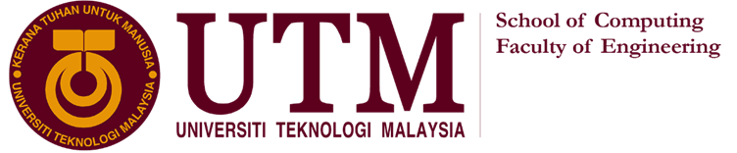

TECHNOLOGY AND INFORMATION SYSTEM  
SECP1513 – SECTION 7

INDUSTRIAL EXHIBITION  
NEW ACADEMIA LEARNING INNOVATION  
(NALI) 2019 & 2019 ENGINEERING-INDUSTRY INNOVATION DAY

(EII DAY)

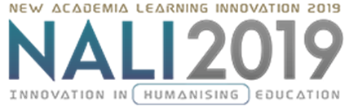

LECTURER: DR. SARINA BINTI SULAIMAN

|  |  |  |
| --- | --- | --- |
| **NO.** | **GROUP MEMBERS** | **MATRIC NO.** |
| 1. | ROSHANDEV DANIEL A/L | A19EC0156 |
| 2. | NUR LYNNDA BINTI ROSLIZAN | A19EC0134 |
| 3. | KOH XIN YI | A19EC0064 |
| 4. | NG JING ER | A19EC0115 |

**NEW ACADEMIA LEARNING INNOVATION (NALI) 2019**

NALI 2019 INNOVATION IN HUMANISING EDUCATION held on 18th September 2019 from 8.30 am to 5.00 pm. Exhibition and competition had carried out smoothly during the program. Exhibition and competition of this program help NALI research and innovation in teaching and learning recognize by people. Besides, NALI is a stage for sharing of research and innovation in teaching and learning.

Exhibition content

There are seven exhibition booths on the program. Badge printing booths show their various type of badges. The garish display fruit carving booths and the creative cup decorations booths attract the attention of visitors. For cosmetics part, there have hairdressing booths, haircutting booths and nail treatment booths. They even have housekeeping booths and reflexology booths for personalise services. You cannot expect that all of the exhibitions are running by Special Education students who study in the program relevance.

Trends of NALI

NALI is a new model which combine blended learning philosophy, multiple learning modes and materials to provide a better study environment for students to study in the field of entrepreneurial. NALI give support to UTM teaching and learning system to make sure UTM teaching and learning system align with the Malaysian National Higher Education Strategic Plan. NALI help to guarantee students match the qualification of employers and accreditation bodies. NALI also assist to keep UTM teaching and learning system comes closer to first-rate teaching and learning practices of the World's best universities. Students in UTM can experience worthwhile and interactional learning systems, materials, activities and environments with the existence of NALI. Besides, UTM build up own identity by conducting NALI. NALI is profitable to UTM students, UTM students is easier to adapt to the society when they start to work. Students do not only learn the knowledge from book but practice the way to convert the knowledge from book to real situation. We have to advocate NALI in UTM to keep pace with developed countries.

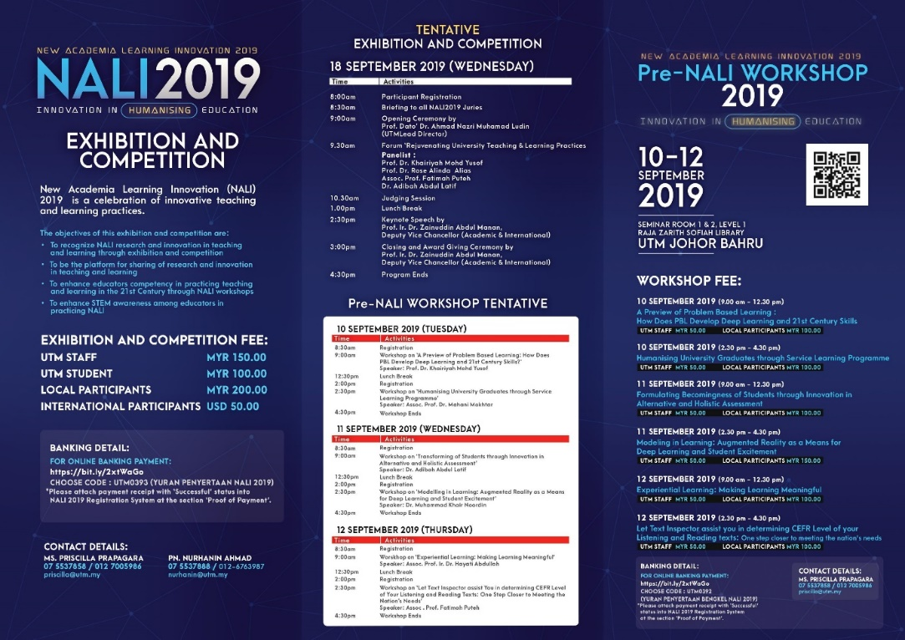

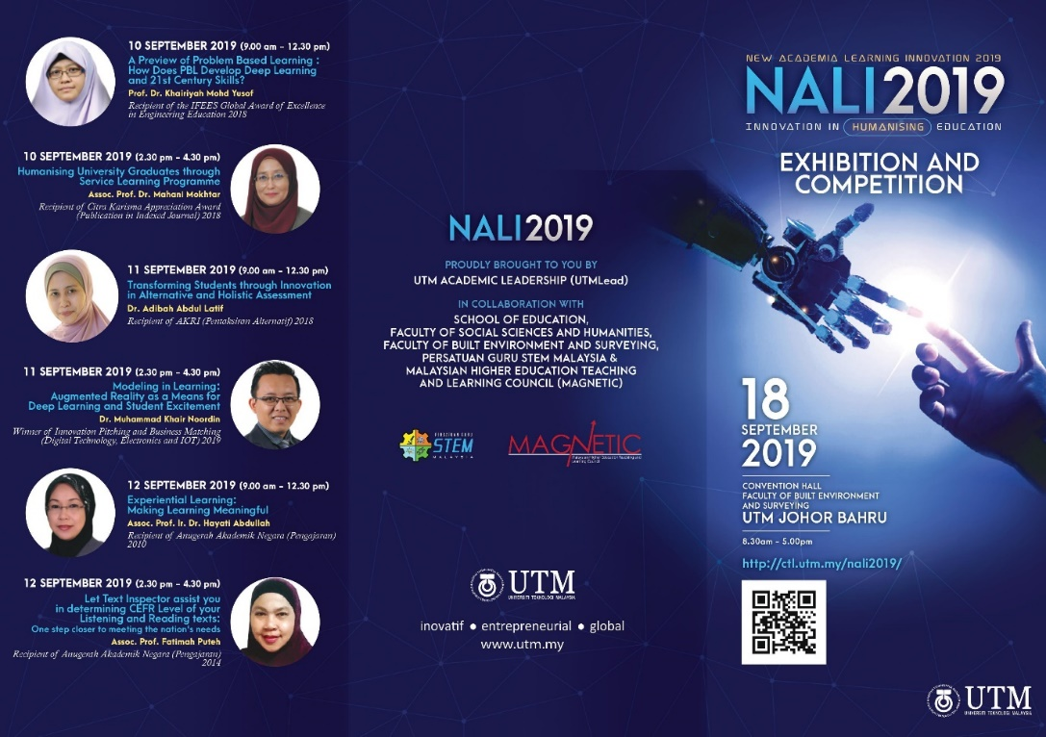

Poster 2: Poster of NALI 2019

Poster 1: Poster of NALI 2019

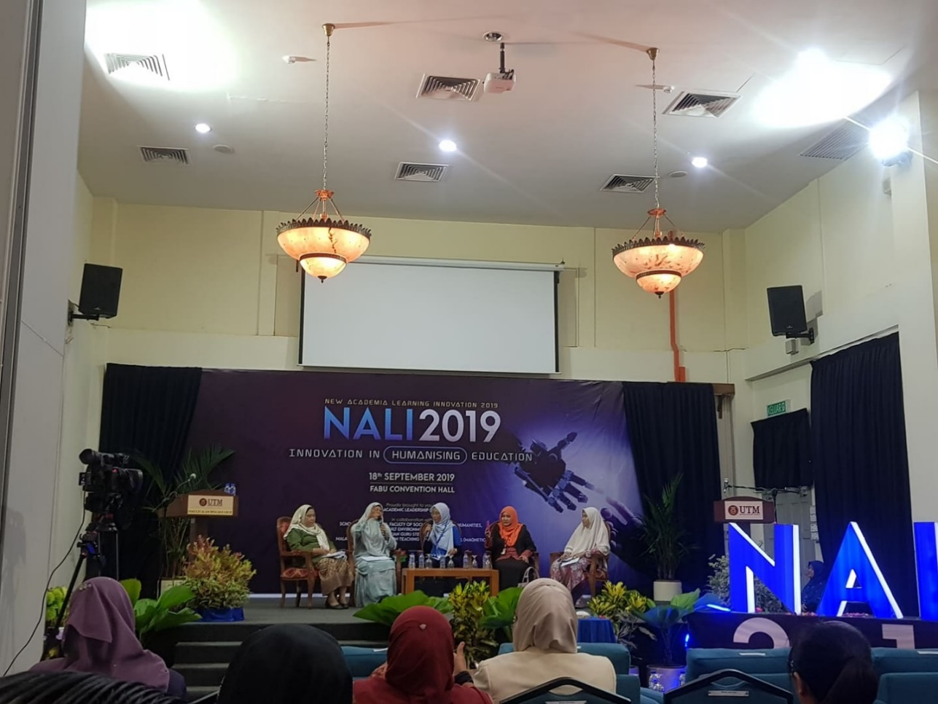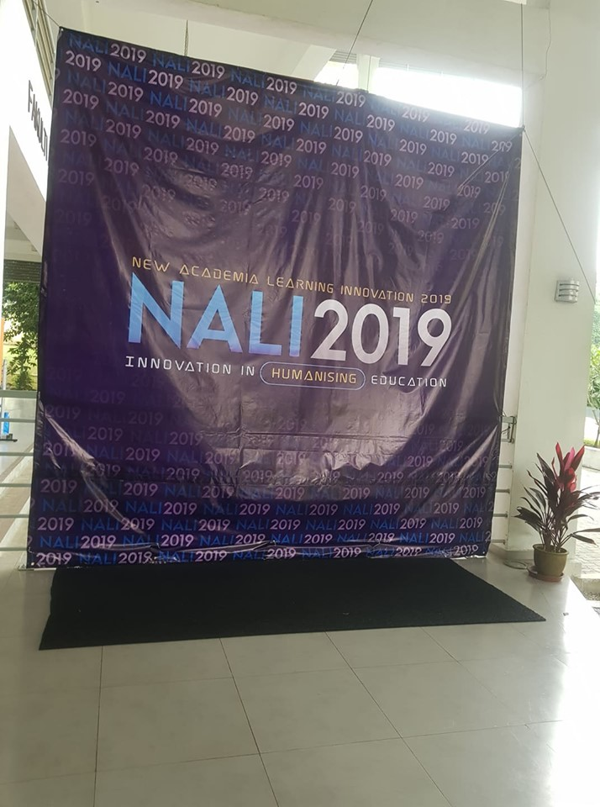

Photo 1: NALI 2019

Photo 2: NALI 2019

AUTOMOBILE VIRTUAL REALITY MODULE (AVRM)

One of the booths that I visited is about Automobile Virtual Reality Module. The most interesting feature of this project is it develops a Virtual Reality (VR) simulation solution for the automobile courses. This will benefit the vocational education and training area. The virtual reality trains the student to dismantle and assemble a typical automobile engine. While in the process of that, the VR module simultaneously teaches the student about engine components, systems and operations. The modules are based on academics & industry standards. It provides students a good learning approach in producing industry-ready skills for the automobile industry.

The objective of this project:

* To provide virtual reality platform for the automobile vocational education and training.
* To incorporate NALI initiatives of scenario-based learning and student edutainment.
* To develop the module that is aligned with the government vocational and working standards.

1.Need:   
As this project develops a Virtual Reality (VR) simulation solution for the automobile courses, it will benefit education of Technical and Vocational Education and Training (TVET). Particularly in the TVET automobile courses, there are common issues that most of the local institutions are facing such as lack of tools and equipment, outdated materials and high-operational cost. The implementation of Automobile Virtual Reality Module increases the quality of graduates which fulfil the demand of industry.

2.Approach:   
There are many common issues faced by local institutions. Automobile Virtual Reality Module can be applied in TVET sector. So, in order to solve these issues, which is related to insufficient training material, car, engine, transmission, high operational cost and student’s safety. It’s is an innovative project as it uses VR, which is a scenario-based approach as part of their automobile training module. Students able to solve the tasks given using their skills and critical thinking. Besides, the unique teaching style and innovative teaching materials not only attract interests of student but also trains the student to solve real-world problems through AVRM.

3.Benefits:   
The teaching and learning module of the AVRM which was then developed and structured to suit the application in virtual reality simulation. It will help to develop the ability and skills of local talents. Compare with the old-style teaching method, AVRM cost effective and preparing students for long life learning experience. This project offers a highly potential product to ensure students’ safety. Besides, this project is environmentally friendly which reduce the pollution to environment.

4.Competition/alternatives:  
AVRM is targeted mainly for the teaching and learning in TVET automobile programmes. There are more than 1000 institutions in TWET sector of Malaysia under 7 ministries. AVRM is able to tackle all the common issues facing by local institutions and helps in producing skill-equipped graduates. AVRM has a huge market potential which not only in education but also include car aftersales industry and workshop.

Last but not least, I would like to share about some of my opinions throughout this programme. Through NALI 2019, I discovered that the infusion of technology in education provides a good experience to the students while in the process of learning. And the effort from all walks of life to increase the quality of education cannot be ignored. In order to increase the quality of graduates, AVRM provides a good method for teaching and learning in automobile sector. I think we should train to adapt ourselves to this kind of new style learning method so that we are not getting left behind in this world of ever changing. We will be able to develop 21st century skills and be a more skilful graduate.

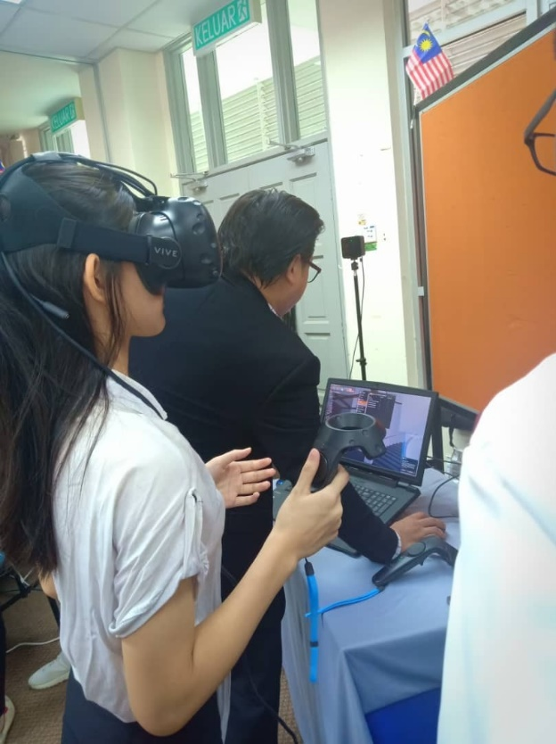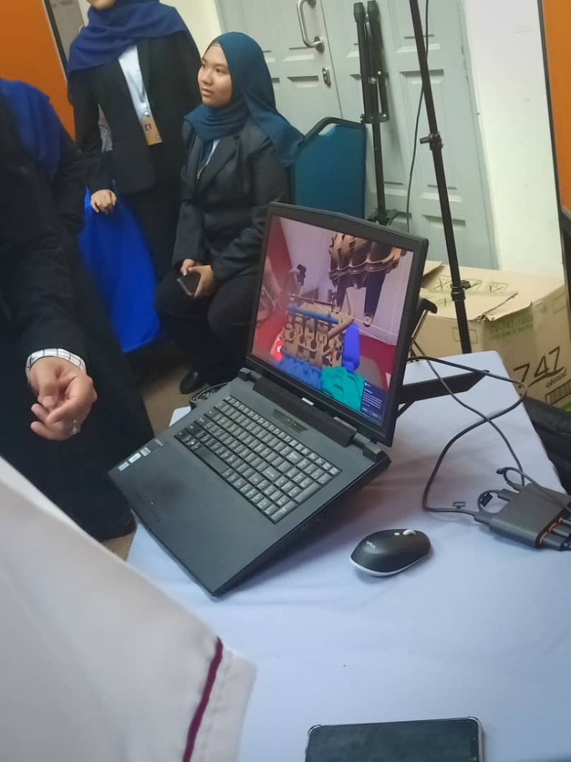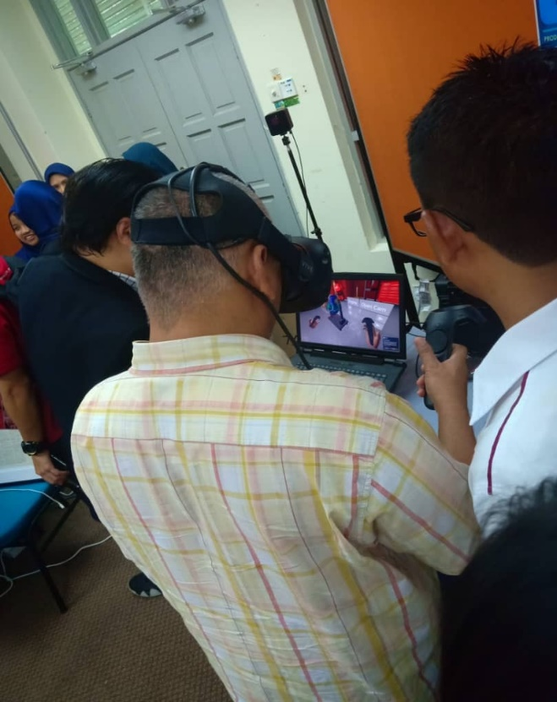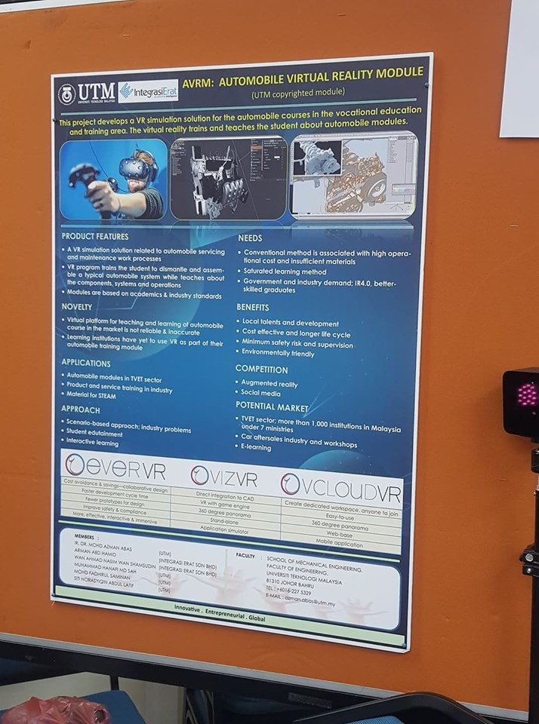

Photo 5: AVRM

Photo 4: AVRM

Photo 3: AVRM

Poster 3:   
Automobile Virtual Reality Module (AVRM)

**2019 ENGINEERING-INDUSTRY INNOVATION DAY (EII DAY)**

2019 Engineering-Industry Innovation Day (EII Day) was held on 11 September 2019 to 12 September 2019 at the Dewan Sultan Iskandar in UTM and is a platform for academicians, researchers and engineers to be brought together to meet and share and discuss on recent research results, new developments and technology trends in engineering areas.

Exhibition content

This event gathered a total of 700 engineering background researchers and academicians, 150 industrial partners and also several government agencies in which activities where held which included two talks, five forums, and exhibitions with 25 exhibitors.

Trends of EII Day

The five forums that conducted covered all aspects of the Fourth Industry Revolution (IR 4.0) including Big Data, Robotics and Automation in Manufacturing, Construction, Information Technology and businesses. These programs were held which included the latest research showcases and product exhibitions. There were plenty of research forums and industrial talks which provided good platforms for the experts to exchange their ideas. Students had the opportunity to broaden their minds in the are of engineering. The most important thing is that there were a lot of talent scouting booths which were looking for the best brains among the engineering and computing students.

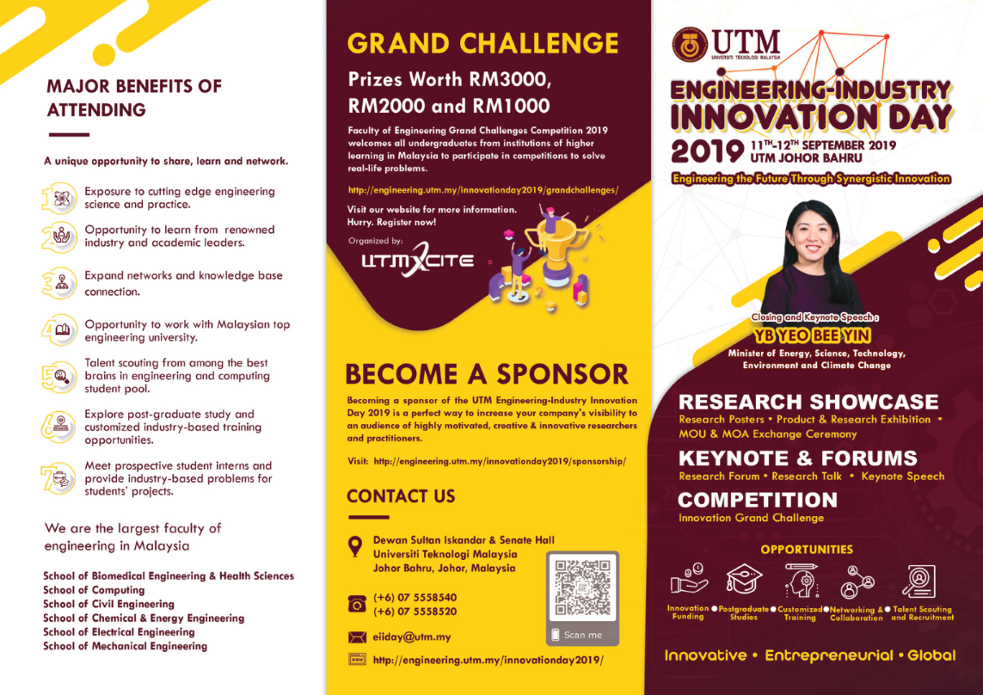

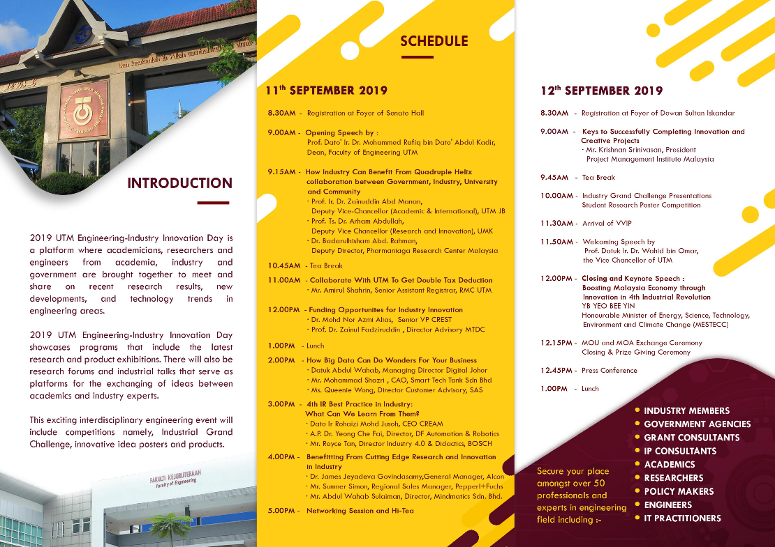

Poster 5 : EII DAY

Poster 4 : EII DAY

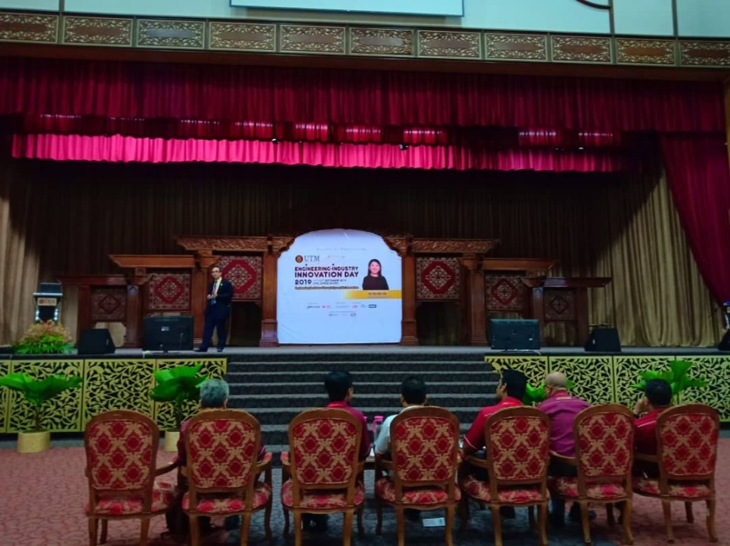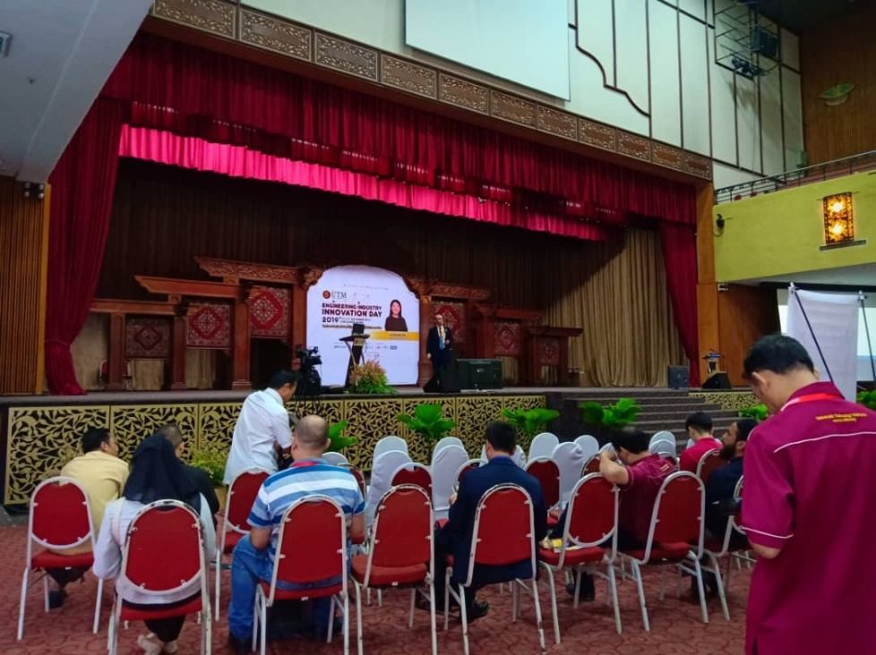

Photo 7 : EII DAY

Photo 6 : EII DAY

ANSYS DISCOVERY SPACECLAIM

One of the booths I visited on EII DAY is about ANSYS Discovery SpaceClaim. ANSYS Discovery SpaceClaim is a multipurpose 3D modeling application providing efficient solutions to common modeling tasks. Built on the direct modeling technology, Discovery SpaceClaim removes geometry problems associated with various 3D CAD operations, such as design or concept modeling, repair of translated CAD files, general model defeaturing, and complete model editing. With its premise of ease of use and simplicity, you'll find Discovery SpaceClaim to be extremely valuable in tackling small to large modeling problems.

1) Need

Helps machinist complete jobs quickly while minimizing downtime on the shop floor. Open, edit and prepare parts from any CAD system and easily convert files into data for machining.

2) Approach

Space Claim's vision from the beginning was to bring to everyone providing a simple fast, flexible design tool. They believe a 3-D tool should be simple, anyone learn it quickly and have fun while doing so.

3) Benefits

Save cost for machinist to test their new project, save time, increase productivity minimize shop floor downtime and gain a better solution for winning new business.

4) Competitors

No other tool is faster to use and does a better job editing geometry, cleaning up corrupt or difficult CAD, and quickly designing jigs and fixtures, Space Claim is the only solution on the market today that helps machinist.

AUGMENTED REALITY

On the 11th of September, I visited the Lazada booth at where they were presenting their augmented reality. Augmented reality (AR) is an interactive experience of a real-world environment where the objects that reside in the real world are enhanced by computer-generated perceptual information, sometimes across multiple sensory modalities, including visual, auditory, haptic, somatosensory and olfactory.

1.Needs:   
Their solution to satisfy clients to create a simulator of a solution towards a problem without their clients having to incur any type of loses as the usage of augmented reality uses a computer to create or superimpose an environment.

2.Approach:  
Research and Development also saves their money and time as augmented reality is able to access the problem without having to waste any raw materials

3.Benefits:   
Cost is cut down causing a competition among rival companies as the price is more affordable by companies.

4.Competition:  
Augmented reality has paved a way for clients to use the system all in one as it is user friendly rather than having to buy different types of intelligence system.

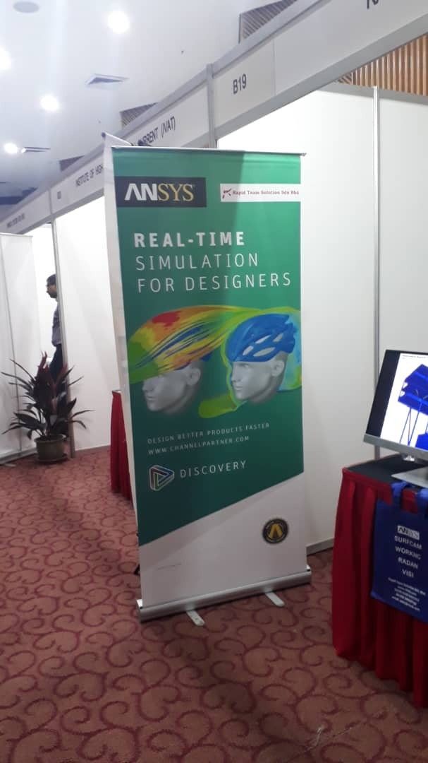

Photo 8 :   
ANSYS Discovery SpaceClaim

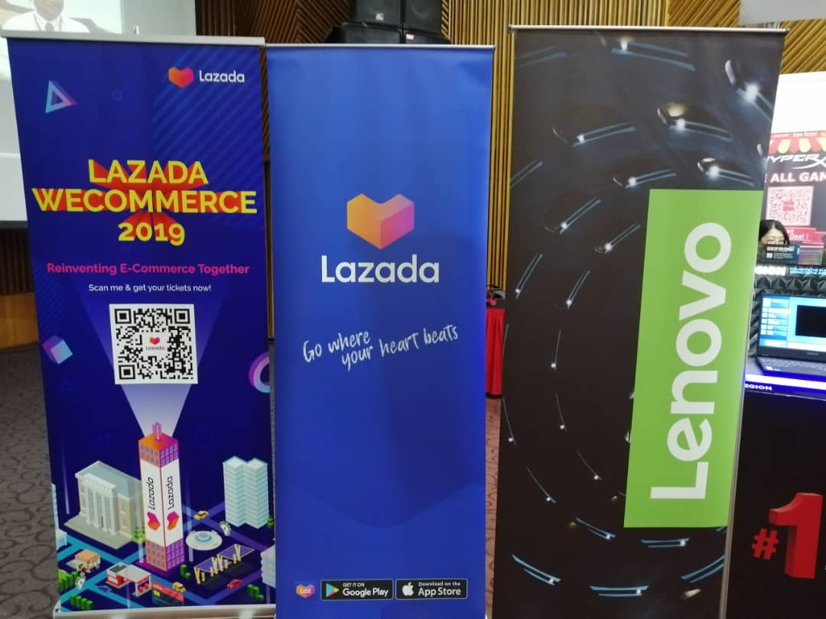

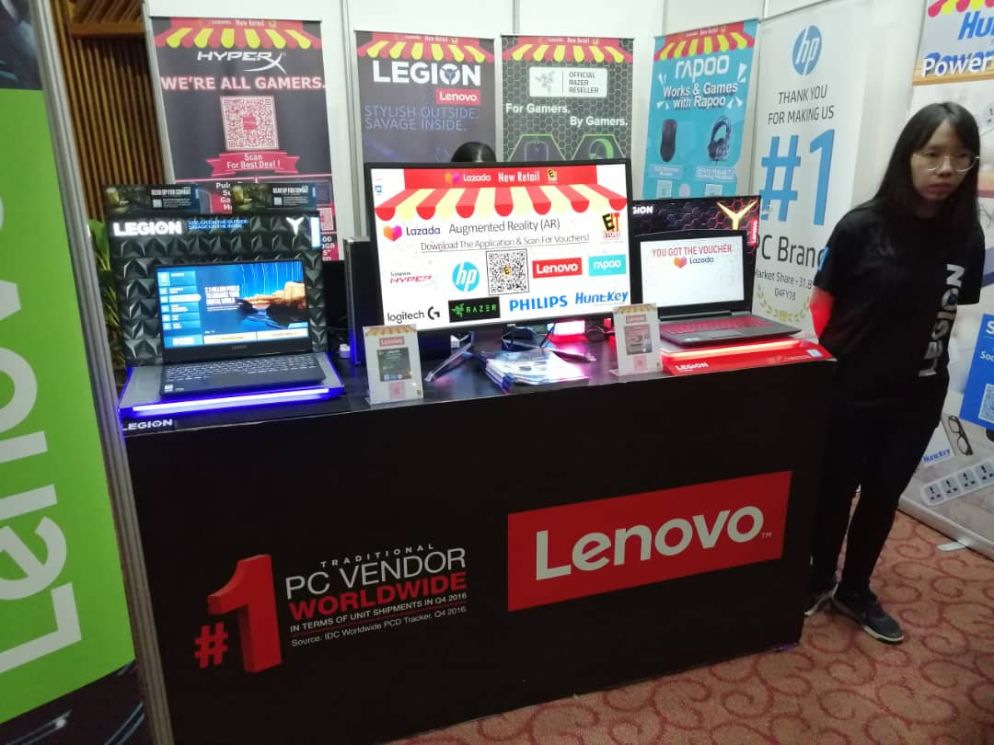

Photo 9:

AUGMENTED REALITY

References

1. Mohd Shafie b. Rosli. (2019) PROCEEDING OF NEW ACADEMIA LEARNING INNOVATION (NALI 2019) EXHIBITION & COMPETITION. Retrieved from <http://ctl.utm.my/nali2019/wp-content/uploads/sites/16/2019/09/Proceeding-NALI-2019-Edaran-Web.pdf>
2. New Academia Learning Innovation 2019 (NALI 2019). Innovation In Humanising Education.Retrieved from <http://ctl.utm.my/nali2019/>
3. Chin Jit Sin. (25 October 2018). [Continue TVET efforts to spur auto sector, New Hoong Fatt urges government](https://jpkmalaysia.com/continue-tvet-efforts-to-spur-auto-sector-new-hoong-fatt-urges-government/). Retrieved from <https://jpkmalaysia.com/tag/malaysian-automotive-institute/>
4. ANSYS website page. Retrieved from https://www.ansys.com/products/3d-design/ansys-spaceclaim

|  |  |  |
| --- | --- | --- |
| **No.** | **Members** | **Task** |
| 1. | NG JING ER | Summarise for poster 1, compile |
| 2. | KOH XIN YI | Summarise for poster 1 |
| 3. | NUR LYNNDA BINTI ROSLAN | Summarise for poster 2 |
| 4. | ROSHANDEV DANIEL | Summarise poster 3, compile, check and edit |