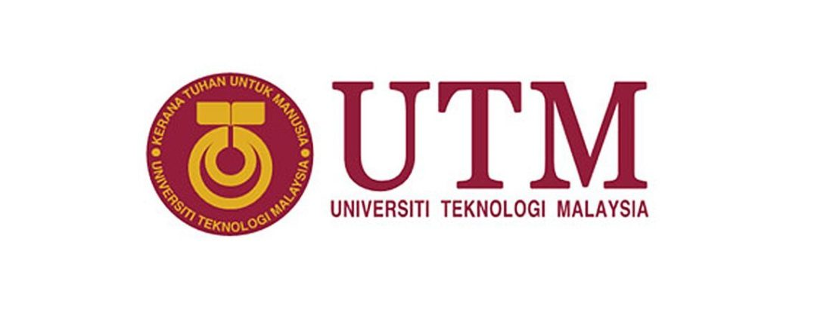

**REPORT DESIGN THINKING**

**SUBJECT:**

SCSP1513-02 TECHNOLOGY AND INFORMATION SYSTEM

**TOPIC:**

SECONDARY STORAGE

**LECTURER’S NAME:**

DR ARYATI BAKRI

**GROUP MEMBERS:**

|  |  |
| --- | --- |
| NAME | MATRIC NO. |
| LEE SZE YUAN | A19EC0068 |
| MIRZA SABRINA BINTI MOHD SALMI | A19EC0086 |
| JOSIAH JEEVANRAJ JOSEPH | A19EC0060 |
| MOHAMAD AMIN HAZEEQ BIN HISHAM | A19EC0087 |

Contents

INTRODUCTION 1

DETAILED STEPS 2

DETAILED DESCRIPTION 3

1.0 Problem 3

2.0 Solution 5

3.0 Team Working 8

DESIGN THINKING ASSESSMENT 9

DESIGN THINKING EVIDENCE 10

REFLECTION 17

1. Lee Sze Yuan 17

2. Mirza Sabrina 18

3. Mohamad Amin Hazeeq 19

4. Josiah 20

CONCLUSION 21

REFERENCE 22

# INTRODUCTION

Design thinking is a process starts with the people with problem that they can’t overcome and end with solutions that are tailored-made to suit their needs. It consists of 5 phases in order to achieve the goal. These 5 phases are Empathy, Define, Ideate, Prototype and Testing.

Secondary storage is one of the most important invention in Information Technology history and also human history. With secondary storage, humans are able to store the gigantic amount of data in one small piece of gold. In the data that stored inside the secondary storage, there is various kind of information, knowledge, entertainment and software.

For this project, we are required to investigate and research on Secondary Storage devices from various aspects like characteristics, advantages, disadvantages, limits and etc. Then, we need to find out what users need and want about the secondary storage device. After that, we will find out the solutions like how this secondary storage devices overcome the problem of another one. Finally, we will create the prototype of each secondary storage devices out.

First, in the Empathy phase, we have interviewed several respondents to gain their opinion in this topic. Then, through several discussion within our group members, we have truly understand the needs of users in secondary storage and list our problems of various type of secondary storage devices. After that, we quickly start to find out all the solutions that how each devices overcome the problems of their previous one. That is the Define and Ideate phase. Finally, we build up our prototype product.

In this project, we have studied on various of secondary storage devices from different generation. We have studied floppy disk and hard disk from 1st generation. We have also studied optical disk storage from 2nd generation and pen drive from 3rd generation. Lastly, we have also studied Cloud Storage.

# DETAILED STEPS

In the design thinking process, we have gone through 5 phases which are empathise, define, ideate, prototype and testing. For Empathise phase, we decide to do understand the users’ needs and problem through interview session. We have recorded the interview in the form of video and audio too. Then, data and information are collected and listed out in the interview. Each one of us have also done some research in internet in order to has a more detail understand in this topic.

After that, we make our moves to the next phase, the define phase. We have carried out several discussion about our interview and research results from the empathy phase. Through discussion, we can figure out what user needs from secondary storage and the problem of each kind of secondary storage devices.

Then, during the third phase, the ideate phase, all of us have a brainstorming session together to figure out solution for each of the problem defined. We compare every secondary storage device from various aspects. We list out the solutions one by one based on how 1 secondary devices overcome the problem of other secondary storage devices.

In the prototype phase, we make the prototype of every secondary storage devices we have studied by using paper and cardboard. We first draw a draft and then think on the design of our prototype. We make the prototype out of cardboard. Then, we further design it by color papers.

When the prototype is done, we have a test on it to examine its function and also the features included in this application.

All of the procedure of our design thinking process is recorded and compile into a video as a further reference and also an evidence for our work.

# DETAILED DESCRIPTION

## Problem

We have studied various type of secondary storage devices. We list down all the problem of each secondary storage. These are the problem we will study to find out the solution.

1. Floppy disk

* Big in size, not convenient to bring it
* Limited capacity
* File size can be stored is less than 700 MB
* Short life-span

2. CD/DVD

* Data will lose due to physical damage or corrosion of reflecting layer
* Vulnerable to physical damage like breaking, melting/ scratching
* Blocking of laser light by dirt, paint, ink, glue on the disc surface
* Need third party device: CD/DVD ROM  in order to access the data stored in disc
* Movie and audio need to convert to mpacc to play

3. Pen drive/ Flash Memory Card

* Risk of Loss of Pen Drive and Memory Card due to its Small Size
* Damage if not Handled Properly
* Risk of Virus and Malware

4. Hard Disk Drive

* Risks of being stole
* Space-consuming.
* Transferring or copying data can create security issues if the PC is infected.
* Slower rate to access data than ROM or RAM chips
* Hard disks can crash which stop the computer from working
* Regular crashes can damage the surface of the disk, leading to loss of data in that sector
* Some disk is fixed inside the computer and cannot easily be transferred to another computer.

5.Solid State Drive

* More expensive per GB than Hard Disk Drive
* Smaller storage capacity than Hard Disk Drive

6. Cloud storage

* Privacy and security personal data are at risk
* Limited space for free using.
* Expensive for extra space
* Need the access of internet in order to manage the data stored in Cloud
* People fear of the cloud since they don’t know where their data is.
* Speed and performance depend entirely on the internet speed and connection.

## Solution

We have studied the advantages and disadvantages for different kind of secondary storage devices. We compare them one by one and then study how one secondary storage device overcome the problem of previous one. We compare CD/DVD/Blu-ray to Floppy disk, Hard disk to CD/DVD/Blu-ray and Cloud Storage to Hard disk. As we know that floppy disk is very slow in term of speed and the capacity is very low compared to others secondary storage nowadays. For this solution, floppy disk’s users are better to use CD/DVD/Blu-ray because the speed is much better than the floppy disk and the storage size capacity is bigger. Basically, (Bayne, 2017) (Jani, 2017) states floppy disk can only store 1.4 MB which is very small. CD/DVD/Blu-ray are also still available at the market and it has no problem to find it. In fact, (Jani, 2017) states CD-ROM has greater capacity than floppy disk which is 700MB. (Michelle, 2017)But the problem is CD-ROM can read only but cannot write so you can only read information from them, but not save to them while floppy disc can do both which perhaps become the reason for floppy drives to survive quite long (Antonaccio, 2009). Although CD-ROM can overcome many problems in floppy disk but it still has one problem. (Antonaccio, 2009) (Michelle, 2017)The solution for CD-ROM is CD-R and CD-RW, CD-R drive had become popular because it can write once while CD-RW drive can write about 1000 times but both have a very slow data transfer rate and storage space not huge enough.

To overcome those issues for CD-R and CD-RW, we can use DVD. Honestly, DVD drives are cheap and affordable so it really isn't an issue. (Michelle, 2017)DVD drives are not only able to play and write to DVD media, but also CD-ROM and DVD also support HD media. (Michelle, 2017)The main difference between CD-ROM and DVDs is the size of available storage. (Jani, 2017)For CD, you'll get around 700MB at the most rather than a DVD will be able to store 5GB to 8.5GB normally. According to (Jani, 2017) (Michelle, 2017) problem in DVD is it does not support Blu-ray and the maximum storage capacity is around 8.5 GB only. Although the size is quite big, but nowadays there are many software especially video games require big storage space. So, the solution is we overcome this DVD by using Blu-Ray.

Blu-ray was invented to tackle the issues of even more capacity being needed for higher quality video. Based on (Jani, 2017) (Michelle, 2017)basically, Blu-ray can stored 25GB to 128GB making it more versatile means of storage space. Despite Blu-ray media is not supported or unable to play on DVD drives but it is not backward compatible with DVD players, Blu-ray still possible to load up and write to both CDs and DVDs with a Blu-ray drive. That is why Blu-Ray is much better than DVD because it is support for higher-definition media. Although these drives are slightly more expensive. (Jani, 2017) It essentially supports the highest capacity of Blu-ray excluding Ultra HD Blu-ray and will be super-fast. But the problem is Blu-Ray is very costing. Besides all of these type of disk they still need to have the device to play the disk which is the third-party devices or otherwise it cannot be played. So the solution is we need to overcome CD/DVD/Blu-ray with hard disk or HDD (Hard Disk Drive) and flash drive (USB Flash Drive).

Hard drive and flash drive cost cheaper than Blu-Ray. (Khan, 2019) (Every USB Find Your Drive, 2011) For high capacity storage, hard disk drive are the cheapest option per megabyte of storage space even solid-state drives cost five to ten times as much as a hard disk drive of the same capacity. Based on (Jani, 2017) (Khan, 2019)normally, hard disk has 8TB storage size while flash drive is 2GB to 128 GB maximum storage capacity which is far huge than Blu-ray disc and it is also still available and easy to find it. Luckily, it does not need third-party devices compared to Floppy disk/CD/DVD and Blu-ray. In term of speed hard disk is two times slower than solid state. Durability and portability, flash drive is much better than hard disk because which hard drive have moving parts as compared with USB flash drives, which have none. Given their size and weight, (Page, 2019) USB flash drives are far easier to carry compared to external hard drives. They also don’t need extra cables or power cords. (Jani, 2017)Hard drive typically connect via USB 2.0 interface generally have slower data transfer rates when compared to internally mounted hard drive connected through SATA. Although hard drive and flash drive are the most powerful devices, hard drives contain several moving parts inside an enclosure. (Page, 2019)These include spinning plates and a delicate arm. Hard drive is easy to damage and read or write errors if it is moved too vigorously or too often without sufficient protection while flash drive can easily to lose. Hard drive and flash drive need to take good care of it as it is easily to damage or virus-infected.

Then, we find the solution for hard drive is cloud storage as it has some features that consist more advantage over hard drive and flash drive. First, we found that hard drive and flash drive both share a problem that cloud storage don’t have. Next, (Jani, 2017) hard drive and flash drive is in physical form, they will consume space but cloud storage will not. So, user won’t have troubles in creating space for it in home or in traveling. Besides, hard drive like pendrive has a risk of getting stolen or getting corrupted. While, (NT, 2014) data stored in cloud storage won’t have this kind of risk. Based on (NT, 2014) as long as there is internet connection, then user can access to their data whenever and wherever they are. (Lord, 2018) They only need certain passkey and access, they can access to their data at any computer or mobile devices. Data stored on the cloud storage is protected and maintained by the authority of cloud storage. Further, when user wants to transfer or recover their data from one device to other devices, there is a risk of security. Because, by chance, when we copy data form and virus-infected pc into the hard disk, the virus might be stored into the hard disk with the data together. So, when users want to insert the data into another pc. The virus will also infect the pc. Besides, hard disk may crash and damage the disk and stop the computer from working normally. This will result in loss of data. For cloud storage, there is no problem like that. (Lord, 2018) Besides, data stored on cloud storage will get encryption, two-way authentication and cloud can be more secure. (NT, 2014) Cloud relies on multiple servers so that data can be duplicated over two or more servers as a backup to ensure on-demand recovery in case of any data loss.

## Team Working

In order to ensure this project runs smoothly, we discuss together on our topic which is Secondary Storage and do some research on it during our first meeting. In this design thinking process, there are five phases to solve a problem which are empathy, define, ideate, prototype and test. After we had understood regarding our topic, we move to the first phase which is empathy. We prepared a few questions to interview the users. We fairly divided tasks for each member. Mirza filmed the interview session while Yuan was interviewing the user. Hazeeq was taking notes from the user’s experience in using secondary storage devices. At the same time, Josiah was audio recording. He used the audio recording for video editing to make sure the voices in the video are clear.

Second, during the define phase, we listed down the problems by hearing the voice recorded. Through this process, the problem becomes clearer and easier for us to think about the solution. Next is ideate phase which required everyone to brainstorm ideas on how to overcome the problem that the users faced. We bring the ideas together to generate the best solution that can improve the performance of the secondary storage device. After that, we decided to start writing our report. Yuan wrote the introduction, detailed step and design thinking assessment. Mirza was writing the team working and conclusion. Besides, Hazeeq wrote the problem and the three of us were contributing in writing the solution together.

Then, we move to the prototype phase where we sit together and started to build the prototype using boxes. To reduce time consuming, each member was building only one device. Hazeeq built floppy disc and hard disks, Yuan built optical disc and drive, while Mirza built pen drive and memory card. As cloud server is bigger in size, we decided to build it together. Lastly, we present our slideshow and prototype in front of the class to be evaluated. We distributed our tasks evenly within the members and we helped each other to finish our tasks on time.

# DESIGN THINKING ASSESSMENT

This design thinking process consist of 5 phases which are empathy, define, ideate, prototype and deploy. We need to go through each phase based on this topic. Each phase has their own specifications where all these are the guidance for us to understand how design thinking is carried out. While, there are a few significant problems we faced and manage to solve in this project.

During the empathise phase, we have face difficulties to find suitable respondents. Based on our focus, we plan to find people that have used or owned various kind of secondary storage devices before especially Floppy disk. People like this can share their own experience with us. But all the technician I found hasn’t used floppy disc before. Luckily, we found a lecturer and technician experienced using all these kind of secondary storage before. Then, we conducted interview with them and jot down all their opinion and experience that they shared with us. Besides, each one of us have done research about our topic. So, with all the information we get, we finally understand the user’s needs. Next, we move on to the next phase which is ideate phase.

In define phase, we start to analyze all information we have about secondary storage devices. Then, we have found each kind of secondary storage devices have their own advantages and also disadvantages at the same time. We believe those disadvantages are the problem of each type of secondary storage devices that need to be solved. We also realize the Advantages are the solution to disadvantages of other secondary storage devices. So, we carry out the next step, ideate phase.

In ideate phase, just like we have mentioned above, the feature and advantages of each secondary storage devices are the solution to the problem or disadvantages of other secondary storage devices. So, we compare every secondary storage device one by one. Then, we realize it is a challenge. Because every secondary storage device has their own advantages and also their own disadvantages. There is no perfect secondary storage device which is the solution to all the problem of secondary storage devices. However, we still manage to figure out the solution to each problem. Finally, we carried out the last phase, prototype phase

Further steps in prototype phase, we create all the devices using paper and cardboard. We have created pen drive, memory card, cloud server, optical disc drive. Besides, we decorate all the prototype by using marker or color pencil. This is how we conduct each phase and transist from 1 phase to another phase.

# DESIGN THINKING EVIDENCE

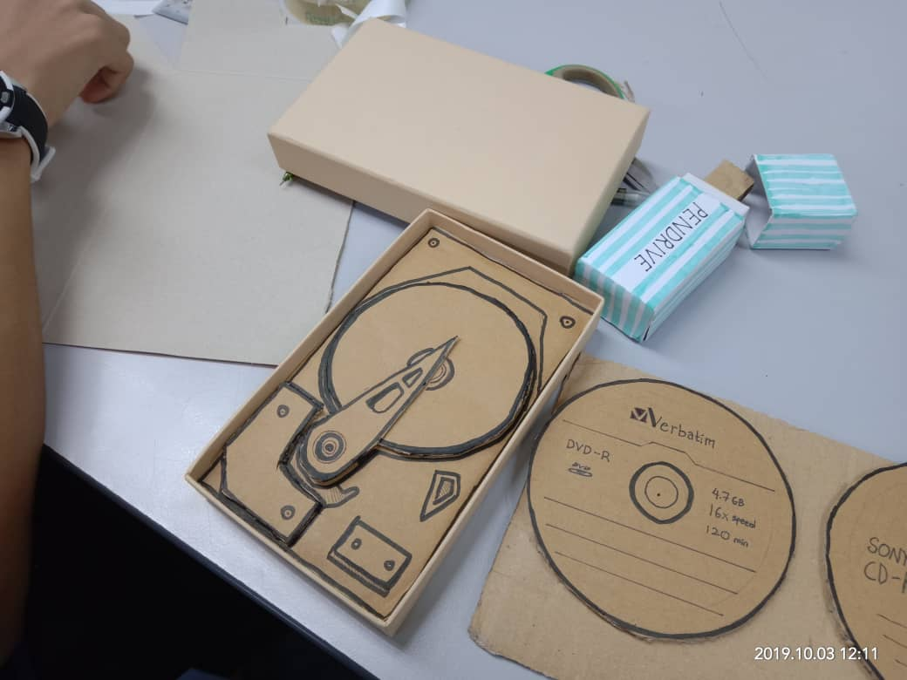

Figure 1.1 Image of Prototype

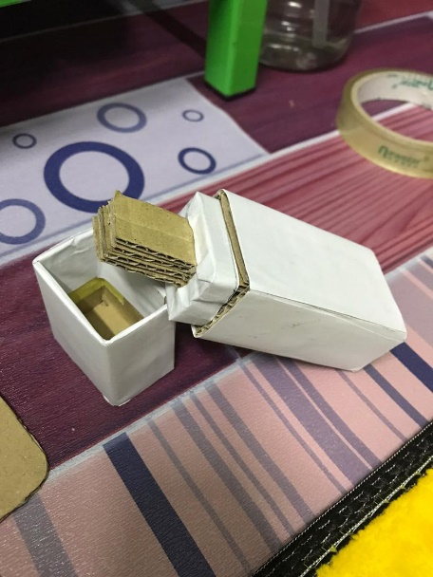

Figure 2.2 Image of Prototype

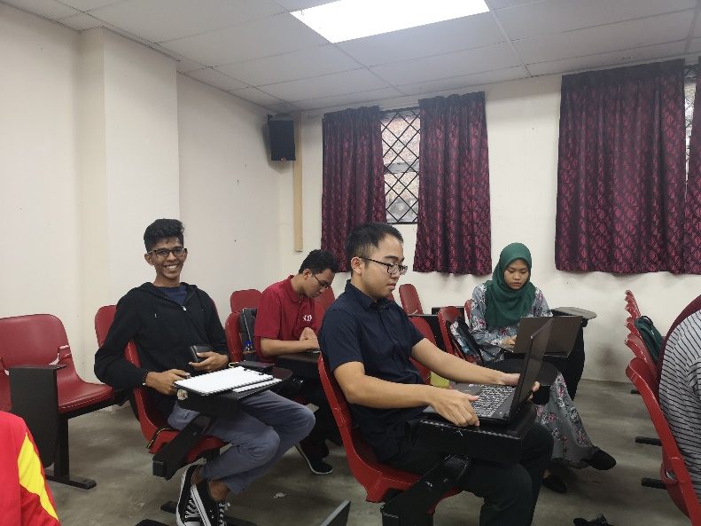

Figure 1.3 Group Discussion and Task Delegation

This is the YouTube link to the video we make for this project and video footage of our interview with the respondents. :

<https://www.youtube.com/watch?v=u6jwxE_CTL0&feature=youtu.be>

These are the questions we prepared to ask the respondent

1. What kind of secondary storage device you have back in the day
2. How is it. Good/efficient/convenient/costly?
3. What is the problem/short-comings of each devices?
4. During that time, using this (device), is there any problem that make guys really hope it it can get improved?
5. What is your opinion about the secondary storage of this age? Is it good?
6. What is the best devices you think and why?
7. Have you used cloud storage before? What is your opinion. Does it suit your current work or life-style or not?
8. How do you feel as if you put all your data on Cloud storage? Will you feel safe or insecure?
9. What do you think about the future of secondary storage (What kind of specification it should have?) (in term of data storage)

DR. LIZAWATI

1. I have tried using Floppy disk, CD and DVD, Pen Drive and also Cliud Storage.
2. Floppy disc storage has a really limited capacity and the file size it can store is really small. However, Floppy disc is the cheapest secondary storage device during that time. Then, for CD. I think the problem is we need to CD drive to use it.
3. The CD and DVD need to be kept properly in order to prevent scratches that leading to data lost.
4. Nowadays, the size of file is getting bigger and bigger, user need to have a better device which has much bigger capacity and not space-consuming.
5. Nowadays, there are many brands of Pen Drive, so user had many choices based on the size of storage they want and budget they have. So, it is really good. Not like in the past, there is only a few choices for users to choose. The size of storage device (pendrive) become smaller, easy to bring to anywhere but easy to lose it which leads user to move to cloud storage.
6. Pen Drive! because had many choices based on that size of storage and budget. Besides, the size of Pen Drive is really small which is portable. It don’t need any drive like a CD drive to access to the data inside it. However, it has a high chance of losing it..
7. I have used Cloud Storage services like Dropbox and google drive. It is really convenient. However, it has only a limited free space for every user
8. It is insecure to use a lot of cloud storage because we all will have a doubt on the privacy and security, right? But, it is easier for us to access the data everywhere.
9. Everyone will move to cloud storage. As data is getting bigger day by day, maybe there no free cloud storage instead everyone needs to buy it which is more trusted rather than the free one.

MR. MUHAMAD AZMI

1. According to the history, I divided each type of secondary storage device into 4 generations. In 1st generation, there is the floppy disk or diskette. Then, in 2nd generation, there is CD and DVD. In the 3rd generation, we have Memory Card and Pen Drive. Lastly, the 4th generation, we the secondary storage device that I first exposed to belongs to the second generation.
2. From my experience, compared to today, data storing is considered really easy now. In the past, the process for us to access to the data we stored is really slow. Besides, during that time, we even need third party device like CD/DVD ROM in order to access to the data in CD/DVD.

But for the time when we have Pen Drive, there is no problem that I mentioned just now. But… there is still some drawback for pen drive, like Pen drive is small, so there is a high chance we lose them. We also afraid of the risk of virus and malware

1. The problem during that 2nd generation is during that time, we may face problem like when we burn data in the form of Audio and Video into disc, we want to play it on a player. It cannot run on the player due to error in burning process. But, Pen Drive won’t have this kind of problem.
2. I think secondary storage device now is really excellent, especially Cloud Storage. Just the problem of Cloud Storage is we cant store our main OS system is Cloud Storage. Then, about SSD, I think it is really good, it is fast and efficient. Just it is expensive and the capacity is smaller.
3. Normally, I only use Cloud Storage to store 30% of my work file. For other data like my personal data, I still prefer to use physical form of storage device.
4. I know user of Cloud Storage is curious about where their data is and scare of their data get stolen. I think I have no this kind of concern to Cloud Storage. Because in UTM, we only Cloud Storage that has been verified by UTM and Cyber Security Board. So, the Cloud Storage we used has been proven to be safe.
5. I believe in future, there is no more physical form of storage device. We will store all our personal or private data in the Cloud Storage.

# REFLECTION

## Lee Sze Yuan

To me, I always love to learn or study on things that I don’t know. So, I enjoy the process of gaining new knowledge, I even more enjoy the process of analyzing and interpreting things! That is why I choose this course, Data Engineering. When I first learned about this course, I am deeply attracted to this course and its career path. I dream to become a professional data engineer by using the analytical and interpreting skills. Then, through this design thinking project, I master the skills necessary for my career path. I learned the way to understand users’ needs, and correct way to think of the problem that I need to solve. I also learned how to solve the problems one by one. This process of design thinking really makes me more understand in how I should finish every task that I will face in the future as a data engineer. So, this make me realize I need to be better in this design thinking skill because I strongly believe that design thinking skill is necessary to me to become more potential in this data engineering field. So, I plan to carry out some programming project by myself. I believe this is a way for me to understand more in design thinking.

## Mirza Sabrina

Throughout this project, I can see that design thinking is very beneficial for me to train myself to do critical thinking or think outside the box in order to solve a problem. I have learned a lot of new knowledge due to the process of researching on our topic which is Secondary Storage. Besides, I have gain new experience in dealing with adults as we need to book for an interview session. I have also improved my communication skill because I need to communicate a lot with users, the lecturer, and my teammates to complete this project. The five phases of design thinking had helped me to develop my problem-solving skill and innovation. As written above, it is clear that the design thinking project has helped me a lot in improving my soft skills. I realize that I had to become more creative in order to improve my potential in the industry. This is because creativity connects ideas and presents them in a new way that can create something truly new. Therefore, I must explore extra knowledge and not only rely on my syllabus in class.

## Mohamad Amin Hazeeq

Me Mohamad Amin Hazeeq Bin Hisham reflects from this project, I have a dream regard to my data engineering course which is i want to apply them into my career goal and want to work in this data science field. Data science is a fast-moving industry, and nowadays it is very crucial in this world to develop many unthinkable new invention from time to time. Design thinking impacts me a lot especially to become a productive person and I learned on how to handle the design thinking project which we need to work in team, making interview with some experienced person and many others to finish this project. Unfortunately, I accidentally gain more knowledge and also improve my communication skills with my team member. Design thinking teach me on how to encourage and to build on wild ideas regard to the project of researching in the topic “Secondary Storage”. I need to improve my soft-skills and keep on reading many revision books and do a lot of exercises in programming from any sources that relates to data engineers so I can prepare myself to involve in the professional world and easy to adapt especially in the industry.

## Josiah

From this project, I learned a lot about secondary storage. I learned the evolution of it over the years. The problems of it and how we overcame it. The evolution of secondary storage shows how we’ve evolved in our ways of thinking. We have learned to solve problems more accurately. Besides that, this project has taught me how to work as a team and be a team player

# CONCLUSION

In conclusion, design thinking or “outside the box” thinking is a good exposure to students as we had learned how to solve a problem when we face it. The five phases of design thinking which is empathise, define, ideate, prototype and test had helped us to generate ideas in order to solve problems. On empathise phase, we need to listen to the problem that the user faced. We had to find the target users and their contact numbers to book the interview session. This helps us a lot in improving our communication skills. After we had understood the problems, we move to define phase which we need to conclude the problem in order to solve them. Then, ideate is the phase where we had to brainstorm ideas to develop a solution. Finally, we meet the prototype phase where we need creativity so that we can build the new product. Throughout these phases, we had learned a lot of new knowledge and experience. Besides, we can see that design thinking project had given us an opportunity to improve the product. We had also improved our soft skills, problem-solving skill, and innovation. We realize that these values are very important in order to survive in this competitive era.

# REFERENCE

Antonaccio, N. (2009). Floppy and CD drives. *Hardware: Floppy and CD drives*.

Bayne, G. (2017). What is the Capacity of a Floppy Disk ? *Floppy Disk*.

Every USB Find Your Drive. (2011). How External Hard Drives Are Different. *Flash Drives vs. External HDD & SSD: What’s the Difference?*

Jani, D. S. (2017). Floppy disk, CD-ROM,DVD,Blu-ray,Hard drive,Magnetic Tape. *Portable Storage Solutions*, 7.

Khan, R. (2019). What are the Characteristics of Storage Devices? : Hard drives. *Characteristics of Storage Devices*.

Lord, N. (2018). What Is Cloud Encryption ? *Data Protection101*.

Michelle, M. (2017). Optical Storage Media. *The ICT Lounge*.

NT, B. ( 2014). 5 advantages of using Cloud Storage. *5 advantages and disadvantages of using Cloud Storage*.

Page, C. (2019). Cost,Capacity,Size,Durable,Speed. *Advantages & Disadvantages of Hard Disks*.