**3D Printing Manual**

**Model : TRONXY P802MA**

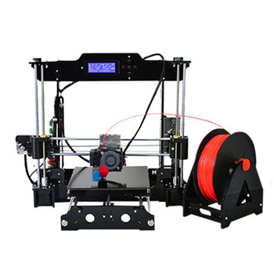

Prepared by: Muhammad Fikri Irsyad

**Table of Content**

1. Warning and Precautions 3
2. Requirement 4
3. Instruction
4. Designing a model 5
5. Setting up Repetier Host 6
6. Preparing model for 3d Print 11
7. Extra note 12

**WARNING AND PRECAUTION**

Toxic Substance



THE MELTING OF PLASTIC FILLAMENT PRODUCE TOXIC GAS AND SHOULD NOT BE INHALE DIRECTLY. LONG TERM OF DIRECT INHALATION WILL CAUSE HEADACHE AND NAUSEA. USE FACE MASK.

HOT SURFACE



THE NOZZLE AND BED MAY EXCEED 60° WHICH CAN RESULT 1ST DEGREE BURN. BE CAREFUL WHEN NAVIGATING NEAR NOZZLE AND BED. DO NOT USE BAREHAND WHEN REMOVING DIRT OR SCRAP WHEN PRINTER IS ON.

MOVING PARTS



THIS 3D PRINTER MOVE RANDOMLY WHEN OPERATING. DO NOT PLACE THINGS NEAR TO THE PRINTER OTHERWISE IT WILL BLOCK THE PRINTER MOVEMENT. KEEP CLEAR OF PRINTER SURROUNDING.

**REQUIREMENT**

1. 3D MODELLING SOFTWARE. (SOLIDWORK, AUTOCAD, ETC..)



1. REPETIER HOST. (3D PRINTER USER INTERFACE SOFTWARE)



1. 3D PRINTER AND FILLAMENT.



1. LAPTOP OR PC.



1. ARDUINO BLUE CABLE.

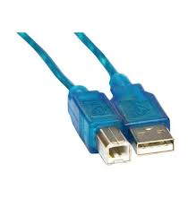

**INSTRUCTION**

1. DESIGNING A MODEL

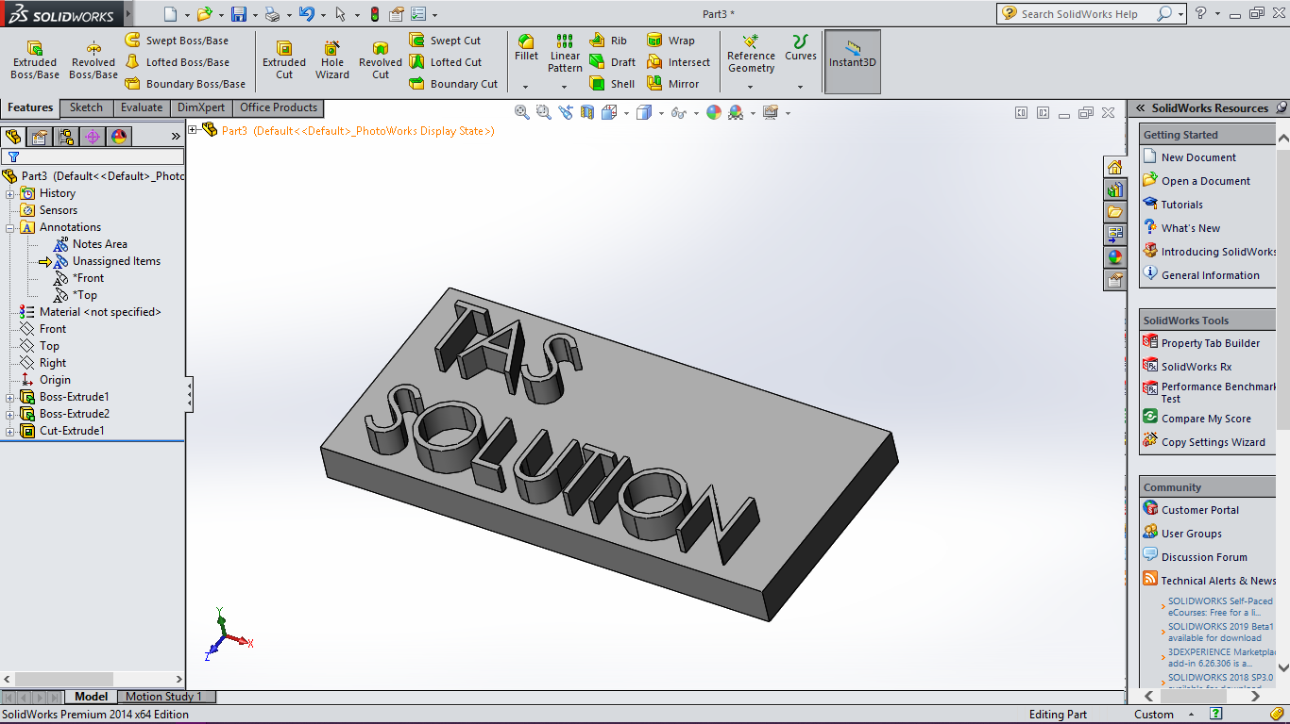

When designing a model, make sure the model dimension do not exceed bed size. If large model need to be print, design a model in parts, print consecutively and assemble later.

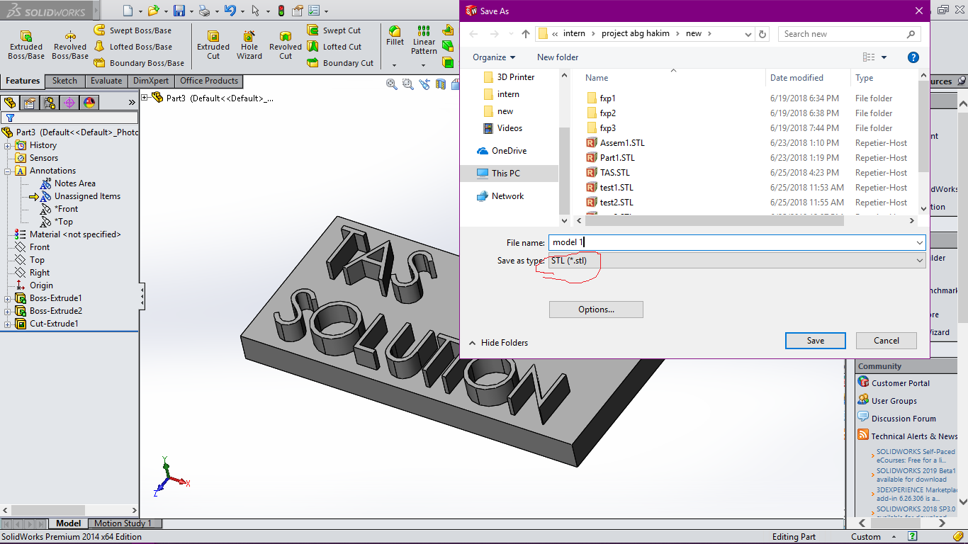

Save the model in available format that compatible with Repetier Host. In this case, .stl format can be use.

1. **Setting up Repetier Host**

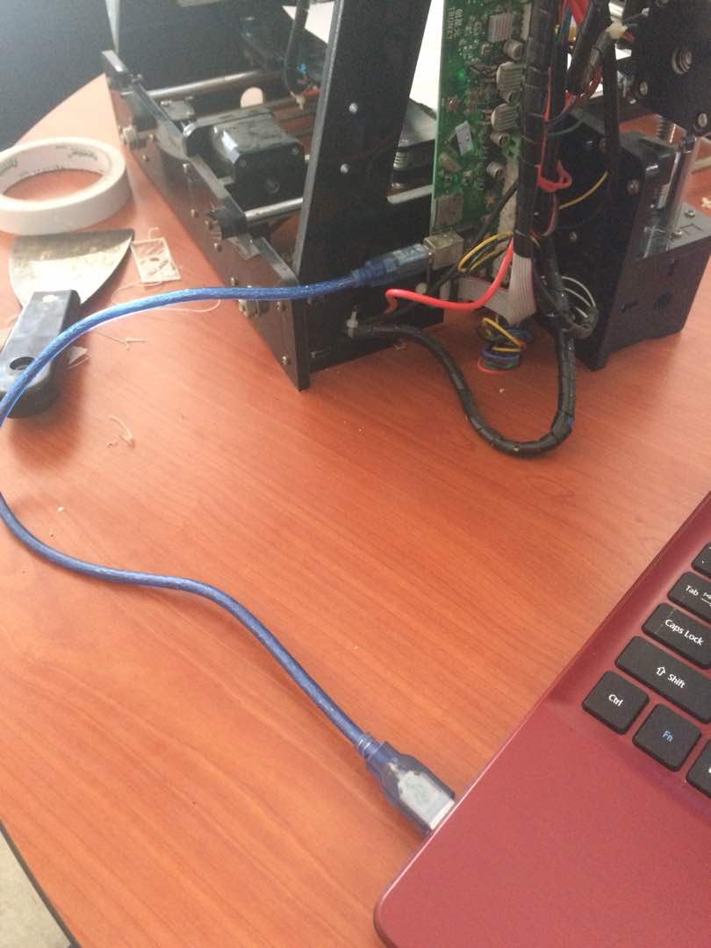

Connect 3D printer and laptop using Arduino cable.

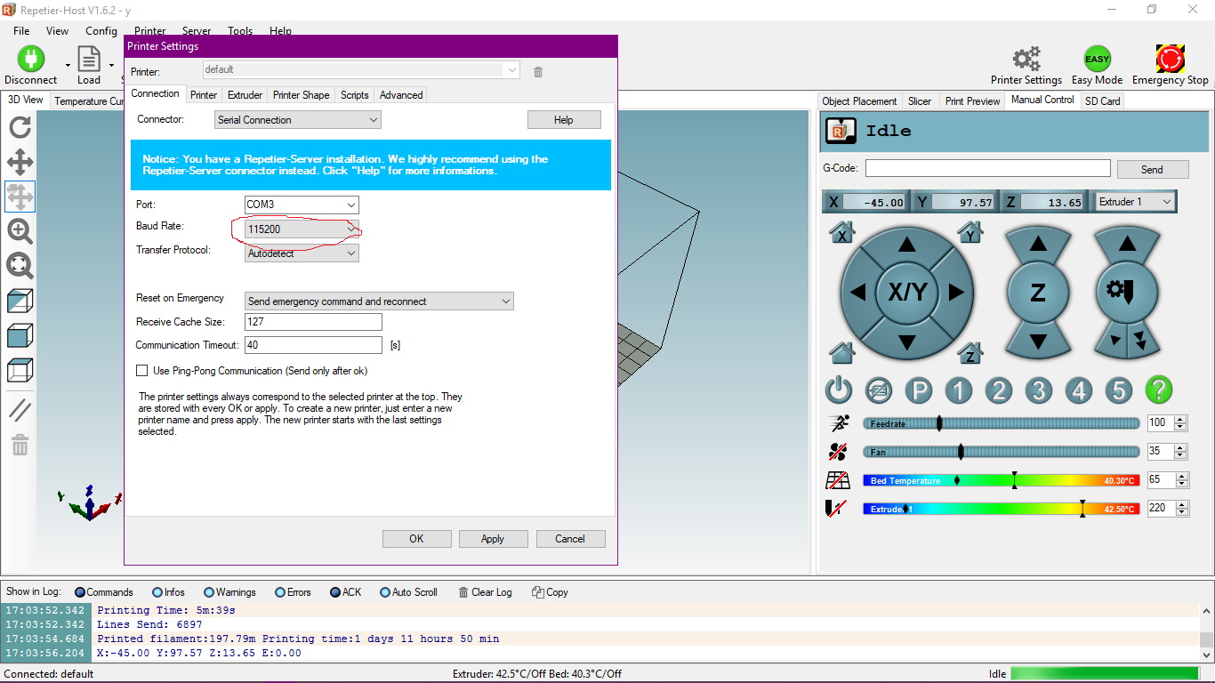

Open Repetier Host. Click connect on upper left corner. Click Printer Settings, on printer settings, change the Baud rate to 115200.

Pick slicer tab and click configuration.

Set all configuration as bellow.

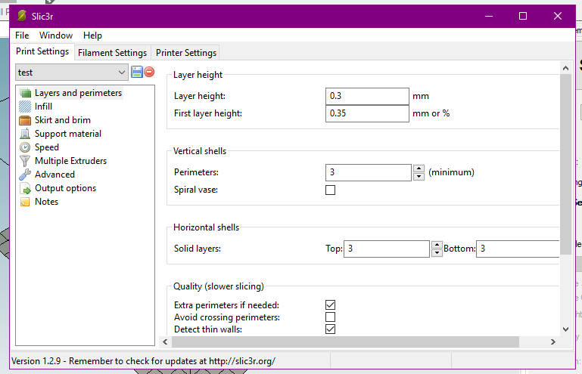

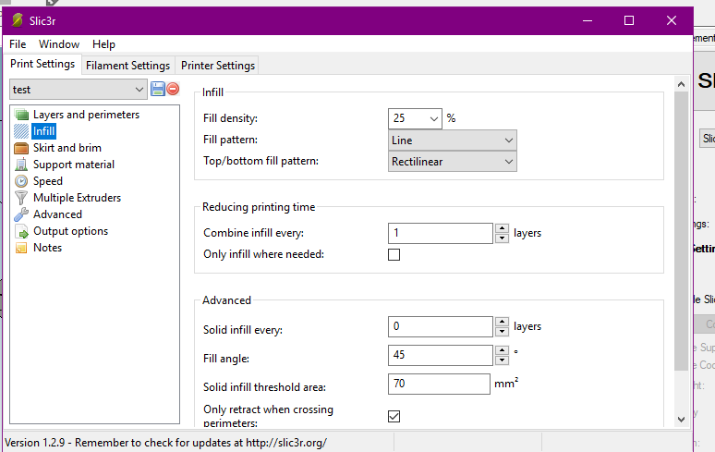

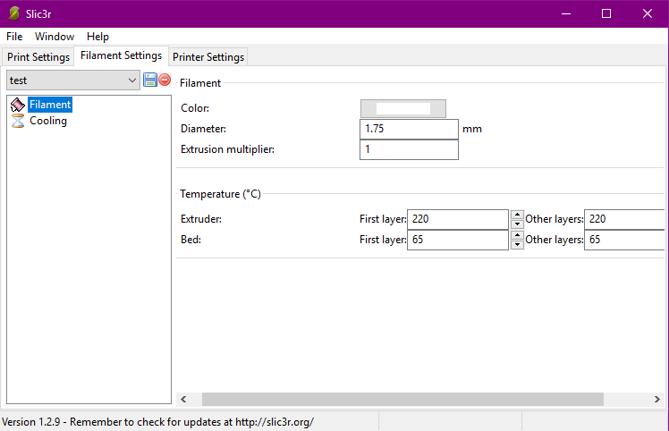

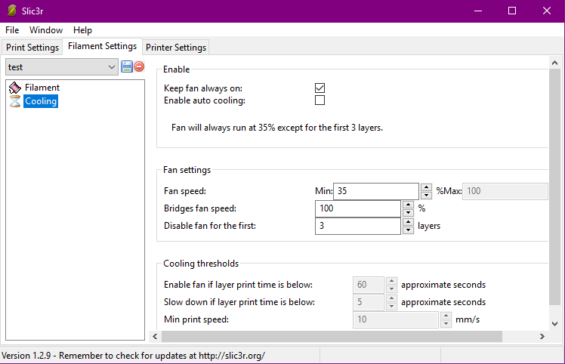

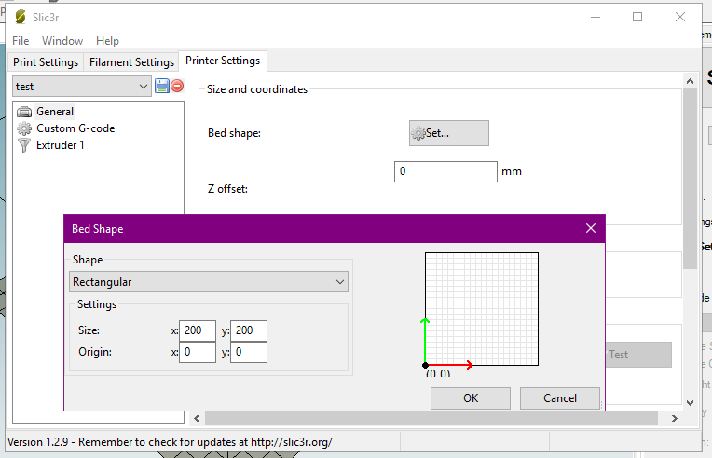

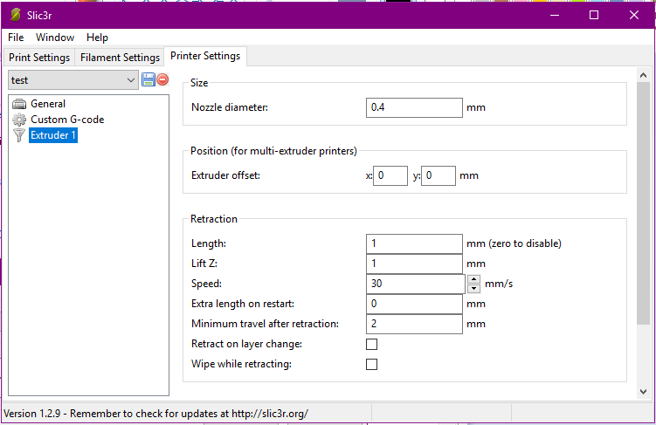

Save the configuration by clicking the save button.

1. **Preparing the model for 3D print**

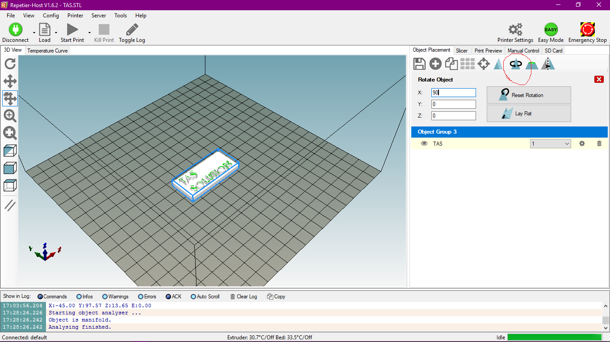

Load the model by clicking load button. The model need to be properly oriented so that when printing, it will not fall or topple. To adjust the orientation, click the button in red circle and insert appropriate angle value.

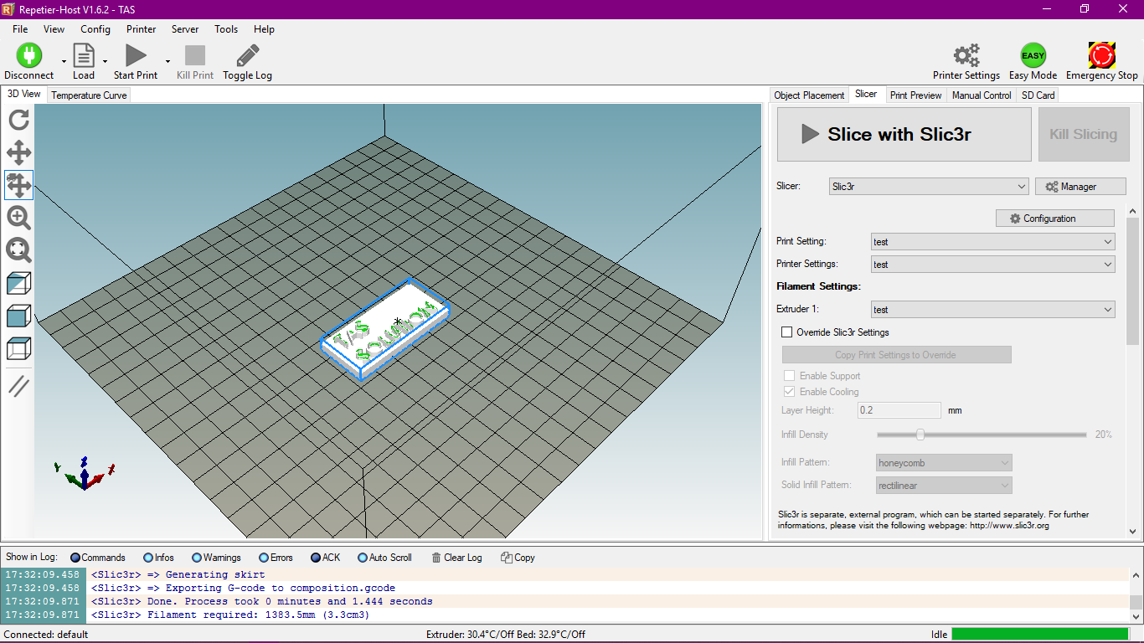

When all is set, click “slice with slic3r” and hit the Start Print button at top. Now wait until printing process done.

**Extra note**

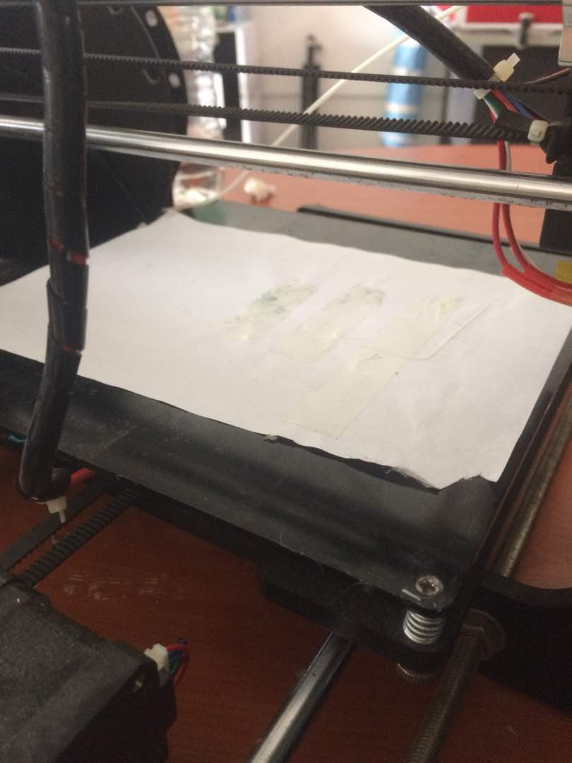

Before printing, a piece of A4 paper may need to be placed on top of the bed. This to provide friction for the first layer of filament as the surface of the bed is slippery. Use double sided tape to stick the paper for easy removal after done printing.