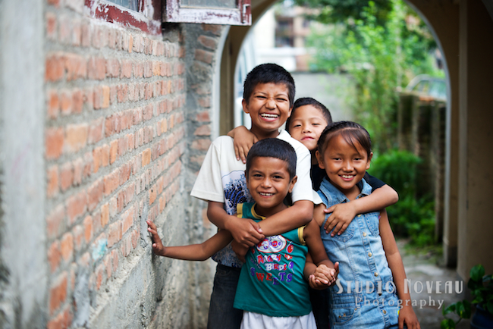

“HELPING FOSTER, MAKING LAUGHTER.”
A VISIT TO AN ORPHANAGE.

FACULTY OF COMPUTING
COURSE: UHMT 1012 (SECTION 24)

CHEONG CHIEN LI A19EC0186
ANIKA SHAHZAD A19EC4007
HUSNY MUSHARRAF BIN SHAMSUL KAMAL A19EC0051
NUR AIN BINTI MAHAMMAD SALLEH A19EC0126
NABILA HUSNA BINTI ROSLI A19EC0110

TABLE OF CONTENTS

INTRODUCTION 3

OBJECTIVE 4

PROBLEM STATEMENT 5

ORGANISATION STRUCTURE 6

DUTY AND RESPONSIBILITY OF COMMITTEE MEMBER 7

BUDGET AND EXPENDITURE 9

DATE, TIME AND LOCATION 13

CONCLUSION 14

SELF – REFLECTIONS 15

APPENDIX 20

MINUTE OF MEETINGS 21

INTRODUCTION

Orphans are children whose parents have either passed away, are unknown to them, or abandoned them. Without the care of their parents, these children need a place to stay and be taken care of in order for them to successfully transition into adulthood. An orphanage is a place where these orphans are cared for and housed with love. A typical orphanage will usually provide food, shelter, care, and comfort to the orphans and it is a great place for orphans to get to know other orphans and make new friends.
There are a few benefits to visiting an orphanage. They include:
- Educating ourselves
Learn to grasp the feeling of being an orphan. If we are able to feel how the orphans are feeling, there is no doubt that we will sympathize them more and will try our best to help the orphans to the best of our abilities. Which in turn allows the orphans to feel understood and loved.

- Giving hope to the orphans
A visit to an orphanage will undoubtedly allow interactions between the orphans and the visitors. During their interaction, it is possible for the visitors to give hope to the orphans and motivate them in order to not let their lack of parental care drag them down in life.

- Fulfills the particular needs of adoptive parents
Visitors will be able to act as a “temporary parent” of the orphans and educate them about some important life lessons so that the orphans will grow into a respectful and well-mannered adult.

- Expand the social circle of the orphans
An orphanage visit will be able to show the orphans that it is possible for them to make friends not only with other orphans but also with people who have their parents. This will cause the orphans to not feel like they can only mix well with other orphans and give them a huge boost in confidence when making new friends.

Hence, it can be seen clearly that a visit to an orphanage will be able to bring many benefits to not only the orphans, but also allow us to learn to appreciate our parents more.

OBJECTIVE

There are a few objectives for a visit to an orphanage. This is because there is a high possibility that many orphans have faced many difficult hardships in their childhood. Furthermore, without the guidance of their parents, orphans will often be led into a wrong way of life and grow up into problematic adults. Hence, there are plenty of different objectives of an orphanage visit.
First and foremost, an orphanage visit can be aimed to providing love and affection to the orphans so that they can feel what it is like to be loved. This is an important objective because children who are not given love and attention often times will develop many psychological illnesses such as depression. Hence, one of the objectives of an orphanage visit is to provide the children with enough love and care in order for them to feel loved and be happy.
Next, educating orphans about important lessons in life is also a major objective for an orphanage visit. Many children who grew up without their parents’ guidance often do not know or understand some basic moral principals in life. This leads to the existence of disrespectful and immature adults. Hence, one of the objectives of a visit to the orphanage can be to act as their “temporary parents” and educate them about some simple and basic moral values and principals so that when they grow into adults, they will be respectable and well-rounded members of the society. Thus, educating the orphans is an important objective of an orphanage visit.
Apart from that, another important objective of a visit to an orphanage is to allow the interaction between the orphans and the visitors. This interaction between them is unimaginably important because it will allow the orphans to expand their social circles beyond only having other orphans. This interaction will allow the orphans to make new friends who might not be orphans, and this will provide the orphans with the confidence needed to make new friends. Once they see that it is possible for them to make friends with those who are not orphans, they will start to believe that not having their parents’ guidance does not affect their ability to make new friends, this in turn will greatly boost their confidence when making new friends.
Lastly, the visitors will also be able to benefit through this interaction. This is because interacting with the orphans will allow them to somehow grasp how it feels like to be an orphan. This is great for the visitors because once they can understand how the orphans feel, they will definitely appreciate their parents more and also sympathise the orphans more, which might motivate them to do something to help the orphans to live better lives. Thus, it is clear that one of the most important objectives of a visit to an orphanage is to allow the interaction between the visitors and the orphans in order for them appreciate what they have and gain confidence in making new friends respectively.

PROBLEM STATEMENT

There are a few major problems in the modern society that exists due to the lack of these visits to orphanages. The first, most significant problem is that many people tend to forget that there are many kids out in the world growing up without being able to feel loved by their parents. This is because everybody is busy living their own lives, facing their own problems every single day. Hence, it is not surprising for many people to forget about the existence of these orphans. This is why visits to orphanages is needed in the modern society; to remind people about the existence of orphans so that the orphans will be able to feel loved and appreciated in a way that they are unable to feel from their parents.
Moving on, the next problem in the modern society is that many orphans tend to grow up without being able to feel love and affection from their parents. Hence, this might lead them down a dark path in life where they might turn towards committing crimes such as doing drugs, or stealing in order to command some attention from others. Hence, more of these visits should be organised in order to provide more love and affection to young orphans so that they will not grow into criminals just because they want to seek some attention from others.
Additionally, it is undoubtedly true that many people who grew up with a complete and happy family, tend to forget how lucky they are to have their parents with them throughout their childhood and they tend to take having both their parents by their side for granted. Since their parents have always been there for them, it is easy to underappreciate what they have and completely overlook the fact that they are lucky. This is a growing problem in the modern society, where we can clearly see that many kids nowadays take their parents lightly and speak to their parents in a rude manner. Thus, more of these visits to orphanages should be organised so that the participants will be able to realise that they are lucky to have their parents by their side when they were young, and start to really appreciate their parents. Hence it is clear that the fact that parents are being taken for granted in this modern society is a growing problem, and a visit to the orphanage is a great way to solve this issue.
Lastly, there is a minor problem in the current society where orphans and non-orphans do not have much opportunities to meet and get to know each other and expand their social circles respectively. This is because many great friendships are made since young, and without being exposed to each other, the orphans and non-orphans might have a lower chance of forming a strong friendship since young. Hence, these visit to orphanages are important to solve this problem because they allow the orphans and non-orphans to interact with one another, possibly forming great friendships that might last a lifetime. Thus, it is clear that these visit to orphanages are crucial to solving the problem of lack of interaction between orphans and non-orphans.

ORGANISATION STRUCTURE

Event Director
- Cheong Chien Li
Treasurer
- Husny Musharraf Bin Shamsul Kamal
Program Co-ordinator
- Nur Ain Binti Mahamad Salleh
- Nurul Izzah Binti Abdul Hamid
Equipment Co-ordinator
- Bethany Lei Lou Moe
- Luvindraan A/L Anbarasu
Promotions Co-ordinator
- Hoe Li Phook

Secretary
- Anika Shahzad

Venue Co-ordinator
- Nabila Husna Binti Rosli

Hospitality Co-ordinator
- Sum Ting Wong
- Nur Amirah Syarina Binti Hakim

DUTY AND RESPONSIBILITY OF COMMITTEE MEMBER

- Event Director

- Coordinating with the members, event participants and University authorities.
- Developing the plan for the visit.
- Representative of the event at hand (dealing with outside bodies such as sponsors of the event and media platforms).
- Help build positive relations within the team and external parties/bodies (participants / visitors).
- Monitor the progress of the proposal and ensuring everything will be done in time.

- Secretary

- Arrange and organize new meeting and appointment to keep up with the proposal deadline.
- Prepare letters, memos and forms.
- Filling empty work and job scope. (Helping whenever and wherever needed).

- Treasurer

- Manage the financial part of the proposal.
- Budgeting and planning the estimating the expenditures by preparing and presenting budgets for new or ongoing work.
- Report the financial status to the event director (present regular reports on the organizations to event director or program coordinator.)
- Ensure proper records of finances are kept.

- Program Coordinator

- Planning the program and the activities to be carried out.
- Ensure that the organized activities are organized according to the budget presented by the treasurer.
- Ensure the activity proposal develops progressively according to the plan and deadline.

- Venue Coordinator

- Searching and reserving the venue of the event (visit).
- Do final checks with the venue hosts on the day of the event to ensure everything run smoothly as planned.
- Ensure that the buses arrive on time and the participants arrive at the orphanage on time according to the plan.

- Equipment Coordinator

  - Ensure that all the equipment needed for the activities during the visit are ready.
  - Ensure all of the participants arrived safely by the transportation provided.
  - Prepare all necessary safety equipment to handle the situation in case of accidents.

- Promotions Coordinator

- Develop advertisement materials like brochures and flyers to advertise the event.
- Develop promotional plans and coordinates the photography of the event.
- Ensure the publicity of the event is well spread.
- Advertise the event.

- Hospitality Coordinator

- Coordinate food orders for the participants and orphans.
- Remove dirty plates, glasses once the event is complete.
- Keep all areas at the venue of the visit clean and hygienic.

BUDGET AND EXPENDITURE

ESTIMATED INCOME

Sponsorship | Amount (RM)
Cash Sponsorship  - Student Affair UTM & Majlis Perwakilan Mahasiswa UTM (MPM UTM)  - Pusat Islam - Zakat | 1000  500
Products Sponsorship  - Corporate Company  - Eco Shop  - Gardenia Bakeries Sdn Bhd  - Mak Ngah Catering | 250  200  150
Total Income | 2,100

ESTIMATED EXPENDITURE

Activity | Amount (RM)
- Food & Beverage  - For Host of Orphans (RM10*3 persons)  - For orphanage (RM8*35 persons)  *included breakfast and lunch | 30  280
- Program  - Activities equipment | 150
- Gift & Souvenir  - For host of orphans (RM25*3 persons)  - For orphanage (RM30*5 groups) | 75  150
- Publicity  - T-shirts for members (RM15*11 persons) | 165
- Donations  - Rumah Anak Yatim Raudhatul Maryam | 1250
Total Expenditures | 2100

SPONSORSHIP PACKAGE

- Pre-Event
Marketing Communications
- Logo of the sponsor are included in the event poster.

- On-site
- shirt design
- Sponsor’s logo is included in the design of the t-shirts for the members
Giveaway and souvenir
- Sponsor’s logo is printed on the goodie bags.

- Post-Event
- Mention the name of the sponsors as well as the logos in the post-event email.

SAMPLE OF SPONSORSHIP LETTER
4th December 2019
Program “Helping Foster, Making Laughter”,
School of Computing, Faculty of Engineering,
Universiti Teknologi Malaysia, Johor Bahru
012-3456789 | a@gmail.com
Dear, [ Recipient name],
Assalamualaikum and Good Day!
Warm greetings from Universiti Teknologi Malaysia (UTM). I hope this message finds you well.
Firstly, I would like to introduce myself. My name is Anika Shahzad, the secretary of this “Helping Foster, Making Laughter” event. It is a great pleasure for us to offer your organization a great opportunity to collaborate with us and become a valuable sponsor of the event, which will be happening on the [date].
For your information, “Helping Foster, Making Laughter” is a one-day event of visiting an orphanage which takes place in [venue]. There will be a lot of activities that will be carried out during this event such as ice breaking and explorace.
We would dearly invite you to come forward and contribute not only in terms of monetary funds, but also by items and food and beverages as well. We would be really grateful if you could collaborate with us in order to make this event a success. It would be an honor to be associated with a reputed company such as Gardenia Bakeries Sdn Bhd.
We look forward to an affirmative response of collaboration from you, as we believe that your contribution would be a valuable addition to the event. By this, I have included some related documents of this program. Please do not hesitate to contact us if you have any inquiries.
Thank you so much for your time, and we look forward to hear from you!
Sincerely,
----------------------
Anika Shahzad.

DATE, TIME AND LOCATION

Date: 7th January 2020
Time: 8.00 am – 1.00 pm
Location: Rumah Anak Yatim Raudhatul Maryam, Taman Universiti, Skudai, Johor Bahru
Transportation: 2 Buses provided by UTM.

Date | Time | Activity
 | 7.30 am | Students assemble at Library of Sultanah Zanariah, UTM and have a very light breakfast.
 | 7.45 am | Bus arrive at the Library and head to the orphanage.
 | 8.00 am | Arrive at the orphanage and prepare for the activities.
 | 8.20 am | Assemble the orphans and visitors for the opening speech by the Headmaster of the Raudhatul Maryam Orphanage.
 | 8.30 am | Ice Breaking Session and grouping for the orphans.
 | 8.50 am | Aerobics exercise and dances.
 | 9.00 am | Explorace.
 | 11.30 am | Cleaning up after activities and a quick rest. Preparing the food for lunch.
 | 11.50 am | Talk session with the orphans about reflections on the whole visit.
 | 12.15 pm | Closing ceremony and final speech by Head Director of the program (Cheong Chien Li). Giving out donations and prizes for the winner of the explorace.
 | 12.40 pm | Lunch Time.
 | 1.00 pm | Bus arriving and return back to UTM.
PROGRAM TENTATIVE

Explorace Activities:
- Six Frog Jumping
- Paper Puzzle
- Hidden Candy in a flour (Use mouth to find)
- Connecting the Dots (Mind-blowing puzzle)
- Human Twister
- One paper, 10 people.
- Group Juggling
- Balloon Responsibility

CONCLUSION

The main purpose of the program is to provide love and care to those who did not have a chance of to feel loved and cared by their parents. In addition, it is also for us who still have families and parents to be grateful and thankful that we are raised with love and a full care by our parents. As a result of that, this program does not only affect the orphans, but for both sides to learn and take it as a lesson to be more grateful for what we have. For instance, for the Explorace, we group the orphans with the visitors as a facilitator, this way we can see how both parties need each other by helping one another. Besides, it is our responsibility to take care of the orphans, if one does not think of helping them, it will be a sin for all of us. Furthermore, this will also make the orphans realize that their past does not define who they are, it is about what they choose to be now and in the future. As a conclusion, visiting an orphanage is a great opportunity for everyone to learn. We do not have to wait for such program to appear to go and visit, we can always visit the orphanages by ourselves when we are free, because it does not only benefit ourselves, but also for the orphans.
It is hoped that this program will be supported by all parties including students, lecturers, and university authorities. With enough support, there is no doubt that this program will be a great success and be able to bring happiness to not only the orphans but also to everyone who participates in it. This program benefits both the orphans and the visitors in a way that no other programs will be able to provide. Hence, let us all make the world a better place by helping foster, making laughter.

SELF – REFLECTIONS

CHEONG CHIEN LI (A19EC0186)

First and foremost, I would like to thank all of my group members, Anika, Husny, Ain, and Nabila for their restless efforts in helping to plan and complete this proposal. It is undeniable that they contributed greatly to this group work. Although there were many difficult problems that we faced while coming up with this proposal, this team held together strong and powered through all the hardships. It was a blessing to have them as my team members and it was a great pleasure to be able to work with them to come up with this proposal.
Apart from that, I would like to thank our lecturer Dr Hadi for always being there to guide us through any problems we faced related to his course. It is clear to me that Dr Hadi is a professional at work and should be set as a role model for many students. It was an honour to have the opportunity to be taught by Dr Hadi.
Moving on to the point, the whole experience of coming up with this proposal had been fun and educational at the same time. By exposing myself to making proposals like this, I was able to get a good feel on how to plan big events. This is because while planning this proposal, I had to think about many problems that might arise throughout the event. The event that my group members and I decided to propose was a visit to an orphanage, titled “Helping Foster, Making Laughter.”. I was able to learn a lot while planning this event simply due to the fact that there were many problems that has to be solved if the program were to be successful. Problems such as advertising the event such that it will be known to many people and be able to attract many participants. Not just that, my group members and I also had to figure out which orphanage that we want to visit. Many factors were considered when choosing the location of the visit so that the participants would not have to travel long distances in order to partake in our event. After that, we had to find an affordable and safe way of transporting all the participants to the orphanage, which was also another major problem for us to solve. We finally decided to request the assistance of our university busses to transport all our participants to the orphanage. Moreover, one of the hardest problems that we had to solve was to come up with several different games that must be educational to the orphans and be able to teach them about some valuable life lessons. After days of thinking we were finally able to come up with some fun and interesting games.
Those were only a fraction of the problems that we had to solve while planning this proposal. Thus, it is only natural that I was able to learn much about the difficulties of planning large events through this proposal. This is important to me because it helped me to appreciate the big events organised by others out in the society. It is definitely true that we will appreciate the work and effort of others if we know how hard it is to be able to do what they did.
As a conclusion, I was able to learn and expand my knowledge unimaginably not just through planning this proposal, but also throughout the whole course. Graduate Success Attributes have not only given me an opportunity to experience the hardships of planning an event, it also taught me about some important characteristic values in order for me to be a successful graduate in the near future. Values such as leadership and scholarship will undoubtedly help me a great deal throughout my four years of university life and beyond. Hence, I would like to thank Dr Hadi once again for everything that he has done for us, providing us with the necessary skills to be successful in life.

ANIKA SHAHZAD (A19EC4007)

Dr Hadi, our Graduate Success Attributes (GSA) lecturer gave us a task to make a proposal. This activity is very beneficial for me in many ways. Firstly, he made a group of both international and locals. Secondly, he has given the opportunity to do some social activity which would be beneficial for us as well as the community.
The topic our group has choose for the proposal is about visiting an orphanage.
I have never actually visited an orphanage so it is a completely new experience for me to plan one. I was very excited when my group members decided to make this as our proposal. Nowadays, it is very rare for people to visit orphanages so I can only imagine the smiles on the orphans faces if we actually visited them.
I am really pleased to have been part of this movement as it has the opportunity to launch this working group programme.
The problem we have faced is to find a sponsorship and cooperation of the orphanage authority. But we have succeeded to cope with all the difficulties as the saying goes, “Every time you do a good deed you shine the light a little farther into the dark”.
In conclusion, I would like to say that to realise what the society is suffering from, we should have to be a part of a charity programme and must experience this, and I hope that this will not only be an assignment for my group members, I hope that they will proceed with carrying it out in the future.

HUSNY MUSHARRAF BIN SHAMSUL KAMAL (A19EC0051)

As a student who considered myself as an introvert, I rarely join an activity nor become an active member of a club. I was a very active student when I was in secondary school, from form 1 to 3 I was not very active, but somehow in just 2 years period which was when I was Form 4 and 5, I joined multiple activities until I did not have time to rest, even on weekends. However, things have changed ever since I went to University, I always told myself that I am not capable to handle big things such as leader, secretary and organizer of an event. Due to this fact, I have no experience in making a proposal about a program at all.
Before I continue, firstly I want to thank Dr Muhammad Abd Hadi Bunyamin for giving us this opportunity to learn how to write a proposal of a programme. At first, I really thought it was impossible for me to create one as I have never done any of this before, but I am glad it was a group assessment. I love how Dr Hadi is the one who decided which student goes into which group, I can see how our bonding between international and local students are improving. The topic of our programme is a visit to an orphanage. Me and my group members had discussed for a several times thinking about what programme we should do, at last we decided to go and visit an orphanage.
Secondly, our group leader, Cheong Chien Li really done a great job as a leader. I love how he calmly decide things and influence us to do this great proposal. Our group has one international student, so it was hard for us to meet as the international live a bit far from our college. This is one of the challenges that we faced, but we managed to arrange some effective meeting sessions with everyone’s attendance. I am a student who lack self-motivation, lazy, experience and knowledge. However, my group members really motivated me.
Furthermore, halfway into our proposal, I said to myself that it was not that difficult to make a proposal, no wonder why there are hundreds of events being held in UTM. However, there was one part where I found it quite hard to settle which was the sponsorship part. We needed to find a good company to sponsor us, but not just that, we needed to write a sponsorship letter properly, otherwise we will never be getting the sponsorship. Even though this proposal is only an assignment, we took this chance to plan it like the event will actually be held. By doing this, we did learn many things from this. For instance, the format of writing the proposal, leadership and teamwork. These are essential for us to take note.
To put in a conclusion, I want to thank my group members for being great members and giving a good teamwork despite of our different schedules. I have gained so much this past few weeks, and I am grateful to be able to have this chance to make a programme proposal.

NUR AIN BINTI MAHAMMAD SALLEH (A19EC0126)

Previously in GSA class, Dr Hadi had assigned us with an assignment to make a proposal. At the very first moment I heard about this assignment, I really thought it would be impossible to come out with a great activity. After that, Dr Hadi randomly assigned us in a group whereas the group are mixed with different races and gender. I was glad that this happened because I am very sure it would be very hard if we have to assign ourselves in the group on our own and at the some points it might be unfair.
Even though I have experienced in some big events when I was in school but I don’t have that confidence that I can make it this time. This is because I believe that when I was in school the teachers and my great fellow friends had done it nicely while I was still learning on how to work it out. Gladly, there’s great people in my group such as Chien Li, Husny, Nabila and Anika. Chien Li as the group leader played his role greatly and I admired him as he is always calm in handling every situation. Since there is international student in our group, it was hard to meet but we handled this one problem by having discussion through WhatsApp.
After having some discussions, we have decided to make a proposal of visiting an orphanage. We had some other choices on our mind but we thought the best of the best is to visit an orphanage. The next thing we did was choosing a great name for this event and after all we chose our group leader’s idea which is “Helping foster, Making laughter”.
During the time of doing this proposal, I found it hard for me to settle on the sponsor part. To choose a sponsor that is valid as well as the amount and all the budgets were not easy to handle. Not only that, we have to make sure it is valid and compatible with the other parts of the proposal. Even though I have experienced in finding sponsors but it still hard for me. However, I am glad that each of us always give opinions for each other’s task.
In conclusion, it was great to experience this kind of work since I gained lot of knowledge. Not only did I get to know how a proposal is done, but I also learned about how to work with people with different races. The effort and the great work together were priceless.

NABILA HUSNA BINTI ROSLI (A19EC0110)

There is a saying that goes: “If you want happiness for an hour, take a nap. If you want happiness for a day, go fishing. If you want happiness for a year, inherit a fortune. If you want happiness for a lifetime, help somebody.” So, our group has come to the decision where we’ve decided to hold a program to visit and donate to an orphanage. By engaging in these activities, we can indirectly build some awareness in ourselves and the participants' so that we will always have a good intention to always help those in need. As we know, living on the brink of poverty is very difficult. Then, we can imagine the misery of living without mom and dad.
I am very happy to be part of this group that has the opportunity to launch this committee programme. Honestly, I’ve once did the charity programme called “Care for Community” where we packed some food for the homeless and begin our search for them at midnight. It is very memorable and valuable experience. It really gave us some kind of grateful feelings to have been born in a family that can afford our tuition fees, unlike them, they have lost their opportunity and are not able to support their own lives. In my opinion, I think everyone should participate in this kind of charity programme at least once in their lives, so that we could realise that there are tons of people suffering in their life.
Upon the end of this program, I hope that the participants will not stop continuing to participate and will never get tired of joining this kind of charity programme. I would always take the opportunity and time to be part of such a warm program. I really hope that the people from our country will realize that there are people who really need our help. This kind of program will surely teach us that giving is better compared to receiving.
In conclusion, I would like to say thanks to my team members whom have provided so much time and effort throughout this proposal, whom has made this proposal run smoothly and successfully. Their co-operation has contributed to the success of the proposal. I hope we could make our charity programme come to life in the future.

APPENDIX

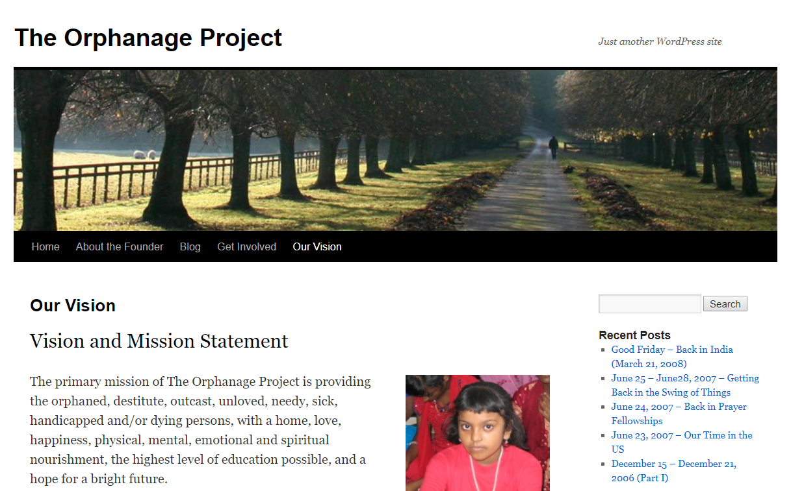

http://www.theorphanageproject.com/our-vision/

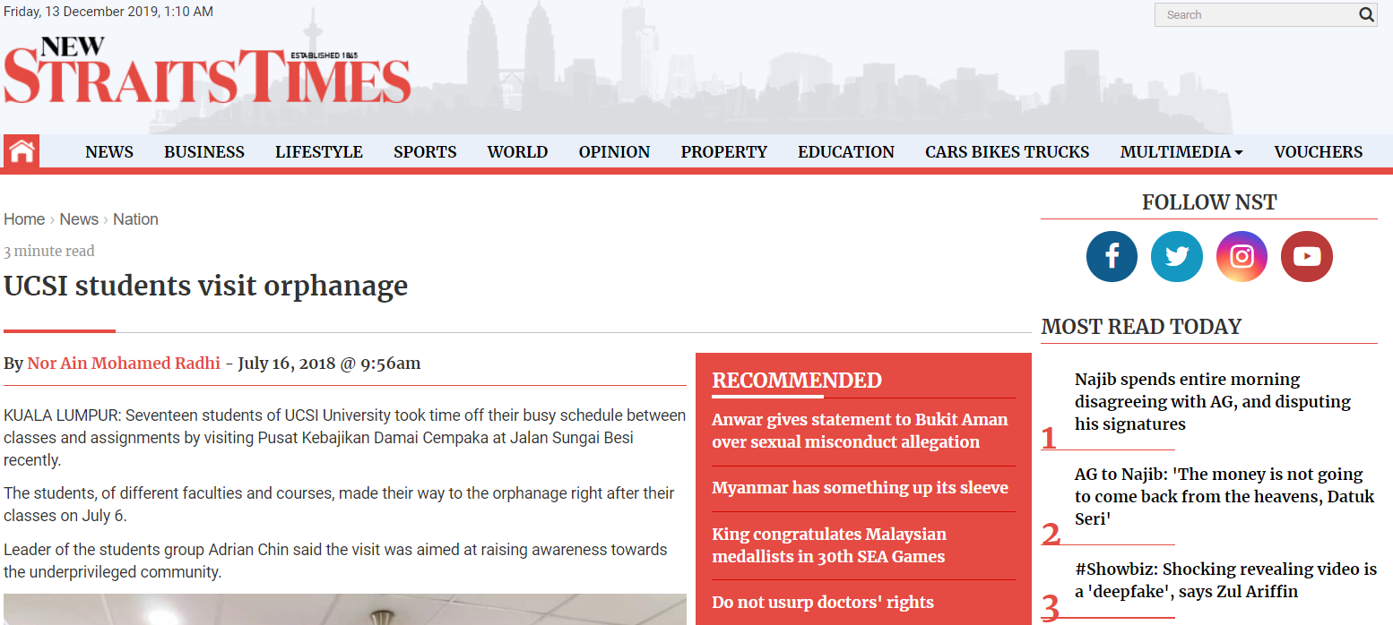

https://www.nst.com.my/news/nation/2018/07/391233/ucsi-students-visit-orphanage

MINUTE OF MEETINGS

DATE | MEMBERS | TIME | PLACE | PROGRESS | SIGNATURE
3 / 12 / 2019  (TUESDAY) | CHIEN LI | 9AM – 11AM | N28 | - DECIDE ON THE TOPIC OF PROPOSAL.  - DISCUSS AND CLARIFY ROLES FOR EACH MEMBER. | CL
 | HUSNY |  |  |  | HUSNY
 | AIN |  |  |  | AIN
 | ANIKA |  |  |  | ANIKA
 | NABILA |  |  |  | NABILA
8 / 12 / 2019  (SUNDAY) | CHIEN LI | 10AM – 11AM | N28 | - UPDATE EACH OTHER ON THE PROGRESS  - DISCUSS SOME PROBLEMS FACED BY EACH MEMBER | CL
 | HUSNY |  |  |  | HUSNY
 | AIN |  |  |  | AIN
 | ANIKA |  |  |  | ANIKA
 | NABILA |  |  |  | NABILA
10 / 12 / 2019  (TUESDAY) | CHIEN LI | 12PM – 2PM | WhatsApp Discussion | - SEND ALL THE COMPONENTS OF THE PROPOSAL TO LEADER FOR COMPILATION | CL
 | HUSNY |  |  |  | HUSNY
 | AIN |  |  |  | AIN
 | ANIKA |  |  |  | ANIKA
 | NABILA |  |  |  | NABILA
15 / 12 / 2019  (SUNDAY) | CHIEN LI | 10AM – 11AM | N28 | - REVIEW THE FINAL VERSION OF THE PROPOSAL.  - REHERSE THE PRESENTATION AND REVIEW THE SLIDES. | CL
 | HUSNY |  |  |  | HUSNY
 | AIN |  |  |  | AIN
 | ANIKA |  |  |  | ANIKA
 | NABILA |  |  |  | NABILA

