

**SECR2013-10 NETWORK COMMUNICATIONS**

**NETWORK DESIGN FOR SCHOOL OF COMPUTING**

**BLOCK N28B BY SUNFLOWER**

**GROUP 7 – SUNFLOWER**

Nurul Syamira binti Amat Jifri (A19EC0145)

Khaireennur Khaliesha Binti Mohamad Jais (A19EC0300)

Sarah Chintya Rachmi (A19EC0283)

**Lecturer’s Name**: Dr. Syed Hamid Hussain Madni

**TABLE OF CONTENTS**

Table of Figures 3

Introduction 4

Project Background 5

A compiled solution of:

Task 1 7 - 10

Task 2 11 - 13

Task 3 14 - 29

Task 4 30 - 41

Task 5 42 - 46

Conclusion 47

Team Members and Responsibilities 48

References 49

Appendices

Team Meeting Minutes 50

**TABLE OF FIGURES**

|  |  |  |
| --- | --- | --- |
| **No. of table/figure** | **Description** | **Page** |
| Figure 1 | Floor plan for first floor | 7 |
| Figure 2 | Floor plan for second floor | 8 |
| Figure 3 | Organisational chart of group Sunflower | 11 |
| Figure 4-6 | Switches  -D-Link PoE+ Switch, 24 28 Port Fast Ethernet Managed Web Smart 2 Gigabit  -D-Link DGS-1210-10P Smart Gigabit Ethernet Switch 10 port  -CISCO Four port 10/100/1000 Ethernet switch interface card EHWIC-4ESG | 17  18  19 |
| Figure 7-9 | Router  -Cisco 900 Series Integrated Services Routers  -Cisco IR1101 Integrated Services Router Rugged  -Cisco 4000 Router ISR4331 (ISR4331/K9) | 19  20  21 |
| Figure 10-11 | Cabling and connectors  -Twisted pair cable  -Fiber optic cable | 22 |
| Figure 12-16 | Network Interface Card (NIC)  -Ethernet NIC  -PCI Express LAN RJ45 4port Gigabit Ethernet NIC Wiretek  -Maikou Pci-e Adaptor Lan Ethernet Gigabit Rtl8111e 1000 mbps Nic 8111e  -Wareshare Wireless Network Card Intel 8265AC 8265NGW 2.4G/5G  -TP-Link AC1300 Wireless Dual Band PCI Express Adapter-Archer T6E | 23  24  25  26  27 |
| Figure 17 | Workstations and servers  -C240 M5 Rack Server  -Cisco UCS C4200 Series Rack Server Chassis | 27 |
| Figure 18 | Work areas for floor plan | 28 |
| Figure 19 | Total of connections on the work areas | 30 |
| Figure 20-27 | Connection 1-7 close ups | 32 - 35 |
| Figure 28-33 | -Network Lab  -General Purpose Lab  -Lecturer Room / Admin Room  -Conferencing Room 1/2  -Computer Security Lab  -IOT Lab | 38 - 41 |
| Table 1 | Calculation of IP Address 1 | 43 |
| Table 2 | Calculation of IP Address 2 | 44 |
| Table 3 | Calculation of IP Address 3 | 45 |
| Table 4 | Team members and responsibilities | 48 |
| Table 5 | Team meeting minutes | 50 |

**INTRODUCTION**

The purpose of this project is to set up a small network with its appropriate components for a new building that will be built for The School of Computing (SC). In the process of setting up the network, a lot of proper planning must be done by the company that is in charge. A network company named Sunflower Sdn. Bhd. with the assigned members in positions of IT Project Manager, Network Designer and Designer.

The aim of this project is to be able to fulfill the clients’ needs, which soon the network facilities to be used by the user such as lecturer, staff and student. It is important to provide a scalable network in the building to be high in performance when being used by the users. Also, the main point that our company focuses on is a network system and infrastructure that are reliable, efficient, secure and also easy to control.

The scope of this project is basically from planning, designing, calculating and researching a lot. Not to forget, it really emphasizes the teamwork of a group to be able finish the project.

**PROJECT BACKGROUND**

The background of this project is starting with the situation in the School of Computing (SC) that expects a 10% increase in their total populations in the faculty. These include the students from undergraduate and postgraduate also, academic and supporting staff. Hence, to support this escalation, the SC chair decides to build a new 2-storey building. SC Chair also has listed down all the areas that he demands to be in the building. Following building a new building, a network setup for the building will be needed.

In order to be provided with the best network system in the new building, SC chair has set the goals for the new system. The purpose of these goals is to achieve the best possible network infrastructure that can be easily managed also, the long-term advantage to follow the up-to-the-minute technology.

**COMPILED SOLUTIONS FOR TASK 1-5**

**TASK 1**

**The purpose of the floor plan**

The floor plan is made by a request and hopefully fulfills the need that customer wishes. This floor plan is based on the 2-storey building that will be built. Which is, the first floor is fit with the second floor. Imagine if this is the real building, and it may have some sketch if anyone wants to build it. The floorplan makes the customer know how if the sketch can already be realized. The customer's opinion makes it very easy to describe sketches in order to fulfill the customer's own desires. With good communication between customer and sketch maker is needed for maximum results. We apologize if there are any errors or shortages.

**Floor plan layout**

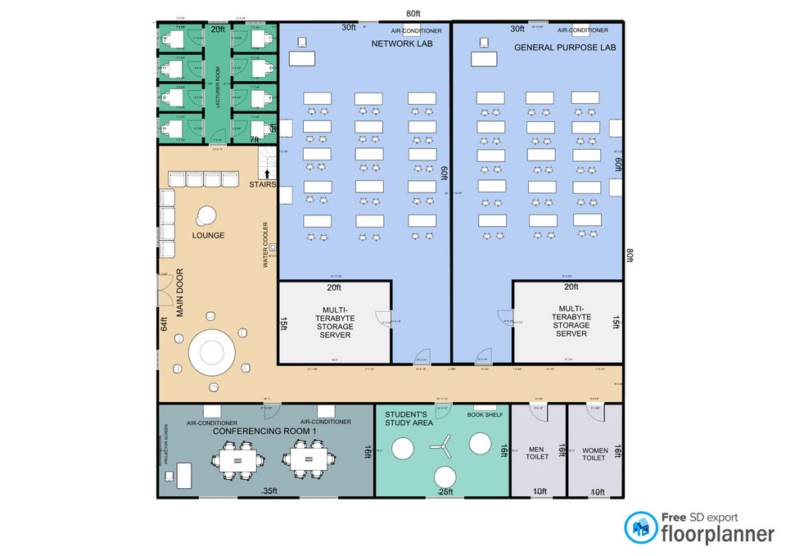

Figure 1: Floor plan for first floor

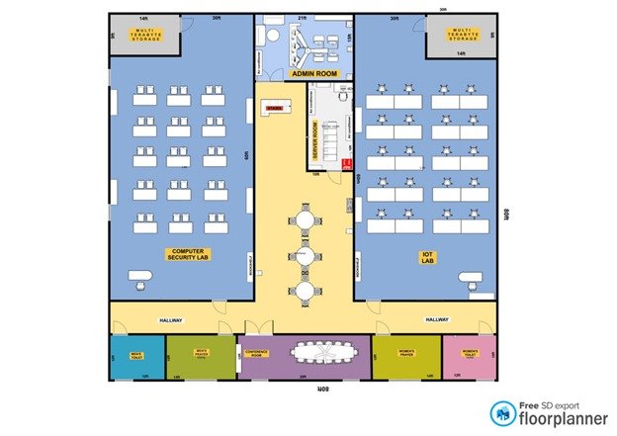

Figure 2: Floor plan for second floor

**Overall Floor Plan Explanation**

From the floorplan that has been created, there are the following rooms:

Lounge - as a gathering place or meeting place between students and visitors.

Network Lab - As a place to do a lab in the subject of network.

General Purpose Lab - Used as a lab used in any subject.

Conferencing Room - Used for meetings, discussion venues, and more.

Student's Area - Used for students to study or just sit around to read the subject materials.

Toilet - Used for people who want to use the toilet according to the room that has been shared, namely male or female.

Computer Security Lab - Used for lab or use in security computers. Where, usually in this room is always equipped with the facilities needed for computer security.

Multi Terabyte Storage - Usually used for large-scale data storage that can no longer be stored in a computer's memory. This is used to store the backup of the data you still want to keep.

IOT Lab - Used for research and other purposes.

Prayer Room – This room is used for anyone who wants to pray.

Conference Room – Usually used for meeting and any gathering.

Lecturer’s Room - Room for lecturer to do their work and maybe to consult with students in private.

Admin Room - Room for staff or admin to do their office work and for technical staff rest during leisure time.

**Reflection**

Sarah Chintya Rachmi: I do this for the first time. Design is the most known-knowledge we have learned. This is the beginning for the Start looking forward if we already have a job. Because, this project's purpose is to fit the customer's needs.

Nurul Syamira: To read the study case and do a floor plan layout for the first task is quite exciting. As this is the first time I have done this since in the first year the subjects are not focused on the network nor the building that is built with all network equipment.

Khaireennur Khaliesha: I enjoy doing this floor plan as well. But it’s a bit harder than I thought. But it helps us to know how the network will be used in the building. Beside this is my first time I know about network communication.

**Conclusion**

In conclusion, we should try to design as realistic as possible. As we must fit the scale and also fits the requirements in the study case. In the study case, we must focus on the new system that they required for the new building.

**TASK 2**

**INTRODUCTION**

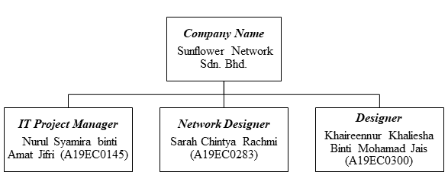

Figure 3: Organisational chart of group Sunflower

**QUESTIONS AND ANSWERS**

1. Why we choose this floorplan?

* We choose this floor plan because it’s so simple and easy to understand by anyone.

2. What type of server that we required on our building?

* For Network lab we required to use a server that can install and configure network operating system.
* For IOT lab we required to use a server that is connected to many sites and many gateways, and a very large number of nodes. Also, easily interact with the server from personal phones or PCs using a web browser or custom applications.
* For Computer Security Lab we required to use a server that can reinstall the operating system so it’s clean but configured state in case of a virus or simply as maintenance. The server can also be used to filter the external information the clients can access it. Besides, we also use the server that can store the profile of each client and back up their work from session to session.

3. What security that required on our building?

* Security that we required on our building is that can physically secure the network to protect against hackers, bots and viruses.

4. What router we use?

* Wireless router. It distributes data packets using one or more antennae. Wireless receiver can then receive radio signals and convert them back into binary code and establish a wireless local area network (Wi-Fi).
* Virtual router. Act as a default router for computers sharing a network not like wireless router

5. What media that we use?

* Guided media (consists of 2 separately insulated conductor wires wound about each other) - Optical fibre cable.
* Features of guided media: high speed, secure and used for comparatively shorter distance (e.g in the same building).
* Unguided media (no physical medium or wireless is required for the transmission of electromagnetic signals) – Radio Waves, microwaves, infrared.
* Features of unguided media: signal is broadcasted through air, used for larger distances.

6. How many budget?

* Budget is depend on what requirement or model that we use. The more expensive model that we use, the more budget spending is used.
* The hardware recommends offers the best value for money possible.

7. What is network design for the purpose?

* To satisfy data communication requirements while minimizing expenses.

8. What is the estimated size of network; how many users will use the network service?

* Wide Area Network (WAN). Covers large geographic areas and uses multiplexers to connect local and metropolitan networks to global communications networks like the Internet.

9. How important is network security?

* A good network security system helps business reduce the risk of falling victim of data theft and sabotage.
* Protect the workstation from harmful spyware

10. Does the client have an existing network? and what is its function?

* Local Area Network (LAN). As it’s common to have this network that share communication line or wireless link within a small geographic area. Usually, this network has applications and data storage that are shared in common by multiple computer users.

11. What is the maximum bandwidth expected for each labs?

* 100Mbps and above. The higher the capacity of the communication link, or pipe, the more data can flow through it per second.

**FEASIBILITY OF THE PROJECT**

This proposal is to know what a client wants and needs. In the interview, the client has agreed with our list of questions and answers, also the client seems interested with our project. However, the client has requested his budget for RM50,000 only. So, we think the budget is not sufficient enough for us to do as he wishes. It’s because the more expensive the model that he wishes, the more budget spending is used. So we think our project would be feasible if the client wants to upgrade his budget and we can fulfill what the client wishes.

**TASK 3**

**a) Research on the different network devices that needed to accomplish the objective**

Choosing network devices is one of the most important decisions to make for the technology infrastructure and will have far-reaching results over the long-term. It’s a decision that requires careful thought in order to get it right from the start to prevent wrong choices that can lead to an expensive mistake. There are considerations to be done when selecting network devices:

* Ease of use - Lecturers, staff and students be able to use the devices easily
* Compatibility - The devices to be used together without problems and then can connect to network
* Ease of maintenance
* Ease of installation

Without network devices such as router, hub, switch and more, data cannot be transmitted from one computer to another in a LAN or WAN network. These devices will connect all local and remote network segments with each other to make data communication from one segment to another. Two important devices for a big network are routers and switches. A computer network with a good base that is properly placed and configured, is helpful in reducing the operational cost, improving the performance, manageability and reliability.

**b) Decide which LAN devices needed to accomplish the needs as mentioned in the case study**

LAN devices can be grouped into two categories, hardware components and software components. The most important is the hardware components which consists of:

* Workstations and servers
* Network Interface Card (NIC)
* Cabling and connectors (Twisted Pair Cable)
* Hub
* Switch
* Router

**Switch**

A switch receives a frame and regenerates each bit of the frame on to the appropriate destination port. This device is used to segment a network into multiple collision domains. In general, switches are chosen for connecting devices to a LAN. Inside the LAN will be one or more hubs or switches to connect the end devices to the LAN.

In a network, a network switch performs the same functionality as a hub expects a separate switch that does not broadcast the data packets on all computers like a hub in a network. There are several ports for a network switch, such as 4, 8, 16 and 24, etc. The Ethernet cable links all the computers in a wired network directly to the switch. Switches restrict traffic to and from each port and provide the full available bandwidth for all the devices connected to the switch. The built-in firewall features like the routers are not supported by Switch. Infrastructure switches play an important role in telecommunications and packet switches. Based on the IP address, they send the data towards their destination. Switches operate on a layer of data connections.

**Router**

Router is the primary device used to interconnect networks. Each port on a router connects to a different network and routes packets between the networks. Routers have the ability to break up broadcast domains. Routers are also used to interconnect networks that use different technologies. They can have both LAN and WAN interfaces. Each LAN will have a router as its gateway connecting the LAN to other networks.

When selecting a router, we need to match their expandability to its purpose. Since router can be used to connect different types of networks, extra care must be taken to select the appropriate models. Also, router already has a built-in Operating System known as IOS.

We choose network-edge router because as more services and applications begin to be managed on the network edge of an organization rather than in its data center or in the cloud, edge routers play a fundamental role. Wireless capabilities, often built into network edge devices, Dynamic Host Configuration Protocol (DHCP) services and domain name system (DNS) services are considered suitable services for edge router management.

**Workstations and servers**

A workstation is a personal computer used for high-end applications including graphic design, video editing, CAD, 3-D design, or other intensive programs for CPU and RAM. Usually, a workstation has a top of the line, fast processor, several hard drives, and a lot of memory for RAM. For special editing work, a workstation can also have special audio, video, or processing cards. A workstation, while the server is more of a utility system, is sold to technical users by computer manufacturers.

A server is an application or device that performs a linked client service as part of the architecture of the client server. It may also be a computer device designated to run a particular program for the server . On an intranet, a server can also serve applications to users.

Workstations are mainly intended to be used by one person at a time, although other users can typically still access them remotely when needed. Servers fulfill the user link task and usually have no user or just one user. The most popular operating systems for servers are [FreeBSD](http://en.wikipedia.org/wiki/FreeBSD), [Solaris](http://en.wikipedia.org/wiki/Solaris_%28operating_system%29) and [Linux](https://www.diffen.com/difference/Linux_vs_Windows) while workstations run on UNIX.

**Network Interface Card (NIC)**

A network interface card (NIC) is a part of hardware without which it is not possible to link a device over a network. It is a machine-installed circuit board that provides the computer with a dedicated network connection. It is often referred to as a network interface controller, LAN adapter or network adapter. NIC enables communications between local area network (LAN) connected computers as well as large-scale network communications through Internet Protocol (IP).

**Cabling and connectors (Twisted Pair Cable)**

Both wired and wireless communications are possible via NIC. NIC is both a physical layer and a data link layer unit, i.e. it provides the hardware circuitry required so that it can operate on the physical layer processes and certain data link layer processes.

Twisted pair cable is a pair of wires running through a flat and lightweight cable. It is lighter than any cables so it is easier to install. It has phone-style plugs at the end of the cable that can easily be put into jacks of computers, switches, hub or more.

**c) Information on the devices that have chosen**

**Switches**

# **D-Link PoE+ Switch, 24 28 Port Fast Ethernet Managed Web Smart 2 Gigabit**

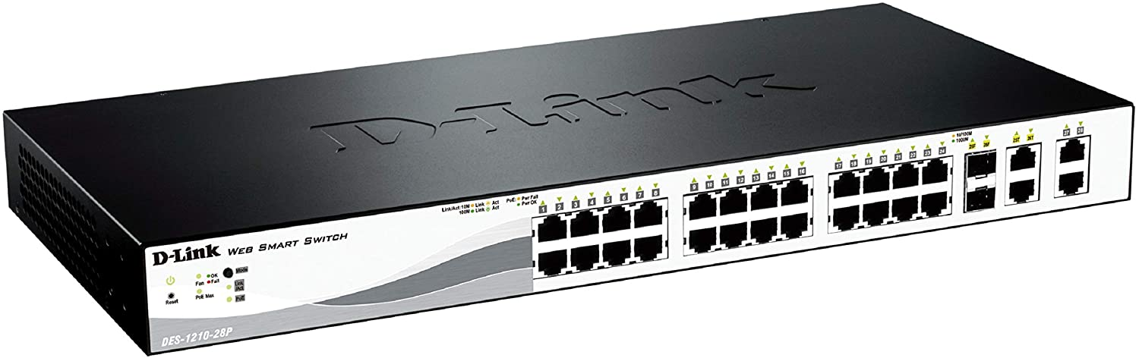

Figure 4

* Web Smart Switch with 24 10/100Mbps Ports, 2 10/100/1000BASE-T and 2 combo 10/100/1000BASE-T/SFP.
* For the security features it can access control list, D-Link Safeguard Engine and Port Security.
* Intuitive Management: SmartConsole or Web-Based GUI, Built-in MIB Browser for SNMP, D-View 6.0 Module Support and Compact CLI through Telnet
* PoE support for 802.3af and 802.3at up to 193W total budget.24-Port Fast Ethernet PoE Smart Managed Switch with 4 Gigabit Ethernet ports (including 2 Combo SFP) (24 x PoE ports, smart fans).
* Cost for this switches is around RM1000 and above.

# **D-Link DGS-1210-10P Smart Gigabit Ethernet Switch 10 port**

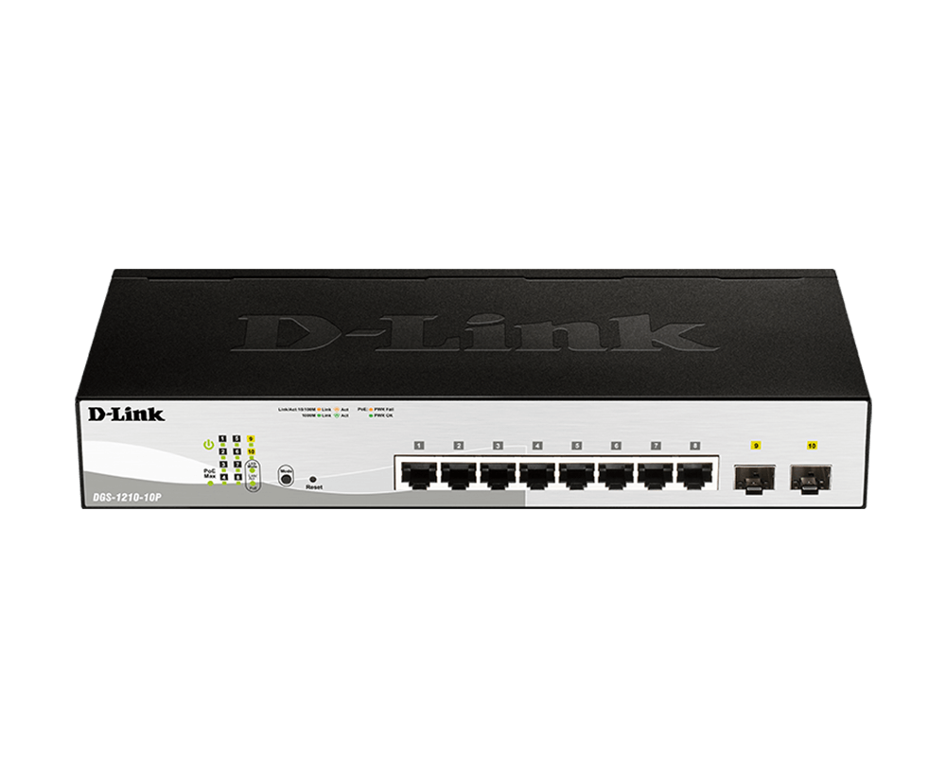

Figure 5

* 2 10/100Mbps Fast Ethernet ports
* 2 10/100Mbps copper gigabit ports
* Auto MDI/MDIX for each port
* Full/half-duplex support for each port
* Flow control for protection against data loss for each port
* Auto-learning of network configuration
* Secure store and forward switching scheme
* Per port auto correction of reverse twisted pair polarity
* Standard 19 inch rack mount size Non-Blocking and wire speed
* Cost for this switches is around RM900 and above.

# **CISCO Four port 10/100/1000 Ethernet switch interface card EHWIC-4ESG**

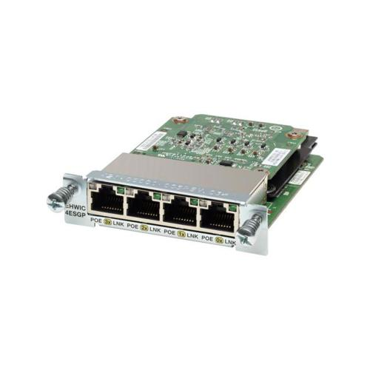

Figure 6

* 4-Port Gigabit Ethernet Enhanced High-Speed WAN Interface Card
* 4 x RJ-45 10/100/1000Base-T Network WAN
* IEEE 802.1P QoS
* IEEE 802.1Q VLAN
* SNMPv1; v2; and v3
* Telnet
* CiscoWorks LAN Management Solution
* Price: RM2069 and above

**Router**

# **Cisco 900 Series Integrated Services Routers**

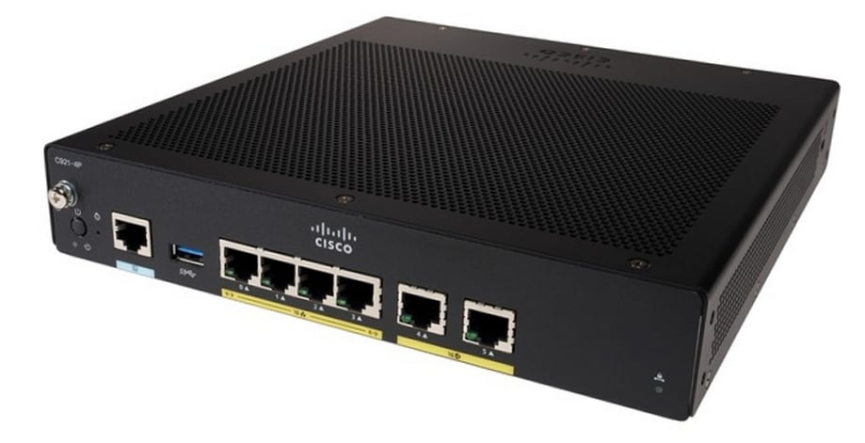

Figure 7

* Redundant WAN connections for failover protection and load balancing
* Dynamic failover protocols such as VIRTUAL ROuter Redundancy Protocol (VRRP , RFC 2338) , Hot Standby Router Protocol (HSRP) , and Multigroup HSRP (MHSHRP)
* Can run multiple services simultaneously with no performance degradation
* Supports LAN connections
* Simplifies and centralize configuration and management of wireessand wireline devices
* Support separate console ports
* Network perimeter security with integrated application inspection firewall.
* Data privacy through high speed IP security (IPsec) Triple Data Encryption Standard (3DES) and Advanced Encryption Standard (AES) encryption
* Enforced security policy with intrusion prevention
* Flex VPN
* Price: RM3000 and above
* **Cisco IR1101 Integrated Services Router Rugged**

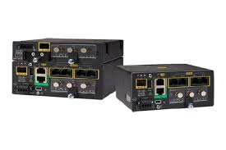

Figure 8

* A single form factor with multiple WAN (LTE, LTE-Advanced, SFP Ethernet) and storage options enable flexibility to add or upgrade modules as technologies evolve.
* With two LTE modules (LTE and LTE-Advanced1 with carrier aggregation), the IR1101 enables concurrent connectivity to two cellular networks for WAN redundancy, enhanced data throughputs, and reliability.
* Open and standards-based APIs with programmable manageability. Enables end-to-end security with next-generation encryption, and reduces business and network complexity allowing you to deploy new services faster.
* High WAN availability and simplicity for large-scale distributed networks.
* Multi-layer security for mission-critical deployments. Cisco Trust Anchor technologies to ensure authenticity of hardware and software,hardware-accelerated next-generation encryption and Quantum computer-resistant algorithms,firewall and VPN services and alerts and notifications for physical and cyber security.
* Price: RM2800 and above
* **Cisco 4000 Router ISR4331 (ISR4331/K9)**

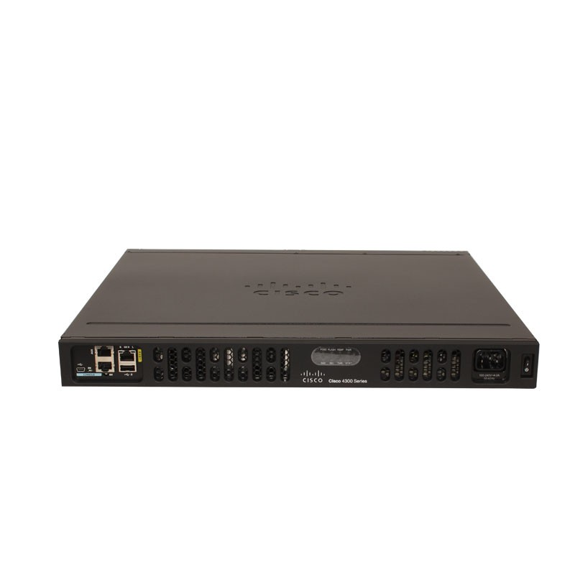

Figure 9

* (3GE,2NIM,1SM,4G FLASH,4G DRAM,IP Base)
* Cisco 4000 Router
* 100Mbps-300Mbps system throughput
* 3 WAN/LAN ports
* 2 SFP ports
* multi-Core CPU
* 1 service module slots
* Security
* Voice
* WAAS
* Intelligent WAN
* OnePK
* AVC
* Price: RM4000 and above

**Cabling and connectors (Twisted Pair Cable)**

* **EZ RJ45 CAT6 connector with 3U gold RJ45 pass through connector**

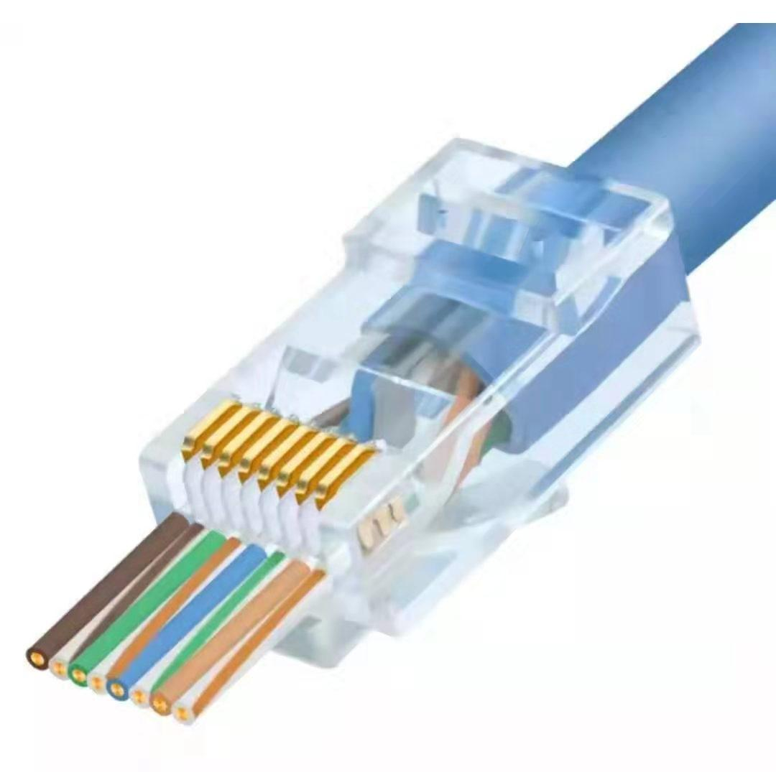

Figure 10

* 250V AC max at 2 amps.
* Dielectric with standing 500volts AC.
* Insulation Resistance: 500 megaohms.
* Termination Resistance: 35 megaohms.
* Cable-to-plug tensile strength-20lbs ( 89N ) min.
* 500 mating cycles
* Price: RM200 and above
* **Fiber Optic Cable**

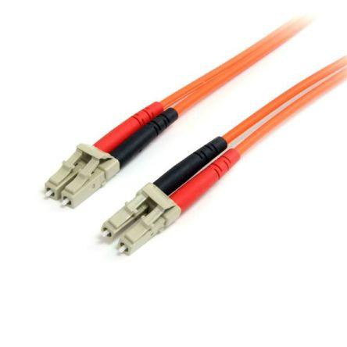

Figure 11

* **Bandwidth and data transfer** - In contrast to fibre optics, older metal data cables, typically copper, provide comparatively small bandwidth. Initially, copper-type communication cabling was designed to transmit voice signals that do not need almost as much bandwidth for mass data transmission as is now needed by many modern applications.
* **Speed** - As opposed to other data transfer modes, the use of light signals as the primary source of information conveyance gives fibre optic cables a significant speed advantage. In this respect, fibre will usually well exceed the predicted output of even high-grade (Cat5 or Cat6) copper cables.
* **Distance** - As well as being lightning fast, due to their low rate of signal power loss, fibre optic cables can also carry their signals over far longer distances than conventional forms of cabling. In terms of decent quality transfer reach, copper cables are commonly quoted as having a 328-foot limitation; on the other hand, provided the right combination of materials, signal form (wavelength) and network configuration, some single fibre optics can carry a signal over hundreds of kilometers.
* **Interference -** Fibre optics, since they do not physically bear an electrical signal, have far greater interference protection than conventional metal cable types. This further increases their ability to easily transmit data over much longer distances without experiencing severe loss of the signal.
* Price: RM25 and above depending on metre of cable

**Network Interface Card (NIC)**

#### **Ethernet NIC**

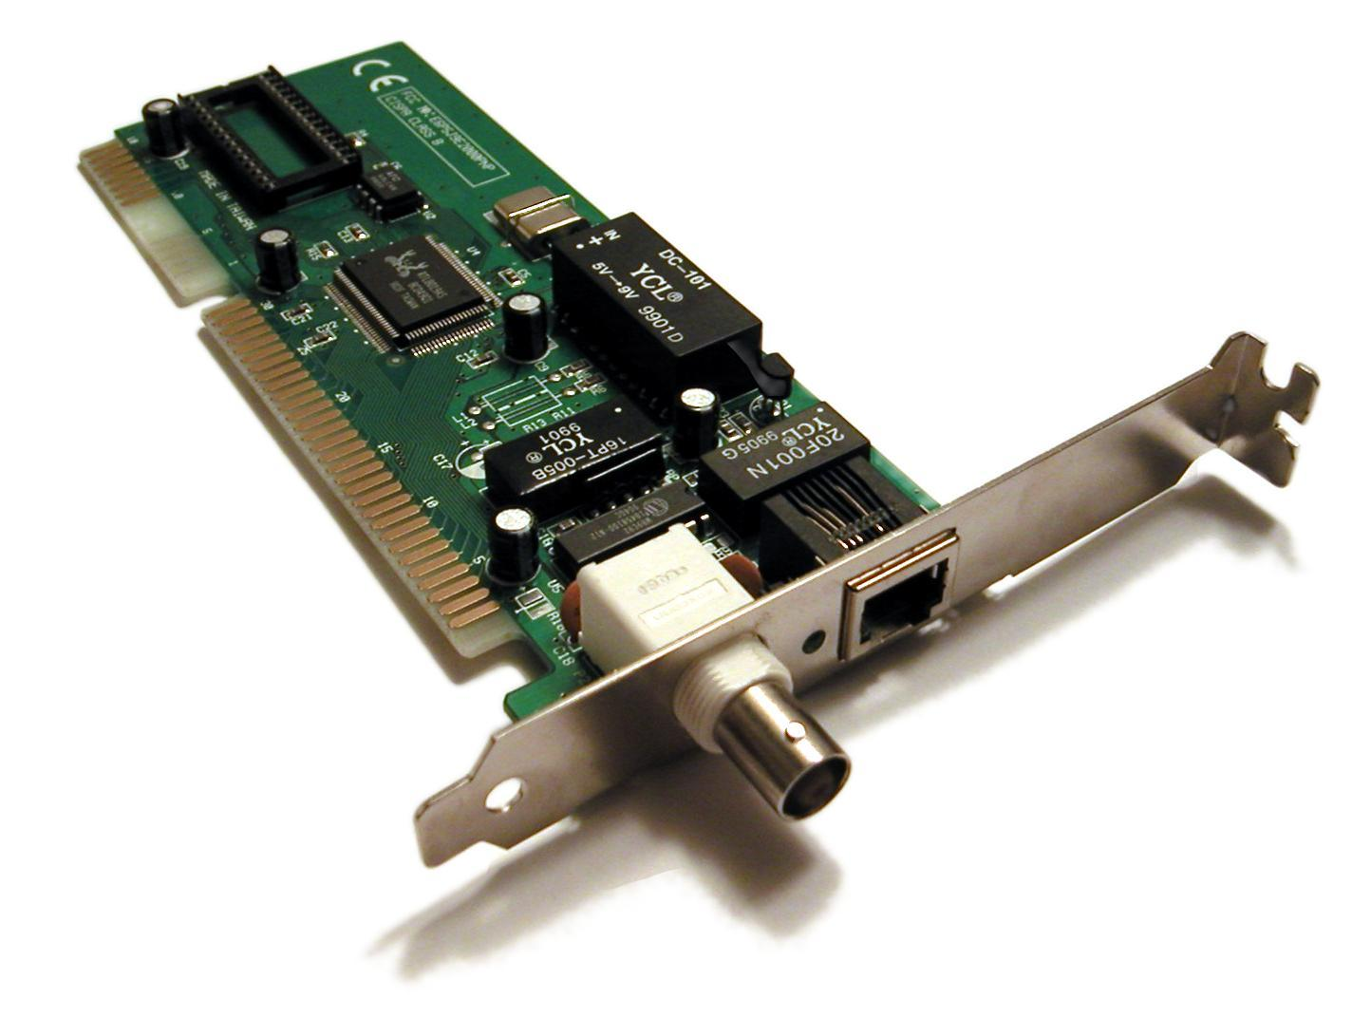

Figure 12

# **PCI Express LAN RJ45 4port Gigabit Ethernet NIC Wiretek**

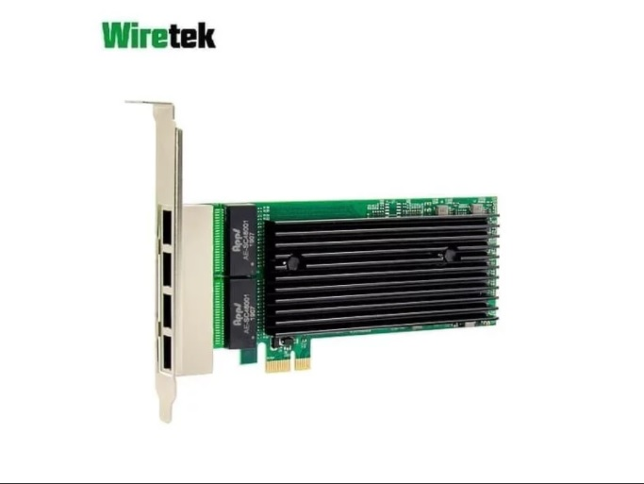

Figure 13

* PCIe v2.0 (2.5 GT/s) x4/x2/x1
* Quad Port 10/100/1000Mbps adapters
* MDI (Copper) standard IEEE 802.3 Ethernet interface for 1000BASE-T, 100BASE-TX, and 10BASE-T applications (802.3, 802.3u, and 802.3ab)
* RJ45 Connectivity
* Network Virtualization
* Improves performance and throughput by reducing the I/O overhead due to the software virtualization layer
* Data Plane Development Kit (DPDK) support
* Simple Network Management Protocol (SNMP) and Remote Network Monitoring (RMON) statistic counters
* Low profile and full-height bracket
* Price: RM 260 and above

# **Maikou Pci-e Adaptor Lan Ethernet Gigabit Rtl8111e 1000mbps Nic 8111e**

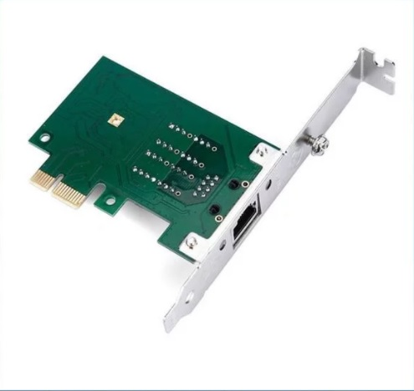

Figure 14

* Realtek RTL8111E
* 10 M 100 M 1 Gbps (1000 Mbps)
* PCI-Express 2,5 Gb/s
* PCI Express 1.0a.
* PCI Express x1 interface compatible PCI Express x1... x4... x8... x16
* duplex (IEEE 802.3x).
* compatible IEEE802.3, 802.3ab, 802.3u, 802.3x, 802.1q, VLAN.
* Compatible IEEE 802,1 P
* Sistem operative compatible: Windows 98SE, Windows ME, Windows 2000, XP, Vista, windows 7/8/10, Mac Linux/Unix
* Price: RM152 and above

**Wireless Network NIC**

# **Wareshare Wireless Network Card Intel 8265AC 8265NGW 2.4G/5G**

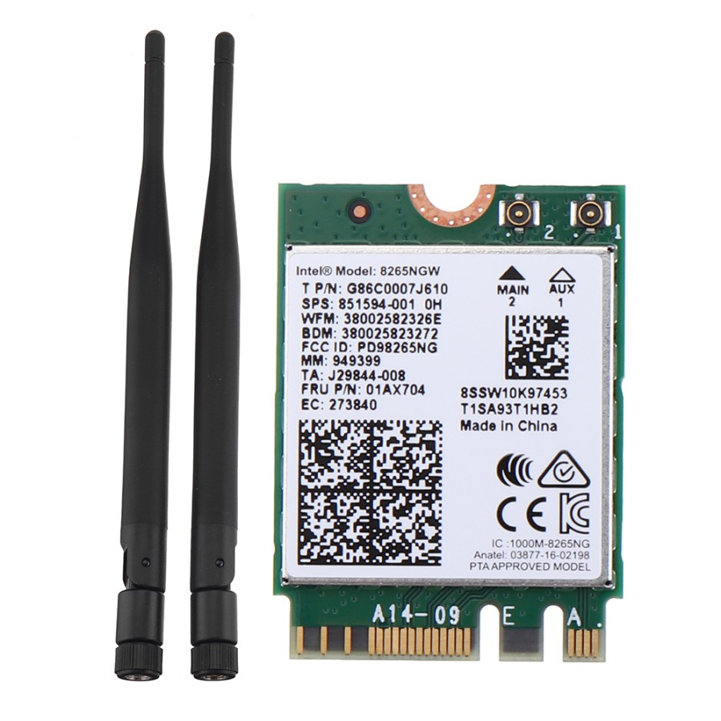

Figure 15

* The dual-mode wireless network card for Jetson Nano supports 2.4GHz / 5GHz
* dual-band WIFI and supports Bluetooth 4.2.
* Parameter: NIC
* chip: Intel 8265ACWireless
* band: 2.4GHz / 5GHzWireless
* rate: 300Mbps / 867MbpsWIFI
* protocol: 802.11acBluetooth
* version: 4.2Network
* card interface: NGFF (M.2)Antenna
* interface: IPEX interfaceCompatible
* systems: Linux, Windows 10/8.1/8/7Product
* Price: RM150 and above
* **TP - Link AC1300 Wireless Dual Band PCI Express Adapter - Archer T6E**

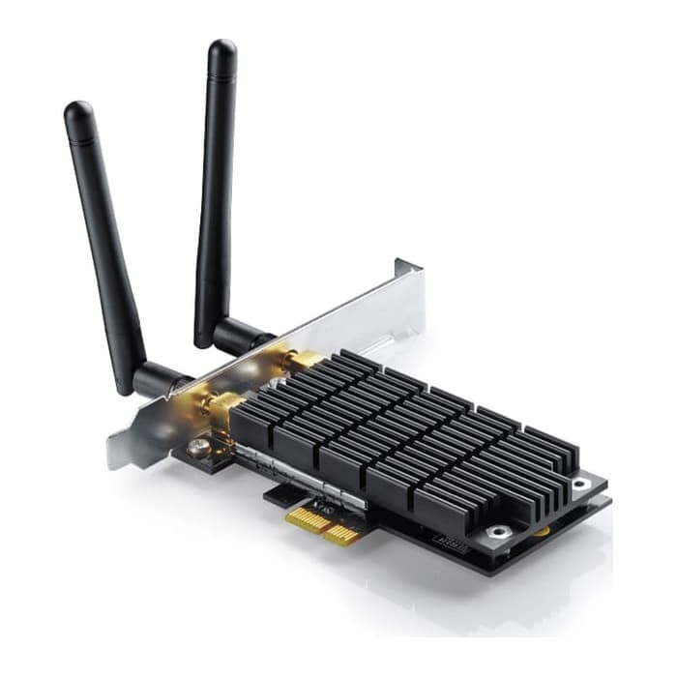

Figure 16

* Easy Installation – Upgrade your desktop system easily by plugging the Archer T6E Wi-Fi adapter into an available PCI-E slot
* Hi-Speed Wi-Fi – Up to 1300Mbps Wi-Fi speeds (867Mbps on 5GHz band or 400Mpbs on 2.4GHz band)
* 802.11ac Dual Band – 3 times faster than the 802.11n standard, perfect for hi-intensity network usage
* Backward Compatibility – With support for 802.11 a/b/g/n standards
* Broad Wireless Range – 2 external antennas ensure a greater range of Wi-Fi connection and stabilit
* Price: RM137 and above.

**Workstations and servers**

* **C240 M5 Rack Server**

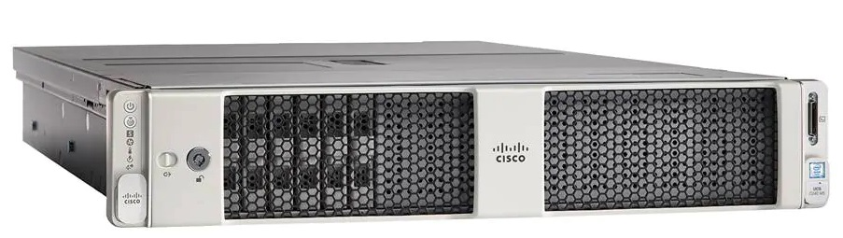

Figure 17

* The latest second-generation Intel Xeon Scalable CPUs, with up to 28 cores per socket
* Supports the first-generation Intel Xeon Scalable CPU, with up to 28 cores per socket
* Support for the Intel Optane DC Persistent Memory (128G, 256G, 512G)[[1]](https://www.cisco.com/c/en/us/products/collateral/servers-unified-computing/ucs-c-series-rack-servers/datasheet-c78-739279.html#_ftn1)
* Up to 24 DDR4 DIMMs for improved performance including higher density DDR4 DIMMs
* Up to 26 hot-swappable Small-Form-Factor (SFF) 2.5-inch drives, including 2 rear hot-swappable SFF drives (up to 10 support NVMe PCIe SSDs on the NVMe-optimized chassis version), or 12 Large-Form-Factor (LFF) 3.5-inch drives plus 2 rear hot-swappable SFF drives
* Support for 12-Gbps SAS modular RAID controller in a dedicated slot, leaving the remaining PCIe Generation 3.0 slots available for other expansion cards
* Modular LAN-On-Motherboard (mLOM) slot that can be used to install a Cisco UCS Virtual Interface Card (VIC) without consuming a PCIe slot, supporting dual 10- or 40-Gbps network connectivity
* Dual embedded Intel x550 10GBASE-T LAN-On-Motherboard (LOM) ports
* Modular M.2 or Secure Digital (SD) cards that can be used for boot
* Price: RM346 and above
* **Cisco UCS C4200 Series Rack Server Chassis**

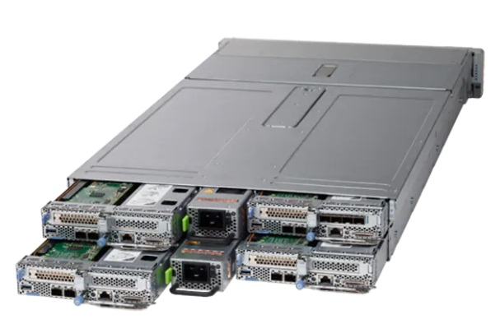

Figure 18

### More servers per rack. Scale out applications need more servers and data center space can be at a premium. With the C-Series Multinode Rack Servers, you get up to 100% more server density compared to the Cisco UCS C220 M5 rack server.

### More processor cores. Compute intensive, scale out, workloads benefit from additional cores per server. The UCS C125 M5 server node with AMD® EPYC™ processors have 128% more cores than other UCS M5 servers and up to 343% more cores per rack.

### Better memory bandwidth. Process data as fast as memory can deliver it. The UCS C125 M5 server node has 33% more memory bandwidth that other UCS M5 servers allowing to unlock and quickly extract economic benefit from your data.

* Price: RM733 and above.

**Reflection**

At the end of research and choosing, we concluded that prices for network devices are quite high. Beside, it helped us to improve our understanding of networking models, networking protocols, networking devices, networking media, networking topology, the concept of various servers, the concept of network security, the implementation of LAN and WAN, the connection to the internet of a particular office or site, the safeguarding of a particular site from outside the wireless network and its security, simple troubleshooting of the network.

There are comparison for same network devices but from different brands. For example, Cisco is known as the best brand for most of network devices because it is said that Cisco have a massive support machine. Users can get their customer service online and also through WebEx meeting which users can share their screen and the staff will get it done for them. Besides that, Cisco is a well certified company for their equipments. Cisco is a functionality wise and worth the money purchase for their devices. Hence, most of the devices we chose are from Cisco.

In conclusion, to setup network in a building do need a big budget. This is to ensure that the money invested on all the devices give the best outcomes to the clients. This includes the functionality, application, management, security, maintenance and more are working well.

**TASK 4**

1. ***Identify work areas on your floor plan***

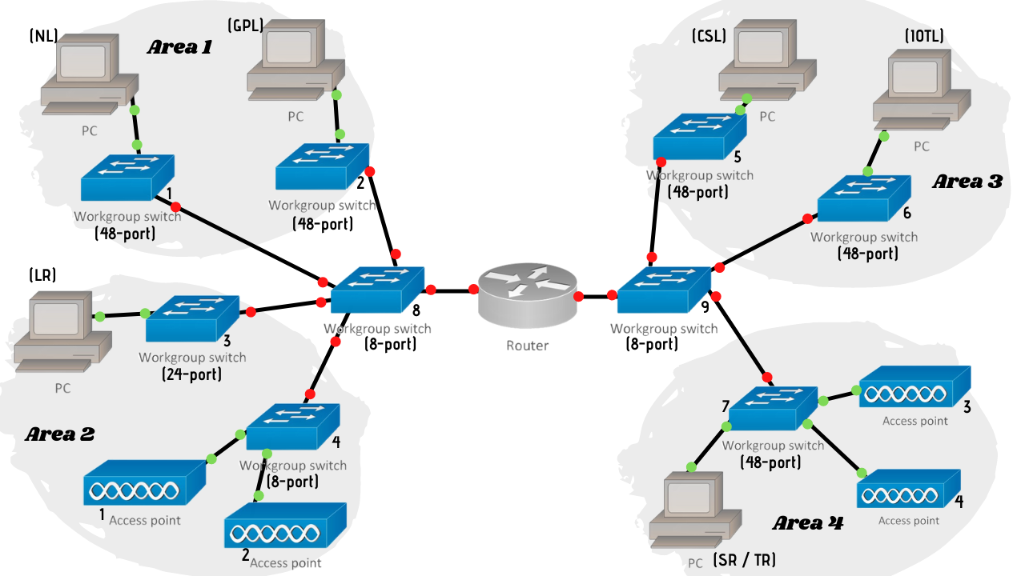

Figure 19: Work areas for floor plan

**Work Area 1**

The north-east area which is placed in the first floor, there are two labs which are Network Lab (NL) and General Purpose Lab (GSL). In NL, switch1 (48-port) connects to the end user (student’s PC). In GSL, we use the same method that connects the student’s PC to switch2 (48-port). 48-port switch enables connection to all PCs with the servers.

**Work Area 2**

The west-south area that is also on the first floor of the building, there is one Lecturer’s room (LR), Conferencing Room 1 and students’ study area. End user (lecturer’s PC) is connected to switch 3 (24-port). Meanwhile, access point1 and access point2 are placed in the area since there is space for end users (students and lecturers) to sit and access to WiFi provided. These access points are connected to switch 4 (8-port). Also, Conferencing Room 1 also needs access to WiFi in case the users are accessing video in the room.

**Work Area 3**

Moving to the second floor of the building, there are placed another two labs which are Computer Security Lab (CSL) and IOT Lab (IOTL). In CSL, switch5 (48-port) connects to the end user (student’s PC). In IOTL, we use the same method that connects the student’s PC to switch6 (48-port).

**Work Area 4**

The other areas on the second floor are Staff Room (SR) and Technician Room (TR), Conferencing Room 2 and students’ study area. There are few PCs in SR/TR, so the PC is connected to switch7 (48-port). While in the other two areas that need WiFi connection to be allowed, there are access point3 and accespoint4 placed in both areas.

1. ***How many connections, patch cords and switch ports have you determined you need?***

***Connections***

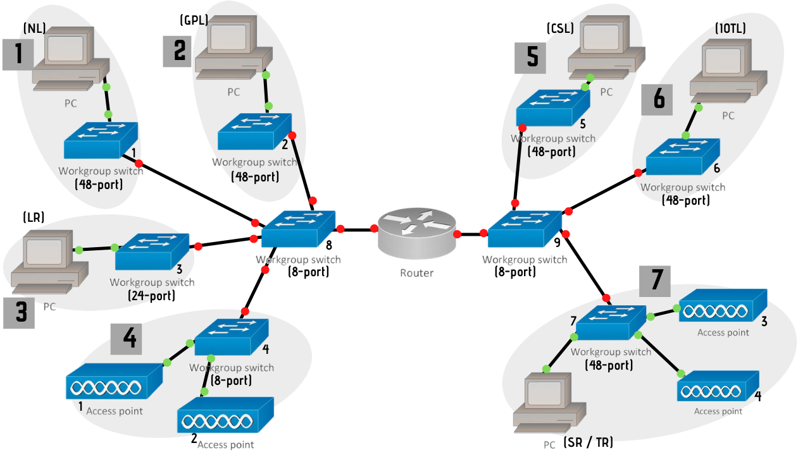

Figure 20: Total of connections on the work areas

Based on the topology we have done above, there are seven (7) connections for this building.

***Connection 1***

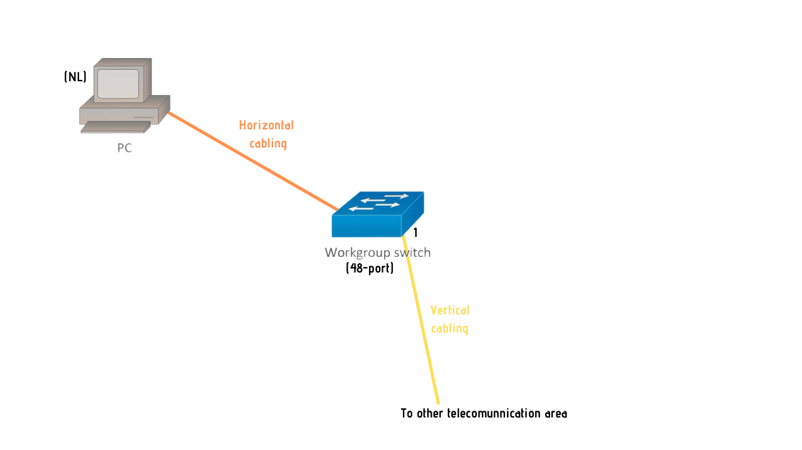

Figure 21

***Connection 2***

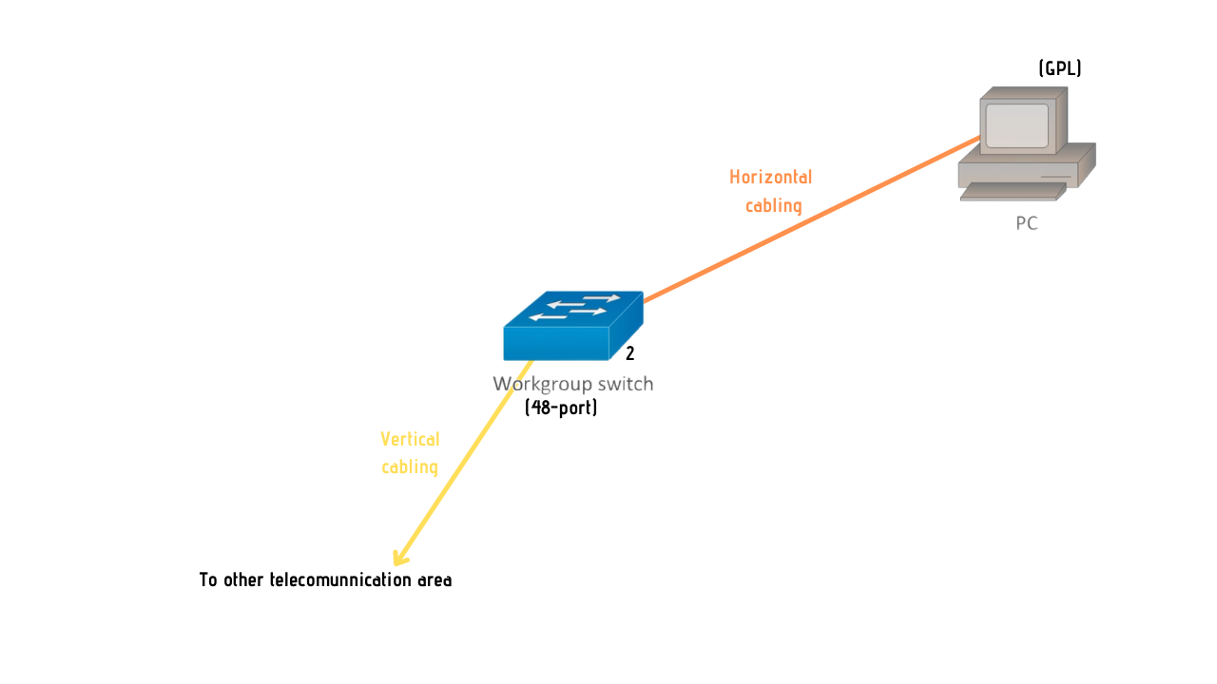

Figure 22

***Connection 3***

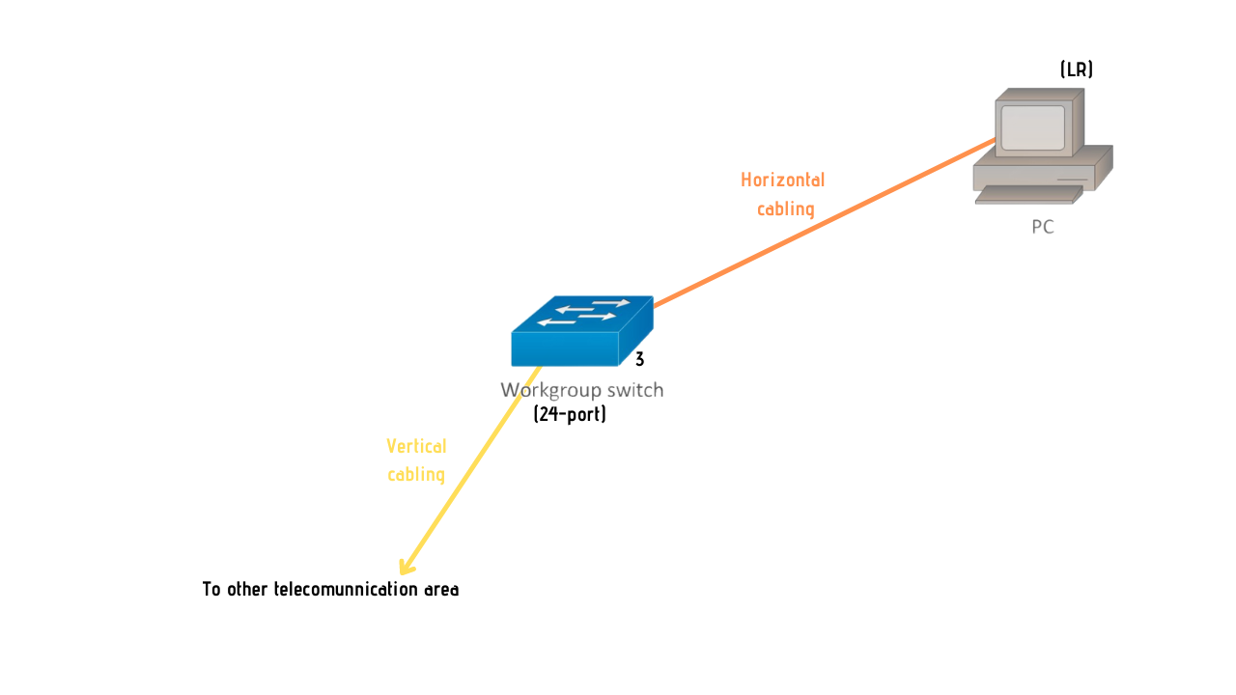

Figure 23

***Connection 4***

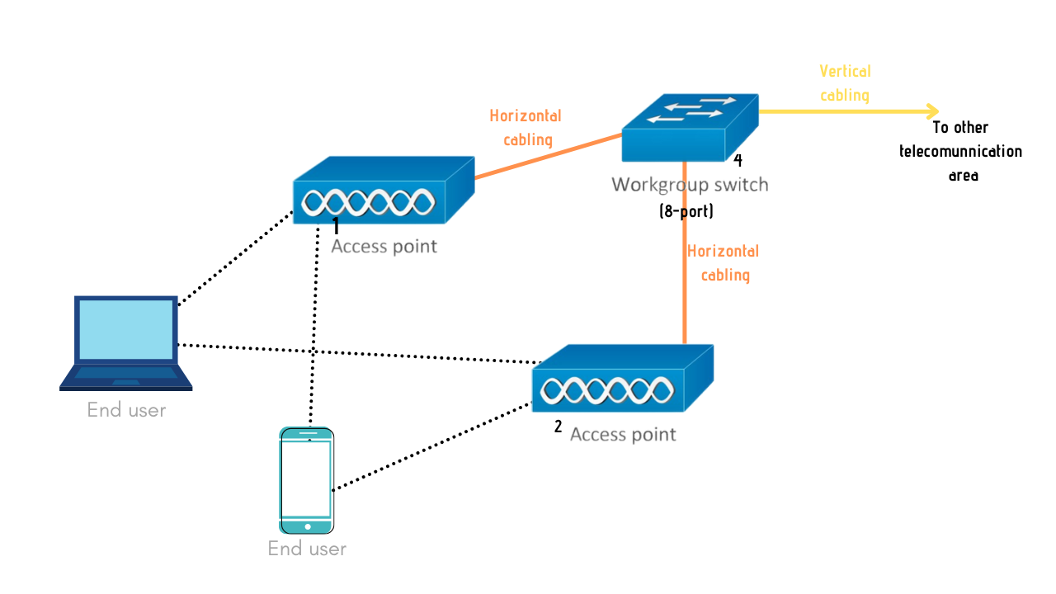

Figure 24

***Connection 5***

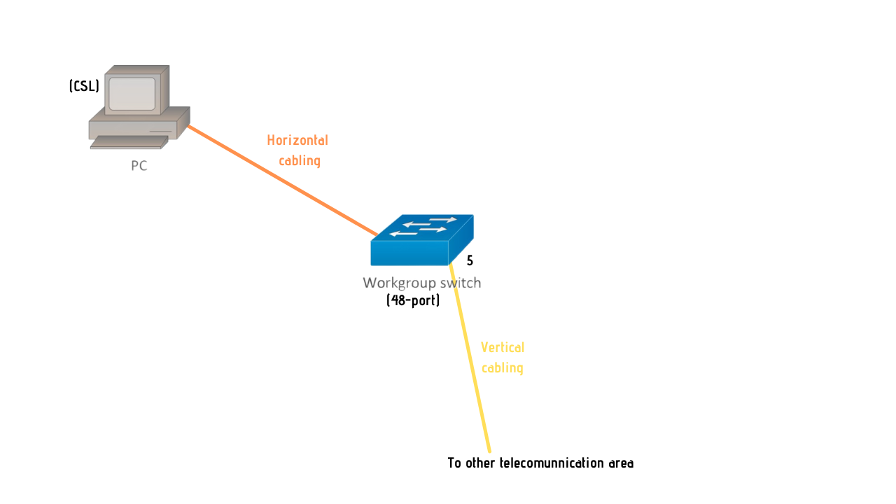

Figure 25

***Connection 6***

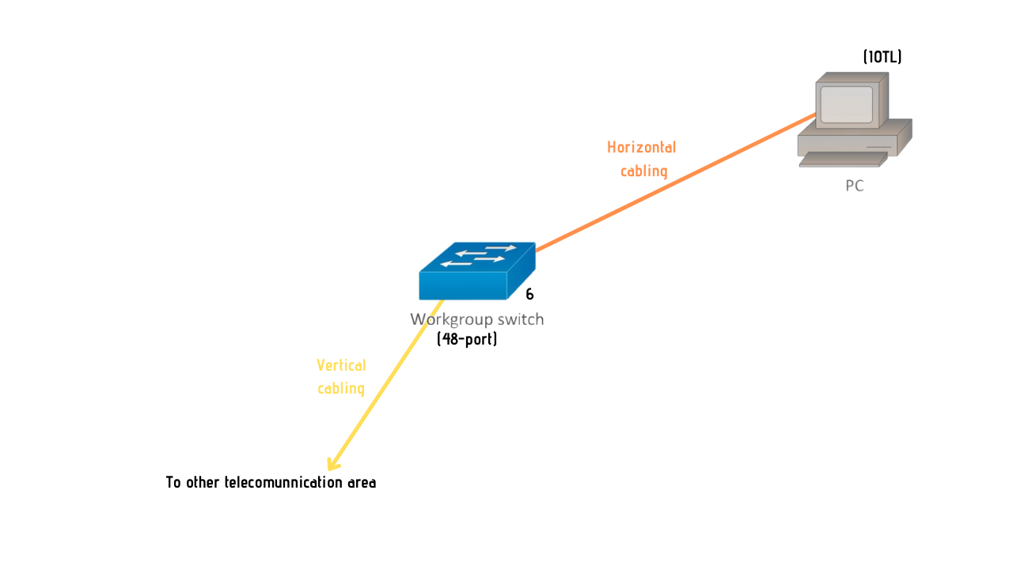

Figure 26

***Connection 7***

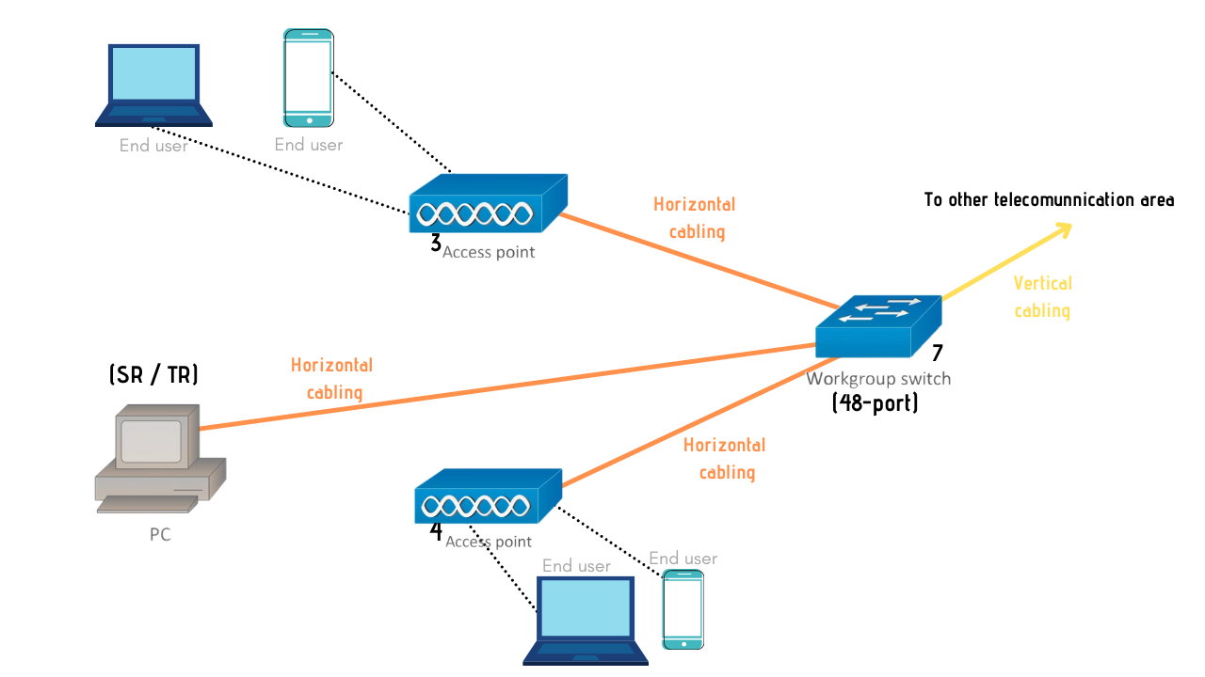

Figure 27

***Patch Cords***

For the patch cords, we have decided to use 5 'Patch Cable Cat6 for patch cord (patch cable) (# A3L980-05-BLU from Belkin). The price for a unit of this cable is approximately RM58.88, according to what we find. We will use approximately 32 patch cords because we assume that these short cables are used in Iot lab and Computer Security Lab to link the patch block to the switch. So, now the average price is RM1884.16.

***Switch Ports***

For the switch ports, we intend to use two 48-port switches, three 24-port switches, and four 8-port switches for this project. To build a mesh network topology, a total of nine switches are required. At IOT Lab and Network lab, the 48-port switches are used. Finally, the 8-port switches are used to connect all five network access points.

The total cost expected to pay for all the switches is approximately RM240,068.20. In addition, we have selected switches that have PoE. Power over Ethernet (PoE) is a technology for wired Ethernet LANs (Local Area Networks) that requires data cables rather than power cords to hold the electrical current required for the operation of each unit. In order to mount the network, doing so minimizes the amount of wires that must be strung. The switches we select are capable of transmitting high-speed data according to what the main staff at the School of Telecommunication want.

***(c)Identify cable types and length***

**Network Lab**

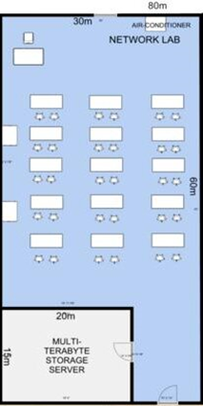

Figure 28

**UTP Cable** because it is the best option for a student's PC. There is no problem to use this standard cable only for Network Lab. As long as the cable length is enough to accomplish the needs of the regular use.

**Cable length:** Ethernet cables should be limited to a maximum distance of 100 meters or 328 feet between active devices. Either a capacitive tester that is calibrated to the capacitive characteristics of the cable or a Time Domain Reflectometer (TDR) tester may measure the cable length. So, we decided to use 30 meter in network lab.

**General Purpose Lab**

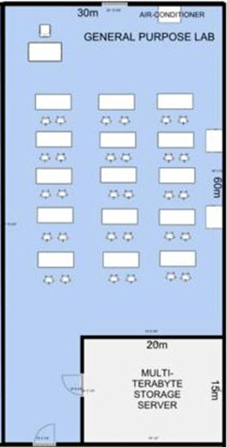

Figure 29

**UTP Cable** because it is the best option for student’s PC

**Cable length:** Ethernet cables should be limited to a maximum distance of 100 meters or 328 feet between active devices. Either a capacitive tester that is calibrated to the capacitive characteristics of the cable or a Time Domain Reflectometer (TDR) tester may measure the cable length. So, we decide to use 30 meters for general purpose lab.

**Lecturer room / Admin room**

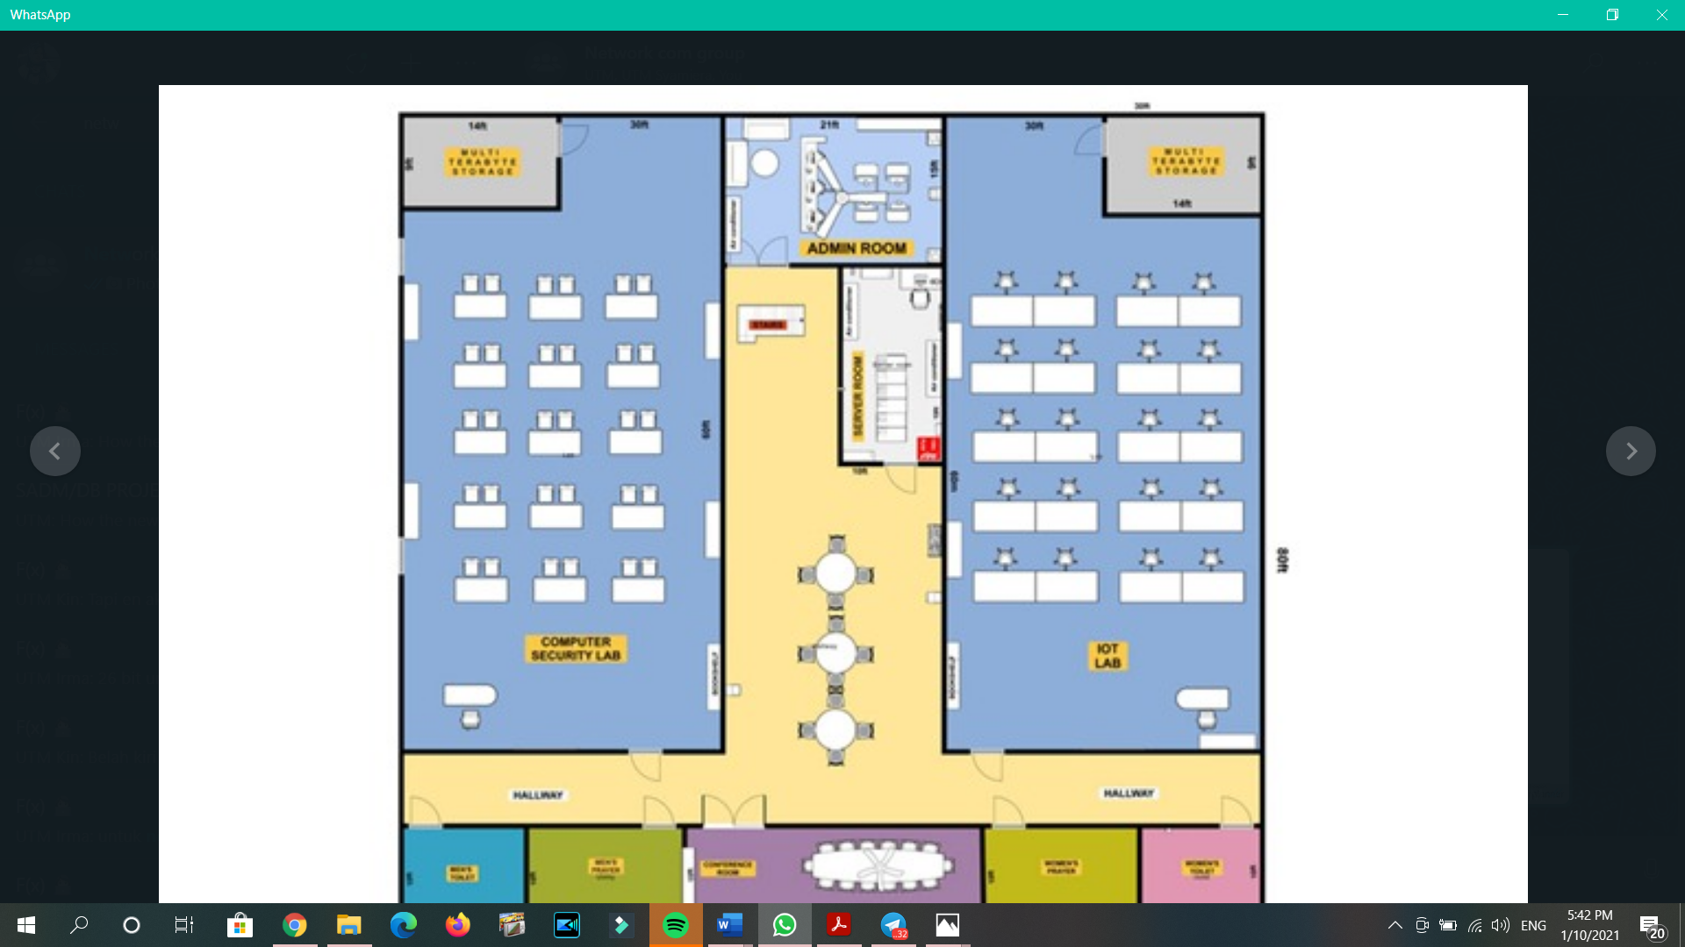

Figure 30

**UTP Cable** is the most suitable for this room because the lecturer room/admin room doesn’t have too many signal interference device and least expensive, and also enough for the room condition

**Cable length:** Ethernet cables should be limited to a maximum distance of 100 meters or 328 feet between active devices. Either a capacitive tester that is calibrated to the capacitive characteristics of the cable or a Time Domain Reflectometer (TDR) tester may measure the cable length. So, we decide to use 30 meter in the admin room.

**Conferencing room 1 / 2**

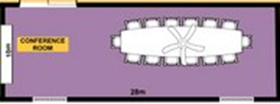

Figure 31

**STP Cable** because it need to be protected from the signal interference that might exist in the conferencing room

**Cable length:** The maximum length is 100 meters, without using any kind of signal regeneration device, and a maximum data transfer rate of 1000 Mbps for Gigabit Ethernet. Shielded Twisted Pair (STP), like UTP, also has four pairs of wires with each wire in each pair twisted together. So in conferencing room, we decide to use 10 meters.

**Computer Security Lab**

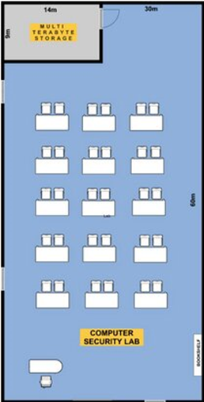

Figure 32

**UTP Cable** because it is the best option for student’s PC .

**Cable length:** Ethernet cables should be limited to a maximum distance of 100 meters or 328 feet between active devices. Either a capacitive tester that is calibrated to the capacitive characteristics of the cable or a Time Domain Reflectometer (TDR) tester may measure the cable length. So, we decide to use 30 meter in computer security lab.

**IOT Lab**

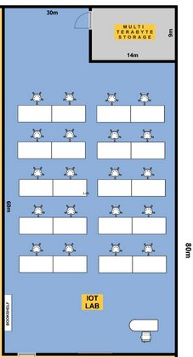

Figure 33

**UTP Cable** Because it is the best option for student’s PC

**Cable length:** Ethernet cables should be limited to a maximum distance of 100 meters or 328 feet between active devices. Either a capacitive tester that is calibrated to the capacitive characteristics of the cable or a Time Domain Reflectometer (TDR) tester may measure the cable length. So, we decided to use 30 meter in IOT Lab.

**TASK 5**

***a) IP Addresses given by the lecturer***

1. 120.10.0.0

* Class A
* N.H.H.H
* Huge network

1. 132.10.0.0

* Class B
* N.N.H.H
* Small network

1. 221.1.11.0

* Class C
* N.N.N.H
* Reasonable small server

Total workstations in lab = (15x3) + 20 = 65

Total routers = 3

Total switches = 9

Total servers in server room = 5

Total multi-terabyte storage server = 4

**IP Address 1: 120.10.0.0**

|  |  |
| --- | --- |
| Step | Calculation |
| 1 | 120.0000 0000.0000 0000.0000 0000 |
| 2 | 2^n - 2 >= 65  2^7 - 2 >= 65  126 >= 65 |
| 3 | 120.0000 0000.0000 0000.0000 0000 (⇠right to left) |
| 4 | 120.1111 1111.1111 1111.1111 1111  8 + 8 + 8 = 24 |
| 5 | 120.255.255.0/24 (Last subnet) |
| 6 | 120.0.0.0/24 (First subnet)  120.0.1.0/24 (Second subnet)  120.0.2.0/24 (Third subnet)  120.0.3.0/24 (Fourth subnet)  .  .  .  120.255.255.0/24 (Last subnet) |

Table 1: Calculation of IP Address 1

**IP Address 2: 132.10.0.0**

|  |  |
| --- | --- |
| Step | Calculation |
| 1 | 132.10.0000 0000.0000 0000 |
| 2 | 2^n - 2 >= 65  2^7 - 2 >= 65  126 >= 65  n = 7 |
| 3 | 132.100.0000 0000.0000 0000 (⇠right to left) |
| 4 | 132.100.1111 1111.0000 0000  8 + 8 + 8 = 24 |
| 5 | 132.10.255.0/24 (Last subnet) |
| 6 | 132.10.0.0/24 (First subnet)  132.10.1.0/24 (Second subnet)  132.10.2.0/24 (Third subnet)  132.10.3.0/24 (Fourth subnet)  .  .  .  132.10.255.0/24 (Last subnet) |

Table 2: Calculation of IP Address 2

**IP Address 3: 221.1.11.0**

|  |  |
| --- | --- |
| Step | Calculation |
| 1 | 221.1.11.0000 0000 |
| 2 | 2^n - 2 >= 65  2^7 - 2 >= 65  126 >= 65  n = 7 |
| 3 | 221.1.11.0000 0000 (⇠right to left) |
| 4 | 221.1.11.0/24 |
| 5 | 221.1.11.0/24 |

Table 3: Calculation of IP Address 3

***(b) Divide it in the best possible way for your network – all the different labs and rooms***

Generally, we choose **IP Address 2: 132.10.0.0**, which is a class B IP address with a total of 65,536 addresses. From the total, two of IP addresses are initially for network address and broadcast address. Both network and broadcast addresses are 132.10.0.0/24 and 132.10.255.0/24.

On the first floor, we have Network Lab and General Purpose Lab. In Network Lab, we have 15 workstations, 1 switch and 1 multi-terabyte storage server For that, we assigned an IP address from 132.10.1.0/24 to 132.10.18.0/24. Next, for General Purpose Lab, also with 15 workstations, 1 switch and 1 multi-terabyte storage server. We assigned an IP address from 132.10.19.0/24 to 132.10.35.0/24.

Meanwhile, on the second floor, we have a Computer Security Lab, IOT Lab and also a server room. In Computer Security Lab, with 15 workstations, 1 switch and 1 multi-terabyte storage server. So we are assigning IP addresses from 132.10.36.0/24 to 132.10.53.0/24. In IOT Lab that contains 15 workstations, 1 switch and 1 multi-terabyte storage server, we also assigned IP addresses from 132.10.54.0/24 to 132.10.71.0/24. For the server room, we assigned 4 IP addresses in the room from 132.10.72.0/24 to 132.10.76.0/24. For the main router on the building, we assigned it with 132.10.77.0/24.

We have remaining 178 IP addresses to be used on other devices after setting up the network in the whole building has been done. In conclusion, we think this total of remaining IP addresses is enough for the building.

**CONCLUSION**

The entire project was a great learning process as we get to know and understand more about the network. As we are in progress of completing the project, our understanding from the course material and some self-learning and researching helped a lot. The main understanding from working on the project is to set up a network for a building is to have a lot of researching, brainstorming and also accurately estimating all the calculations involved. The period of doing this project is long as it requires a lot of research and then understanding it for example, cabling and measurements, and knowing how to differentiate the functions of network devices also calculate IP addresses. As setting up a network is the first phase before how Internet connection is able to be used, it is such an useful experience to know the process of it. In good words, this project is a high level which is very good for the students’ understanding.

**TEAM MEMBERS AND RESPONSIBILITIES**

|  |  |
| --- | --- |
| Team members | Responsibilities |
| 1. Nurul Syamira binti Amat Jifri   (A19EC0145) | -Group representative  -Divide the work with the group  -Draw floor plan for first floor (Task 1)  -Brainstorm for list of questions (Task 2)  -Research on network devices (Task 3)  -Identify work area (Task 4)  -Calculate IP address (Task 5)  -Report final checking |
| 1. Khaireennur Khaliesha binti Mohamad Jais (A19EC0300) | -Draw floor plan for second floor (Task 1)  -Brainstorm for list of questions (Task 2)  -Compare prices for network devices (Task 3)  -Estimate cable length (Task 4)  -Conclude the choice of IP address (Task 5)  -Report final checking |
| 1. Sarah Chintya Rachmi   (A19EC0283) | -Compiling report for each task  -Brainstorm for list of questions (Task 2)  -Compare prices for network devices (Task 3)  -Identify total of connections (Task 4)  -Conclude the choice of IP address (Task 5)  -Report final checking |

Table 4: Team members and responsibilities

**REFERENCES**

1. Reinhold, Fran (1989, December). *Use of Local Area Networks in Schools* [Blog post]*.*Retrieved from <https://www.ericdigests.org/pre-9214/local.htm>
2. Cisco Networking Academy (2017, December 1). *LAN Design* [Blog post].

Retrieved from <https://www.ciscopress.com/articles/article.asp?p=2832408&seqNum=3>

1. Students of DCME(Diploma in CoMputer Engineering), AITAM, Tekkali, Srikakulam, A.P, India (2013). *Explain LAN Devices* [Google Sites].Retrieved from <https://sites.google.com/site/cprorgrams/sem-4/ch--nw/lan-components-and-networking-addressing/explain-lan-devices>
2. Faculty of Engineering Computer, Engineering Department, Islamic University of Gaza (2012). *Network Lab #8: Network Design* [PDF File]. Retrieved from <http://site.iugaza.edu.ps/djabal/files/Network-Lab-8.pdf>
3. Orenda (2017, February 15). *Do You Know the Difference Between Hub, Switch & Router?* [Blog post]. Retrieved from <https://medium.com/@fiberstoreorenda/do-you-know-the-difference-between-hub-switch-router-b74c2e8a8143>
4. Josh Biggs (2019, November 21). *6 Factors When Choosing a Network Topology* [Blog post]. Retrieved from <https://www.meldium.com/6-factors-when-choosing-a-network-topology/>
5. John (2016, November 16). *Structured Cabling: Backbone Cabling vs Horizontal Cabling*[Blog post].Retrieved from <https://community.fs.com/blog/horizontal-cabling-vs-backbone-cabling.html>
6. iPrice Groups Sdn. Bhd. (2021). *Latest Switches & Hubs in Malaysia Price List for January, 2021* [Blog post]. Retrieved from <https://iprice.my/computing/network-gear/switches-hubs/>

**APPENDICES**

Team meeting minutes:

|  |  |  |  |  |
| --- | --- | --- | --- | --- |
| Meeting no. | Date and Time | Platform | Duration | Description |
| #1 | 21/10/2020  5:00PM | WhatsApp | 40 minutes | -Start briefing on the case study  -Dividing part for Task 1 |
| #2 | 28/10/2020  1:00PM | WhatsApp | 30 minutes | -Updated floor plan  -Compiling each part for Task 1 |
| #3 | 06/11/2020  8:00PM | WhatsApp | 1 hour  15 minutes | -Discussing list of questions  for Task 2 |
| #4 | 07/12/2020  9:00PM | WhatsApp | 30 minutes | -Discussing what to do for Task 3  -Dividing part for Task 3 |
| #5 | 29/12/2020  8:00PM | WhatsApp | 45 minutes | -Discussing on Task 4 |
| #6 | 04/01/2021  9:30PM | WhatsApp | 30 minutes | -Working on calculating IP address for Task 5 |
| #7 | 25/01/2021  7:00PM | WhatsApp | 30 minutes | -Dividing part on doing group report for Task 6a  -Reminding to do each personal report for Task 6b |

Table 5: Team meeting minutes