**ACKNOWLEDGEMENT**

First and foremost, we would like to express our gratitude to our lecturer, Mr. Firoz bin Yusuf Patel Dawoodi for assisting us from the start until this mini project is successfully accomplished in given time. He has been teaching us about the important parts for this mini project. For the whole mini project, he has given us clear explanations and guides by uploading appendixes for our references. The appendixes are giving a lot of help by including the manual for WinCUPL and Wellon programmer. He also shared us an example video on the practical work using ETS-5000 Digital Training Kit. Not to mention, his effort to take some of the class hours to explain the project to us until we got the idea of this mini project.

We also would like to thank our parents who have been supporting us physically and mentally throughout the entire process of completing the project. Big thanks to our friends who have helped us for the practical work in the lab and throughout the process of completing the report.

Furthermore, huge thanks to our faculty, Faculty of Computing for providing all the necessaries materials and facilities to complete our mini project. The materials we have used like ETS-5000 Digital Training Kit and IC GAL22V1Z are only available in the lab where we used them to complete our practical work. All of the materials are very important for this project and they are able to function well when we used them.

Last but not least, thanks to ourselves, Ang Ke Wei and Amirah Syafiqah for being able to be cooperative and supportive as group partner throughout the project.

**TABLE OF CONTENTS**

**ACKNOWLEDGEMENT**…………………………………………………………………1

**CONTENT**

DESIGN OF 3-BITS XEROX MACHINE IN DEEDS.…………………………….3-4

BACKGROUND…………………………………………………………………….5

PROBLEM.………………………………………………………………………….5

SUGGESTED SOLUTION…………………………………………………………5-6

REQUIREMENT……………………………………………………………………6

SYSTEM IMPLEMENTATION……………………………………………………7-10

**CONCLUSION**.…………………………………………………………………………….11

**REFERENCES**……………………………………………………………………………..12

**APPENDIX**…………………………………………………………………………………12

**The Design of the 3-Bit Xerox Machine in Deeds**

In the content of the design of photocopy (XEROR) machine, it consists of input switches, low level inputs, high level inputs, 7-segment outputs, XOR gates,NAND gates, JK flip flops, NOT gates and clock generator.

There is a 3-bit input switches to represent the number of copies entered by the user, where it can print up to maximum seven pages and minimum one page. These three input switches are connected to a 7-segment display to display the desired input entered, and the three inputs are connected to the comparator combination made up of NOT gate, NAND gates and XOR gates. The comparator compares the binary values generated by the counter (which is an asynchronous counter made up of three JK flip flops) with the binary value inserted using the input switches. The counter consists of three JK flip flops with its inputs are always HIGH which is ‘1’, which make the flip flops to act as a T flip flop. These flip flops do not connected to a common clock so it is an asynchronous counter. It is an asynchronous count-up counter. There are asynchronous inputs, CLEAR and PRESET inputs connected to the counter. CLEAR and PRESET both are active low which will only activate when it is switched off. CLEAR is to clear the output of counting print, while PRESET is to set the output of counting print to the maximum value that can be printed. A START input is switched to HIGH when the user wants to start printing.

When the number of copies is entered by user, the START input is set to HIGH, and the clock generator is enabled, the printing process starts. During that time, the counter will count up until the value of comparator and value inserted are the same then the counter will stop at that value and do not increase anymore.

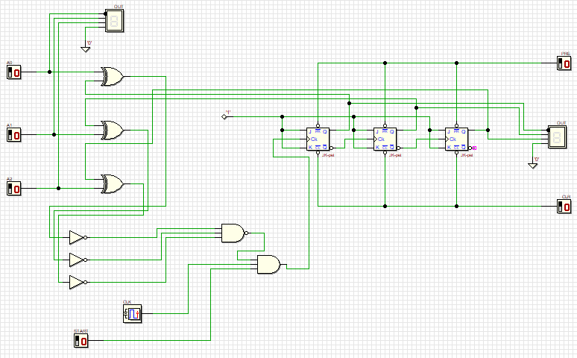

**Enhancement of the Xerox machine**

**Background**

This project will be using 3 components on an ATMEL device. The three components are:

1. Count up counter
2. 3-bits comparator
3. Clock disabler

**Problem**

The machine would accept user input for the number of copies required and the passcode to the machine. The counter will count the number of copies that have been photocopied if the passcode entered is correct. Once the required number of copies entered by user earlier is reached, the machine will stop counting.

**Suggested Solution**

The photocopying machine used three core components; counter, comparator and clock disabler. The counter control the number of copies that has been made. The comparator determines the number of copies until it met the required number of copies. The clock disabler will disable clock and stop the counter from counting once the number of copies has been met. An implementation is added for authentication. A string of 6 digits input must be entered by the user before the printing process start. 110011 must be entered to unlock the photocopy machine, else the photocopy machine does not run. The photocopying machine will display the required number of copies and the amount that has been produced. The values are displayed by using the seven segment display. All of the components of this machine is shown in the block diagram in Figure 1.

In order to make the photocopy machine function, a string of number which 110011 must be entered to unlock it, then a 3-bit input will be entered by the user to represent the number of copies he/she wants. Since the machine is 3-bit, the allowed number is from 0 to 7, but to make the machine start printing, the input number must at least 1. The START input is switched on means start printing, both PRESET and CLEAR must be switched off so that both of CLEAR and PRESET do not function. The output of printed copies will keep counting up if it is not similar with the value of switches. When the counter value reaches the same value as the value of the input, a signal will be generated to stop the counting. This photocopy machine is represented by using DEEDS.

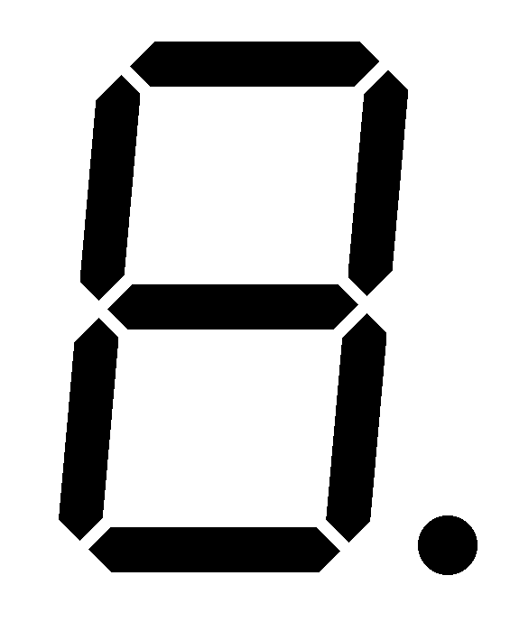

3-bit Switches

3-bit Counter

3-bit Comparator



Clock Disabler

External Clock

Figure 1

**Requirement**

*Switches*: to set the required number of copies

*Counter*: to count the number of copies that has been printed

*Comparator*: to compare the number of copies required with the number of copies produced

*Clock Disabler*: to stop the operation of the counter

*If*

*Copies produced < Required Copies, Counter will count up*

*Else*

*Counter will stop counting*

**System Implementation**

All the components are implemented as a WinCUPL code that will be programmed into ATMEL.

*Switches*

Use switches provided by the ETS 5000 Digital training kit

*Clock Disabler*

The counter will count if there it arrives at edge of the clock signal. We want to eliminate that edge when we want to stop the counting and allow it when we want the counter to keep on counting.

*Comparator*

A comparator is a combinational circuit that can be designed using XNOR gate. Figure 2 shows a 3-bits equality comparator.

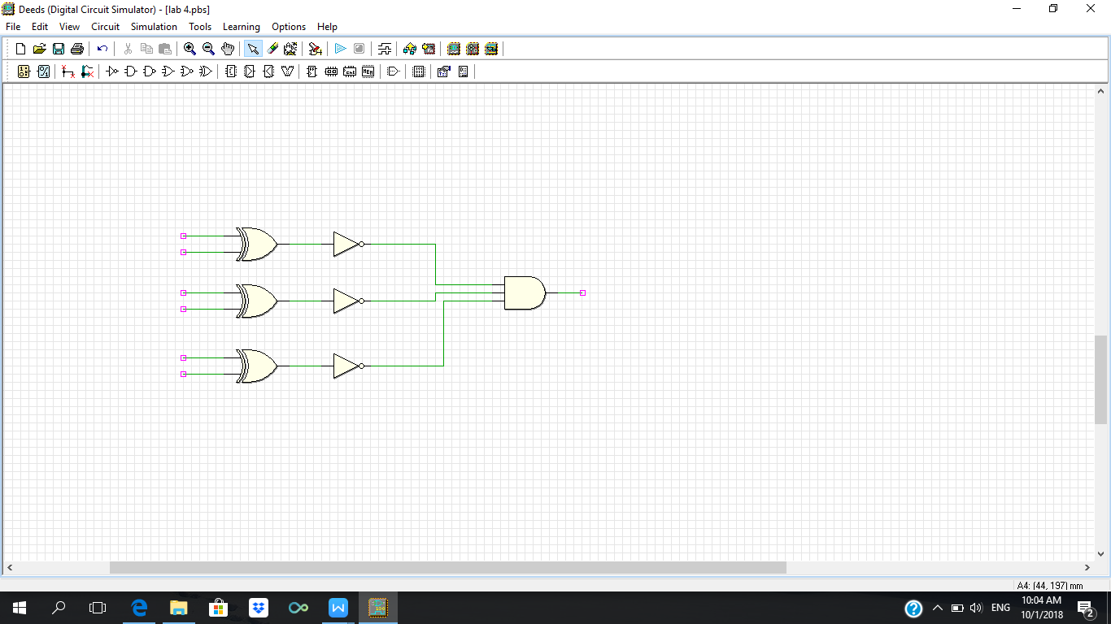

**X**

**F**

**E**

**D**

**C**

**B**

**A**

3-bits equality comparator

*Full Code in WinCUPL*

Name XeroxMachine2BIT ;

PartNo 00 ;

Date 07/12/2017 ;

Revision 01 ;

Designer Engineer ;

Company UTM ;

Assembly None ;

Location ;

Device G22V10 ;

/* *************** INPUT PINS *********************/

PIN 1 = clk ; /* clock */

PIN 2 = reset ; /* reset */

PIN 3 = preset ; /* preset */

PIN 4 = a0 ; /* Comparator A */

PIN 5 = a1 ; /* */

PIN 6 = a2;

PIN 7 = b0 ; /* Comparator B */

PIN 8 = b1 ; /* */

PIN 9 = b2 ;

PIN 10 = startPrt ; /* Start Printing */

/* *************** OUTPUT PINS *********************/

PIN 17 = diffCmp ; /* XOR (A B not equal HIGH) */

PIN 18 = sameCmp ; /* XNOR (A B equal HIGH) */

PIN 21 = q0 ; /* output counter */

PIN 22 = q1 ; /* output counter */

PIN 23 = q2;

/***** Function Comparator************************/

sameCmp = !(a0$b0)&!(a1$b1)&!(a2$b2);

diffCmp = !sameCmp ;

/**** Function Clock Enabler *********************/

clkEn=startPrt & diffCmp;

/*** Function Counter 2 Bit UP *******************/

field count =[q2..0];

$define s0 'b' 000

$define s1 'b' 001

$define s2 'b' 010

$define s3 'b' 011

$define s4 'b' 100

$define s5 'b' 101

$define s6 'b' 110

$define s7 'b' 111

count.ar=reset; /* connect reg AR to reset (Asyn Mode) */

count.sp=preset; /* connect reg AR to preset (Syn Mode) */

sequence count{

present s0 if clkEn next s1;

default next s0;

present s1 if clkEn next s2;

default next s1;

present s2 if clkEn next s3;

default next s2;

present s3 if clkEn next s4;

default next s3;

present s4 if clkEn next s5;

default next s4;

present s5 if clkEn next s6;

default next s5;

present s6 if clkEn next s7;

default next s6;

present s7 if clkEn next s7;

default next s7;

}

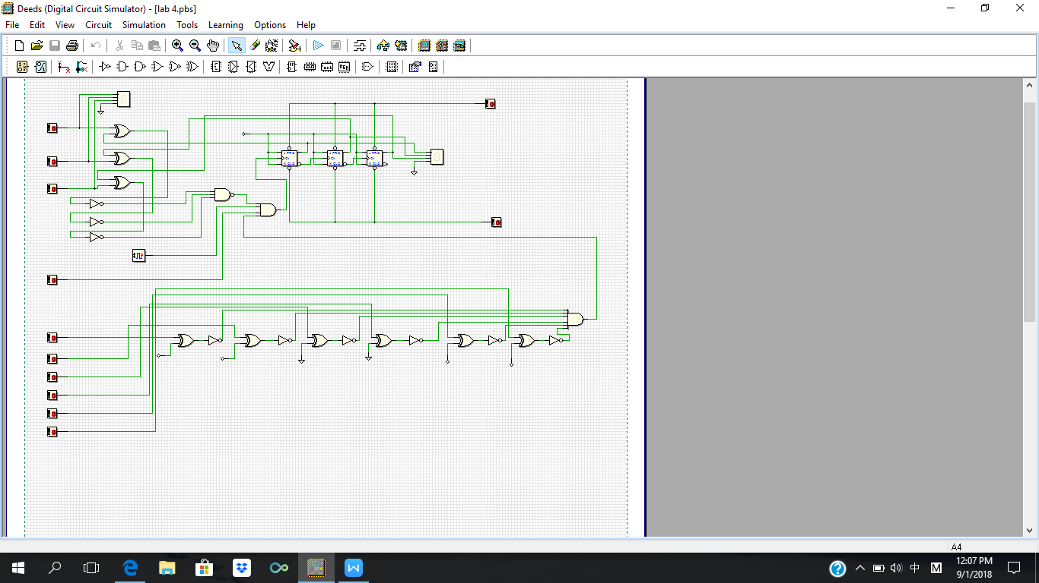

Deeds drawing for system implementation

**CONCLUSION**

**Reflection**

The Xerox photocopying machine mini project have successfully completed after few weeks. The objectives for this mini project have been achieved which were to introduce students to the development of a PLD device and simple Hardware Description Language. After finishing this project, we were able to program the PLD device using WinCUPL compiler and used it to develop a simple photocopying machine. We were also able to use a simple Hardware Description Language (Wellon Programmer).

**Achievement**

We have successfully developed a simple 3-bits photocopying machine through Deeds simulator. The photocopying machine can run the process of counting the number of copies until the maximum value for this photocopy machine. It also has a passcode function which will only allow the machine to work if the passcode is entered correctly. The Deeds simulator of the machine can run well.

**Improvement**

Instead of using 3-bit input, we should use more bit to represent a bigger value of input. A 3-bit input can only represent 0 to 7 while more bit can represent wider range of number.

**REFERENCE**

# Department of Computer Science, Faculty of Computing. (2017). Lab Manual . By Mazleena Salleh, Abd. Bahrim Yusoff and etc. , *Digital Logic* (4th ed., pp. 386-396). Universiti Teknologi Malaysia: desktop publisher.

**APPENDIX**

The total hours spent in the lab for practical work is 2 hours.

