# **The Importance and Trending of IT Project Management**

# **Hanis Rafiqah bt. Hisham Razuli, Goh Yitian, Indira A/P Thangaraj, Iman Ehsan Bin Hassan**

# **School of Computing, Faculty of Engineering, Universiti Teknologi Malaysia**

***ABSTRACT***

**This article is based on the talk given by Mohd Khairul Reeza Ruslan on the importance and trending of IT project management. Project management is the application of knowledge, skills, tool and techniques to project activities to meet the project requirements. The importance of project managements are finishing project with a good quality in a given time, scope and cost. On the other hand, PRINCE 2 is a methodology used in project managements developed by the UK government. There are 7 principles in PRINCE 2. Those principles are important in project environment. In addition, there are 7 trends in IT project management which are globalized ‘Gig economy’, focus on BiG Data, automation and artificial intelligence, method melding, emotional intelligence, change in management, tools and solution.**

# I. INTRODUCTION

IT is the short form of information technology. IT includes a larger scope of work such as cloud computing, web and mobile app development, database management, network configuration, network and computer security and more. IT project management is the process of managing and supervising the plan and organization to achieve certain goals. There are 5 stages in IT project management are initiation, planning, execution, monitoring and closing the project. IT project managers are responsible for controlling the process of the project and supervising other workers involved in the project. IT project management is usually used for software development, app improvisation and hardware installation. There also some IT project management software such as Basecamp, Teamwork Projects and ProofHub.

# II. IT PROJECT MANAGEMENT

*A. The Importance of IT Project Management*

Project management is the application of knowledge, skills, tool and techniques to project activities to meet the project requirements.

The characteristics of project are time, cost, quality, scope, risk and benefit.

Figure below shows the difference between Portfolio management, Programme management and Project management which is developed by Prince 2, a project management methodology developed by UK government. Basically, a few projects will be contributing to a programme, and a collection of programmes contributing to a portfolio.

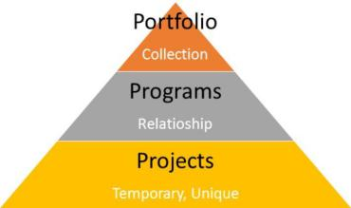

# Figure 1: 3 Key Differences Between Project Program & Portfolio Management

There are 7 principles of project management in Prince 2:

1. Continued business justification
2. Learn from experience
3. Defined roles and responsibilities
4. Manage by stages
5. Manage by exception
6. Focus on product
7. Tailoring to suit the project environment

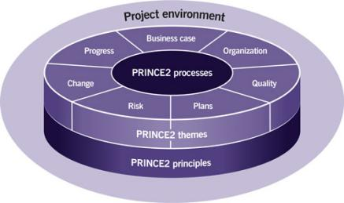

Figure 2: Prince 2 method

Principles, themes, processes and project environment are the elements of prince 2 method.

In the project management, there is a lot of process, but we cannot expect the set of process to be applied fully in the project, so we need to tailor the process. Tailoring is the process that select the compatible methods, tools and techniques, inputs, outputs and phases of the life cycle to meet the requirement of the project and customers satisfaction.

*B. Trending in IT Project Management*

There are a few of trends in IT project management. The first one is globalized Gig economy. Gig economy is short-term contracts or freelance work as opposed to permanent job. Second one is greater focus on Data. Big data consist of data analytics and numbers. From understanding customer need to detailing risks, analyzing data for important insight is a key activity in almost any development project. The third one is automation and Artificial Intelligence. Artificial Intelligence is a digital project manager where it constantly changing digital technologies. The fourth one is the importance of change management to project success. This is to stay flexible by bending over backwards as it is a daily project management activity. Then, method melding. After that we have advance project management tools and solution. We have to do project planning as Scheduling and time tracking. The last one is the impact of emotional intelligence. When you have higher IQ, you will get hired, when you have EQ, you will get promoted.

III. RELEVANT IT CAREERS

There are many relevant IT careers when we talk about the project management. For example, there are support specialist which their jobs are to review and solve the computer network and hardware problems for some business. Next, computer programmer also can be considered when we talk about IT careers in a project management. Their job is to write new computer software using coding languages like HTML and JavaScript. Video game software can be updated to improve online gameplay, which the programmers will do some adjustment with the troubleshoot problems experienced by gamers. Then, there are Management Information Systems Director. Their job is to check whether the implementation of software, equipment installation and other projects can be improved the quality of a company's information systems. System analyst also is a job to be considered because their job is to review the design components and uses their knowledge of information technology to solve business problems.

IV. Reflection

My goals on my course is to learn about knowledge of IT worlds and can applied the knowledge to my assignments. I will benefit the principles that I learned in this talk in my studies in order to improve my strategies in the industry.

My goal on my course is to complete all given tasks and assignments successfully .From this talk, I have learned how to implement project management in real life, to have well-organized plan and strategy to finish the project. I will use all the information and tips given in my daily life to achieve my goals by planning every project using the 7 principles.

After watching the video, I found out that actually project management is a huge and difficult task. It involved a lot of people to conduct a project. The people in the project should help each other to accomplish the project. After project is done, I think everyone should have the credit for completing the project.

What I gain from this talk is that project management is not easy. It took a lot of effort on making it done. From time, money, energy spent on doing something is a lot. From the talk, I know now that we have to plan out our ideas carefully in order not to make mistakes when managing our project.

ACKNOWLEDGEMENT

We would like to thank to Madam Azurah for giving us the opportunity to gain some knowledge about the project management .

REFERENCES

1. Axelos.com. 2020. *What Is PRINCE2? | Methodology & Qualification | AXELOS*. [online] Available at: <https://www.axelos.com/best-practice-solutions/prince2/what-is-prince2>
2. Career Guide. (2020, November 24). Retrieved from Indeed.com: https://www.indeed.com/career-advice/finding-a-job/types-of-it-jobs
3. Margaret Rouse.It Project Management. Tech Target, Retrieved From URL <https://searchcio.techtarget.com/definition/IT-project-management>
4. Praveen Malik, P., 2020. *3 Key Differences Between Project Program & Portfolio Management | PM-By-PM*. [online] Pmbypm.com. Available at: <https://www.pmbypm.com/difference-project-program-and-portfolio/>
5. Tutorialspoint.com. 2020. *Project Management Fundamentals - Tutorialspoint*. [online] Available at: <https://www.tutorialspoint.com/pmp-exams/project_management_fundamentals.htm>