

Project 1

**AVERAGE TIME SPENT DAILY ON   
SOCIAL MEDIA**

|  |  |  |
| --- | --- | --- |
| Group Member | 1. How Kah Hui | A18CS0074 |
| 2. Lee Huey Miin | A18CS0096 |
| 3. Leong Wai Yui | A18CS0097 |
| 4. Yap Xin Yin | A18CS0276 |
| 5. Nur Hidayu Binti Mohamed | A18CS0193 |
| Subject | SCSI 2143 : Probability & Statistical Data Analysis |  |
| 2018/2019 Semester 2 |  |
| Lecturer | Assoc. Prof Dr Azlan bin Mohd Zain |  |

Contents

1 Abstract 3

2 Introduction 4

3 Methodology 5

4 Result 7

4.1 Gender 7

4.2 Age 7

4.3 Course 8

4.4 How many social media sites do you have accounts with? 8

4.5 List 3 of your favourite social media and rank then from 1(most favourite) to 3 (least favourite) 9

4.6 How many times a day do you look at social media? 10

4.7 How much time do you spend on social media per day? 11

4.8 How often do you post on social media? 12

4.9 When do you access social media? 12

4.10 What do you use social media for? 13

4.11 Do you check social media before you get out of bed? 14

4.12 Do you consider yourself addicted to social media? 14

4.13 Do you agree social media helps you in academic? 15

4.14 Do you agree spent more time on social media will affect your health? 16

5 Appendix 17

6 Conclusion 22

**Table of Appendix**

Table 1:Appendix(a) 17

Table 2:Appendix(b). 17

Table 3:Appendix(c). 18

Table 4:Appendix(d). 18

Table 5:Appendix(e). 18

Table 6:Appendix(f). 19

Table 7:Appendix(g). 19

Table 8:Appendix(h). 19

Table 9:Appendix(i). 20

Table 10:Appendix(j) 20

Table 11:Appendix(k) 20

Table 12:Appendix(l) 20

Table 13: Appendix(m) 21

Table 14: Appendix(n) 21

# **Abstract**

In this project, we done a survey about the average time spent daily on social media. The students of School of Computing in University Teknologi Malaysia act as respondents in this survey. There are several purpose or aim which are to investigate the average time spent daily on social media among the student from School of Computing in University Teknologi Malaysia. Besides that, we determine the factor and effect on the spending time on social media. From this project, we also knew the famous or favourite social media that student often use. After the survey, we knew the view of the students on social media.

# **Introduction**

According to Vanderbilt University (2017), social media is the collective of online communications channels dedicated to community-based input, interaction, content-sharing and collaboration. Based on Margaret Rouse (2014), social media also refers to online tools and services that allow any Internet user to create and publish content. Many of these sites use personal profiles where users post information about themselves. The “social” in social media comes in as these individuals find others with similar interests and interact with them through online communities, sharing information and knowledge, offering support and networking. Social media also allows for the easy sharing and re-purposing of existing content, expanding the reach of your work and enabling others to share it with their friends and networks. Popular social media services include Facebook, Twitter, Instagram, YouTube and WhatsApp.

In this assignment, we done an online survey form about time spent daily on social media. There are two software that can use to analyses the data which are SPSS and R-programming. After group discussion, we decide to use r-programming to analyses the data and draw various type of graph such as histogram, pie chart and bar chart. Before that, we use Excel to record and list up all the data that we collect through online survey form.

In this coursework, there are some objectives to be achieved. First and foremost, to discuss the questions that can be used on online survey form to collect data. Second, to choose a suitable techniques to collect data on time spent daily (in minutes) for a sample of n students. After the group discussion, we select to use the R programming to analyses data.

# **Methodology**

In this project, we had chosen the students in University Technology Malaysia as population and student from School of Computing in University Technology Malaysia as a sample. After that, we use the rubric and notes that given by lecturer as a reference. After having a group discussion, we prepare some suitable questions for survey and send a google form via WhatsApp group to collect data from the students. After we had collected 40 respondents’ data, we arrange all the data using Microsoft Excel. Then, we analyze them by using R-programming. We use R-studio to draw the graph of the data. Below shows few steps to access r-Studio.

Step 1: Store the data collected from the survey form into Microsoft Excel.

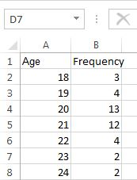

The data store in the Microsoft Excel file need to be arranged accordingly as shown in the figure above.

Step 2: Open r-Studio software and import data set from Microsoft Excel.

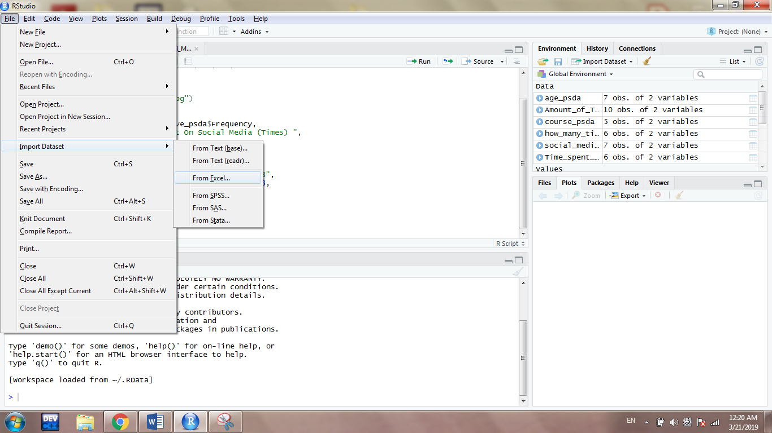

Step 3: Start coding on the left console and accessed the imported data by typing the Microsoft Excel file name with the using of $ symbol.

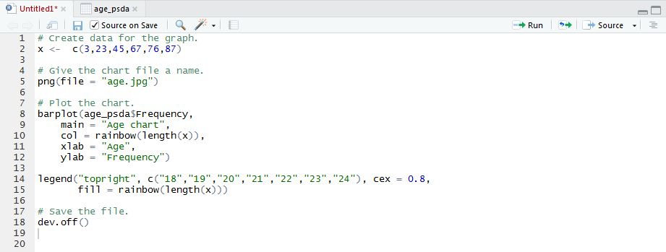

The chart created from r Studio can be automatically store as a jpg image by writing the coding as in line 5. Furthermore, xlab represents x-axis whereas ylab represents y-axis. Next, the rainbow() function shown in line 10 is to fill the colour of the chart. Lastly, dev.off() function need to be included to save the file.

# **Result**

## **Gender**

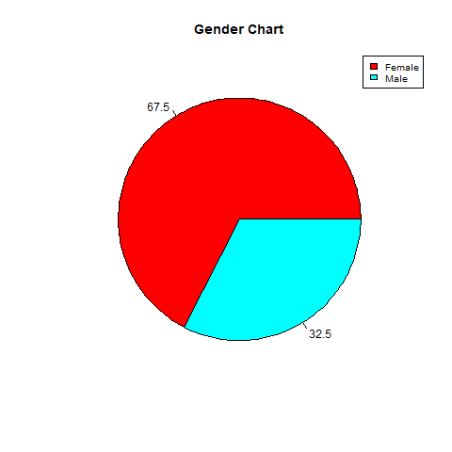

Chart 1

Gender is collected in nominal form and is presented in pie chart form as shown in chart 1. The pie chart shows that 67.5% of respondents are female and 32.5% of respondents are male. Refer to Table 1(appendix(a)).

## **Age**

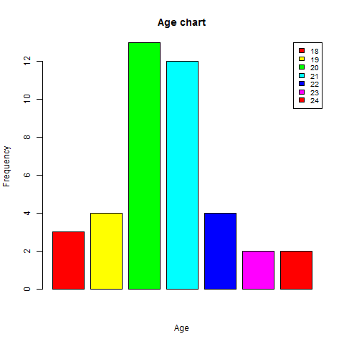

Chart 2

In the survey form, age is included. The level of measurement for age is ratio scale. Bar chart 2 above shown the age of the respondents. Respondents with age of 21 have the most number (14). The x-axis of bar chart is age and y-axis is frequency. However, the least frequency is age 23 and 24 (2). Refer to Table 2(appendix(b)).

## **Course**

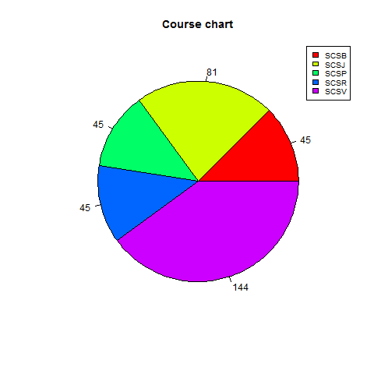

Chart 3

Moving on to another pie chart. The data is collected in nominal form. Chart 3 shows the course taken by the respondents. It is clearly shown that our respondents mostly took SCSV course which is 144° out of 360°. Next is followed by course SCSJ which was 81°, SCSB, SCSP, and SCSR that owned 45° each. Refer to Table 3( appendix(c)).

## **How many social media sites do you have accounts with?**

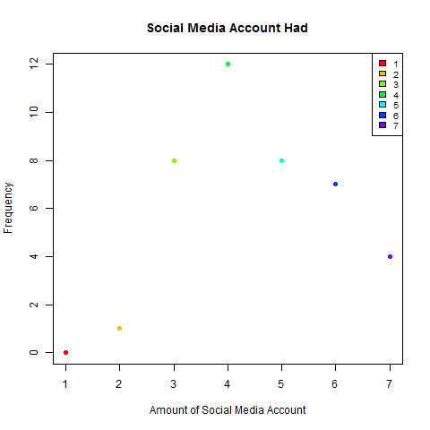

Chart 4

The chart shown above is a scattered plot with one variable. This is to present the data for the social media account that a respondent had. Based on the survey, there is none of the respondents owned only one social media account. However, there is 1 respondent who owned 2 social media accounts. Moving on, frequency that the respondents owned 3 and 5 social media accounts are the same (8). The frequencies for those who owned 6 and 7 social media accounts are 7 and 4 respondents respectively. The highest frequency is 12 (owned 4 social media accounts). The data shows that the teenagers nowadays tends to create as much social media accounts as they could. As time goes by, the teenagers will feel boring towards certain social media and started to ignore all those social media account that had been created. Refer to Table 4(appendix(d)).

## **List 3 of your favourite social media and rank then from 1(most favourite) to 3 (least favourite)**

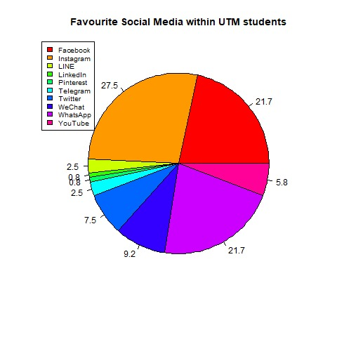

Chart 5

Chart 5 above shows a pie chart with the most favourite social media among UTM students. This data is collected in nominal form. From the pie chart, Instagram is the most favourite social media among UTM students (27.5%), followed by Facebook and WhatsApp(21.7%), WeChat(9.2%), Twitter(7.5%), YouTube(5.8%), Telegram and LINE(2.5%) and the least is Pinterest and LinkedIn(0.8%). Instagram is the most favourite social media among UTM students because Instagram is easier to use compare to others social media. Since the user can just watch or search for images and videos, and can comment or like the post, hence people of all age like to use it. Refer to Table 5(appendix(e)).

## **How many times a day do you look at social media?**

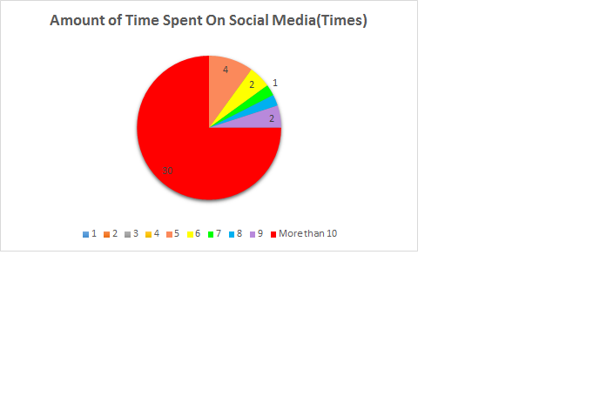

Chart 6

Pie chart above shows the amount of time spent on social media by calculating how many times the respondents do spent on social media daily. The pie chart shown that there is none of the respondents surfed the social media for 1 to 4 times. Moving on, there is only 1 respondent who surfed the social media 7 times daily and the same frequency goes to the respondent who surfed the social media 8 times. Next, the frequency is the same for respondent who surfed 6 times and 9 times on social media daily (2) while there are 4 respondents who surfed the social media 5 times daily. The data shows contrast when there are 30 respondents out of 40 respondents surfed the social media more than 10 times daily. This clearly reflects that a teenager’s daily life is inseparable with social media. For teenagers that surfed more than 10 times daily on social media not only causes them to neglect their studies but also lead to addiction. In the long run, an individual’s health may be ruined by the radiation. Refer to Table 6(appendix(f)).

## **How much time do you spend on social media per day?**

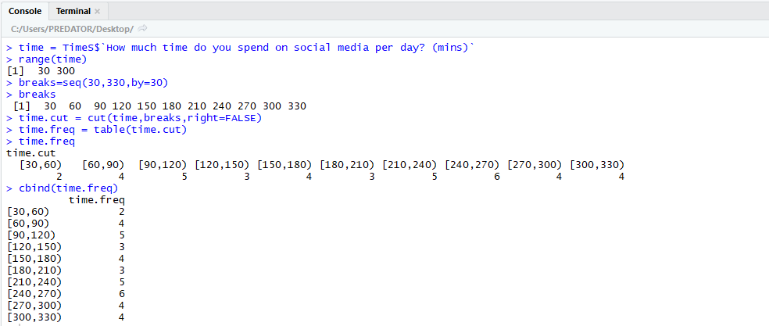

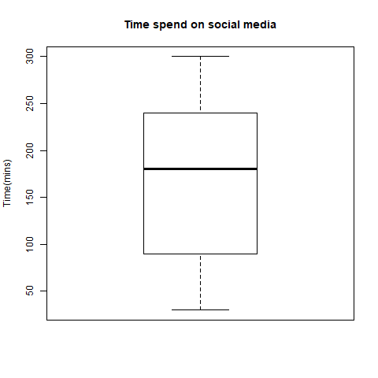

From the survey data, we have collected the data in ratio form with a title of time spend on social media. Most of the respondents spent 240 minutes to 270 minutes on social media per day which is 6 students and the time spent on social media in 30 minutes to 60 minutes on social media have only 2 respondents. We use the boxplot representating and the frequency disstribution to represent the data. From the boxplot representating, we know the first quartile(Q1) is 90 minutes, median(Q2) is 180 minutes and third quartile(Q3) is 240 minutes. The interquartile range of this data is 150 minutes. This data is because respondents think that 240 minutes to 270 minutes is the suitable time for them to access the social media per day. Refer to Table 7(appendix(g)).

## **How often do you post on social media?**

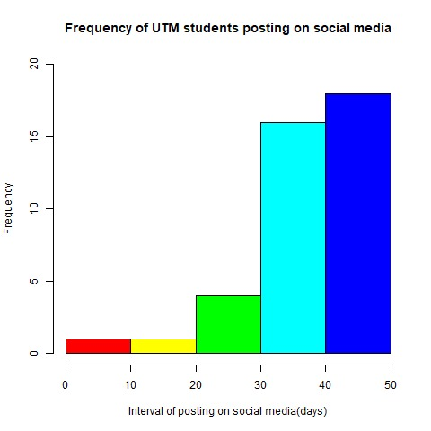

Chart 7

The histogram shows the frequency of UTM students posting on social media. This data is collected in the form of ratio. The histogram above shows that most of the students in UTM (18 students) will posting on their social media since the last post after 40 to 50 days and there are only one student who will posting on social media in 0 to 10 days and one student will posting on social media in 10 to 20 days. This is because most of the students busy with their study and seldom have free time to write a post on his or her social media account, as they do not want to waste their precious time on such activities. Some of them will only posting the post when they are attending certain activities, some special experiences to be shared with public or let off their feelings. Refer to Table 8(appendix(h)).

## **When do you access social media?**

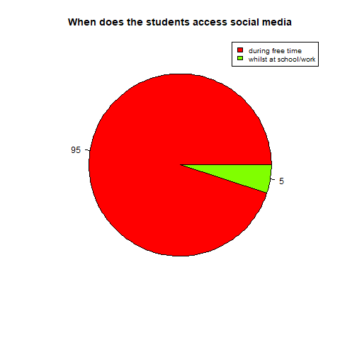

Chart 8

When does the students access social media is a title of collected data in nominal form and is represented in pie chart. This pie chart shows that 95% students access social media during free time (38 out of 40 students) and only 2% student access social media whilst at school or work (2 out of 40 students). The data is because students usually access social media like Facebook or Instagram to pass their free time. Refer to Table 9(appendix(i)).

## **What do you use social media for?**

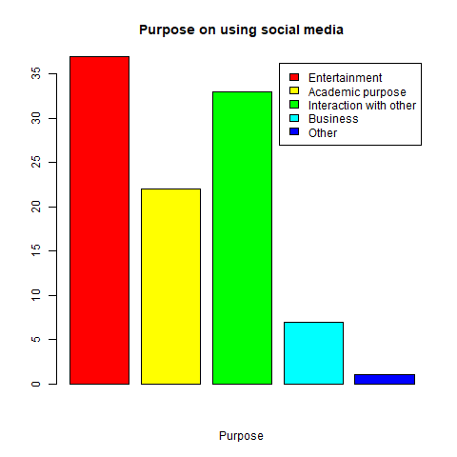

Chart 9

Chart 9 shown above is a bar chart that shows the purpose on using social media by students. We collect this data in nominal form to see students using social media for what purpose. In this bar chart, we can observed most of the students using social media for entertainment purpose (37 students) compare to another and only 1 student use social media for other purpose. This is because we can know more entertainment information through social media such as the latest information about some movies. Refer to Table 10(appendix(j)).

## **Do you check social media before you get out of bed?**

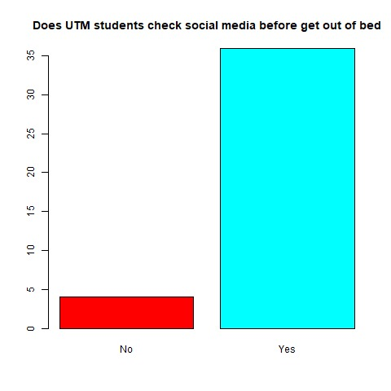

Chart 10

Bar chart above shows does the UTM students check their media social before get out of bed. This data is collected in nominal form. This bar chart shows that 36 students agree that they have check their social media before get out of bed while another 4 students do not. This is because always checking media social had become one of their habit. This is to avoid them to miss out the important message as people nowadays always update themselves through media social. Refer to Table 11( appendix(k)).

## **Do you consider yourself addicted to social media?**

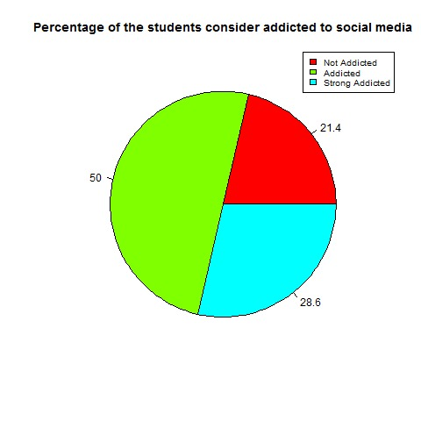

Chart 11

According to chart 11, total number of students that consider themselves addicted to social media is collected in ordinal form and is presented in pie chart data. This pie chart shows that 21.4% of respondents are not addicted to social media, while 50% of respondents think they are addicted to the social media and the rest (28.6%) of respondents agree that they really addicted to social media. Refer to Table 12(appendix(l)).

## **Do you agree social media helps you in academic?**

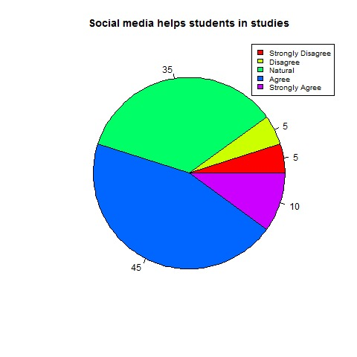

Chart 12

Pie chart above shows us the percentage of respondents agree social media helps them in academic. We collected this data in ordinal form to see how many of respondents agree with the statements. In pie chart above, we can see the same percentage between strongly disagree and disagree which means social media can affect the respondents with the positives side which is the respondents can retain extra information on social media . We can see, the most (45%) choices are agree that social media can helps the respondents in academic studies. Refer to Table 13(appendix(m)).

## **Do you agree spent more time on social media will affect your health?**

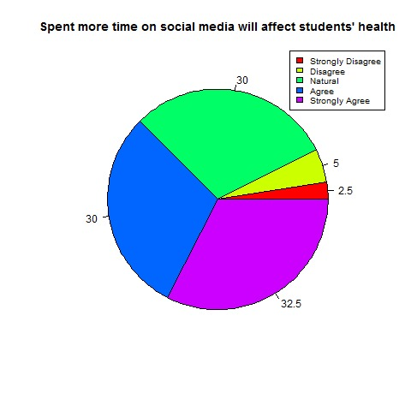

**Chart 13**

The pie chart represents the percentage on spent more time on social media will affect our health. The data collected in ordinal form to make it clearly justify the score. The least (2.5%) are disagree with this statements and the most (32.5%) are strongly agree with this statements. In this data shows, we can see some of the respondents realised that social media gives them bad effects to their health. Refer to Table 14(appendix(n)).

# Appendix

|  |
| --- |
| Table 1:Appendix(a) |

|  |
| --- |
| Table 2:Appendix(b). |

|  |
| --- |
| Table 3:Appendix(c). |

|  |
| --- |
| Table 4:Appendix(d). |

|  |
| --- |
| Table 5:Appendix(e). |

|  |
| --- |
| Table 6:Appendix(f). |

|  |
| --- |
| Table 7:Appendix(g). |

|  |
| --- |
| Table 8:Appendix(h). |

|  |
| --- |
| Table 9:Appendix(i). |

|  |
| --- |
| Table 10:Appendix(j) |

|  |
| --- |
| Table 11:Appendix(k) |

|  |
| --- |
| Table 12:Appendix(l) |

|  |
| --- |
| Table 13: Appendix(m) |

|  |
| --- |
| Table 14: Appendix(n) |

# **Conclusion**

From this project, we conclude that majority of the UTM student access social media when they are free. Besides that, most of the students spend average total 240 minutes to 270 minutes on social media because social media plays an important role among the students in their daily life. They can have online shopping, interacts with other, get the latest information which already convenience them. The favourite social media within UTM students is Instagram because the people can communicate with each other and know about their current situation. Majority of the students have more than one account because they have different identity base on different account, for example, some of them have another account for business. From this project, we knew how to use R-programming software to analyses the data. Besides that, we knew how the importance of teamwork. We knew that the total time spend of School of Computing students on social media and the favorite social media among School of Computing students.