**Ceramics**

**White Waxes**

White wax is a generic term for ceramic products which are usually white and of fine texture. These are based on selective grades of clay bonded together with varying mount of fluxes and heated to a moderately high temperature in kiln of 1200-1500 0C. Because of the different amounts and kinds of waxes there is a variation in the degree of vitrification. Among white wax, from earthenware to vitrified china the degree of vitrification is the progressive reduction in porosity provides the basis for the useful classification of ceramic products as follows;

1. **Earthen ware** – some times called as semi vitreous thinner ware is porous, non translucent with a soft glaze.
2. **China ware** – a vitrified translucent ware with a medium glaze which resist abrasion to degree which is used for non-technical purposes.
3. **Porcelain** – a vitrified translucent ware with a hot glaze which resist abrasion at maximum degree. It includes chemical, insulating and dental porcelain.
4. **Stone ware** – one of the oldest ceramic products developed and rewarded as throughout porcelain.
5. **Sanitary ware** – formed from clay is porous and preferred for vitreous application with a tri-axial composition.
6. **White ware** – white ware tiles available in number of times, classified as floor tiles, resistant to abrasion and impervious to stain penetration and used as  wall tiles of a variety of colors and is formed small surface.

[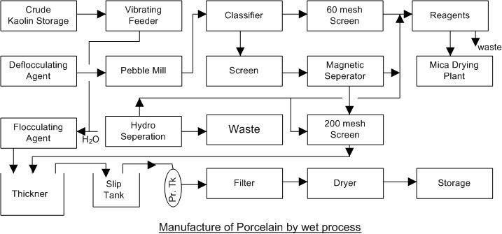](https://sites.google.com/a/sdsenthil.com/www/chemical-technology/Porcelain%20-%20wet%20process.jpg?attredirects=0)

To represent a typical manufacturing procedure in the ceramic group, porcelain is chosen below. There are three lines of production.

**Wet process porcelain** – used for production of fine grained, highly glazed insulators for high voltage application and cast porcelain necessary for making pieces to large are too intricate for the other two methods.

The 3 processes are based on the same raw materials. The difference in manufacture is the drying and forming steps.

**Description of Process**

Raw material of proper proportions and properties to furnish porcelain of the desired quality are weighed from overhead into the weighing car. Feldspar clays and flint are mixed with water in the blender (clay-water mixture) and then passed over a magnetic separator, screen and store. Most of the water is removed by filtration. All the air is removed by the mill with the help of vacuum operation. This produces stronger or hard porcelain. The prepared clay is formed into blanks and hot pressed suitably. They are then dried, trimmed and finally completely dried all under carefully controlled conditions. The hydro separator removes the water and moisture containing impurities. The vitrification is carried out in ‘tunnel kilns’ at a particular temperature and then porcelain articles are protected by Saggers fitted in the final stage of the process. The glazing and firing are simultaneously done to obtain lustre or shiny nature of the porcelain. They are immediately tested for electrical insulation after storage for sale.

The table-ware is manufactured by more complicated procedure then illustrated by the porcelain process. Some objects are obtained by the porcelain process. Some objects are obtained by the potter’s wheel in the conventional cottage industry employed in rural areas. For separate application, complex shapes for chemical laboratories are manufactured by different mould for the required applications.

Glazing is an important process in the manufacture of white wax. Some times a glaze is a thin coating of glass melted on the porcelain surface for porous application. The chemicals used are soda ash, potash, fluorspar, borax for this type of special application. The temperatures for glazing is around 1050-1500 0C.

**Refractory and colorants for ceramics**

It is broadly divided into two groups; one for clay based products like tiles, sanitary wares and thinner ware and the other based on silica as a major ingredient. In the manufacture of glasses continuous for laboratory conditions at normal temperature and pressure color is obtained by a suspension of the coloring medium when final stages of the product obtained.