TECHNOLOGY AND INFORMATION SYSTEM

SECP1513 (SECTION 01)

INDUSTRIAL VISIT 1 REPORT- MAGICX UTM

LECTURER NAME:

DR. ZURAINI BT. ALI SHAH

GROUP MEMBERS:

LEE BAO YI (A19EC0066)

NURUL HAZLEEN NATASYA BINTI YUSNI (A19EC0143)

NISHA PRITY A/P P.RAVICHANDAR (A19EC0120)

XU CHANG (X19EC0027)

1

Contents

**1.** **Introduction and details of the visits** 3

**2.** **Detailed Descriptions** 4

**a.** **MAGICX background introduction by the MAGICX Managers:** 4

Figure 1: Industrial Visit at MaGICX 4

**b.** **Exhibition on 3D printer:** 5

Figure 2: Instructions on how to use the 3D Printer Figure 3: 3D Printing Machine 5

**c.** **Driving Car Simulation:** 6

Figure 4: UTM Driving Car Simulation 6

Figure 5: Output displayed Figure 6: Serial input by Arduino 6

Figure 7: User experience on Driving Car Simulation Figure 8: Driving Car Simulation Parts 7

**d.** **Explanation on Kinect Interactive Wall:** 8

Figure 9: Demonstration by facilitator on how to use the interactive wall 8

Figure 10: Information of Rabbani media Figure 11: Information of V3X Malaysia SDN.BHD 9

**e.** **Demo on Virtual Reality of Oculus Quest:** 9

Figure 12: User is given a headset to wear with a pair of controllers that helps her to travel into a different world virtually. 10

Figure 13: A picture of a headset with a pair of controllers 10

**3.** **Reflections** 11

**4.** **The task for each member:** 12

Figure 14: Group photo at MaGICX exhibiton, T03 UTM 13

# **Introduction and details of the visits**

On 7 October 2019(Monday), our group had visited the Media and Game Innovation Centre of Excellence (MAGICX) UTM for Industrial Visit. This MAGICX Industrial Visit was organised by the collaboration between Universiti Teknologi Malaysia (UTM) and Iskandar Regional Development Authority (IRDA). One of the staff members in MAGICX UTM is Prof. Madya. Dr. Mohd Yazid Bin Yahya (Faculty of Engineering, Mechanical Engineering School). MAGICX UTM took place in T03 Building, UTM, started from 2’o clock in the afternoon. On the day, there were approximately 150 people taking part in the visit, including both students and faculty members. As we are First Year students from School of Computing under the Industrial Visit Program for the course of Technology and Information System, we were offered this chance to participate in this visit.

In this visit, we were given a tour in MAGICX UTM and a talk by the MAGICX Managers. During the visit, we were exposed to a few significant projects developed by MAGICX UTM regarding the application of technology in daily lives. In order to find out more about the details of the facilities, we have visited all the stations, including exhibition on 3D printer, driving car simulation, Kinect Interactive Wall and a demonstration on virtual reality of Oculus Quest. This industrial visit promotes the coordination of theoretical knowledge and practical applications in the field of Technology and Information System.

3

# **Detailed Descriptions**

# **MAGICX background introduction by the MAGICX Managers:**

Media and Game Innovation Centre of Excellence (MaGICX) was established in 2013, it is a strategic cooperation between University Technology Malaysia (UTM) and Iskandar Regional Development Authority (IRDA). Its purpose is to support and promote the development of creative industries and ecosystem digital content that focus on gamification and enrichment.

MaGICX will play an integral part as the anchor for the Iskandar Malaysia Innovation Valley envisioned to offer industry players/SMEs/clients technical expertise/consultation, research/product development, business development, publishing, marketing and/or training in producing commercially.

Aspires to create an environment that contributes toward talent development, industry promotion, knowledge-sharing, and international collaboration, MaGICX’ s credits include projects related to augmented reality, mixed and virtual environment, image processing, computer vision, multimedia software engineering, medical computing, computer interaction, human interface, usability, animation and technology, speech and signal processing, visualization, multimedia and software innovation, and emerging technology.

Source :<https://ihumen.utm.my/magicx/about-us/>

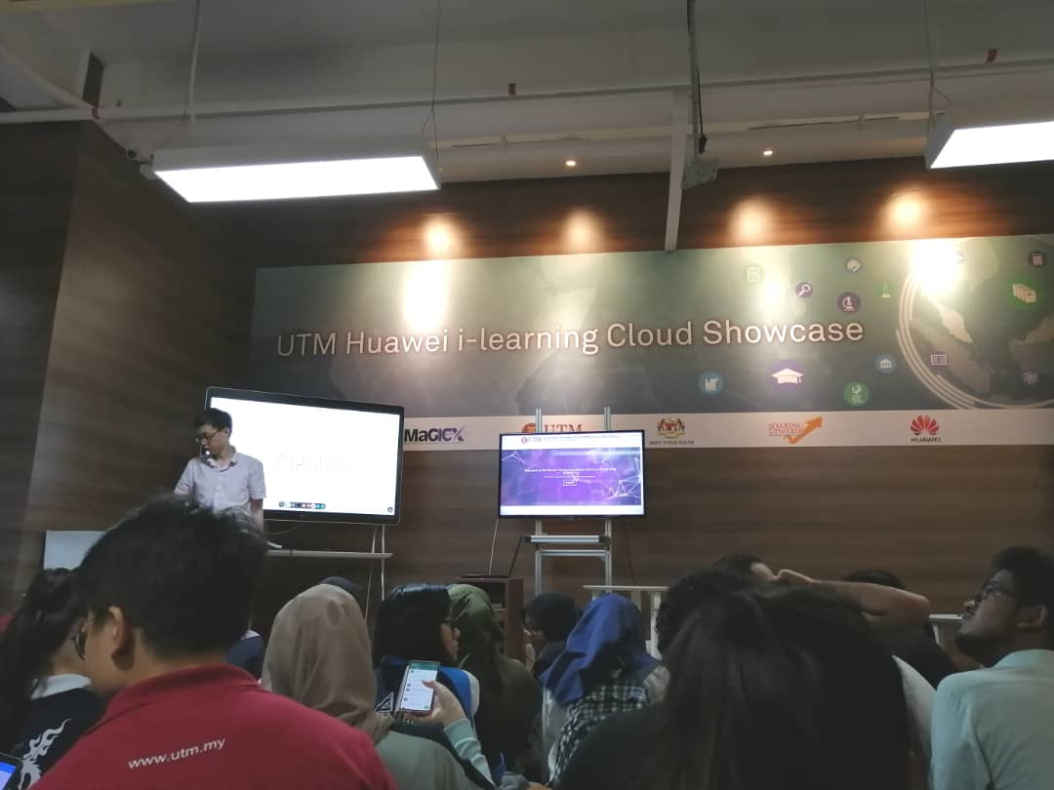

# Figure 1: Industrial Visit at MaGICX

4

# **Exhibition on 3D printer:**

3D Printing is a process of building a three-dimensional object from a computer-aided design (CAD) model, usually by successively adding material layer by layer, which is called additive manufacturing. Based on observation, in recent years, 3D Printing is performing decisive role as important manufacturing, custom art and design including architecture.

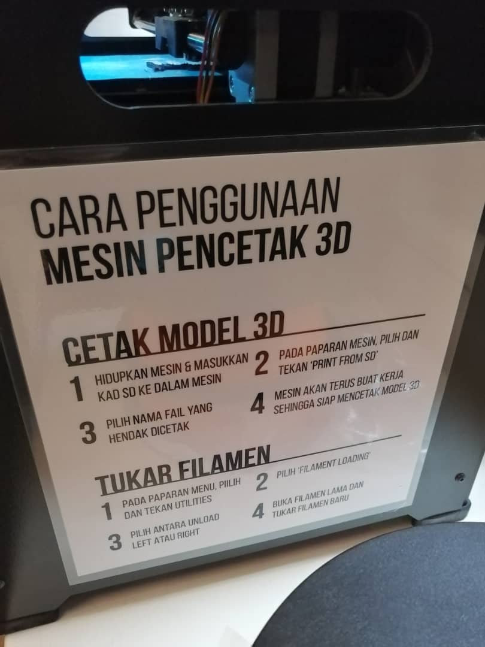 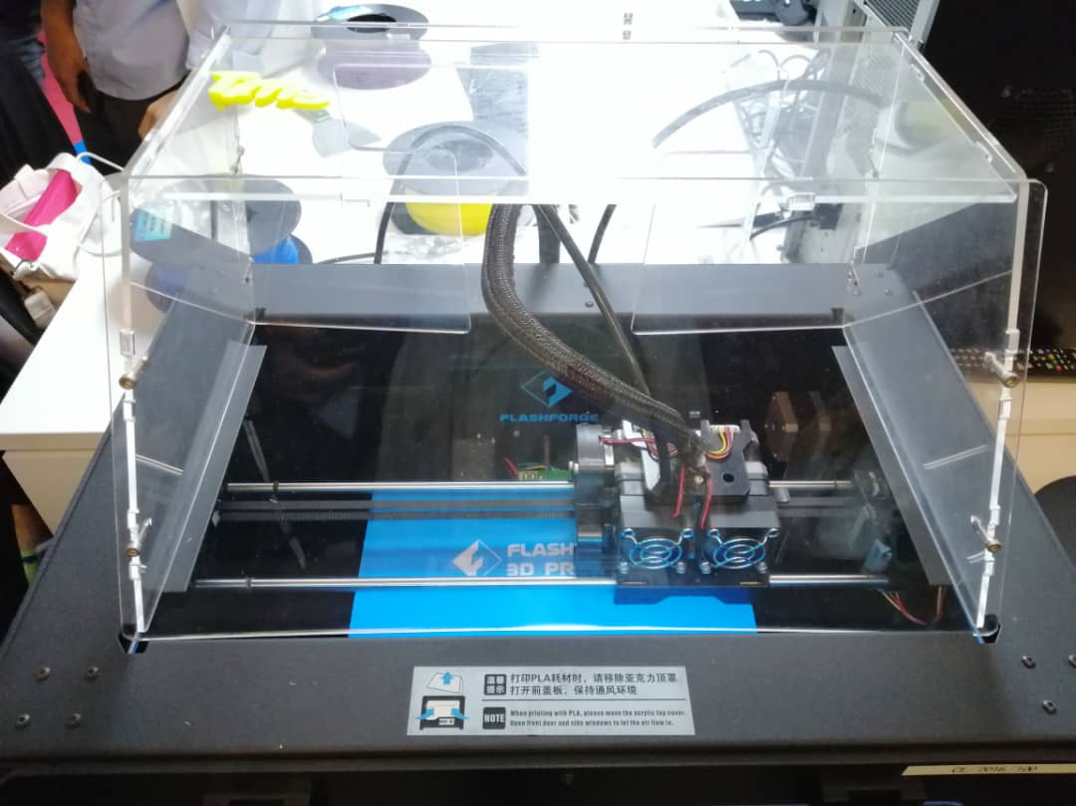

# Figure 2: Instructions on how to use the 3D Printer Figure 3: 3D Printing Machine

The process 3D Printing will usually take around minimum 6-7 hours per product depends on the size of the product. If this innovation is commercialized to public, it will be one of the profit-earning sources because the cost for 3D printing services is based on the duration of printing, the weight and size of the product to be printed. This machine uses filament as ink for the printing products. For more information, in printing sector, there are a few varieties of filament which is CREALITY 3D PLA, CREALITY 3D ST-PLA, CREALITY 3D TPU and CREALITY 3D WOOD FILAMENT.

Even though this innovation gives a new world to printing sector which many benefits that can we can get from this innovation but there are some drawbacks. As an example, the machine printer is quite pricey as it costs more than thousands to build a machine and the price is not affordable to commercialize to the public. Therefore, the developer could develop and analyze this innovation again to make sure that the machined can be commercialized to public and has an affordable price.

5

# **Driving Car Simulation:**

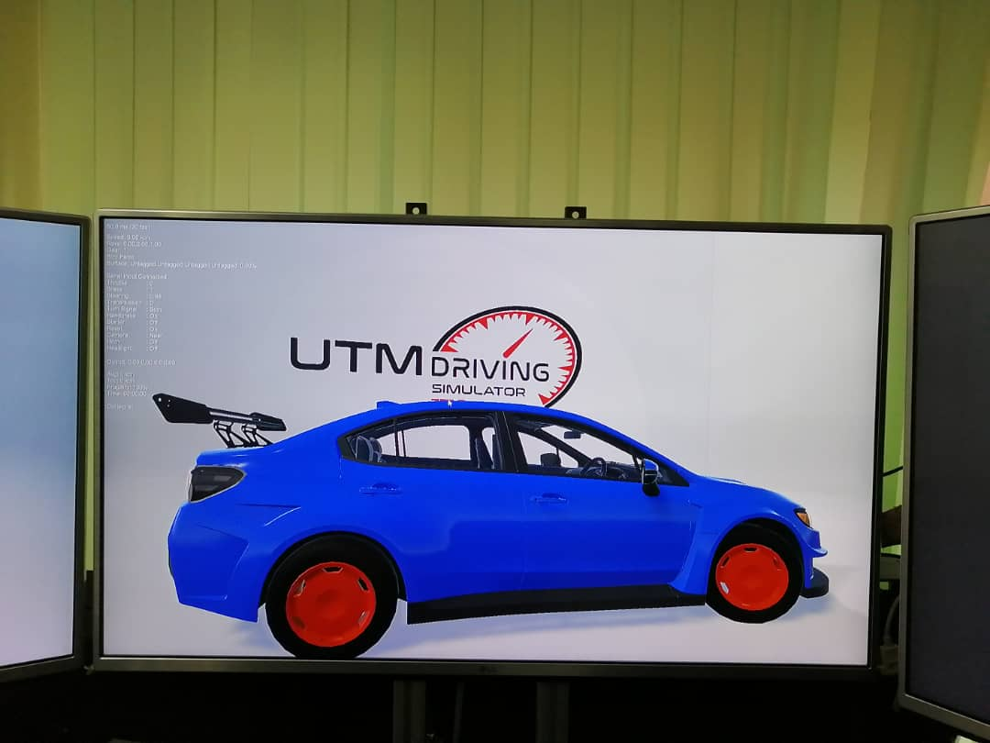

# Figure 4: UTM Driving Car Simulation

According to the facilitator, Mr. Imran, a UTM graduate in the course of Software Engineering, currently working as a Research Assistant in UTM, the graphic in the Driving Car Simulation is developed using a software called ‘Unity’, for example the map of the car simulation displayed on the screen).The serial input of sterling, gear stick, break pedal, clutch pedal and even accelerator by the user is recorded by *Arduino* which acts as a controlling station. *Arduino* language is a set of functions C/C++ and therefore it can also do the coding language such as *const int*. The average speed and the time spent on the driving car simulation can also be calculated and recorded using *Arduino*.

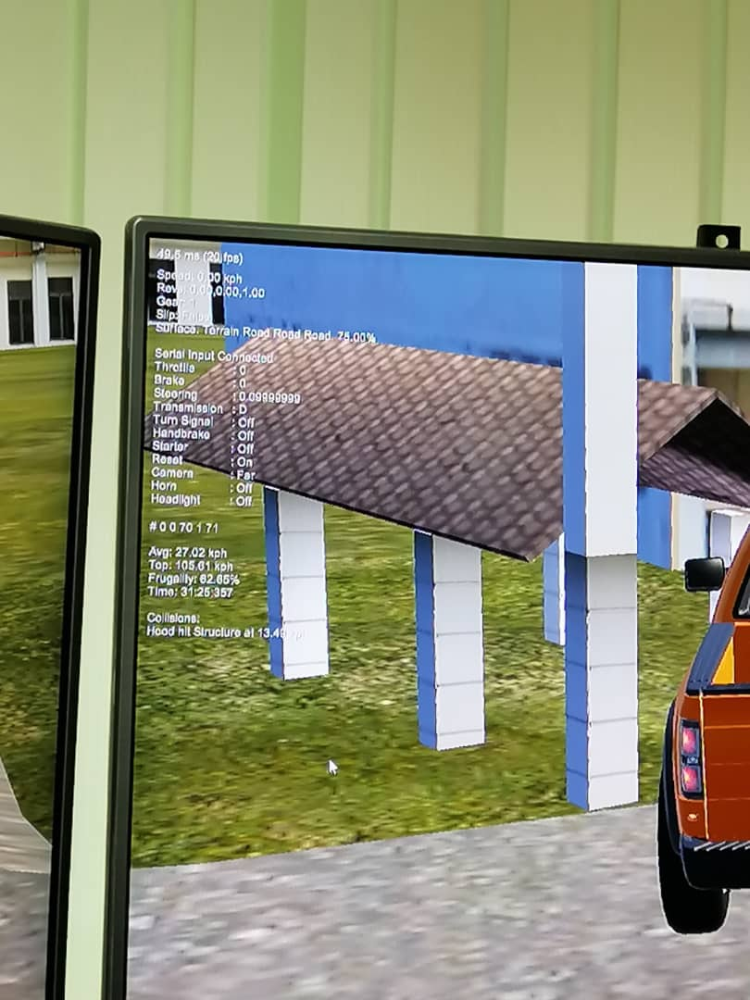 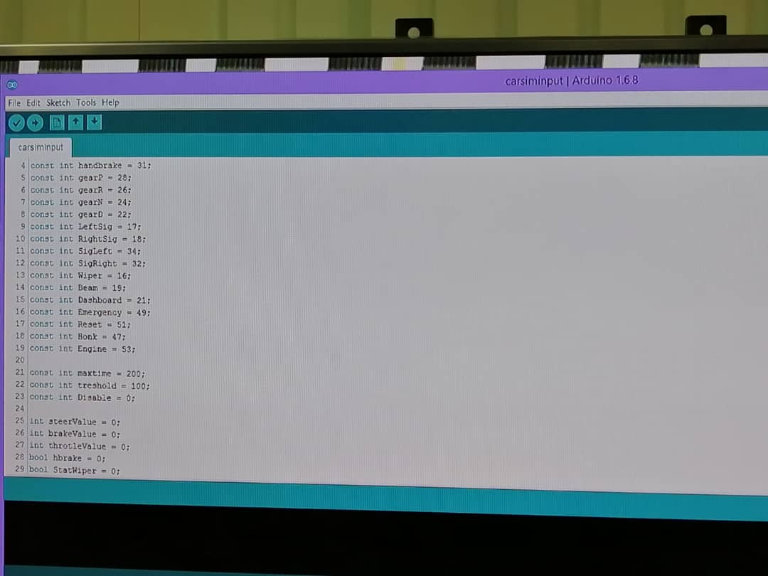

# Figure 5: Output displayed Figure 6: Serial input by Arduino

6

From Mr. Imran also, this driving car simulation system is last updated in July, 2018. The updated version is still not released for now, however the current simulation system is working to bring out its greatest usefulness. In this driving car simulation, there are 2 types of view, including “near” (first person’s view) and “far” (second person’s view). When using view of “near”, the car will be automatically driven through to another display when reaching the end of map. Therefore, view of “far” is recommended for better experience.

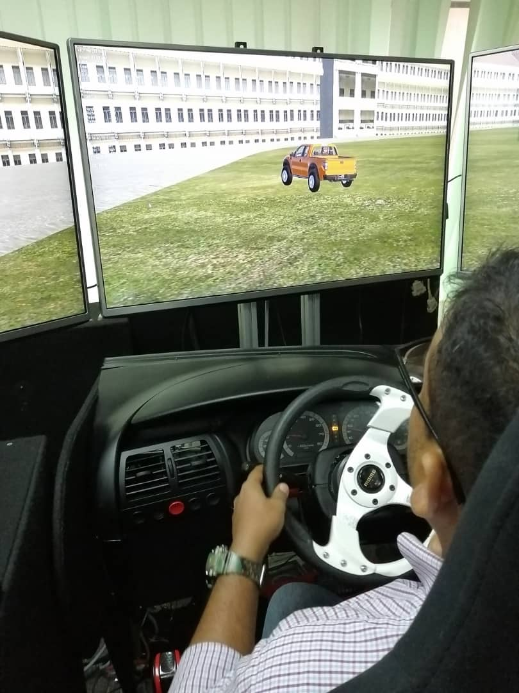 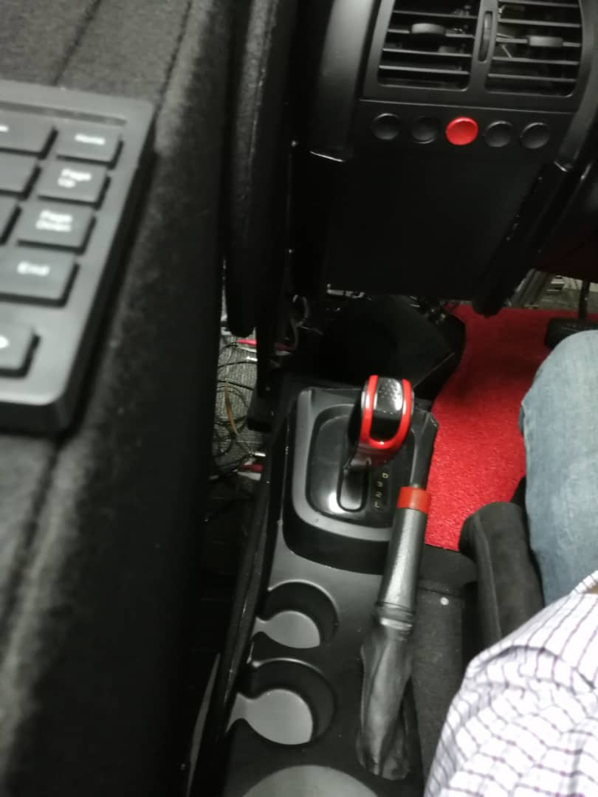

# Figure 7: User experience on Driving Car Simulation Figure 8: Driving Car Simulation Parts

One of the limitations is that the steering is sensitive. The direction of the driven car would be easily changed towards another direction when steering is turned. Another limitation is the speed, which is 130 kph. However, it is glad that the limitations mentioned above do not bring much disturbance in the implementation process.

The objective of this driving car simulation is to display the graphics and the integration process of *Arduino*. In *Arduino*, the developer has to do coding including the variables. For example, the colour coding of every object appeared (car, building, road and others).

Although there is no remarkable commercial potentials for now, the driving car simulation is currently used for multimedia purpose. Also, this is suitable to be used for learning purposes. In this context, secondary students can learn on how to operate on the driving steps as their first experiences. In short, driving car simulation brings advantages to human’s daily lives especially for learning purposes.

7

# **Explanation on Kinect Interactive Wall:**

Kinect Interactive Wall by MaGICX is the next generation gesture tracking platform with endless possibilities. This Kinect product is developed by MaGICX UTM under Ministry of Sciences, Technology and Innovation. Capabilities of Microsoft Kinect was used to develop this innovation to create an interactive customer information centre. The Microsoft Kinect is a peripheral that was introduced for the XBOX360 in 2010 and was developed to be the motion controller for their games.

Next, this innovation is capable to function with the gesture of user hand which is using sensor to detect the movement of the user hand. At first, it will detect one of the user face’s by standing in front of the screen which is sensor is allocate below of the screen to detect the user face’s before the user can access the information. After that, the sensor will detect the movement of user’s hand. The selection of information will pop out on the screen and the sensor will follow the hand movement. Next, the sensor will detect the chosen information made by user then click at the information. By that, the information chosen will display on the screen.

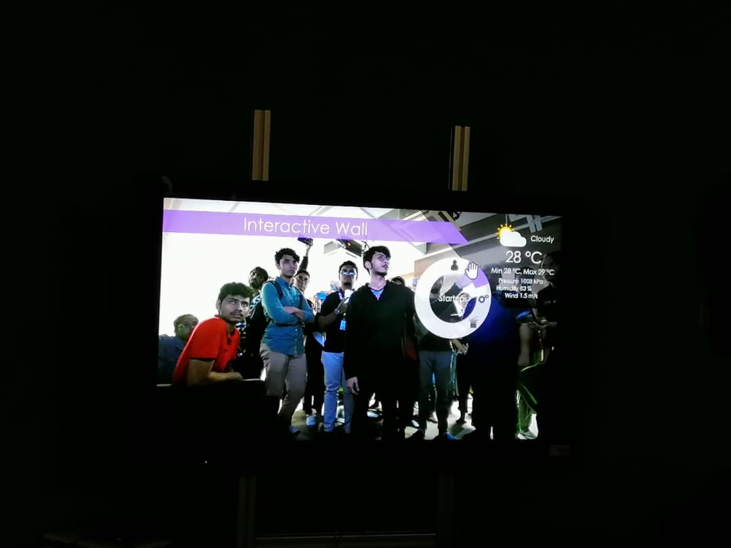

# Figure 9: Demonstration by facilitator on how to use the interactive wall

Besides that, there have some of information were programmated in this Kinect Interactive Wall. As an example, there is information about the background of MaGICX itself. Another than that, there have also Islamic information in this technology called as Rabbani media which is coincides with their slogan “Dakwah Melalui Teknologi “. In addition, the developer develop this innovation with more function which is this wall not just will display the information had programmated but it also will give information to the user about current weather of the day at upright of the screen wall. This made this wall looks so interactive and very useful innovation. V3X Malaysia SDN.BHD and COOL CODE also one of the selection of the information programmated in this wall.

8

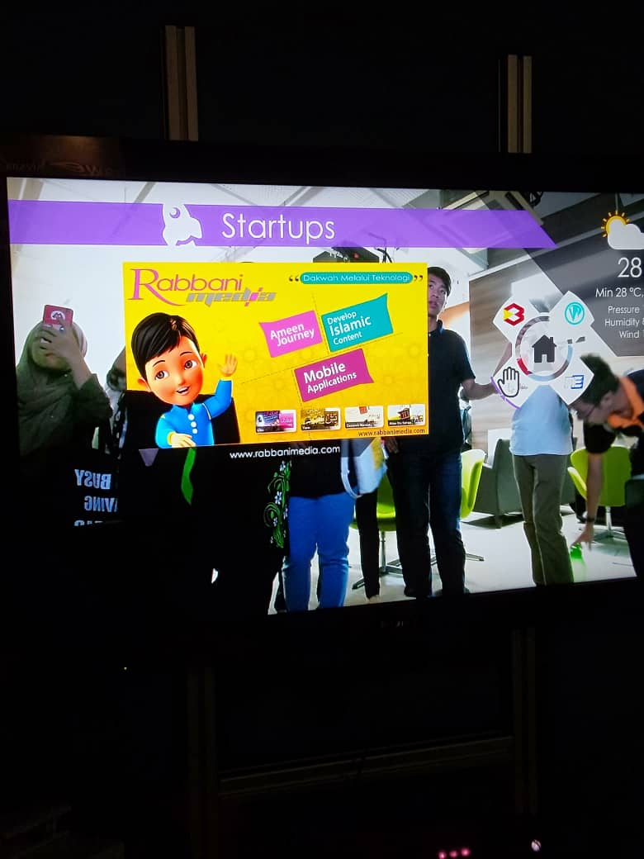 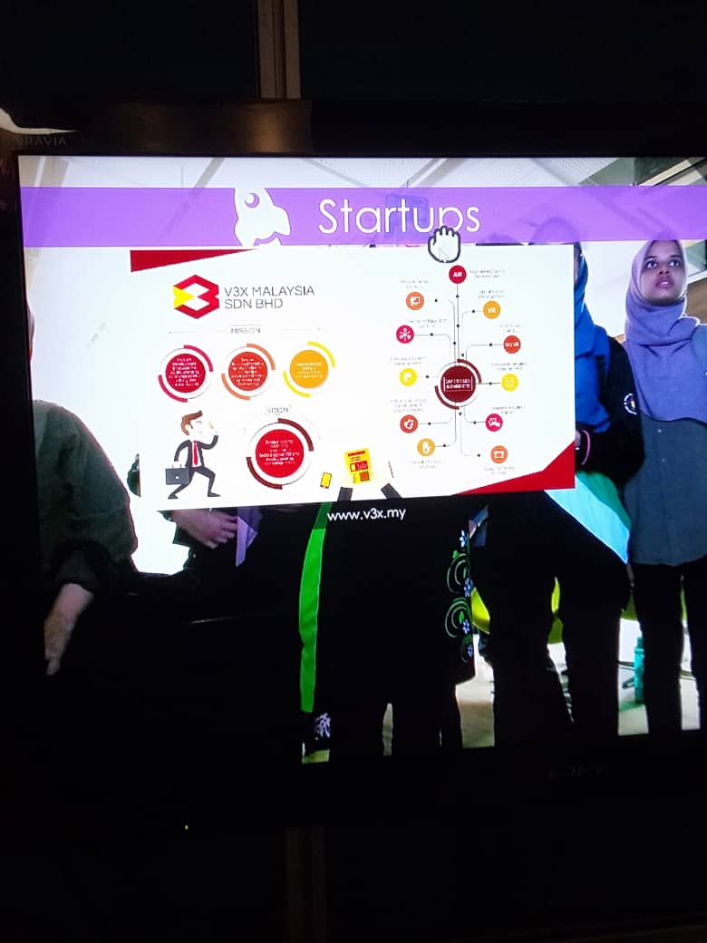

# Figure 10: Information of Rabbani media Figure 11: Information of V3X Malaysia SDN.BHD

# **Demo on Virtual Reality of Oculus Quest:**

Oculus Quest is our first all-in-one gaming system for virtual reality. It was one of the most exciting section of all. Oculus Quest was conducted by Mr. Shamine. Basically, we are given a headset to wear with a pair of controllers that helps us to travel into a different world virtually. The given headset will track our every movements and will directly transfer them onto VR. Meanwhile it will always keep the user aware about the surrounding and especially the nearby objects.

Oculus Quest was officially launched on 21st of May in 2019. It can be found in two forms of storage, 128 GB in RM2700 and 64 GB in RM2400. Before this, there were 2 oculus such as Oculus Rift and Oculus Loop. This latest version includes all in one including the operating system, hardware and games. Users do not need the usage of external connection to laptop or computer as all appliances are completely wireless and comes under one device. It has a battery that last between two and three hours. The Quest was heavier than the Rift. The touch controllers recreate our hands, our gestures and any interactions. Thus, every game is real enough to reach out and touch.

Oculus Quest has an audio built directly into the headset. This audio helps users to hear their other teammates or what is sneaking up behind users even without headphones. Oculus Quest can be still played while the user is standing or sitting in either big or small spaces. It will be absolutely a great experience for all the students as they will get to visualise a different kind of world.

9

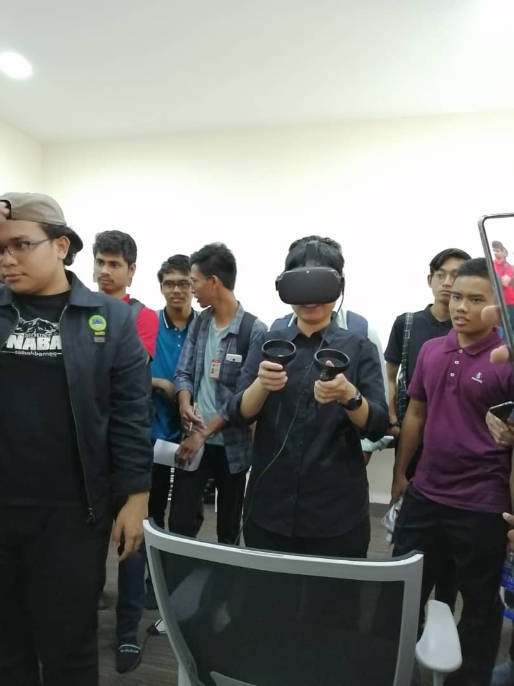

# Figure 12: User is given a headset to wear with a pair of controllers that helps her to travel into a different world virtually.

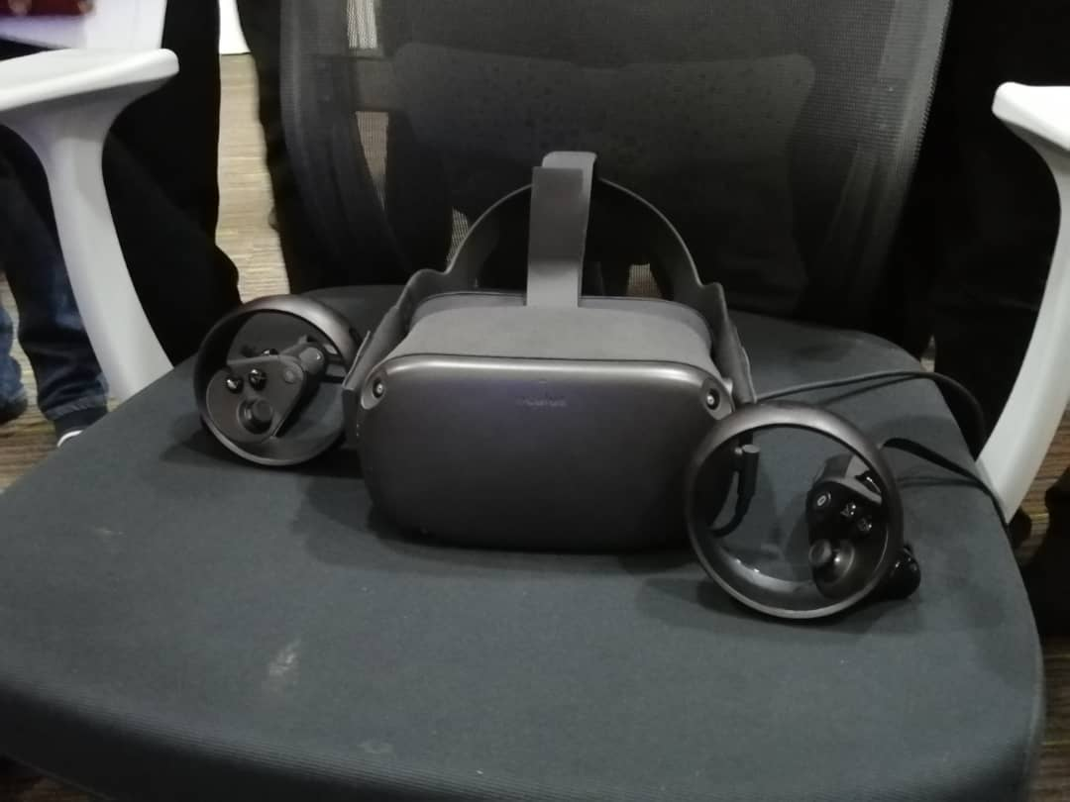

# Figure 13: A picture of a headset with a pair of controllers

10

# **Reflections**

In conclusion, we have learnt about technology in many aspects. As bioinformatics students, it was really helpful as we were able to get a great exposure on technology on recent times. Firstly, as we went to Driving Car Stimulation we got to know more about gaming and how it is being conducted. In addition, we learnt about the usage of Arduino language in gaming. For example, the average speed and the time spent on the driving car simulation can also be calculated and recorded using *Arduino*. The driving car stimulation is been useful for multimedia purpose on recent times. Undoubtedly this helps us in learning purposes. As a first experience for most of us, we learnt on how to operate the driving steps before and while driving.

Apart from this, as we went to take a close look on 3D Printing project, we have learnt about the processes a 3D printer usually undergoes. 3D printing enables us to produce complex shapes using less materials rather than using traditional manufacturing methods. This innovation gives a new world to printing sector which benefits us in many ways. On the other hand, we went to Kinetic Interactive Wall. This innovation is capable to function with the gesture of user’s hand where using sensor to detect the movement of a user’s hand. Hand gestures help users play on boardgames, as well as to carry our research on internet.

Last but not least, our final trip was to the demo on virtual reality of Oculus Quest. Oculus Quest is the first all-in-one gaming system for virtual reality. The given headset will track our every movements and will directly transfer them on VR. It was nice catching up with this session as it helps us feel the world from a different perspective as every game was real enough to reach out and touch.

Overall, through this exhibition we got to know that technology plays a vital role in our life especially in computing field. In order to succeed in our field, we should have a bigger exposure on technology. In addition, we learnt the importance of computing terms while communicating with other users. It will be a lot easier if we learn the computing or gaming terms to survive in this field. We should cultivate our learning skills in any aspects to be a successful person.

11

# **The task for each member:**

**Nisha:**

* Coach: When the team members encounter difficulties, she will give pointers to help.
* Supporter: When any team member encounters difficulties, she gives suggestions and ready to help.
* Evaluator: As a leader, she can evaluate the ideas of group members and make recommendations for improvement if any.

**Bao Yi:**

* Planner: Take the initiative in distributing the tasks. Quickly develop a simple plan for the group to complete the task, and sort out the process of executing the task.
* Timer: Remind the team to pay attention to the progress of the task and ensure efficiency.
* Supporter: When any team member encounters difficulties, she is ready to help.
* Model: Because of the attentions to details in compiling the report, the quality of the task is usually high. Therefore, she is taken as a role model for team members.

**Hazleen:**

* Supporter: When any team member encounters difficulties, she lends a helping hand.
* ‘Creative bodyguard’: Think of interesting and new ideas for the team to complete the task.
* Give opinions and involve in multimedia part, for example editing video

**Chang:**

* Supporter: When any team member encounters difficulties, she lends a helping hand.
* Opinion Collector: When members of the group have different opinions on how to accomplish the task well, she is responsible for listening to the discussion.
* Partner: Do something that she can do.

12

Group cooperative learning is a new way of learning. It has changed the single and rigid drawbacks of traditional classroom teaching, and truly made learning a part of students' life and promoted the active and comprehensive development of students.

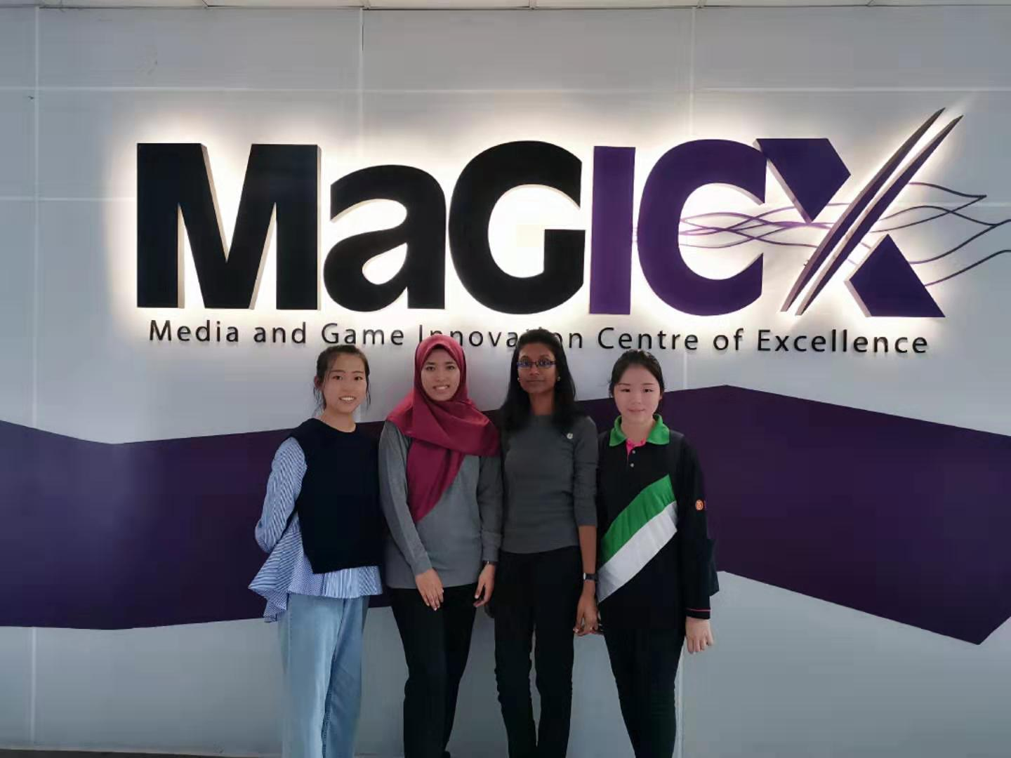

# Figure 14: Group photo at MaGICX exhibiton, T03 UTM

13