

# **UHMT1012-45 (GRADUATE SUCCESS ATTRIBUTES)**

# **SEMESTER 1, 2020/2021**

# **ENGINEERING FACULTY**

**GROUP REPORT**

**TOPIC:**

**REPORT ON FINDINGS FROM INTERVIEW WITH ENTREPRENEUR**

**GROUP B MEMBERS:**

|  |  |  |  |
| --- | --- | --- | --- |
| **NO** | **NAME** | **MATRIC NO.** | **IC N0.** |
| 1. | TERENCE LOORTHANATHAN | A20EC0165 | 010417100285 |
| 2. | RISHMA FATHIMA BINTI BASHER | A20EC0137 | 011231140734 |
| 3. | LUQMAN ARIFF BIN NOOR AZHAR | A20EC0202 | 010830100297 |
| 4. | MADINA SURAYA BINTI ZHARIN | A20EC0203 | 010915100376 |
| 5. | KELVIN EE | A20EC0195 | 010622070185 |
| **NO** | **NAME** | **MATRIC NO.** | **PASSPORT NO.** |
| 6. | HAFIZ SURYA NUGRAHA | A20EC0304 | B5029567 |

**SUBMITTED TO:**

**DR LEONG HONG YENG**

**Introduction**

Entrepreneurship is the process of identifying opportunities by putting useful ideas into practices and adding value to certain products. This can be done individually or in a group typically using creativity and a willingness to take risks. Entrepreneurs are the people who pursue opportunities and take on the risks by starting a new venture. They put together all resources needed for example money, people, strategies, and risk bearing ability to transform an invention into a business.

**Overview**

Prior to the Graduate Success Attributes subjects, we were instructed to interview an entrepreneur to gain a wider picture on the enterprising skills that had been learned in the class. Although it took time to reach an entrepreneur, luckily, we got to contact Dr Yeong Che Fai via email and pursued the interview sessions via Google Meet. He is the Co-Founder and the Director of an automation company, based in Johor Bahru (HQ), Kuala Lumpur and Penang which is DF Automation and Robotics Sdn. Bhd. Some of our findings from the interview are the description of his business, target groups, business history, business strategies, challenges and lastly, his strengths and weaknesses. Following the findings, there is also some information regarding this project which are ways we conduct this project, difficulties or challenges including the solutions to the problems, and also the lesson learned from this project.

**How you conduct/organize the project**

Firstly, we identified the task assigned and we held a meeting for a brainstorming session where each member will identify the desired objective or outcome. This is to ensure that each member understands his or her duties.

Secondly, we are looking for an entrepreneur for our interview as told in the task given, after we got our entrepreneur, we conduct a second meeting to discuss the time and questions we want to ask, and in the meeting each of us give questions related to the task given.

Thirdly, we sorted the tasks to be completed and we divided each task, multiple tasks will be sequential, and some will be simultaneously. For example, we must create a report first before creating a video slideshow. In line with that, we also had to think about making a video because this is a sequential task.

Nextly, we determined the time required for each task. Some tasks took little time to perfect such as report writing, while others took a few days such as making a slideshow video and we divided the time for each task so that we do not pass from the due date.

Then, we think of the quality of our task. Quality is one of three constraints of time, creative ideas, and space. Thus, we need better quality to incorporate more time or creative ideas for us

To determine the appropriate quality standards for our tasks and how they are fulfilled.

To carry out quality activities to ensure the execution of tasks meets established

process standards. and to monitor the suitability of project results against established configuration standards and identify errors from our tasks.

Lastly, we performed the closing phase, this stage is the end of our task activities. At this stage, the final results of the project and its documentation are to be submitted to our lecturers, and we conducted an implementation review to find out the success rate of the project and recorded every lesson learned during the task activities as a lesson for future projects.

**The difficulties while conducting the project**

There are some challenges we faced throughout the project. One of them was, it was very difficult for us to find an entrepreneur who was ready to join the interview session with us. At first, we contacted two entrepreneurs by emailing them, we waited for a few days, but we never received any information or reply from them. Moreover, it was very difficult to find an entrepreneur list in Malaysia. There is not much information about the entrepreneur list and ways to contact them.

Next, we also faced a lot of difficulties discussing with groupmates. Since everything is done virtually, we could not convey our point of view clearly. Most of us had to spend a lot of time in order to ensure other groupmates understand what we are trying to convey. Moreover, the discussion is made on ‘WhatsApp’ app. So, texting was not easy, when we talk to someone by looking at their face, the body modulation could be seen and it makes the conversation smoother but when it is done virtually, we can only see the text. Hence, the discussion period was too long because we had to wait for each and one of us to finish typing their ideas and send it to the group.

Finally, we could not schedule a meeting easily with the group mates because not all of us are from the same course. We had classes and tests at different times. Hence, it was challenging to find one right time where all of us are available for the discussion.

**The solutions for each difficulty**

**T**he biggest setback faced by the team was communication among the team members. Since there are many platforms to communicate on, we all agreed on one platform which was ‘WhatsApp’. Through WhatsApp our minute meetings were done to not overcomplicate situations. We often miscommunicate, therefore we all seamlessly agree on not ‘Spam’ which often leads to miscommunication. Not to mention, we also try to keep every message in the platform short and to-the-point as possible to avoid miscommunication.

Since our group consists of people taking various courses offered by UTM, scheduling meetings was tough. To be more detailed, everyone in the team was doing the same course except one individual who goes by the name of Hafiz. So, to solve scheduling problems, Hafiz updates us in his spare time to schedule a minute meeting or a meeting and the rest of us agrees to one of the times listed by Hafiz.

Reaching an entrepreneur is easier said than done, we foraged through the internet trying to find entrepreneurs that are willing to lend us their free time to do an interview. To speed up the search many techniques were used, a thread was posted to Reddit, a discussion platform managed by communities. We asked around family members and friends trying to seek out an entrepreneur returning with no luck. Eventually, we asked Dr Leong Hong Yeng who introduced us to Dr Yeong Che Fai, a successful entrepreneur willing to be interviewed by us.

**Findings From The Interview with Dr. Yeong Che Fai Founder and current CEO of DF Automation And Robotics Sdn Bhd.**

**• The description of his business**

Dr. Yeong Che Fai learnt about business while serving responsibilities as an academic lecturer. During this 5-year journey, Dr. Yeong has been equipped with world knowledge, academia, and entrepreneurship. Since then, he has guided several students to entrepreneurship and collaborated between UTM and external industries. Dr Yeong Che Fai was pursuing a PHD in bioengineering at Imperial College London from 2006 to 2010. While doing his dissertation on the function of a rehabilitation robot, he had the opportunity to travel to another country. He witnessed firsthand the importance of business in strengthening the economy and wealth of the nation in these developed countries.

He stated, “If you ask any university students in the US, UK, Korea and other developed countries, they will share with you their thoughts on starting their own company.”

The simple reason for this drive is because students there have witnessed successful giants in their own country, such as Facebook in the US, Samsung in Korea, Sony in Japan, and others.

Therefore, when he returned to Malaysia in 2010, he wanted to start several companies, hoping that some of these companies might make it big, by being listed on a local bourse or becoming a global brand and being an inspiration to Malaysians.

Dr. Yeong Che Fai started by combining DF Automation and Robotics Sdn Bhd in 2012 because there is a need for automation in the industry. Many companies have been looking for automated guided vehicle (AGV) solutions, but most makers are based overseas, and this translates to higher costs and poor local support.

Dr. Yeong Che Fai also has a spin-off company based on UTM to commercialize his research work. In short, Dr. Yeong has practical experience combining microcontrollers for a wide range of applications ranging from simple to advanced embedded systems.

**• His target groups**

The targeted people for Dr. Yeong Che Fai when starting his DF Automation & Robotics **S**dn Bhd company was SME (small medium companies). So, the small medium companies are his main targeted people. But afterwards, he realized that the small medium people are not ready to adapt the changes and technology. Moreover, they are not welcoming the new changes to their company because they think it is very complicated to adapt the changes. Besides, the small companies are not willing to spend a lot of money for the changes and technology to be applied for their companies. Not only that, but it is also very difficult to reach all the small companies in Malaysia.

Afterwards, the target people are moved to people who have a huge business who are willing to adapt the changes and technology in their company. In this case, those big companies have a huge budget to invest with Dr. Yeong’s company.

Then as time goes, the targeted people keep changing based on the necessity. The sector where people expect for the use of technology to be implemented become the next target people. At first, hospitals needed technology help in order to help the medical staff. This is mainly during the Covid-19 pandemic. As well all know, during the Corona virus can easily spread. So, it is very important to ensure the medical staff are not infected from the patients who are suffering from Coronavirus. Hence, a robot named “Mak Cik Kiah” is invented to fulfill their needs.

Not only during the pandemic of Covid-19 but even before the pandemic of Covid-19, the medical sector played a huge role as a targeted people. It is because nowadays the medical staff are having lots of work to be done. Moreover, medical staff are facing a lot of challenges in their job. Hence, as they have a lot of problems to be faced, as an entrepreneur, Dr. Yeong Che Fai decided to solve the problems they face. Besides, there are a lot of hospitals and a lot of medical staff in Malaysia that are facing the same problems. Furthermore, Dr. Yeong’s targeted people are not limited, because there are so many medical staff from different countries who are facing the same problem as medical staff in Malaysia.

Lastly, it is very important to be a flexible entrepreneur who is ready to adapt the changes in the company. When there is a need to change the targeted people, it is better to change the targeted people because an entrepreneur always finds a way to solve a problem, not just to solve a problem for a certain people. Targeted people might change as the company develops but the main part is there should always be targeted people for a company to run successfully.

**• His business history**

Dr Yeong Che Fai started his company DF Automation and Robotics about 8 years ago. It was not always a smooth ride ever since he started the company. Opening a business is easy but to maintain the business, to make the company have revenue with a net profit is difficult he said. He initially thought handling a business was very easy and a direct profession, though he realised it soon that it was as simple as that.

There were a lot of things that he went through at the early stages of his entrepreneurial journey. Facing challenges, he never could anticipate was a huge setback for him and his business. He and the other founder of the company had no experience nor knowledge about finance. That led him to taking courses, classes and self-researching all he needed to know about handling a business.

At the early phases of DF Automation and Robotics, Dr Yeong prioritise small medium companies or SME companies to do business with. Unfortunately, SME companies were not willing to put in too much money for the adaptation of their company with the help of the products from DF Automation and Robotics. Budget is a huge obstacle especially for SME companies as Dr Yeong as his colleagues themselves are facing. Understanding this, Dr Yeong then focuses on big companies, companies that are willing to put in a huge amount of money for any significant change.

As the years have passed, DF Automation and Robotics changes with the time. They were adapting here and there depending on the current interests. The year 2020 was a horrible year for everyone, especially businesses. DF Automation and Robotics too felt this massive wall holding them back. The recession put on quite a toll on them as they were not making as much profit as they would do in the previous years. There were many planned deals that had to be cancelled due to the pandemic as they could not meet the customers face-to-face. This led DF Automation and Robotics to start looking for other alternatives such as working with the local government on helping them with the pandemic or try to lessen the spread of the virus as much as possible.

Perhaps one of the most significant breakthroughs DF Automation and Robotics made last year was to be displayed in multiple news outlets for their product, Mak Cik Kiah robot. The robot replaced nurses or doctors to do simple tasks. This is due to the fact that robots could not be infected by the virus compared to humans. This would lessen the probability of frontline workers to contract the virus which would be one of the worst-case scenarios.

**• His business strategies**

Dr Yeong Che Fai started and ran DF Automation and Robotics company with step-by-step business strategies. Firstly, he rented a place by considering a few things which are the best location and good internet connections. This is important as he needs to spend almost RM10,000 monthly for rental and need to renovate the building which cost around RM200,000. Secondly, he hired people. There are some outlier staff but a key person that may affect the whole team motivation. Supposedly, he needs to hire extra staff to manage the situation, but they do not have enough money. Therefore, he needs to take some time while managing everything by reading extra to grow the company well.

Thirdly, he attends courses and does more research about revenue or finance as he did not have any finance background. However, it split his focus, so he hired someone with a finance background to handle it. Next, he improves his marketing strategies by learning about Facebook, Google analytics and so on. This is important as he needs to make sure people know that DF Automation and Robotics company exist, hence getting more clients.

Moreover, he stated that there are a lot of decisions to be made when running a company. Either to ask a third-party to manage the marketing which requires RM100,000 to RM200,000 per year, improve HR policy such as giving more bonus or dividend, buy a better computer, or hire a more talented person. Thus, a wise decision should be made by considering the financial status of the company.

In conclusion from his business strategies, we can see that it is not easy to build and maintain a company. However, strategies and decisions are the most important things as it shapes the development of a company. Dr Yeong Che Fai also encourages people for life-long learning as there is a lot of knowledge outside their own professions to be learned and implemented while working especially when building a huge company.

**• His challenges in business**

After a short meeting with Dr Yeong Che Fai, we as a team came to round up the challenges, he faced building up DF Automation and Robotics. Firstly, Dr Yeong said that losing key team members of DF Automation and Robotics was a major setback for the company. This is mainly caused by the lack of employees to replace them, not to mention limited funding to replace them. Since this puts the company in risk of going under Dr Yeong himself took up the responsibility to study more and learn more about the problematic fields resulting in less dependence towards employees.

Another setback faced by Dr Yeong was that the company had desires to enter and provide services to the medical field, but this was expected to be reality in 8 years’ time which would cause a company at infancy such as DF to suffer major losses. This challenge eventually resolved when pandemic struck Malaysia and the country needed more manpower or unmanned power which put DF into the picture. DF Automation and Robotics developed Mak Cik Kiah (MCK) which granted major exposure to the company resulting in profits, not to mention help frontline workers during the pandemic.

MCO was not all good for DF though Dr Yeong and his team at DF was losing RM300,000 a month because like tourism DF model is meant to be physical, DF robots needed maintenance once a while which brings health issues during the pandemic. Dr Yeong also reported that most consumers prefer seeing the models in person which results in losses to DF. MCO also made deals with international companies from Japan, India, and China unviable therefore DF suffered major loss in terms of cash and exposure. Due to insufficient revenue in 6 months’ time DF losses piled up to a staggering 1.8 million ringgits. But this in turn gained media’s attention and attracted the medical site to make an investment totalling up to 5.5 million. The investment paid off due to the development of the MCK robot.

Dr Yeong also mentioned DF suffered in marketing and threats imposed by poor marketing to a small company, consisting of smaller revenue. According to Dr Yeong he had a conversation with a consumer in which the consumer informed he was not aware that a Johor based automation company existed for a considerable time.

**• His strength and weaknesses**

The biggest strength of Dr Yeong Che Fai is that he is a determined person. During the short meeting, he once said that it was not easy to hold up his business for such a long duration. He never thinks to give up even though he has faced different kinds of challenges in his career like Movement Control Order (MCO), the factory does not provide Wi-Fi availability and he does not have professionality on finance knowledge. Meanwhile, Dr Yeong is also a creative and innovative person. He always thinks of how he and his company could help the society. For example, he and his team came up with the healthcare robot during the MCO and played a significant role to the medical team. In his university life, he often participated in various kinds of events and won the prize. He mentioned that the only way you must do in order to win the prize is that you registered yourself into the competition. This inspires us a lot. For his weakness, he mentioned that he does not have the knowledge about finance and business. To resolve his weakness, he told us that he used much of time to learn about financial knowledge like gearing, revenue and so on. Meanwhile, he also hired people with professional in Finance, Business and Accounting to help him and his team out from the situation.

**Lesson learnt from this project**

This project has taught us a thing or two especially about entrepreneurship. Though we have no interest whatsoever in it, it was always amazing how people find success in this field.

Their stories were always different thus the lessons we learned from it were also different. This one taught me that doing something new or starting something is never an easy task especially when a person has no idea what they should and should not do. It also comes down to luck as well. Even as for the most hardworking person, it does not necessarily mean they would taste success in their business.

Therefore, being smart rather than putting in plain efforts is what an entrepreneur should do instead. Indeed, it is quite a controversial opinion but those who refuse to accept the truth are the ones who will never succeed in their entrepreneurial journey.

We often see the success of an entrepreneur but rarely see the struggle they went through.

**Ending**

In a nutshell, this report has strongly shown that we as a team contribute ourselves from different positions to carry out this assignment. Meanwhile, we are grateful for having the chance to interview with Dr Yeong Che Fai who is the founder of DF Automation and Robotics Sdn Bhd. Throughout the interview, we learnt about entrepreneurship which is the process of identifying opportunities by putting useful ideas into practical and value verifying to certain products. The interview that Dr Yeong inspires us a lot by motivating us in such a way that might impact our future life. With development in these areas of robotics, we can look forward to lighter, cheaper, and more economical robots in the next decade. Such developments might well provide the needed spark to rejuvenate Malaysia's auto industry and to further decrease our rate of human usage.

We would like to end with Dr Yeong Che Fai philosophy,

“Every person will encounter challenges, if they overcome them it will reward them greatly.”

**Appendix**

**Preparing questions for the interview with Dr Yeong**

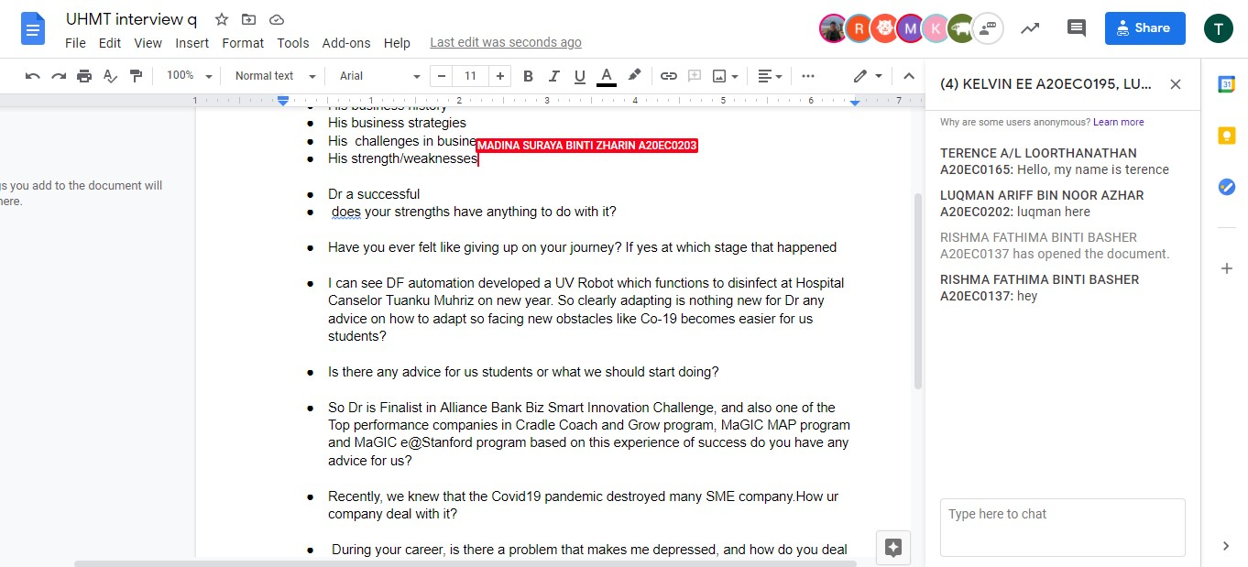

**Minute Meetings**

**First minute meeting.**

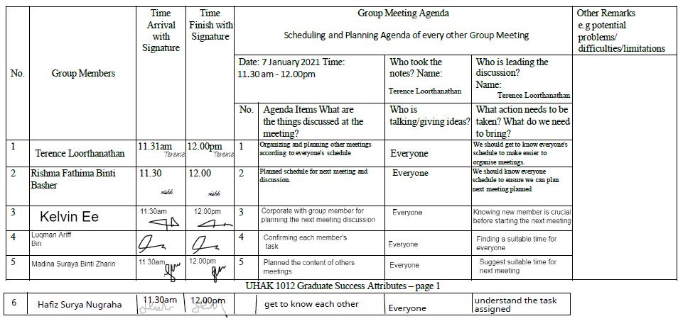

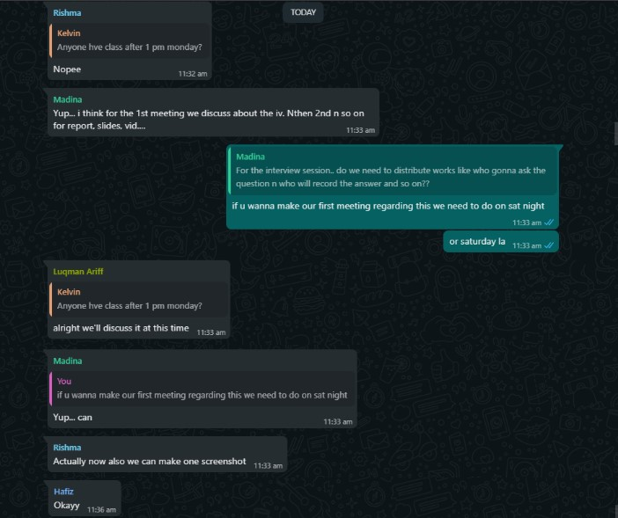

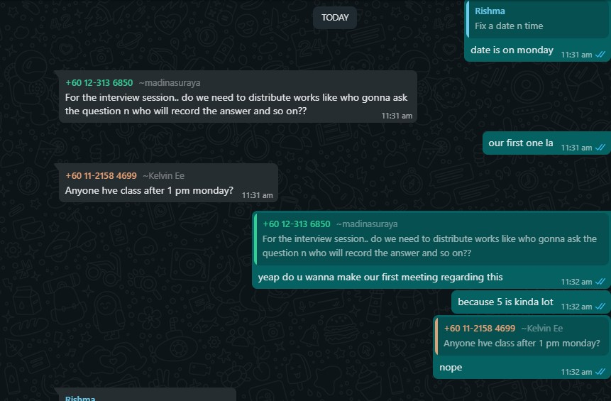

**Second minute meeting.**

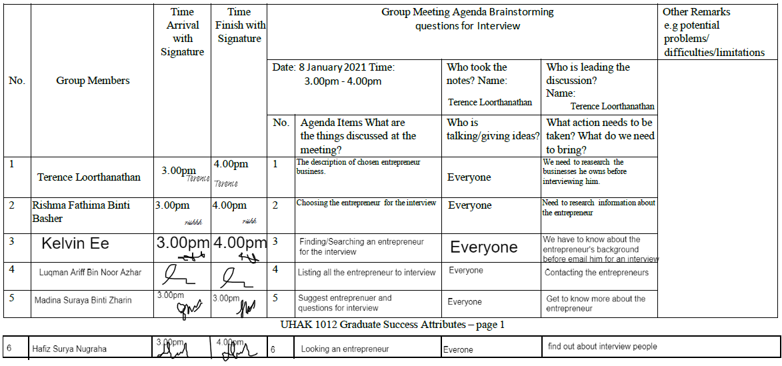

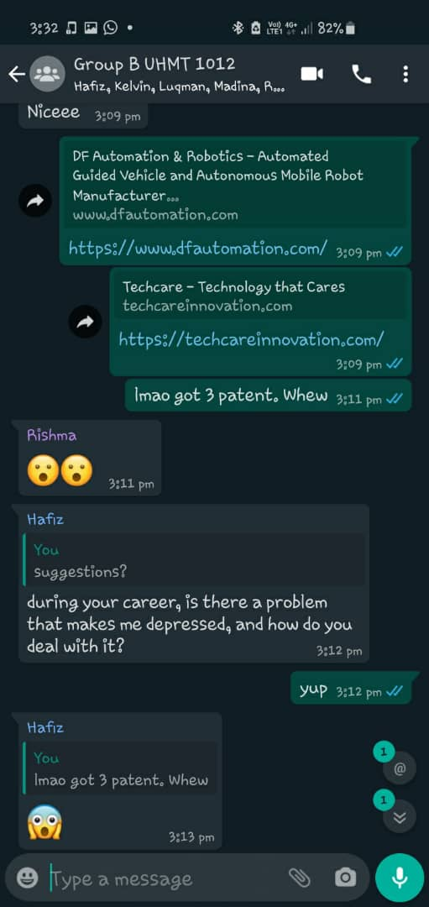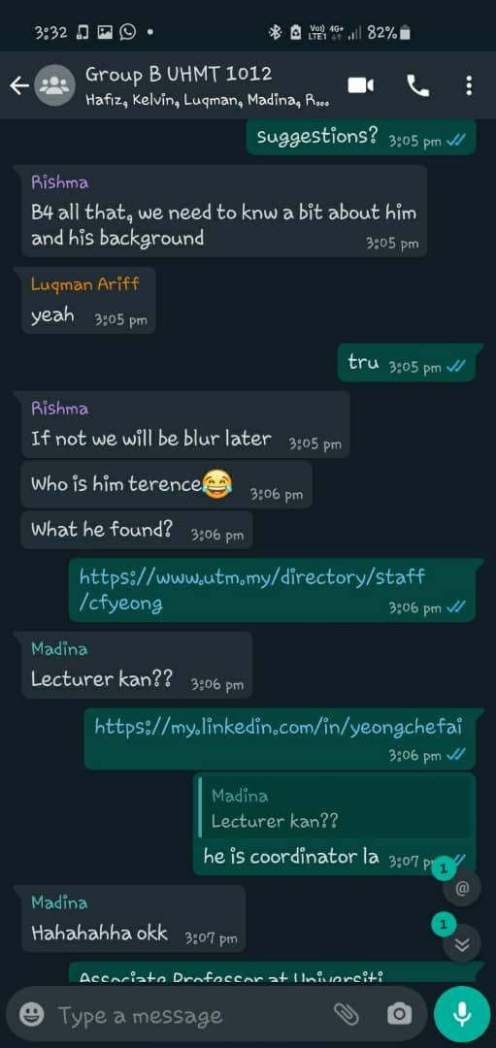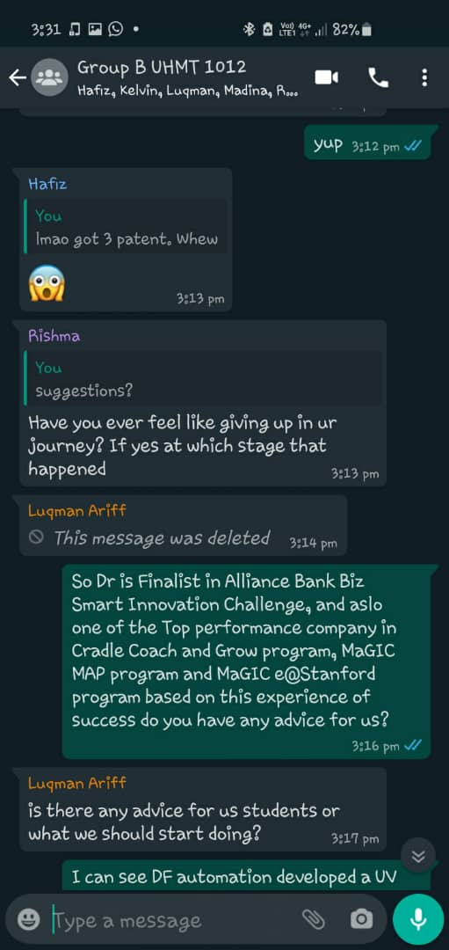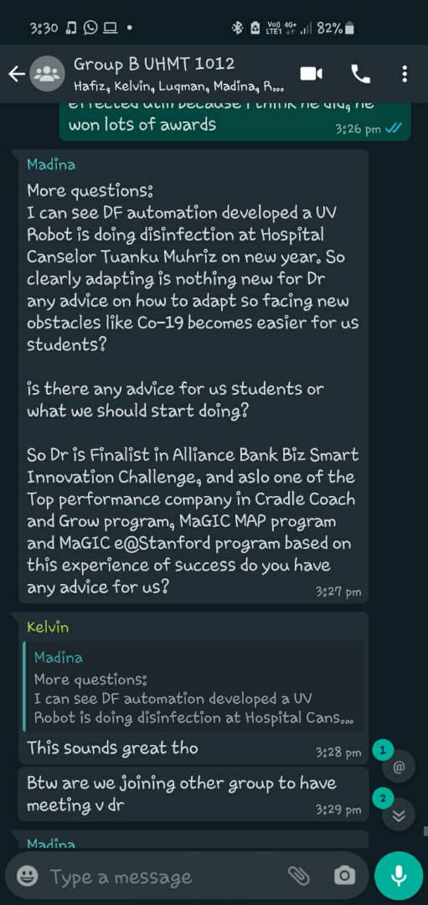

**Third minute meeting.**

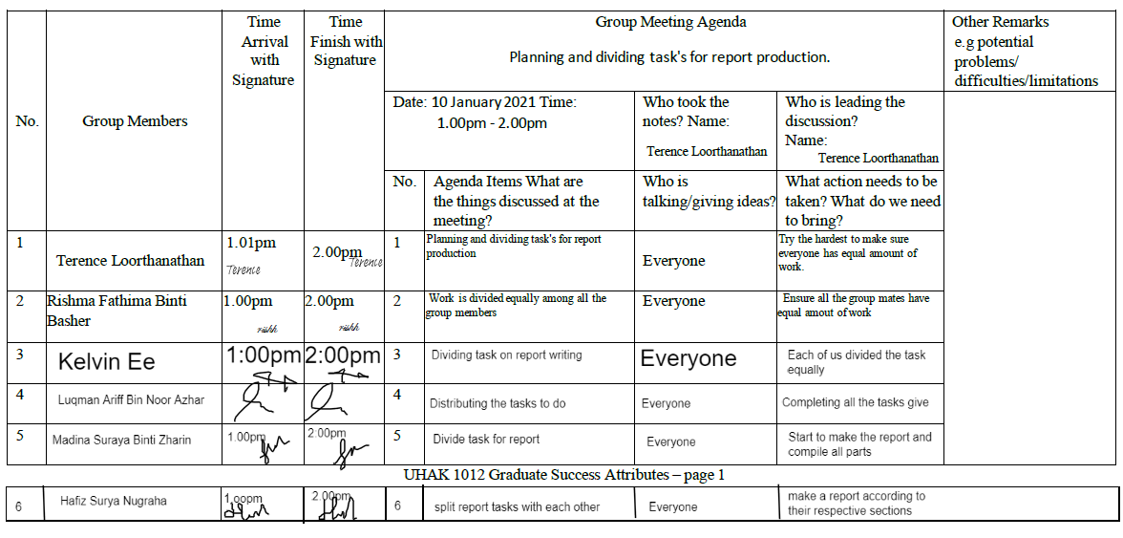

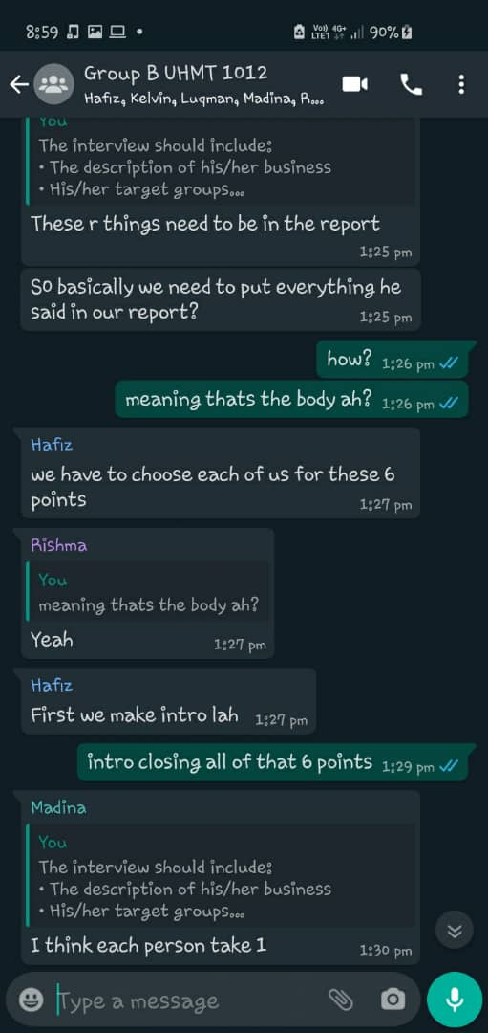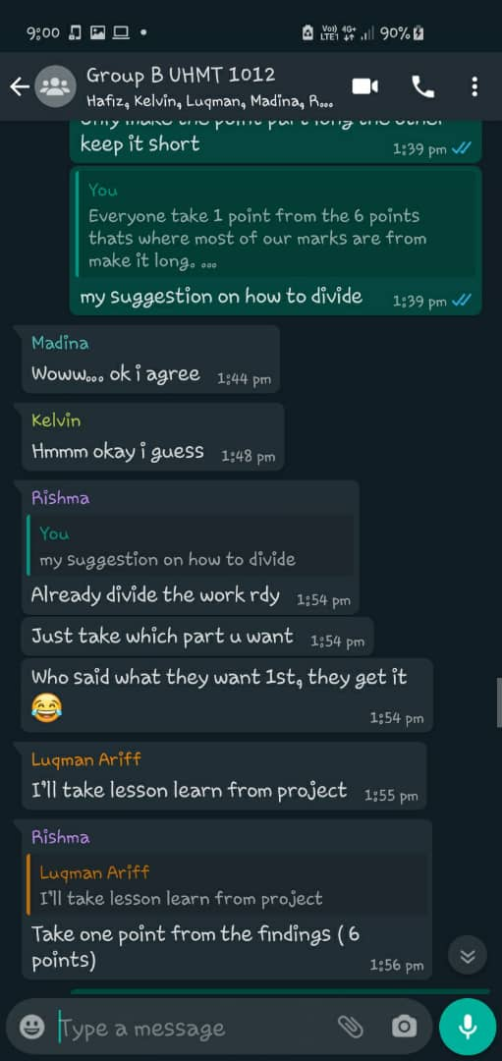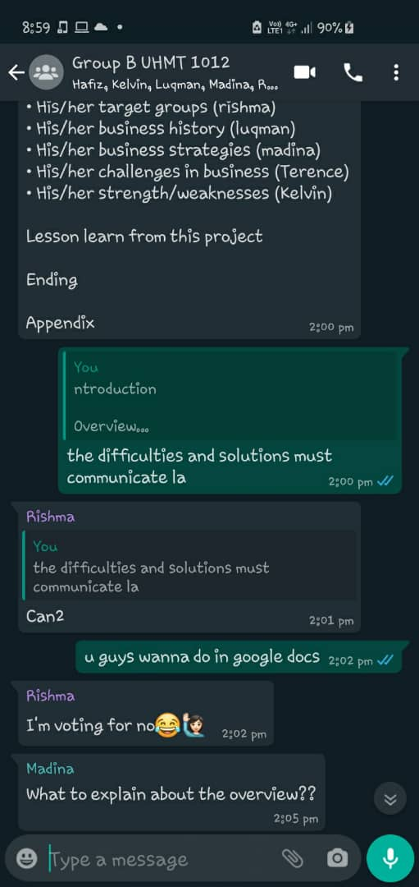

**Fourth minute meeting.**

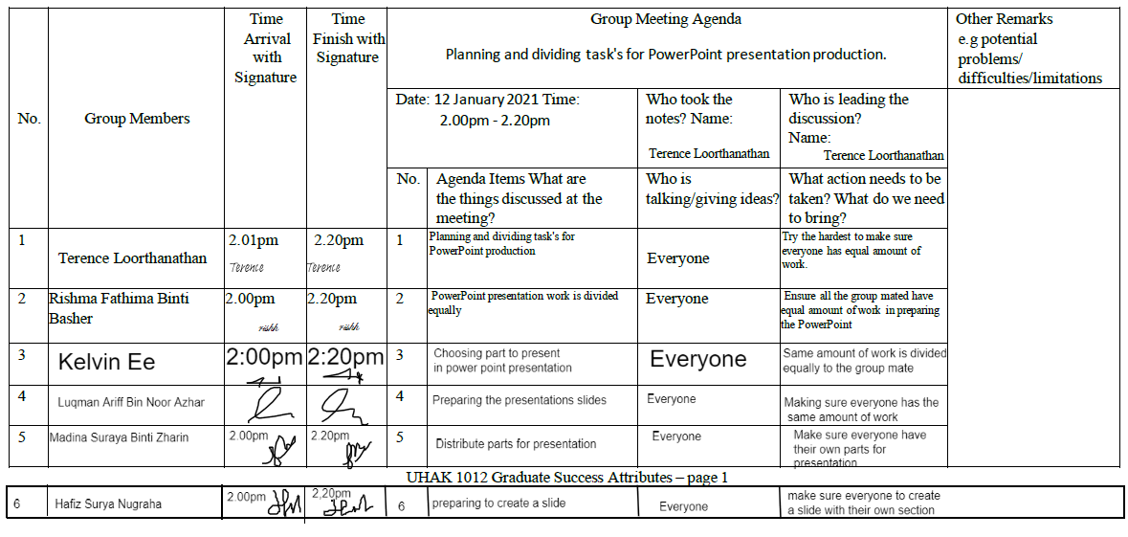

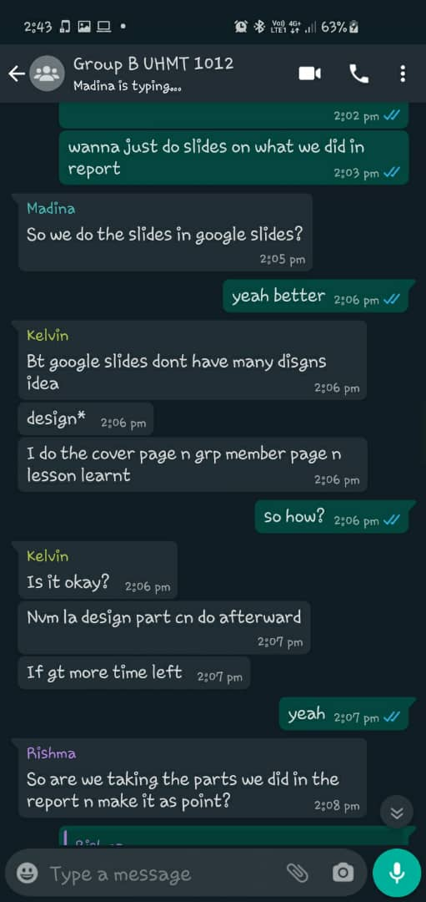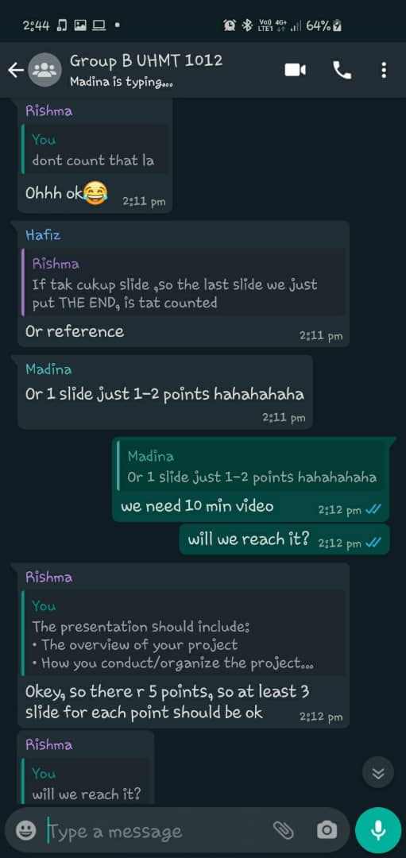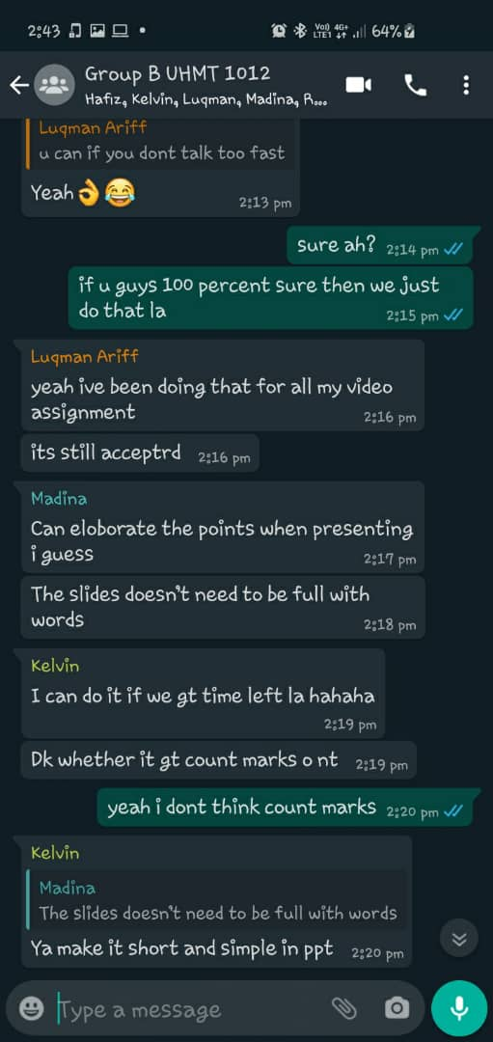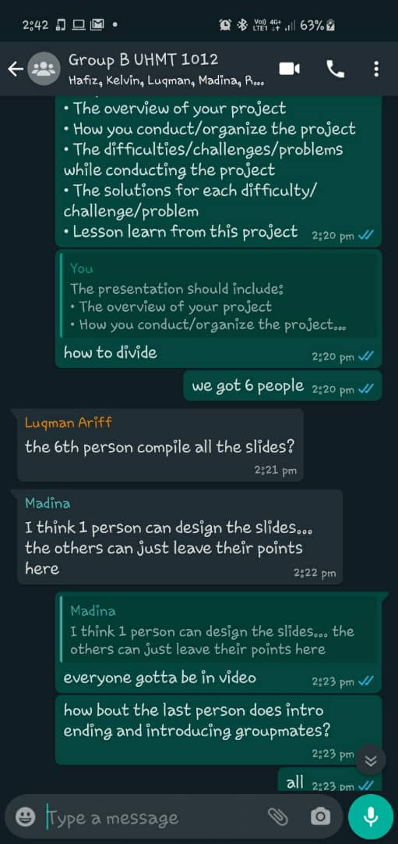

**Fifth minute meeting.**

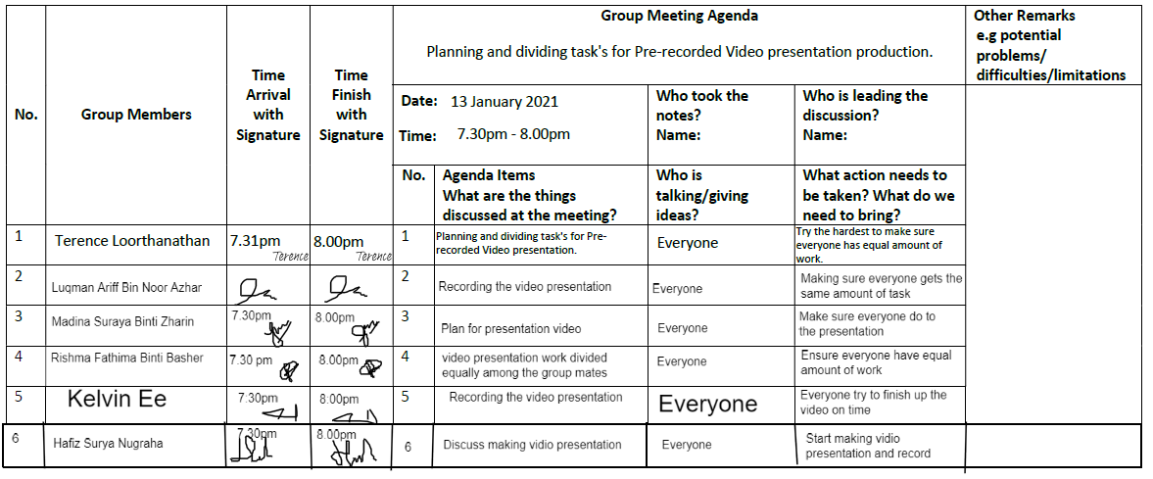

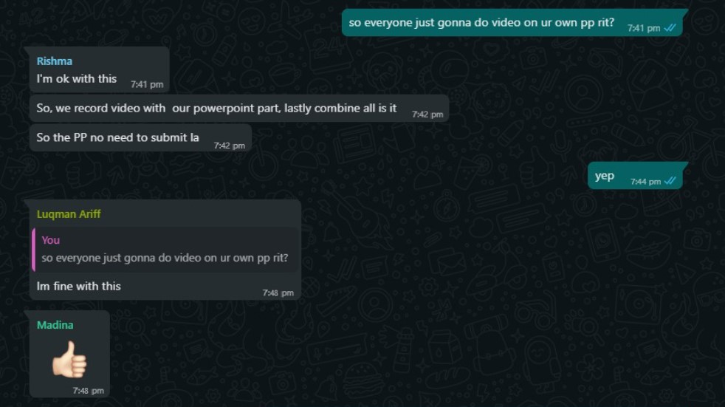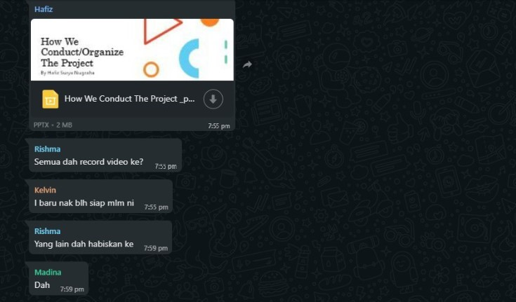

**Group Members Assessment**

