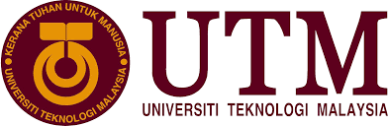

**SCSP1513**

SECTION-06

**TECHNOLOGY AND INFORMATION SYSTEM**

**Industrial Visit – CICT UTM**

LECTURER:

**DR. NOR BAHIAH BINTI HAJI AHMAD**

**GROUP-01 (TECHNOCRATS):**

SEOUL HOSSAIN-A18CS4017

RAYHAN SHARIF APON-A18CS4010

TIARA AFDELY PUTRI-A18CS0332

NUR QAMARINA BINTI TUAH-A18CS0200

PUA LEE LING-A18CS0234

***Table of Contents:***

**Introduction and details of the visits …………………………………………………….…1-2**

**Detailed descriptions …………………………………………………………………….......3-6**

**Reflections …………………………………………………………………………………....7-8**

**References ................................................................................................................................9**

**Introduction and details of the visits:**

Industrial visit is considered as a part of education where students visit CICT UTM and get knowledge of the internal working environment. The industrial visit also provides an insight into how CICT work and give useful information related to the practical aspects of the course which cannot be possible in lectures. Industrial visit is considered one of the most important methods of teaching because industry students can know things practically by visiting.

We had visited the Center for Information and Communication Technology (CICT) in UTM on 01 October 2018. It is a support unit that offers and delivers ICT services for the students and staffs such as ICT infrastructure, system development, and administrative activities. The aim for this visit is to know more detail about the CICT works. The visit starts with a briefing from the speaker by introducing to the students the history of CICT and its beautiful location. The Computer Center was established in 1975. After that, the speaker told us about the whole management system of CICT.

During the visit to CICT UTM, we know how they work to store every student and staff data and what kind of services they can provide for students. After this, we also visited Galleria CICT where we saw some early days of computer equipment used in UTM. We were informed about the initial equipment that was used to carry out administration work on campus. In Galleria, there has some collection like Mainframe Terminal, Controller, Mainframe Data Storage, Magnetic Tape Unit, IBM Tape Control Unit etc. By doing this visit we can get an opportunity to gain in-depth knowledge about this field which helps us to develop our future career.

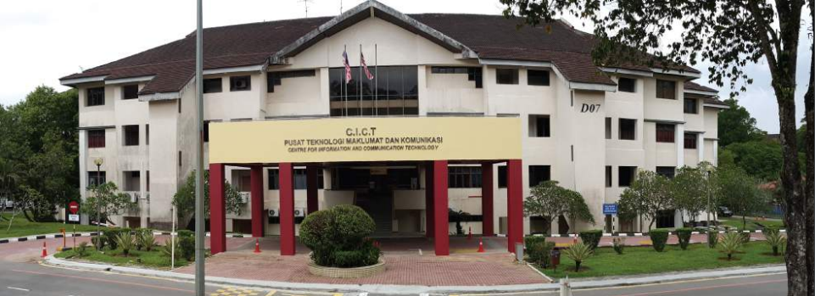

*Fig 01-CICT UTM*

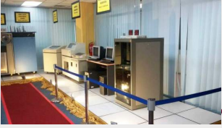

*Fig 02-Gallerium CICT*

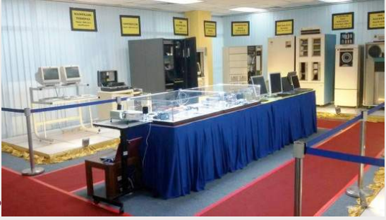

*Fig 03-Gallerium CICT*

**Detailed descriptions (organization structure, services, achievements, information systems that have been developed or maintained by CICT)**

During the industrial visit to CICT, UTM on 01 October 2018, we were introduced about organization structure, services, achievements, information systems that have been developed or maintained by CICT and so on.

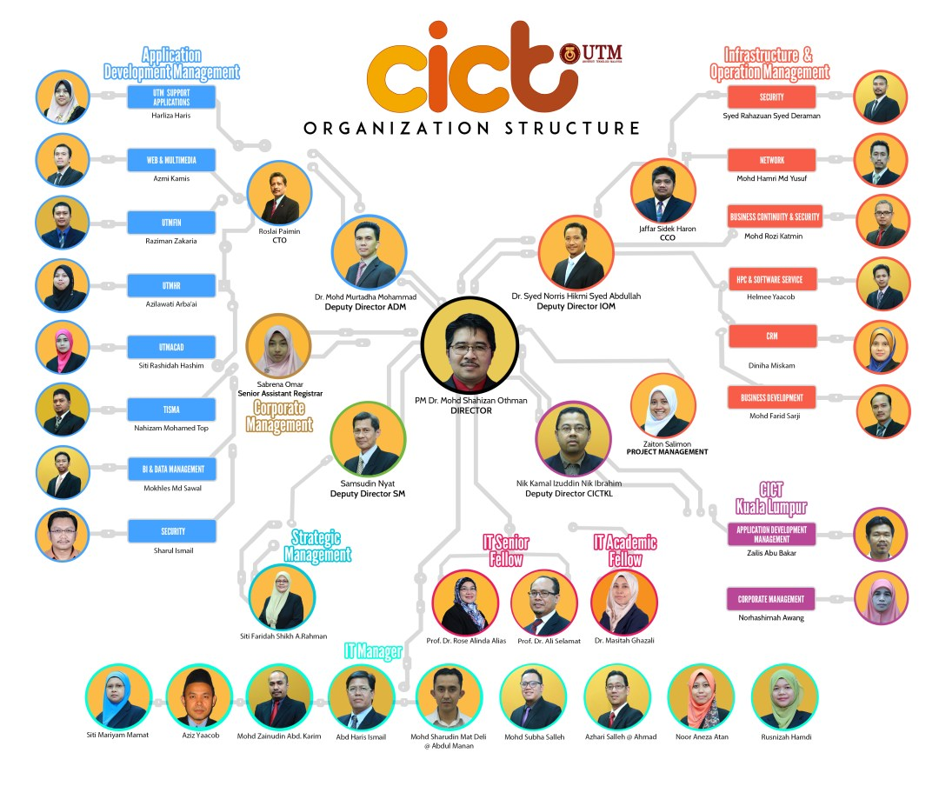

*Fig 04-Organization structure of CICT UTM*

The director of CICT UTM is PM Dr. Mohd Shahizan Othman, the Deputy Director SM is Samsudin Nyat, the Deputy Director ADM is Dr. Mohd Murtadha Mohamad, the Deputy Director IOM is Dr. Syed Norris Hikmi Syed Abdullah, the deputy director CICTKL is Nik Kamal Izuddin Nik Ibrahim, Senior Assistant Registrar is Sabrena Omar is in charge of Corporate Management while Zaiton Salimon be in charge of project management. Besides that, there are also people in charge of Infrastructure and Operation Management, CICT Kuala Lumpur, Strategic Management, Application Development Management, IT Senior Fellow, IT Academic Fellow, and IT Manager.

The services provided by CICT UTM were internet WIFI, VPN, ACID and so on. UTM WIFI was the internet can be accessed by the UTM community whether using WIFI or wired. UTM community also used VPN (Virtual Private Network) to access UTM intranet services from outside UTM campus. Academic Computing ID (ACID) was a unique user ID for UTM community to log in to most of university main application system.

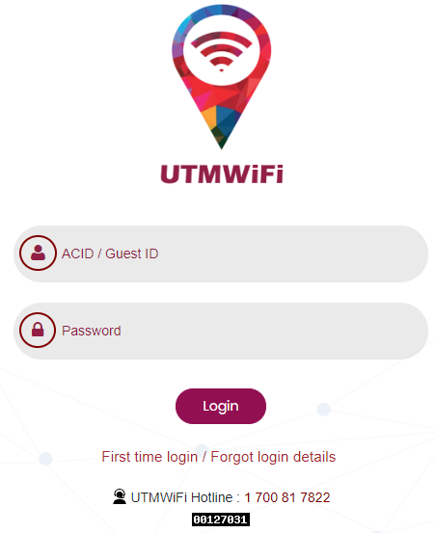

*Fig 05-The log in page for UTM WIFI*

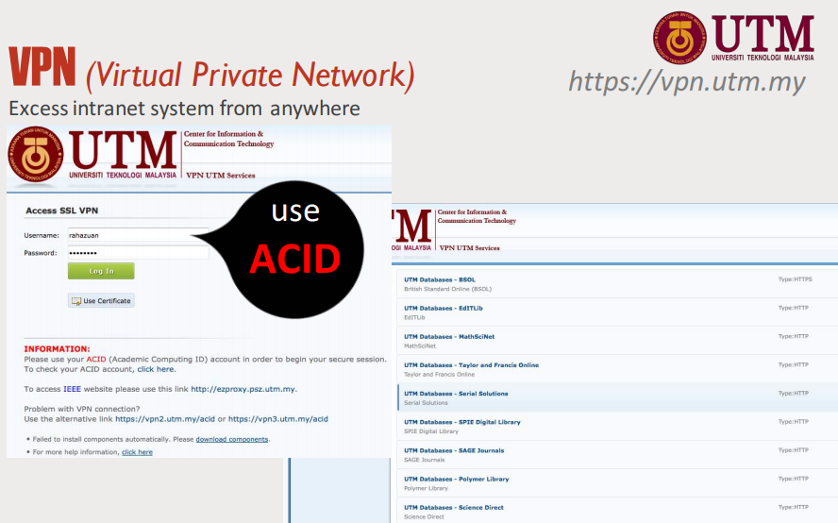

*Fig 06-Portal of VPN UTM*

There were some achievements of CICT UTM. As an example, CICT UTM had successfully prepared the best technical documents and received the Saga Compliance Certificate (Standard Accounting System For Government Agencies Award 2017) from the Accountant General’s Department of Malaysia (AGD) on 22 November 2017. Besides that, CICT was awarded the Quality Service Category PTJ Award for 2017 on 10 July 2017. CICT was selected as the top three finalist with the Research Management Center (RMC) and the Treasurer's Office of UTM.

The information systems that have been developed or maintained by CICT were e-Learning, Myline, e-PPP, and others. e-Learning was an educational portal that assists student and lecturers in teaching and learning process to be more effective and flexible. MylinE (Online Resource for Learning in English) was a self-access learning resource developed for students at tertiary level to enhance their English language communication skills. e-PPP (Lecturer’s Teaching Evaluation) was a web application that enables students to evaluate and give comments on lecturer’s teaching performance.

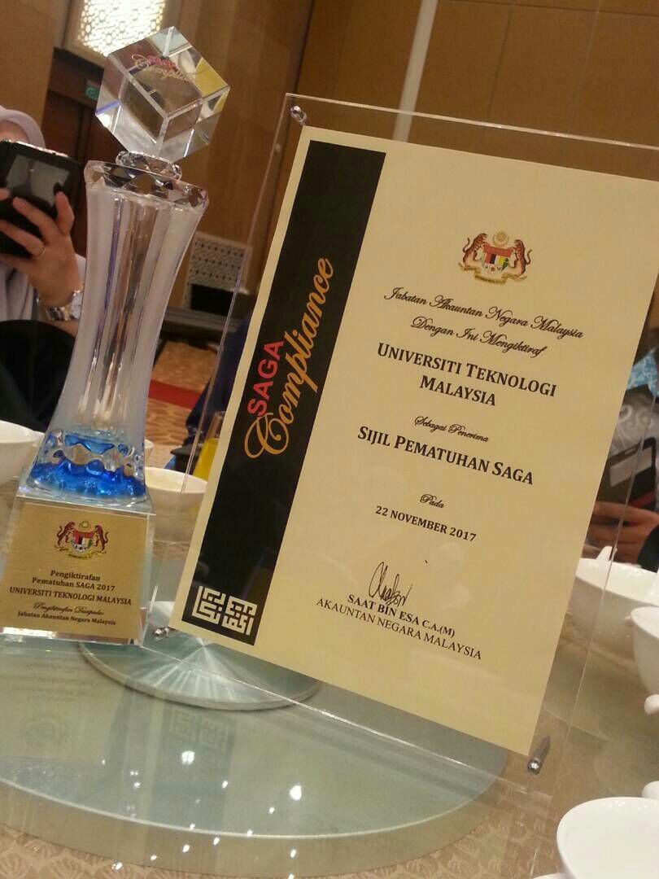

*Fig 07-Saga Compliance Certificate*

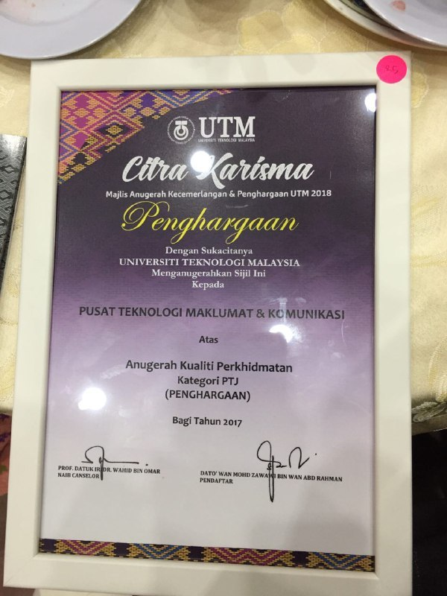

*Fig 08-Quality Service Category PTJ Award*

**Reflections**

**a) What is your goal/dream with regard to your course/program?**

As a software engineering student, we have a lot of different directions we can go in. Moreover, we can set the goals depending on what we want to achieve. There are our goals regarding our course which is Software Engineering. First thing first, we obviously want to become a Software Engineer with a good skill in solving problem, correct any errors and managing a complicated program easily since those are important things a software engineer should have. After graduating, one of our main goals is to work for a big company, doing a small part of something huge. For instance, being a small part of an amazing team making one of the world’s great products such as Google, Twitter, or Facebook. Furthermore, we want to build a company and create something great based on our designs and styles. Besides we will get paid enough, we will also feel proud of people’s feedback for our project we have made. Last but not least, the important goal that we really want to achieve is making a new change to our country with our invention. For example, creating a program which can change the way of learning in school, creating application or feature for increasing the economy of our country and other beneficial invention for the development of our country.

**b) How does this visit impact on your goal/dream with regard to your program?**

This program exaggerated a very massive impact in our dream or future career. We got excellent motivation with a huge concept about our study related sphere. From that industrial visit, we visualized lots of ancient computers and the digital computers of this modern era. The speaker delivered a very influencing speech by which we got a clear idea of our university internet, data communication, and bandwidth. This industrial visit promoted our computer knowledge and provided us a tremendous opportunity to visualize a lot of hardware to have realistic knowledge. As a software engineering student, this visit was very important for us to enable us as eligible people to get proper placement in our career. From our childhood, we had a dream to be a software entrepreneur to make our career. This visit influenced us immensely which will be very significant in our life.

**c) What is the action/improvement/plan necessary for you to improve your potential in the industry?**

Information and Communication Technology (ICT) is one of the digital technology that is growing rapidly and widely used throughout the world. Nowadays, we can see many people use their gadgets everywhere such as smartphones, laptops, and smartwatches. However, there are many ways that we can improve our potential in the industry.

We can join programs that related to IT so that we can gain some knowledge or experiences and apply them in the future. For instance, we can join programs that is held by UTM such as a visit to the CICT. During the visit to CICT, we were introduced by a staff of CICT about mainframes, printers, servers and other things. He also explained how to use all of the technologies. Besides that, education nowadays has been improved where the students learn by using IT. For example, UTM encourages the students and lecturers to use e-Learning. Students can get notes from this website so that they do not have to go for getting the lecture notes from lecturers. Students can do the activities or assignments that given by the lecturers in e-Learning. Hence, technology has been improved from time to time to ease the users to use.

***References***

1. Rokiah. (2018, July 22). TAHNIAH CICT-Memenangi Anugerah Kualiti Perkhidmatan Kategori PTJ (PENGHARGAAN) Bagi Tahun 2017. Retrieved from <http://cict.utm.my/2018/07/tahniah-cict-memenangi-anugerah-kualiti-perkhidmatan-kategori-ptj-penghargaan-bagi-tahun-2017/>

2. Achievement. (n.d.). Retrieved from <http://cict.utm.my/ict-knowledge-repository-2/>

3. CICT Organization Structure. (n.d.). Retrieved from <http://cict.utm.my/organization-structure/>