

**Semester I 2019/2020**

Subject : Technology and Information Systems (SECP1513)

Section : 07

Task : Industrial Exhibition – NALI Symposium or EII Day 2019

|  |  |  |
| --- | --- | --- |
| NO | NAME | MATRIC NUMBER |
| 1 | PG. KHAIRIL QAYYIZ BIN PG PUTRA | A19EC0147 |
| 2 | ELMIRA AKMA BINTI RAMAN | A19EC0042 |
| 3 | LIM CHIN QING | A19EC0071 |
| 4 | ILIMBEK ISMANOV | A19EC4029 |

**INTRODUCTION**

New Academia Learning Innovation 2019 (NALI 2019) was held in Faculty of Built Environment and Surveying on 18th September. During the innovation, NALI presented its new innovative project which opens new directions of learning students. Due to new developed system of learning, many activists are able to get quality training not only in theory, but practice their knowledge by working out skills of working with people and develop themselves socially. Such scheme used in S-L (Service-Learning). S-L focuses on improving student based on non-traditional learning. Practice outside of classes, many activities and work in group directed to unleash the potential of personality which will help in future to develop a better life. S-L has a wide range of different practices, but in this essay we will discuss such topics as:

1. **Smart Mini Town Game**
2. **Automobile Virtual Reality Module**
3. **Snazzy Sets Game Cards**

**EXHIBITION CONTENT**

The exhibition are up to 10 booth that serves the various type of education skills, some of the booth came out with the game to attract student interest, some use food beverages and snack to attract the student and some of them use gadget since these student high tendency towards online games and gadget. For games the inventor use a game that the student can play outside its means an outdoor activity classroom so that these student become more active in class.

**TRENDS IN NALI 2019**

New Academia Learning Innovation 2019 (NALI 2019) is a model which combine multiple learning ways to improve a better environment for students to study in different ways, and that is Service-Learning (S-L). Service-Learning is a philosophy that directs learning to the well-being of the community while focus on developing students’ potential in soft skills. This platform provide students with an outstanding opportunity to learn not only inside of the classroom but also giving them chance to involve in an organization or the community. It is proven that service-learning improved students’ academic experience and allow them to learn various type of skills which is crucial these days, like leadership skills and communication skills. NALI 2019 provide support to University Technology Malaysia (UTM) by implementing service-learning towards UTM’s students which will help students to be active learners through their involvement in an organization or the community. Students will be able to connect the ideas, helped shape a student’s understanding of their experience while connecting it to learning and help students to prepare required job skills.

**SMART MINI TOWN GAME**

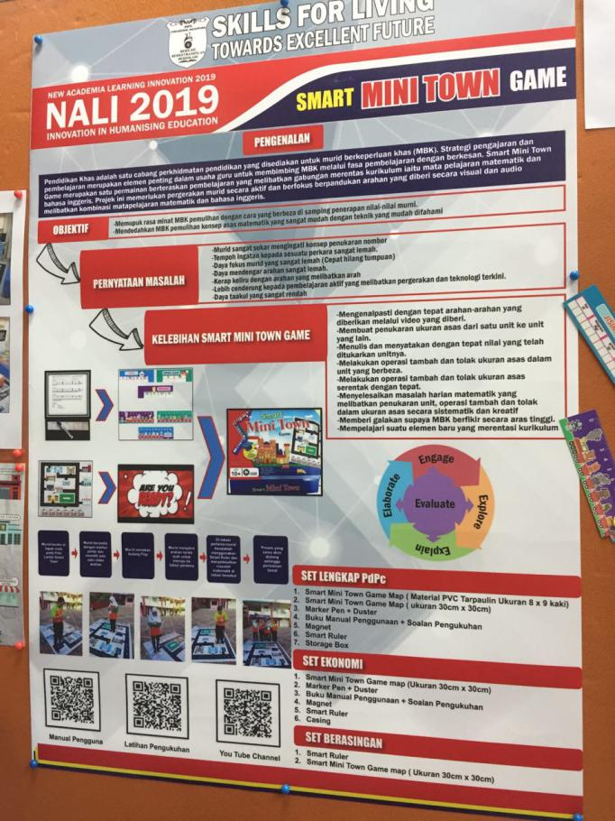

The innovation was held many booth promotes to the student and staff of UTM also a committee member from outside about their new innovation and new ideas how to ensure the student especially secondary and primary can learn how to study smart not study hard. Since NALI is about the education so, we visited one of the booth that attract us how to teach a special student who lose their sense which is include a blind, a deaf and also a mute. But for Smart Mini Town Game they stress on deaf and blind student. As students sometimes we also found it hard for us to convert a unit of measurement, that’s why we understand how this special student feel when they struggle to convert a measurement unit. So this committee they come out with a game since kids nowadays love game so much and most of them love online game but not for a special student. So this game is the one way to help special student to be more active and learn through it so for example most of the teacher in this school they usually buy a smart ruler where they teach special the basic one which is convert the measurement first and then they will start to do an outdoor game which is smart mini town game map. Up until now the presenter of the booth tell me that all the school that they supply this material all give a positive feedback.

**Need**:

Since this project specially made for special students that lose their sense that all normal people have so first thing first, what they need is they have to do some research how this student develop their brain since they abnormal, so most of them cannot catch up like a normal student learn in school, so this idea come out from the inventor to help this student since they also have a bright future.

**Approach**:

As a Malaysian people, we can see on digital media and on news how they can perform well in studies and curriculum, all start from their interest in learning to achieve a better result, without interest in learning they will easily give up even though it is a small matter or problem because they dint have any interest in learning, this abnormal student they little bit different form normal student where they easily sensitive on certain things because of their level of confidence and passion on something not same as normal student since they were born to be deaf, blind and mute.

**Benefits**:

In our point of view, we think that these abnormal students are easily to teach them since they are easily to attract with game so this booth really made a progress on where they can attract these student by playing a game rather than teaching all the time in class, at least these students can interact with other student and build more leadership between them. Other than that, benefit from this activity is the students like them know how to convert the measurement unit without memorize the converter value.

**Competition**:

To teach these special students cause a lot of pressure for a teacher to teach them since there are very sensitive on sensitive issue. Since there are a slow-learning students so every teacher in school need to teach them patiently and slowly. Another factor that can affect the competition for inventor is they need to come out with the game that can easily attract these students since gen-z nowadays were born with an advance technology where all mobile game nowadays become addictive for them including special student. That’s the biggest competition for them to attract the student so they build up a game map where the students need to play it outside the classroom.

In our point of view, we think that this is the best way to teach a slow-learner student and also a special student since every school in Malaysia they have a class for this student called “Pendidikan Khas”. So game is a better idea to make this student become more interest in learning and never give up just because they lack of ability like a normal person.

**AUTOMOBILE VIRTUAL REALITY MODULE (AVRM)**

Then we visited a booth which they were presenting about automobile virtual reality module.

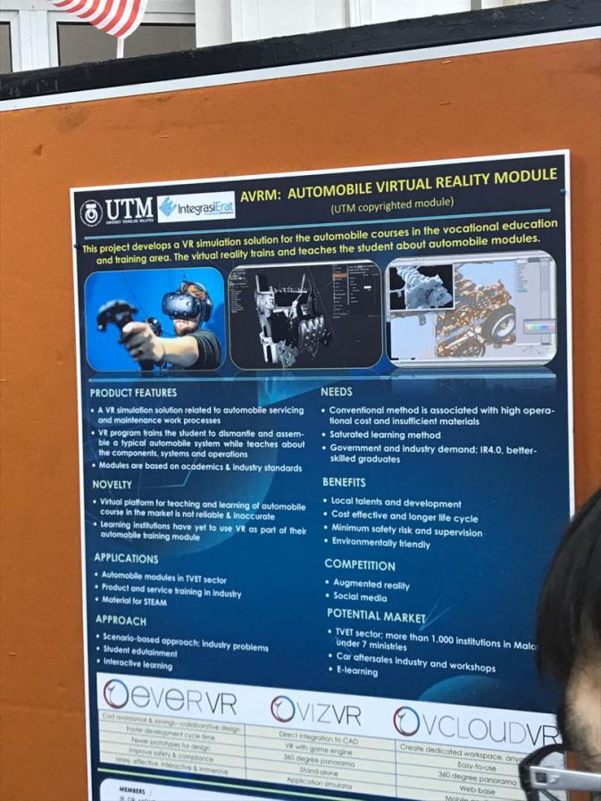

Automobile Virtual Reality Module (AVRM) is project which develops a virtual reality simulation solution for the automobile courses in the vocational education and training area which related to automobile servicing and maintenance work process. The virtual reality program trains the student to dismantle and assemble a typical automobile system while teaches about the components, systems and operations based on academics and industry standards.

**Need**:

Government and industry demand better skilled graduates. Automobile course required students to work with specialized equipment and materials which requires specific technical skills that cannot be obtained through theoretical learning. Even most car manufactures use virtual reality to train their employee because it is well suited for complex skills development and working out different scenarios.

**Approach**:

Student edutainment. Edutainment is the routine of learning through a medium that both educates and entertains using any various media, such as virtual reality. Students are easily attracted to animations, so by using virtual reality, students would not feel bored studying subjects, in facts it will be easier for them to understand through graphics and animations.

**Benefits**:

Learning through virtual reality is environmentally friendly because traditional theoretical learning uses text books requires a lot of papers that are made from plants. Virtual reality is working through software in computers, so the environment will not be affected by this.

**Competition**:

Social media is a useful medium for students because they can find information through it, but with virtual reality, students can experience run the systems and the operations itself virtually. Students understand better by learning vocationally rather than theoretically.

And of course in the last topic it is worth to mention about our last booth.

**SNAZZY SETS GAME CARD**

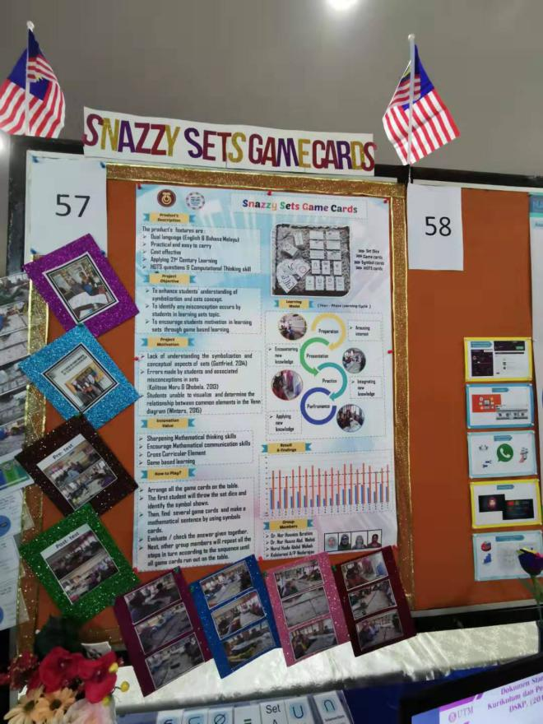

This booth was about to introduce a game based learning mode, which is Snazzy Sets Game Cards which aims to promote a better understanding among students in Mathematics, specifically in symbolization and sets concept. There are four types of games, which are set dice, game cards, symbol cards and HOTS cards. It also includes a four-phase learning cycle, which is preparation, presentation, practice and performance. The group members who introduced this Snazzy Sets Game Cards are Dr. Nor Hasniza Ibrahim, Dr. Nur Husna Abd. Wahid, Nurul Huda Abdul Wahab and Kalalarasi A/P Nadarajan.

**Needs:**

In Mathematics subject, many students are found unable to visualize and determine the relationship between common elements in the Venn diagram (Winters, 2015). Besides that, lack of understanding in the symbolization and conceptual aspects of sets (Gottfried, 2014) has also encouraged the making of the game cards.

**Approach:**

After doing some research, they found out that games are the easiest and fastest way to encourage students’ motivation in learning. Therefore, these game cards are invented to enhance student’s understanding of symbolization and concept of sets.

**Benefits:**

It is believed to be effective in sharpening Mathematical thinking skills, as well as encouraging Mathematical communication skills among students. Students are able to learn and have a better understanding about the symbolization and concept of sets while playing the games.

**Competition:**

It applied 21st century learning mode, including High-Order Thinking Skills (HOTS) questions and Computational Thinking Skill. Apart from that, it is cost effective, infused with dual languages, practical and portable as it is light.

In our point of view, we find it interesting as it can make learning fun, as compared to previous learning style that is more boring on the basis of making students understand about the concept and theory of sets.

In the end, it becomes clear that the new system allows not only to interest students in learning, but to significantly increase the understanding of subjects. Simple games can dramatically change the attitude towards the subject and simplify life in hard learning. In addition to exciting studies, there is also a practice where you can more effectively test your knowledge and prove yourself in teamwork.

**REFERENCES**

Ahlfeldt, S. L. (2009). Thoughtful and informed citizens: An approach to service-learning for the communication classroom. Communication Teacher

Jaafar, J. M. and Mee, M. Y. (2010). Learning from the Deaf to Enhance Learning for the Deaf. The Open Rehabilitation Journal, 3, 16-22

University Technology Malaysia (2019), <http://ctl.utm.my/nali2019/wp-content/uploads/sites/16/2019/09/Proceeding-NALI-2019-Edaran-Web.pdf>

**GROUP MEMBERS**

|  |  |
| --- | --- |
|  | PG. KHAIRIL QAYYIZ BIN PG PUTRA |
|  | ELMIRA AKMA BINTI RAMAN |
|  | LIM CHIN QING |
|  | ILIMBEK ISMANOV |