

**PROJECT 1 -**

**DATA COLLECTION AND DATA PRESENTATION**

SUBJECT : SCSI2143 PROBABILITY AND STATISTICAL DATA ANALYSIS

SECTION : 01

LECTURER : NOR ERNE NAZIRA BAZIN

GROUP MEMBERS :1) LOW WEI XIN A17CS0278

2) ANG KE WEI A17CS0016

3) NURAINNA FATIHA IZZUWAN A17CS0296

4) HIEW JIA YEE A17CS0053

**CONTENT**

**1.0 INTRODUCTION**

**1.1 Background study**

**1.2 Objective of study**

**2.0 DATA COLLECTION METHOD**

**2.1 The Sample**

**2.2 Parameters and Variables**

**2.3 Method of Collection**

**3.0 Data Analysis**

**3.1 Information of Respondents**

**3.1.1 Gender of Respondents**

**3.1.2 Year of Study of Respondents**

**3.1.3 Sleeping Hours of Respondents**

**3.2 Measure of Health, Productivity and Emotion of Respondents**

**based on their daily sleeping hours**

**3.2.1 Number of minutes respondents can focus on a lecture.**

**3.2.2 Number of times respondents contribute ideas during discussion**

**3.2.3 Number of times respondents feel depressed per month**

**3.2.4 Number of times respondents think of suicide per month**

**3.2.5 Number of times respondents have poor appetite per month**

**3.2.6 Number of times respondents have overeating habits per month**

**3.2.7 Number of times respondents sick per month**

**4.0 CONCLUSION**

**5.0 APPENDIX**

**1.0 INTRODUCTION**

**1.1 Background study**

As we know, sleep is very important for everyone in order to restore our brain and energy. It could actually affect a person’s health, weight, emotion and productivity. In this study, we are going to investigate whether the number of a student sleeps as well as the all nighter habits would really affect the weight, emotion and productivity. As when it goes from semester to semester, the syllabus will become more challenging and difficult. We are going to collect the data that include the average number of hours that was spent on sleeping including day time naps, number of students that have all-nighter habit, weight of respondents, emotional level of respondents and level of productivity of respondents.

**1.2 Objective of study**

The purpose of this study is to give awareness to students about the importance of quality sleeps in order to maintain a good physical and mental health.

**2.0 DATA COLLECTION METHOD**

**2.1 The Sample**

The population that become our target are undergraduate students which are year 1 until year 4 students. We have decided to choose 65 students among them as our sample size for this project.

**2.2 Parameters and Variables**

These are the following questions that were asked in the survey :

* Number of minutes students can focus during lecture
* Number of times students feel depressed within a month
* Number of ideas contribution during discussion
* Number of times students think of suicide
* Number of times students get sick per month
* Number of times students has overeating habits
* Number of times students has poor appetite

**2.3 Method of Collection**

We collect our data by providing a survey and the targeted respondents need to fill up the survey by answering a few questions.

**3.0 DATA ANALYSIS**

**3.1 Information of Respondents**

**3.1.1**

Gender of Respondents

|  |  |
| --- | --- |
| Gender | No. of Respondents |
| Male | 28 |
| Female | 37 |

Table 1.1

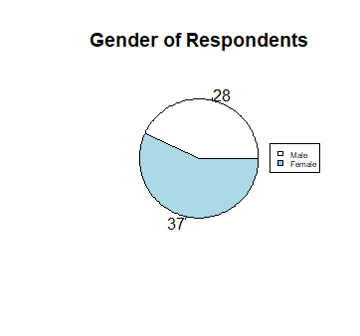

Figure 1 :Pie chart of the gender of the respondents

From the pie chart as shown as above, there are 37 female respondents (56.92%) and 28 male respondents (43.08%) who took part in our research study.

**3.1.2**

Current Year of Respondents

|  |  |
| --- | --- |
| Year | No. of respondents |
| Year 1 | 17 |
| Year 2 | 17 |
| Year 3 | 17 |
| Year 4 | 14 |

Table 2 : Current year of respondents.

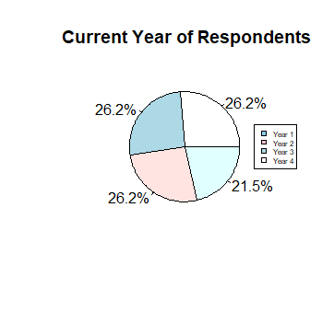

Figure 2 : Pie chart of the year studied of respondents

From the pie chart shown above, there are 17 Year 1, Year 2 and Year 3 respondents (26.2%) and 14 Year 4 respondents(21.5%) who took out in our research study.

**3.1.3**

Sleeping Hours of Respondents per day

|  |  |
| --- | --- |
| Sleeping hours | No. of respondents |
| 2-4 hours | 7 |
| 4-6 hours | 33 |
| 6-8 hours | 20 |
| 8-10 hours | 5 |

Table 3: Sleeping hours of respondents per day

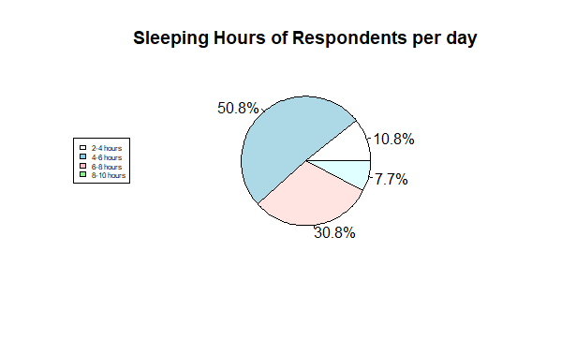

Figure 3: Pie chart of sleeping hours intervals of respondents per day

From the pie chart as shown above, 7 respondents (10.8%) sleep between 2 to 4 hours per day, 33 respondents (50.8%) sleep between 4 to 6 hours per day, 20 respondents sleep between 6 to 8 (30.8%) hours per day and 5 respondents (7.7%) sleep between 8-10 hours per day.

**3.2 Measure of Health, Productivity and Emotion of Respondents based on their daily sleeping hours**

**3.2.1**

Number of Minutes Students can Focus on Lecture Based on their Daily Sleeping Hours

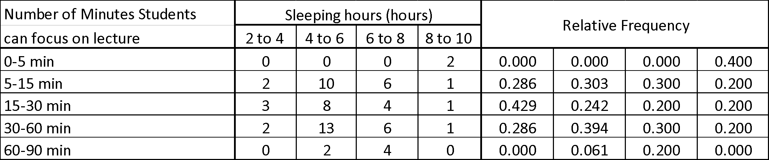

Table 1.1

|  |  |
| --- | --- |
| Mean | 30.69 |
| Median | 16.44 |
| Mode | 30.55 |
| Standard Deviation | 7.35 |
| Skewness | 2.29 |

Table 1.2

Relative frequency of respondents that can focus on lecture based on their daily sleeping hours

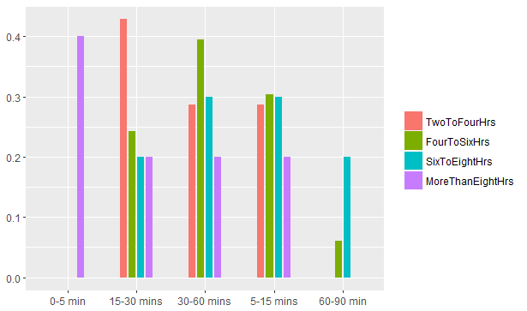

Graph 1

The bar graph above compares the sleeping hours of the respondents with the number of minutes they can focus on lecture.

From the graph 1, we can noticed that 3 out of 7 respondents who sleep between two to four hours have highest relative frequency, which is 0.43 to focus on lecture only within 15 to 30 minutes followed by respondents who sleep between four to six hours (0.24). Respondents who sleep between six to eight and more than eight hours have the lowest relative frequency, which are 0.2 to focus on lecturer within 15 to 30 minutes. 13 out of 33 respondents who sleep between four to six hours have the highest relative frequency , which is 0.394 to focus on lecture within 30 to 60 minutes followed by respondents who sleep between six to eight hours (0.30), two to four hours (0.29) and more than eight hours (0.20). However, 10 out of 33 respondents who sleep between four to six hours also have highest relative frequency , which is 0.303 to focus on lecture only within 5 to 15 minutes. On the other hand, 4 out of 20 respondents who sleep between six to eight hours has highest relative frequency , which is 0.20 to focus on lecture between 60 minutes to 90 minutes followed by respondents who sleep between four to six hours (0.06). None of the respondents who sleep between two to four hours and more than eight hours focus on lecturer among 60-90 minutes.

Thus, we can say that most of the respondents will have their sleep between 4 to 6 hours and the average time for them to focus on a lecture is 30.69 minutes. The mode and median are 30.55 and 16.44 respectively.

**3.2.2**

Number of times respondents contribute ideas during assignment discussion based on their daily sleeping hours.

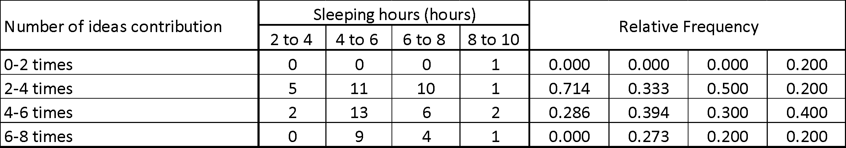

Table 2.1

|  |  |
| --- | --- |
| Mean | 4.54 |
| Median | 4.36 |
| Mode | 3.73 |
| Standard Deviation | 0.58 |
| Skewness | 1.61 |

Table 2.2

Relative frequency of respondents contribute ideas during assignment discussion based on their daily sleeping hours.

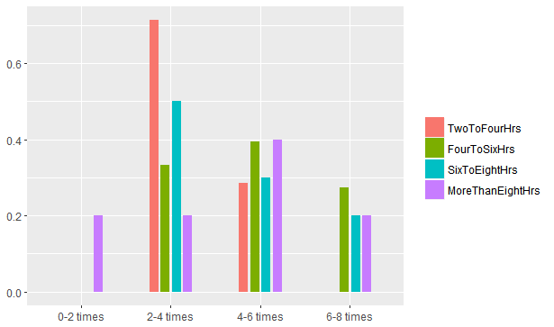

Graph 2

The bar graph above shows the relationship between the number hours a student sleeps and the number of ideas contribution by students during discussion.

The graph shows that the lowest number of ideas contribution comes from students who sleep for more than 8 hours which refer to one respondent only while the highest number of ideas contribution which is 6 to 8 times comes from students who sleep for 4 to 6 hours which is 64.29% out of 14 respondents. The highest relative frequency of students who contribute around 2 to 4 times during group discussion comes from those who sleep for 2 to 4 hours which is 0.714 out of 33 while the lowest relative frequency of respondents who contribute the same number of ideas comes from those who sleep for 8 to 10 hours per day which is 0.2 out of 5 respondents. Other than that, as for the category of students who contribute ideas around 4 to 6 times during group discussion, the students most likely sleeps for 4 to 6 hours with the relative frequency of 0.394. Furthermore, as the highest number of ideas contribution during group discussion which is six to 8 eight times, none of the respondent who sleeps form two to four hours contribute their ideas.

Other informations that can be obtained from the graph are mean value which is 4.54, median value which is 4.36 and mode which is 4.33. The distribution for the data collected is positive skewed which is 1.61 and the distribution is asymmetrical and points in the positive direction as mean > median > mode. The standard deviation for this data is 0.58.

Lastly, what can be concluded from this data is the ideal sleeping hours for students to maintain their productivity in group discussion is between 2 to 4 hours.

**3.2.3**

Number of times respondents feel depressed per month based on their daily sleeping hours

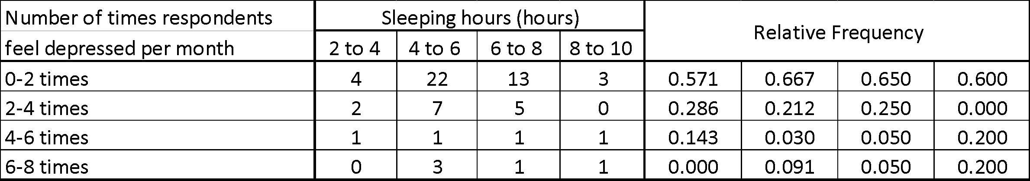

Table 3.1

|  |  |
| --- | --- |
| Mean | 2.14 |
| Median | 1.55 |
| Mode | 1.20 |
| Standard Deviation | 0.73 |
| Skewness | 5.52 |

Table 3.2

Relative frequency of respondents feel depressed per month based on their daily sleeping hours

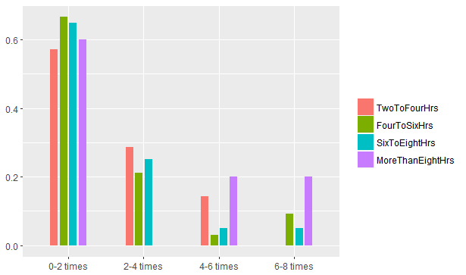

Graph 3

The bar graph above compares the sleeping hours of the respondents with the number of times they feel depressed per month.

From the graph, we notice that 22 out of 33 respondents who sleep between four to six hours has the highest relative frequency , which is 0.667 that will feel depressed only 0 to 2 times per month followed by 13 out of 22 respondents who sleep between six to eight hours (0.65) and 3 out of 5 respondents who sleep more than eight hours (0.60) while 4 out of 7 respondents who sleep between two to four hours has the lowest relative frequency (0.571) that will feel depressed around 0 to 2 times per month. However, 2 out of 7 respondents who sleep between 2 to 4 hours have the highest relative frequency (0.286) to feel depressed around 2 - 4 times per month whereas respondents who sleep more than eight hours have the lowest relative frequency which is 0 followed by 7 out of 33 respondents who sleep between four to six hours (0.21) and 5 out of 20 respondents who sleep between six to eight hours (0.25). On the other hand, respondents who sleep between eight to ten hours have the highest relative frequency (0.20) to feel depressed around 4-6 times and 6-8 times per month. Respondents who sleep between 4 to 6 hours have the lowest relative frequency ( 0.03 ) to feel depressed around 4 - 6 times per month followed by 1 out of 20 respondents who sleep between six to eight hours (0.05) and 1 out of 7 respondents who sleep between two to four hours (0.14). None of the respondents who sleep between two to four hours has the lowest relative frequency to feel depressed aroung 6 to 8 times per month (0). Respondents who sleep between six to eight hours has the second lowest relative frequency ( 0.05 ) to feel depressed around 6 to 8 times per month followed by 3 out of 33 respondents who sleep between four to six hours (0.09).

The mean and median of respondents who feel depressed per month are 2 times whereas the mode is 1 times. Since the mode is smaller than mean and median, and the standard deviation is 5.52, thus we can conclude that this is a positive skewed distribution.

**3.2.4**

Number of times respondent think of suicide per month based on their daily sleeping hours

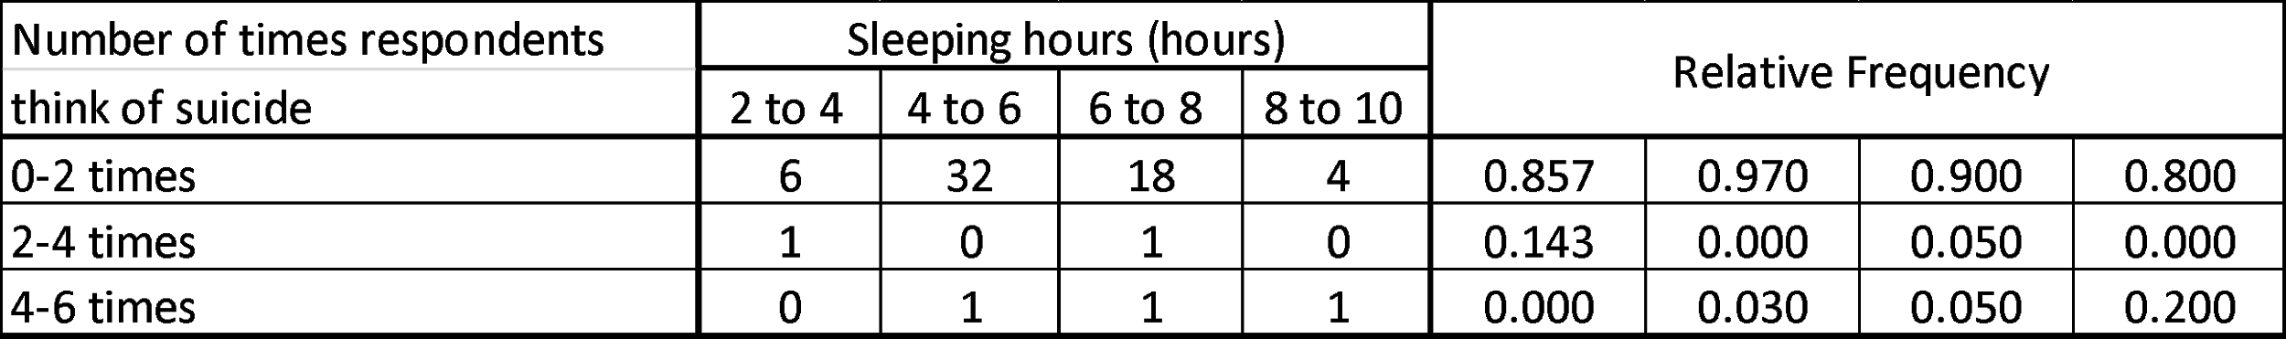

Table 4.1

|  |  |
| --- | --- |
| Mean | 1.25 |
| Median | 1.08 |
| Mode | 1.02 |
| Standard Deviation | 0.90 |
| Skewness | 1.24 |

Table 4.2

Relative frequency of respondent think of suicide per month based on their daily sleeping hours

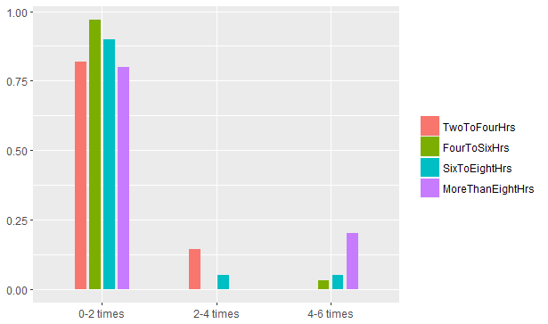

Graph 4

The bar graph above compares the sleeping hours of the respondents with the number of times they thinking of suicide per month.

From the graph 4, there are 32 respondents (97%) who sleep 4 to 6 hours have 0 to 2 times think of suicide per month, while 4 respondents (75%) who sleep 8 to 10 hours have 0 to 2 times think of suicide in a month. Sleeping hours of the category of 2 to 4 hours and 6 to 8 hours each contribute 1 respondent who think of suicide for 2 to 4 times per month, which is 14.3% and 5% from each category, while the other 2 categories of sleeping hours does not contribute any respondent. Every category of sleeping hours has 1 respondent that think of suicide 4 to 6 times except the category of 2 to 4 hours, each of the category contribute 3%, 5% and 20% from its category. However, majority of the respondents who sleep 4 to 6 hours or 6 to 8 hours, which is having sleeping hours closer to the amount of sleeping hours required for their age, they have the least number of times think of suicide which is 0 to 2 times. This have been proven by the mean number of times think of suicide of the respondents which is 1.25 which falls in the category of 0 to 2 times think of suicide. The median is 1.08, while mode is 1.02. The standard deviation is 0.90. The distribution for the data collected is positive skewed as the mode have the smallest value compare to median and mean. Mean have the highest value among the measure of central tendency. In addition, the skewness calculated is 1.24 which is greater than 1, which shows that this is a positive skewed distribution.

From the data above, we can say that students who have more enough sleep (based on the number of hours of sleep required for their age) would less think of suicide.

**3.2.5**

Number of times respondents have poor appetite per month based on their daily sleeping hours

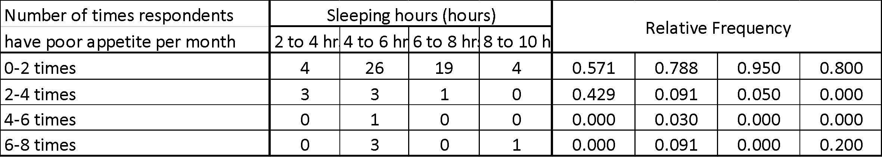

Table 5.1

|  |  |
| --- | --- |
| Mean | 1.65 |
| Median | 1.23 |
| Mode | 1.07 |
| Standard Deviation | 1.59 |
| Skewness | 0.75 |

Table 5.2

Relative frequency of respondents have poor appetite per month based on their daily sleeping hours

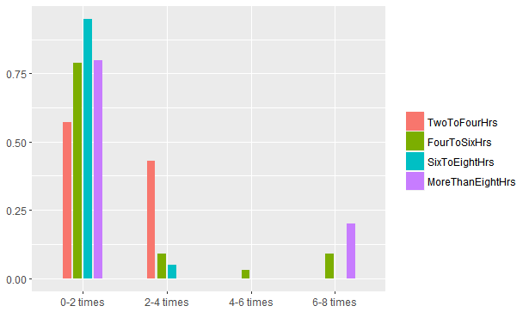

Graph 5

The bar graph above compares the sleeping hours of the respondents with the number of times they having poor appetite per month.

From the graph 5, among the 4 categories of the undergraduate students sleeping hours mostly have 0 to 2 times poor appetite per month. For the category of 2 to 4 sleeping hours, 4 (57.1%) of the respondents have 0 to 2 times poor appetite per month, whereas for the category of 4 to 6 sleeping hours is 26 (78.8%) respondents. Moreover, 19 (95%)and 4 (80%) of the respondents who sleep 6 to 8 hours and 8 to 10 hours respectively.

There are no respondents who sleeps 2 to 4 hours and 6 to 8 hours have 4 to 6 times or 6 to 8 times poor appetite per month. Whereas for the category of 4 to 6 sleeping hours, only one (3%) respondents has 4 to 6 times poor appetite per month. For the category of 8 to 10 sleeping hours, none of the respondents have 2 to 4 times or 4 to 6 times poor appetite per month.

The mean for the students having poor appetite per month is 1.65, whereas the median is 1.23 and for the mode is 1.07. This shows that mode < median < mean , thus the graph is positively skewed. It can be proven by the skewness of the graph is 0.75 which is more than 0. The standard deviation for this graph is 1.59.

**3.2.6**

Number of times respondents have overeating habits per month based on their daily sleeping hours

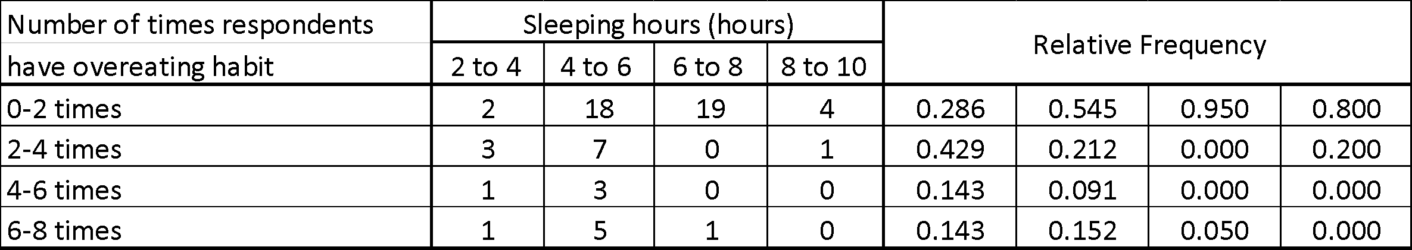

Table 6.1

|  |  |
| --- | --- |
| Mean | 2.23 |
| Median | 1.51 |
| Mode | 1.15 |
| Standard Deviation | 2.02 |
| Skewness | 0.24 |

Table 6.2

Relative frequency of respondents have overeating habits per month based on their daily sleeping hours

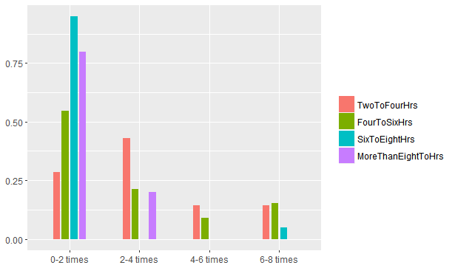

Graph 6

The bar graph above compares the sleeping hours of the respondents with the number of times they having overeating habit per month.

The graph 6 shows that most of the respondents who sleep 4 to 6 hours, 6 to 8 hours and 8 to 10 hours have 0 to 2 times overeating habit per month. For instance, 18 (54.5%) of the respondents who are in 4 to 6 sleeping hours category, 19 (95%) of the respondents who are in 6 to 8 sleeping hours category and 4 (80%) of the respondents who are in 8 to 10 sleeping hours category have overeating habit per month. Meanwhile, 3 (42.9%) of the respondents from 2 to 4 sleeping hours category mainly have 2 to 4 overeating habits.

There are only one (14.3%) respondents who sleep 2 to 4 hours for both, 4 to 6 times and 6 to 8 times overeating habit per month. While for the category of 4 to 6 sleeping hours, the least number of respondents have 4 to 6 times overeating habit per month which are 3 persons (9%). On the other hand, there are none of the respondents who sleep 6 to 8 hours has 2 to 4 times or 4 to 6 times overeating habit per month. Same goes to the category of 8 to 10 sleeping hours has no respondents who overeating for 2 to 4 times or 4 to 6 times per month.

The mean for the students having poor appetite per month is 2.23, whereas the median is 1.51 and for the mode is 1.15. This shows that mode < median < mean , thus the graph is positively skewed. It can be proven by the skewness of the graph is 0.24 which is more than 0. The standard deviation for this graph is 2.02.

**3.2.7**

Number of times respondents sick per month based on their daily sleeping hours

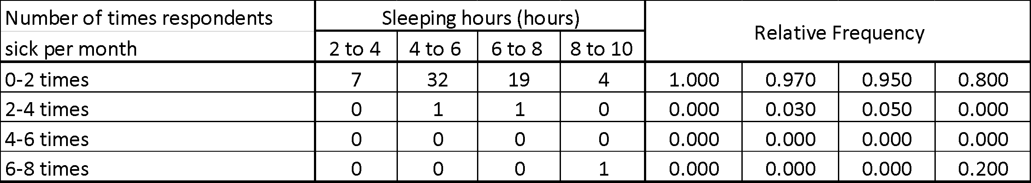

Table 7.1

|  |  |
| --- | --- |
| Mean | 1.15 |
| Median | 1.05 |
| Mode | 1.02 |
| Standard Deviation | 0.81 |
| Skewness | 7.73 |

Table 7.2

Relative frequency of respondents sick per month based on their daily sleeping hours

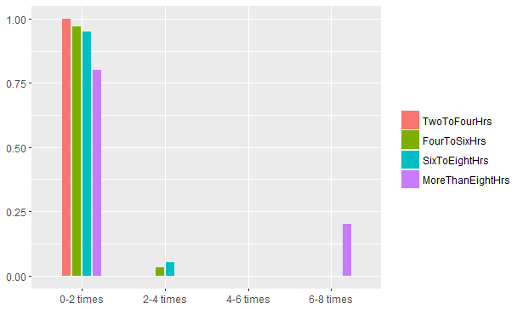

Graph 7

Based on the graph 7, 7 respondents from the category of 2 to 4 hours sleeping hours (100%) have 0 to 2 times sick monthly. 32 respondents which have 4 to 6 hours of sleeping hours (97%) have 0 to 2 times sick per month. Only 1 respondent from the same category (3%) have 2 to 4 times sick monthly.

19 respondents who sleeps 6 to 8 hours (95%) sick 0 to 2 times,while 1 respondent from this category (5%) sick 2 to 4 times monthly. 4 respondents from the category of 8 to 10 hours sleeping time (80%) sick for 0 to 2 times, while the another one respondent of this category (20%) sick for 6 to 8 times monthly.

The mean is 1.15, while median is 1.05, and the mode is 1.02, the standard deviation calculated is 0.81. Since mean>median>mode, it is a positive skewed distribution. Besides that, the skewness calculated through formula is 7.73 which is greater than 1 also shows that the distribution is positive skewed.

From the data above we know that the number of times of sick in a month is not affected by the sleeping hours, because from the survey, there is respondent who sleep 8 to 10 hours but sick for 6 to 8 times monthly. Therefore, we can conclude that the number of sick of the respondents in a month is not affected by the number of hours the respondents sleep

**4) Conclusion**

In conclusion, the average number of minutes students can focus during lecture is 30-60 minutes with 2 to 4 hours and 4 to 6 hours of sleeps meanwhile the average number of ideas contribution by students is 4 and this is determined by 2 to 4 hours and 6 to 8 hours of sleeps. Next, the average number of students feeling depressed in a month is 2 and students who sleeps for more than 8 hours has the highest frequency of feeling depressed which is 6 to 8 times per month. The same thing happened with the number of students who has been thinking of suicide in a month, the highest frequency comes from students who sleep for more than 8 hours which is 6 to 8 times in a month. This result showed that getting enough sleep does not ensure the the stability of mental health of the students. Other that that, the average number of students who have poor appetite and poor eating habits per month is 1 and 2 respectively. The ideal number of sleeps that can prevent students from having these habits is 2 to 4 hours per day as students who sleeps for 2 to 4 hours per day are the least likely to have these habits. Lastly, the average number of students getting sick per month is 1. Getting too much sleeps which is more than 8 hours and getting too little amount of sleep could lead to getting sick as the highest frequency of students who gets sick for more than 6 times comes from those who sleeps for more than 8 hours.

All in all, the significance of this study is getting enough sleep could improve the productivity in our daily life and help us to maintain our physical and mental health.