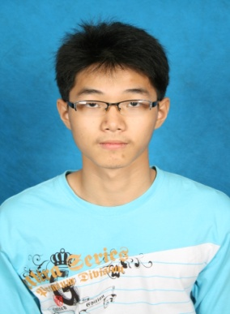

**NAME :** CHONG JUHN YUNG

**SEX :** MALE

**STATUS :** SINGLE

**HAND PHONE :** 014-3851189

**ADDRESS :**316,Jalan Gunung Datok 7,Taman Angsamas,70300

Seremban,N.Sembilan

**I/C NO :** 910729055069

**SPOKEN LANGUAGE**

MALAY - GOOD

ENGLISH - MODERATE

MANDARIN - EXCELLENT

**Objective**

Seeking a full-time position to enhance the industrial mathematics for assist in the job.

**Education**

* 2004-2008 SPM at SMK BUKIT KEPAYANG Seremban 2 with 4A1,3A2,1B3,1B4
* 2009-2010 STPM at SMK KGV,Seremban with GCPA 2.92
* Obtain Degree in industrial mathematics from Universiti Teknologi Malaysia(UTM),Malaysia in year 2014 with first honour.

**Work Experience**

* As a promoter for Bedding Department in Jusco AEON for one year(during form 5 break-time)
* As a temporary teacher at SJK(C) KG Baru Mambau for 9 month during form 6 break-time

**Personal Characteristics**

* Cheerful, hardworking, high cooperation, strong research abilities and persistence

**Reference: 1.Dr Normah Maan 019-7007014**

**2.Dr. Norhaiza Ahmad 019-7747457**