

**School of Computing, Faculty of Engineering**

**UniversitiTeknologi Malaysia, 81310 Skudai,**

**Johor Bahru, Malaysia.**

PROJECT: WECARE

Lecturer’s Name: Puan Azurah Binti A Samah

Section: 8

|  |  |  |
| --- | --- | --- |
|  | **NAME** | **MATRIC NO** |
| 1 | MUHAMMAD HAZMAN NASRULLAH BIN SUKIMAN | A18CS0147 |
| 2 | MUHAMMAD SYAFIQ BIN SHAIFUDIN | A18CS0158 |
| 3 | YOUSSEF MOHAMED HAMED ABDO | A18CS0334 |
| 4 | MAAD YASSER ABDULLAH ABDULJABBAR | A18CS4016 |
| 5 | MUHAMMAD MAHFUZUR RAHMAN | A18CS0312 |
| 6 | MUHAMMAD ALIEMEEN FARHAN BIN RAMZEE | A18CS0123 |

# **1.0 INTRODUCTION**

Have your ever heard of a mother saying, ‘Did my child reach the school safely, did my child eat his/her lunch’ etc. These are the normal things that we here for parents in everyday life. But we sometimes also here, ‘Where is my child, I cannot find him anywhere’ saying that in agony and in the state of crying. What happened to there their child that they are in these states? There are many reasons of these to happen. They might be:

* The child could get lost.
* Kidnapping.
* Human trafficking.

These are some of the reasons that have being worrying the parents for ages and still worrying them. Many people in everyday life, they are trying to solve these kinds of problems through social awareness, public speeches, some in developing applications etc. We fall in sort of people especially in developing software or application for those children. In this report, we will try to describe when, why and how we came to this decision.

# **2.0 PROBLEMS BACKGROUND**

As I mentioned earlier about the problems that the children face all the time, I give a little bit detail information. Let us first come to the point of child getting lost. Children usually get lost in shopping malls, supermarkets as they are very energetic and tend to search for new things and in progress they get lost and by kidnappers. Statistics shows that:

Every 40 seconds a child goes missing somewhere in the United States. There are more than 460,000 missing children each year. Of those missing children, almost 1,500 of them are kidnapped.

Some classification among them:

How many kids are kidnapped each year? There are approximately 1,435 kidnappings each year. This number is an estimate, however, as not every case gets reported, especially as it pertains to family member abductions. How many kids are kidnapped by family members?

A family abduction is the taking or concealing of a child under the age of 17 against the person’s legal rights. Family members abduct children in 1,230 of the total kidnapping cases.

How many kids are kidnapped by strangers? A stranger abduction, also known as a non-family abduction, is the result of a stranger taking or luring a child under the age of 17. Of the 1,435 kidnappings per year, 205 were non-family abductions. What is the most common age group of traditional stranger kidnappings? Females aged 12-17 were the most commonly abducted group. Among those females, a majority of them did not live with two parents (either biological or adopted). How many children abducted by strangers make it home safely? 90% of children abducted by strangers make it home safe and sound.

What is the most common age of an abducted child? Children aged 12 and over are the victims of kidnapping in more than 80% of the cases. Teen behavior and irresponsibility are often considered the culprit before officials consider abduction. This is not the case for children aged 12 and under. A younger child who has gone missing often prompts quicker action. How many children are reported missing each year?

In 2016, 465,676 children were reported missing to the authorities. During the same year, there were a total of 647,435 missing people. What percentage of reported missing children are not actually abducted? In almost 90% of the reported missing children cases, abduction is not the issue. It’s often due to miscommunication, getting lost, or children running away.

Now, let’s come to the part of human trafficking. Though statistics regarding the magnitude of child trafficking are difficult to obtain, the International Labor Organization estimates that 1.2 million children are trafficked each year. Every year 300,000 children are taken all around the world and sold by human traffickers as slaves. 17,000 of those children are brought to the United States, so that is 46 children per day.

I forgot to talk about one thing that is Child sexual abuse. According to the Study on Child Abuse: India 2007 published by the Ministry of Women and Child Development (MWCD), about 53% of children in India are abused. The highest numbers of cases were reported from Uttar Pradesh, Assam, Delhi, Andhra Pradesh and Bihar. As per the National Crimes Records Bureau, 15,039 children were identified as victims of assault under the Protection of Children from Sexual Offences (POCSO) Act in 2015.The global prevalence of child sexual abuse is estimated at 19.7% for females and 7.9% for males. The highest incidence of sexual assault was reported among children on the street, at work and in institutional care. It is commonly believed that only girls are victims of CSA. But that’s a myth. The MWCD study found that 52.94% of CSA victims were boys and 47.06% girls. According to a survey in Delhi, almost as many boys were victims of sexual abuse as girls, but the problem was far less reported or talked about. Studies have shown that boys who are sexually traumatized often grow up to be perpetrators of violence.

# **3.0 METHODOLOGY**

The issue was how we can let parents avoid losing their kids. We found out that lots of parents start to forbid their kids of going out and the more this issue increase the more kids’ limitation get decreased, just to avoid losing their children. However, this is not a solution. Definitely by closing your kid in a room he will not get missing, but you are going to solve this issue with bigger problem. If you kid did not get a mental issue because of keep him away this world then at least he will not be able to contact with others in his future, his ability of learning, socializing and being successful will decrease. So we discussed the reasons of kids getting lost such as kidnapping and disappearing in crowed. We tried to figure out a solution with forbidding kids from their space. We couldn’t get it unit we found out that the main reason of missing kids is that parents cannot keep eyes on their kids for 24 hours. So we start analysing ideas and we come up with a GPS watch. This watch is connected with the App we are going to make which can easily locate your kid. This app will give the ability to locate as many as your kids is. The GPS will still work on when the watch went off cause it will has a battery-saving mode for the GPS. In addition, the App will send a notification whenever the battery about to die.

## **3.1 Design Thinking Assessment Points**

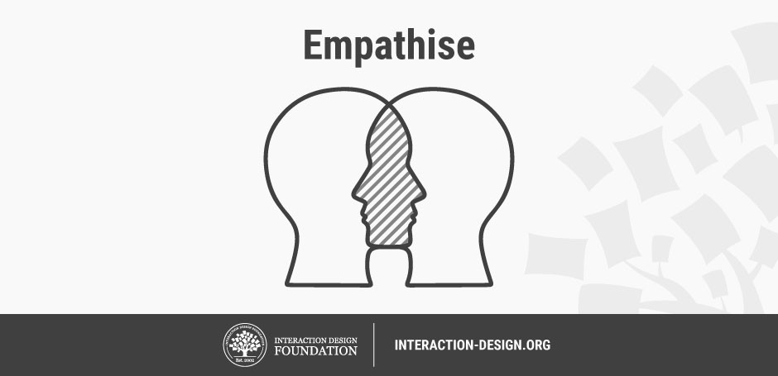

**PHASE 1:**

**EMPATHIZE:**

We stumbled upon that there are more children getting lost from their parents or kidnaped, we ask miss Rashida about if anyone in her family or her friend lost a child and found the child she said that her friend lost her child when he was playing in the mall because children are so energetic and the tend to get lost every time so we go through phase 2

**PHASE 2:**

**THE IDEA:**



So after interviewing miss Rashida we had an idea to make a tracking system on a watch that we track our children wherever they go like if they go on a picnic and your child went to play with their friends after playing you find out that your child missing and you don't know where we went and you keep searching for him or her and you get tired and you can't find him so we had an idea to make you invent a watch that have a tracking system so the parent can connect with his or her child by call them or by taking them from our GPS app then we go through the phase 3

**PHASE 3:**

**THE PROTOTYPE:**

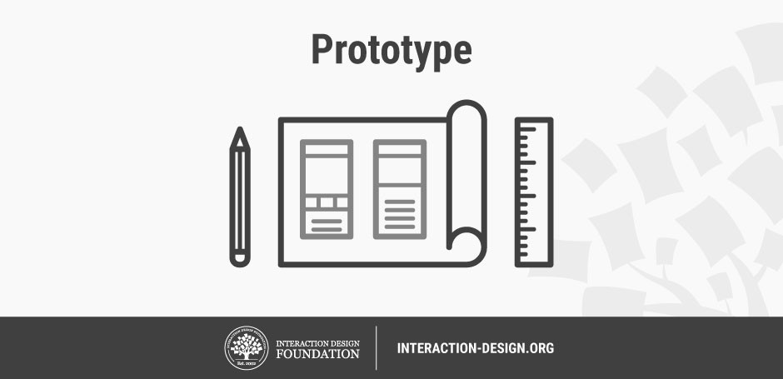

The prototype is that we are making a worldwide tracking system that tracks our children to our prototype is first to make an app for the connect of the parent to children or app will be

called “**we care**” our front page of the app will be the sign in so go through the sign in link for example you list your family name, how many children you got , how old are they, list their name , then you go through the watch that you want to connect to the phone so after you go through all of this now you are ready to go so when your kid go missing you can call him and they will answer you and you and track they too then we go through the last phase

**PHASE 4:**

**THE TEST:**



In the near future we are now developing the app we are still working on it.

# **4.0 FEATURES OF PROTOTYPE AND SOLUTION**

As we know, most parents faced a problem which is lost their children as mention in section 2.0. This encourage us to solve this problem by develop an application, WeCare to help parent track their children’s location. This application is a solution for parent to avoid kidnapping or lost their children. The application connected from the phone to the GPS tracker which is placed in children watch. Firstly, the user must create an account, then they must connect them to the GPS tracker. The GPS tracking system use the Global Navigation Satellite System (GNSS) network. Its network use microwave signal to transmit data which is the location from the GPS tracker to the phone. The signal also can detect the speed and time of the tracker. This application can be download from several platform such as Google Play Store and Apple App Store.

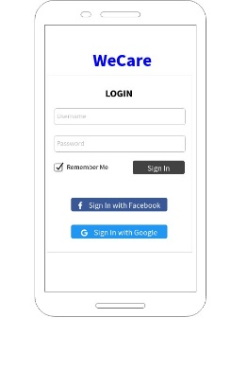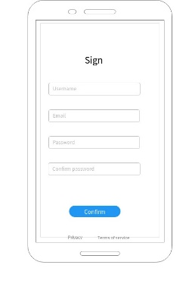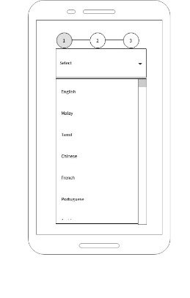

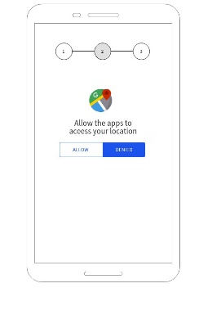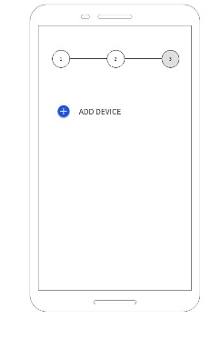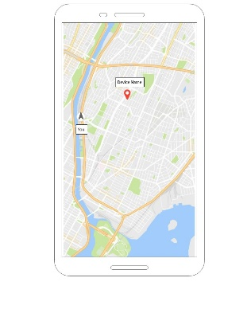

# **5.0 MARKET STUDY**

A study has been made to test the eligibility of the product in market so we can improve it to be better. We had made questionnaires through Google form and have been distributed to get feedback from our potential prospect. Most of our prospect is parents and guardians. The questionnaires are consist of with several question which are targeted market, feedback, their expectation towards our product, the awareness of similar product and many more.

**Finding and Discussion from our Questionnaire**

***Respondent’s Background***

We had made a Google form and distributed it via Whatsapp. There are 24 respondents within 2 days. Most of our respondents are parents for our market study. They all have same problems which is they had lost their children for a while, while going out to the mall or at theme park. They also realized about the statistic of kidnapping cases in Malaysia. Therefore, our focus markets are parents.

***Identified Problems Faced by the Parents***

All parents are concern about the safety of their children especially for those ages between 2-12 years old. Due to the increase kidnapping cases and the problem that the parent always lost their children when go to the crowded places. This is because the children always become hyperactive when go to the crowded places, they tend to search for new things. As parents, sometimes they overlooked at their children, so they cannot monitor their children’s movement. This application helps the parents, so they can always monitor their children by only using the smartphone or any other gadgets.

Figure 1.0

Now the parent can let their children to search new things if the go to theme park without feel worried, because they can always monitor their children.

***Prospect Expectation towards the Application***

From the questionnaire that we have been distributed, most of parent are expecting the best form our product. As simplified, 7 out of 10 parents wants the application must be user-friendly interface, therefore it will be much easier to use later on emergency. They also want the application can detect the exact location of their children and must come out with affordable prices. Last but not least, the watch must be dust and water resistant because it will be used by a kid, so it must be durable to the environment.

***Similar product***

Half of the respondents knows that there are also similar product that already in the market, some of them had use it but it is not user friendly and quite expensive. Half of them are opposite. The similar product does not specific for kid like our product do. We are trying our best to make the application runs smoothly and the devices to be affordable.

***Feedback Customer***

Our prospect agreed that the device is user friendly and easy to use. The product obviously enable parent to keep in focus on their daily life while monitor their children easier. Most of feedback that we got are positive feedback so that we can improvised our product day by day.

# **6.0 BUSINESS ANALSYS**

Evaluation of WECARE application continues with business analysis using Eliminate-Reduced-Raised-Reduced (ERRC) approach. Table 2 shows a summary of the ERRC for WECARE Application.

**Table-2.** Summary of ERRC for HAJJRAH application

|  |  |
| --- | --- |
| **ELIMINATE** | **REDUCED** |
| * The risk of children lost in a place | * The parent’s worriedness about their children safety |
| **RAISE** | **CREATE** |
| * Awareness in the issue of kidnapping of kids nowadays | * An environment where children are safe to go anywhere * A place where safety is assured. |

WECARE application eliminates the risk of children lost in a place. With WECARE application embedded in a GPS. Now, after the creation of this prototype, parents do not have to worry about their children getting lost or kidnapped.

Children getting lost which is very problematic to most parents is addressed by WECARE application with feature that is able to track and locate children. The facility is beneficiary to parents who have children that is hyperactive and cannot sit around in a place so they can track them and to parents that are worried about the issue of kidnapping nowadays. The parent’s worriedness about their children safety is now reduced as they can keep updated to their children where about.

# **7.0 REFLECTIONS AND CONCLUSION**

The discussion on WECARE application and its market study reveal the contribution of this innovative product which is twofold. First, it assists parents to keep watch of their children if they children are out of their sight with the help of the applications, updating the where about of their children location anytime using innovative features provided by the application. WECARE application also reduce the rate of kidnapping or lost because the location of the children will always be known. Features of this innovative applications offer assistance and solutions to many parents around the world in keeping their children safe.