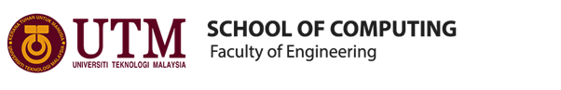
BACHELOR OF COMPUTER SCIENCE
(DATA ENGINEERING)
SEMESTER I 2019/2020

TECHNOLOGY AND INFORMATION SYSTEM
(SECP1513-02)
REPORT
(PETRONAS VISIT)

NAME OF STUDENTS : AINA ALIAH BINTI RUSLAN
NUR HADIRAH MUNAWARAH BINTI ROZMIZAN
SHASITHER A/L SANDRAN
LECTURER : DR. ARYATI BINTI BAKRI
SUBMISSION DATE : 29TH SEPTEMBER 2019
SIGNATURE & :
SCORE :
TABLE OF CONTENT

CONTENTS
Introduction and summary……………………………………………………………………… 2
Timeline of visit………………………………………………………………………………….3
Detailed description……………………………………………………………………………...4
Self-reflection……………………………………………………………………………………6

INTRODUCTION

On 11th September 2019, students of year one in data engineering UTM were having a trip to Kuala Lumpur. The programme was held in Petronas Kuala Lumpur Convention Centre (KLCC). It was about greet meeting with our seniors which were year 4 students. Dr Aryati Binti Bakri as our technology and information system has proposed the trip and accompanied by Dr Eqbal. Both of them with 37 students of Bachelors of Computer Science (Data Engineering) took part in the visit.
Overall, it was a really informative trip as it really gives the student the introduction of the real-life industry. It also allows students to see the opportunity in hands-on experience of how industry is operated. Furthermore, the students are able to become more aware of the requirement of intake of the industry. The industrial exposure gained will enable the students to well equip themselves with essential skills to be more industry-ready.

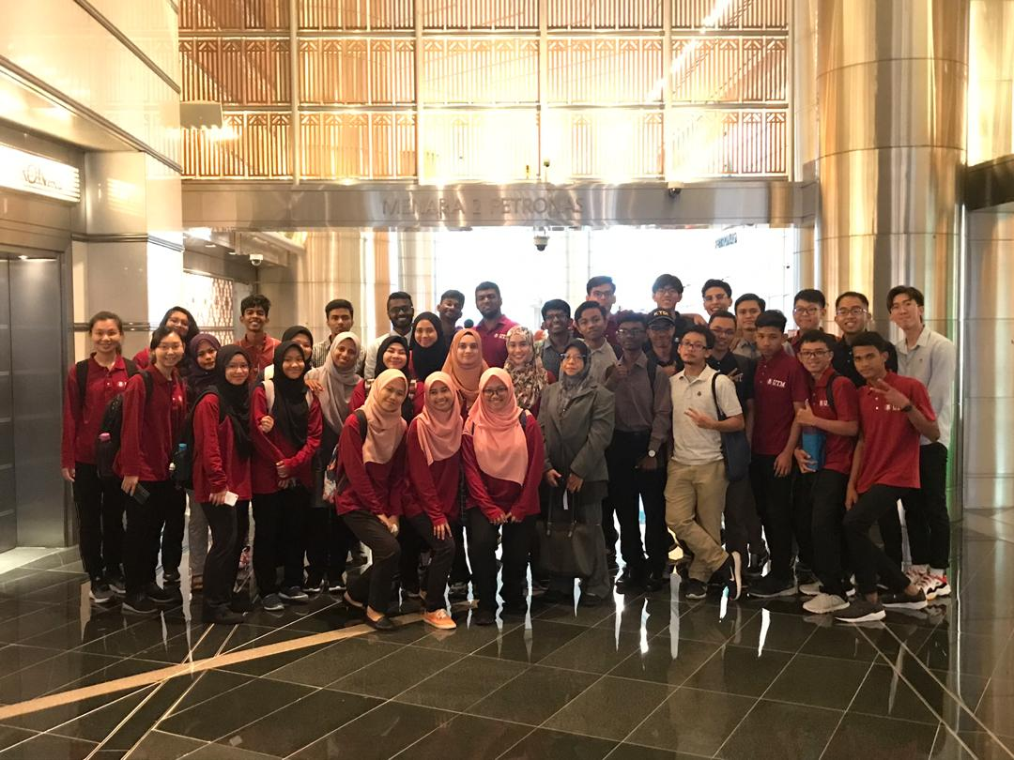
Picture 1 : Group picture before registration at Tower 2, Petronas Twin Towers

TIMELINE OF VISIT

8.00 am | Arrived at Petronas, KLCC
8.15 am | Registration at Tower 2
8.30 am - 8.45 am | Light Refreshment
8.45 am - 9.45 am | Talk by Dr. Niza Adila Binti Hamzah, GTD & Knowledge Management, Petronas
10.00 am | Visit to GTD Office @ Level 44, Tower 3
10.15 am-11.00 am | Sharing session with year 4 UTM senior students
11.00 am-11.15 am | Quick tour around the office

DETAILED DESCRIPTION

Petroliam Nasional Berhad (Petronas) was an establishment of the Government of Malaysia in the year of 1974 as part of the National Oil Legislation with the purpose of identifying, refining and marketing the oil within its borders. As a result of growing demand for energy and a push of boundaries towards a better future in the sustainable energy, Petronas today is ranked among the largest corporations on FORTUNE Global 500®. Currently under Petronas, there various different groups and organizations which solely works for the business growth of Petronas. One of such the group is called the Group Technical Data (GTD) which operates in Petronas Digital Collaboration Centre (PDCC) at Level 22 Petronas Twin Towers. The head of Group Technical Data which is under the Project delivery and technology department is Datin Habsah Nordin. GTD was first established back in 1974 with the name Data Management under Petroleum Management Unit. Then, in 1981, this unit was also tasked to manage data for Petronas CariGali Sdn. Bhd. GTD works under the sole principle of a custodian of Petronas’ technical data acting in regard of Petronas to responsibly manage the Upstream, Midstream and Downstream data of the organization.
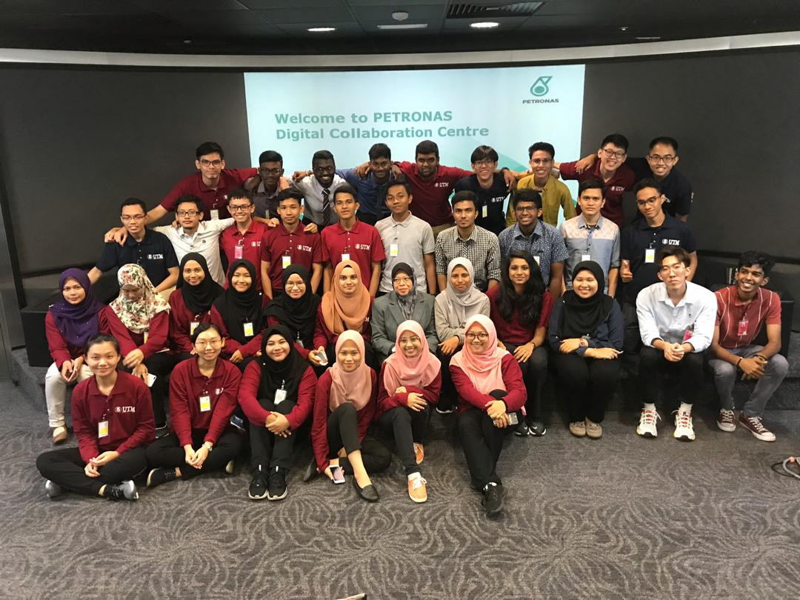
Picture 2 : Group picture at Petronas Digital Collaboration Centre (PDCC) before the talk by Dr. Niza Adila

The responsibilities of GTD were further expanded from just managing large amount of data beginning 2016, when they began to think of various ways to utilize the data to come up with efficient business solutions and add more value to the organization through Data Analytics. This group of staff have the excess to all technical data of Petronas to analyses data for strategic technical decisions as well as efficient risk management systems. GTD works on both the Upstream and Downstream data for Petronas as a whole. Upstream includes the exploration and production activities where else Downstream is the retail and marketing to the industries and users. The purpose of GTD is to look into the technical insights of their business data to improve the operational efficiency and support their business growth in the long term. Thus, they study the seismic data and then advice or propose potential business solutions on areas that should be explored. In other words, GTD are the advisors for the operations at Petronas in the long run.
When we look into the structural organization of Group Technical Data which is headed by Datin Habsah Nordin, there are several divisions with various responsibilities. This includes Project and Physical services, Data Governance and Compliance, Knowledge Management and Data Management. Talking about data management there are data operations, Geoscience data, production and operations data and Technology data. Since there are different classifications of data, there should also be various different personnel and experts working on those data. There is a total of nearly 150 staff at Group Technical Data of Petronas. This comes from 53% with technical background such as Geoscience, Petro Chemical and Engineering, 29% specializing in Computer and Information Technology Systems and finally 18% from non-technical background. This makes GTD very unique because expertise from various backgrounds are deployed together to work on the data and them come up with ideal business solutions. The knowledge and experience of each personnel is equally evaluated to contribute to the success of the organization. This clearly indicates that if we are capable of exploring the technical skills of other engineering disciplines, it will make the data analyzation more valuable.
The dimensions GTD are looking after is more than 70 petabytes of data worth more than RM 80 million in total. They do acquire data from about 22 partners, carry out more than 30 thousand technical and user issues survey and look after almost 300 technical applications worldwide. One of the major challenges faced by GTD in their daily operations is that they do not have competent applications to process back-dated data right from the 1970s to serve the users. Their structured data is processed using ETL which are of different data types such as Geoscience data, Petroleum Engineering data, production and operations data as well as Petroleum projects data. For this a dedicated team is employed called the Data Operation Team which focuses merely on managing unstructured data and the data flow. In addition to this, GTD also works on Data Architecture which governs how the data is being collected, analyzed, stored and put into use in systems. Currently, GTD basic procedures in data analytics are Data Capture, Data Quality and Inventory Data Delivery, Data Type and technology Forecasting. With this being in practice together with Data Indexing and Cataloguing, Big Data of Petronas could be analyzed in proper manner to extract its business insights. Eventually, GTD could be able to enable machine and human data interconnectivity in the future for the benefit of their business. Therefore, data engineers are the key players in the current industrial revolution who could play a significant role in the data science field. Data engineers have the advantage of able to bring values to the business through the insights of data and at the same time able to gain knowledge of the business. With that being said, big data engineers are highly encouraged to take that extra steps to learn the technical skills of other engineering disciplines to broaden their knowledge about the industry.

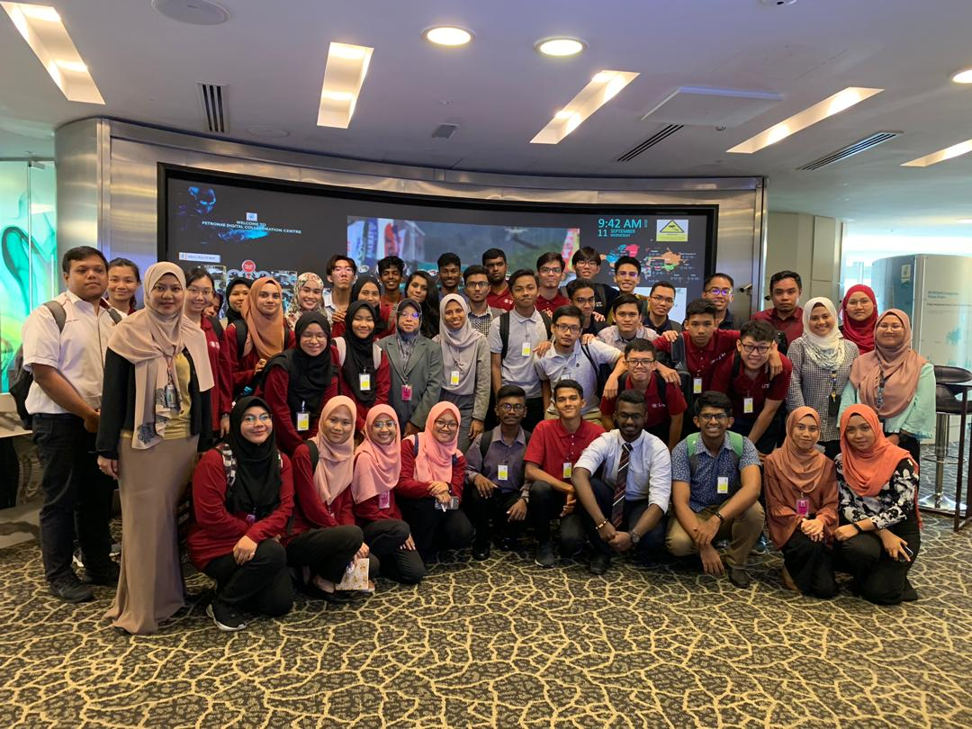
Picture 3 : Picture taken with officers after the talk by Group Technical Data (GTD) Petronas

SELF REFLECTION

From this industrial visit, we gained a lot of benefits including tones of information and knowledge. First of all, this visit enlighten us more about how the group technical data (GTD) Petronas works and we get to know others information related to Petronas. It also makes us more aware of real life industry demands and exposures specifically. So, indirectly, we can make some preparations mentally and physically to face the upcoming challenges and also, we were motivated to study harder in order to achieve our goals. Secondly, this visit tells us to always be up-to-date about the technology developments nowadays. During the sharing session, the speaker mentioned that every second, there are new data being generated. Dealing with this large scale data will be hard but by the existence of technology, it makes them easier. For example, the usage of cloud computing to back up the data is one of the ways to prevent data loss. It is vital to know about the newest technologies that can be utilized so that it will produce an even better result in analyzing the data. So, this simply showed us that be the up-to-date person about the technologies is a must and make sure we are one step ahead about technologies so that we can catch up with the today’s evolutions.

Apart from that, during the sharing session with the seniors of our program, they advised us to have teamwork among us. During their practical, they said that most of their works are group based. So, if we do not have the teamwork, how are we going to finish the work that had been assigned to us. Henry Ford, the founder of the Ford Motor Company, said that Coming together is a beginning, keeping together is progress, working together is success. So, in order to produce a good and successful result, teamwork is what we need to practice in our daily life. What we can do are help each other when study, the student who are better in that particular subject help the others that are not well performed. So together we can be a successful person. Same goes when we do group assignment. Discuss the task with the teammate so that everyone will be satisfied with the work. Last but not least, the seniors also said that we need to focus in our class because the lessons that we learn will be very useful during our work. Apply what we studied in our life and truly understand what is the objective we study the subject. Regret later is useless, so now is the time to start.
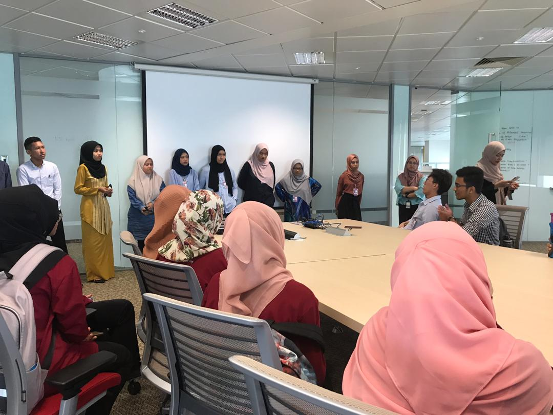
Picture 4 : Sharing session with UTM Student Interns currently with Petronas

