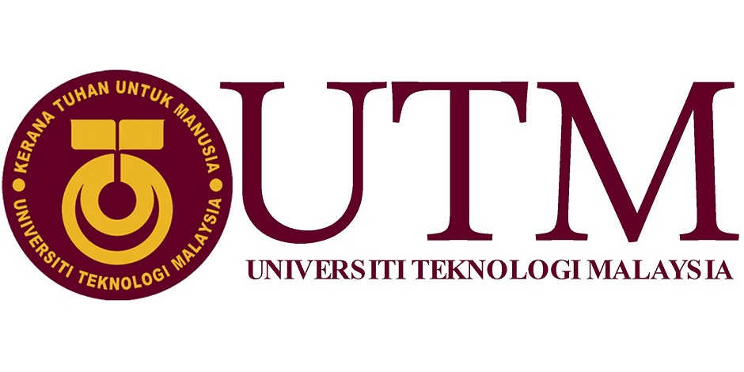

**Report on Industry Visits (CICT)**

Group 5

Name:

1. Muhamad Ridha
2. Raja Aidid
3. Tousif
4. Thattshini
5. Siti Nur Atikah

Lecturer Name:

Dr. Nor Bahiah Bt Hj Ahmad

Subject:

Technology and Information System (SCSP1513-SECTION06)

**Content**

|  |  |  |
| --- | --- | --- |
| NO. | TOPIC | PAGES |
| 1. | INTRODUCTION | 1 |
| 2. | DISCUSSION:   * ORGANIZATION STRUCTURE * SERVICES * ACHIEVEMENT * REFLECTION | 2  3  3-5  6-7 |
| 3. | CONCLUSIONS | 8 |
| 4. | REFERENCES | 9 |

**Introduction:**

The purpose of the report is to expose and understand for the students what’s CICT for the university, what kind of service they’d served. The visit was held on 1st October 2018 at CICT building who are involved in computing students. The vision of the CICT for UTM is to be “A frontier digital university's leading academics centric service delivery”. Mission to lead in development of an entrepreneurial digital ecosystem by nurturing innovative digital professionals and promoting collaborative digital. There are several services from CICT like the internet, infrastructure &security, application development, web management, software, ICT support. CICT stands for Centre for Information & Communication Technology with the tagline Creative, Innovative, Cohesive, Technopreneur. CICT is a support unit that provides and delivers ICT for the university (staff, lecturer, and student) especially in ICT infrastructure, system development, and academic or administrative activities. However, it’s also given to the student there are many jobs can they applied when them after graduated especially in course computer science.

**Discussions:**

1. **ORGANIZATION STRUCTURE**

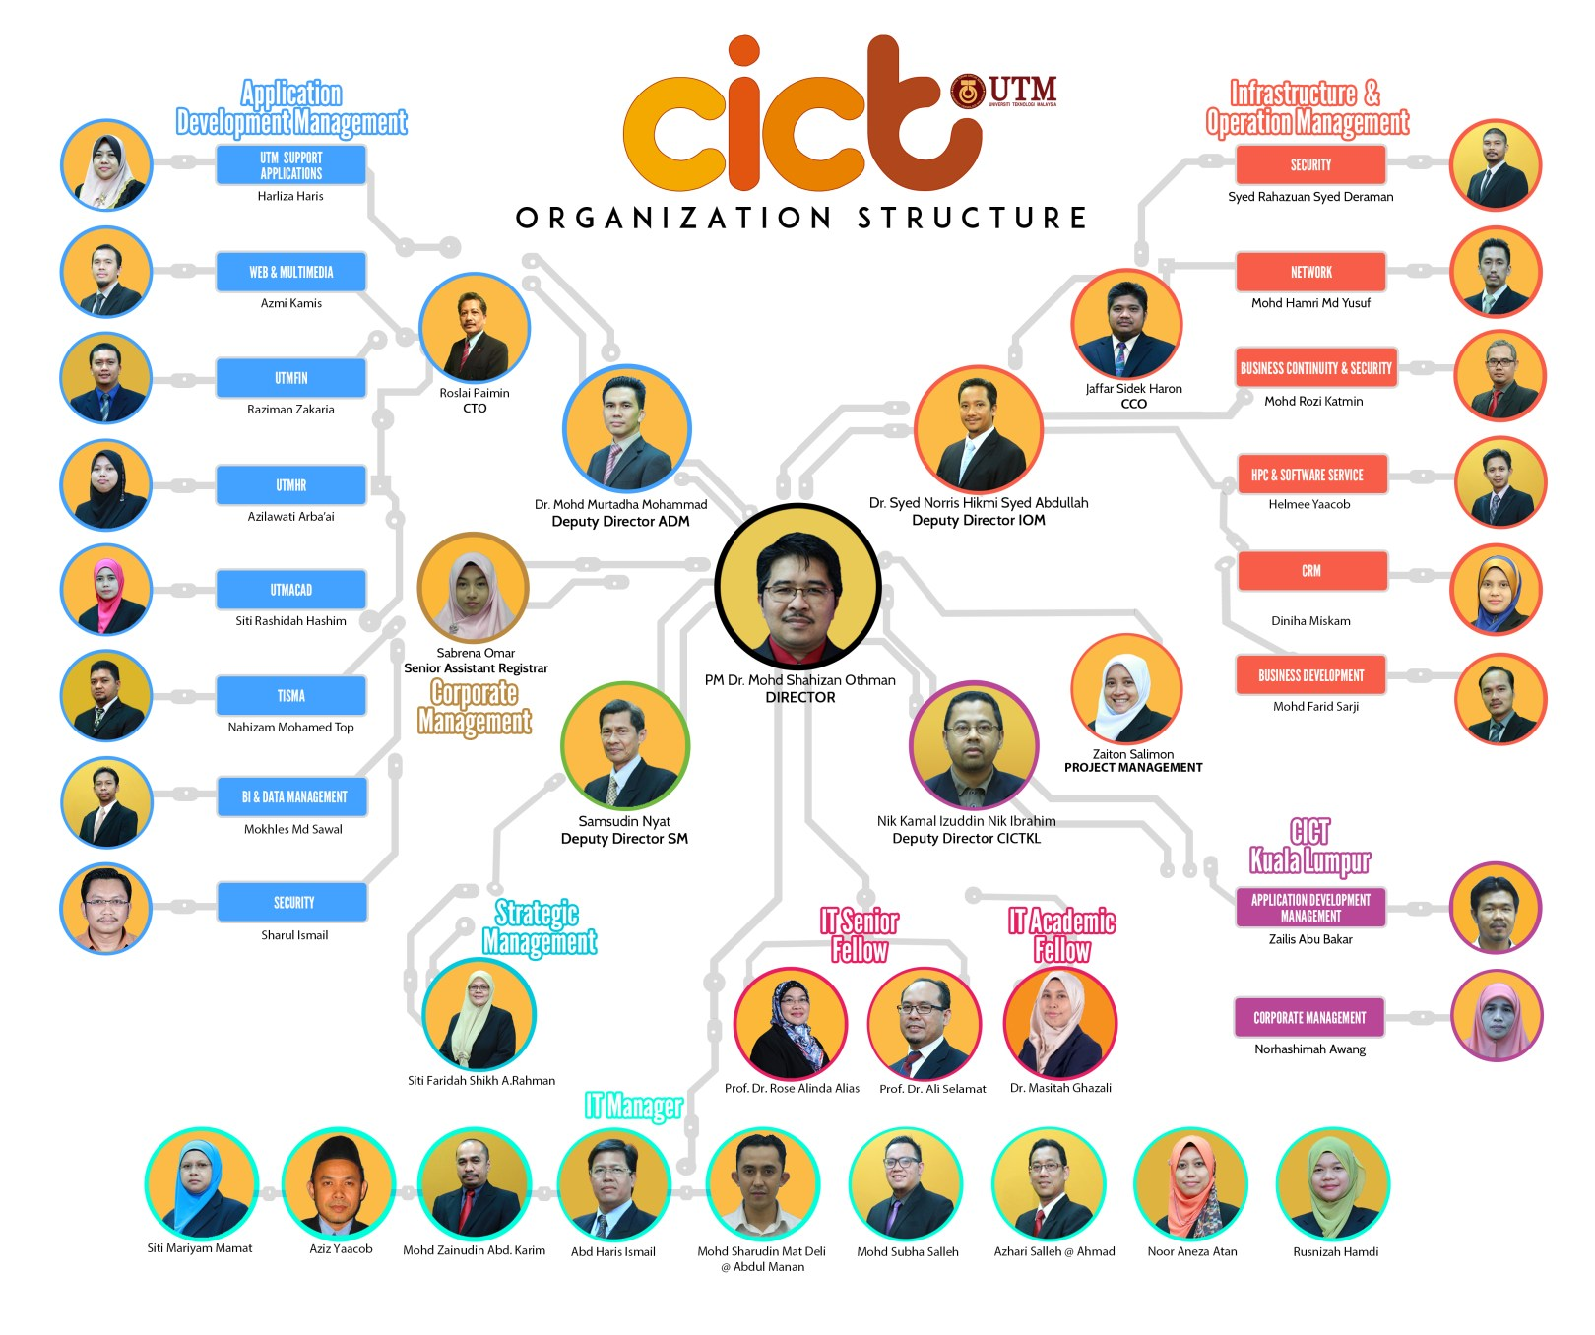

1. **Services**

CICT is the heart of UTM. They have to maintain a lot of things such as the internet. CICT is in charge of providing the internet all over the UTM. Nowadays, all of the works that we are doing is done digitally. Thus, having internet is a must. Ranging from library documents to student records are taken into online. In fact, to find books and journal in the library, we have to use the internet.Next, infrastructure and security provided by CICT. Firstly, we need to highlight the ID Account and access. At the very first stage of registration of UTM, CICT provides ACID ID for all of the new students, complete with their personal information. They also provide an email id which have multi-purpose such as having an unlimited google drive storage. CICT is currently using Next Generation Firewall which includes more layers of complexities for a higher security. In short, the key features of CICT is the Firewall policy, URL filtering, Application Control, and Intruder prevention.Not only that, CICT also provides application development. In order to deliver quality and efficient service of UTM, CICT builds and manage Administrative, Support, Multimedia, Teaching and Learning Applications. They also develop and maintains web and mobile based application as what have been required by the PTJ in terms of data requirement. Montage and videos that needs to be used by the university is also provided by the CICT. Lastly, the support provided by CICT. CICT have a dedicated team who is maintaining and supporting all aspects of CICT like Business Intelligent, Data Management, ICT training, ICT Consultation, Customer Relationship Management.

1. **Achievements**

On the 22nd of November in 2017, the CICT of UTM has been awarded a certificate of “Sijil Pematuhan SAGA 2017” that is delivered by the Malaysian department of Accounting. This certification is rewarded due to an outstanding technical document that has been prepared by the UTM CICT. UTM was one of the 59 out of 416 agencies that has been awarded the “Sijil Pematuhan SAGA 2017”.

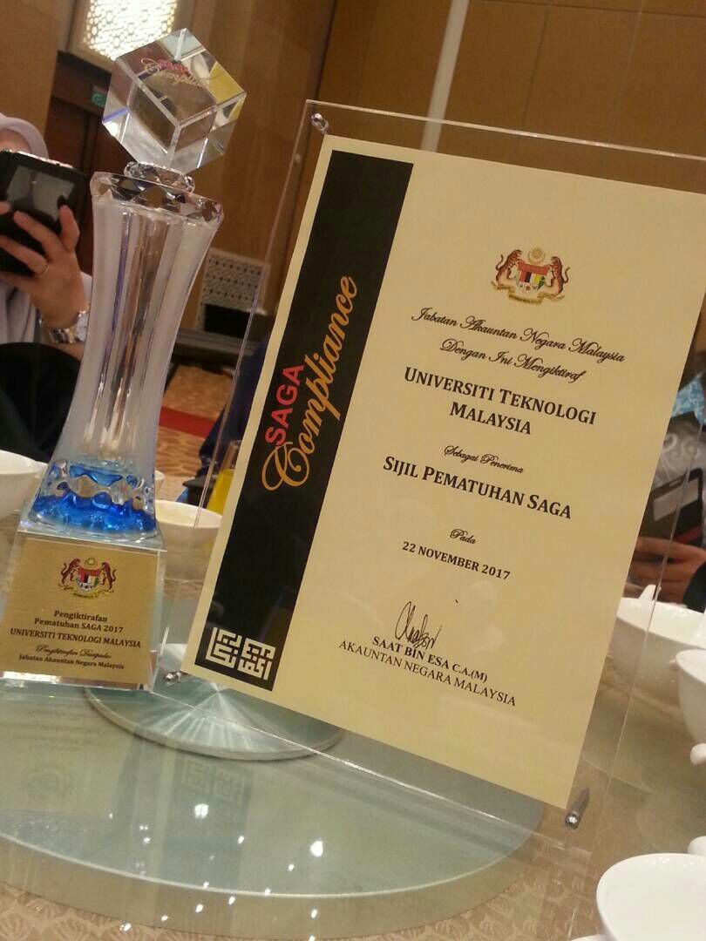

Not only that, the CICT of UTM has also won the most active PTJ for Senam Robik Perdana Siri 2/2017 for Arcturus Zone that has been held on the 7th February 2017. The staffs of the CICT who attended the event was 50 people out of 123 staffs. Thus, making the CICT of UTM, the most active PTJ for this event.

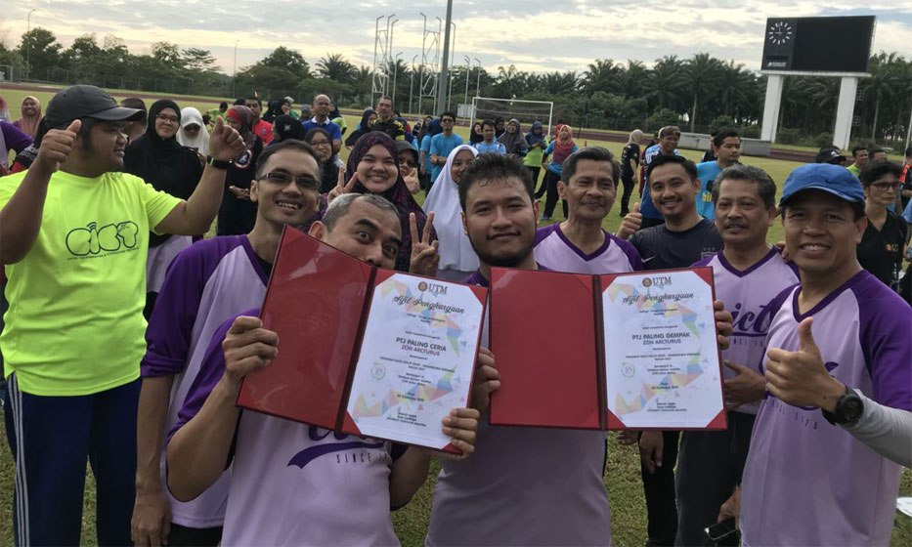

1. **Reflections:**

CICT has been an inspiration to us as a fresh first-year student in general. We are inspired to think creatively and be more innovative in the invention of new ideas. As students of software engineering course, it’s typical for us to have dreams of developing new software or applications that make it significant to the real world and serve its purpose in its best. Therefore, it is vital to come up with unique ideas and continuously work towards it. A software or an application that has a high quality and serve its customers the best shall be developed in conjunction with that. Being able to see the improvements made and ideas proposed that are being made to motivate us to think further and see ideas more than just an imagination but as a prototype in reality. Besides, the visit to CICT has taught us to be sincere and dedicated in our work to produce an excellent product. As the saying goes, with passion grows a fruit and dedication never fails us as hard work always gives out positive end product an laziness gets us nowhere further. The talk has also provoked us to a different level. Technology is the future and present. Technology never fails us and is always evolving making human’s life simpler.Hence, working in this field and inventing new ideas with an aim to simplify tasks has been set as another goal of ours as a first-year student of software engineering. As we know that CICT provides a perfect program to help all of the systems in UTM from basic things into complicated things. For example, they provide wifi all over UTM even though some of the site the wifi are not very fast and comfortable to use. But I think it is very good works that have been done by CICT, as we know UTM has huge location to cover.because of my visit to CICT me as a software engineering student really wanted to create something that can make all of our actions regarding to wifi connection,data storage more comfortable so that UTM will be having a better quality of modern study environment so that we can compete with technic university that has a better rank than us.for example Nanyang university and others even though the best one which is MIT.

As software engineering students we wanted to increase the capability of modern technology at any aspect,we also want to provide a device or something like that to charity foundation to make them easier to help each other.because we live in this world and study not just for our own.if we get a good knowledge we must share the knowledge with others or if we have capability we must share what we can to be helpful to others so that we live in this world will be remember not just be a selfish person. We also want to improve our skill and develop our country to get better at it site,lets take example of indonesia.indonesia has a lot of human resources that has capability to do great at it site.but because of leak of knowledge and leak of facility they can’t improve themself to surf more about this IT era. Thats why we learn far from our home to bring back a good knowledge there so that maybe we can make something like CICT or better.

**Conclusions:**

In a nutshell, the visit to CICT has opened our eyes on the roles of CICT. Without it, it is fair to say that UTM will not be able to operate as well as how it is because the operation of UTM is mostly aided with the facilities and services of CICT. Not only that, the visit also has taught and familiarizes us about the technologies and devices that had been used throughout the years. There are various kinds of old and new devices on the CICT galerium. Therefore, the student will learn technology follow the year. Although the CICT have a top-notch services and facilities, there is always room for improvements that can be made as what we have been mentioned in earlier paragraph

**References:**

* <http://cict.utm.my/ict-knowledge-repository-2/>
* <http://cict.utm.my/organization-structure/>
* http://cict.utm.my/vision/