Senai Airport

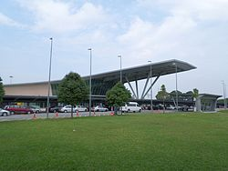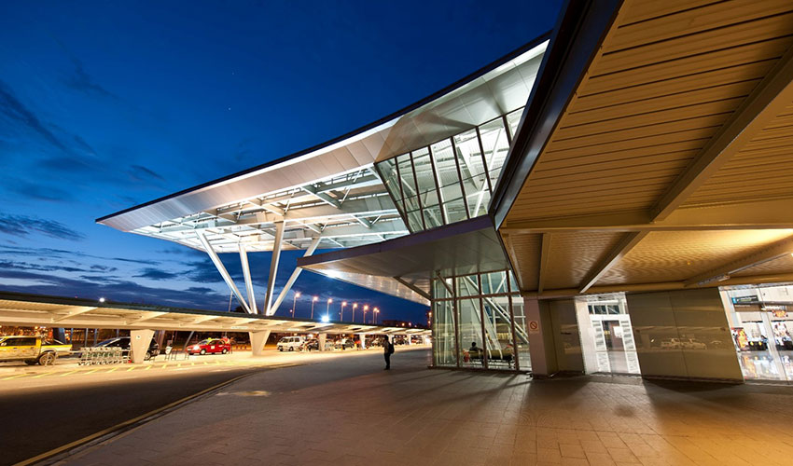 On 3th December, we had an industrial visit in Senai Airport. The visit was about to learn how the systems of Senai Airport works. We had a briefing where the staff members where they explained about the infrastructure of their system. They mentioned about their mission that is to deliver the technology and information services to respective department and needed to fulfil the requirements from business needs. They also mention about their vision of which they are dedicated to ensuring the integrity of data, improving the delivery of information and fostering a bright technological future.

Senai International Airport, formerly known as Sultan Ismail International Airport is an international airport in the town of Senai, Kulai District, Johor, Malaysia. The airport is located approximately 32 km north-west of the Johor Bahru city Centre. In 2017, Senai International Airport reached a total of 3,124,799 passengers and 7,614 tons of freight with a combination of 42,744 schedule and non-schedule commercial aircraft movements. The airport is a hub for AirAsia. Opened in 1974, it serves the state of Johor as well as people from the southern states of Peninsular Malaysia. Senai International Airport is the hub of AirAsia. It was a domestic hub of Malaysia Airlines until the rationalization of its domestic routes to cut the company's losses. After the rationalization, Malaysia Airlines only served two destinations from Senai.

Today, the airport is managed by Senai Airport Terminal Services Sdn Bhd, which took over the operations from Malaysia Airports Holdings Berhad (MAHB) in 2003. Senai International Airport is capable to handle up to 3.5 million passengers and 80,000 tons of cargo per annum. There are plans to increase the capacity of the airport to 10 million passengers in the long term and turn the airport into a cargo hub. Recent expansions and upgrades include lengthening of the runway to 3800m and building a parallel taxiway to increase runway capacity.

Senai Airport Terminal Services Sdn Bhd, the operator of the airport announced a multi-billion-ringgit (MYR) project called Airport City or Aeropolis. The project, on 1,133 hectares near Senai Airport, will comprise three main components – residential-commercial-hospitality amenities, an air cargo logistic center and a high-tech park. The first component will cover 323 hectares while the other two will occupy 405 hectares each. On 26 May 2008, SATS announced a MYR 70 million plan to build an Aero Mall, a stand-alone and external airport mall. The mall will have a retail space of 10,000 square feet (930 m2). Due to be completed in the late 2009 / early 2010-time frame, the Aero Mall was officially opened in July 2010.On 8 July 2008, Kuwait's Al-Aqeelah announced a project to build an aviation academy near the airport. The project will cost around US$100 million. On 12 February 2009, the Hong Kong-based Plaza Premium Management Ltd opened its third Plaza Premium Lounge in Senai International Airport. Since December 2009, the airport provides free WIFI service for all customers at the Main Terminal and Cargo Centre. Firefly announced on 22 February 2011 that Senai International Airport would be their fifth hub in Malaysia and operate with two fleets of Boeing 737-400. The proposed routes included flights to Jakarta, Bandung and Surabaya, Indonesia (in third quarter) and Bangkok, Thailand (in fourth quarter). Due to the share swapping between MAS and AirAsia, Firefly will be restructured and all of the jet routes were suspended in 2011.In 2015, it was announced that Senai Airport will be the main hub for fly mojo. The airline will transform the airport into a key regional aviation & logistics hub. It will also play a key role in developing Iskandar Malaysia. However, the airlines never started and their air operator's certificate (AOC) expired on 30 May 2016 without any extension sought by the airlines.

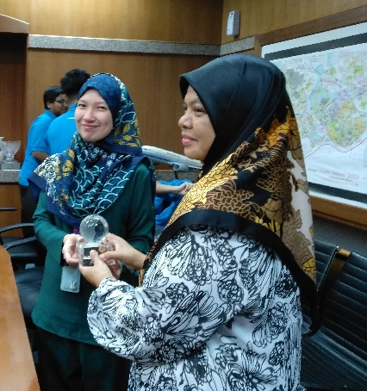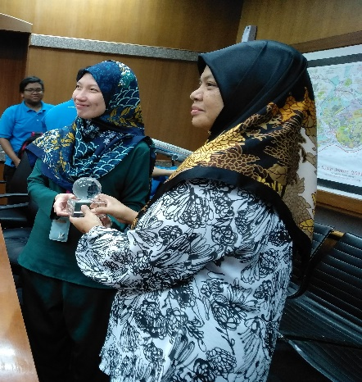 After the speech delivered by the staff members finished our Professor Azurah gave some souvenirs from UTM as an appreciation of letting us having this wonderful visit.

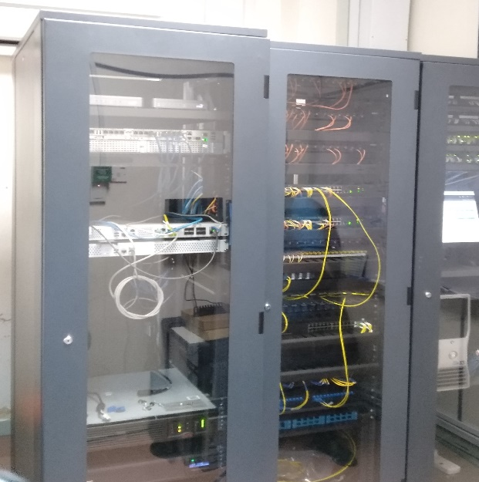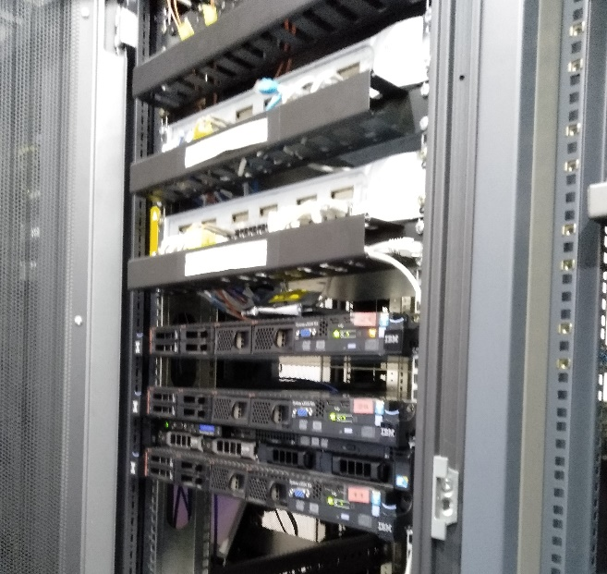Furthermore, they guided us throughout the whole airport even to their server room and firewall room.

Airlines Destinations

|  |  |
| --- | --- |
| AirAsia | Alor Setar, Bangkok Don Mueang, Guangzhou, Ho Chi Minh City, Ipoh, Jakarta Soekarno Hatta, Kota Kinabalu, Kuala Lumpur International, Kuching, Langkawi, Miri, Penang, Sibu, Tawau |
| Firefly | Kuala Lumpur Subang |
| Indonesia AirAsia | Surabaya |
| Jin Air | Seoul Incheon |
| Malaysia Airlines | Kuala Lumpur–International  **Seasonal:** Jeddah, Medina |
| Malindo Air | Haikou, Ipoh, Kuala Lumpur International, Kuala Lumpur Subang |
| Thai AirAsia | Bangkok Don Mueang |

These are some of the Airlines that you will find in Senai Airport.

| **Airlines** | **Destinations** |
| --- | --- |
| MASkargo | Kuala Lumpur International, Tokyo Narita |
| Raya Airways | Kuala Lumpur International |

**Cargo**

Traffic and statistics

| **Annual passenger numbers and aircraft statistics** | | | | | | |
| --- | --- | --- | --- | --- | --- | --- |
| **Year** | **Passengers handled** | **Passenger % change** | **Cargo (tonnes)** | **Cargo % change** | **Aircraft movements** | **Aircraft % change** |
| 2010 | 1,235,400 | Decrease 6.1 | 6,239 | Steady | 11,934 | Steady |
| 2017 | 3,124,799 | Increase 10.5 | 7,614 | Increase 21.9 | 42,744 | Increase 3.0 |
| 2015 | 2,581,966 | Increase 11.1 | 5,272 | Increase 6.9 | 41,892 | Decrease 2.5 |
| 2016 | 2,828,074 | Increase 12.1 | 6,245 | Increase 18.0 | 42,744 | Increase 2.0 |
| 2014 | 2,325,816 | Increase 16.9 | 4,934 | Increase 43.3 | 42,976 | Increase 13.1 |
| 2012 | 1,376,383 | Increase 3.0 | 3,149 | Decrease 42.1 | 12,506 | Decrease 17.4 |
| 2013 | 1,989,979 | Increase 44.6 | 3,443 | Increase 9.3 | 37,998 | Increase 203.8 |
| 2011 | 1,337,562 | Increase 8.3 | 5,438 | Decrease 12.8 | 15,167 | Increase 27.1 |
| 2009 | 1,316,082 | Steady | N/A | Steady | N/A | Steady |

| **Busiest international flights out of Senai International Airport by frequency** | | | |
| --- | --- | --- | --- |
| **Rank** | **Destinations** | **Frequency (Weekly)** | **Airlines** |
| 1 | [Thailand](https://en.wikipedia.org/wiki/Thailand) Bangkok–Don Mueang, Thailand (DMK) | 16 | AK, FD |
| 2 | [China](https://en.wikipedia.org/wiki/China) Guangzhou, China | 8 | AK |
| 3 | [Vietnam](https://en.wikipedia.org/wiki/Vietnam) Ho Chi Minh, Vietnam | 8 | AK |
| 4 | [Indonesia](https://en.wikipedia.org/wiki/Indonesia) Surabaya, Indonesia | 5 | QZ |
| 5 | [Korea](https://en.wikipedia.org/wiki/Korea) Seoul, Korea | 4 | LJ |
| 6 | [Indonesia](https://en.wikipedia.org/wiki/Indonesia) Jakarta, Indonesia | 3 | AK |
| 7 | [China](https://en.wikipedia.org/wiki/China) Haikou, China | 2 | OD |
| 8 | [Saudi Arabia](https://en.wikipedia.org/wiki/Saudi_Arabia) Jeddah, Saudi Arabia | Seasonal-Hajj | MH |
| 9 | [Saudi Arabia](https://en.wikipedia.org/wiki/Saudi_Arabia) Medina, Saudi Arabia | Seasonal-Hajj | MH |

| **Busiest domestic routes out of Senai International Airport by frequency** | | | |
| --- | --- | --- | --- |
| **Rank** | **Destinations** | **Frequency (Weekly)** | **Airlines** |
| 1 | [Selangor](https://en.wikipedia.org/wiki/Selangor) Subang, Selangor (SZB) | 94 | FY, OD |
| 2 | [Kuala Lumpur](https://en.wikipedia.org/wiki/Kuala_Lumpur) Kuala Lumpur (KLIA) | 89 | AK, MH, OD |
| 3 | [Penang](https://en.wikipedia.org/wiki/Penang) Penang, Penang | 51 | AK |
| 4 | [Sarawak](https://en.wikipedia.org/wiki/Sarawak) Kuching, Sarawak | 32 | AK |
| 5 | [Sabah](https://en.wikipedia.org/wiki/Sabah) Kota Kinabalu, Sabah | 22 | AK |
| 6 | [Perak](https://en.wikipedia.org/wiki/Perak) Ipoh, Perak | 18 | AK, OD |
| 7 | [Sarawak](https://en.wikipedia.org/wiki/Sarawak) Sibu, Sarawak | 17 | AK |
| 8 | [Kedah](https://en.wikipedia.org/wiki/Kedah) Langkawi, Kedah | 8 | AK |
| 9 | [Sabah](https://en.wikipedia.org/wiki/Sabah) Tawau, Sabah | 7 | AK |
| 10 | [Kedah](https://en.wikipedia.org/wiki/Kedah) Alor Star, Kedah | 4 | AK |
| 11 | [Sarawak](https://en.wikipedia.org/wiki/Sarawak) Miri, Sarawak | 3 | AK |
| 12 | [Terengganu](https://en.wikipedia.org/wiki/Terengganu) Kuala Terengganu, Terengganu | 3 | AK |

Having this visit, will help us in many ways as we are computer science (network and security) students as learned about the infrastructure of the whole system.