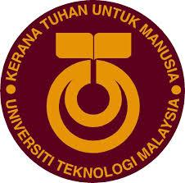

**SECP1513 - TECHNOLOGY AND INFORMATION SYSTEM**

**INDUSTRIAL VISIT TO PETRONAS SDN BHD**

**SECTION 02**

|  |  |
| --- | --- |
| **NAME** | **MATRIC NO** |
| Chua Chen Wei | A19EC0038 |
| Muhammad Anas Alif Shah Bin Azeli Shah | A19EC0193 |
| Nor Hafiyzha Bt. Md Husni | A19EC0124 |

**LECTURER:**

DR. ARYATI BINTI BAKRI

**DATE OF SUBMISSION:**

29 SEPTEMBER 2019

Contents

Introduction 3

Details of The Visit 4

Detailed Descriptions of the Visit 5

Detailed Description of Industrial Visit to Petronas Sdn Bhd 6

Summary Group Technical Data in Petronas 8

Reflections 9

References 11

# Introduction

Our class have been invited by Group Technical Data of Petronas Sdn Bhd to share their services, achievements and organization structure. We were guided by two lecturers which Dr. Aryati Binti Mohamed, Technology and Information Science lecturer and Dr Iqbal, Database lecturer.

This program is held on 11th September 2019 with the purpose of showing us the improvements of data in industry and the data services for business that relate to the company such as the evolution of the technical data since 1974 and managing data for their investor. There’s some general information about Petronas Organization Chart that shows a variety of department that helps to improve the development and research project. Besides their success, they also shared some of the challenges that they had to face on upgrading their data industry.

# Details of The Visit

|  |  |  |  |
| --- | --- | --- | --- |
| **Time** | **Activities** | | **Venue** |
| 8:15 a.m | Gathered at the ground floor to register | | Petronas Tower 2 |
| 8:30 a.m | Had refreshment that provided by the department | | Petronas Tower 2 (Floor 26) |
| 8:45 a.m | Listening to the speech given by the supervisor of project delivery and technology department | |
| 9:45 a.m | Headed to Group Technology Data department and had a tour | | Petronas Tower 3  (Floor 44) |
| 10:15 a.m | Had a QnA session with the internship students | |
| 11:00 a.m | | End of visit session | Petronas Tower 3 |

# Detailed Descriptions of the Visit

|  |  |
| --- | --- |
| **Time** | **Activities Description** |
| 8:15 a.m | After having breakfast, we’re heading to Petronas Twin Tower with data engineering undergraduates and both lecturers. As we arrived, we’re gathering at the ground floor for the registration. |
| 8:30 a.m | We’re heading to the Product Delivery and Technology department. While waiting for the speaker arrived, they provided simple refreshments at the pantry. |
| 8:45 a.m | We attended the speech by the Group Technical Data (GTD) team to introduce what is the role of the department and how it created. The speakers lead by the supervisor of the PD & T department. After that, one of the data engineers called Muhammad Akmal gave some information about the basic ETL and subsurface.   1. ETL   Basically ETL is a short form of extract, transform and load data from the source system and transfer to data warehouse (DTH).   1. Subsurface   Subsurface is the longest data that has been created in Petronas |
| 9:45 a.m | One of the trainee guided us to the Petronas Tower 3 level 44 which is the Group Technical Data department to get the experiences by seeing those trainee working and sharing their working experience. They also share some tips on how to perform well in this course and showing up our ability to enhance the development of data nowadays. |
| 10:15 a.m | We had a short QnA session with all Data Engineering fourth year undergraduates from UTM. There’s a lot of information that we got from the QnA such as, ways to develop our soft skills and tips to improve our critical thinking. |
| 11:00 a.m | End of our industry visit session with Petronas Sdn Bhd. |

# Detailed Description of Industrial Visit to Petronas Sdn Bhd

The industrial visit was held in Petronas Tower 2 floor 26 where the PD&T department sit. We’re first brought to one of its seminar room been there for hearing some speech from the manager of the Group Technical Data and two of the data engineers from the department about the role of GTD department in Petronas, how it grows, achievements and more.

First and foremost, they showed us an extraordinary montage about what is GTD and how it’s created as in Figure 1.0. In that montage, there are 4 vision of GTD department which is network, collaboration, visualisation and intervention. Then, the speech started with the organization structure where the GTD is one the biggest department in Petronas Sdn Bhd. (Pn Niza Adilah Binti Hamzah GTD’s Manager,2019) GTD started with Data Management team in 1974 and keep evolved rapidly till now. (Pn Niza Adilah Binti Hamzah GTD’s Manager,2019) These are the organization structure of Petronas Sdn Bhd where GTD department was under PD&T department.

**HEAD OF GROUP TECHNICAL DATA**

(DATIN HABSAH BINTI NORDIN)





KNOWLEDGE MANAGEMENT

PROJECT AND FEE SERVICES

DATA GOVERNERS AND COMPLIERS

DATA MANAGEMENT





DATA OPERATION

GEOSCIENCE DATA

TECHNOLOGY DATA

PICKY DATA

PRODUCTION AND OPERATION

MPM DATA

Figure 1.0 – PD&T and GTD Organization Structure

Next, (Pn Niza Adilah Binti Hamzah GTD’s Manager,2019) there are some information about their contribution towards Petronas which is provide technical advisor on how they can develop the area that had been identified. After they build the platform and hub, they will operationalized the platform. Downstream was a department who responsible on PDP and Petronas Gas Station. Once the hydrocarbon whether it’s oil or gas been retrieve, it will go through refinery process and that is downstream business up to when they sold to their customers. There’s a task that they had to face each year on finding energy resources because hydrocarbon resources in Malaysia is depleting and may no longer for another 20 years. (Pn Niza Adilah Binti Hamzah GTD’s Manager,2019) GTD also got several achievements after being in the industry for more than 45 years which are they got more than 70 petabyte of data from the clients, nurture pervasive use of analytics, acquire data and managing the data and not to forget, there are more than 30 apps that had been develop by the GTD department. After the speech has ended, we took some pictures in the seminar room for memories as shown in Figure 2.0.

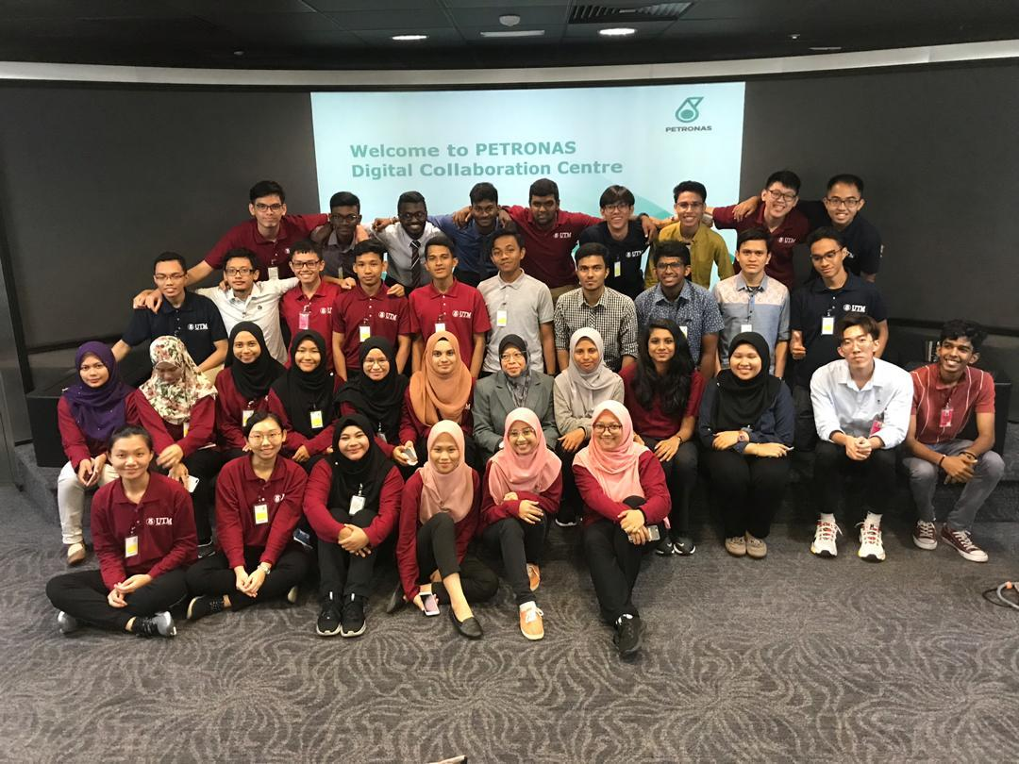

Figure 2.0 – UTM Data Engineering undergraduates and lecturers

# Summary Group Technical Data in Petronas

It started in 1974 which known as Data Management under Petronas Management Unit then it was established oin1981 under Petronas Cari Gali to manage the data for Cari Gali. Next, it has been evolved up to 2016 where it’s been centralized as a group technical data where the scope of their work as a data management has been widen. From that, they started to think on what they can do with data other than technical services. Other than that, GTD also a custodian of Petronas Technical Data. They also responsible in managing data services for business by knowledge captured and replicate the data to be a useful data. As a custodian of Petronas Technical Data, they have access to all technical data to govern and stear technical data. They also responsible to guard and safe keep relevant technical data. (Pn Niza Adilah Binti Hamzah GTD’s Manager,2019) GTD department also have their own pledge which is fortify data governance, be brilliant at basics, develop value creators, co-create analytic solutions and reboot knowledge management. We managed to take a group photo with the GTD Members as shown in Figure 3.0.

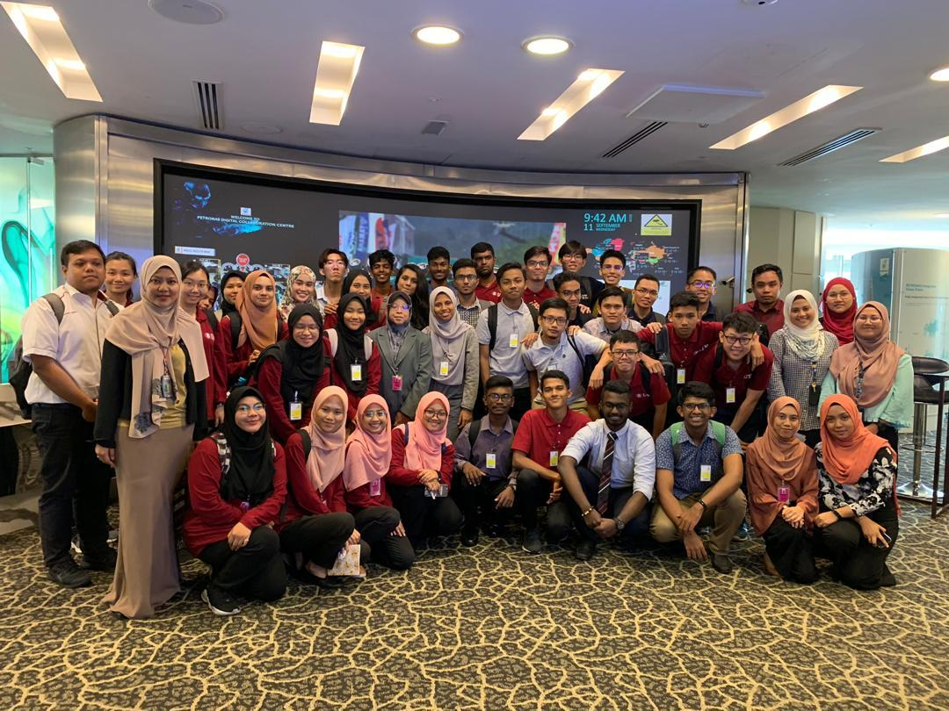

Figure 3.0 – GTD Members with UTM Data Engineering undergraduates

# Reflections

Chua Chen Wei

 During the trip to PETRONAS,I got the chance to feel and see the working atmosphere in PETRONAS.It felt nice and extraordinary which makes me determined to work harder in order to achieve this in my future.Before I go to this trip, I always question myself : “ What does a data engineer actually do ? “The person in charge solved the question for me.She provide the information on how important and demanding data engineer is in the industry nowadays where data Is used in empowering other sectors and help the company make better decisions.Furthermore,our 4th year seniors which are doing internship in PETRONAS motivated me a lot and through their advice, I realized that it is not easy to get a place in the industry if I am  not hardworking and determined enough.I will work hard and look up to our seniors and try to create a better result than them.

Nor Hafiyzha Binti Md Husni

This Petronas industrial visit gave such a big impact towards my dreams. I promised myself that will do the best as I can to improve and work hard on my studies so that I could achieve my goals which is to be one of the data engineers in big data companies. One of the UTM fourth year students, Siti Hafizah said that “Keep exploring the development of data so that you wouldn’t left behind since the development enhanced rapidly day by day”. I take that as a motivation to improve my potential in the industry by exploring common programming software such as Phyton and observe what’s the industry need day by day.

Muhammad Anas Alif Shah Bin Azeli Shah

This industrial visit to Petronas at the Petronas Twin Tower had opened my eyes about what the big company actually is. They have a lot of departments and one of it is the Technical Data team in which we focused more on its details during the visit. For me, it was a very good visit because we as a Data Engineering students were exposed to what actually the role of a data scientist in a big company like Petronas. We atleast gained ideas on how the working environment really is and what we actually need to develop in ourselves. We also got to meet our seniors from UTM that are on their internship at Petronas and had a knowledgeable Question and Answer with them. They highlighted to us that we as a student need to explore with our own initiative into data industry and always work together as a team.

Personally, this visit had boosted my enthusiasm and energy ever since that time to work harder and smarter to explore and excel my studies in UTM. I also think that we should do more industry visit like this so students can develop their interest on data industry and are keen to contribute our efforts in the future.

# References

*Petronas Group of Companies.* (31 December, 2017). Retrieved from Petronas: https://www.petronas.com/ws/sites/default/files/about-us/petronas-group-of-companies-2018.pdf

*PETRONAS' transformation journey.* (n.d.). Retrieved from Petronas: https://www.petronas.com/about-us/milestones?year=2015-2017

Zuriati Azhari, Z. B. (9 September, 2015). *https://platinum.petronas.com/News/Pages/Knowledge%20Management%20Community%20of%20Practice%20Forum%20.aspx*. Retrieved from Platinum Petronas: https://platinum.petronas.com/News/Pages/Knowledge%20Management%20Community%20of%20Practice%20Forum%20.aspx