

SECI1013-06 STRUKTUR DISKRIT

TUTORIAL 4

Lecturer: Assoc. Prof. Dr. Roselina Sallehuudin

|  |  |  |
| --- | --- | --- |
| No. | Name of Students | Student ID |
| 1 | Muhammad Aniq Aqil bin Azrai Fahmi | A20EC0083 |
| 2 | Muhammad Kasyfi bin Kamarul Hamidi | A20EC0093 |
| 3 | Muhammad Naim bin Abdul Jalil | A20EC0096 |
| 4 | Muhammad Azzam Hamiludin | A20EC5003 |

1. Let G be a graph with 𝑉(𝐺) = {1, 2, … . , 10}, such that two numbers ‘v’ and ‘w’ in 𝑉(𝐺) are adjacent if and only if | v – w| ≤ 3. Draw the graph G and determine the numbers of edges, 𝑒(𝐺).

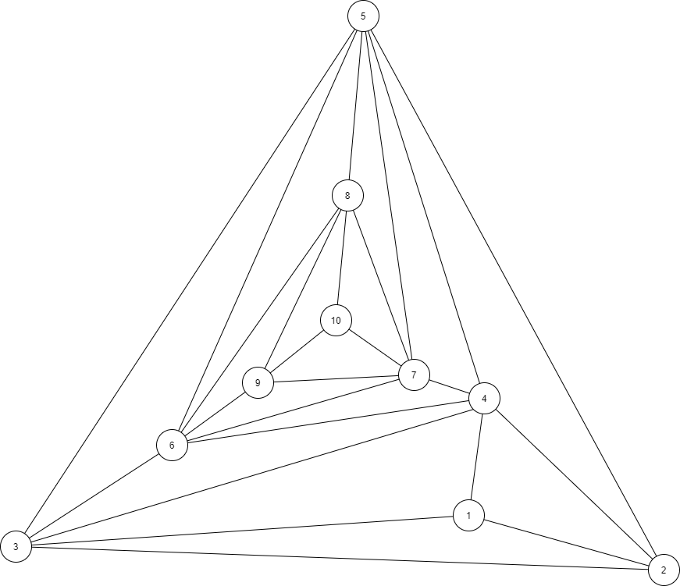

Number of edges, *e*(*G*) = 24

1. Model the following situation as graphs, draw each graphs and gives the corresponding adjacency matrix.
   1. Ahmad and Bakri are friends. Ahmad is also friends with David and Chong. David, Bakri and Ehsan all friends.

(Note that you may use the representation of A= Ahmad; B = Bakri; C = Chong; D = David; E= Ehsan)

A B C D E

A

B

C

D

E

A =

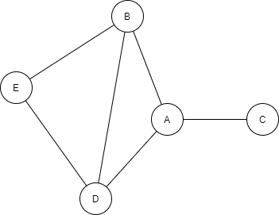

* 1. There are 5 subjects to be scheduled in the exam week: Discrete Mathematics (DM), Programming Technique (PT), Artificial Intelligence (AI), Probability Statistic (PS) and Information System (IS). The following subjects cannot be scheduled in the same time slot: -
     1. DM and IS
     2. DM and PT
     3. AI and PS
     4. IS and AI

DM

PT

AI

PS

IS

DM PT AI PS IS

A =

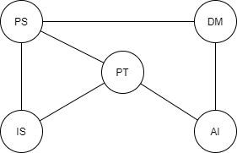

1. Show that the two drawing represent the same graph by labeling the vertices and edges of the right-hand drawing to correspond to left-hand drawing.

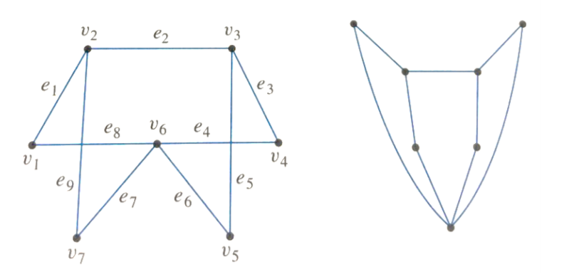

Answer:

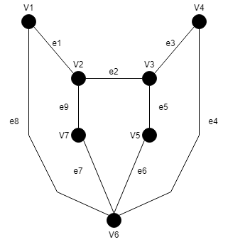

1. Find the adjacency and incidence matrices for the following graphs.

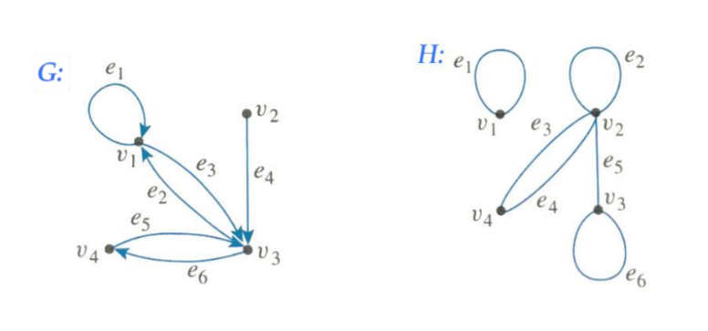

G:

H:

1. whether the following graphs are isomorphic.
   1. 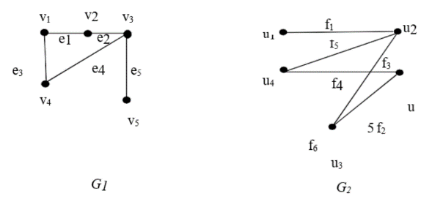

* Both have 5 vertices and 5 edges
* Both are connected and simple graph
* Both have 1 vertices with 3 degree, 3 vertices with 2 degree and 1 vertices with 1 degree

and are isomorphic

* 1. 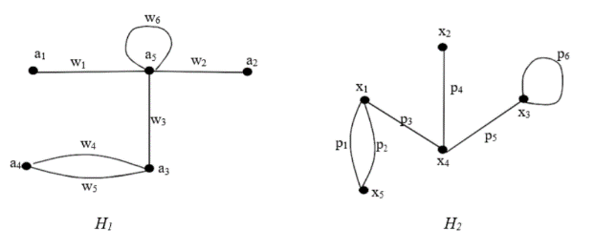
* Both have 5 vertices and 6 edges
* Both are connected and simple graph
* Only has 1 vertices with 5 degree
* So, cannot be defined

and are not isomorphic

1. In the graph below, determine whether the following walks are trails, paths, closed walks, circuits/cycles, simple circuits or just walks.

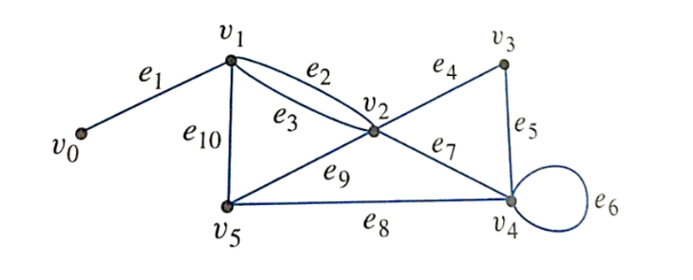

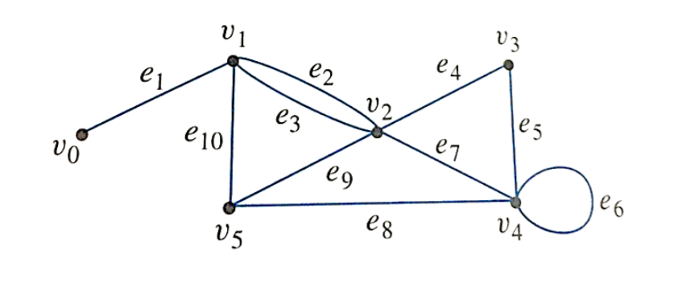

trail because vertex are repeated and edge are not



Just walk because vertex and edge are repeated

Trivial walk because single vertex



Circuit/cycle because start and end at the same vertex and not contain a repeated edge



Closed walk because start and end at the same vertex and contain repeated edge



Path because not contain any repeated vertex and edge

1. Consider the following graph.

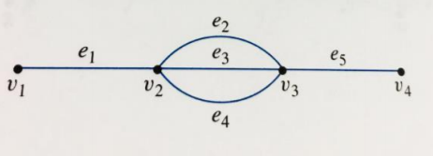

* 1. How many paths are there from to ?

1. )
2. )

Therefore, there are 3 paths from to

* 1. How many trails are there from to ?

1. )
2. )

Therefore, there are 9 trails from to

* 1. How many walks are there from to ?

undefined because edge and vertex are allowed to repeat.

1. Determine which of the graphs in (a) – (b) have Euler circuits. If the graph does not have a Euler circuit, explain why not. If it does have a Euler circuit, describe one.

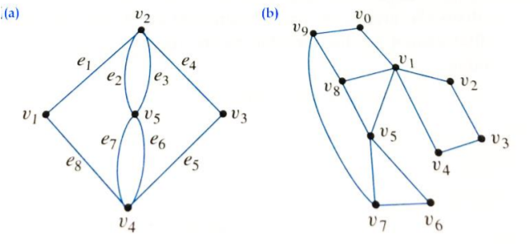

|  |  |  |  |  |  |
| --- | --- | --- | --- | --- | --- |
| Vertex |  |  |  |  |  |
| Degree | 2 | 4 | 2 | 4 | 4 |

Graph (a) has a Euler circuit because every vertex has even degree.

()

|  |  |  |  |  |  |  |  |  |  |  |
| --- | --- | --- | --- | --- | --- | --- | --- | --- | --- | --- |
| Vertex |  |  |  |  |  |  |  |  |  |  |
| Degree | 2 | 5 | 2 | 2 | 2 | 4 | 2 | 3 | 3 | 3 |

Graph (b) do not has a Euler circuit because some vertex has odd degree

1. For each of graph in (a) – (b), determine whether there is an Euler path from 𝑢 to 𝑤. If there is, find such a path.

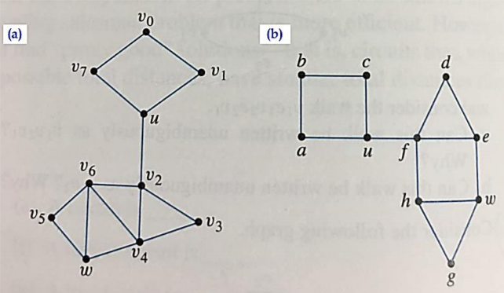

|  |  |  |  |  |  |  |  |  |  |  |
| --- | --- | --- | --- | --- | --- | --- | --- | --- | --- | --- |
| Vertex | *u* |  |  |  |  |  |  |  |  | *w* |
| Degree | 3 | 2 | 2 | 4 | 2 | 4 | 2 | 4 | 2 | 3 |

Graph (a) has an Euler path because only *u* and *w* have odd vertex.

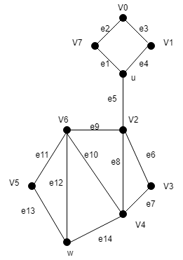

|  |  |  |  |  |  |  |  |  |  |  |
| --- | --- | --- | --- | --- | --- | --- | --- | --- | --- | --- |
| Vertex | *u* | *a* | *b* | *c* | *d* | *e* | *f* | *g* | *h* | *w* |
| Degree | 3 | 2 | 2 | 2 | 2 | 3 | 4 | 2 | 3 | 3 |

Graph (b) do not has Euler path because vertex other than u and w also have an odd degree

1. For each of graph in (a) – (b), determine whether there is Hamiltonian circuit. If there is, exhibit one.

No for both graphs because for (a), no matter which path we take, we will always revisit vertex *u* and *.* While for (b), no matter which path we take, we will always revisit vertex *u* and *f.*

1. How many leaves does a full 3-*ary* tree with 100 vertices have?

m = 3

n = 100 vertices

1. Find the following vertex/vertices in the rooted tree illustrated below.

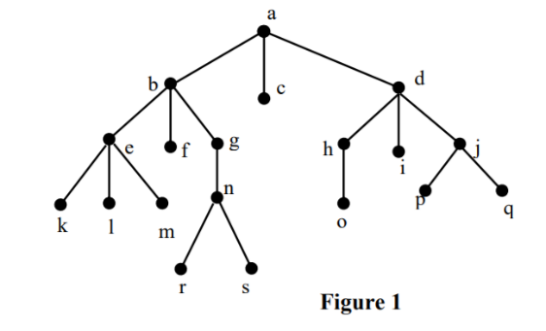

* 1. Root

a

* 1. Internal vertices

a, b, d, e, g, h, j, n

* 1. Leaves

c, f, i, k, l, m, o, p, q, r, s

* 1. Children of *n*

r, s

* 1. Parent of *e*

b

* 1. Siblings of *k*

l, m

* 1. Proper ancestors of *q*

a, d, j

* 1. Proper descendants of *b*

e, f , g, k, l, m, n, r, s

1. In which order are the vertices of ordered rooted tree in Figure 1 is visited using preorder, inorder and postorder.

Preorder : a, b, e, k, l, m, f, g, n, r, s, c, d, h, o, i, j, p, q

Inorder : k, e, l, m, b, f, r, n, s, g, a, c, o, h, d, i, p, j, q

Postorder : k, l, m, e, f, r, s, n, g, b, c, o, h, i, p, q, j, d, a

1. Find the minimum spanning tree for the following graph using Kruskal’s algorithm.

|  |  |  |  |  |  |  |  |  |  |  |
| --- | --- | --- | --- | --- | --- | --- | --- | --- | --- | --- |
| AB | GH | BC | AF | BF | CD | BG | CG | DE | DG | EH |
| 1 | 1 | 2 | 3 | 4 | 4 | 5 | 6 | 7  forms a cycle | 7  forms a cycle | 8 |

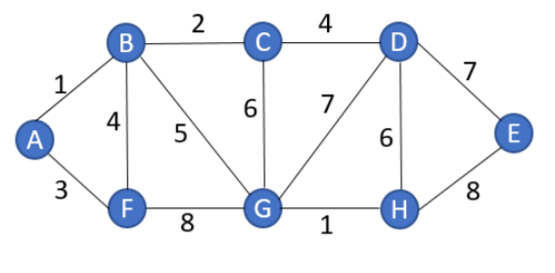

forms a cycle

forms a cycle

|  |  |  |  |  |  |  |
| --- | --- | --- | --- | --- | --- | --- |
| AB | GH | BC | AF | CD | BG | DE |
| 1 | 1 | 2 | 3 | 4 | 5 | 7 |

Solution:

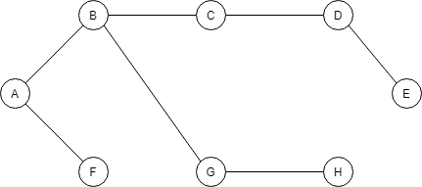

The minimum spanning tree is 23

1. Use Dijsktra’s algorithm to find the shortest path from M to T for the following graph.

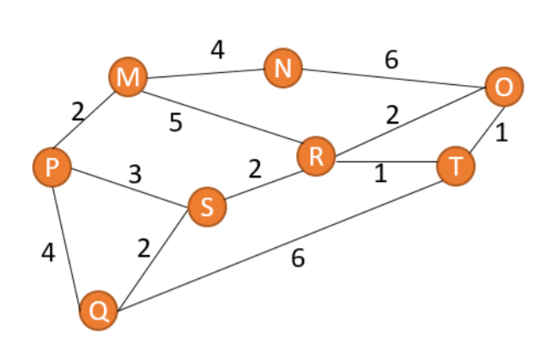

|  |  |  |  |  |  |  |  |  |  |  |
| --- | --- | --- | --- | --- | --- | --- | --- | --- | --- | --- |
| No. | S | N | L(M) | L(N) | L(O) | L(P) | L(Q) | L(R) | L(S) | L(T) |
| 0 | { } | {M, N, O, P,Q, R, S, T} | 0 |  |  |  |  |  |  |  |
| 1 | {M} | {N, O, P,Q, R, S, T} | 0 | 4 |  | 2 |  | 5 |  |  |
| 2 | {M, P} | {N, O, Q, R, S, T} | 0 | 4 |  | 2 | 6 | 5 | 5 |  |
| 3 | {M, P, N} | {O, Q, R, S, T} | 0 | 4 | 10 | 2 | 6 | 5 | 5 |  |
| 4 | {M, P, N, R} | {O, Q, S, T} | 0 | 4 | 7 | 2 | 6 | 5 | 5 | 6 |
| 5 | {M, P, N, R, S } | {O, Q, T} | 0 | 4 | 7 | 2 | 6 | 5 | 5 | 6 |
| 6 | {M, P, N, R, S, Q} | {O, T} | 0 | 4 | 7 | 2 | 6 | 5 | 5 | 6 |
| 7 | {M, P, N, R, S, Q, T} | {O} | 0 | 4 | 7 | 2 | 6 | 5 | 5 | 6 |

The shortest path is M-R-T