

**TECHNOLOGY AND INFORMATION SYSTEMS**

**SCSP 1513 (SEC-08)**

**SCHOOL OF COMPUTING**

**UNIVERSITI TEKNOLOGI MALAYSIA, 81310, JOHOR BAHRU**

**JOHOR, MALAYSIA**

GROUP REPORT

**INDUSTRIAL TALK 2 – NALI SYMPOSIUM**

**25TH -26TH SEPTEMBER 2018**

PREPARED FOR

**Dr. AZURAH BTE A SAMAH**

PREPARED BY

**SHARIZZAT BIN SHAMSUL**

**BADRUL FITRI BIN SHAIFUL NAIM**

**MD. FARDIN MUTTAKI**

**MATHESH A/L KUMAR**

**YOUSSEF MOHAMED HAMED ABDO**

**New Academia Learning Innovation (NALI) 2018**

New Academia Learning Innovation (NALI) 2018 is an exhibition and competition held at Dewan Sultan Ismail, UTM Johor Bahru on 25th and 26th September. The NALI exhibition and competition is organized by UTM Academic Leadership (UTMlead) in collaboration with School of education, Faculty of Social Science & Humanity and Asia Technological University Network (ATU-NET). New Academia Learning Innovation Model is a framework comprising student-centred and blended learning philosophy, multiple learning modes and materials towards achieving entrepreneurial academia. Entrepreneurial Academia is the outcome of New Academia Learning Innovation Model. NALI is in line with the National Higher Education Strategic Plan (PSPTN). The plan has now reached Phase 2 (2011-2015 – Enhancement and Empowerment). At this phase, the focus is given on improving the quality of teaching and learning with the implementation of Student-centered teaching methods. Based on the NALI2018 website, the purpose of the event is :

* To recognize NALI research and innovation products in teaching and learning through exhibition and competition
* To be the platform for sharing of research and innovation products in teaching and learning
* To improve educators competency in practicing teaching and learning in the 21st Century through NALI talk series and workshops,
* To improve STEM awareness among educators in practicing NALI
* To emulate best teaching and learning practices from the World’s best universities.
* To develop UTM own identity related to teaching and learning models, activities, materials, environments and systems.
* To create meaningful and interactive learning activities, materials, environments and systems appropriate to UTM Graduate Student Attributes.

Therefore they target the students to welcome and gain knowledge and experience from the exhibition.

Throughout the event, our group consist of 5 members which is is Youssef Mohamed Hamed Abdo, Badrul Fitri Bin Shaifull Naim, MD. Fardin Muttaki, Sharizzat Bin Shamsul andMathesh A/L Kumar manage to go some of the booth there to get the knowledge and the information about the innovation from that booth. Due to a lot of classes, we lack of time to stop by at all the booth there. The booths that we manage to go titled School Go Green, Using Toy Bricks as an Innovative Teaching in Operations Management and Collaborative Online Social Learning Activities (COSLA).

The aim of **SCHOOL GO GREEN** to develop the social community engagement between students and community through greening the environment The objective of this program is to inculcate the awareness on the importance of protecting our nature here is an example of some issues that need to be fixed:

**Oil Drilling-** This issue is one that causes a great deal of environmental destruction. Our dependence on fossil fuel is a global addiction that affects every aspect of the world. Oil spills and offshore drilling poison marine life, oil drilling (on land) suffocates the earth, and the combustion of fossil fuels add to the increased atmospheric CO₂, which in turns causes the progression of global warming and ocean acidification. This is a multifaceted issue and is a good cause to get involved with because it covers such a broad spectrum of issues.

\***Deforestation-** Millions of acres of forest are cut down for industrial benefit, such as large scale farming, oil mining, and the production of paper goods. Deforestation causes wildlife and biodiversity extinction. The International Union for Conservation of Nature (IUCN) has a Red List of environmentally threatened species with up-to-date information. Oftentimes, the cause for their threatened existence is listed as loss of habitat as it is for many Amazonian species.

\***Production of Plastic Goods-** Currently our society creates a great deal of waste and much of that waste is comprised of plastic. According to the Environmental Protection Agency (EPA) in 2010 alone 31 million tons of plastic waste was created. This waste ends up all over the globe in both land and water, a good example is the Great Pacific Garbage Patch. Not only is plastic waste an issue, but the production of plastic is also dependent on fossil fuel combustion. According to the U.S. Energy Information Administration (EIA) in 2010 191 million barrels of liquid petroleum gases (LPG) and natural gas liquids (NGL) were used in the U.S. alone to produce plastic goods.

The ideas from the School Go Green project as a new learning innovation is by:

\***create more planting areas at school in promoting oxygen production**

For this objective we are a lot of advantages for example teaching the how to plant a tree and water there tree and another example it will produce more oxygen for the school if they mad a planting area in the school

\***to create more lively and beautiful areas at school**

Examples for this objective is making **Keep your classroom layout flexible**

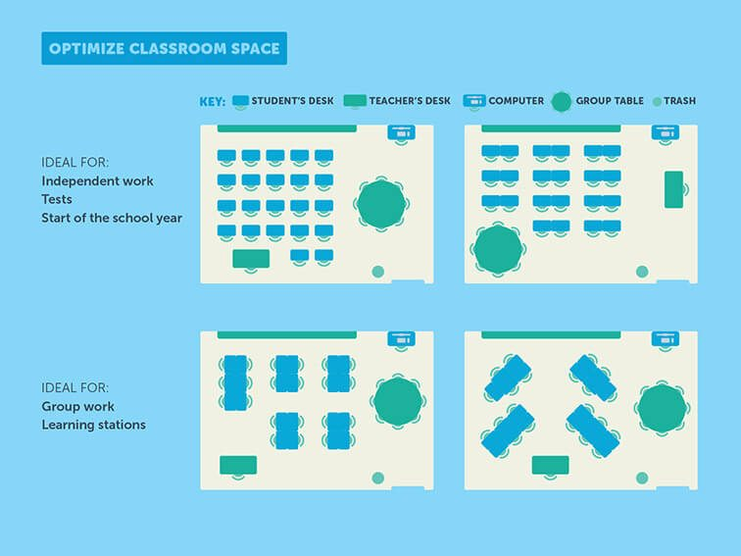

**\*****Creating botanical garden and harvesting their crops eventually**

Example for this after the school children have learned to plant a tree or vegetable or a fruit plant the will harvest what ever comes from it and serve it as a school food in the school

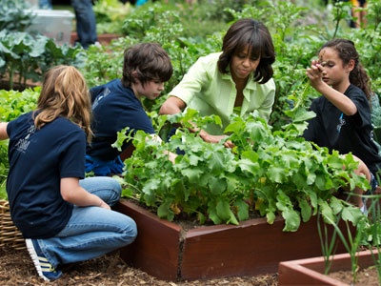

**\*To share with the school pupils hands-on on herb and trees planting exercises**

Examples for this objective Is School children can take an active role in helping to green their schools by teaming with their teachers, administrators, and parents to plant trees on their school property. These projects pay multiple benefits by improving environmental conditions and providing multi-disciplinary learning for students of all ages.

Next, Using Toy Bricks as an Innovative Teaching in Operations Management, this is an innovative technique of teaching Operation Management course using toy bricks stimulation game. This course (Operation Management ) is typically delivered through lecture, discussion, studies and case studies. The toy bricks stimulation game was introduced in class to stimulate production scenario in order to get some feedback on the effectiveness of this technique, a survey has been conducted in investigating students perspectives. Findings from the survey show that majority of the students agreed that this technique increase their interest and understanding of the subject, it is regarded as a valuable tool in learning Operation Management course and should be incorporated in the future business curriculum.

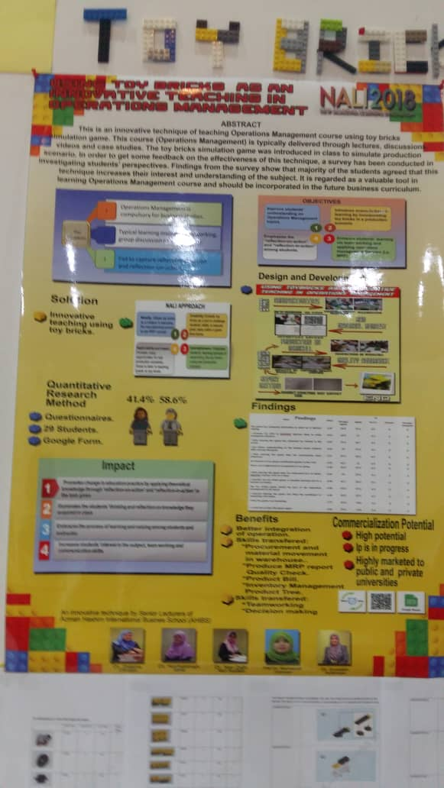

Solution :

* Innovative teaching using toy bricks for increase their interest and understanding of the student in Operation Management

Quantitative Research Method :

* Questionnaires
* Google forms

Benefits :

* Help enhance motor skills and hand-eye coordination
* Promote better spatial reasoning
* May enhance cognitive flexibility (ability to quickly shift your focus from one relevant stimulus to another)
* Toy blocks are linked with language development
* Toy blocks may stimulate creative, divergent problem-solving
* Cooperative construction play helps kids improve social skills
* Construction play develop engineering skills

Commercialization Potential :

* High potential
* Ip is in progress
* Highly marked to public and private universities

Toy blocks, also called "building blocks," are solid shapes used for construction play. Some are simple planks made of wood. Others are fancy, like the interlocking bricks of plastic made by Lego and MegaBlox. But whatever form they take, blocks can function as powerful learning tools. Studies suggest that toy blocks can help students develop

* motor skills and hand-eye coordination,
* spatial reasoning,
* cognitive flexibility,
* language skills,
* a capacity for creative, divergent thinking,
* social competence, and
* engineering skills.

There is also evidence that complex block-play is linked with higher mathematical achievement. How does it all happen? It's easy to see how stacking and arranging toy blocks could stimulate a toddler's motor development. But for other skills, it's likely that students need to do more than simply move blocks around. Research suggests that students benefit when construction play incorporates additional elements, including:

* building from templates,
* engaging in cooperative projects, and
* talking with others about spatial relationships.

The existing of Facebook brought new ways in learning for higher education setting. Facebook is one of the technological tools that can be used for online teaching and learning. Thus, a study was conducted utilizing learning materials within Facebook environment namely as Collaborative Online Social Learning Activities (COSLA) that involved five learning activities The COSLA is mainly developed based on two learning strategies which are online collaborative learning and online problem involving learning Authoring Language subject. The COSLA as tested among 23 undergraduate's students within 34 weeks. The finding shows that the COSLA has a positive and impactful effect on student’s performance. COSLA can foster the ability of being students centered learner, engaging and empowering students throughout in their learning session.

The objective of the innovation is:

* To design the interactive and comprehensive learning materials namely Collaborative Online Social Learning Activities (COSLA) in Facebook.
* To investigate the effect of Collaborative Online Social Learning Activist OSLA) toward student' performance.
* To examine the strength of Collaborative Online Social Learning Activities (COSLA) towards students' performance.

Innovativeness:

* Problem Solving Taks
* Collaborative Learning Task
* Learning Activities
* Facebook

Today, technology has changed the teaching and learning method. Most of instructor and students are using computer and online medium to implement teaching and learning method even though they not classroom. By using online medium, learning also can be occurred anywhere anytime. Within the learning process, psychological processes can be occurred and same goes to online learning. Psychological processes perform any types of activities that use a variety of processes such as thinking, remembering, problem solving, interpretation and others. One of the psychological processes in online learning is problem solving. Problem solving refers to the mental process that involves discovering, analyzing and solving problems (Cherry 2003) .Nowadays, by using variety of online medium, problem solving can be applied within teaching and learning through online discussion. This paper discusses about a meta-analysis of research of problem solving activities in online discussion. There are a lot of online learning medium that are used within discussion among students through online learning. For example, Facebook, e-learning, web based online, blog and online forum are the online medium used for online discussion. Positive impact to students can include:

* Students-centered learning
* Increase student’s performance
* Increase student’s engagement
* Active learner
* Improve method teaching and learning in 21st century
* Good problem solver
* Good in teamwork

A lot new ideas and innovations to improving our learning style to make it more interesting and effective to the students. We learned many new things and got new experienced especially when mostly the representative are UTM master students. That give us inspiration to study hard and compete in the international platform. The ideas they invented never we thought of it before. This shown there are many method and style in delivery a knowledge but still need to study further on it to make sure it give more positive impact on students and also for the teachers. This kind of program should continue on the other years. Our hope from this exhibition is that all the innovation can help improving our country education system to the next level.