Industrial Visit 1 – MAGICX UTM Report

Subject : Technology and Information Systems (SECP1513)
Section : 07
Lecturer : Dr. Sarina binti Sulaiman

Group 9
Members:
- Chai Ming Choy (Leader)
- Wan Nur Atiqah binti Junaidi
- Goh Jo Ey
- Zaimi Mohamed

1. Introduction
Media and Game Innovation Centre of Excellence (MaGICX) started in 2013 with a purpose of a bridging Universiti Teknologi Malaysia (UTM) and Iskandar Regional Development Authority (IRDA) to support and promote the development and ecosystem of creative industry that focuses on gamification and enrichment of digital content. MaGICX will play an essential part as the presenter for the Iskandar Malaysia Innovation Valley envisioned to offer industry players/SMEs/clients technical expertise/consultation, research/product development, business development, publishing, marketing and/or training in producing commercially.
Aiming to create an environment that donate toward talent development, industry promotion, knowledge-sharing, and international collaboration, MaGICX’s credits include projects related to augmented reality, mixed and virtual environment, image processing, computer vision, multimedia software engineering, medical computing, computer interaction, human interface, usability, animation and technology, speech and signal processing, visualization, multimedia and software innovation, and emerging technology

2. Details of the Visit
Our tour began at 2:30 p.m. at T03 building which is the with a quick introduction of Media and Game Innovation Centre of Excellence (MagicX), there was a participation of other sections from the Computing School, then all the participants got divided into multiple groups of 18 members.
Once the groups were made ,the tour started on each booth singularly , it took almost 1 hour for each group to gather information about all the projects before leaving the MagicX. There are 5 different booths in total, which are the 3D printer exhibition, driving car simulation, Kinect Interactive Wall booth, Virtual Reality (VR) of Oculus Quest and last but not least the demo on Augmented Reality (AR). Each session consists of around 15 minutes and each group take turns to visit different sections. After the visit, each group including us take turns to take a group photo for each group, and also for the whole class. The visit ended around 3.30 p.m. and all of us took school buses to go back to our hostel.
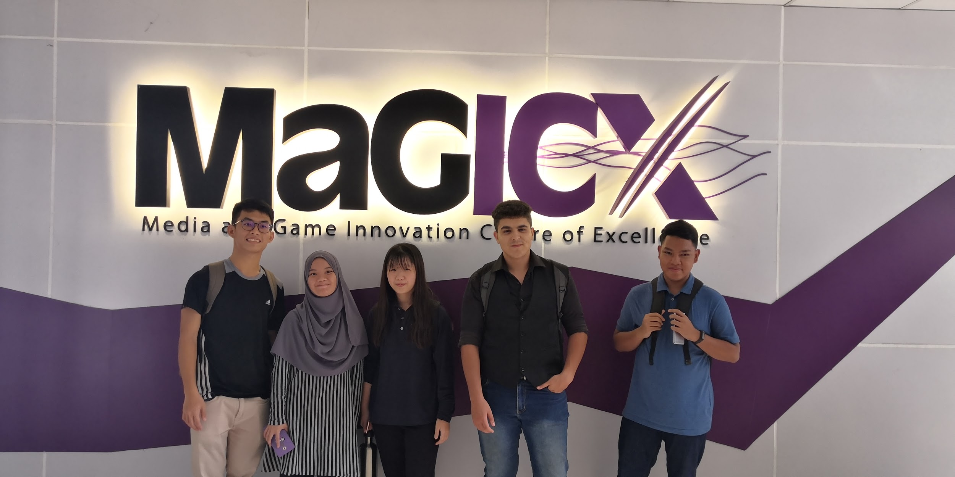
Figure 2 a: Photo of Group 9
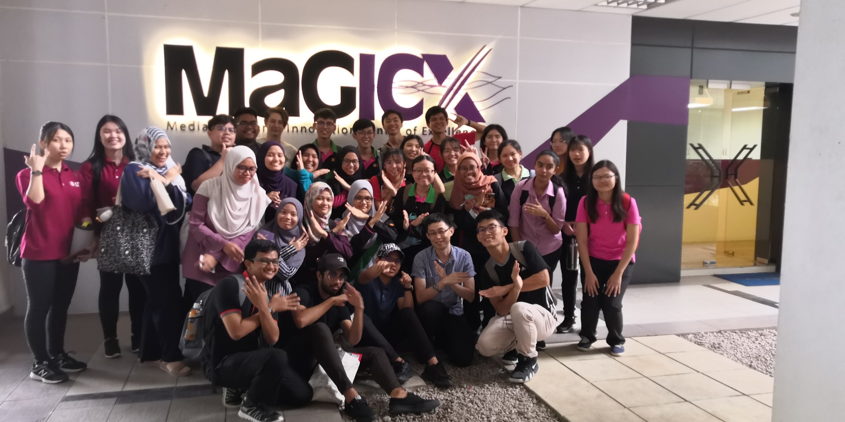
Figure 2 b: Group photo of class 1/SECV

3. Detailed Descriptions
a. MAGICX background introduction by the MAGICX Manager
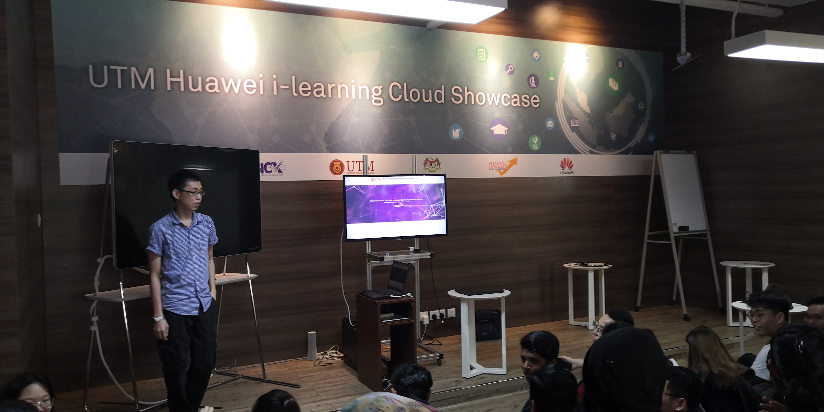
Figure 3(a) i : Introduction given by Dr. Wong Lih Fong

The visit started with a talk given by Dr.Wong Lih Fong, who is the manager of MagicX to give us some briefing about this visit and introduction to the MagicX centre. The MaGICX manager, Dr. Wong Lih Fong said that MaGICX stands for Media and Game Innovation Centre of Excellence which mainly focus on media and games development. MaGICX in UTM have been cooperating with Iskandar Regional Development Authority (IRDA) to be the anchor for Games and Gamification industry and the nucleus for Iskandar Malaysia Innovation Valley. Their main services are augmented reality (AR) for kids to learn, virtual reality (VR), mobile app and web development such as building a safety system, kinect enhancements, training and learning programme and games. On the second floor, it had been said that there is a future classroom in renovation in which a room that give a 360 degree view of what the required environment to be. For example, students decided to learn about the forest. Therefore, forest can be projected in that classroom plus additional effects such as the wind, and the sound of birds chirping can also be felt and heard. The future classroom can be linked to other schools in UTM, and it is not just limited for Science subjects. For their ecosystems, the inventors are among the Post Doc, PhD and Master students. Workshop and seminar are provided as they help, guide and teach on how to market and to become the best digital entrepreneur.
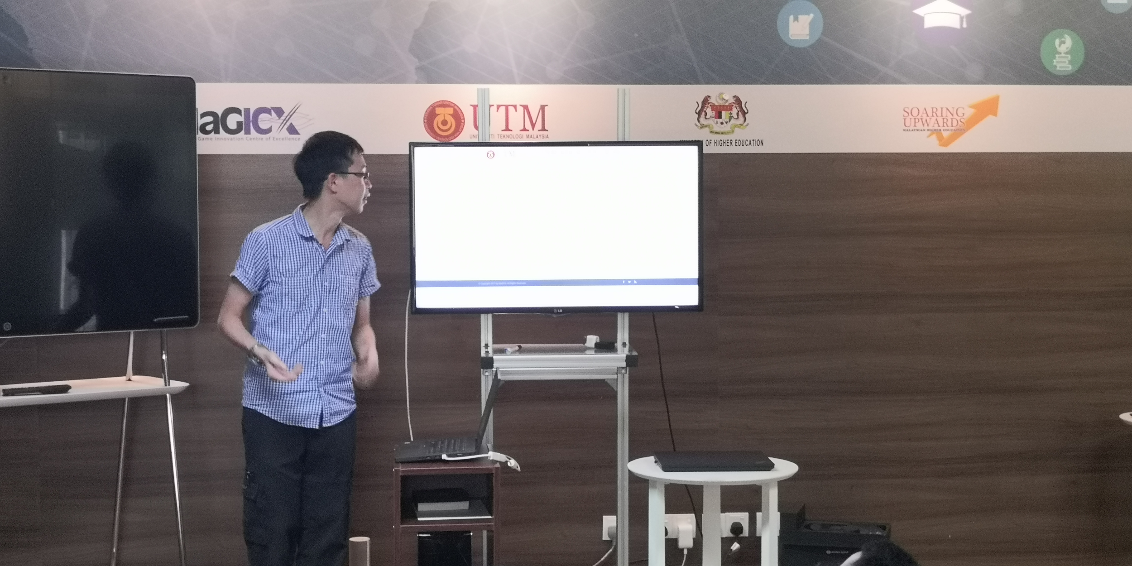
Figure 3(a) ii : Briefing by Dr.Wong on the staff and surrounding of MagicX

b. Exhibition on 3D printer
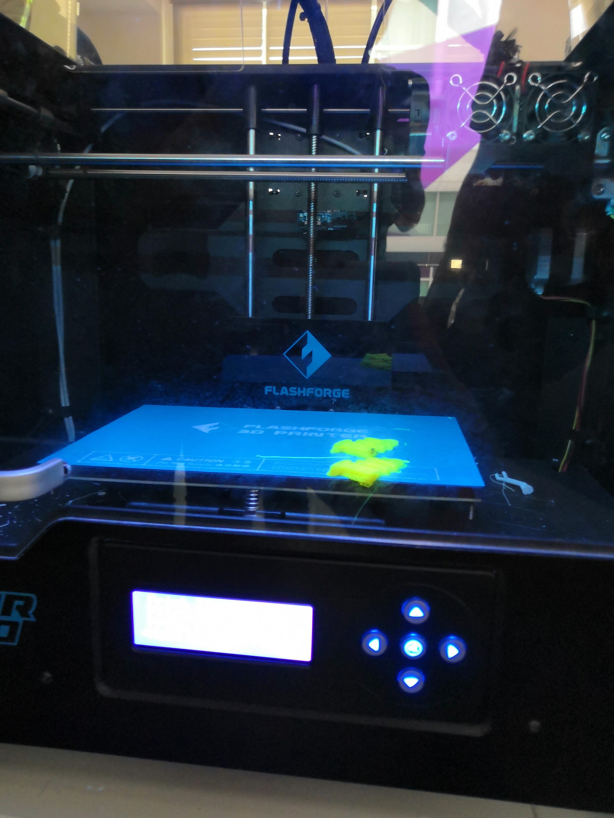
Figure 3(b) i : The front view of 3D printer in MagicX

3D printing is also one of the technology used in media and gaming industries and it is also shown in this exhibition. This session is conducted by a senior UTM student which is also one of the “Magician” in MagicX. 3D printing is also known as additive manufacturing. It is a manufacturing process where a 3D printer creates three-dimensional objects by depositing materials layer by layer in accordance to the object’s 3D digital model. According to the speaker, the 3D printer is usually used to produce prototype of a product to see its appearance before launching it to the market or starting to produce abundantly in the factories. The common material used for 3D printing are a 3D filament. A 3D filament is a 3D printer plastic that is used to make three-dimensional printing. Different types of 3D printer can withstand or support different usage of materials. For the 3D printer in MagicX, it uses the ABS (Acrylonitrile ButadieneStyrene) and PLA ( Polylactide or Polylactic acid) filament as its material for 3D printing. There are also other types of 3D filaments such as PVA (Polyvinyl alcohol), PET or PETG (Polyethylene terephthalate), HIPS (High impact plastic) and also other materials other than plastic for example nylon, wood, sandstone, metal, magnetic iron and carbon fiber depending on which type of materials is supported by the 3D printer.
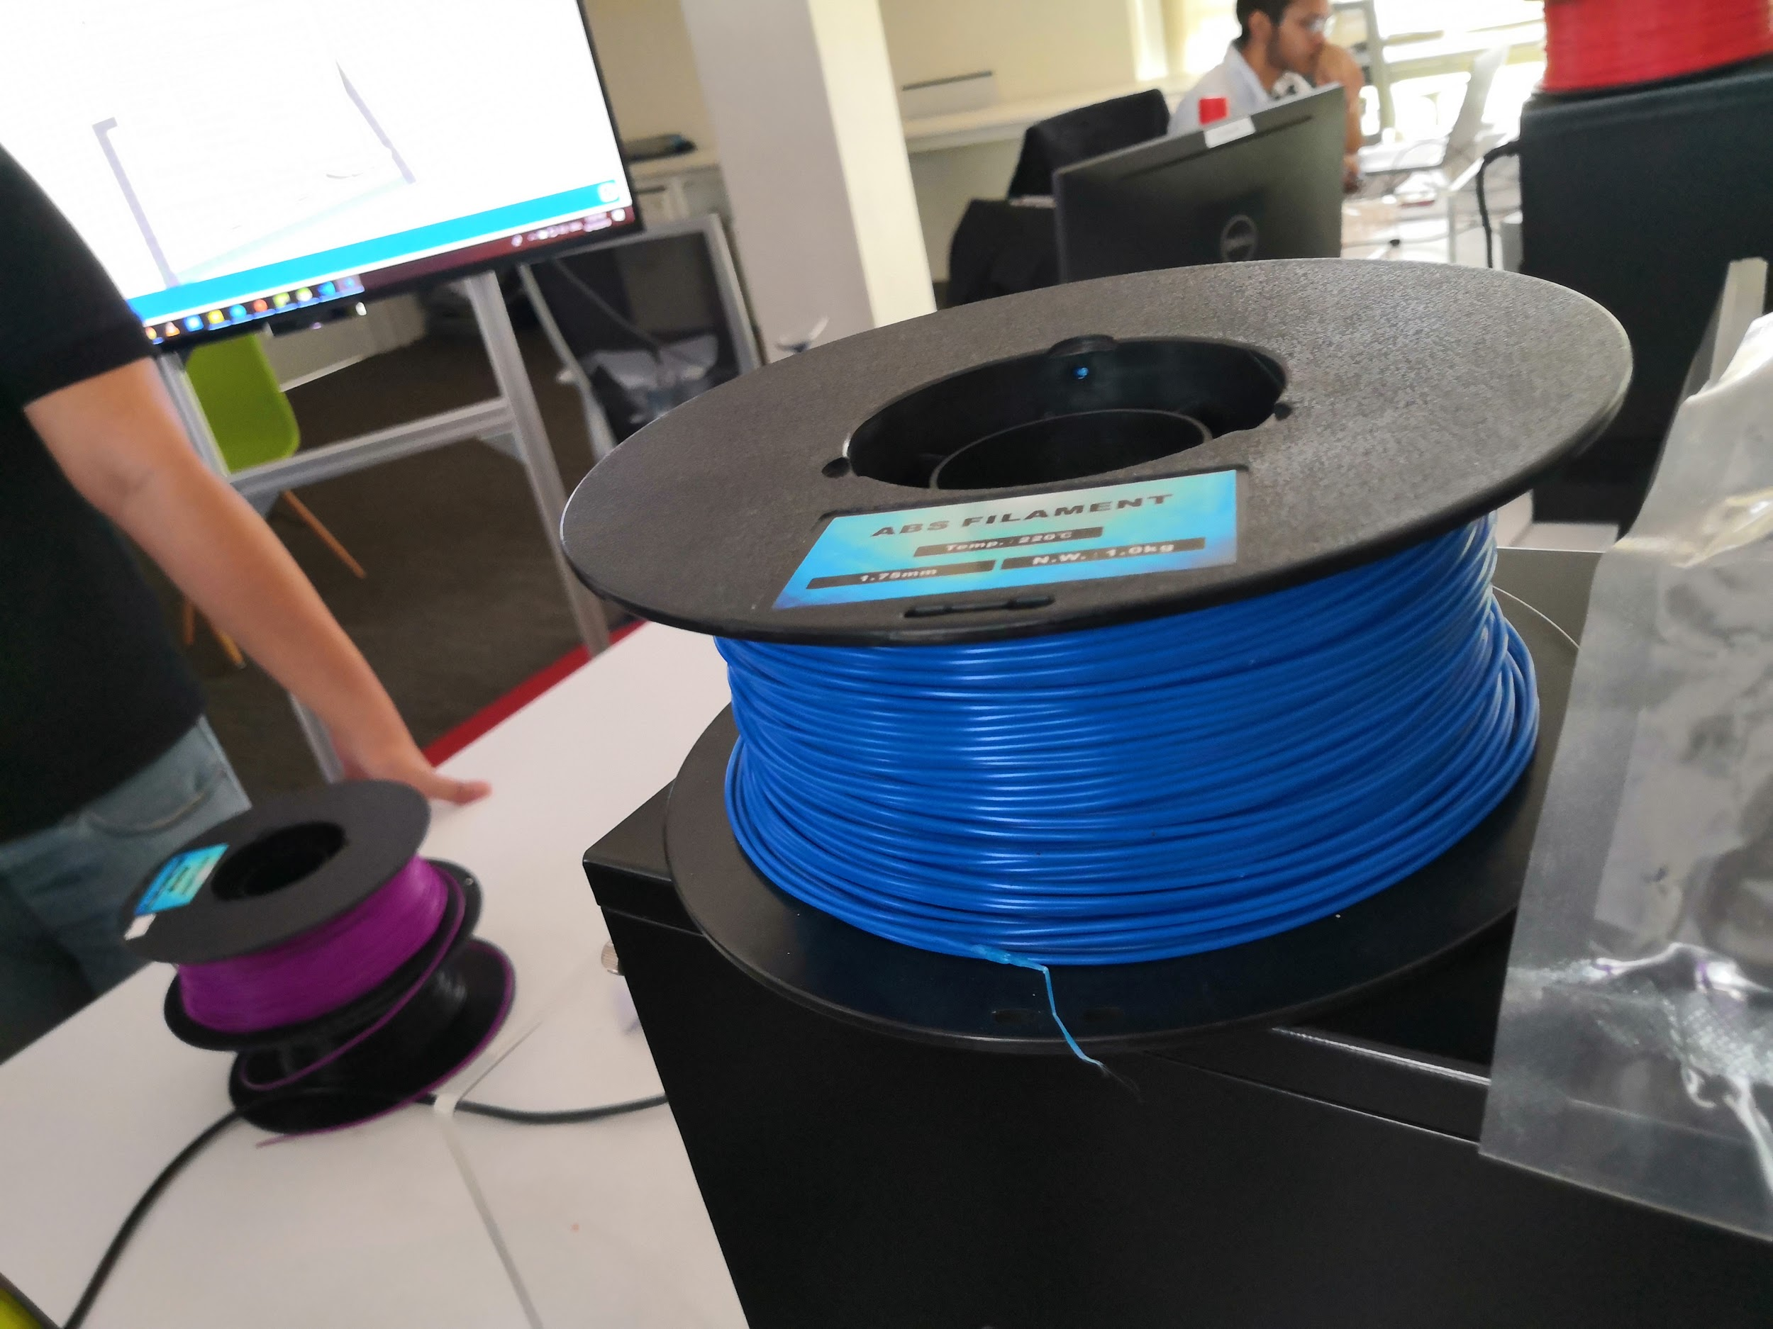
Figure 3(b) ii : ABS filament used for 3D printing
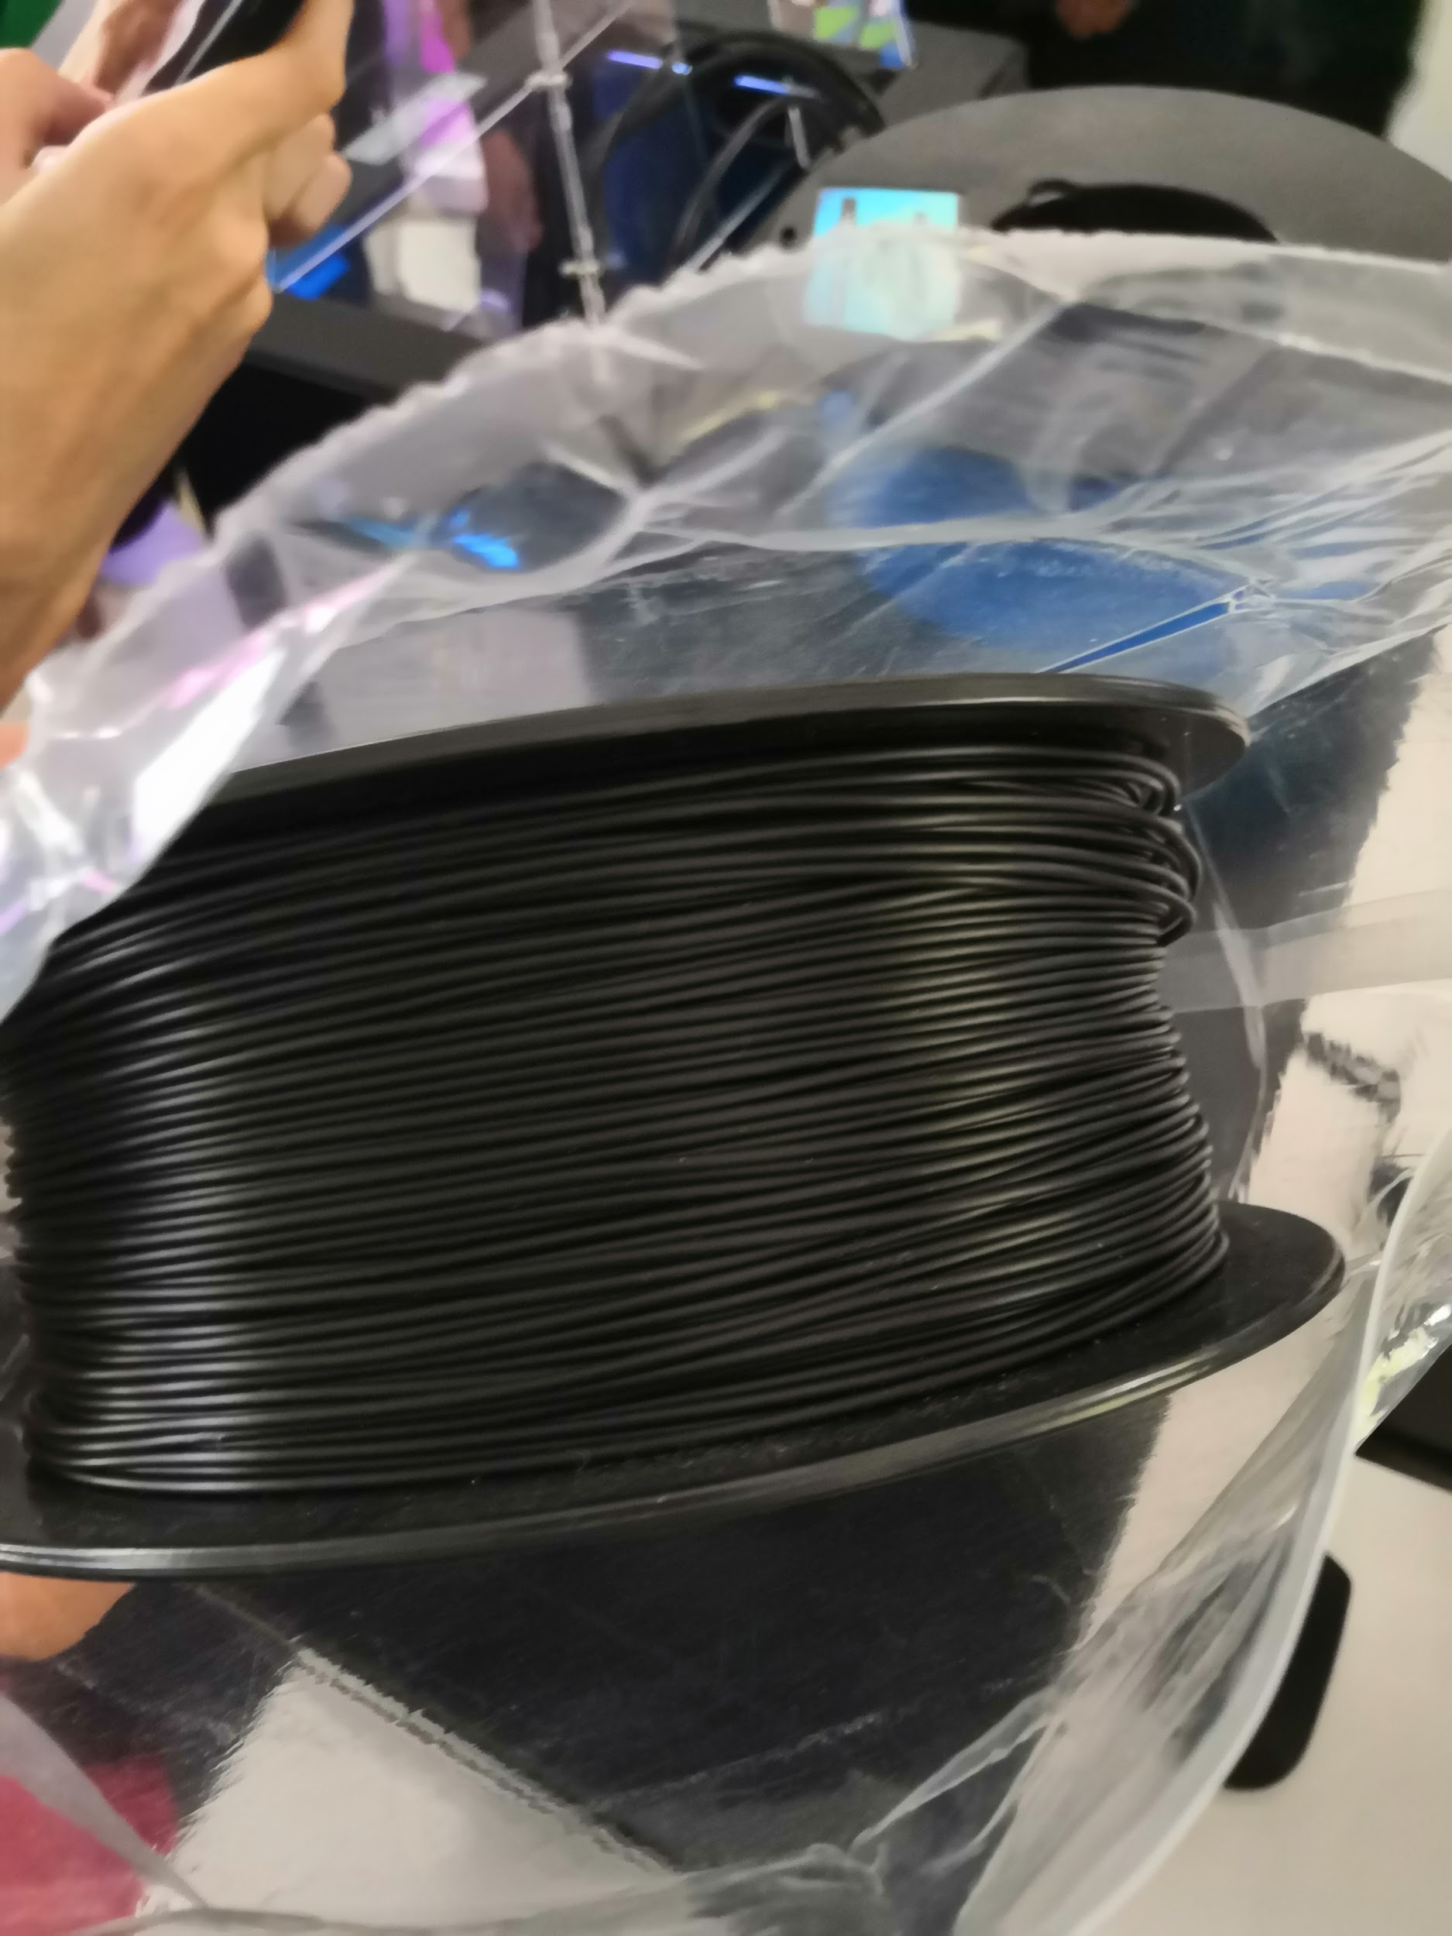
Figure 3(b) iii : Black ABS filament
There are a few simple steps in order to perform 3D printing. First, we need to select the model that we want to print from our computer. This can be done by using online 3D printing webpage as there are many 3D models prepared for 3D printing used. The 3D printing website recommended or used by the speaker are https://www.thingiverse.com/. The website provides digital design file for 3D model which can be printed.
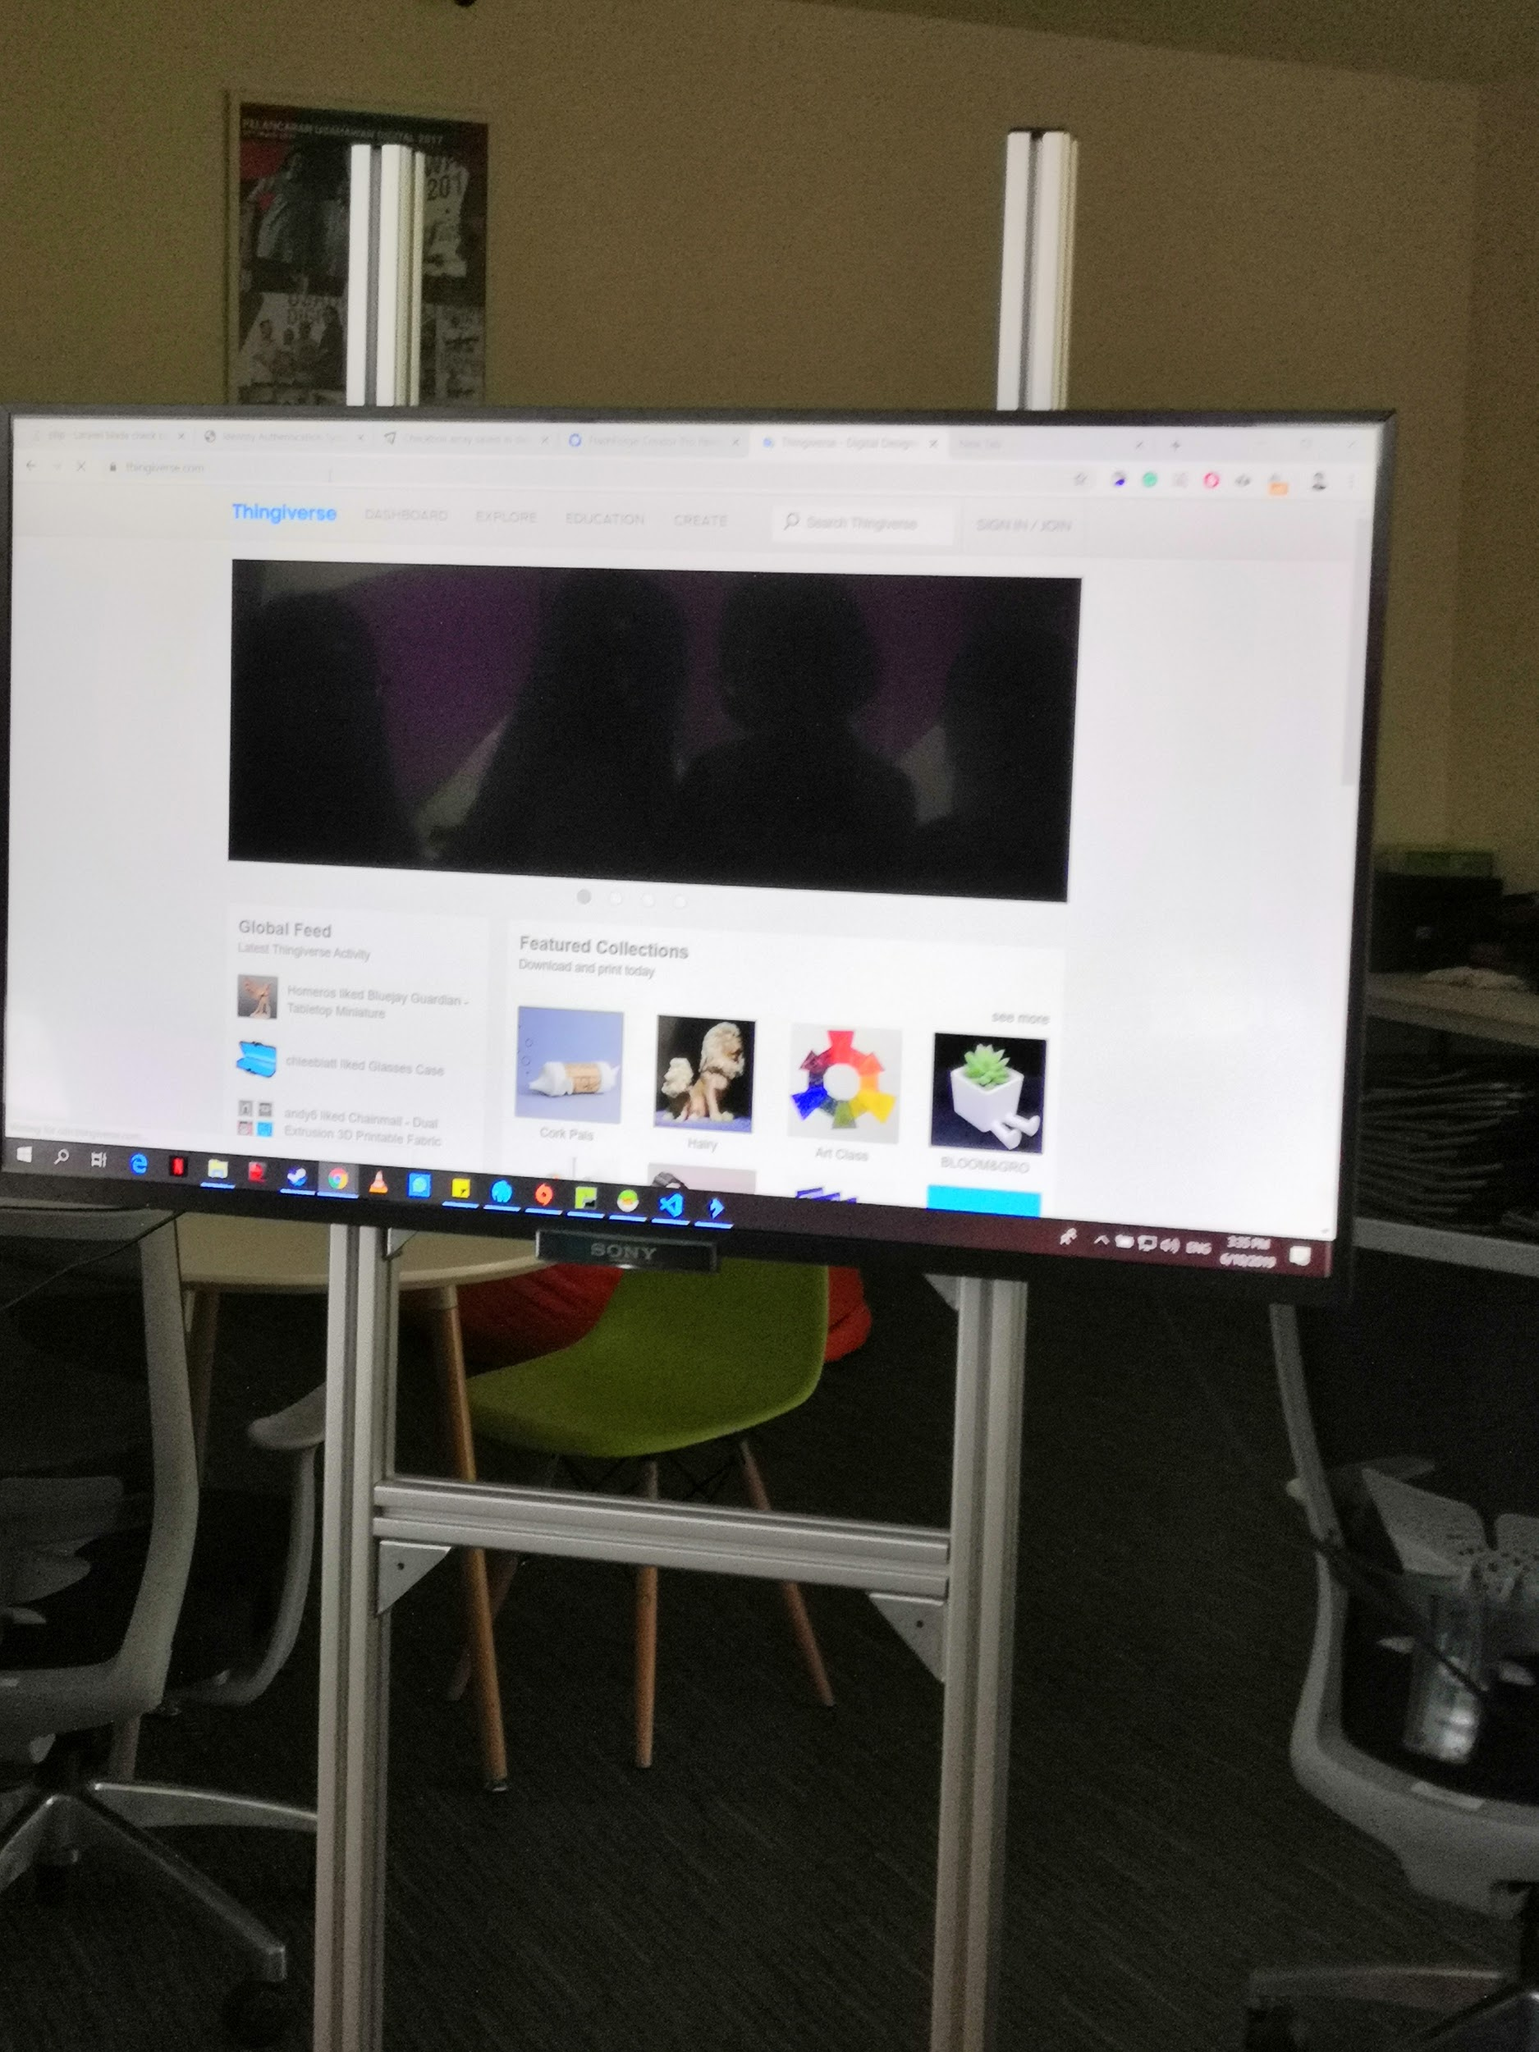
Figure 3(b) iv : 3D printing website used for 3D modelling
It is really convenient and user friendly as you only need to select the type of model to print and the user can do some adjustment on the angle or orientation of model that will be printed out. After selecting and adjusting, the file is then saved to an SD card. The speaker emphasizes that the file type must be saved in STL type (the most common digital design file type) in order to let the printer read the file. The SD card is then inserted into the slot in the 3D printer machine. Then, from the interface of the printer, select the file that the user would like to print from the SD card. Then, click “print” and the printer will automatically start printing the 3D model which is designed in the file. The printing will take quite some time, usually half a day even for a small model, and can take up to a few weeks or months for larger model.
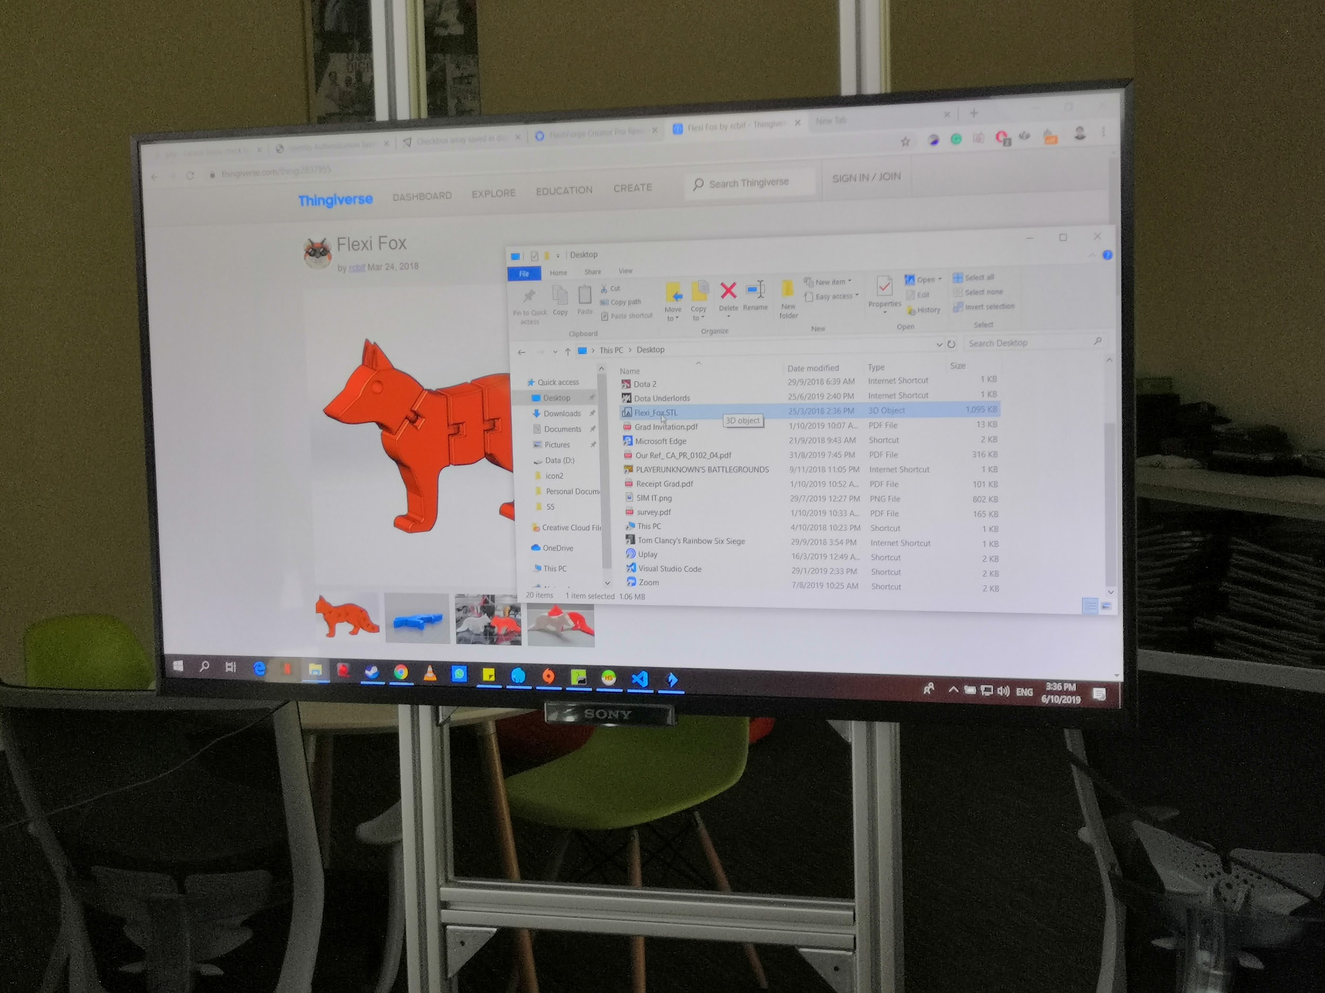
Figure 3(b) v :Fox model printing file
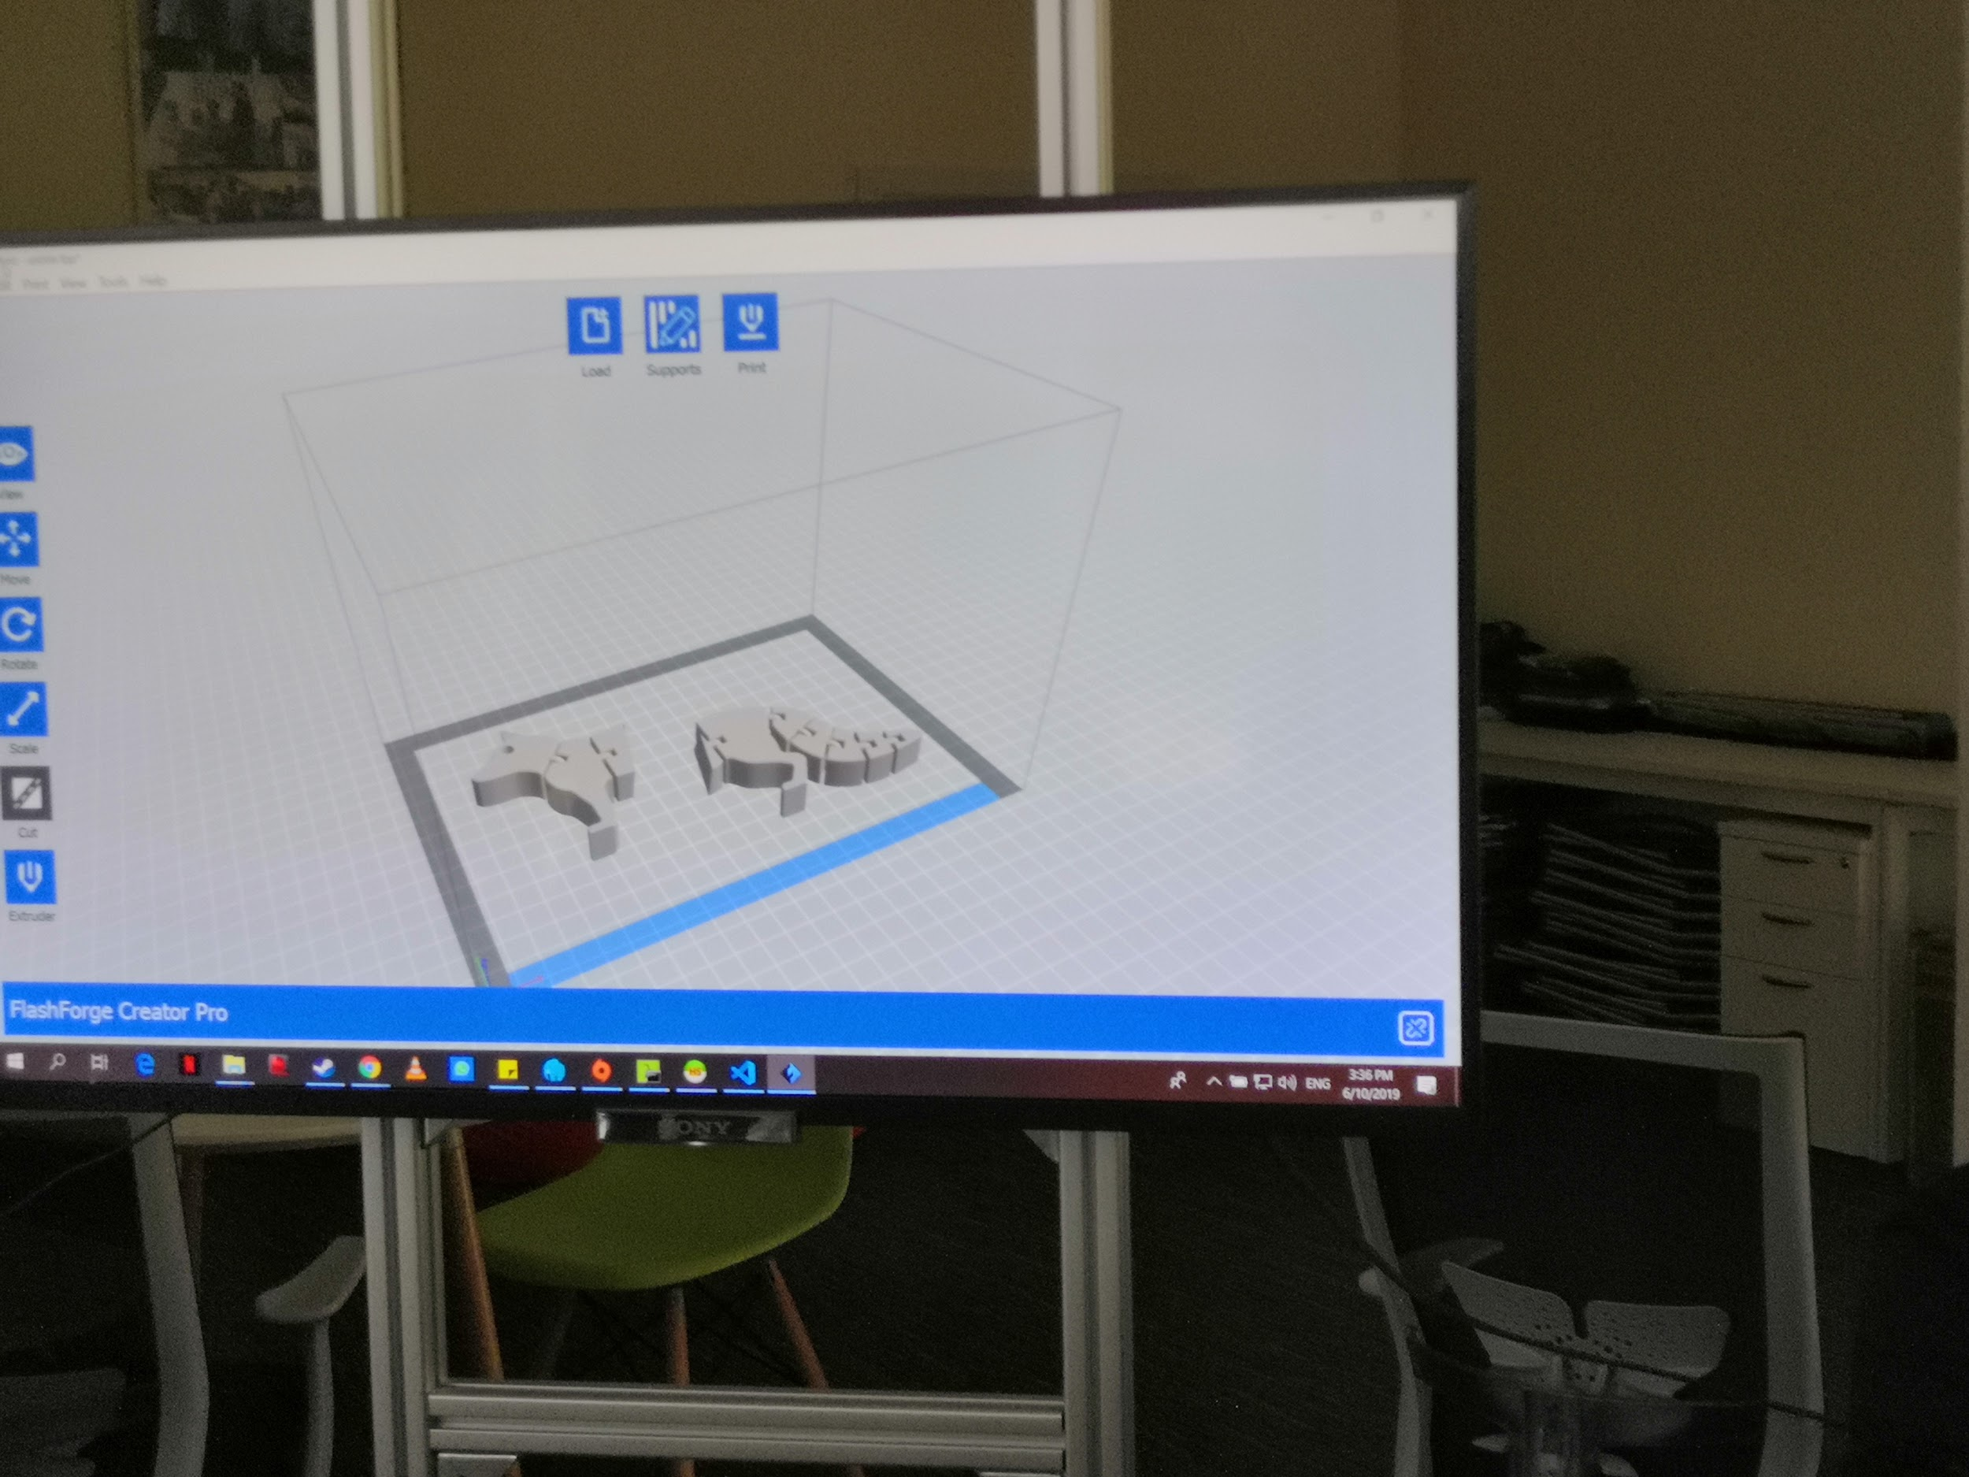
Figure 3(b) vi : Orientation and adjustment made to the fox model

c. Driving Car Simulation
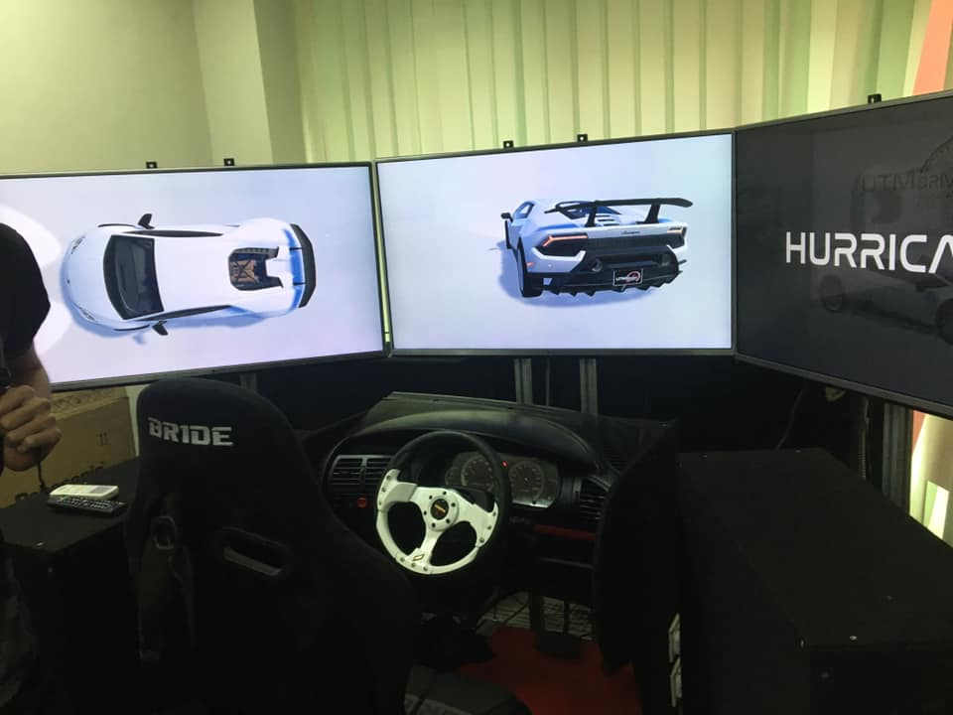
Figure 3(c) i : The model of Driving Car Simulation
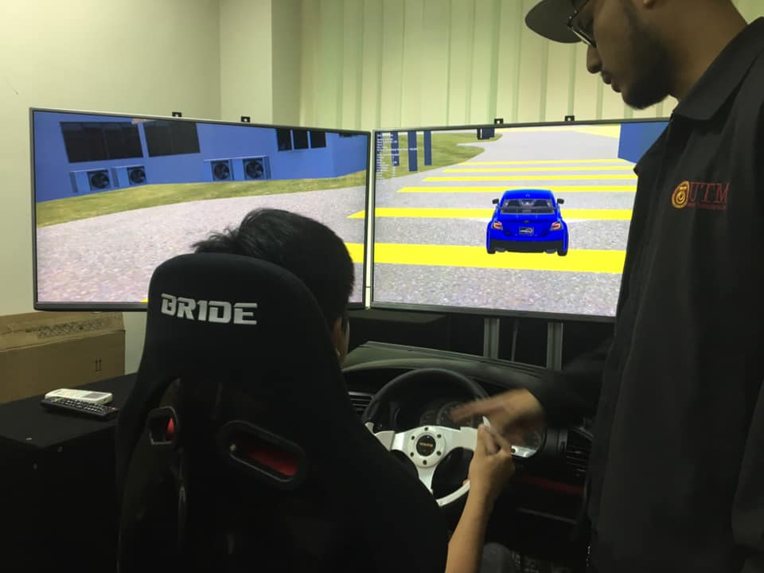
Figure 3(c) ii: The user drive with Driving Car Simulation
Figure 3(c) iii : The data of Driving Car Simulation
Driving simulation is an innovation of 3D technology that provides the user with a realistic interpretation of operating cars. Driving simulation gives people hands-on experience in driving and study driver behavioral issues. This innovation can educate people about safe driving. It also provides data analysis for the study and research of vehicle engineering.
It provides a real interior of the car such as a steering wheel, brake pedal, gear selector and more with a 3D screen in front of the seat. The driving car simulator enables the user to experience real driving. Through the demonstration of driving car simulation in the visit to the MAGICX, the driver can experience driving in the environment of the university. First, the user can choose the car he or she wanted by turning the steering wheel before starting the journey. After that, the user can drive by using the driving car simulation realistically. If any accident occurs during the user’s driving throughout the journey of using driving car simulation, the sensor is able to detect and show on the screen as “critical damage”. The user can restart the journey by pressing a button on the left of the steering wheel.
The environment of UTM is presented in a real-time interactive three-dimensional virtual images. The 3D scene management in the driving car simulation requires high technology in graphics. Driving car simulation is using Adreno Software for the 3D display. By using Adreno Software, all the graphics such as roadway modeling, building modeling, greenery enhancement has been done in three-dimensional and rendering in a virtual environment. In a collaborative driving simulation, the responses of VE objects with respect to human driver’s maneuvering must be displayed in real-time conditions.(Lee and Kang, 2017)) In order to do so, the longitudinal velocity, lateral velocity and yaw motion of the virtual reality car model are the important data that are needed to study for this innovation. Besides, the data of the driving process such as speed profile, times of brake and times of horn are recorded on the top left of the screen. All these data can be analyzed and recorded as the references for the study of driver behavioral issues. Driving car simulation is an important innovation no matter in the study of driver behavioral or vehicle engineering in the future.

d. Explanation on Kinect Interactive Wall
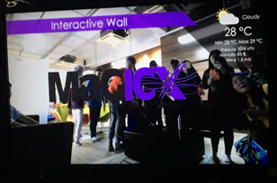
Figure 3(d) i : Kinect Interactive Wall
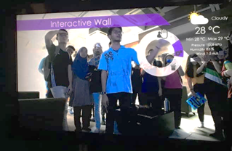
Figure 3(d) ii : The user interacts with the Kinect Interactive Wall
Figure 3(d) iii : The user interacts with the Kinect Interactive Wall
Kinect interactive wall is an innovation that uses the coordination of hands and eyes. Kinect interactive wall developing an interactive education. This application involves a blending of mental and physical activities and creates a new learning scenario. The action of the user can be detected and viewed by the camera to interact with the application. The instructions to use this application is very simple, which is by standing in front of the camera of Kinect Interactive Wall for the sensor to detect and move the user’s hand to the selection area and close his or her palm. For instance, the user can move his right hand to his option and close his palm for option selection.
Through the demonstration of the manager in the visit, we get to know the information of MAGICX such as the introduction of MAGICX and some images of the facilities in MAGICX. Kinect interactive wall makes the information delivered in a more interesting way unlike delivering any information through magazines or papers in the past. This kind of learning involves the whole body to respond to the application. If this application is applied in the lecture room, learning in the lecture room through the “Kinect interactive wall” enables students to not just sit down and listen to the lecturer, but they also need to move themselves to interact with the application to get any information or knowledge. Students need to concentrate and react to the application all the time.
This application can also promote student-centered learning method. The Kinect Interactive Wall is a product that makes learning and teaching in the lecture room or classroom more interesting. Kinect interactive wall can conduct more effective and productive learning since students are paying more attention to the lessons.

e. Demo on Virtual Reality of Oculus Quest
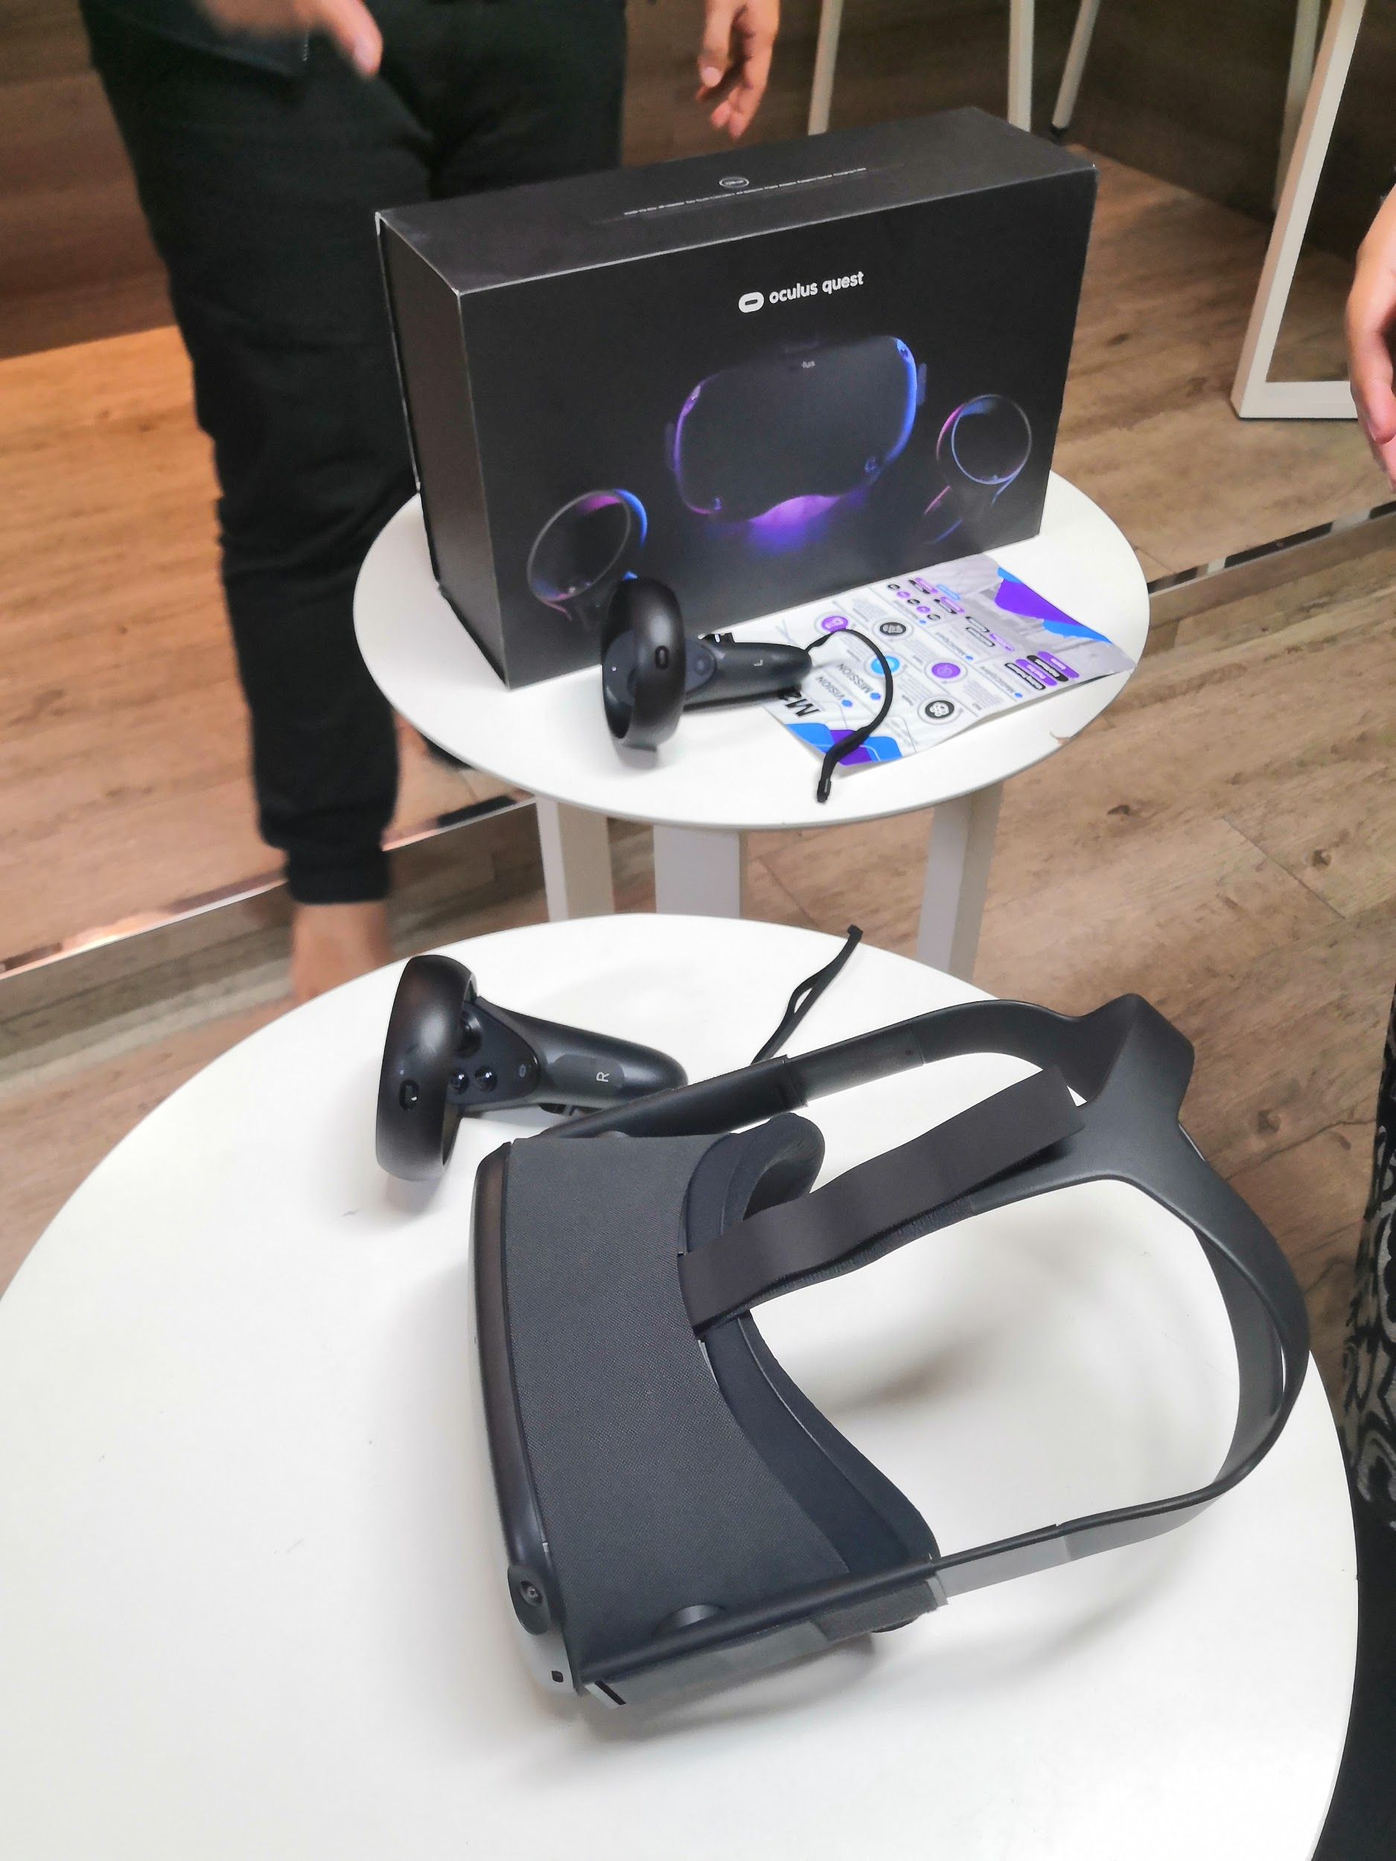
Figure 3e(i): Oculus Quest Set
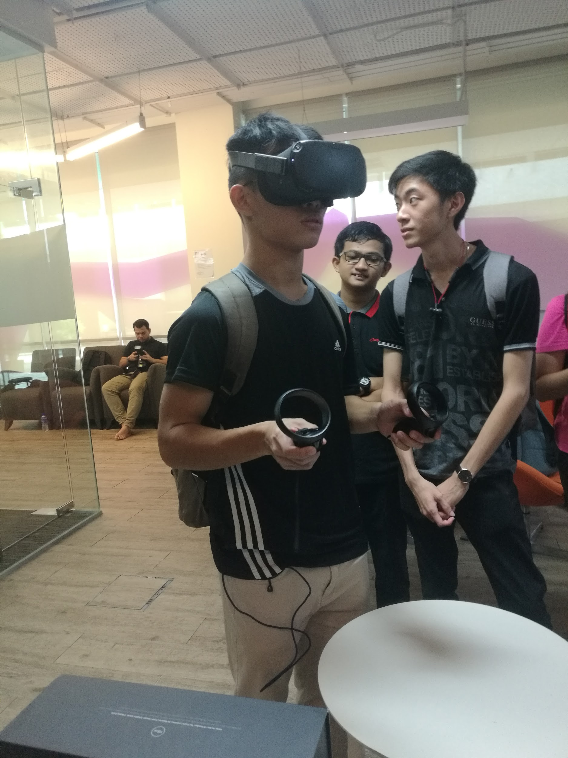
Figure 3e (ii): User experiencing VR of Oculus Quest
Virtual Reality (VR) is one of the technology that had been shown to us during our industrial visit. VR is the use of computer technology to create a simulated environment (Bardi, 2019). It basically gives the user the experience of being there in reality but it is actually just a virtual point of view. We are able to interact in the 3D world and with the existence of sound effect. We are able to hear and totally immersed in the virtual environment. These elements lends a powerful sense of presence to a virtual world.

We have been given the chance to experience the VR by using the Oculus Quest. We were provided with the headset and two touch controllers. The benefits of Oculus Quest are easy to set up in any room, has precision controllers and has all-in-one VR. Oculus Quest has insight tracking and touch controllers in which every move, punch and throw would be instantly translated into VR. Thus, it will look as real as you think. No PC and wires are required to experience the VR. Plus, there is no limit which you can walk inside a room without worries. Even at home or at a new place, Oculus Quest can still work normally. Using Oculus Quest to experience VR is better than using phone.

To conclude, VR is used today mostly in video games or accessing to Youtube in order to get a new and thrilling experience and makes the user experience better as well. However, most importantly, VR plays a vital role for education for example in medical uses especially for surgery. The surgeon or students can practice their surgical skills without having to use a real body. An automobile industry student can also try to fix an automobile module by using simulation in VR. Malaysia is on its way to fuse VR in education in the future .

f. Demo on Augmented Reality for Kids Learning
Augmented reality (AR) is a type of interactive, reality-based display environment that takes the capabilities of computer generated display, sound, text and effects to enhance the user's real-world experience. Augmented reality combines real and computer-based scenes and images to deliver a unified but enhanced view of the world. (AR) is a type of interactive, reality-based display environment that takes the capabilities of computer generated display, sound, text and effects to enhance the user’s real world experience.

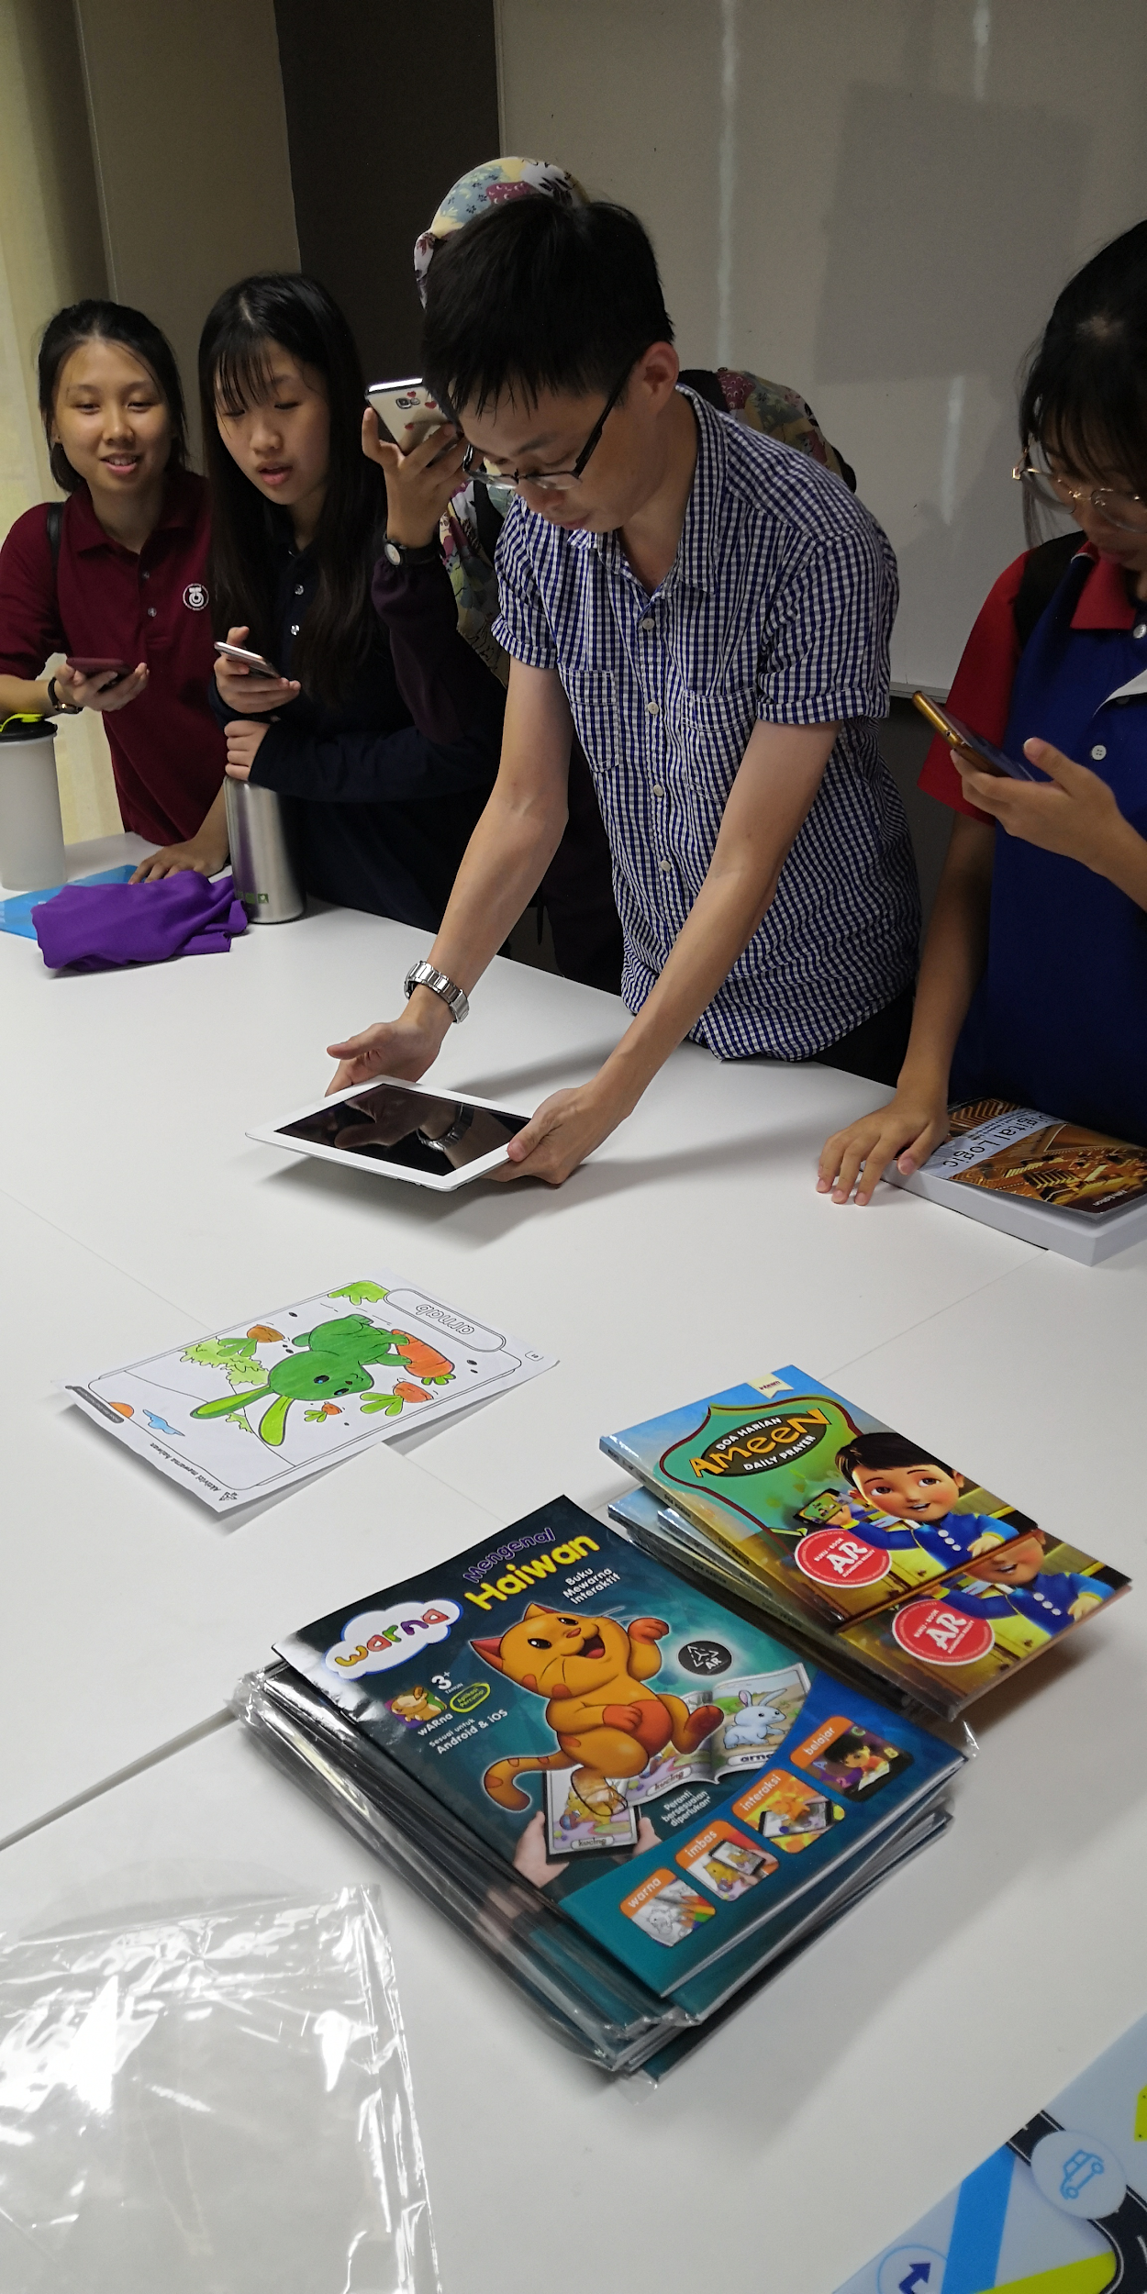
Figure 3(f) i : Introduction on AR in learning by Dr.Wong
This AR demo session is conducted by Dr.Wong Lih Fong. He said that the AR technology is a good combination with the educational content as it creates a new type of automated applications and acts to enhance the effectiveness and attractiveness of teaching and learning for students in real life scenarios. Application can be created aligned with the content of the book in order to make the learning and teaching process more vivid and interesting for both teachers and students. AR teaching enables the teacher to explain something which is abstract more detailed and with more ease as AR technology brings the life out of a boring lessons of facts and theories. Students are able to remember and gain more interest in learning by using AR as the display, sound and text is more lively than just a plain text textbook.

Figure 3(f) ii : The rabbit become lively after scanning from the book into the application in the tablet

Dr.Wong showed us an example of AR learning during the session. An application corresponded to a drawing book is used. It requires the use of phone or tablet in order to download the application. Then, the application enables the user to scan the image in the drawing book, for example a rabbit. When the image of the rabbit is scanned or detected by the application, the application will display a living rabbit and its sound, while reading out the texts in the book. The colour of the image will also be detected and displayed by the application. Through this, an animation of the animals will be shown and the user can learn more effectively through this method, as it is very interesting to see something concrete suddenly becomes lively through AR. This can help children to be more creative and develop a good interest in learning by the help of AR technology in education.

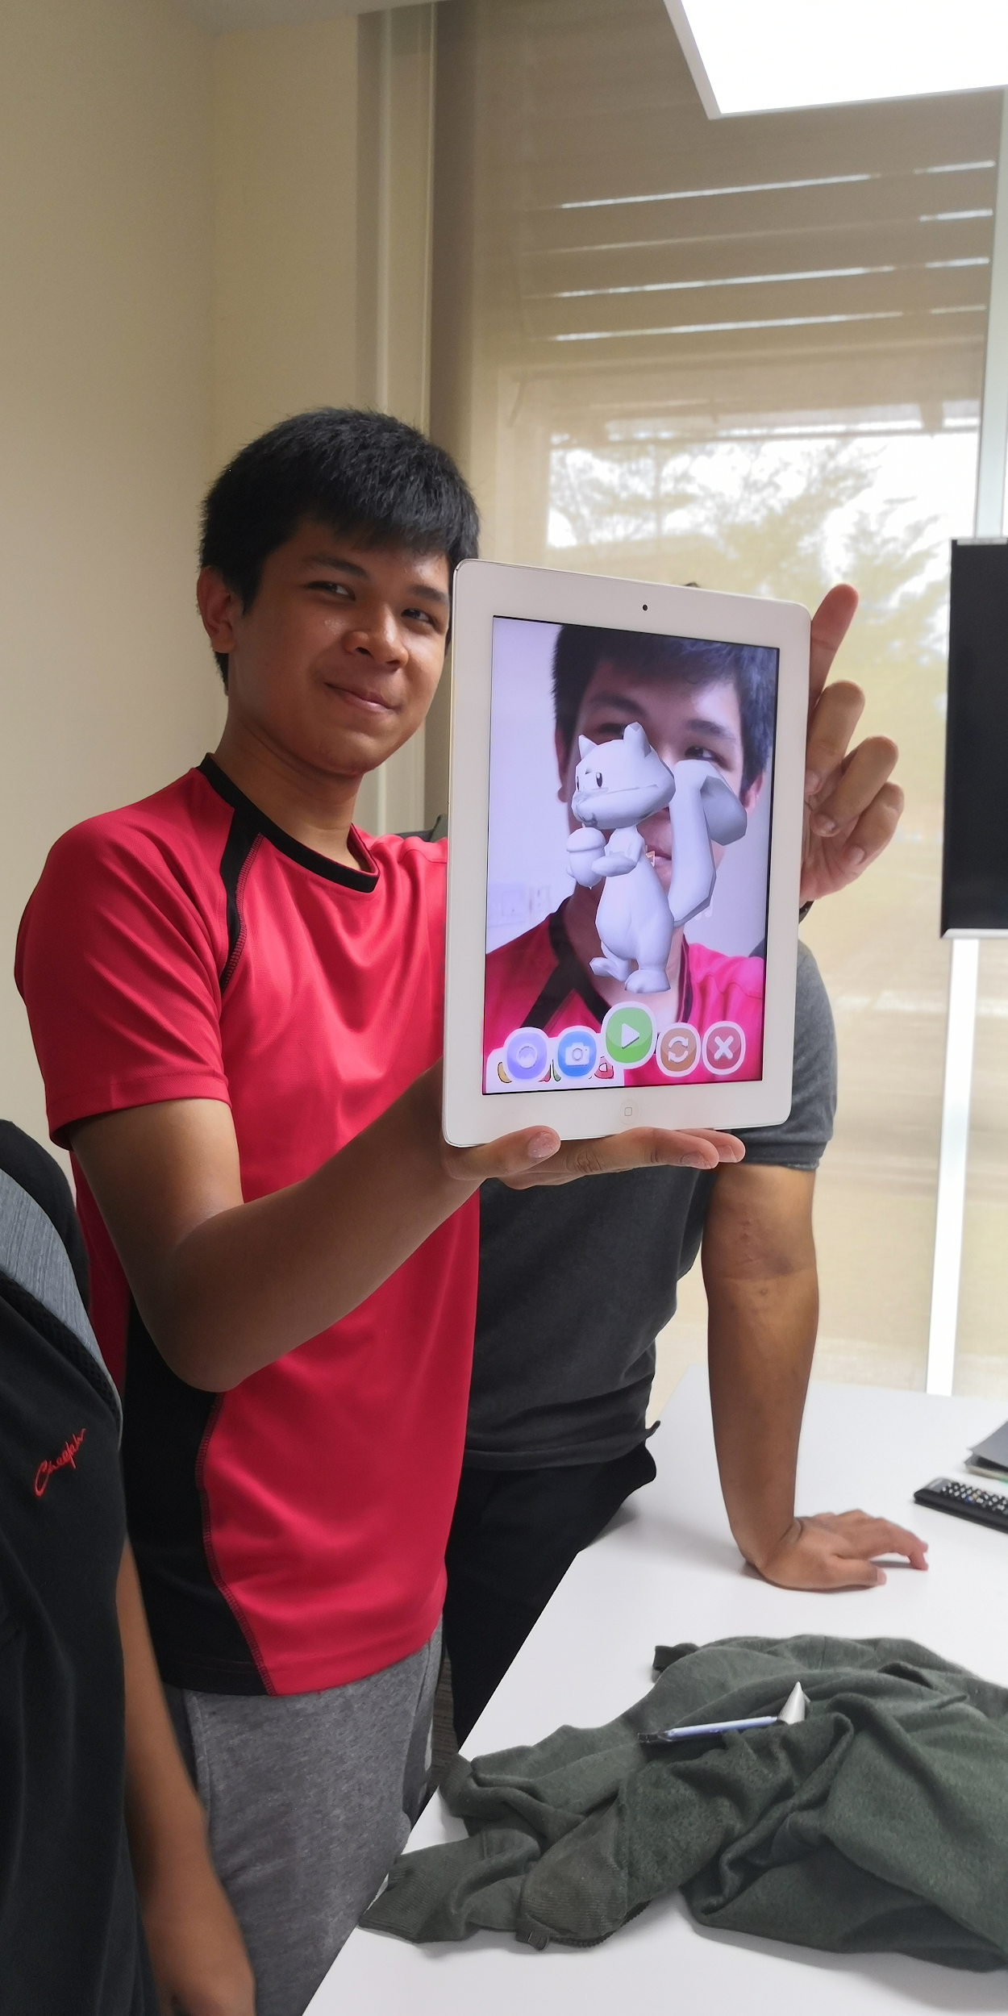
Figure 3(f) iii : The application is tested by our coursemates by scanning a different animal in the book provided
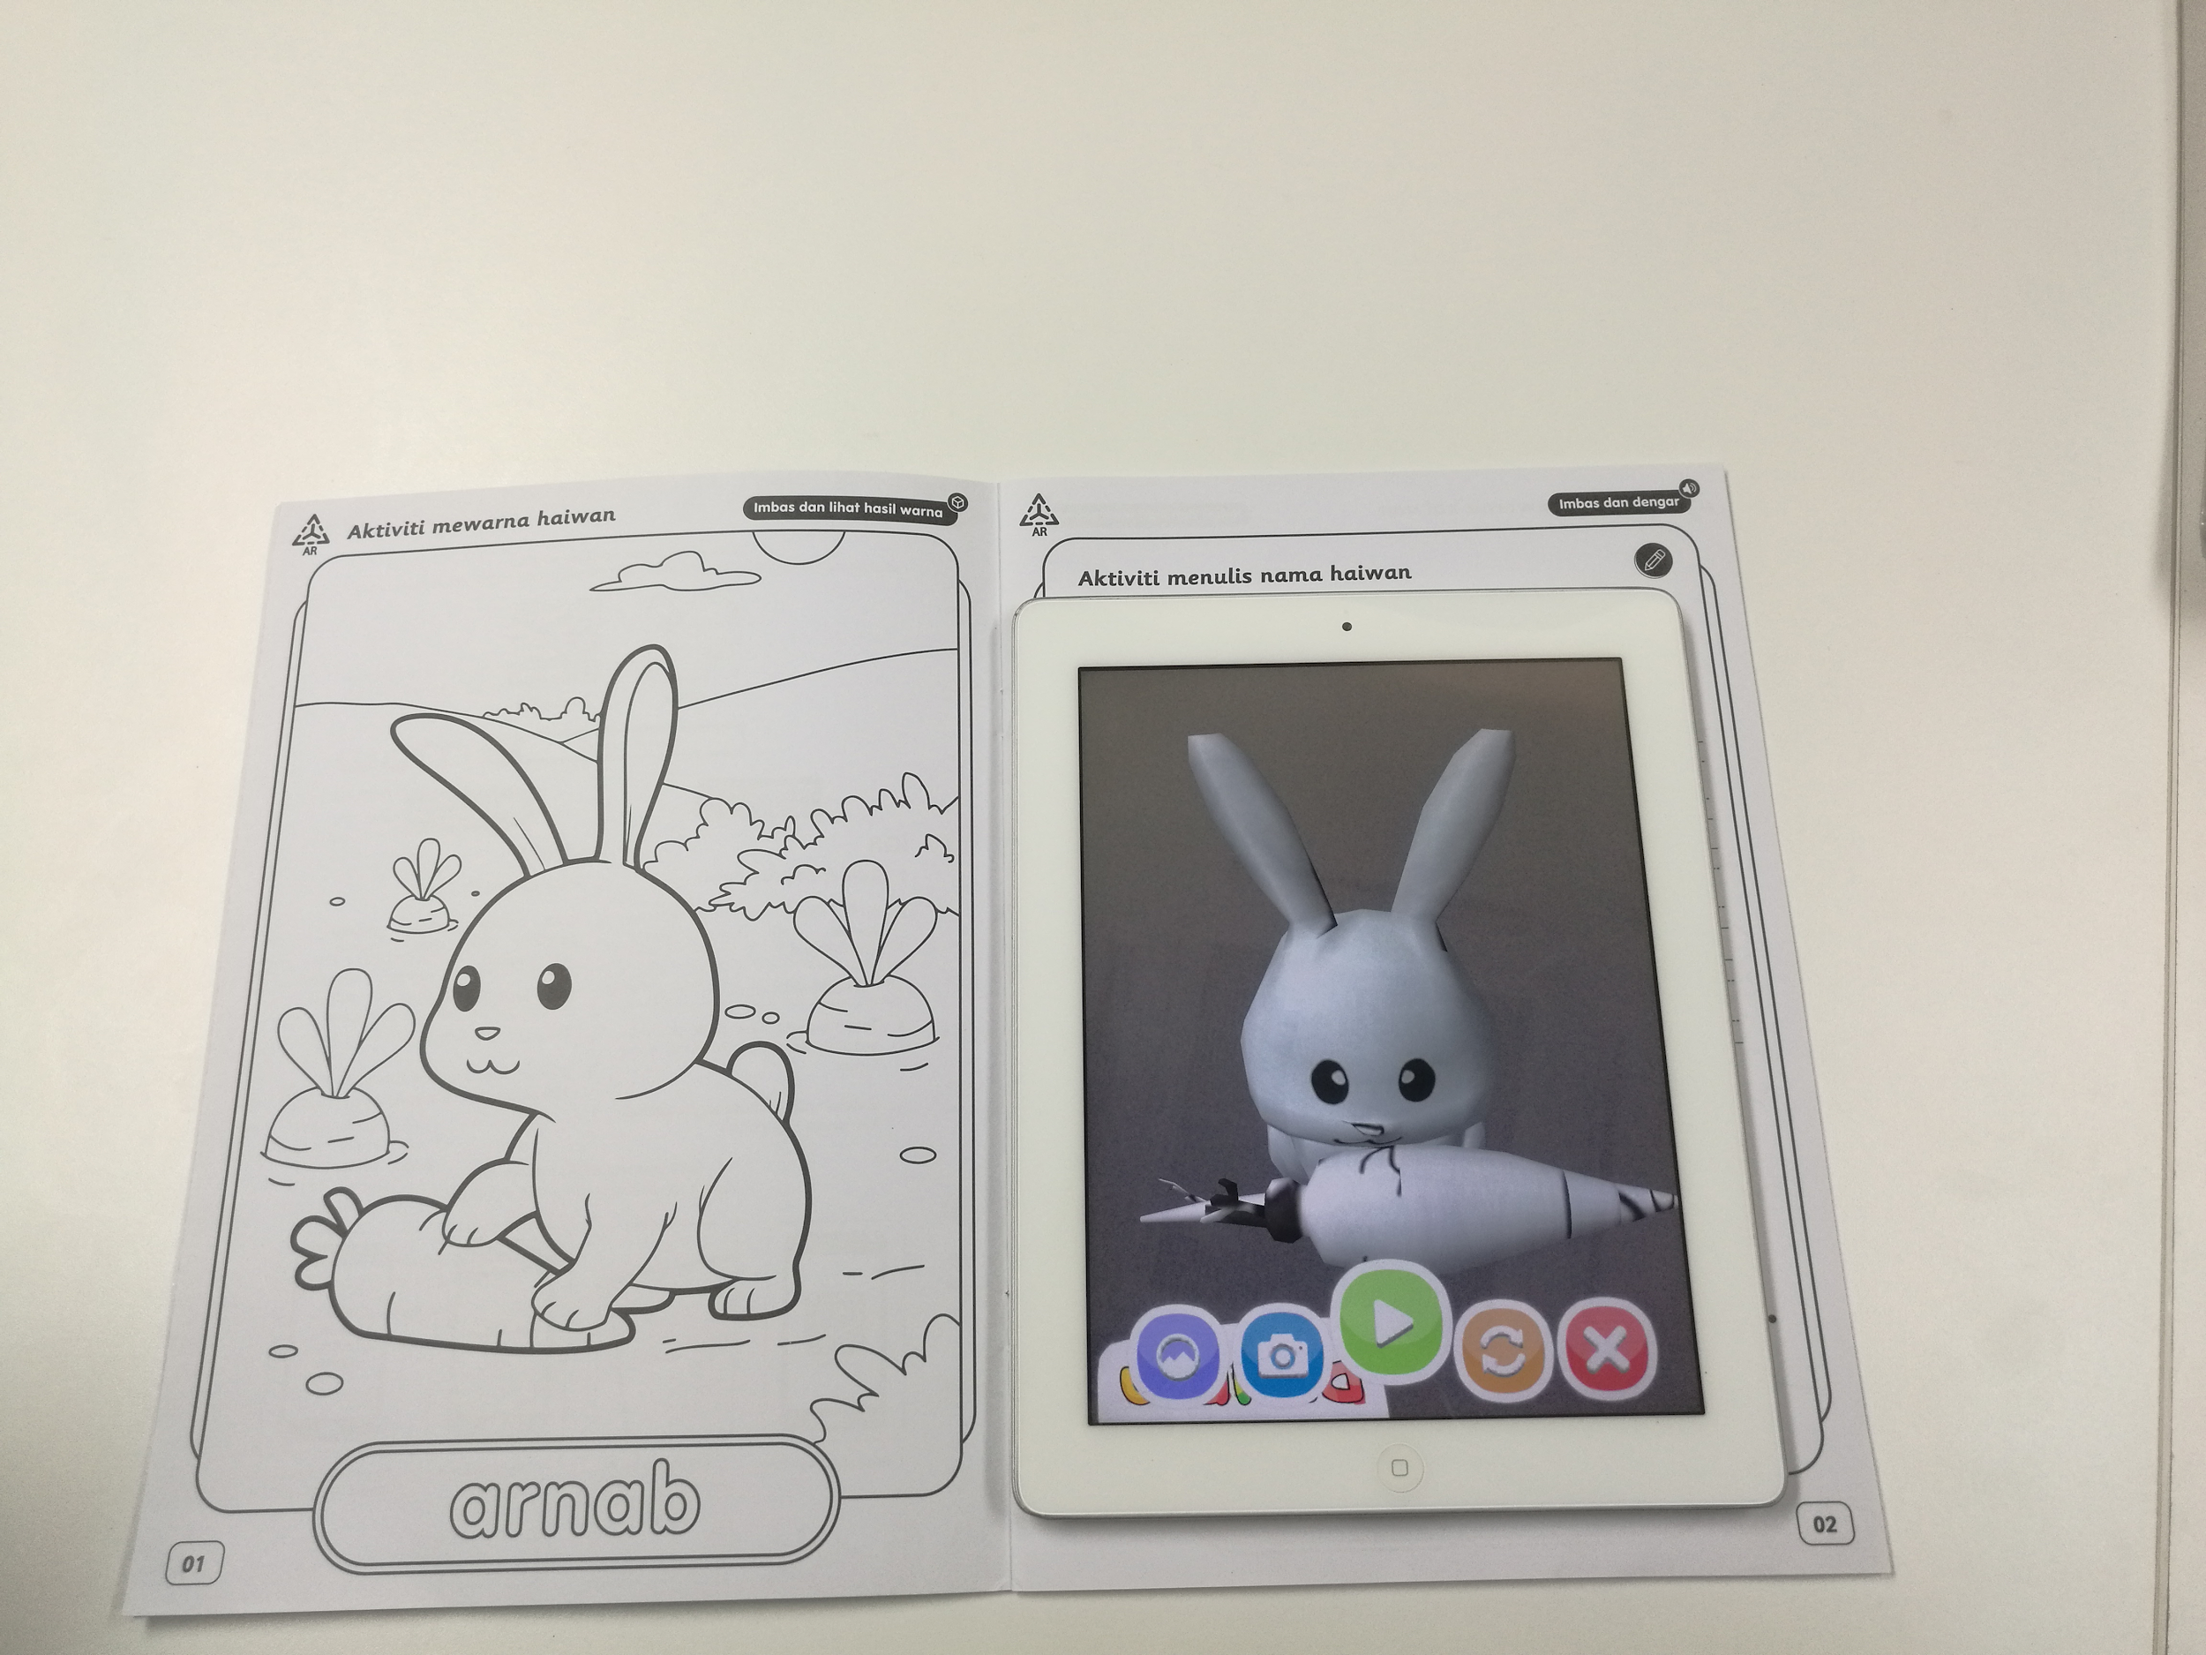
Figure 3(f) iv : The colour of the rabbit can be changed according to the rabbit in the book

4. Reflections
A. What is your goal/dream with regard to your course/program?
Anyone who choose this path of (graphics and multimedia) including all of our team members , have a great passion toward game development and graphic design , and it is an amazing way to represent ideas in real life using computer components . We all hope to make graphics and multimedia software as the main element in our future career for instance in career such as game designer or developer, graphic and multimedia developer or programmer.
B. How does this visit impact on your goal/dream with regard to your program?
It was an eye opening experience for us to see the different types of innovations and technologies which are connected in a way or another to multimedia and games, also it gave us a new method of thinking. We all have the common agreement that technologies and innovation could really help us as a student or learner to learn or gain new knowledge in a very interesting way.
C. What is the action/improvement necessary for you to improve your potential in the industry?
We as a freshman year students , the first thing that we need to do is sharpen our programming skills , also to improve our artistic perspective to produce better 3D modules and graphics in general. With all the previous, it is a must to widen the range of knowledge in all computer science field so that we can improve ourselves and also to prepare us for the future work challenges.

5. Task for each member
Members | Task
Chai Ming Choy | - Assign work for each member  - Exhibition on 3D Printer  - Demo on Augmented Reality for Kid learning
Wan Nur Atiqah binti Junaidi | - MagicX background introduction by the MagicX manager  - Demo on Virtual Reality on Oculus Quest
Goh Jo Ey | - Driving car simulation  - Explanation on Kinect Interactive Wall
Zaimi Mohamed | - Introduction  - Journey Details
All | - Discuss on Reflection and produce a general reflection  - Check overall work  - Add on for any other parts

6. Reference

- Techopedia.com. (2019). What is Augmented Reality (AR)? - Definition from Techopedia. [online] Available at: https://www.techopedia.com/definition/4776/augmented-reality-ar [Accessed 11 Oct. 2019].)

- All3DP. (2019). What is 3D Printing? - Simply Explained | All3DP. [online] Available at: https://all3dp.com/1/what-is-3d-printing/ [Accessed 11 Oct. 2019].

- Thingiverse.com. (2019). Thingiverse - Digital Designs for Physical Objects. [online] Available at: https://www.thingiverse.com/ [Accessed 11 Oct. 2019].

- Bardi, J. (2019). What is Virtual Reality? VR Definition and Examples | Marxent. [online] Marxent. Available at: https://www.marxentlabs.com/what-is-virtual-reality/) [Accessed 11 Oct. 2019].

- Lee, K. and Kang, H. (2017). VIRTUAL REALITY FOR LOW-COST AUTOMOTIVE DRIVING SIMULATOR IN VEHICLE ENGINEERING RESEARCH. Jurnal Teknologi, 79:7(eISSN 2180–3722), pp.71–81.

